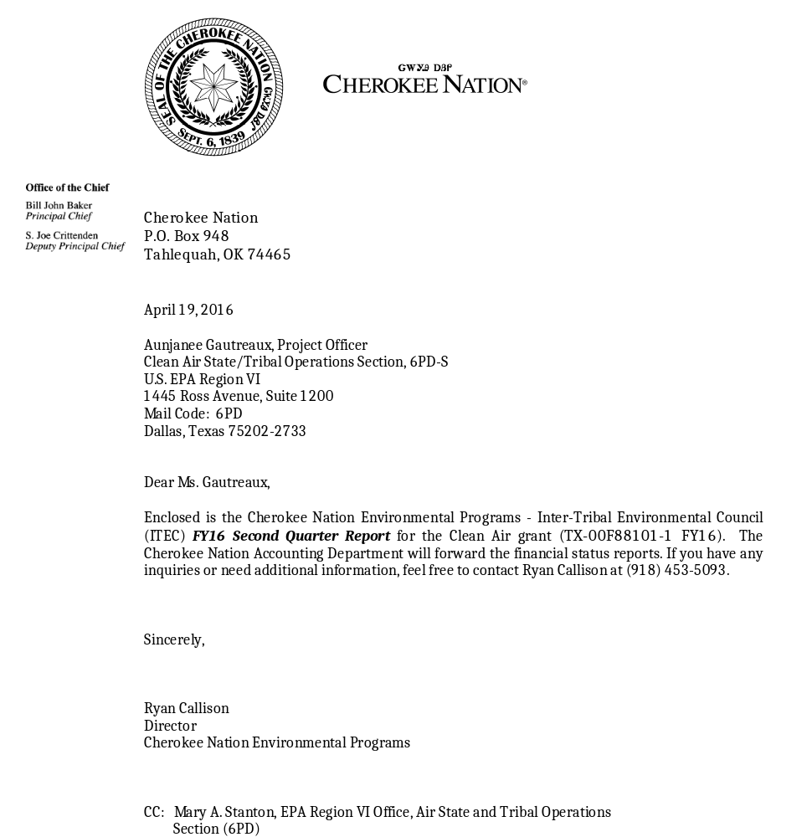

CHEROKEE NATION - ITEC

Clean Air Act, Section 103 Grant
(TX-00F88101-1 FY16)

FY16 Second Quarter Report
01-01-16 thru 03-31-16

submitted to the

Clean Air Section
U.S. Environmental Protection Agency, Region VI

Dallas, Texas

for the

Inter-Tribal Environmental Council (ITEC)

prepared by

Cherokee Nation
Environmental Programs
P.O. Box 948
Tahlequah, Oklahoma 74465
(918) 453-5093

CHEROKEE NATION - ITEC

Grant Information

Quality Assurance Dates:

Criteria: Approved April 29th, 2015
(Expires June 11th, 2016)

IMPROVE: National Program Approved

CASTNet: National Program Approved

Mercury (MDN): National Program Approved

AMNet (Tekran): Submitted to EPA CAMD

CNEP QMP: Approved March 24th, 2016

Task 1: Criteria Pollutants & Meteorological Ambient Air Monitoring Quarterly Report

Equipment operational during this quarter:

Tahlequah Shelter (40-021-9002):
Ozone & meteorological equipment

Newkirk Shelter (40-071-9010):
Ozone & meteorological equipment

Pryor Shelter (40-097-9014):
Ozone & meteorological equipment

Stilwell Shelter (NCORE-CASTNet) (40-001-9009):
Ozone, trace NOY, CO & SO2, CASTNet dry deposition filter pack, mercury deposition network (MDN), meteorological equipment, speciated mercury sampling (Tekran), continuous PM2.5 and PM10, and continuous & non-continuous ammonia sampling.

Roland Shelter (40-135-9021):
Ozone, NOx, continuous PM10 & PM2.5, & meteorological equipment

Mobile Monitor (40-125-9025, Kickapoo Tribe):
Ozone, meteorological equipment & PM2.5 and PM10

Quarterly maintenance was completed at all sites. This includes conducting multipoint audits; replacing desiccant, filters and tubing; and cleaning inlet manifolds, as necessary.

Ozone transfer standards currently in use were verified against the primary standard during the month of March. Ozone analyzers not run year-round were shut down at the end of ozone season (November 30th) and were maintenanced and placed back in the field before March 1st.
Inquest Environmental performed independent audits at all of our monitoring sites during the week of March 14th, with the exception of the NCore site, which was audited in December 2015.

The PM10 BAM at Roland has had no flow since 23:00 on February 22nd and is currently offline; we suspect there is an issue with the pump control from the BAM. Unfortunately, we do not have any replacement parts since the instrument is so old. If Region 6 concurs, we would like to discontinue running this particular monitor. The Arkansas DEQ and CNEP PM2.5 air monitoring partnership continues at the Roland air monitoring station.

Task 2: IMPROVE Monitoring Quarterly Report
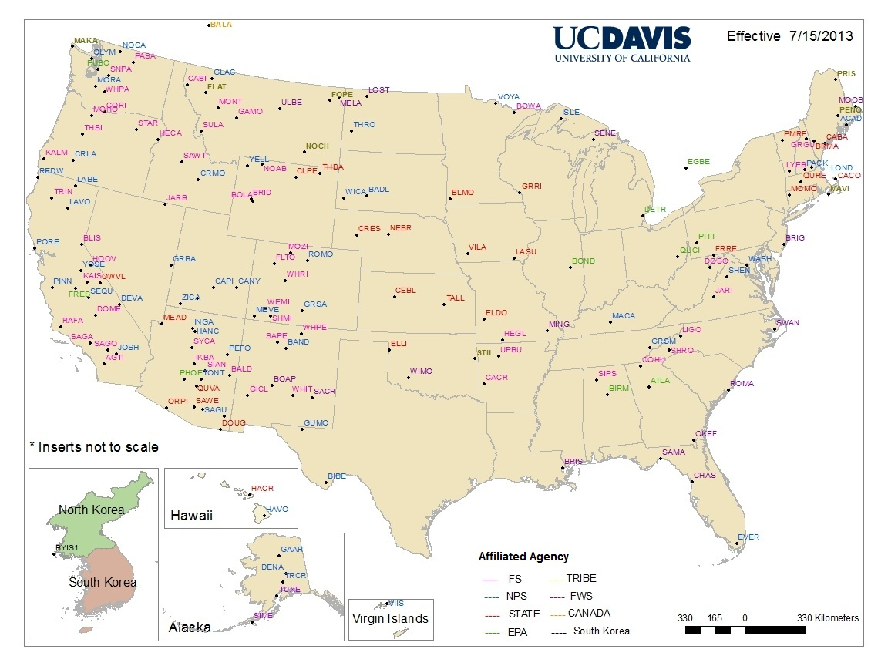
IMPROVE sampling is ongoing with minimal operational issues. The site name was changed from CHER1 to STIL1 to reflect the move from Newkirk to Stilwell in April 2010. This site name and location has been updated on the most recent maps (see left). Data from the laboratory is received within 4-6 months of each sample run.

IMPROVE sampling is conducted on a 1/3 sampling schedule; samples are being collected every Tuesday.

CNEP IMPROVE data and reports are available at:
http://vista.cira.colostate.edu/IMPROVE/Data/IMPROVE/improve_data.htm

Task 3: CASTNet Monitoring Quarterly Report

The CASTNet program is located in Stilwell, Oklahoma; it along with other network projects comprises part of the NCORE program.

AMEC has experienced issues connecting to the CASTNet site via our dial-up modem; to resolve the problem, they sent us a Raven X cellular modem to install. They are now able to connect and download data.

The Illinois State ammonia sampling project (now referred to as the AMon network) continues at Stilwell CASTNet. AMON data are available for a variety of time periods and formats at http://nadp.isws.illinois.edu/AMoN/sites/data/.

Task 4: NCORE Multi-Pollutant Monitoring Quarterly Report

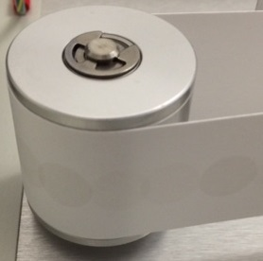
The NCORE site is operational and collecting data. We are experiencing some problems with the Met One BAM PM2.5 at NCore; on a daily basis, we are seeing a few hours of missing data, sometimes preceded or followed by values that seem abnormally high. We downloaded the error log, system settings and some data and did not see anything out of the ordinary; the missing data seems to be due to negative readings lower than the lower limit of -10 µg/m³. We think the high readings are related to hourly sample spots which are slightly overlapping (see arrows in picture). We contacted Met One about the issue, and they recommended some cleaning/maintenance, which was done; however, the problem persisted. Met One said we could get replacement parts for the rollers on the PM2.5, but it may or may not fix the problem; they recommended us sending it in for repair as well as service, considering the age of the unit. It is an “H” serial number unit and they are on “U” now, and there have been some improved mechanical changes over the years. There was not anything wrong with the PM10, but Met One recommended us sending it in as well for service and upgrades since it is a “K” serial number unit; they are concerned that we may have problems with the PM10 in the near future. Both units were pulled on April 8th.

Task 5: Mercury Deposition Network (MDN) Monitoring Quarterly Report

CNEP currently operates one MDN sampler located at Stilwell, Oklahoma. The sampler is fully operational with samples being collected every Tuesday; there were no operational issues to report. No samples were missed during this quarter.

CNEP will be participating in a U.S. Geological Survey (USGS) special study to measure isotopes of gaseous mercury in air samples to be collected with USGS samplers at NADP monitoring sites. The air sampler is approximately 1 foot x 1 foot and weighs 5 pounds; it requires 120-volt AC power and draws less than 500 milliamps. The air sampler has a pump that pulls air into a trap that will collect mercury for isotope analysis by the USGS lab; the sampler will be set up on the old NTN platform. The first sample will run on April 5th.

Site specific MDN data reports and yearly summaries are available at the following website: http://nadp.sws.uiuc.edu/sites/siteinfo.asp?id=OK99&net=MDN.

Task 6: Monitoring Data Management and Analysis Quarterly Report

All applicable site data will be submitted to AQS for accuracy and compliance purposes.

The 1st quarter 2016 data from all sites will be submitted to AQS before June 30th, 2016.

Task 7: Mobile Particulate and Ozone Monitoring Quarterly Report

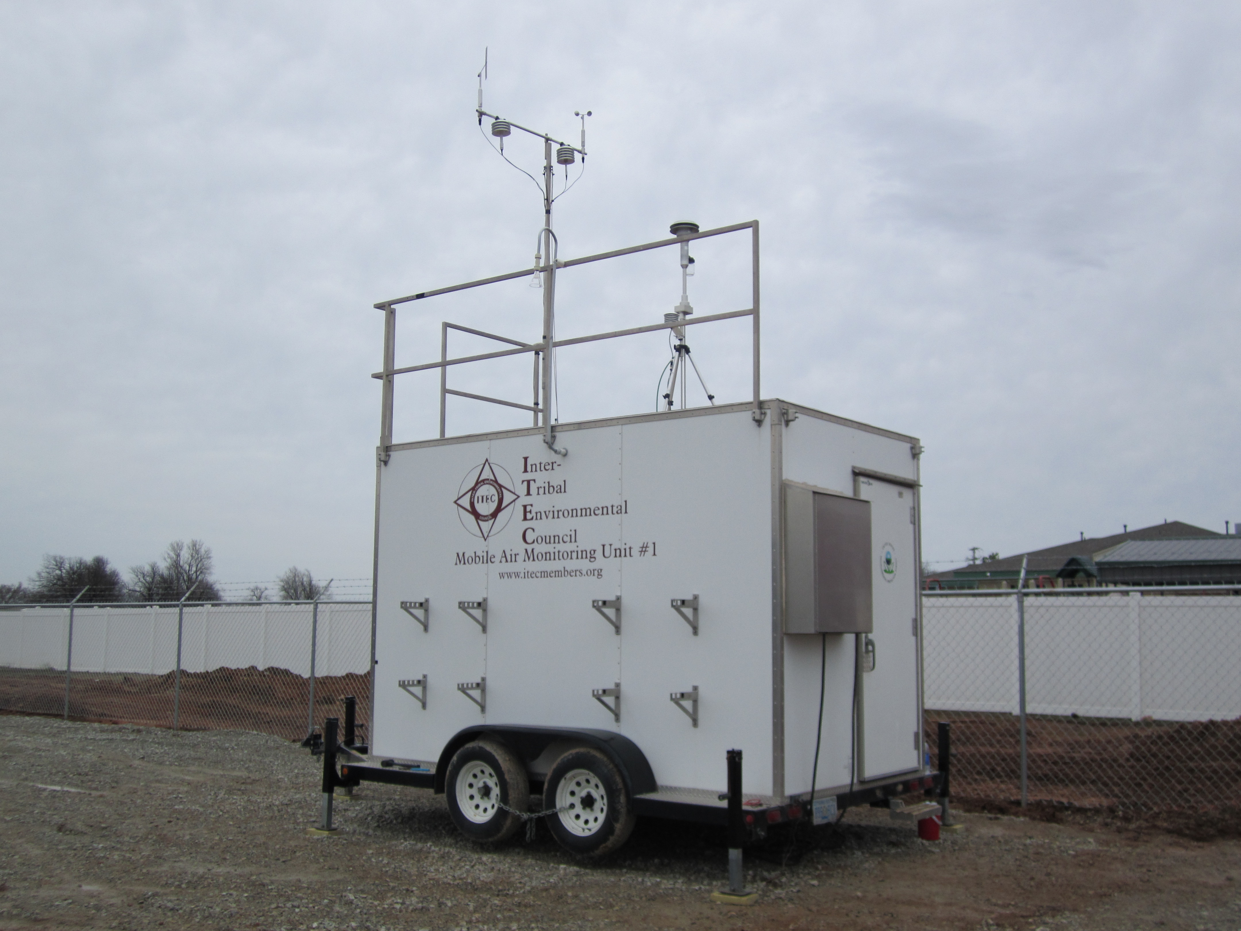
The mobile unit was installed at the Kickapoo site in McLoud, OK on March 20th, 2015 behind the Kickapoo Community Childcare Center. The site is audited on a monthly basis, unless problems are encountered which require immediate attention. We will continue to provide quarterly reports to the host tribe. The next host tribe will be the Wyandotte Nation in Wyandotte, OK; the tentative start date will be late October 2016. We also recently received an inquiry from the Pueblo of Laguna, which is an ITEC member tribe.

Task 8: Technical Assistance to Tribes Quarterly Report

We replaced the old Sabio glass sampling manifold at the Quapaw air monitoring shelter with a refurbished manifold of the same make/model from one of our sites; we replaced all of our Sabio manifolds with Ecotech models, which are easier to clean and maintain. The replacement was done on February 4th while the ozone monitor was still offline.

The 1st quarter independent audit for the Quapaw Tribe was conducted on March 23rd; audited parameters included ozone and the PM2.5 BAM 1020 (at the air monitoring station) and the Tar Creek TSP monitors and the PM10 BAM 1020 monitor at the Picher. (The PM2.5 BAM 1020 monitor at the Picher site was pulled for service.) The ozone analyzer was within specifications at all audit levels. The PM2.5 BAM 1020 passed the temperature, pressure, leak and flow checks during the site visit. The Tar Creek TSP monitors were all within specifications, and the Picher PM10 BAM 1020 instrument passed all checks. The 1st quarter independent audit for Delaware Nation was conducted on March 24th; ozone and meteorological parameters were evaluated. The ozone analyzer and all meteorological parameters were within specifications.

Task 9: CNEP Professional Training and Development Quarterly Report

Attended Cherokee Nation Creative Ways to Praise and Recognize Employees course on January 7th (April)

Attended AQS Webinar on January 28th (April)

Attended Tribal Exchange Network Conference in Albuquerque, NM February 9th – 10th.

Attended the TAMS Steering Committee face-to-face meeting in Las Vegas March 8th – 10th (April)

Attended Exchange Network Tribal Governance Group (TGG) conference calls on January 6th and March 22nd (April)

Attended TAMS Steering Committee conference calls on January 20th and February 17th (April)

Attended CNEP Environmental Festival planning meetings on January 28th and February 18th (staff)

Attended 8 Hour HAZWOPER Refresher course on March 16th (staff)

Task 10: Tribal Air Monitoring Grant Objectives & Priorities

All applicable quarterly site data will be submitted to AQS for accuracy and compliance purposes.

The ozone season for Oklahoma is March 1st – November 30th; only the CASTNet and mobile ozone monitors are operated year-round. All ozone monitors not operated year-round were place back online by March 1st, 2016.

The CNEP FY17 Clean Air proposal was submitted and received on February 22nd. We will submit the final grant application through grants.gov once the funding opportunity is posted.

