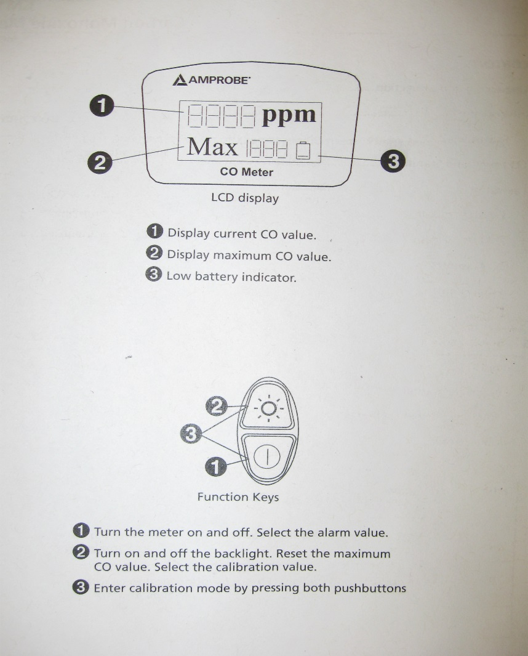

OPERATION

Power the meter on with the lower button. For 15 seconds the preset alarm value and the temperature will flash as the unit performs a Self-Test. The default alarm value is 25ppm, but can be set to CO levels of 25, 30, 35, 50, 70, 100, and 200ppm. To reset this value, when turning the meter on, hold and do not release the lower button “Neon Green Circle” until the desired alarm value is in the display.

CALIBRATION at 0 PPM

Put the meter in an area of 0ppm CO. Turn off the meter and press both buttons simultaneously to start the default 0ppm calibration mode. The display will display a blinking ppm value and finally will stop blinking when the calibration is complete, usually about 10 minutes. Electromagnetic interference, caused by computers, cell phones and other electronic devices will cause these blinking ppm values to be erratic and cause the calibration to take longer or never complete. When calibrating the CO meter, keep it away from electromagnetic interference.

CALIBRATION at 100/500 PPM

After pressing both buttons for two seconds simultaneously with the meter off, the meter enters Calibration mode. At this time pressing the upper button “Light Symbol” will toggle the values 0, 100, and 500 in the lower part of the display. When the correct value is chosen, place the meter into a sealed box filled with a standard gas (100ppm or 500ppm CO) for 15 minutes and the calculation will be performed automatically. Check if the reading meets the calibration value, and if it does not, recalibrate.

Effects of Carbon Monoxide Poisoning next page:

Effects of Carbon Monoxide Poisoning:

|  |  |
| --- | --- |
| 0-1 PPM | Normal background levels |
| 9 PPM | Maximum indoor air quality level |
| 50 PPM | Maximum 8 hour average exposure level |
| 200 PPM | Mild headache, fatigue, nausea and dizziness |
| 400 PPM | Frontal headache, life threatening after 3 hours |
| 800 PPM | Dizziness, nausea, convulsions, DEATH WITHIN 2 TO 3 HOURS |
| 1600 PPM | Nausea within 20 minutes, DEATH WITHIN 1 HOUR |
| 12800 PPM | DEATH WITHIN 2 TO 3 MINUTES |