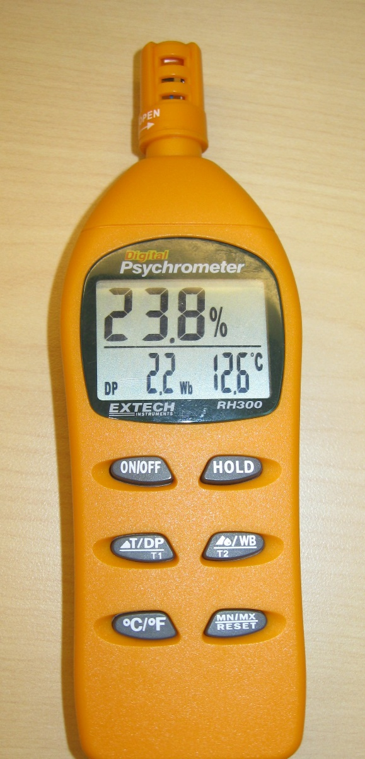

Sensor and Protective Cap

External Temperature Probe

Relative Humidity

Temp or Dew Point Wet Bulb Temp

On/Off Hold Button

Temp/Dew Point Toggle Wet Bulb/External Temp Toggle

Celsius/Fahrenheit Toggle Min/Max Reset

OPERATION

Open the protective sensor cap by twisting counter-clockwise a quarter of a turn. Press the ON/OFF button and the meter will perform a short self-test. Hold the unit in the area to be tested and allow a few seconds for the readings to stabilize. The Relative Humidity appears in the top display.

BUTTON OPTIONS

The Temp/Dew Point Toggle button will select Temp or Dew Point for the lower left display value. Pressing Celsius/Fahrenheit will direct the display to be in degrees C or F. The Hold Button will cause the display to freeze the current reading. Without the External Temp probe the Wet Bulb/External Temp Toggle will not affect the display, the lower right displayed value will remain as Wet Bulb temperature. Press the Min/Max Reset button once and the display will be minimum values in memory for RH and Temp, pressing again the displayed values are the maximum values in memory, pressing a third time will return to live display. Pressing the Min/Max Reset button and holding it in for more than two seconds will clear the current Min/Max values in memory.

Accuracy Verification and Calibration:

The following verification and Calibration procedures require 33% and 75% reference bottles (Model RH305 kit).

VERIFICATION

Insert the meter’s sensor into either the 33% or the 75% reference bottles and check the reading after 10 minutes. The observed RH value should be between 32.0 and 34.0 RH using the 33% reference or between 72.8 and 77.3 RH using the 75% reference to be within the Accuracy Specification of the manual. The temperature accuracy should be ±1.8 degrees F or ±1 degrees C when comparing to a calibrated thermometer to be within specification of the manual.

CALIBRATION (Quoted from the manual)

### Relative Humidity Calibration (33% and 75%)

### Calibration Preparation

* Ensure that fresh batteries are installed in the meter.
* Move the protective vent cap to the *Open* position.
* Power the meter ON and set it to display dew point (*DP)* and wet bulb (*Wb)* in the lower display area.

### Calibration Procedure

1. Follow the Preparation steps above before continuing.
2. Power the meter OFF.
3. Insert the meter into a 33% salt bottle.
4. Leave the meter OFF for one hour (to stabilize).
5. After the meter has stabilized for one hour:
   * Press and hold the °C/°F button while powering the unit ON.
   * The unit enters calibration mode (32.8% flashes on the display).
   * The DP and Wb display areas show DP ---- Wb ----°C.
6. Once the 33% calibration is complete, the display stops flashing and a constant 32.8% is displayed.
7. Allow the meter to remain ON and move it to the 75% salt bottle.
8. Allow the meter to remain for one hour in the 75% salt bottle to stabilize.

### Important: Do NOT power the meter OFF while in the Calibration mode! Note that AUTO POWER OFF is disabled while in the Calibration mode.

1. After one hour, press and hold the MN/MX button until *75.3%* begins flashing on the meter display. The meter has now entered the 75.0% calibration stage.
2. After 30 minutes have elapsed, the meter will automatically exit the calibration mode and return to the normal operating mode.
3. The Calibration is complete, turn power OFF.

Note: To exit from the calibration procedure before completion, press the **ON/OFF** button.

Note: If the salt at the bottom of the calibration bottles appears dry, the bottles should be replaced