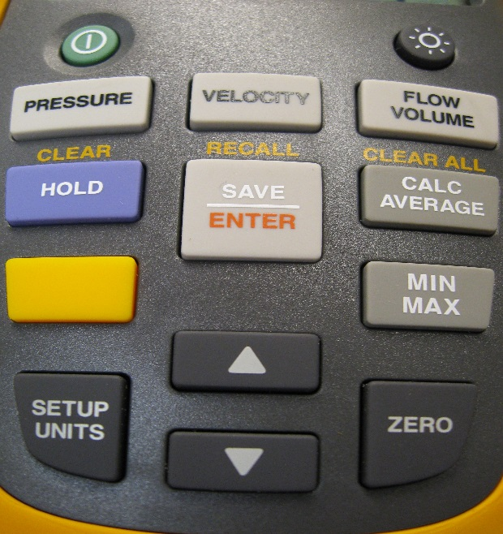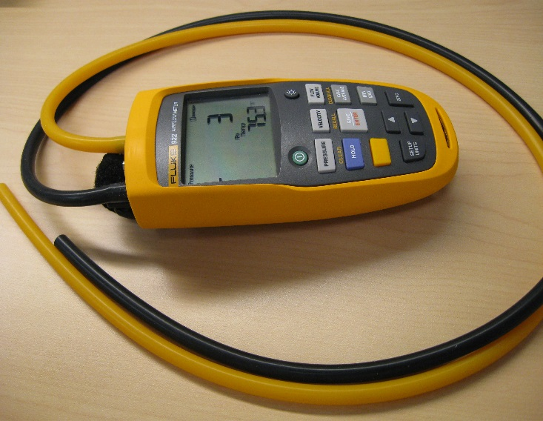

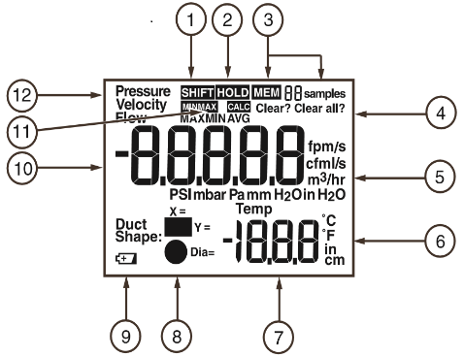

1 Yellow shift key pressed: Clear, Recall, or Clear all.

2 Hold is engaged. Current reading is captured.

3 Memory and number of samples.

4 Clear stored sample or samples?

5 Units of pressure, velocity, and flow.

6 Units of length and temperature.

7 Temperature and setup parameters.

8 Duct shape choices.

9 Low battery indicator.

10 Pressure, Velocity, or Flow values.

11 Min/Max Avg indicators

12 Active mode indicator-Pressure, Velocity, or Flow

**USING THE METER**

**ON/OFF** The round button on the upper left turns the unit on, and the round button on the upper right turns the display backlight on/off.

**SETUP UNITS**  Press the **Setup Units** button to change units for Pressure, Velocity, Flow, Temperature and Duct Dimensions. Use ↑ and ↓ keys to change units and **Save/Enter** key to accept the change. The meter will move to the next parameter.

**PRESSURE** The **Pressure** button starts a differential pressure measurement:

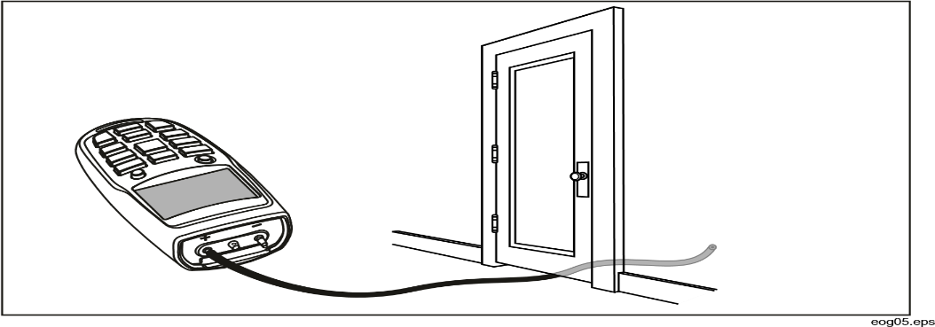Connect a single hose to the Input (+) port. With the tubing open to ambient conditions press and hold **ZERO** for two seconds. Then place the input hose in a different zone than the meter. The meter displays the difference in pressure between the input zone with respect to the reference zone.

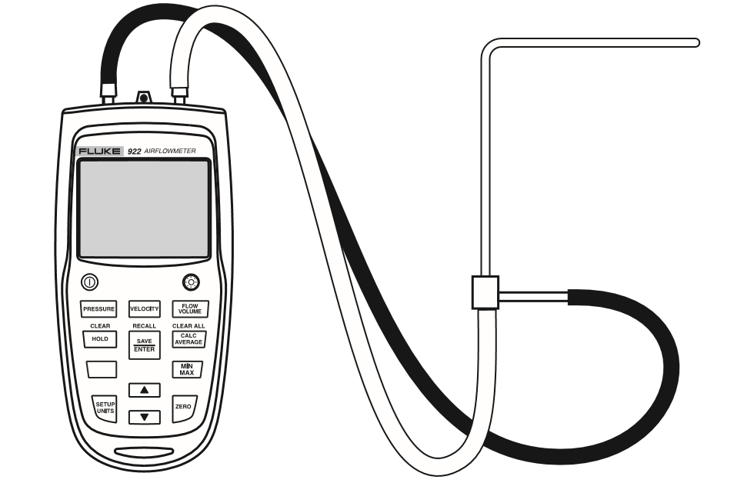**MEASURING VELOCITY**

Press **Velocity** to enter velocity mode. The Input (+) pressure port connects to the yellow hose from the total pressure connection of the pitot tube. The Ref(-) pressure port on the meter connects to the black hose from the static pressure connection of the pitot tube. With the pitot tube open to ambient conditions press and hold **Zero** for two seconds. Then place the pitot tube into the ductwork for a measurement.

**MEASURING FLOW**

Press **Flow/Volume.**  The meter requests the duct shape or Use the ↑ and ↓ keys to select the proper shape, then press **Enter**. Then again use the ↑ and ↓ keys and the **Enter** key to select the X and Y dimensions for a rectangular duct or the diameter for a round duct. The pitot tube is connected in the same manner as a velocity measurement: The Input (+) pressure port connects to the yellow hose from the total pressure connection of the pitot tube. The Ref(-) pressure port on the meter connects to the black hose from the static pressure connection of the pitot tube. With the pitot tube open to ambient conditions press and hold **Zero** for two seconds. Then place the pitot tube into the ductwork for a measurement.

**SAVING SAMPLES**

Press **Save/Enter** to store a sample. The meter can save up to 99 samples in each of its three modes. Press **Calc/Average** to view the average of all the samples taken. **Min/Max** stores live minimum and maximum values. When there is a new minimum or maximum, the meter beeps and stores the new value. Pressing **Min/Max** repeatedly, scrolls through the maximum, minimum, average and live readings. To exit Min/Maxmode hold the **Min/Max** button in for two seconds. In this mode, the meter will not Auto-power off, so measurements can be taken while you are away.

To recall data, press **Pressure, Velocity, or Flow/Volume** to select the data to recall. Press the yellow shift key and (**recall**) to recall samples and use the ↑ and ↓ keys to locate the desired sample.

To clear data, press **Pressure, Velocity, or Flow/Volume** to select the data to clear. Then press the yellow shift button and press (**clear**) for clearing one data value, use the ↑ and ↓ keys and the **Enter** key to clear that data value. For clearing all data, press (**clear all**) and then the **Enter** key.