**STANDARD OPERATING PROCEDURE**

**TITLE:** Uploading Data into AQS

**SOP NUMBER:** TAP 11.3.3

**VERSION:** 2

**PREPARED BY:** Pamela Atcitty**DATE:** 08/08/13

**TITLE:** Tribal Air Specialist

**REVISED BY:**  Jessica Southard **DATE:** 11/03/15

**TITLE:** Administrative Assistant

**REVIEWED BY:**  **DATE:**

**TITLE:**

**APPROVED BY:** **DATE:**

**TITLE:** Environmental Department Director

# Scope of Application

## Gather ambient air data, which have been linked to smog, ozone depletion, acid rain and global warming. This data is needed to support and validate any efforts the Tribe is making to enforce mandated reductions in the amounts of pollutants emitted, and ensure compliance with NAAQS.

# Summary of Method

# Upload data from EN to AQS

# Check for errors

# Post data into AQS

# Interferences/Comments

* 1. Each pollutant can be entered into AQS concurrently.

# Supplies

* 1. Access to AQS

# Preparation

## Pollutant data should have been entered into EN (see SOP 11.3.2 Uploading Data into EN)

## Procedure

## Access AQS using favorites tab or at <http://www.epa.gov/ttn/airs/airsaqs/aqsweb/>, select “Proceed to AQS” and select “Agree to terms of AQS”, Run Java Program.

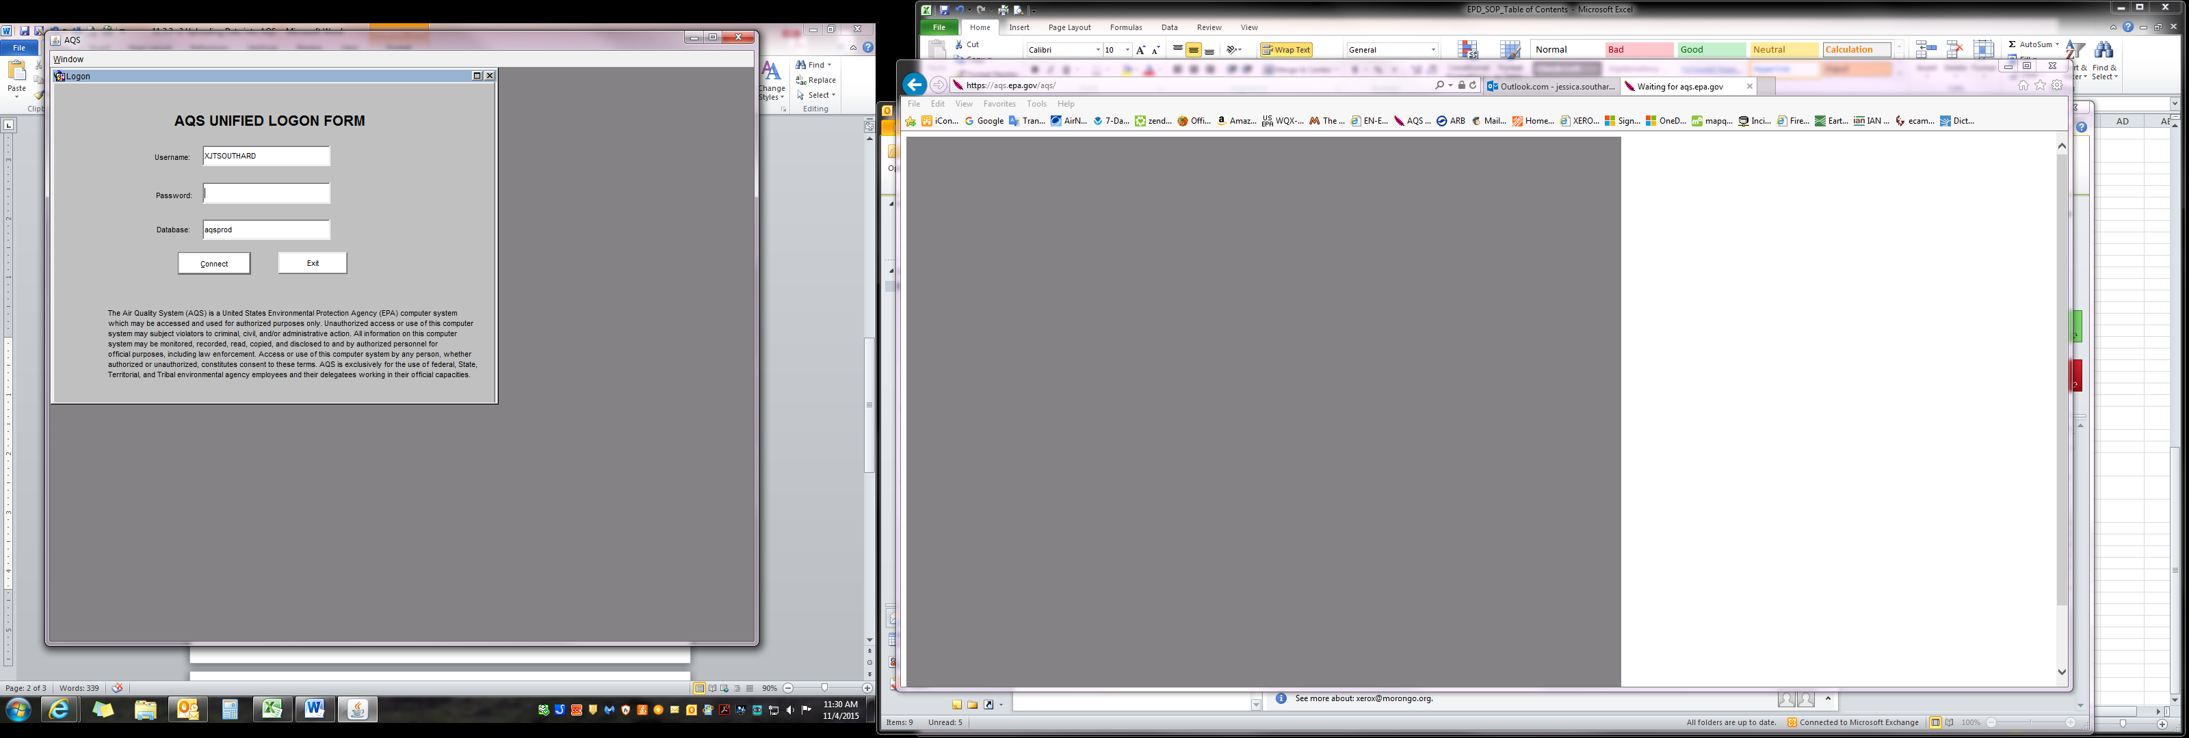

*6.2*

## Sign-in using AQS Login and Password, click connect.

*6.3 & 6.4*

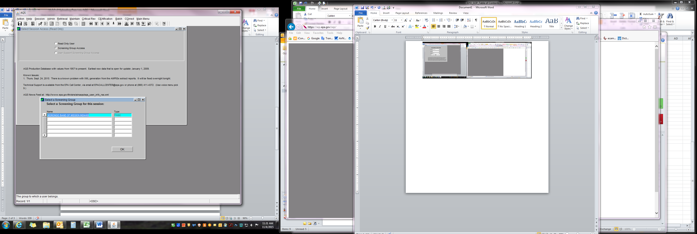

## Select “Screening Group Access”.

* 1. “Select Screening Group” window will appear with Morongo already highlighted, click “OK”.
  2. Select “Batch” tab in menu bar and History and Status screen will appear with most recent uploaded files from EN.
  3. The top, highlighted row is most recent uploaded file.

“Process Status” should read “CRST-Complete” when file

upload from EN is complete. This may take several minutes. Verify the number records are equal to the amount of records submitted.

* 1. Check for errors

## 6.8.1 Review both “Load Summary and Errors” and “Stat CR Report” for any errors in processing upload. If any errors are present, make corrections and reload data.

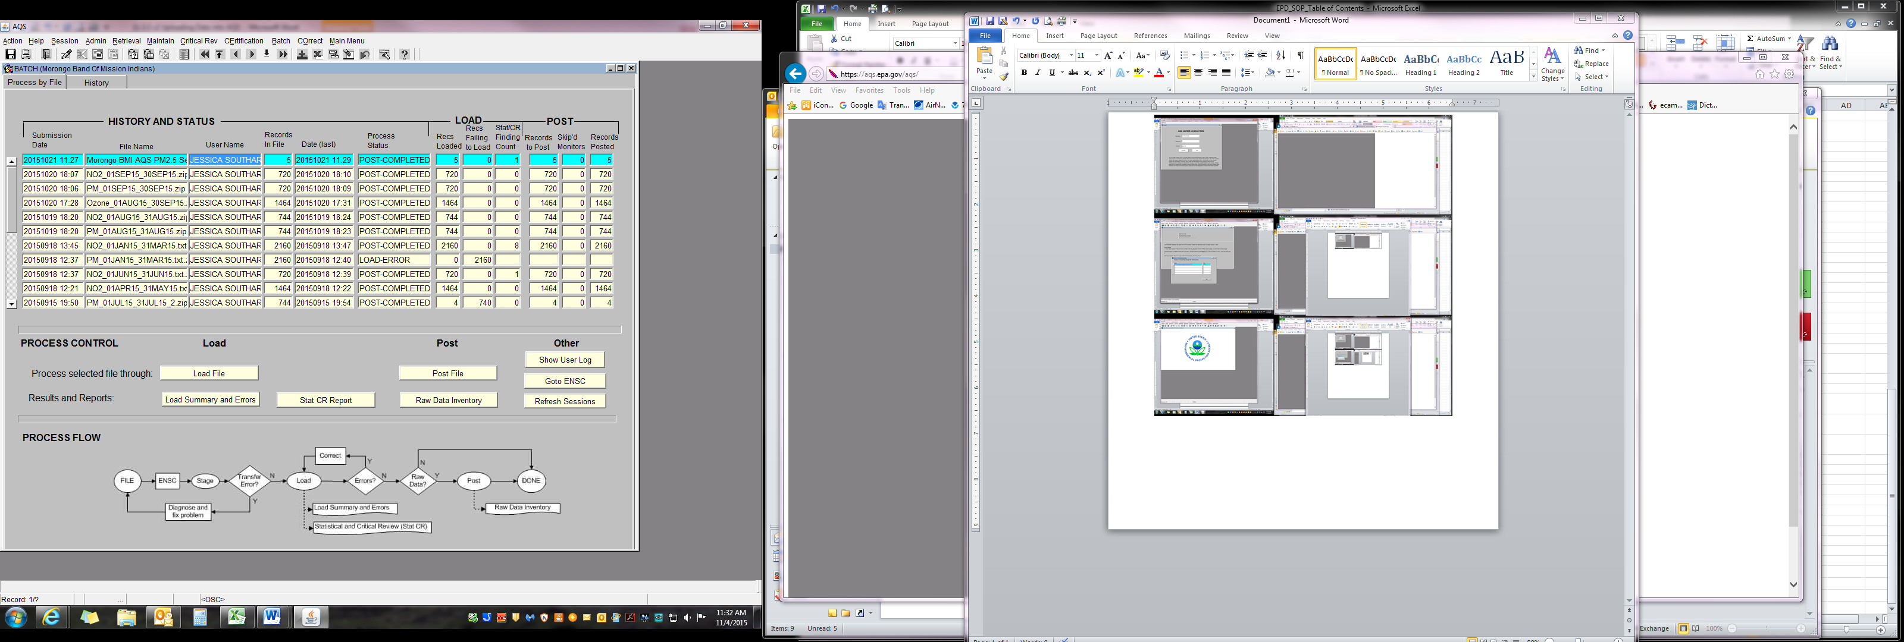

## 6.9 Post data to AQS

6.9.1 Select “Post File” and wait for “Job Successful” to appear. Click “Refresh Sessions” to see updated status.

6.6.1a To enter additional files, repeat steps 6.6 – 6.9.

1. Troubleshooting

Refer to the EPA’s website: <http://www.epa.gov/ttn/airs/airsaqs/faq/aqsfaq_loadingdata.htm> or contact the EPA Help Center at 1-866-411-4EPA (4372).