Before scheduling a submission through OpenNode2, the EN User ID in AQS must be changed to node_user@cherokee.org (the default ID is ahathcoat@cherokee.org).

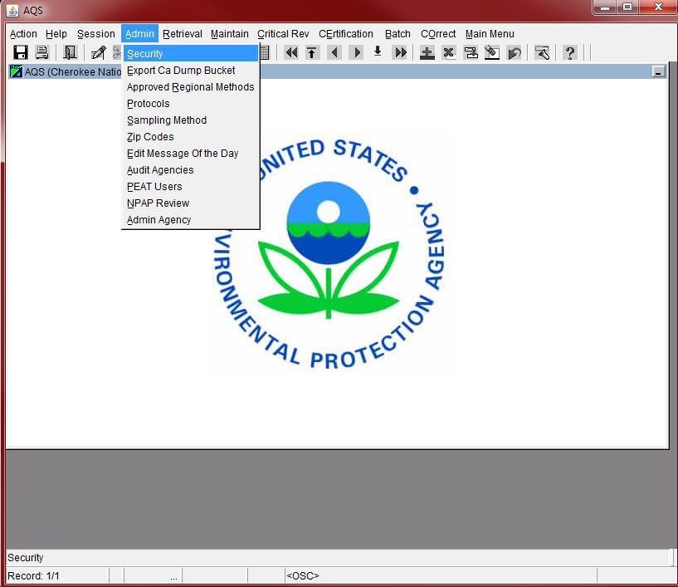

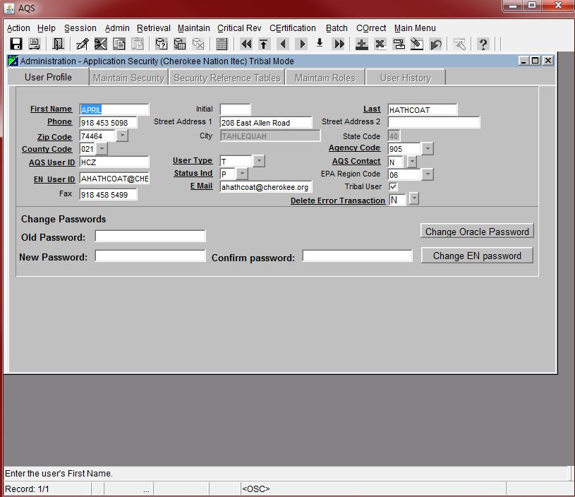

Change the EN User ID and save this change before exiting.

Go to the following address to access OpenNode2: <http://cnvhweboes1/Admin/Login.aspx?ReturnUrl=%2fAdmin%2fSecure%2fDashboard.aspx>

Account: [node_admin@cherokee.org](mailto:node_admin@cherokee.org)

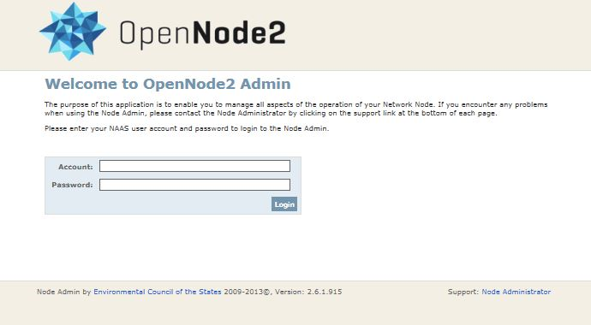

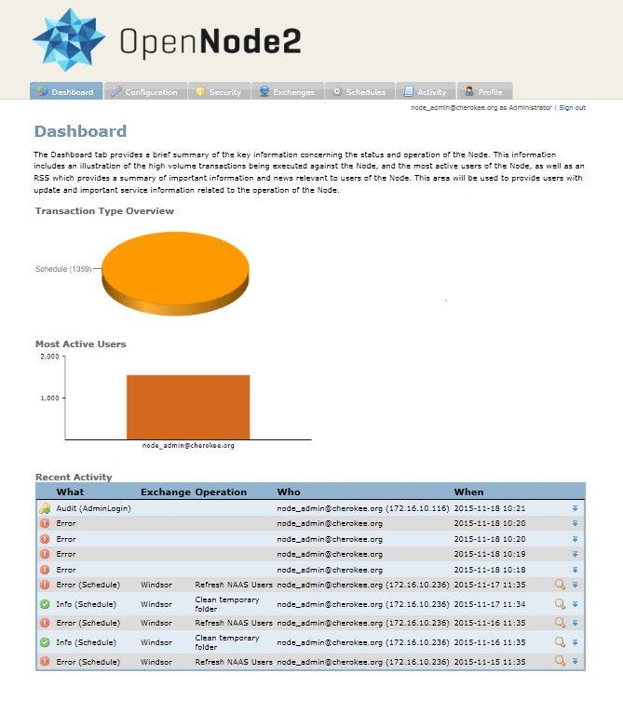

Select Schedules on the OpenNode2 Dashboard.

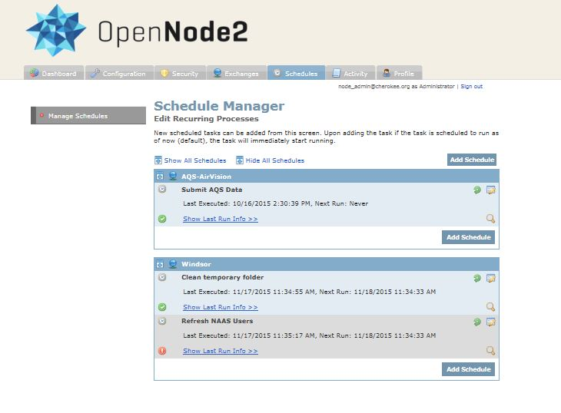

Select Submit AQS Data

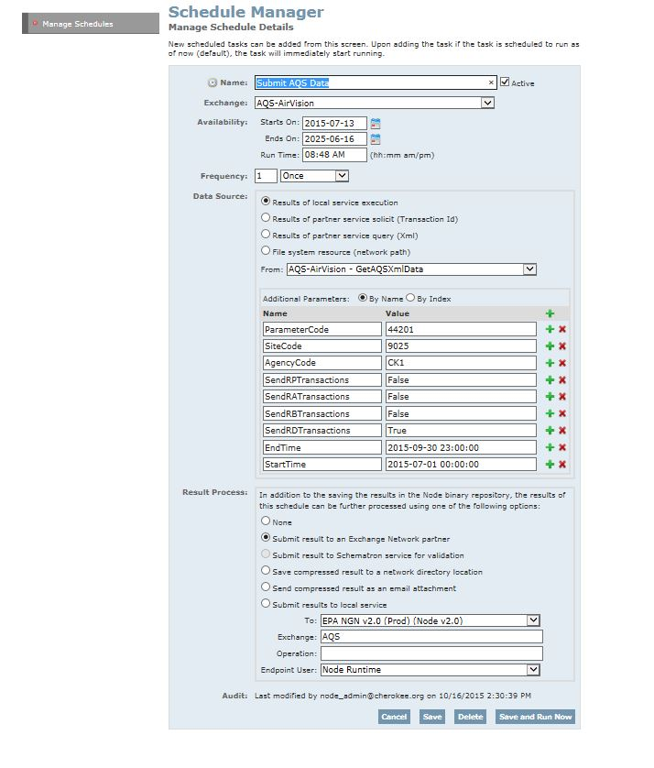

Items outlined in yellow should stay at the current settings.

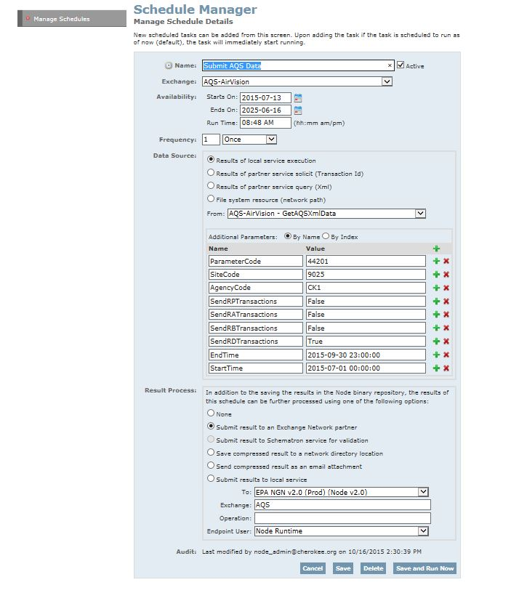

This information will change depending on which site/parameter and dates/times are being entered.

Only ParameterCode, SiteCode, AgencyCode and EndTime/StartTime need to be changed.

Note that AgencyCode, SiteCode and ParameterCode criteria can be chained to create any combination of AND/OR criteria between the three parameters. These three parameters work in conjunction with one another to form a table of additional filter criteria. For example, to filter on Agency Code 123, Site Code 0005 and parameters 42401, 65102 or 44201, the parameters would be entered as follows:

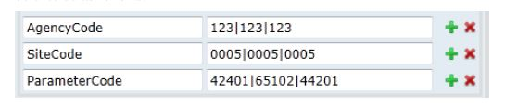



Once all information has been entered, select “Save and Run Now”.

Log into AQS and check the submissions in the Batch screen. If any records fail to load, correct the errors in the COrrect tab and load the corrections using the Load File button in Process Control. The corrected records can then be posted to AQS using the Post file button.

