

**DOCUMENT TYPE:** Standard Operating Procedure

**TITLE:**  Creating “BAM_Validated” Excel file from BAM-1020 Text File (PM2.5)

**NUMBER:** 11.1.2b

**PREPARED BY:**  *07/07/11*

**Tribal Air Program** **Date**

**REVISED BY:**  *08/26/2015*

**Environmental Administrative Assistant**  **Date**

**REVIEWED BY:**

**Environmental Technician**  **Date**

**APPROVED BY:**

**Environmental Department Supervisor** **Date**

# Scope of Application

## The primary work product of the ambient air quality monitoring is data. Accordingly, formalized processes and procedures are required for recording, transformation, transmittal, reduction, storage, and retrieval. This data is needed to support and validate any efforts the Tribe is making to enforce mandated reductions in the amounts of pollutants emitted, and ensure compliance with NAAQS.

# Summary of Method

## Copy raw BAM file onto main computer

## Create Excel file for BAM data

## Copy and paste data into existing “Validated” file

## Rename and save new “Validated” files

# Interferences/Comments

## Data should be collected from BAM unit before completing the following procedures.

# Supplies

## Computer

## Access to the Excel

## Downloaded text file created from BAM-1020

# Preparation

* 1. Download data from BAM-1020, see SOP titled BAM_Data Retrieval

# Procedure

## Create Excel file for BAM data

### Open new Excel file, Select *OPEN* tab. In *FILES OF TYPE* pull down menu, select *TEXT FILES* (as the file you generated when downloading from BAM is a text/notepad file), then search for raw BAM file, saved in folder *O:\Tribal Air Program\DATA\PM_Data\BAM_DATA\2015\Raw Data*, then click on “Open”

## *Text Import Wizard* will open. In *Original data type* select “*Fixed width”*. Then select *NEXT.*

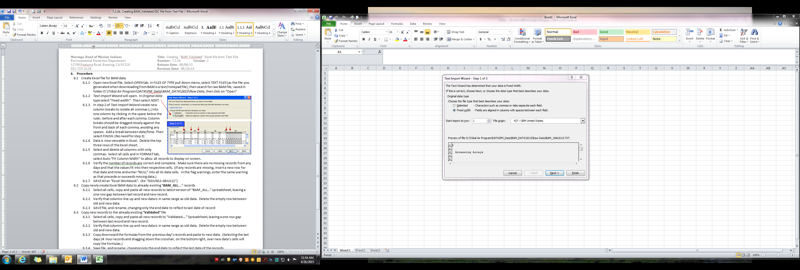

## In step 2 of *Text Import Wizard* create new column breaks to isolate all commas (,) into one column by clicking in the space below the ruler, before and after each comma. Column breaks should be dragged closely against the front and back of each comma, avoiding any spaces. Add a break between date/time. Then select *FINISH*. (No need for step 3)

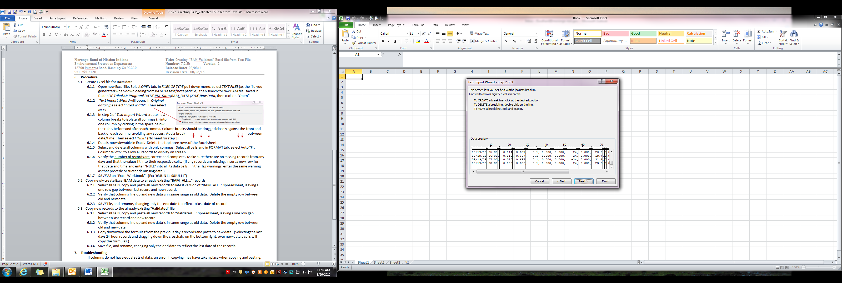 

## Data is now viewable in Excel. Delete the top rows of the Excel sheet before the row with the Column headers.

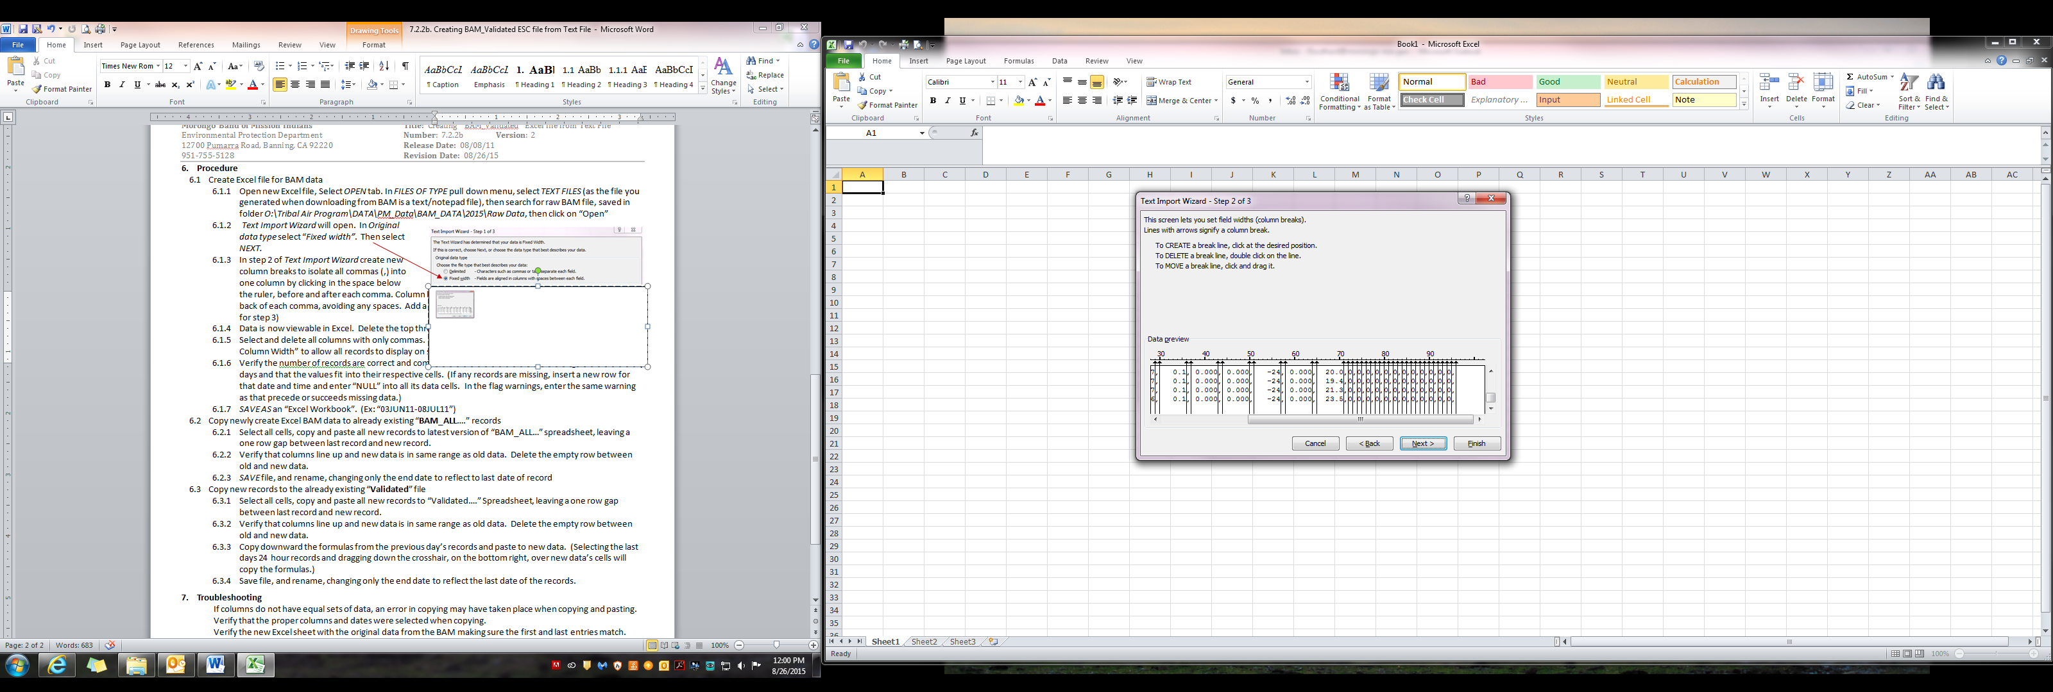

## Select and delete all columns with only commas. Select all cells and in FORMAT tab, select “Auto Fit Column Width” to allow all records to display on screen.

## Verify the number of records are correct and complete. Make sure there are no missing records from any days and that the values fit into their respective cells. (If any records are missing, insert a new row for that date and time and enter “NULL” into all its data cells. In the flag warnings, enter the same warning as that precede or succeeds missing data.)

## *SAVE AS* an “Excel Workbook”. (Ex: “03JUN11-08JUL11”)

## Copy newly create Excel BAM data to already existing “**BAM_ALL**….” records

## Select all cells, copy and paste all new records to latest version of “BAM_ALL…” spreadsheet, leaving a one row gap between last record and new record.

## Verify that columns line up and new data is in same range as old data. Delete the empty row between old and new data.

## *SAVE* file, and rename, changing only the end date to reflect to last date of record

* 1. Copy new records to the already existing “**Validated**” file
     1. Select all cells, copy and paste all new records to “Validated….” Spreadsheet, leaving a one row gap between last record and new record.
     2. Verify that columns line up and new data is in same range as old data. Delete the empty row between old and new data.

## Copy downward the formulas from the previous day’s records and paste to new data. (Selecting the last days 24 hour records and dragging down the crosshair, on the bottom right, over new data’s cells will copy the formulas.)

* + 1. Save file, and rename, changing only the end date to reflect the last date of the records.

# Troubleshooting

## If columns do not have equal sets of data, an error in copying may have taken place when copying and pasting. Verify that the proper columns and dates were selected when copying.

## Verify the new Excel sheet with the original data from the BAM making sure the first and last entries match.