TREX BASICS:

Log in using TREX VPN client. You will need a user name and password. You may have a shortcut on your desktop, but if you have it installed you can always find it by going to Programs, Cisco Systems VPN Client, VPN Client:

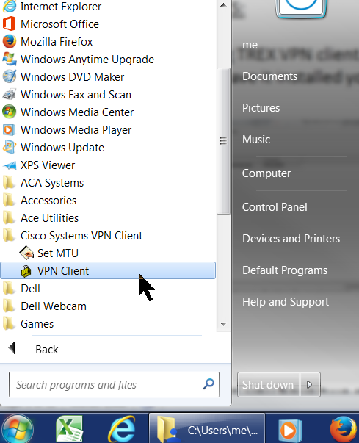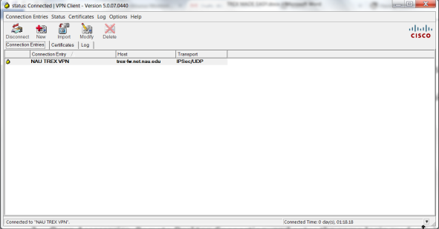

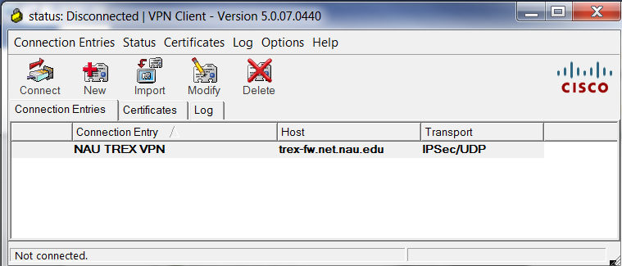Click CONNECT and in the lower left you will see “initializing the connection,” “contacting the security gateway,” etc. etc. and eventually you will be prompted for user name and pw:

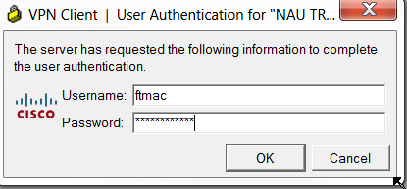

Once the VPN is connected, that interface may minimize and will not see it. It will take a while to connect, perhaps as long as 2-3 minutes. 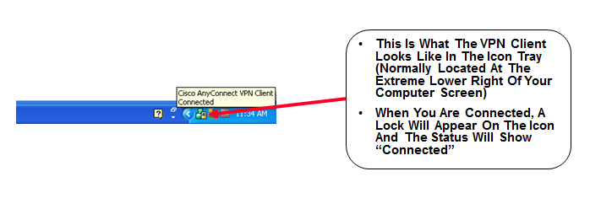

At this point, you have two options.

* You can generate reports from the webpage (see page 12 of this document), or
* Conduct Manual Validation using Remote Desktop Connection

**Manual Data Validation using Remote Desktop Connection** to review any data that was automatically flagged by the system and verify that the flags are correct, to flag other data that are not already flagged, to finalize decisions on whether data are valid, or just to zoomably review data in graph form then flag intervals of time, you need to connect to the NAU server in a way that actually allows you to edit data.

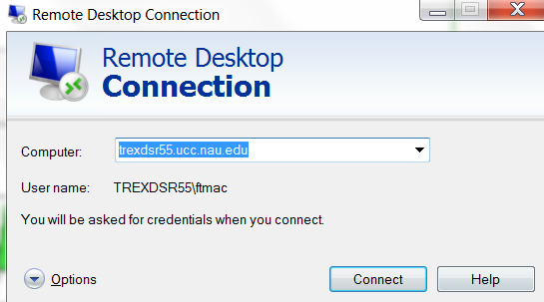To do this, Open Accessories, Remote Desktop Connection, and enter this URL: **trexdsr55.ucc.nau.edu**

.

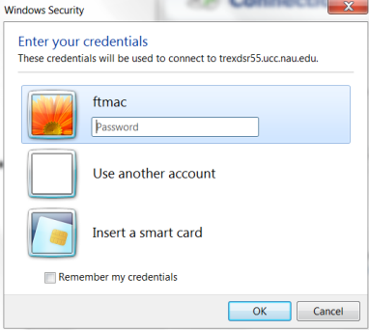You will see another login screen, and you will enter the same login credentials. (If the first time you do not connect, try again as “Use another account,” which seems to reset something that allows the login to work.)

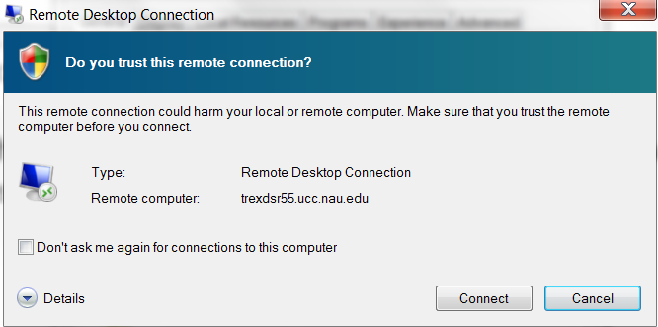

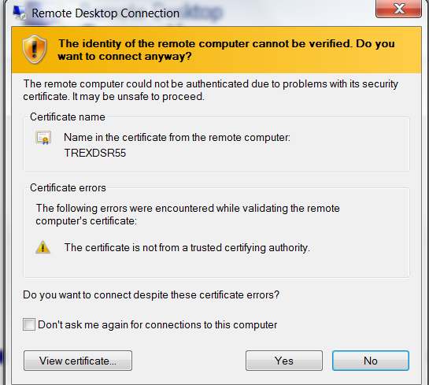

Then you will see a panel listing the agencies on the system (see next screenshot), and you need to log in as validator in the first panel, and you may need to scroll down to enter the pw at the bottom of the screen (if TREX has synced your passwords, all the user name/passwords should be the same):

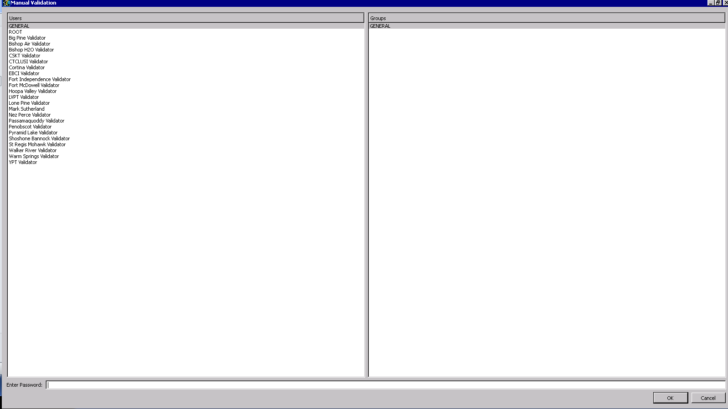

Select your agency, and scroll down (you may have to pull the right most grabber bar down to see the password panel) and enter the password again at the bottom of the screen, then OK on the lower right to access this agency’s data.

The selection panel opens in which you can select the time period to display, time zone (select the local time zone), site, and parameter. It is convenient to validate one month at a time, and a one month period is easy to select (be sure to enter the year) and be sure to get your TIME ZONE for local time set correctly:

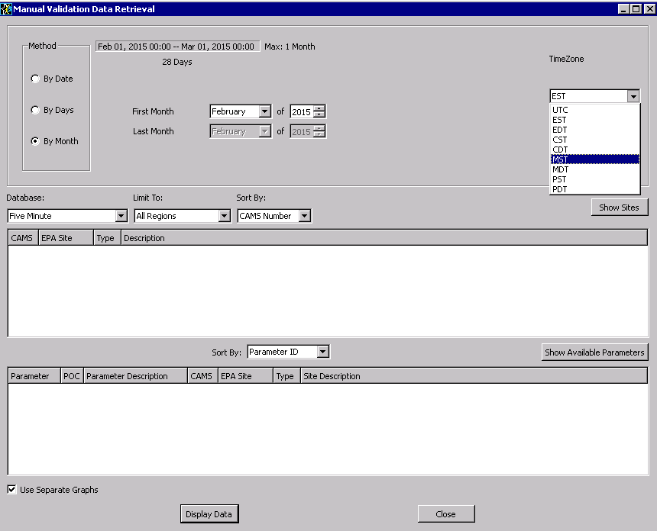

It is easiest to work in five minute data when doing validation, because if the five minute data is validated then the hourly data is validated. Click on the Show Sites button to see:

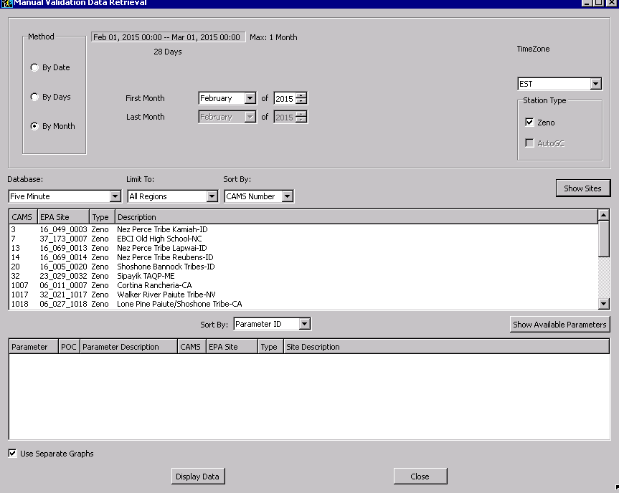Select your agency in the top panel, then click on Show Available Parameters to see:

**Select your site**

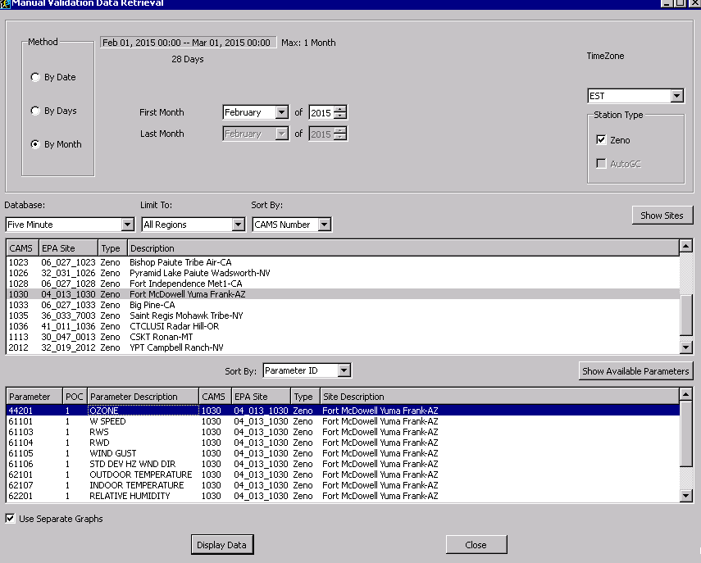If you want to look at several parameters at once, you can hold down the control key and select multiple parameters. This can be very useful if you collect met parameters which can help tell you if changes are valid. For example, at this site I selected PM10 and wind speed, and checked the box to show separate graphs in the lower left:

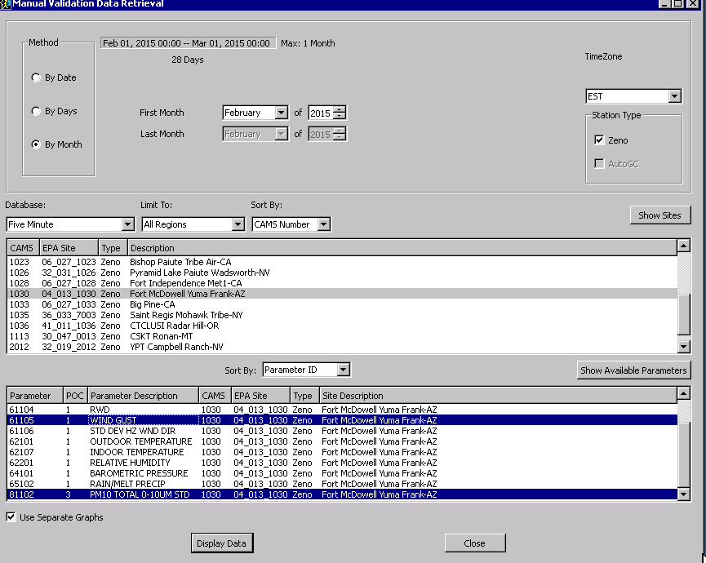

Click Display Data to see:

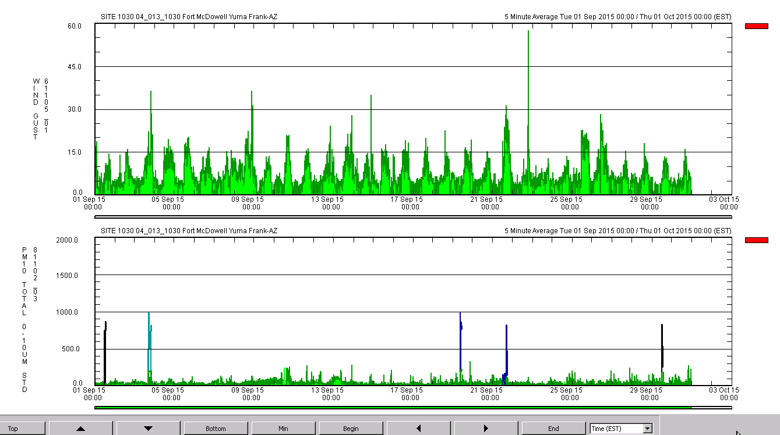

At this point, you can look through your data to see if the system automatically flagged any data due to big changes, which would be called “LIMS”-flagged data, which would show up as dark red magenta in the chart.

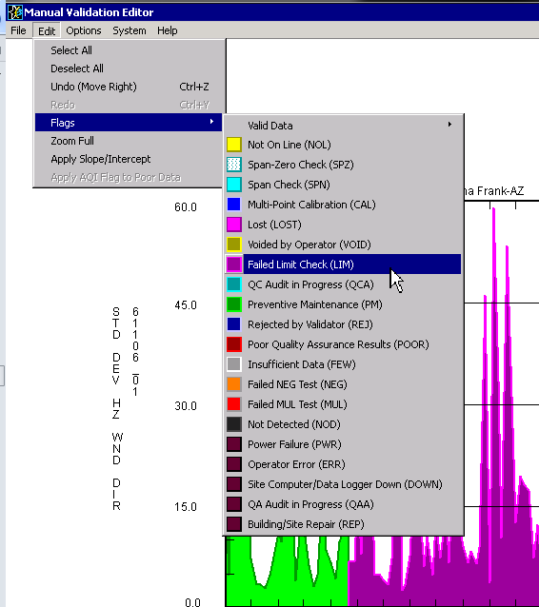

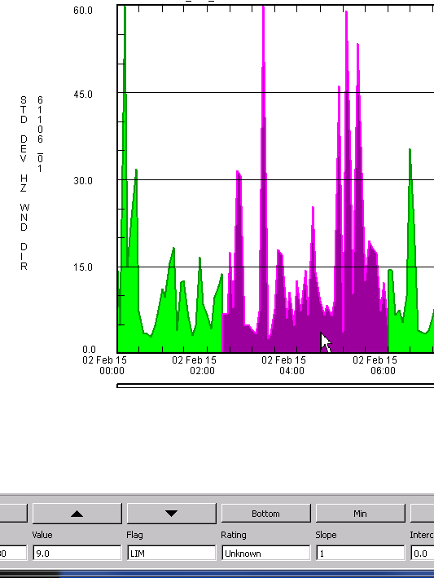

If there are any other automatically-flagged data, or data that are already flagged by someone, they will show up as different colors in the graph. To see the meaning of the colors, hover your cursor over the data that is flagged, and in the bottom panel Flag pane you will see the flag that is applied to that data point.

Most data should be green, which is ambient (valid) data, which appears green in the graph.

This screenshot below shows data that has already been flagged with QC flags applied to QC checks done on Sept.3rd (blue cross-hatch). The colors of the flags can be seen from Edit, Flags (and notice that there are flags for both valid and invalid data—if you flag data with any of the flags in the invalid data list below then after you “validate” the data (see below, you can also save the flags without validating) those points will have AQS null value codes:

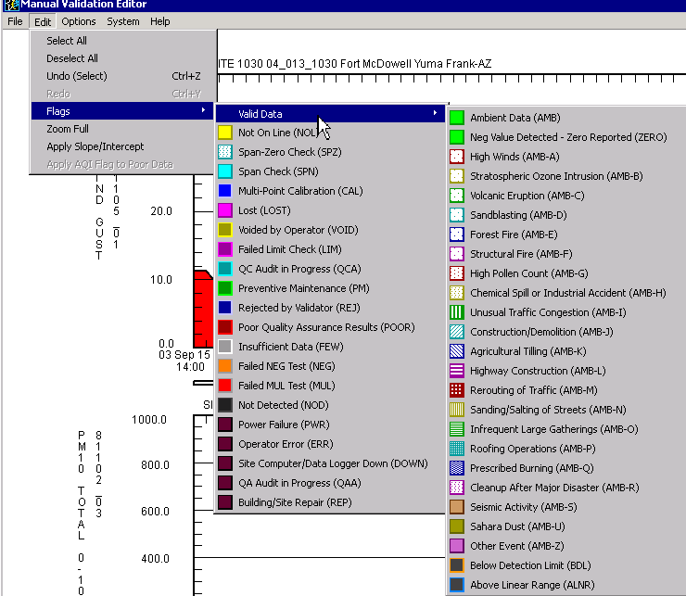

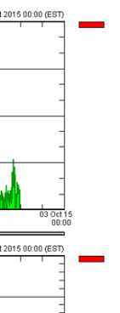

**Zooming and moving around graphs:**

1st, if you have multiple graphs, and you want to keep them “synced” so that the zooming affects both graphs, make sure that the rectangles to the right are both red. If you want to zoom around on only one of the graphs, uncheck the red box that you don’t want to zoom around in.

**To zoom in on a particular date or time (x-axis), hold down the shift key and left click** (with your cursor in the day/time that you want to zoom into)**:**

This allows us to see the spikes in PM10 in the bottom graph, and notice if there are corresponding wind gusts in the wind gust graph in the bottom graph. If I hover my cursor over the Sept 3rd spike in PM10 on the bottom graph, and shift-left click, and then do that repeatedly a few times with the cursor on that blue spike, it zooms in so that I can see that there are actually 2 spikes:

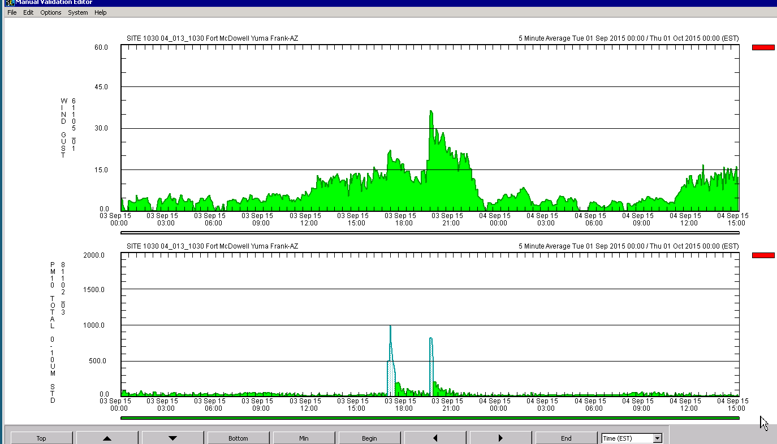

**To zoom out again on the x-axis**, hover your cursor over what you want to zoom out from (kind of like zooming on a map, where you have to keep finding what you want to zoom in/out from and then click from there) and **hold down the CONTROL key and left click**.

**To zoom in on the y-axis**, so that you can see more gradations in the graph, hover your cursor over the point in the graph that you want to zoom in on, and **hold down the shift key and RIGHT click**. In this case, if I hover the cursor over the 500 ppb line on Sept. 3rd and shift-right click, that shows the data presented this way, which zooms in on the y-axis right where your cursor was:

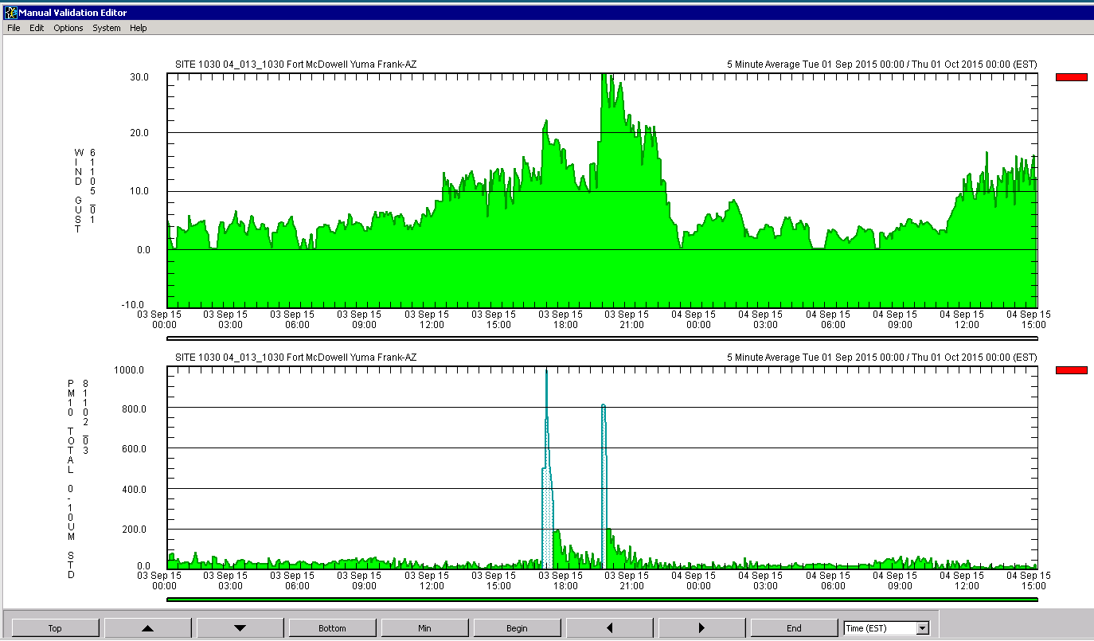

**MIN button**: If there may be negative values, they may not be shown the way the vertical y-axis (parameter, or measurement result) is set up. To make sure that any negative values (below the y-axis the way it is now) are shown, click on the MIN button, and if nothing changes then you know that the graph shows all the values, even those less than zero (if the y-axis is zero).

**If you wanted to set the graph so that the tops of the spikes are at the top of the graph, click on TOP** to see the top of the spikes in the graph, and that just slides the whole graph up so that the top of the spikes are at the top of the graph.

To set the graph so that the lowest values are at the bottom of the graph, **click Bottom**.

The up and down buttons slide the y-axis up and down.

The right and left buttons slide the x-axis right and left.

The begin and end buttons take you to the beginning or end of the dataset you have selected to plot.

**Flagging Data**

To flag data, rubber-band (aka “lasso”) the data you want, making sure to select the top of the spike if there is one, or the negative values if there are any. Hold down the mouse button and scroll over the data you want, making a rectangle, and then all the data OTHER than what I just selected shows red, leaving the existing flag which is ambient in this case:

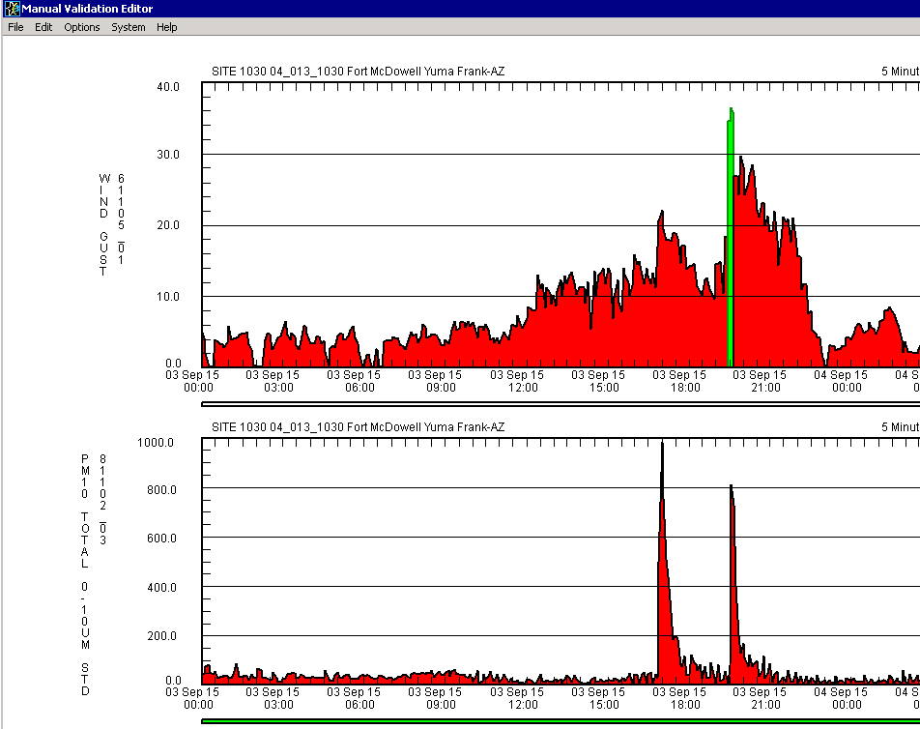

If that was not the data I wanted to select, I can just re-select, or go to Edit, Select All on the menu bar.

Note that you must select the actual point on the peak, so if you miss it then you will see two bands selected like this:

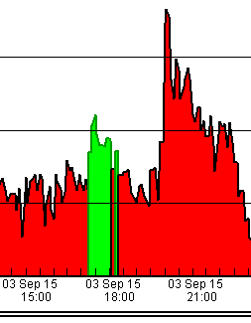

Now, with the points you want “lassoed,” or “rubber-banded,” you can flag them by going to Edit, Flag, and in this case I selected “Rejected by Validator” which is dark blue:

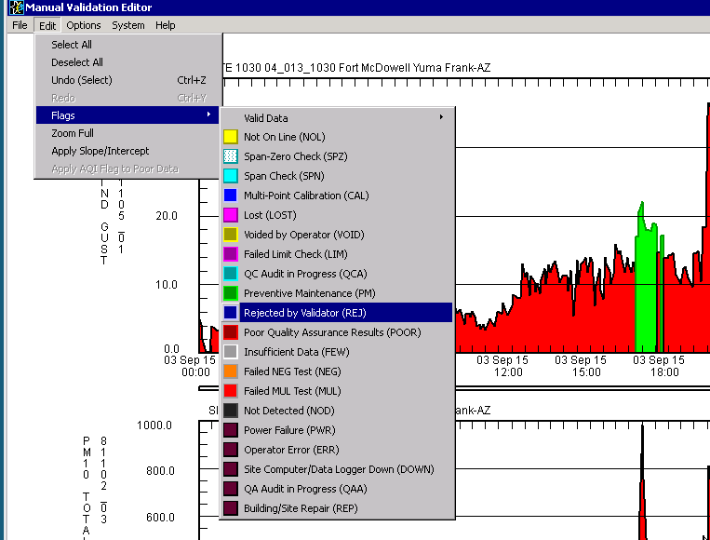

Which makes it then show up in the graph as:

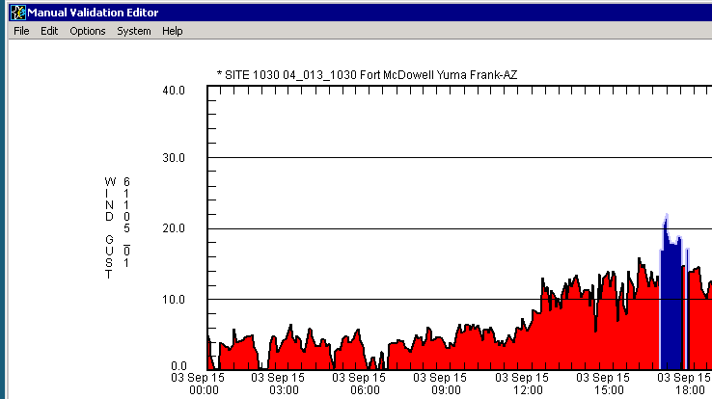

I zoom in a bit to verify that selection that I just flagged, so after shift-left-clicking on that peak I see:

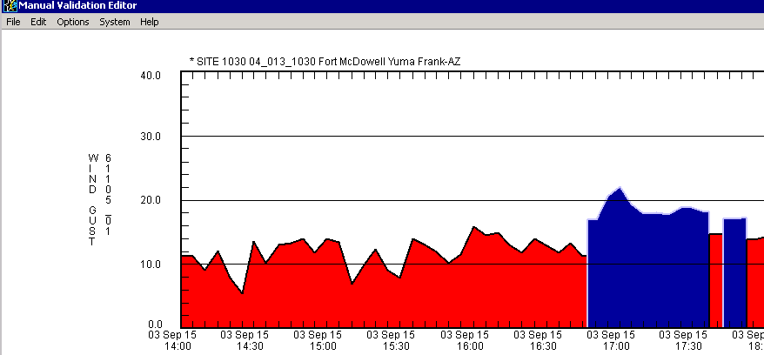

After finishing flagging all the data you want to now, you can either:

Save without Validating, which saves the flags but doesn’t validate the data as is for the AQS file (e.g., this data you just flagged would show up in the AQS-formatted file). Or, you can

Validate, which means that you have to write some notes about what you did in a panel that pops up, and that any flags that

**Webpage Reports:**

Click on this link to open the webpage where you can generate reports: [**http://trexdsr55.ucc.nau.edu/**](http://trexdsr55.ucc.nau.edu/) and you will see 3 blocks of links, and the top two blocks are functional for users: Data Reporting Pages and Status Pages.

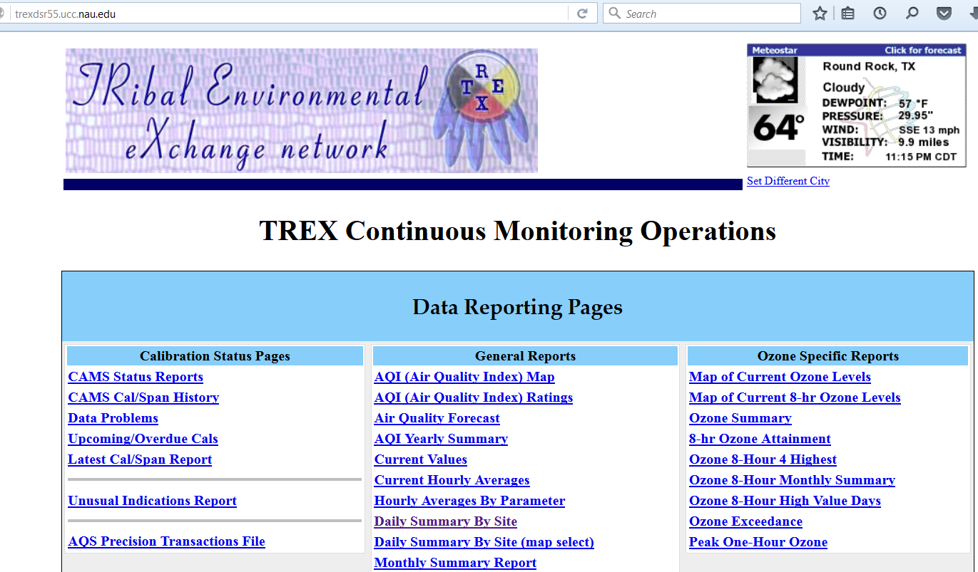

Many of these functions are useful, especially the Create AQS Reports function: 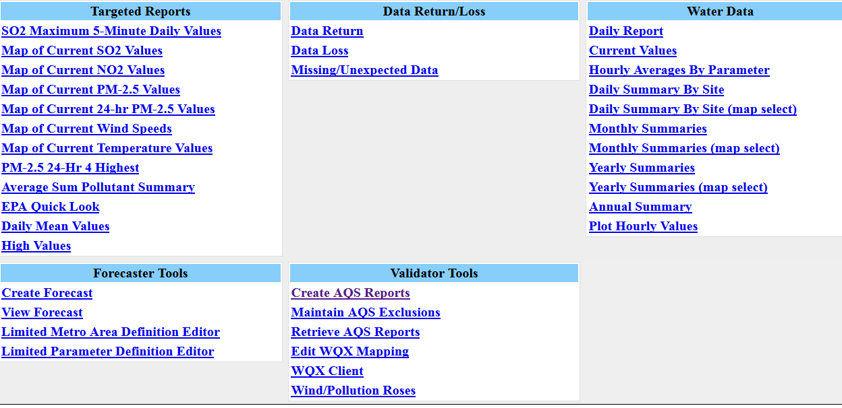

There is an AQS Report Generation SOP that is accessible in the Status Pages block, Training Materials:

