TrEx Data Extractor Instructions

By Emma Ruppell, Bishop Paiute Tribe.

These instructions explain how Tribal users can use the extractor feature to download their 5 min and hourly data. Hourly data can also be downloaded from the regular TrEx website, for any site. Users may not have another mode of obtaining their 5 min data. Doing this ensures that a user has their data locally, in-house, backed up! Not sure if you need to do this? Question: where is your 5 min data stored?!

1. Click on Data Extractor under Status Pages, after you are logged in as usual.

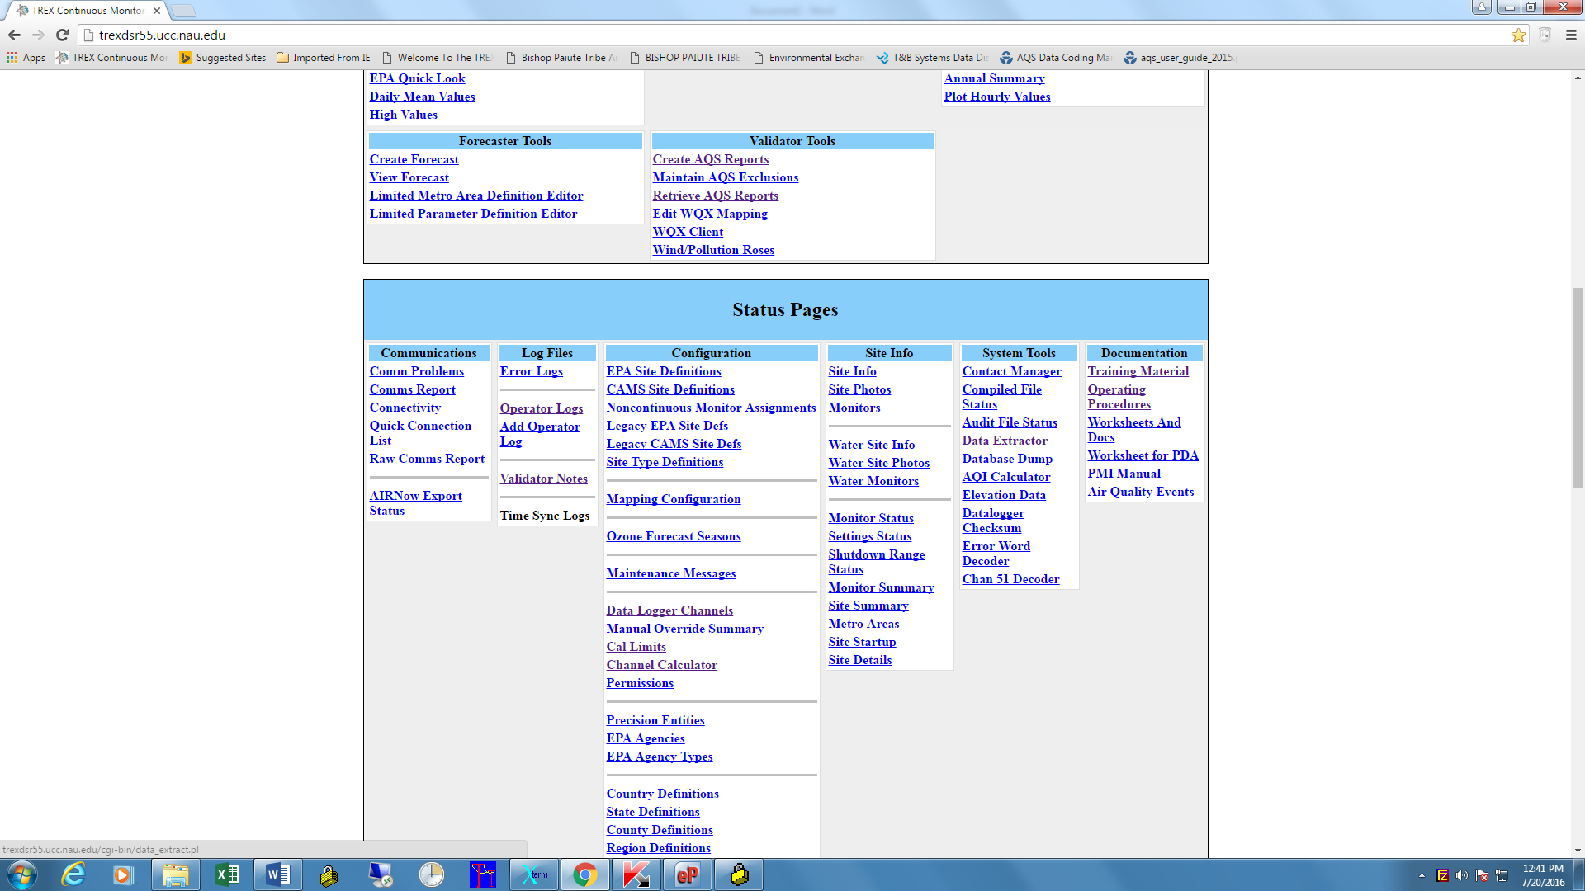

2. Use the drop down menus to select the data you want. Choose 5 minute data for the raw values that go to your Sutron or Zeno logger. For output, choose overwrite or force unique. Force unique is safer if you have to repeat an extract for an error or some other reason. I use a file name that tells me what the data is. The txt_1 appears to be a default and works so leave it as is. The config settings are the way I have been using as below. For past data, doing 1 year at a time is an efficient way to back up data. I always do LST, local time. The rest is your choice; I go with 24-hr, comma delimited, CAMS number, and parameter name.

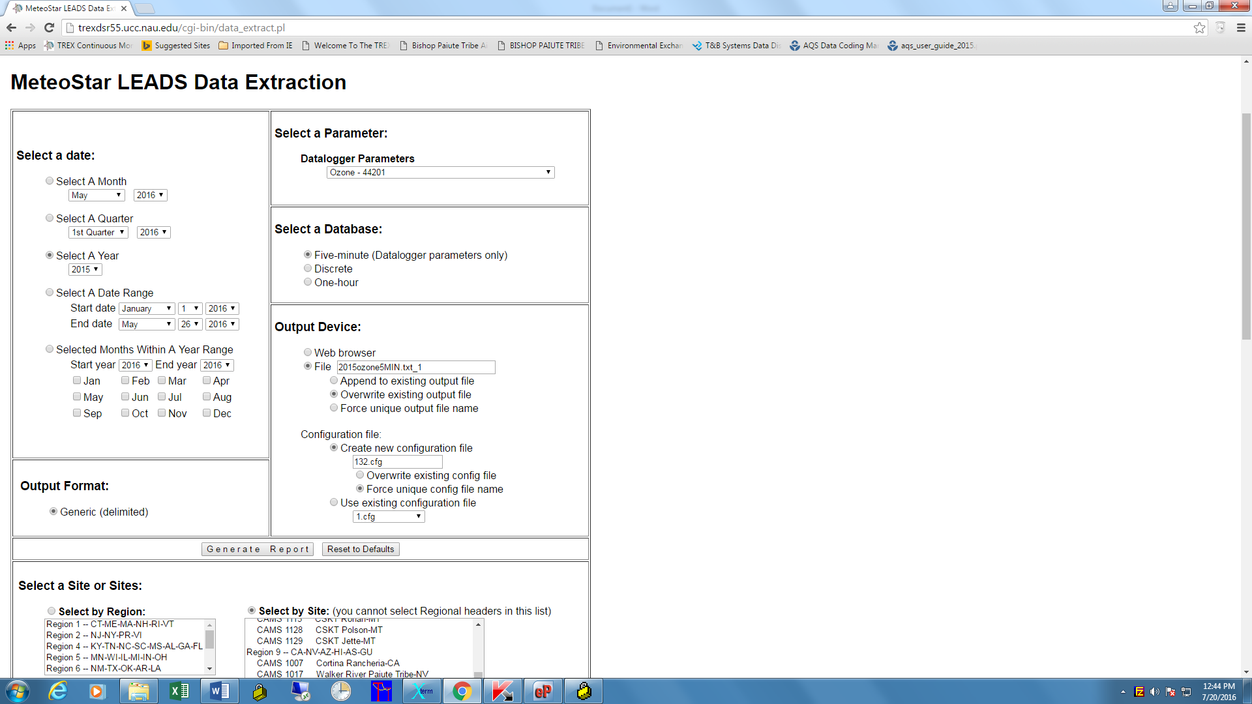

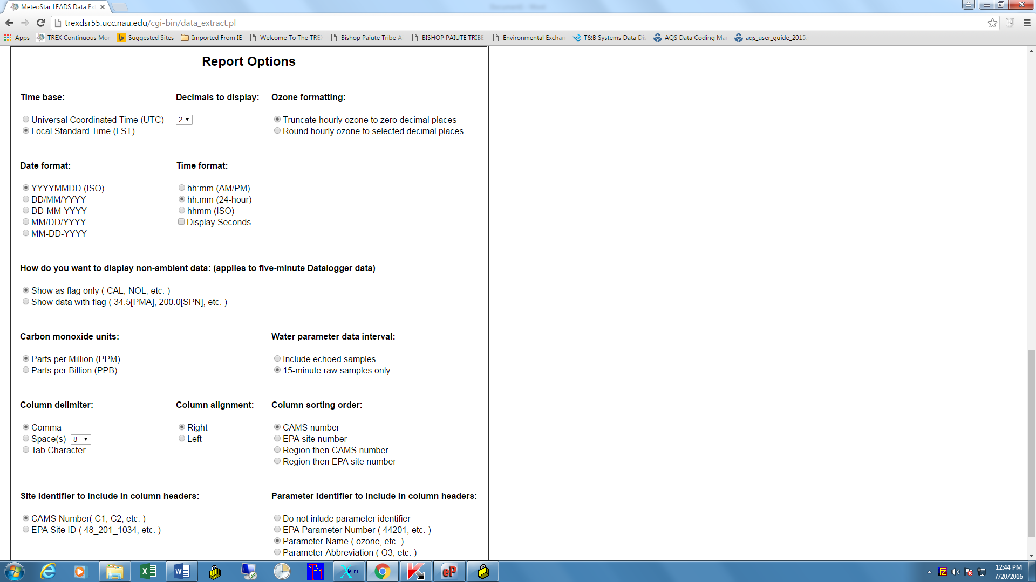

1. There is a button to perform the extraction. After clicking that, this next screen will then show. Note that it takes a few minutes, so wait until the blue circle is done spinning in your browser tab before clicking the link, or it won’t load.

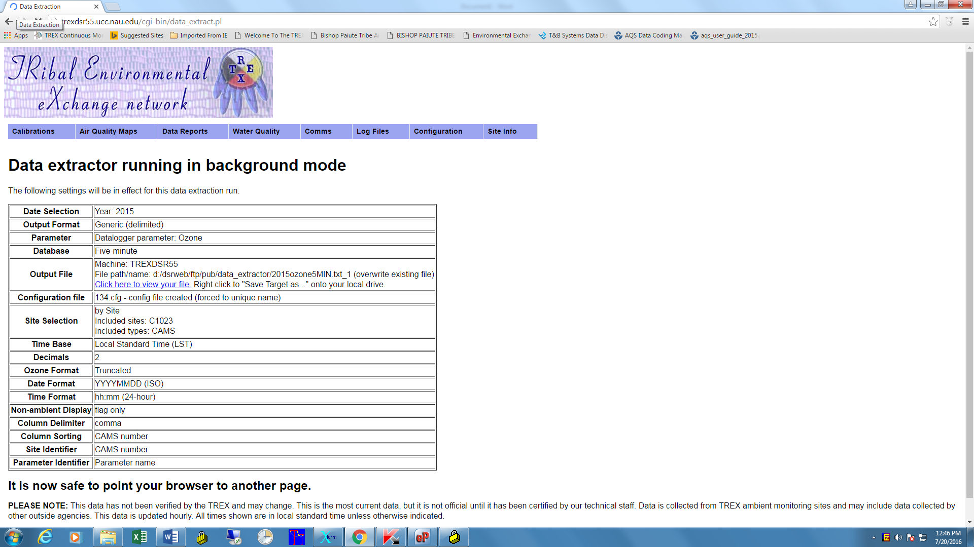

1. Right click to save the file. The file name from the first screen will be used by default.

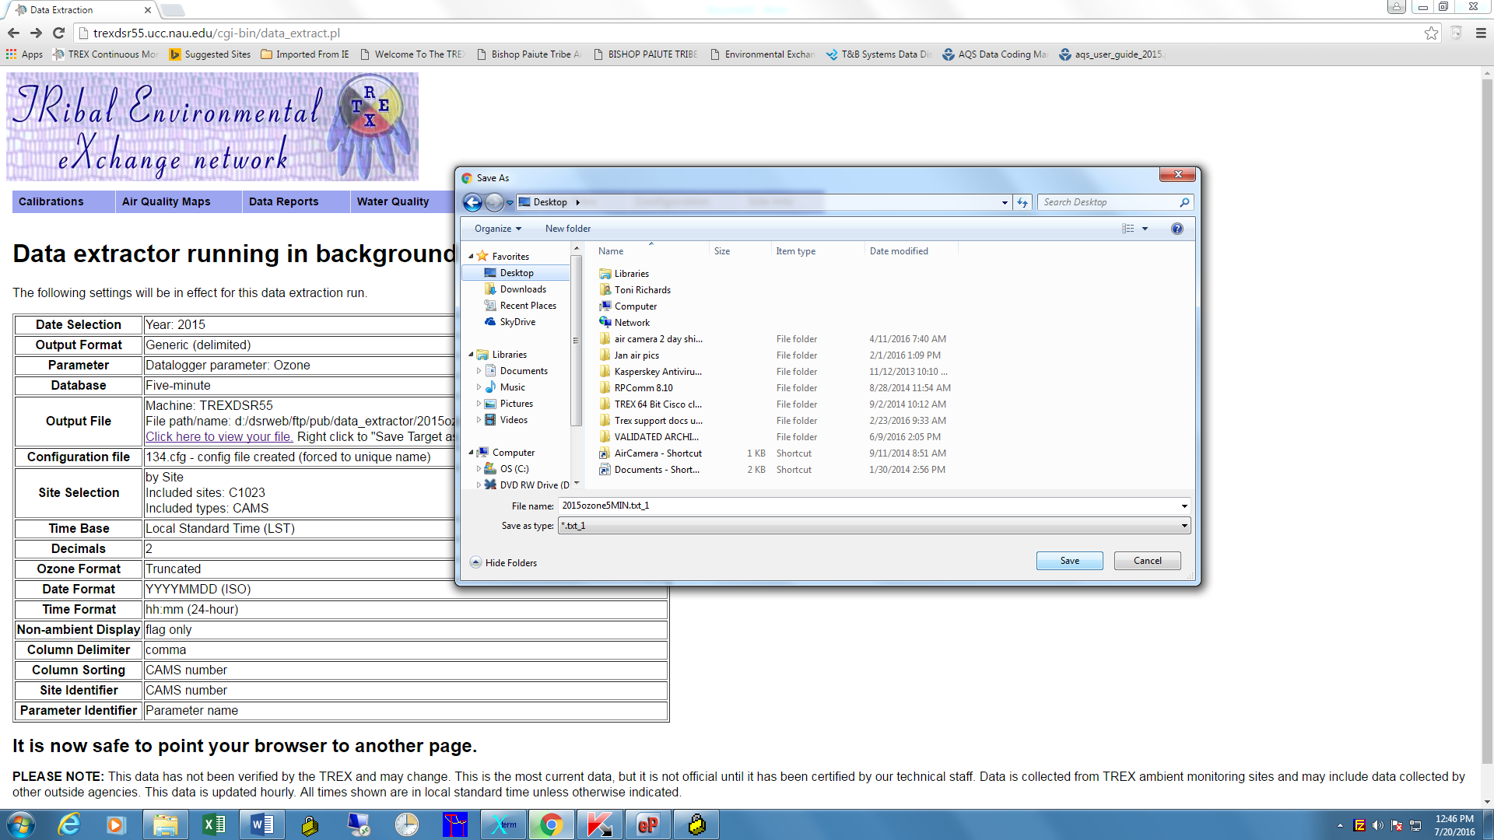

1. The download takes a few moments, so watch the progress in your download tab. If you try to open it before the countdown is over, it won’t load.

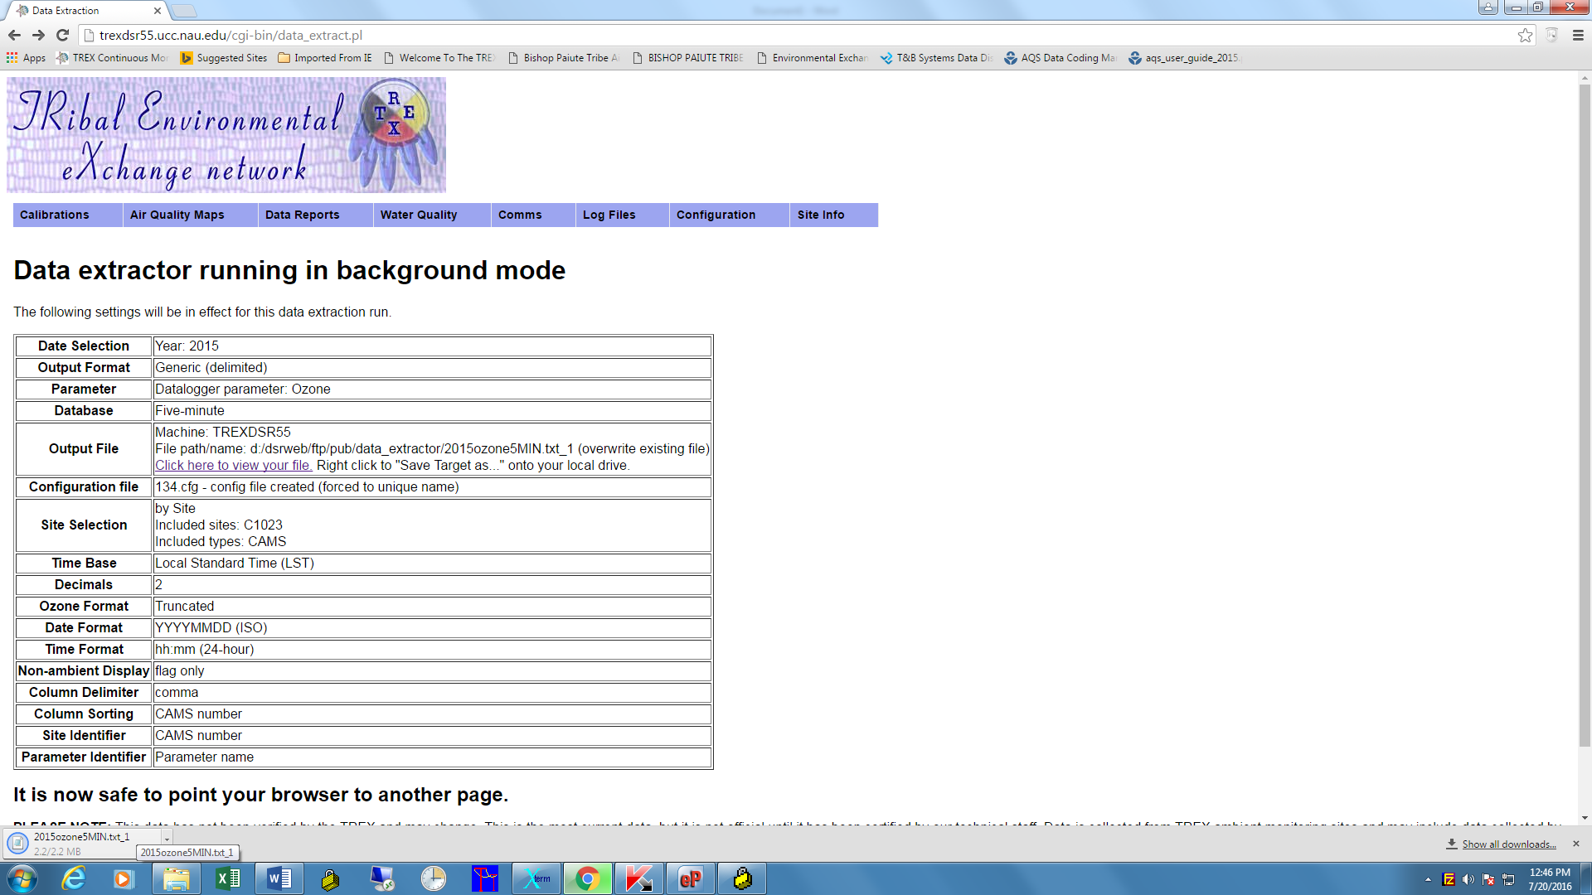

To do another extraction, you can hit the back button in your browser and it will return you to the form page with the drop down arrows. That’s basically it; it’s pretty easy to get your 5 min data even in big chunks.