**The program needs an input of file histogram.txt that contains the classification and histogram of the images.**

Histogram for No Aurora

Histogram for Aurora

**Epochs vs. Error (blue) and Accuracy (red)**

mu = 0.001

total accuracy = 0.5575

mu = 0.01

total accuracy = 0.565

mu = 0.1

total accuracy = 0.65

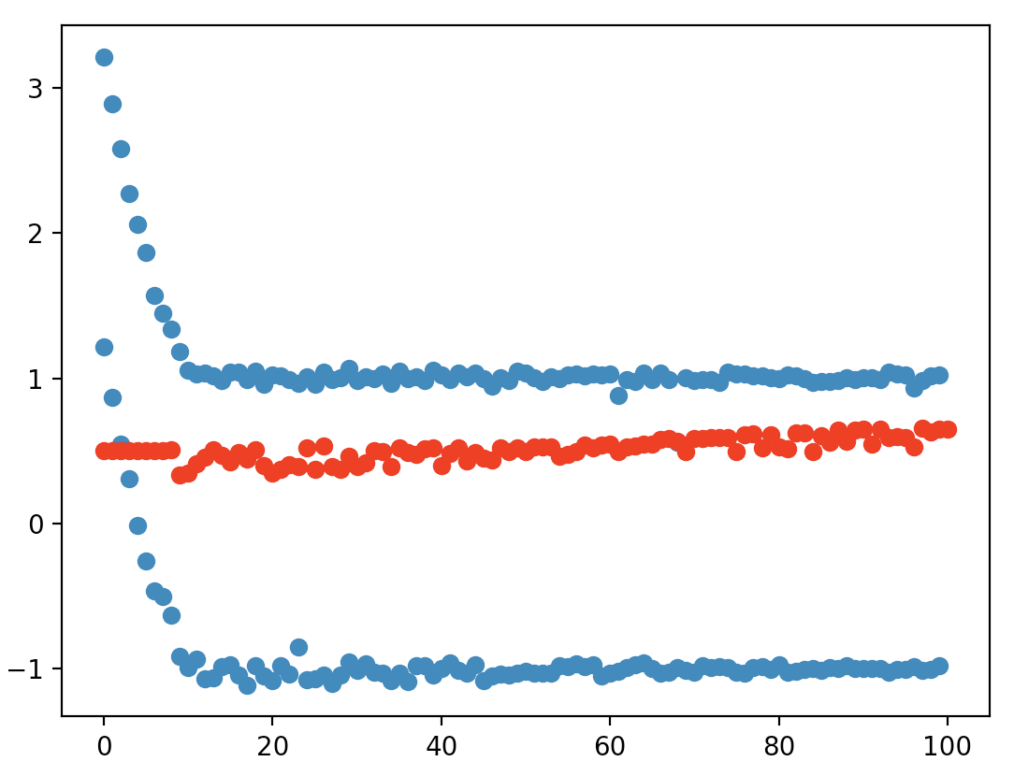

mu = 0.15

total accuracy = 0.685

When looking at the unknown images and comparing them to their predicted values, I would say that the model is somewhat accurate. Pictures that are brighter or have more contrasting colors tend to be predicted as having an aurora, though sometimes there were false positives created by cloud and sky placements.