IST 772 Quantitative Reasoning – Final Examination

Tamilselvan Tamilmani

2021-12-19

# Introduction

We are tasked with analyses and then write up a technical report for a scientifically knowledgeable staff member in a state legislator’s office for the vaccine data in district 19 schools. The legislator’s office is interested to know how to allocate financial assistance to school districts to improve both their vaccination rates and their reporting compliance.

We will begin with exploratory analysis and come up with statistical analysis to help improve the vaccination rate and reporting compliance.

# Questions

## Question 1 1. How have U.S. vaccination rates varied over time? Are vaccination rates increasing or decreasing? Which vaccination has the highest rate at the conclusion of the time series? Which vaccination has the lowest rate at the conclusion of the time series? Which vaccine has the greatest volatility?

set.seed(202112)   
load("districts19.RData")  
load("allSchoolsReportStatus.RData")  
load("usVaccines.RData")  
  
summary(usVaccines)

## DTP1 HepB_BD Pol3 Hib3   
## Min. :81.00 Min. :11.00 Min. :24.00 Min. :52.00   
## 1st Qu.:89.75 1st Qu.:17.00 1st Qu.:90.00 1st Qu.:87.00   
## Median :97.00 Median :19.00 Median :93.00 Median :91.00   
## Mean :94.05 Mean :34.21 Mean :87.16 Mean :89.21   
## 3rd Qu.:98.00 3rd Qu.:54.50 3rd Qu.:94.00 3rd Qu.:93.00   
## Max. :99.00 Max. :74.00 Max. :97.00 Max. :94.00   
## MCV1   
## Min. :82.00   
## 1st Qu.:90.00   
## Median :92.00   
## Mean :91.24   
## 3rd Qu.:92.00   
## Max. :98.00

usvaccineDF <- data.frame(usVaccines)  
usvaccineDF$year <- 1980:2017  
library(reshape2)  
usvaccineDF_melted<-melt(usvaccineDF,id.vars="year")  
colnames(usvaccineDF_melted) <- c("Year","Vaccine","Rate")  
library(ggplot2)  
  
ggplot(usvaccineDF_melted, aes(x=Year, y=Rate,group=Vaccine, color=Vaccine)) +   
 geom_line() + ggtitle("US Vaccine Rates by Vaccine Type") +  
 theme_minimal()

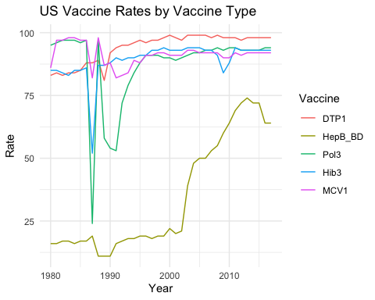

**The plot shows the vaccine rates of individual vaccines over the years.**

library(changepoint)

## Loading required package: zoo

##   
## Attaching package: 'zoo'

## The following objects are masked from 'package:base':  
##   
## as.Date, as.Date.numeric

## Successfully loaded changepoint package version 2.2.2  
## NOTE: Predefined penalty values changed in version 2.2. Previous penalty values with a postfix 1 i.e. SIC1 are now without i.e. SIC and previous penalties without a postfix i.e. SIC are now with a postfix 0 i.e. SIC0. See NEWS and help files for further details.

for (v in names(usvaccineDF)){  
 #print(v)  
 cp <- cpt.var(diff(usvaccineDF[[v]]),class=TRUE)  
 print(paste(v,":",cpts(cp)))  
}

## [1] "DTP1 : 10"  
## [1] "HepB_BD : "  
## [1] "Pol3 : 16"  
## [1] "Hib3 : 8"  
## [1] "MCV1 : 16"  
## [1] "year : "

1. **The US Vaccine rates gradually increased over time, except a sharp drop around late 80’s**
2. **DTP1 - First dose of Diphtheria/Pertussis/Tetanus has the highest rate as of 2017  
   HepB_BD - Hepatitis B, Birth Dose has lowest rate as of 2017**
3. **Pol3 - Polio third dose and MCV1 - Measles first dose has large number of change points at 16, but Pol3 has the greatest volatility, since it has the largest range.**

## Question 2 2. What proportion of public schools reported vaccination data? What proportion of private schools reported vaccination data? Was there any credible difference in overall reporting proportions between public and private schools?

library(scales)  
pct_format = scales::percent_format(accuracy = .1)  
ggplot(allSchoolsReportStatus, aes(x=pubpriv,fill=reported)) +   
 geom_bar(position="fill", stat="count" ) +   
 geom_text(aes(label =pct_format( ..count.. / tapply(..count.., ..x.., sum)[as.character(..x..)])), stat = "count", position = "fill", vjust=1) +  
 scale_y_continuous(labels = percent) + ggtitle("US Vaccine Report by School Type") +  
 theme_minimal()

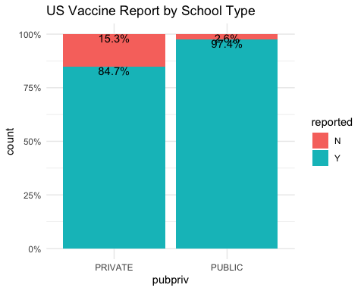

**The plot shows the distribution of vaccine reporting among public and private schools.**

#Is there a difference, using chi.square test for categorical variable  
pub_vs_private<-table(allSchoolsReportStatus$reported,allSchoolsReportStatus$pubpriv)  
pub_vs_private

##   
## PRIVATE PUBLIC  
## N 252 148  
## Y 1397 5584

chisq.test(pub_vs_private)

##   
## Pearson's Chi-squared test with Yates' continuity correction  
##   
## data: pub_vs_private  
## X-squared = 400.49, df = 1, p-value < 2.2e-16

**97.4% of public schools reported vaccine data.  
84.7% of private schools reported vaccine data.  
The p-value of chi square test on the public vs private vaccine reporting is very low, so we can reject the null hypothesis of no difference between the public vs private reporting(non independence), thus favoring the alternate hypothesis of there is a difference in reporting(independence) between public and private schools.**

**So we can conclude there is a credible difference in the reporting between public and private schools.**

## Question 3 3. What are 2013 vaccination rates for individual vaccines (i.e., DOT, Polio, MMR, and HepB) in California public schools? How do these rates for individual vaccines in California districts compare with overall US vaccination rates (make an informal comparison to the final observations in the time series)?

calf_2013_rate<- c(round(100 - mean(districts$WithoutDTP)), round(100 - mean(districts$WithoutHepB)),  
 round(100 - mean(districts$WithoutPolio)), round(100-mean(districts$WithoutMMR)), "California-2013" )  
us_2017_rate <- usvaccineDF[usvaccineDF$year==2017,]  
  
df <- subset(us_2017_rate,select=-c(Hib3,year))  
df$Region<-c("US-2017")  
df <- rbind(df,calf_2013_rate)  
df_melted<-melt(df,id.vars="Region")  
colnames(df_melted) <- c("Region","Vaccine","Rate")  
df_melted$Rate<- as.integer(df_melted$Rate)  
ggplot(df_melted,aes(x=Vaccine, y=Rate, fill=Region)) +   
 geom_bar(stat="identity",position="dodge") +  
 geom_text(aes(label=Rate), position=position_dodge(width=0.9), vjust=-0.25) +  
 ggtitle("US vs California Vaccine Rate") + theme_minimal()

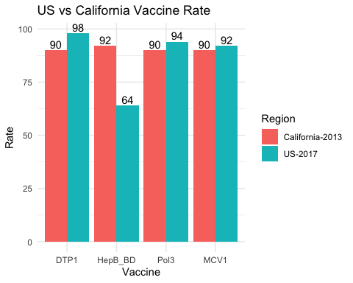

**The Plot show the comparison of vaccine rates between California in 2013 and overall US in 2017.**  
**The individual vaccine rates of DOT, Polio, MMR, and HepB are 90,92,90 and 90 respectively in California public schools.**

**California is leading in HepB vaccine than overall US even before 3 years, and lagging on the remaining three vaccines.**

## Question 4 4. Among districts, how are the vaccination rates for individual vaccines related? In other words, if students are missing one vaccine are they missing all of the others?

library(ggcorrplot)  
ggcorrplot(cor( districts[,c(2:5)]),lab = TRUE,  
 hc.order = TRUE, type = "lower",  
 p.mat=cor_pmat(districts[,c(2:5)]),  
 colors = c("blue", "white", "orangered")) +   
 ggtitle("Correlation Matrix of Vaccine") + theme_minimal()

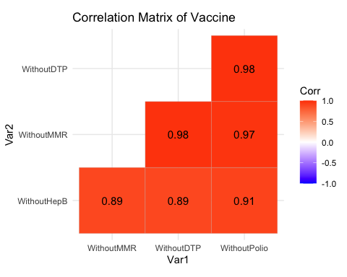

1. **We can use correlation matrix to compare numeric variables.**
2. **The correlation among the vaccine rates are very high and their p values are also high, so its highly likely students are missing all the vaccines if they miss any one.**

## EDA & Data Preparation

(For all of these analyses, use PctChildPoverty, PctFreeMeal, PctFamilyPoverty, Enrolled, and TotalSchools as predictors. Transform variables as necessary to improve prediction and/or interpretability. In general, if there is a Bayesian version of an analysis available, you are expected to run that analysis in addition to the frequentist version of the analysis.)

districts_melted<-melt(districts[,8:13])

## No id variables; using all as measure variables

colnames(districts_melted) <- c("Variable","Value")  
ggplot(districts_melted, aes( y=Value,group=Variable, color=Variable)) +   
 geom_boxplot() + ggtitle("US Vaccine Rates by Vaccine Type") +  
 theme_minimal()

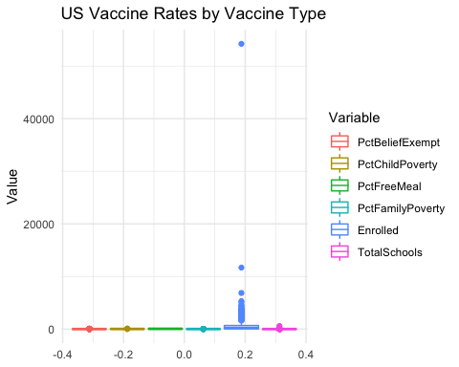

summary(districts)

## DistrictName WithoutDTP WithoutPolio WithoutMMR   
## Length:700 Min. : 0.00 Min. : 0.000 Min. : 0.00   
## Class :character 1st Qu.: 3.00 1st Qu.: 3.000 1st Qu.: 3.00   
## Mode :character Median : 6.00 Median : 6.000 Median : 6.00   
## Mean :10.12 Mean : 9.691 Mean :10.12   
## 3rd Qu.:13.00 3rd Qu.:13.000 3rd Qu.:14.00   
## Max. :77.00 Max. :77.000 Max. :77.00   
## WithoutHepB PctUpToDate DistrictComplete PctBeliefExempt  
## Min. : 0.000 Min. : 23.00 Mode :logical Min. : 0.00   
## 1st Qu.: 2.000 1st Qu.: 84.00 FALSE:41 1st Qu.: 1.00   
## Median : 4.000 Median : 92.00 TRUE :659 Median : 2.00   
## Mean : 7.644 Mean : 87.98 Mean : 5.54   
## 3rd Qu.:10.000 3rd Qu.: 96.00 3rd Qu.: 7.00   
## Max. :77.000 Max. :100.00 Max. :77.00   
## PctChildPoverty PctFreeMeal PctFamilyPoverty Enrolled   
## Min. : 2.00 Min. : 0.00 Min. : 0.00 Min. : 10.0   
## 1st Qu.:13.00 1st Qu.: 31.00 1st Qu.: 5.75 1st Qu.: 55.0   
## Median :21.00 Median : 50.00 Median :10.00 Median : 219.5   
## Mean :22.45 Mean : 49.18 Mean :11.57 Mean : 641.5   
## 3rd Qu.:30.00 3rd Qu.: 70.00 3rd Qu.:16.00 3rd Qu.: 686.2   
## Max. :63.00 Max. :100.00 Max. :44.00 Max. :54238.0   
## TotalSchools   
## Min. : 1.000   
## 1st Qu.: 1.000   
## Median : 3.000   
## Mean : 7.396   
## 3rd Qu.: 8.000   
## Max. :582.000

Q <- quantile(districts$Enrolled, probs=c(.25, .75), na.rm = FALSE)  
iqr <- IQR(districts$Enrolled)  
up <- Q[2]+1.5*iqr   
low<- Q[1]-1.5*iqr  
outlier_removed<- subset(districts, districts$Enrolled > low & districts$Enrolled < up)  
summary(outlier_removed)

## DistrictName WithoutDTP WithoutPolio WithoutMMR   
## Length:636 Min. : 0.00 Min. : 0.00 Min. : 0.00   
## Class :character 1st Qu.: 3.00 1st Qu.: 3.00 1st Qu.: 3.00   
## Mode :character Median : 7.00 Median : 6.00 Median : 6.00   
## Mean :10.47 Mean :10.06 Mean :10.51   
## 3rd Qu.:14.00 3rd Qu.:13.00 3rd Qu.:14.00   
## Max. :77.00 Max. :77.00 Max. :77.00   
## WithoutHepB PctUpToDate DistrictComplete PctBeliefExempt   
## Min. : 0.000 Min. : 23.00 Mode :logical Min. : 0.000   
## 1st Qu.: 2.000 1st Qu.: 84.00 FALSE:29 1st Qu.: 0.000   
## Median : 4.000 Median : 92.00 TRUE :607 Median : 3.000   
## Mean : 7.981 Mean : 87.59 Mean : 5.862   
## 3rd Qu.:10.000 3rd Qu.: 96.00 3rd Qu.: 7.000   
## Max. :77.000 Max. :100.00 Max. :77.000   
## PctChildPoverty PctFreeMeal PctFamilyPoverty Enrolled   
## Min. : 2.00 Min. : 0.00 Min. : 0.00 Min. : 10.00   
## 1st Qu.:13.00 1st Qu.: 30.00 1st Qu.: 5.00 1st Qu.: 44.75   
## Median :21.00 Median : 50.00 Median : 9.00 Median : 169.50   
## Mean :22.41 Mean : 48.68 Mean :11.46 Mean : 340.13   
## 3rd Qu.:30.00 3rd Qu.: 69.00 3rd Qu.:15.25 3rd Qu.: 484.75   
## Max. :63.00 Max. :100.00 Max. :44.00 Max. :1595.00   
## TotalSchools   
## Min. : 1.000   
## 1st Qu.: 1.000   
## Median : 2.000   
## Mean : 4.222   
## 3rd Qu.: 6.000   
## Max. :23.000

**The enrolled students have outlier in it, so we removed the outlier by using the IQR method described in** [**https://www.r-bloggers.com/2020/01/how-to-remove-outliers-in-r/**](https://www.r-bloggers.com/2020/01/how-to-remove-outliers-in-r/) **.**

**The Schools also have outliers in them, by removing the corresponding enrolled students the schools are also got rectified.**

## Question 5 5. What variables predict whether or not a district’s reporting was complete?

glm5_1<- glm(DistrictComplete~PctChildPoverty+PctFreeMeal+PctFamilyPoverty+Enrolled+TotalSchools, data = outlier_removed, family = binomial())  
summary(glm5_1)

##   
## Call:  
## glm(formula = DistrictComplete ~ PctChildPoverty + PctFreeMeal +   
## PctFamilyPoverty + Enrolled + TotalSchools, family = binomial(),   
## data = outlier_removed)  
##   
## Deviance Residuals:   
## Min 1Q Median 3Q Max   
## -3.5701 0.1537 0.2197 0.3062 1.5682   
##   
## Coefficients:  
## Estimate Std. Error z value Pr(>|z|)   
## (Intercept) 4.591826 0.635352 7.227 4.93e-13 ***  
## PctChildPoverty 0.037037 0.033129 1.118 0.264   
## PctFreeMeal -0.019823 0.012310 -1.610 0.107   
## PctFamilyPoverty -0.063415 0.040326 -1.573 0.116   
## Enrolled 0.009781 0.002187 4.473 7.73e-06 ***  
## TotalSchools -0.798517 0.154302 -5.175 2.28e-07 ***  
## ---  
## Signif. codes: 0 '***' 0.001 '**' 0.01 '*' 0.05 '.' 0.1 ' ' 1  
##   
## (Dispersion parameter for binomial family taken to be 1)  
##   
## Null deviance: 235.76 on 635 degrees of freedom  
## Residual deviance: 194.64 on 630 degrees of freedom  
## AIC: 206.64  
##   
## Number of Fisher Scoring iterations: 7

exp(coef(glm5_1))

## (Intercept) PctChildPoverty PctFreeMeal PctFamilyPoverty   
## 98.6744548 1.0377318 0.9803720 0.9385541   
## Enrolled TotalSchools   
## 1.0098288 0.4499960

library(BaylorEdPsych)  
PseudoR2(glm5_1)

## McFadden Adj.McFadden Cox.Snell Nagelkerke   
## 0.17440414 0.11502058 0.06260352 0.20211736   
## McKelvey.Zavoina Effron Count Adj.Count   
## 0.33577306 0.09618136 0.95125786 -0.06896552   
## AIC Corrected.AIC   
## 206.63873267 206.77227798

library(car)

## Loading required package: carData

vif(glm5_1)

## PctChildPoverty PctFreeMeal PctFamilyPoverty Enrolled   
## 4.279861 1.949058 3.675201 15.296711   
## TotalSchools   
## 15.392057

**Both Enrolled and Totalschools are highly correlated due to collinearity. So, we will combine them by normalizing the enrolled stutdents to enrolled per school.**

**Child Poverty and Family Povery are again correlated, so we will remove the child povery which has higher vcf**

outlier_removed$Enrolled_norm <- outlier_removed$Enrolled / outlier_removed$TotalSchools  
glm5_2<- glm(DistrictComplete~PctFreeMeal+PctFamilyPoverty+Enrolled_norm,  
 data = outlier_removed, family = binomial())  
summary(glm5_2)

##   
## Call:  
## glm(formula = DistrictComplete ~ PctFreeMeal + PctFamilyPoverty +   
## Enrolled_norm, family = binomial(), data = outlier_removed)  
##   
## Deviance Residuals:   
## Min 1Q Median 3Q Max   
## -2.8781 0.2049 0.2621 0.3415 0.7320   
##   
## Coefficients:  
## Estimate Std. Error z value Pr(>|z|)   
## (Intercept) 3.050060 0.568368 5.366 8.03e-08 ***  
## PctFreeMeal -0.010786 0.010734 -1.005 0.31498   
## PctFamilyPoverty -0.027718 0.026695 -1.038 0.29911   
## Enrolled_norm 0.014841 0.005533 2.682 0.00731 **   
## ---  
## Signif. codes: 0 '***' 0.001 '**' 0.01 '*' 0.05 '.' 0.1 ' ' 1  
##   
## (Dispersion parameter for binomial family taken to be 1)  
##   
## Null deviance: 235.76 on 635 degrees of freedom  
## Residual deviance: 222.49 on 632 degrees of freedom  
## AIC: 230.49  
##   
## Number of Fisher Scoring iterations: 6

exp(coef(glm5_2))

## (Intercept) PctFreeMeal PctFamilyPoverty Enrolled_norm   
## 21.1166156 0.9892723 0.9726623 1.0149512

PseudoR2(glm5_2)

## McFadden Adj.McFadden Cox.Snell Nagelkerke   
## 0.05628497 0.01386814 0.02064783 0.06666215   
## McKelvey.Zavoina Effron Count Adj.Count   
## 0.14539294 0.02036979 NA NA   
## AIC Corrected.AIC   
## 230.48597265 230.54936409

vif(glm5_2)

## PctFreeMeal PctFamilyPoverty Enrolled_norm   
## 1.726192 1.727606 1.005246

**Free meal and Family poverty are some what correlated, so we will remove free meal since it has high vif.**

glm5_3<- glm(DistrictComplete~PctFreeMeal+Enrolled_norm,  
 data = outlier_removed, family = binomial())  
summary(glm5_3)

##   
## Call:  
## glm(formula = DistrictComplete ~ PctFreeMeal + Enrolled_norm,   
## family = binomial(), data = outlier_removed)  
##   
## Deviance Residuals:   
## Min 1Q Median 3Q Max   
## -2.8384 0.2070 0.2683 0.3453 0.6305   
##   
## Coefficients:  
## Estimate Std. Error z value Pr(>|z|)   
## (Intercept) 3.082506 0.578259 5.331 9.79e-08 ***  
## PctFreeMeal -0.017745 0.008327 -2.131 0.03308 *   
## Enrolled_norm 0.014524 0.005516 2.633 0.00846 **   
## ---  
## Signif. codes: 0 '***' 0.001 '**' 0.01 '*' 0.05 '.' 0.1 ' ' 1  
##   
## (Dispersion parameter for binomial family taken to be 1)  
##   
## Null deviance: 235.76 on 635 degrees of freedom  
## Residual deviance: 223.52 on 633 degrees of freedom  
## AIC: 229.52  
##   
## Number of Fisher Scoring iterations: 6

exp(coef(glm5_3))

## (Intercept) PctFreeMeal Enrolled_norm   
## 21.812995 0.982411 1.014630

PseudoR2(glm5_3)

## McFadden Adj.McFadden Cox.Snell Nagelkerke   
## 0.05189386 0.01796040 0.01905242 0.06151133   
## McKelvey.Zavoina Effron Count Adj.Count   
## 0.14204697 0.01698787 NA NA   
## AIC Corrected.AIC   
## 229.52120028 229.55917496

vif(glm5_3)

## PctFreeMeal Enrolled_norm   
## 1.001986 1.001986

library(MCMCpack)

## Loading required package: coda

## Loading required package: MASS

## ##  
## ## Markov Chain Monte Carlo Package (MCMCpack)

## ## Copyright (C) 2003-2021 Andrew D. Martin, Kevin M. Quinn, and Jong Hee Park

## ##  
## ## Support provided by the U.S. National Science Foundation

## ## (Grants SES-0350646 and SES-0350613)  
## ##

bayes_glm5_3<- MCMClogit(DistrictComplete~PctFreeMeal+Enrolled_norm, data = outlier_removed)  
summary(bayes_glm5_3)

##   
## Iterations = 1001:11000  
## Thinning interval = 1   
## Number of chains = 1   
## Sample size per chain = 10000   
##   
## 1. Empirical mean and standard deviation for each variable,  
## plus standard error of the mean:  
##   
## Mean SD Naive SE Time-series SE  
## (Intercept) 3.12819 0.574174 5.742e-03 0.0184684  
## PctFreeMeal -0.01803 0.008270 8.270e-05 0.0002710  
## Enrolled_norm 0.01484 0.005559 5.559e-05 0.0001818  
##   
## 2. Quantiles for each variable:  
##   
## 2.5% 25% 50% 75% 97.5%  
## (Intercept) 1.997120 2.75399 3.10485 3.50516 4.296901  
## PctFreeMeal -0.034025 -0.02363 -0.01786 -0.01260 -0.001747  
## Enrolled_norm 0.004724 0.01085 0.01469 0.01851 0.026538

plot(bayes_glm5_3)

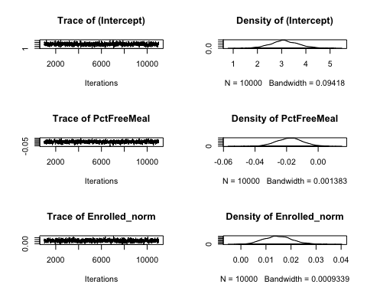

1. **Out of the three models we select the third one which has lower AIC score after eliminating the collinear variables.**
2. **PctFreeMeal and Enrolled students per School predicts the districts reporting is complete or not. The frequentist method gives us a very low r square of 7% (Nagelkerke), makes us not very confident in our model.**
3. **The Percent Free Meal is significant with p-value .036, and also the HDI does not cross zero, -0.037(2.5%) to -0.002(97.5%), both the frequentist and Bayesian confirms the significance.**
4. **The Enrolled per School is also significant with p-value .011, and also the HDI does not cross zero , 0.005(2.5%) to 0.029(97.5%), both the frequentist and Bayesian confirms the significance.**
5. **Further the trace of the variables has no outliers, indicating the mcmc converged.**
6. **And both frequentist and Bayesian agree on the coefficients at -0.02 for PctFreeMeal and .02 for Enrolled per School.**
7. **When converted to odds the compliance improves about .98:1 odds for Free Meal and 1.01:1 odds for enrolled students per school.**

## Question 6 6. What variables predict the percentage of all enrolled students with completely up-to-date vaccines?

glm6_1<- glm(PctUpToDate~PctChildPoverty+PctFreeMeal+PctFamilyPoverty+Enrolled+TotalSchools, data = outlier_removed, family = gaussian())  
summary(glm6_1)

##   
## Call:  
## glm(formula = PctUpToDate ~ PctChildPoverty + PctFreeMeal + PctFamilyPoverty +   
## Enrolled + TotalSchools, family = gaussian(), data = outlier_removed)  
##   
## Deviance Residuals:   
## Min 1Q Median 3Q Max   
## -62.675 -4.115 2.417 7.486 20.323   
##   
## Coefficients:  
## Estimate Std. Error t value Pr(>|t|)   
## (Intercept) 79.723887 1.265946 62.976 < 2e-16 ***  
## PctChildPoverty -0.001448 0.081225 -0.018 0.98578   
## PctFreeMeal 0.066323 0.029900 2.218 0.02690 *   
## PctFamilyPoverty 0.219635 0.113081 1.942 0.05255 .   
## Enrolled 0.019260 0.003876 4.969 8.7e-07 ***  
## TotalSchools -1.041962 0.349053 -2.985 0.00294 **   
## ---  
## Signif. codes: 0 '***' 0.001 '**' 0.01 '*' 0.05 '.' 0.1 ' ' 1  
##   
## (Dispersion parameter for gaussian family taken to be 146.7208)  
##   
## Null deviance: 107834 on 635 degrees of freedom  
## Residual deviance: 92434 on 630 degrees of freedom  
## AIC: 4985.6  
##   
## Number of Fisher Scoring iterations: 2

PseudoR2(glm6_1)

## McFadden Adj.McFadden Cox.Snell Nagelkerke   
## 1.428104e-01 1.426806e-01 1.000000e+00 1.000000e+00   
## McKelvey.Zavoina Effron Count Adj.Count   
## NA 1.428104e-01 4.716981e-03 -7.106599e-02   
## AIC Corrected.AIC   
## 9.244609e+04 9.244622e+04

vif(glm6_1)

## PctChildPoverty PctFreeMeal PctFamilyPoverty Enrolled   
## 4.235801 2.388627 3.744828 9.886842   
## TotalSchools   
## 9.884949

glm6_2<- glm(PctUpToDate~PctFreeMeal+Enrolled_norm, data = outlier_removed, family = gaussian())  
vif(glm6_2)

## PctFreeMeal Enrolled_norm   
## 1.013247 1.013247

PseudoR2(glm6_2)

## McFadden Adj.McFadden Cox.Snell Nagelkerke   
## 1.268940e-01 1.268198e-01 1.000000e+00 1.000000e+00   
## McKelvey.Zavoina Effron Count Adj.Count   
## NA 1.268940e-01 4.716981e-03 -7.106599e-02   
## AIC Corrected.AIC   
## 9.415641e+04 9.415645e+04

summary(glm6_2)

##   
## Call:  
## glm(formula = PctUpToDate ~ PctFreeMeal + Enrolled_norm, family = gaussian(),   
## data = outlier_removed)  
##   
## Deviance Residuals:   
## Min 1Q Median 3Q Max   
## -62.529 -3.689 2.800 7.383 22.162   
##   
## Coefficients:  
## Estimate Std. Error t value Pr(>|t|)   
## (Intercept) 76.58527 1.26315 60.630 < 2e-16 ***  
## PctFreeMeal 0.11387 0.01961 5.807 1.01e-08 ***  
## Enrolled_norm 0.07589 0.01097 6.920 1.11e-11 ***  
## ---  
## Signif. codes: 0 '***' 0.001 '**' 0.01 '*' 0.05 '.' 0.1 ' ' 1  
##   
## (Dispersion parameter for gaussian family taken to be 148.7368)  
##   
## Null deviance: 107834 on 635 degrees of freedom  
## Residual deviance: 94150 on 633 degrees of freedom  
## AIC: 4991.3  
##   
## Number of Fisher Scoring iterations: 2

lm6_2<-lm(PctUpToDate~PctFreeMeal+Enrolled_norm, data = outlier_removed)  
summary(lm6_2)

##   
## Call:  
## lm(formula = PctUpToDate ~ PctFreeMeal + Enrolled_norm, data = outlier_removed)  
##   
## Residuals:  
## Min 1Q Median 3Q Max   
## -62.529 -3.689 2.800 7.383 22.162   
##   
## Coefficients:  
## Estimate Std. Error t value Pr(>|t|)   
## (Intercept) 76.58527 1.26315 60.630 < 2e-16 ***  
## PctFreeMeal 0.11387 0.01961 5.807 1.01e-08 ***  
## Enrolled_norm 0.07589 0.01097 6.920 1.11e-11 ***  
## ---  
## Signif. codes: 0 '***' 0.001 '**' 0.01 '*' 0.05 '.' 0.1 ' ' 1  
##   
## Residual standard error: 12.2 on 633 degrees of freedom  
## Multiple R-squared: 0.1269, Adjusted R-squared: 0.1241   
## F-statistic: 46 on 2 and 633 DF, p-value: < 2.2e-16

library(BayesFactor)

## Loading required package: Matrix

## ************  
## Welcome to BayesFactor 0.9.12-4.2. If you have questions, please contact Richard Morey (richarddmorey@gmail.com).  
##   
## Type BFManual() to open the manual.  
## ************

bayes_glm6_2<- regressionBF(PctUpToDate~PctChildPoverty+PctFreeMeal+PctFamilyPoverty+Enrolled_norm, data = outlier_removed)  
summary(bayes_glm6_2)

## Bayes factor analysis  
## --------------  
## [1] PctChildPoverty : 42263.42 ±0%  
## [2] PctFreeMeal : 26836164 ±0%  
## [3] PctFamilyPoverty : 8417333 ±0%  
## [4] Enrolled_norm : 18963713207 ±0%  
## [5] PctChildPoverty + PctFreeMeal : 4078650 ±0%  
## [6] PctChildPoverty + PctFamilyPoverty : 963856.4 ±0%  
## [7] PctChildPoverty + Enrolled_norm : 4.072524e+14 ±0.01%  
## [8] PctFreeMeal + PctFamilyPoverty : 48186059 ±0%  
## [9] PctFreeMeal + Enrolled_norm : 2.051801e+16 ±0.01%  
## [10] PctFamilyPoverty + Enrolled_norm : 2.038377e+15 ±0.01%  
## [11] PctChildPoverty + PctFreeMeal + PctFamilyPoverty : 12556532 ±0%  
## [12] PctChildPoverty + PctFreeMeal + Enrolled_norm : 4.685417e+15 ±0%  
## [13] PctChildPoverty + PctFamilyPoverty + Enrolled_norm : 3.871342e+14 ±0%  
## [14] PctFreeMeal + PctFamilyPoverty + Enrolled_norm : 1.259119e+16 ±0.01%  
## [15] PctChildPoverty + PctFreeMeal + PctFamilyPoverty + Enrolled_norm : 1.796828e+15 ±0%  
##   
## Against denominator:  
## Intercept only   
## ---  
## Bayes factor type: BFlinearModel, JZS

bayes_glm6_2_final<-lmBF(PctUpToDate~PctFreeMeal+Enrolled_norm, data = outlier_removed,posterior=TRUE, iterations=10000)  
summary(bayes_glm6_2_final)

##   
## Iterations = 1:10000  
## Thinning interval = 1   
## Number of chains = 1   
## Sample size per chain = 10000   
##   
## 1. Empirical mean and standard deviation for each variable,  
## plus standard error of the mean:  
##   
## Mean SD Naive SE Time-series SE  
## mu 87.59580 0.48693 0.0048693 0.0048693  
## PctFreeMeal 0.11193 0.01923 0.0001923 0.0001923  
## Enrolled_norm 0.07436 0.01090 0.0001090 0.0001090  
## sig2 149.09171 8.39686 0.0839686 0.0839686  
## g 0.24932 0.81796 0.0081796 0.0089048  
##   
## 2. Quantiles for each variable:  
##   
## 2.5% 25% 50% 75% 97.5%  
## mu 86.62948 87.26879 87.59491 87.91920 88.55752  
## PctFreeMeal 0.07389 0.09910 0.11177 0.12499 0.14963  
## Enrolled_norm 0.05336 0.06703 0.07423 0.08174 0.09555  
## sig2 133.48392 143.22621 148.86930 154.59817 166.75043  
## g 0.02772 0.06324 0.10960 0.21754 1.24343

plot(bayes_glm6_2_final)

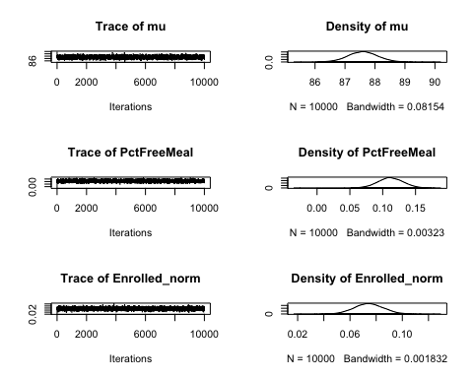

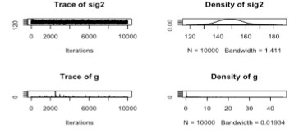

1. **We tried linear modeling, it didn’t give a good R square value, So we tried with GLM and normal distribution, which gave a high pseudo R square and low AIC making us more confident in our model.**
2. **Out of the two models we select the second one which has lower AIC score after eliminating the collinear variables.**
3. **PctFreeMeal and Enrolled students per School predicts the Percentage of Students up to date with vaccines.**
4. **The frequentist method gives us a very high r square of 100% (Nagelkerke), makes us very confident in our model, although the Adjusted McFadden is in line with the LM model at 11%**
5. **The Percent Free Meal is very significant with p-value 1.15e-07, and Enrolled per School is also significant with p-value 3.10e-09.**
6. **And Bayesian method also picked PctFreeMeal + Enrolled_norm as the predictors with highest factor at 2.77478e+12.**
7. **The HDI intervals are also not crossing zero, giving us high confidence for the coefficients and are in line with frequentist estimates at 0.12 and 0.07 for PctFreeMeal and Enrolled students per School respectively.**
8. **Further the trace of the variables have no outliers, indicating the mcmc converged.**

## Question 7 7. What variables predict the percentage of all enrolled students with belief exceptions?

glm7_1<- glm(PctBeliefExempt~PctChildPoverty+PctFreeMeal+PctFamilyPoverty+Enrolled+TotalSchools, data = outlier_removed, family = gaussian())  
summary(glm7_1)

##   
## Call:  
## glm(formula = PctBeliefExempt ~ PctChildPoverty + PctFreeMeal +   
## PctFamilyPoverty + Enrolled + TotalSchools, family = gaussian(),   
## data = outlier_removed)  
##   
## Deviance Residuals:   
## Min 1Q Median 3Q Max   
## -13.108 -4.360 -1.683 1.728 64.732   
##   
## Coefficients:  
## Estimate Std. Error t value Pr(>|t|)   
## (Intercept) 11.474353 0.896462 12.800 < 2e-16 ***  
## PctChildPoverty 0.121285 0.057519 2.109 0.0354 *   
## PctFreeMeal -0.096838 0.021173 -4.574 5.77e-06 ***  
## PctFamilyPoverty -0.192876 0.080077 -2.409 0.0163 *   
## Enrolled -0.010870 0.002745 -3.960 8.35e-05 ***  
## TotalSchools 0.542614 0.247177 2.195 0.0285 *   
## ---  
## Signif. codes: 0 '***' 0.001 '**' 0.01 '*' 0.05 '.' 0.1 ' ' 1  
##   
## (Dispersion parameter for gaussian family taken to be 73.574)  
##   
## Null deviance: 54330 on 635 degrees of freedom  
## Residual deviance: 46352 on 630 degrees of freedom  
## AIC: 4546.6  
##   
## Number of Fisher Scoring iterations: 2

PseudoR2(glm7_1)

## McFadden Adj.McFadden Cox.Snell Nagelkerke   
## 0.1468476 0.1465899 0.9999964 0.9999964   
## McKelvey.Zavoina Effron Count Adj.Count   
## NA 0.1468476 0.1430818 -0.1571125   
## AIC Corrected.AIC   
## 46363.6204088 46363.7539542

vif(glm7_1)

## PctChildPoverty PctFreeMeal PctFamilyPoverty Enrolled   
## 4.235801 2.388627 3.744828 9.886842   
## TotalSchools   
## 9.884949

glm7_2<- glm(PctBeliefExempt~PctFreeMeal+Enrolled_norm, data = outlier_removed, family = gaussian)  
summary(glm7_2)

##   
## Call:  
## glm(formula = PctBeliefExempt ~ PctFreeMeal + Enrolled_norm,   
## family = gaussian, data = outlier_removed)  
##   
## Deviance Residuals:   
## Min 1Q Median 3Q Max   
## -13.026 -4.380 -1.923 1.229 65.789   
##   
## Coefficients:  
## Estimate Std. Error t value Pr(>|t|)   
## (Intercept) 13.810820 0.896419 15.407 < 2e-16 ***  
## PctFreeMeal -0.095346 0.013915 -6.852 1.73e-11 ***  
## Enrolled_norm -0.045966 0.007783 -5.906 5.74e-09 ***  
## ---  
## Signif. codes: 0 '***' 0.001 '**' 0.01 '*' 0.05 '.' 0.1 ' ' 1  
##   
## (Dispersion parameter for gaussian family taken to be 74.90793)  
##   
## Null deviance: 54330 on 635 degrees of freedom  
## Residual deviance: 47417 on 633 degrees of freedom  
## AIC: 4555  
##   
## Number of Fisher Scoring iterations: 2

PseudoR2(glm7_2)

## McFadden Adj.McFadden Cox.Snell Nagelkerke   
## 0.1272433 0.1270960 0.9999810 0.9999810   
## McKelvey.Zavoina Effron Count Adj.Count   
## NA 0.1272433 0.1493711 -0.1486200   
## AIC Corrected.AIC   
## 47422.7179284 47422.7559031

vif(glm7_2)

## PctFreeMeal Enrolled_norm   
## 1.013247 1.013247

bayes_glm7_2<- regressionBF(PctBeliefExempt~PctChildPoverty+PctFreeMeal+PctFamilyPoverty+Enrolled_norm, data = outlier_removed)  
summary(bayes_glm7_2)

## Bayes factor analysis  
## --------------  
## [1] PctChildPoverty : 828.5981 ±0.01%  
## [2] PctFreeMeal : 12532822080 ±0%  
## [3] PctFamilyPoverty : 1867517 ±0%  
## [4] Enrolled_norm : 46567829 ±0%  
## [5] PctChildPoverty + PctFreeMeal : 4072760286 ±0%  
## [6] PctChildPoverty + PctFamilyPoverty : 419617 ±0%  
## [7] PctChildPoverty + Enrolled_norm : 20997950912 ±0%  
## [8] PctFreeMeal + PctFamilyPoverty : 2488777965 ±0%  
## [9] PctFreeMeal + Enrolled_norm : 2.323886e+16 ±0.01%  
## [10] PctFamilyPoverty + Enrolled_norm : 2.022349e+12 ±0.01%  
## [11] PctChildPoverty + PctFreeMeal + PctFamilyPoverty : 33415534503 ±0.01%  
## [12] PctChildPoverty + PctFreeMeal + Enrolled_norm : 6.118625e+15 ±0.01%  
## [13] PctChildPoverty + PctFamilyPoverty + Enrolled_norm : 284317833088 ±0%  
## [14] PctFreeMeal + PctFamilyPoverty + Enrolled_norm : 3.352769e+15 ±0%  
## [15] PctChildPoverty + PctFreeMeal + PctFamilyPoverty + Enrolled_norm : 6.081803e+15 ±0.01%  
##   
## Against denominator:  
## Intercept only   
## ---  
## Bayes factor type: BFlinearModel, JZS

bayes_glm7_2[9]

## Bayes factor analysis  
## --------------  
## [1] PctFreeMeal + Enrolled_norm : 2.323886e+16 ±0.01%  
##   
## Against denominator:  
## Intercept only   
## ---  
## Bayes factor type: BFlinearModel, JZS

bayes_glm7_2_final<-lmBF(PctBeliefExempt~PctFreeMeal+Enrolled_norm, data = outlier_removed,posterior=TRUE, iterations=10000)  
summary(bayes_glm7_2_final)

##   
## Iterations = 1:10000  
## Thinning interval = 1   
## Number of chains = 1   
## Sample size per chain = 10000   
##   
## 1. Empirical mean and standard deviation for each variable,  
## plus standard error of the mean:  
##   
## Mean SD Naive SE Time-series SE  
## mu 5.86464 0.342193 3.422e-03 3.298e-03  
## PctFreeMeal -0.09369 0.014029 1.403e-04 1.403e-04  
## Enrolled_norm -0.04512 0.007804 7.804e-05 7.804e-05  
## sig2 75.09314 4.182570 4.183e-02 4.263e-02  
## g 0.31729 3.491764 3.492e-02 3.492e-02  
##   
## 2. Quantiles for each variable:  
##   
## 2.5% 25% 50% 75% 97.5%  
## mu 5.19608 5.63395 5.86812 6.09015 6.53958  
## PctFreeMeal -0.12086 -0.10313 -0.09368 -0.08426 -0.06603  
## Enrolled_norm -0.06029 -0.05039 -0.04508 -0.03994 -0.02978  
## sig2 67.27460 72.19279 74.99185 77.89071 83.53192  
## g 0.02803 0.06453 0.11232 0.22102 1.21915

plot(bayes_glm7_2_final)

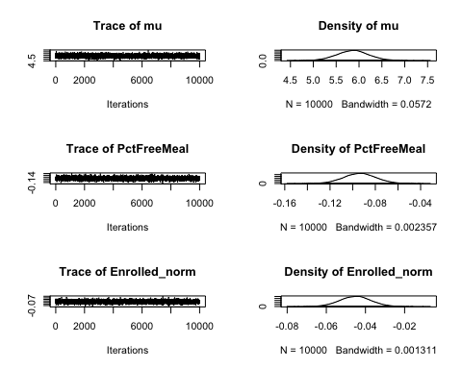

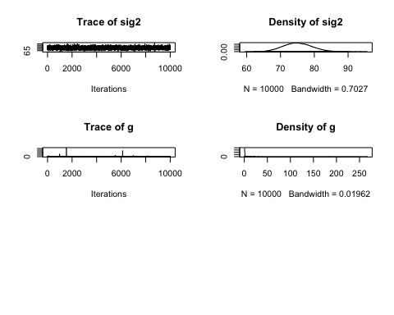

1. **Out of the two models we selected the second one which has lower AIC score after eliminating the collinear variables.**
2. **PctFreeMeal and Enrolled students per School predicts the Percentage of Students with belief exemptions.**
3. **The frequentist method gives us a very high r square of 99.99% (Nagelkerke), makes us very confident in our model.**
4. **The Percent Free Meal is very significant with p-value 4.67e-10, and Enrolled per School is also significant with p-value 4.49e-07.**
5. **And Bayesian method also picked PctFreeMeal + Enrolled_norm as the predictors with highest factor at 4.663353e+12.**
6. **The HDI intervals are also not crossing zero, giving us high confidence for the coefficients and are in line with frequentist estimates at -0.1 and -0.04 for PctFreeMeal and Enrolled students per School respectively.**
7. **Further the trace of the variables has no outliers, indicating the mcmc converged.**

## Question 8 8. What’s the big picture, based on all of the foregoing analyses? The staff member in the state legislator’s office is interested to know how to allocate financial assistance to school districts to improve both their vaccination rates and their reporting compliance. What have you learned from the data and analyses that might inform this question?

g1<-ggplot(outlier_removed,aes(y=PctBeliefExempt,x=PctFreeMeal)) +   
 geom_point() + theme_minimal() +  
 geom_smooth(method="glm")  
  
g2<-ggplot(outlier_removed,aes(y=PctBeliefExempt,x=Enrolled_norm)) +   
 geom_point() + theme_minimal() +  
 geom_smooth(method="glm")   
  
library(patchwork)

##   
## Attaching package: 'patchwork'

## The following object is masked from 'package:MASS':  
##   
## area

g1 + g2 + plot_annotation(title = "Percentage Belief Exempt Students")

## `geom_smooth()` using formula 'y ~ x'

## `geom_smooth()` using formula 'y ~ x'

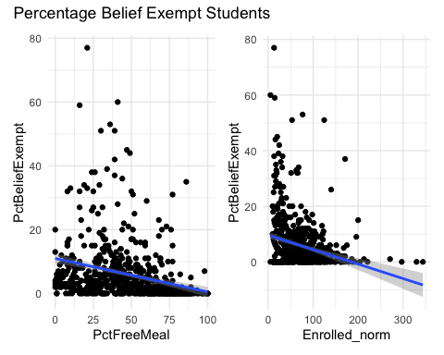

**The figure shows the change in percent Belief exemptions with respect to Free Meals and Enrolled students. The percentage of belief exempt students go down with increase in percent Free Meal and it is significant. So, we recommend the state department to increase the funding for free meal programs.**

**The lower the enrolled students the higher the belief exemptions, so given the size of enrolled students we can guess this might belong to rural areas, we need to verify the school locations and see is there a significant correlation to it. If so then concentrate on increasing the vaccine awareness in identified areas from the follow up analysis.**

g3<-ggplot(outlier_removed,aes(y=PctUpToDate,x=PctFreeMeal)) +   
 geom_point() + theme_minimal() +  
 geom_smooth(method="glm")  
  
g4<-ggplot(outlier_removed,aes(y=PctUpToDate,x=Enrolled_norm)) +   
 geom_point() + theme_minimal() +  
 geom_smooth(method="glm")   
  
g3 + g4 + plot_annotation(title = "Percentage up to date on Vaccines")

## `geom_smooth()` using formula 'y ~ x'  
## `geom_smooth()` using formula 'y ~ x'

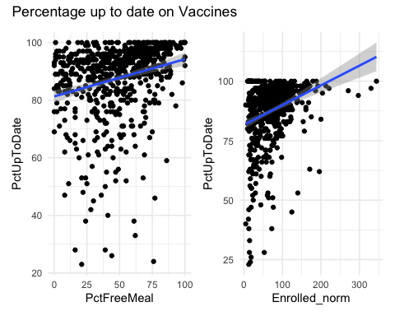

**The figure shows the chnage in percent up to date on vaccines with respect to Free Meals and Enrolled students. The percentage up to date go up with increase in percent Free Meal and it is significant. So, we recommend the state department to increase the funding for free meal programs to improve the continued vaccination.**

**The lower the enrolled students the lower the percent up to date, so given the size of enrolled students we can guess this might belong to rural areas, we need to verify the school locations and see is there a significant correlation to it. If so then concentrate on increasing the vaccine awareness in identified areas from the follow up analysis.**

p<-ggplot(outlier_removed,   
 aes(x=PctFreeMeal,y=Enrolled_norm,color=DistrictComplete)) +  
 geom_point() +theme_minimal()  
p+facet_wrap(vars(DistrictComplete )) + ggtitle("Compliance Plot")

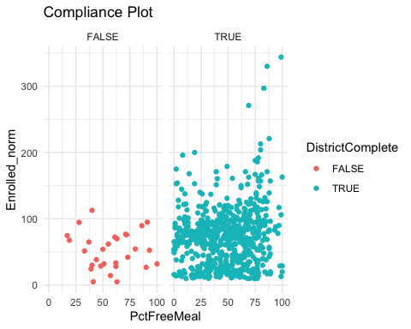

**The figure shows the district complete on vaccination with respect to Free Meals and Enrolled students. We can clearly see the non-complaint districts have low enrollment and medium adoption of percentage free meal.**

**The lower the enrolled students the lower the district complaint, so given the size of enrolled students we can guess this might belong to rural areas, we need to verify the school locations and concentrate on increasing the vaccine awareness.**

## Conclusion – Big Picture

**From the analysis we can clearly establish, that small to medium sized schools in district 19 have difficulty in vaccinating all the children. And further if any kid misses a vaccine, he/she is likely to miss all of them. Also, we can see providing a free meal incentive helps them to take up the vaccine, but we do not know why, is this because the kid needs to be vaccinated to receive free meal.**

**So, investing in free meals at small to medium schools will increase the overall compliance and increase the vaccine adoption both in terms of completeness and belief exemptions.**