**Homework #3: Optimizing Product Pricing**

**Group #3**

Alter, Cassandra

Fjellberg, John

Parker, Victoria

Tamilmani, Tamilselvan

Wong, Steven

**Background**

The Book Emporium wants to price books to optimize profits. The spreadsheet for this homework has sales data on Harry Potter book 7. For each week, the Book Emporium varied prices on Harry Potter 7 to determine a demand curve. The percent of customers who visited BookEmporium.com and purchased Harry Potter book 7 is shown in the spreadsheet. J.K. Rowling has announced a sequel to the Harry Potter series. Determine the price for the sequel.

1. Assume that the demand for the book sequel will be similar to Harry Potter 7.

2. Assume that 100,000 customers will consider purchasing a book from you

3. The data is not an entirely accurate prediction of the demand, but a regression on the

data using a power model will give a reasonable prediction

4. Assume that you pay the publisher $5.00 for each book

**Solution**

1. Regression analysis (40%)  
   a. Graph the percent purchased against the price (5%)

When we created a scatter plot, we got an inverse curve showing a sharp decline in the books purchased when the price increases. The plot matches the power curve.

b. Perform a regression using power regression to determine the predicted %

column.

* 1. Graph the new curve (5%)

The curve has a similar shape to the % Purchased graph above.

* 1. Estimate the equation of the line (5%)

Predicted % Purchased = 14.098 * Price ^ -1.872

* 1. What does the R2 mean? (5%)

The R2 means we can explain 99% of the dependent variable variance (predicted % purchased) by changes in the independent variable (Price).

c. Assuming there are 100,000 customers who visit your website and the publisher cost is $5.00, estimate the number of books sold (predicted sales column) (5%)

With 100,000 customers and a sale price of $5.00, the anticipated sales are $69,292.

d. Calculate the revenue column (price * predicted sales) (5%)

With 100,000 customers and a sale price of $5.00, the revenue is $346,462.  
e. Calculate the profit column ((price – book cost) * predicted sales) (5%)

With 100,000 customers and a sale price of $5.00, the profit is $0.  
f. Use conditional formatting to highlight the profit values for all prices (5%)

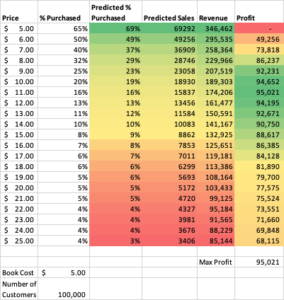

1. Optimization analysis (with constraints) (30%)
   1. Calculate the price point for the highest profit possible
      1. The publisher will sell the books to you at $5.00 each with no minimum order (10%)
         1. Book Price: $10.73 each
         2. Predicted Sales: 16,580
         3. Profit: $95,066.94
      2. The publisher has agreed to sell you the books at $4.50 each if you sell at least 30,000 (10%)
         1. Book Price: $7.82 each
         2. Predicted Sales: 30,000
         3. Profit: $99,586.50
      3. The publisher has agreed to sell you the books at $4.00 each if you sell at least 50,000 (10%)
         1. Book Price: $5.95 each
         2. Predicted Sales: 50,000
         3. Profit: $9,7606.78
   2. Run a constrained optimization for each of the above situations to determine which cost point (from the publisher) and price (to your customer) maximizes your profit. Which cost point should you accept from the publisher?

We should ask for a dollar/book with a 100000 minimum limit from the publisher because we believe we can make the highest profit (of $311,023.06) at that amount.



1. Discussion (30%)
   1. What are the risks of using Harry Potter 7 (HP7) data in predicting your new demand curve for the Harry Potter sequel (HPS)? (15%)

The demand for the Harry Potter 7 books, in predicting the demand for the Harry Potter sequel book, seems to be risky in some respects. The HPS book may not be as popular or received in the same way as the HP7 book. That means that the power curve seen in HP7 may not be the same curve seen in the sequel.

While the overall material is probably similar, we don’t know the specifics about the sequel, such as plot, price, the timing of the release, distribution patterns, potential changes in the marketing campaign, such as timing, methods of delivery, and price sensitization on changes in distribution methods, and differing market segments (i.e., teenagers vs. older people).

Some additional factors could be that the critic rating may be different, driving other traffic. Perhaps Word of Mouth marketing might increase sales. Possibly, the new generation of readers may be digital and won’t even buy a physical copy.

Finally, we also don’t know about Book Emporium’s competition (both direct and indirect) in selling HP7 books, such as Amazon, Barnes and Noble, and the location of nearby competitors such as Target and Walmart.

* 1. What other data would you like to have to perform your analysis? (15%)

Our analysis would be more robust if we could compare information on the marketing and distribution channels used for other Harry Potter books.

Our analysis would also be made more sound by knowing how physical book sales would be potentially impacted by the book’s release date and other potential competitors that might make the bestseller list around the same time the book is released.

Additionally, we may want to broaden our view to data of other books from the same author.

We may want to look at sales in foreign countries.