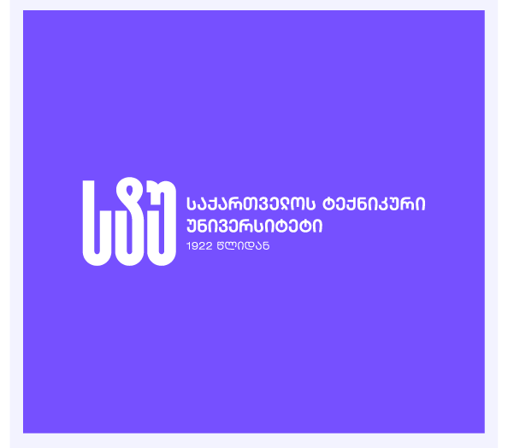
Name: Tamta Termakozashvili, Nino Khorava
Faculty: Informatics and Management Systems
Program: Computer Science (English)

Bachelor’s Thesis
Design and Implementation of an Adaptive Memory System for LLM-Based Culinary Assistants with Multi-Language Support

Georgian Technical University
Tbilisi, 0160, Georgia
February, 2026

Faculty of Informatics and Management Systems
Computer Science Program

Student Tamta Termakozashvili _______________
name, surname Signature

Supervisor Mariam Chkhaidze ______________
name, surname Signature

Contents
No table of contents entries found.

