

Get

started with Map Viewer Classic

Table of Contents

### Lessons

Get started with Map Viewer Classic overview 4

Explore a map 5

Create a map 14

Add a layer from a .csv file 27

Configure pop-ups 34

Make an app 44

Lessons

# Get started with Map Viewer Classic overview

Map Viewer Classic allows you to create and interact with online maps. First, you'll explore an existing web map that shows Hawaii's volcanoes, volcano shelters, and volcano hazard zones. Next, you will reconstruct the web map you explored by searching for and adding layers to an empty web map. Once you add the necessary layers, you will modify symbology and customize other map properties, such as the organization of attributes that display when you click a feature on the map. Last, you'll share your map as a professional-looking web app so other users can explore it.

This lesson was last tested on March 1, 2022.

* Publisher or Administrator role in an ArcGIS organization: ArcGIS Online (get a [free trial](https://learn.arcgis.com/en/become-a-member/)) or ArcGIS Enterprise (learn [more](https://learn.arcgis.com/en/related-concepts/enterprise.htm))

[Include the link to final result in href attribute](https://www.arcgis.com/apps/instant/basic/index.html?appid=9a7e3a0ef4ec4a9fb58fcca3d2418b71)

* [Hawaii Statewide GIS Program](https://geoportal.hawaii.gov/)

# Explore a map

First, you'll open a web map and learn how to navigate and work with it using map tools as you explore volcanoes and the risk of lava flow on the island of Hawaii.

## Open the map

You'll start by opening a map of lava flow hazard zones on the island of Hawaii using Map Viewer Classic.

1. Go to the ArcGIS Online group [Get Started with Map Viewer Classic](http://www.arcgis.com/home/group.html?id=95b198caf94b4c9486f379043e08c5b3&overview).

### Note:

A group is a collection of content on ArcGIS Online.

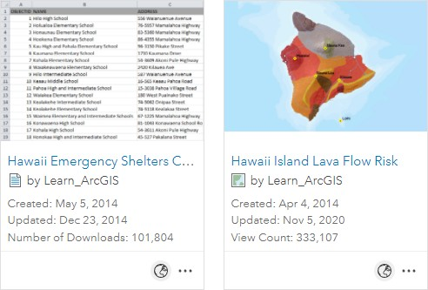

This group contains a .csv file and a web map for use in the lesson.

1. 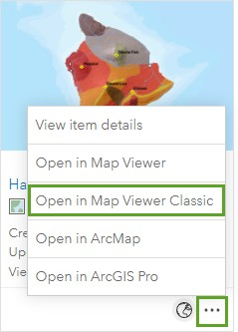On the **Hawaii Island Lava Flow Risk** web map item, click the ellipses and choose **Open in Map Viewer Classic**.

### Note:

If you are prompted to use another version of Map Viewer, click **Not Right Now**

The map appears and shows the island of Hawaii.

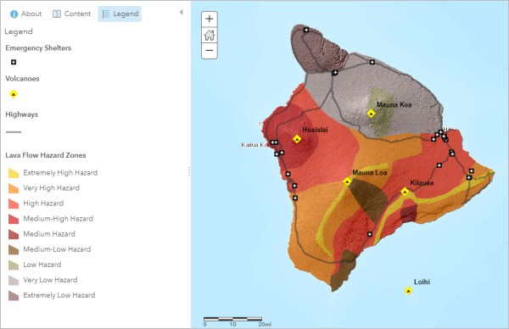

Instead of beaches and greenery, you see a geologic classification of the island into lava flow hazard zones of varying severity. The map also shows volcanoes, emergency shelters, and highways.

## Explore the map

The map contains layers, and each layer contains features. For example, each volcano is a feature in the **Volcanoes**

layer. Next, you'll get information about features and navigate the map.

1. On the map, click a volcano, such as Mauna Loa.

A pop-up appears with more information about the volcano.

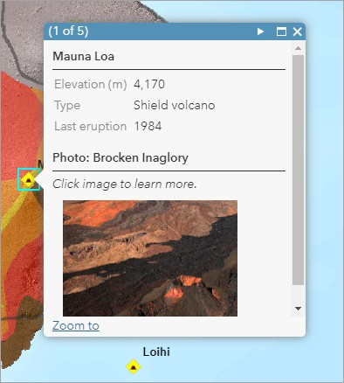

Mauna Loa, which last erupted in 1984, is one of three active volcanoes on the island. (Mauna Kea is extinct.)

1. On the pop-up, click the thumbnail image.

A large, captioned version of the image opens in a new browser tab or window.

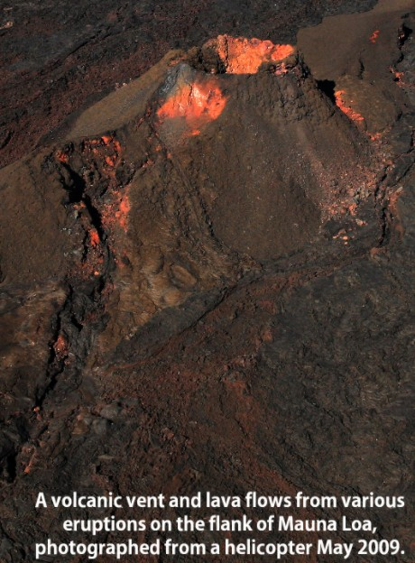

1. Close the tab or window with the detailed image.
2. At the bottom of the pop-up, click **Zoom to**.

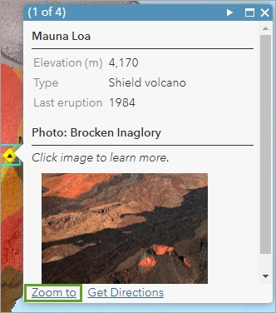

The map zooms in on the feature and you can see the terrain.

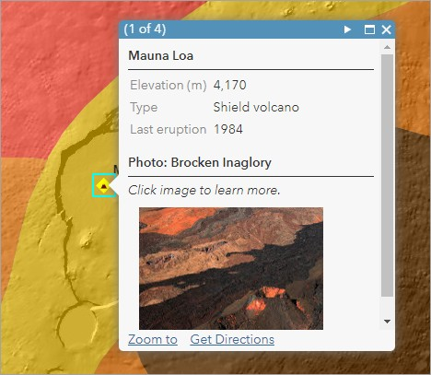

1. Close the pop-up.
2. In the upper left corner of the map, click the **Default extent** button.

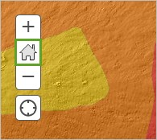

1. On the map, click a lava flow hazard zone.

Another pop-up appears with information about the feature and a thumbnail image that links to a larger picture.

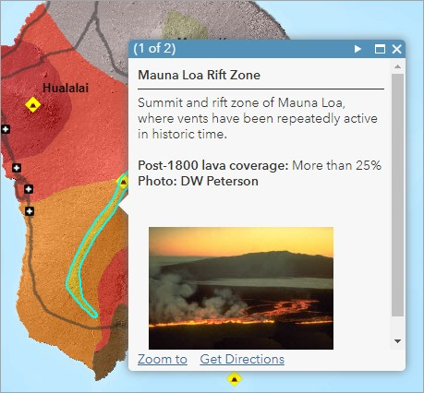

1. On the pop-up, click the thumbnail image to see the large, captioned image.
2. Close the browser tab with the detailed image, and on the map, close the pop-up.
3. On your own, learn more about the volcanoes, hazard zones, and emergency shelters. Use the map navigation tools or your mouse wheel to zoom in and out.

### Tip:

Press the Shift key and draw a box on the map to zoom in on a particular area.

1. When you're finished, click the **Default extent** button to return to a full view of the island.

Now that you know something about how the map works, you'll look at how it's put together.

## View the map contents

To work directly with the map layers, you need to switch to the Contents view of the map.

1. At the top of the **Details** pane on the left, click the **Content** button.

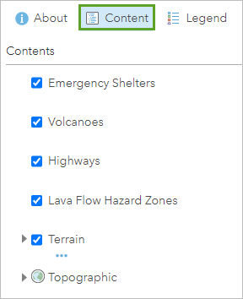

The order of layers in the **Contents** pane is the order in which they are drawn on the map. At the bottom, every map has a basemap layer that covers the entire world. Every layer, except the basemap, can be turned on or off.

1. In the **Contents** pane, check the box next to the **Lava Flow Hazard Zones** layer to turn the layer off.

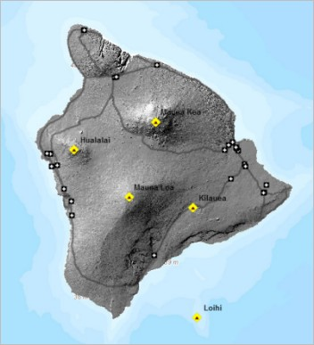

You see the **Terrain** layer underneath. (The **Terrain** layer was already partially visible because of a transparency setting on the Lava Flow Hazard Zones layer.)

1. Turn off the **Terrain** layer to see the **Topographic** basemap.

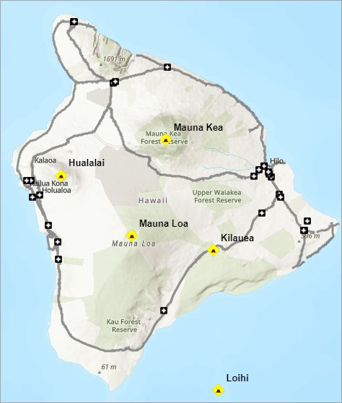

1. Turn both layers back on.

You can adjust the transparency of any layer to enhance the map display and see underlying features, without having to turn layers off. Next, you'll set a transparency for the **Lava Flow Hazard Zones** layer.

1. In the **Contents** pane, point to the **Lava Flow Hazard Zones** layer. Click the **More Options** button and choose

### Transparency.

The **Layer Transparency** pane appears and the layer is set to approximately 40 percent transparent.

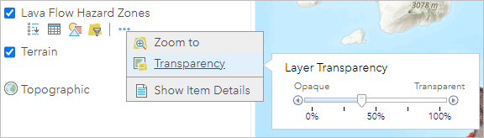

1. Drag the **Transparency** slider left and right.

When the layer is completely opaque, the terrain is obscured. At the other extreme, the **Lava Flow Hazard Zones** layer is invisible.

1. Move the **Transparency** slider to a position you like. Click a blank space in the **Contents** pane to close the **Layer Transparency** pane.

Now that you've explored the map, you'll assemble it in the next lesson.

## Use map tools

You can also work with the map using tools on the ribbon.

1. On the ribbon, click the **Measure** button and click the **Distance** tool. Click the existing units and choose **Miles**.

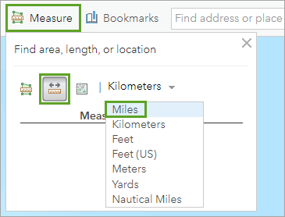

1. On the map, click Mauna Loa to start a measurement.
2. Move the pointer to another volcano, such as Hualalai, and double-click to end the measurement.

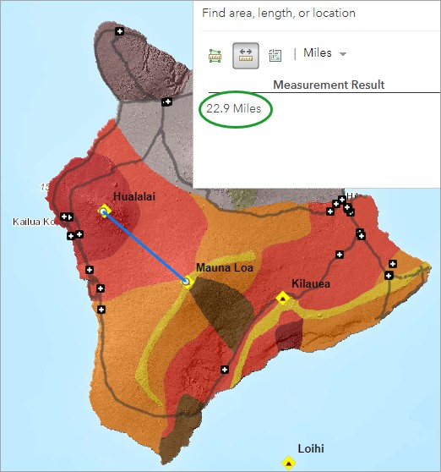

1. Make a few more measurements. When you're finished, close the **Measure** tool.

### Tip:

During a measurement, click to change the direction of the line.

1. Close the web map.

You've explored a map that somebody else made and became familiar with its layers and data. Next, you'll use similar data to create your own map of Hawaii and its lava flow zones.

# Create a map

Every new map starts with a basemap. In an ArcGIS organization, the administrator chooses the default basemap and sets its extent. This lesson assumes that your default basemap is the Topographic basemap and that its default extent is the world. If your settings are different, you'll make changes as needed in the first section.

## Create the map

To create a map, complete the following steps:

1. If a map is already open in your browser, on the ribbon, click **Modify Map**.
2. Click **New Map** and click **Create New Map**.

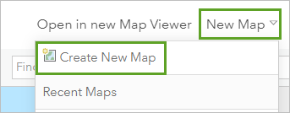

1. In the **Open map** window, click **Yes, Open the Map**.
2. Sign in to your [ArcGIS organizational account](https://www.arcgis.com/home/signin.html) or into ArcGIS Enterprise using a named user account.

### Note:

If you don't have an organizational account, you can sign up for an [ArcGIS free trial](https://learn.arcgis.com/en/become-a-member/).

1. If a map is not open in your browser, go to [ArcGIS Online](http://www.arcgis.com/home/index.html) and click **Map** at the top of the page.

The new map opens to the extent of the world. (Your extent may differ depending on your administrative settings.)

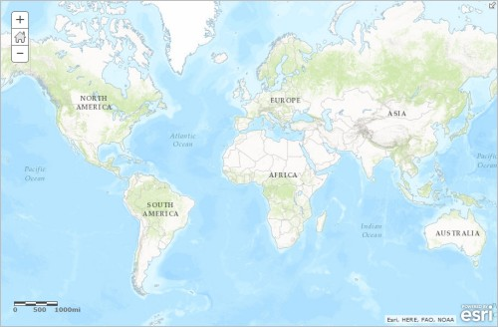

1. On the ribbon, in the **Find address or place** search bar, type Island of Hawaii. In the list of suggested locations, choose **Island of Hawai'i, HI, USA**.

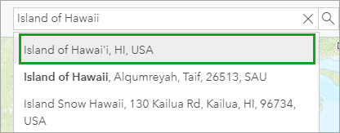

The map zooms to Hawaii.

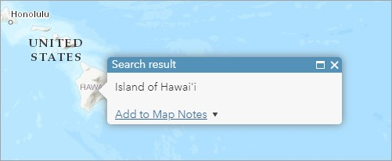

1. Close the **Search result** pop-up.
2. Zoom in on the island. If necessary, pan (drag) the map to center Hawaii in the view.

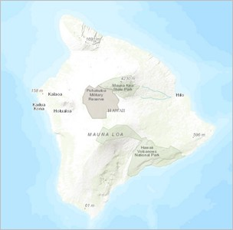

One way you can set the map extent of your map is to save the map. The map extent at the time of saving becomes the extent used by the **Default extent** button. It can also be useful to add spatial bookmarks to navigate to specific map locations. You will create a bookmark for the island of Hawaii.

1. On the ribbon, click the **Bookmarks** button. In the **Bookmarked places** list, click **Add Bookmark**.

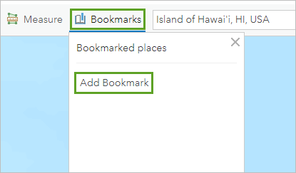

1. 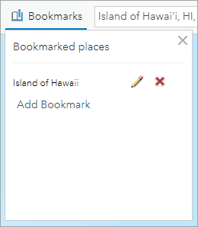Type Island of Hawaii and press Enter .
2. Close the **Bookmarked places** window.
3. At the top of the **Details** pane, click the **Content** button.

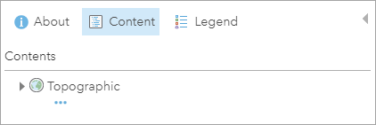

1. If necessary, click the **Basemap** button on the ribbon and choose **Topographic**.

## Add layers to the map

You're ready to start adding layers to the basemap.

1. On the ribbon, click the **Add** button and choose **Search for Layers**.

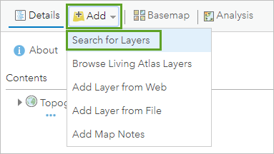

A default list of search results appears.

1. Click **My Content** and choose **ArcGIS Online**.

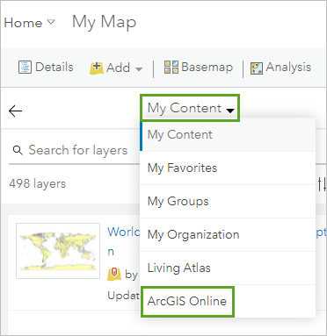

1. In the search box, type Hawaii. To limit the search results to layers owned by the Learn ArcGIS administrator account, add owner:Learn_ArcGIS and press Enter .

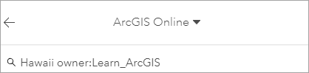

The search results are narrowed to a more relevant list.

1. In the list of results, locate **HawaiiTerrain** by **Learn_ArcGIS**. Click **Add** to add the layer to the map.

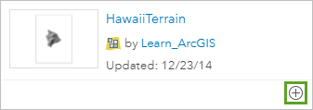

1. In the same way, add the following layers from the search results to the map (all layers are by Learn_ArcGIS):

### Volcanoes

### Hawaii Lava Flow Hazard Zones

### Hawaii Island Major Highways

1. At the top of the search pane, click the **Back** button.

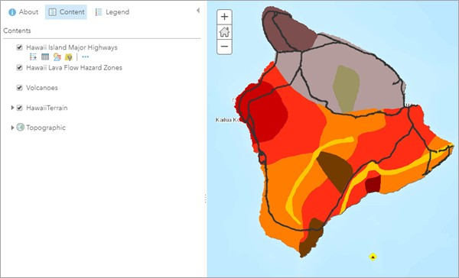

The layers are drawn, with their default symbols, in the order in which they were loaded into the map. (This is usually, but not always, the same order in which you add them.) You don't see the volcanoes on the map because they are underneath the lava flow hazard zones.

## Set layer properties

In this section, you'll change some of the properties of the layers. You'll give them shorter names, change their position in the list of layers, add labels, and adjust transparency. Layer properties are always accessed in the same way: by pointing to the layer name and clicking an appropriate button or clicking the **More Options** button and choosing the property you want to change.

1. In the **Contents** pane, point to the **Hawaii Island Major Highways** layer, click the **More Options** button, and choose **Rename**.

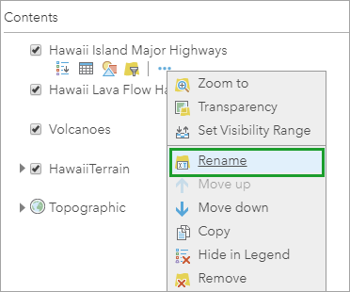

1. 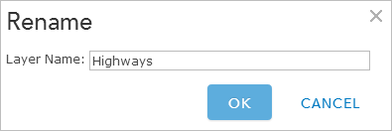In the **Rename** window, change the layer name to Highways and click **OK**.
2. In the same way, rename the **Hawaii Lava Flow Hazard Zones** layer to Lava Flow Hazard Zones.
3. Rename the **HawaiiTerrain** layer to Terrain.
4. In the **Contents** pane, point to the **Volcanoes** layer, click the **More Options** button, and click **Move up**.

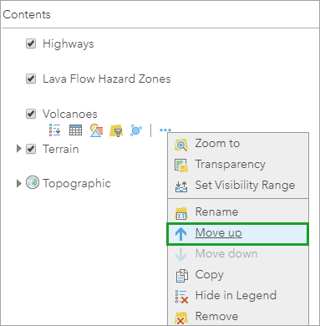

The layer moves up one position, above the **Lava Flow Hazard Zones** layer. The volcanoes are now visible on the map.

1. Move the **Volcanoes** layer up again.

Now the **Volcanoes** layer is at the top of the list. The usual practice is to put points (such as volcanoes) above lines, and lines (such as highways) above polygons. Points, lines, and polygons are all feature layers: they usually represent discrete geographic objects that have more or less precise locations and boundaries.

The **Terrain** layer, like the **Topographic** basemap, is a tile layer. Tile layers are images and cannot be manipulated in the same ways as feature layers. They typically represent large, continuous surfaces rather than discrete objects. Tile layers cannot be moved above feature layers in a map.

1. In the **Contents** pane, point to the **Volcanoes** layer. Click the **More Options** button and choose **Create Labels**.

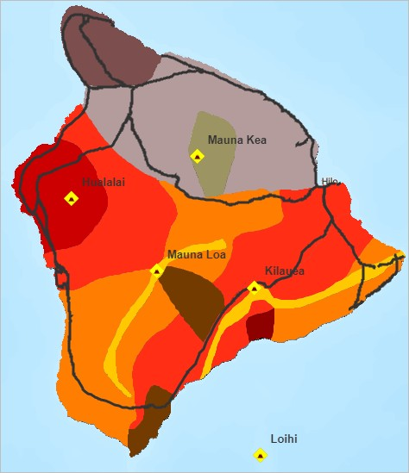

Each volcano is labeled with its name.

1. In the **Label Features** pane, change the label size from **13** to **14** and click **OK**.

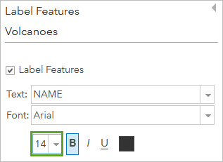

1. In the **Contents** pane, point to the **Lava Flow Hazard Zones** layer, click the **More Options** button and choose

**Transparency**. Make the layer about 40 percent transparent, or whatever looks good to you.

1. In the same way, make the **Highways** layer about 50 percent transparent.

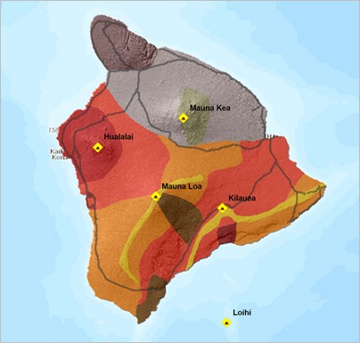

You have re-created the appearance of the map you explored in the last lesson, except for the emergency shelters.

## Define the map legend

When you start a new map, or open a saved map of your own, it opens with the **Contents** pane showing. When anyone else opens your map, however, it opens with the **Legend** pane showing. You should think about how you want the legend to look.

1. At the top of the **Contents** pane, click the **Legend** button.

Legend entries are created for all layers except the basemap. The entry for the Terrain layer (which shows grayscale values) is not useful for interpreting the map.

1. At the top of the **Legend** pane, click the **Content** button.
2. Point to the **Terrain** layer, click **More Options**, and choose **Hide in Legend**.

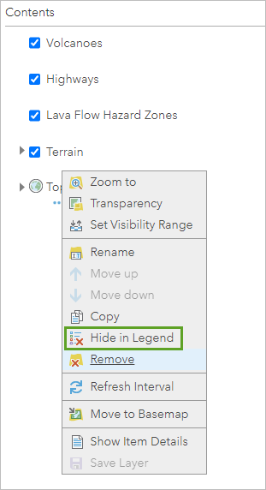

1. View the legend again to see the effect, and then go back to the **Contents** pane.

## Change a symbol

You were able to re-create the map's appearance without too much effort because the symbols, such as yellow diamonds for volcanoes and shades of red and orange for hazard zones, were already set when you added the layers. A layer's default display settings, including its style and pop-up configuration, are made by its owner. Once you add a layer to your own map, however, you can change those settings.

1. In the **Contents** pane, point to the **Highways** layer and click the **Change Style** button.

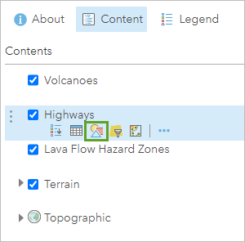

In the **Change Style** pane, the currently selected style is **Location (Single symbol)**, which is indicated by the check mark.

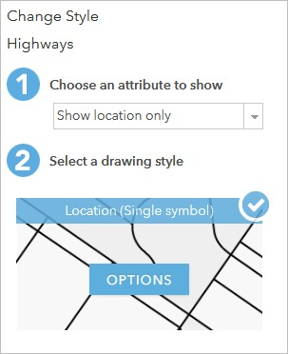

In this style, all features in the layer are drawn with the same symbol. The **Location** style is appropriate when you want to see the features on the map but you're not interested in their particular characteristics, such as names or speed limits.

1. For **Select a drawing style**, under **Location (Single symbol)**, click **Options**.
2. Under **Showing Location Only**, click **Symbols** to change the symbol.

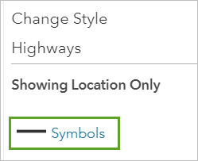

1. On the color palette, choose a dark purple color (such as **#4C0073**) and click **OK**.

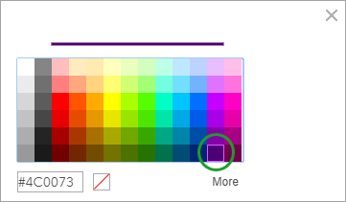

The new color is applied to the map. (If you don't like it, click **Symbols** again to open the color palette and choose a different color.)

1. At the bottom of the **Change Style** pane, click **OK** and click **Done**.

## Save the map

Next, you'll save your map and update some of its item details.

1. On the ribbon, click the **Save** button and choose **Save**.
2. In the **Save Map** window, for **Title**, type Hawaii Island Lava Flow Hazard Zones and add your initials.

### Note:

To ensure all names are unique, you will add the initials for your name at the end of the map name. YN is a generic placeholder to represent the initials for your name.

1. For **Tags**, type words that will help people find the map through searches. After each tag, press Enter .
2. 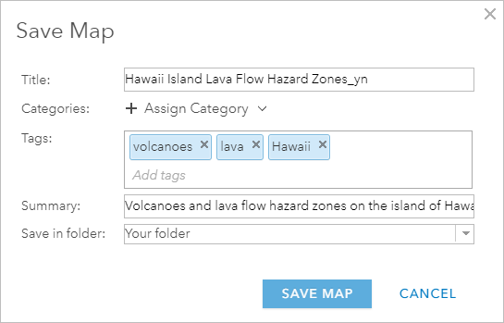For **Summary**, type a brief description of the map's content, such as: Volcanoes and lava flow hazard zones on the island of Hawaii.
3. Click **Save Map**.

The map is saved to **My Content**, which you can access from the content page in the organization.

## Edit item details

Next, you'll edit the information that describes your map (also known as its metadata). The metadata changes you make to your map will carry over to your web app. In particular, you'll edit your map's description, which will allow users to learn about the map's content.

1. At the top of the page, click **Home** and choose **Content**.

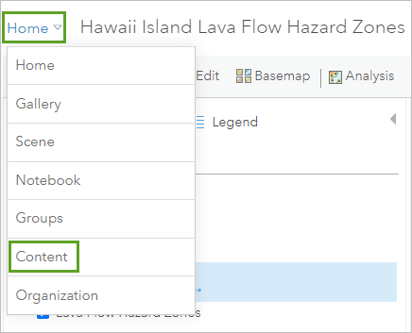

On the **My Content** tab of the content page, the map is listed by its name and other details.

1. Click the map title to view its item details.

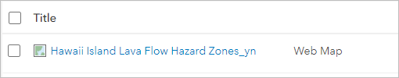

The item details page for your web map appears. The item details page contains information about your map. From this page, you can also share the map, monitor map usage to gauge its popularity, and edit settings such as the map extent.

1. On the item details page, for **Description**, click **Edit**.

### Note:

You can also edit by clicking the blue text below the heading.

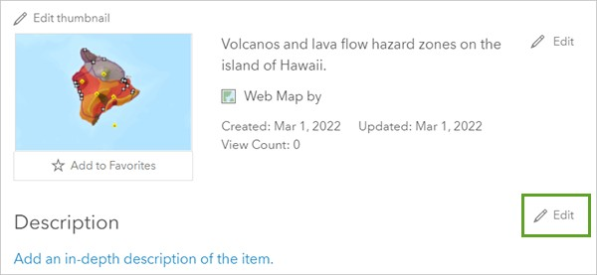

1. In the **Edit Description** box, type (or copy and paste) the following text: The classification of lava flow hazard zones on the island of Hawaii was made by the United States Geological Survey in 1974. The risk levels are based on the location and frequency of historic eruptions.

### Tip:

If you copy and paste the text, it may be formatted in the description box. You can remove the formatting by highlighting the text and clicking the **Remove Format** button on the **Description** toolbar or paste with no formatting by pressing Ctrl+Shift+V .

1. Click **Save**.

Your map is saved to your content and its item details are updated.

You've almost re-created the appearance of the map you explored earlier. Next, you'll add a layer of emergency shelters from a .csv file.

# Add a layer from a .csv file

Previously, you became familiar with the locations of volcanoes and high-hazard lava flow zones on the island of Hawaii. For planning purposes, it might be useful to know where these areas are in relation to highways (which are already on your map) and emergency shelters (which are not).

A lot of information that is potentially spatial in nature is locked away in spreadsheets and text files. If this information is properly formatted, it can be added to ArcGIS and turned into map layers. All you need are well- defined street addresses or pairs of latitude-longitude coordinates.

## Download and view a .csv file

Next, you'll add a .csv file of emergency shelter addresses to your map. A .csv (comma-separated values) file stores table data in a plain text format. It's an import/export format commonly supported by spreadsheet and database applications.

1. Go to the [Get Started with Map Viewer Classic group](http://www.arcgis.com/home/group.html?id=95b198caf94b4c9486f379043e08c5b3).

### Caution:

If you didn't create an ArcGIS organizational account to save your work in the previous lesson, be sure to keep your map open. If you close your map, you may lose your work.

1. Click the **Hawaii Emergency Shelters CSV** thumbnail to download the file.

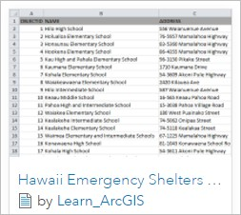

Depending on your browser, the .csv file may appear on your downloads bar or you may be prompted to open or save the file.

1. Open the file with your default application for opening .csv files, such as Microsoft Excel.
2. 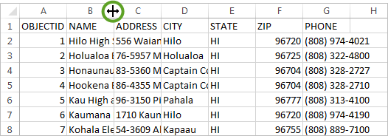If necessary, widen the columns by dragging or double-clicking their edges.

Each row in the table represents an emergency shelter. (On the island of Hawaii, most shelters are schools.) The address columns allow the table to be interpreted as spatial data.

If you're viewing the file in a text editor, you'll see the same information formatted as text separated by commas. ArcGIS will accept it either way.

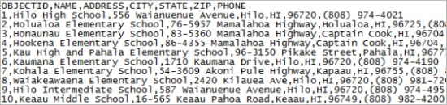

1. In the application in which the .csv file is open, click the **File** menu and choose **Save As**. Save the file as

EmergencyShelters.csv to a location on your computer.

1. If the file is open in Microsoft Excel, you'll be asked whether you want to keep the workbook in CSV format. Click

**Yes**.

1. Close the application in which the .csv file is open. (If you're prompted to save changes again, click **Don't Save**.)

## Add the .csv file as a layer

You can get .csv files from many other public servers or convert them from other file types. You can also make them by copying and pasting information from web pages or other sources.

1. Return to the browser window with your Hawaii map.

### Note:

If you created an account and saved your map, you can open your map from the **My Content** tab of the content page.

1. On the ribbon, click the **Add** button and choose **Add Layer from File**.

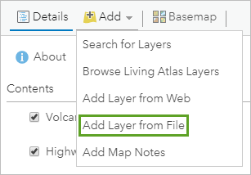

1. In the **Add Layer from File** window, click **Choose File** (or your browser's equivalent command). Browse to the location where you saved EmergencyShelters.csv.
2. Click the file to select it and click **Open**.
3. In the **Add Layer from File** window, click **Import Layer**.

### Tip:

You can also drag a file directly into a web map from your computer.

When you add a .csv file with location information (street addresses or coordinates), the features are located on the map. If you add a .csv file that doesn't contain location information, a table is added instead. In this case, the file is recognized as containing street addresses.

In the table, the **Field Name** column lists the field names (column headings) from the .csv file. In the **Location Fields** column, these field names are matched to appropriate categories of address information for the specified country. The **ADDRESS** field, for example, is correctly interpreted as containing street addresses. The **CITY** field is correctly interpreted as containing city names.

1. Click **World** and choose **United States**.

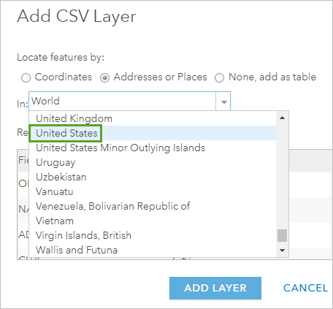

1. Scroll to the bottom of the window to confirm all the field names are being interpreted correctly.

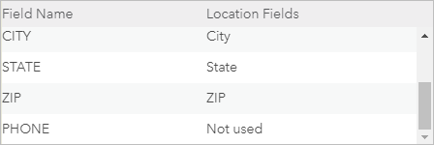

### Tip:

Your .csv file may contain street addresses stored under field names that aren't recognized as address fields. You can apply the interpretation yourself by clicking the value for **Location Fields** next to the field name and choosing the appropriate location information from a drop-down list.

1. Click **Add Layer**.

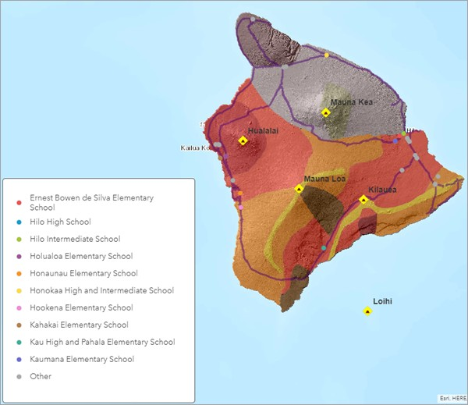

On the map, a point symbol is drawn at the address of each shelter. Most of the shelter locations are schools, which is common for emergency shelters because they have space for many people. In the legend, you can see the name of the shelter. By default, the points are assigned unique colors based on their name. Other drawing options are shown in the **Change Style** pane.

For this map, the individual names aren't important. You're interested in the shelters as shelters, so you want to give them all the same symbol.

1. In the **Change Style** pane, under **Select a drawing style**, for the **Location (Single symbol)** style, click **Select**.

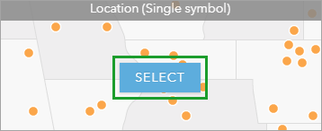

In the **Change Style** pane, the **Location (Single symbol)** style now has a check mark to show that it's selected. On the map, the shelters are drawn with a single symbol.

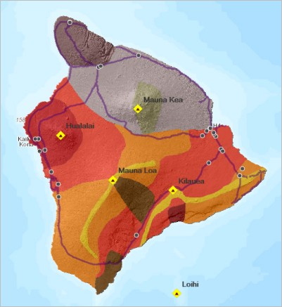

In the next section, you'll apply a different symbol that more specifically represents emergency shelters, but this symbol will do for the moment.

1. At the bottom of the **Change Style** pane, click **Done**.
2. In the **Contents** pane, point to the **Emergency Shelters** layer. Click the **More Options** button and choose

**Rename**. Rename it Emergency Shelters with a space between the words.

## Symbolize the shelters

You'll change the default symbol to something that better represents emergency shelters.

1. In the **Contents** pane, point to the **Emergency Shelters** layer and click the **Change Style** button.

In the **Change Style** pane, the currently selected drawing style is **Location (Single symbol)**. This is the style you selected in the last section.

1. For the **Location (Single symbol)** drawing style, click **Options**.

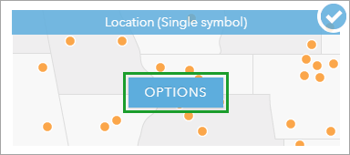

1. Under **Showing Location Only**, click **Symbols** to change the symbol.

A symbol palette appears, showing a variety of symbols that belong to the default Shapes category of symbols. ArcGIS also has many other symbol categories.

1. Click the arrow next to **Shapes** and choose the **National Park Service** category.

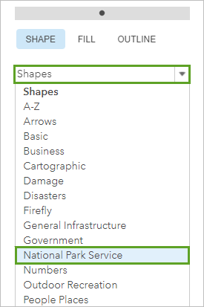

1. In the **National Park Service** category, find the symbol with a white cross on a black background and click it to select it.
2. 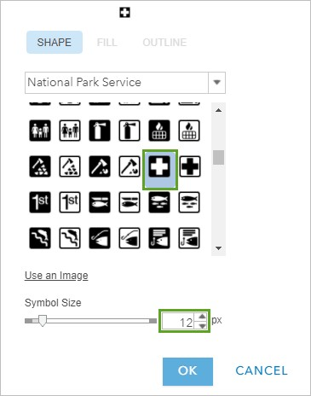Change the symbol size to 12 px (pixels) and click **OK**.

The symbols are updated on the map.

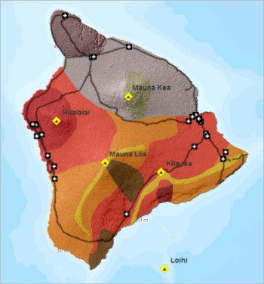

1. In the **Change Style** pane, click **OK** and click **Done**.

The new symbols are intuitively recognizable as emergency shelters. Their strong black and white colors help them stand out from the reds and oranges of the hazard zones.

You've added a layer of emergency shelters from a .csv file. When you explored the **Hawaii Lava Flow Risk** map in the first lesson, you began by opening pop-ups for the volcanoes and lava flow hazard zones. Configuring pop-ups to present useful information is an important part of making good maps. Next, you'll configure the pop-ups.

# Configure pop-ups

Previously, you worked with many different layer properties. An important layer property that you haven't worked with is pop-up configuration. With pop-ups, you can provide relevant and contextual information for your data.

## Configure emergency shelter pop-ups

Earlier when you explored the web map, the pop-ups for the Volcanoes and Lava Flow Hazard Zones layers were prepared for you. Next, you'll see how those configurations were done. You'll start, however, by working on the pop-ups for the Emergency Shelters layer.

1. If necessary, open your Hawaii map.
2. Click a shelter to open its pop-up.

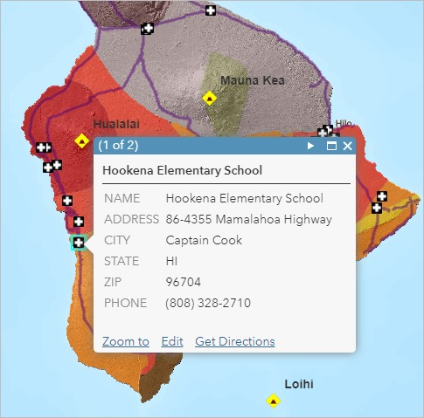

The basic configuration of a pop-up is just what you see: a list of fields and values. The information should be familiar to you because it comes straight from the .csv file. Most pop-ups are essentially stylized views of a table of attributes associated with a layer.

In this case, the default configuration has a few minor problems. For example, the shelter name appears twice: first as the pop-up title, and again in the list of fields. Also, it's probably unnecessary to show the state name—anyone using the map will know that this is Hawaii.

1. Close the pop-up.
2. In the **Contents** pane, point to the **Emergency Shelters** layer, click the **More Options** button, and choose

### Configure Pop-up.

The default pop-up title is a field name, usually the **NAME** field, in braces. Field names in braces work like variables: when you click a shelter on the map, you see the name of that particular shelter.

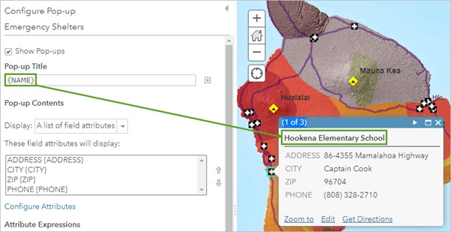

Under the **Pop-up Contents** heading, the **Display** property is set to **A list of field attributes** and represents the list format that you saw in the pop-up that you opened earlier.

1. Under the list of attributes, click **Configure Attributes**.

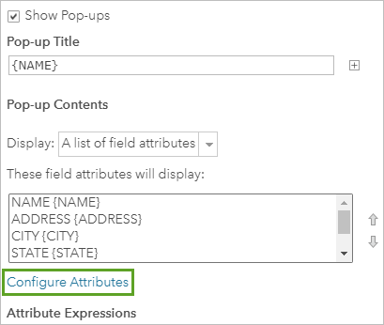

In the **Configure Attributes** window, attributes are listed by their display status (on or off), field name, and field alias.

1. In the **Display** column, uncheck the box for the **{NAME}** field.

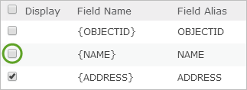

1. Uncheck the **Display** box for the **{STATE}** field and click **OK**.
2. At the bottom of the **Configure Pop-up** pane, click **OK**.
3. On the map, click an emergency shelter to see its updated pop-up.

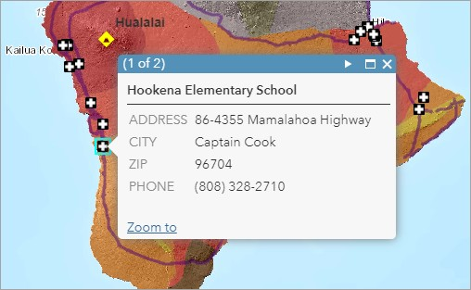

The fields that you unchecked in the **Configure Attributes** window no longer display in the pop-up.

1. Close the pop-up.

## Explore pop-ups for other layers

You'll look again at pop-ups for the other layers in the map.

1. Click a lava flow hazard zone on the map to open its pop-up.

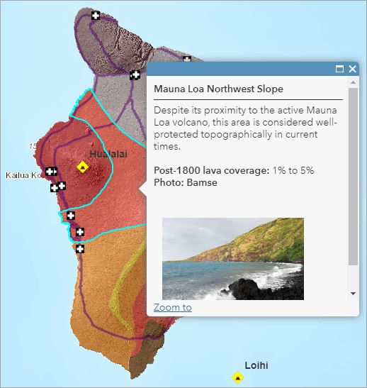

The pop-ups for this layer are configured just as they were in the map you explored in the first lesson. The layer owner has saved this configuration as a default property of the layer. You don't need to do anything with it.

1. Click a highway.

Pop-ups for the Highways layer have been turned off. You can open pop-ups for lava flow hazard zones underneath highways, but not for highways themselves.

1. In the **Contents** pane, point to the **Highways** layer, click the **More Options** button, and choose **Enable Pop-up**.

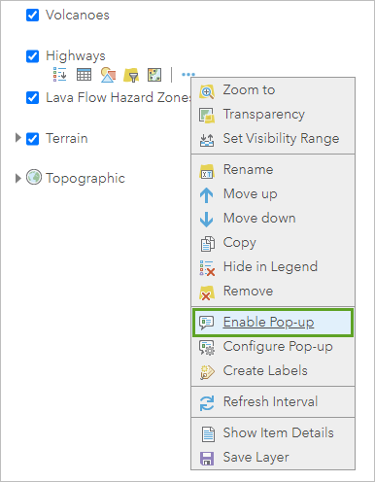

1. Click a highway again.

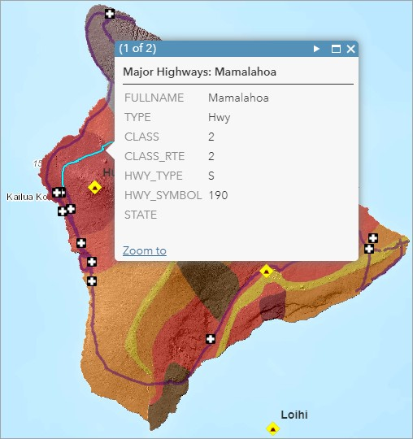

The pop-up isn't clearly configured. You could improve it, but it's not necessary. Map layers that are used for general reference or background may be better off without pop-ups.

1. Close the pop-up.
2. In the **Contents** pane, point to the **Highways** layer. Click the **More Options** button and choose **Remove Pop- up**.
3. Click a volcano feature to open its pop-up.

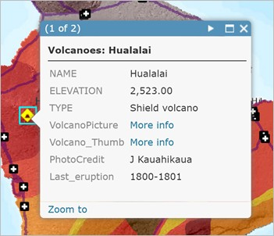

The Volcanoes layer doesn't have the same configuration that you saw earlier. That configuration was saved in the map, but it was not saved as a default property of the layer. So now you see a more typical list of fields and values. It will take some effort on your part to make the pop-up look good again.

With the Emergency Shelters layer, you saw that the information in the pop-up came directly from the .csv file. The same is true for other layers: their pop-ups are formatted presentations of table data.

1. In the **Contents** pane, point to the **Volcanoes** layer and click the **Show Table** button.

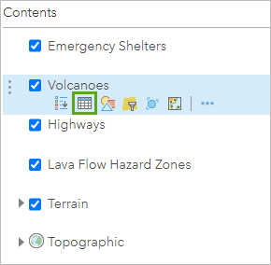

The information in the table matches the information in the pop-up.

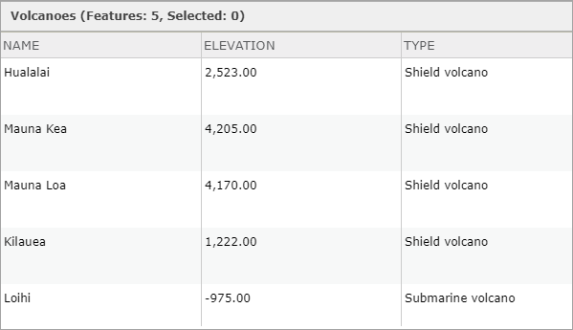

In the table, two of the fields have URLs as values. URLs enable pop-ups to display images and other web resources. In the default pop-up configuration, these URLs are represented by **More info** links.

1. Close the table.

## Configure volcano pop-ups

Configuring pop-ups is the process of specifying which information from a layer's table is shown in the pop-up and how that information is displayed. Part of this process involves formatting attribute names and values. Part of it involves choosing a pop-up style: information can appear in a list, for example, or in a customized paragraph form. The final part involves enhancing the pop-up with images, charts, and links.

1. In the **Contents** pane, point to the **Volcanoes** layer, click the **More Options** button, and choose **Configure Pop-up**.
2. In the **Pop-up Title** box, delete any text before the **{NAME}** field.

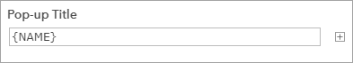

The title will now show only the volcano name, not the layer name as well.

1. In the **Pop-up Contents** section, keep the display set to **A list of field attributes**. Below the list of attributes, click **Configure Attributes**.

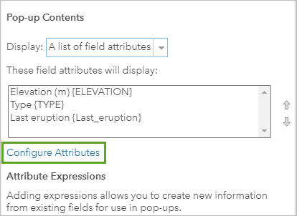

1. In the **Configure Attributes** window, uncheck the **Display** boxes for the following fields:

### {NAME}

### {VolcanoPicture}

### {VolcanoThumb}

### {PhotoCredit}

The **{NAME}** field doesn't need to be displayed because it's already used in the pop-up title. The other three fields will be used in the **Pop-up Media** section. Only the **{ELEVATION}**, **{TYPE}**, and **{Last_eruption}** fields should be checked to display.

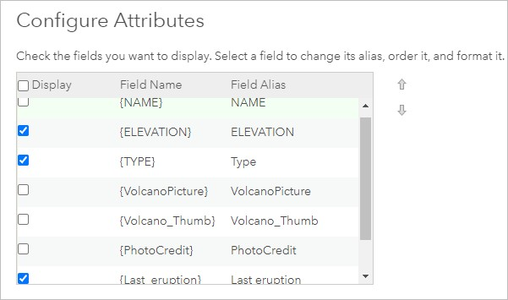

1. In the **Field Alias** column, click **ELEVATION** to make the text editable. Replace it with Elevation (m).
2. On the right side of the window, change **Format** to **0 decimal places**.

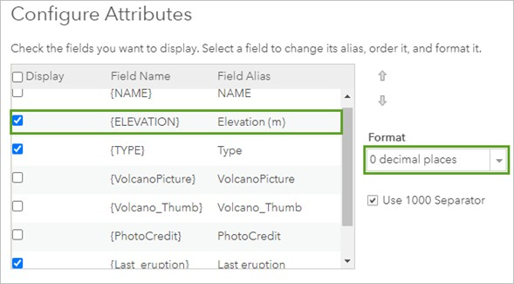

An alias is a display name that replaces the field name in the pop-up. By default, the alias and field names match, but you can change the alias to something more informative or familiar. In this example, the parenthetical m means that the values are in meters—this may not be self-explanatory, and you can use a more descriptive alias if you want.

1. In the **Field Alias** column, click **TYPE**. Replace it with Type and press Enter . Double-click the **Field Alias**

named **Last_eruption**, type Last eruption, and press Enter .

1. Again in the **Field Alias** column, scroll down and click **Last_eruption**. Replace it with Last eruption and press

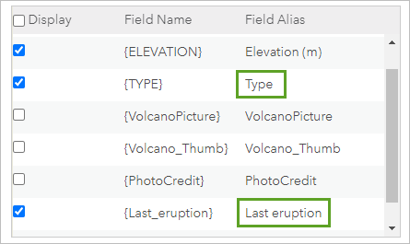

Enter .

Changing case and replacing underscores with spaces are small improvements to the pop-up display.

1. Click **OK**.

Now you'll configure the thumbnail image to display in the pop-up window and link to the large captioned image.

1. In the **Configure Pop-up** pane, under **Pop-up Media**, click **Add** and choose **Image**.

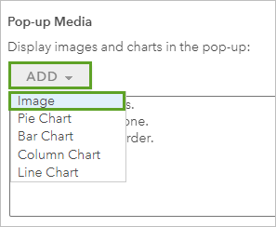

1. In the **Configure Image** window, delete the default title (Image 1). Type Photo: in its place, and press

Spacebar .

1. To the right of the **Title** box, click the **Add field name or expression** button. In the list of fields, scroll down and choose **PhotoCredit {PhotoCredit}**.

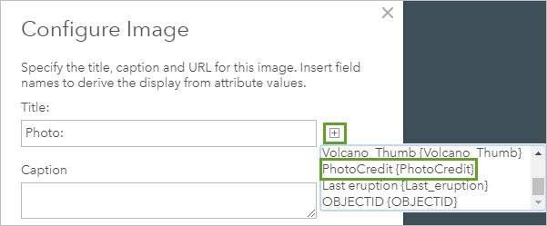

Remember that field names work like variables. In the media part of each pop-up, the correct photographer's name will appear.

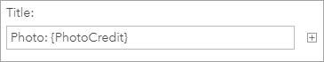

### Note:

When you use the **Add field name or expression** button, the list shows both the field name and its alias. When these are the same, as they are by default, you see entries such as **PhotoCredit {PhotoCredit}**.

1. For **Caption**, type Click image to learn more.
2. For **URL**, click the **Add field name or expression** button. In the list of fields, scroll down and choose

### Volcano_Thumb {Volcano_Thumb}.

The **URL** box must contain paths to images that are stored on a publicly accessible server, such as your account on a photo-sharing site. These images will be displayed in the pop-up and, when clicked, will open the items referenced in the **Link** box.

1. For **Link**, click the **Add field name or expression** button. Scroll down and choose **VolcanoPicture**

### {VolcanoPicture}.

Unlike the **URL** box, the **Link** box doesn't have to refer to images, although it does in this case. It can go to web pages, PDFs, or any resource with a URL.

The **Configure Image** window is configured.

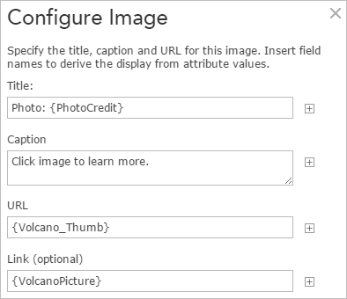

1. Click **OK**.
2. In the **Configure Pop-up** pane, click **OK**.
3. On the map, click a volcano.

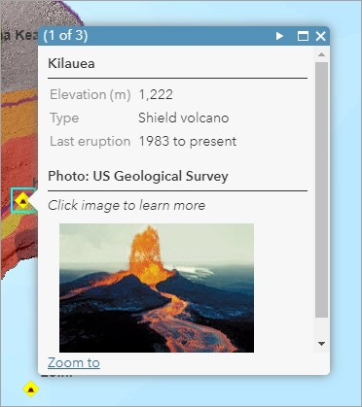

The pop-up reflects your configuration—some text formatting, along with the horizontal separator lines, is applied automatically.

1. Click the thumbnail image to test the link. Close the browser tab or window when you are done reviewing the larger picture.
2. Open pop-ups for some other volcanoes.
3. When you’re finished, close any browser tabs or windows with large volcano pictures. Close the open pop-up on the map.
4. On the ribbon, click the **Bookmarks** button and click the **Island of Hawaii** bookmark.

Your map is complete. Next, you'll acquire an ArcGIS organizational or public account and publish your map as a web mapping app. A web app allows you to customize the appearance and functionality of your map to create an professional user experience.

# Make an app

You can add value to your map by publishing it as a web app. A web app is a customized user interface that enhances your map's appearance, adds (or removes) functionality, and helps you integrate the map with other media. You can choose from several predefined configurable templates, or use ArcGIS Web AppBuilder to design your own.

Next, you'll publish your lava flow risk zone map in the **Basic** template. This web app allows you to choose color schemes, add descriptive text, and decide which map tools you want to make available to users. To create a web app, you'll need either an ArcGIS organizational account or a public account to save and share your map. You can sign up for a free trial account if you do not have one. Before you create the app, you will save the Emergency Shelters layer into your content, because it is currently only saved in the web map but not as its own item.

## Save the shelters as a layer

The Emergency Shelters layer exists in your map but nowhere else. Nobody would be able to find it, for instance, by searching the organization's layers. By saving it as a layer to **My Content**, you can share it and add it to other maps. You'll be its owner, and the properties you give it will be its defaults. When someone else adds the layer to a map (assuming you share it), it will display with the symbology you chose.

1. Near the top of the item page, click **Open in Map Viewer Classic**.

### Note:

If you do not see the **Open in Map Viewer Classic** option, click the drop-down arrow and choose **Open in Map Viewer Classic**.

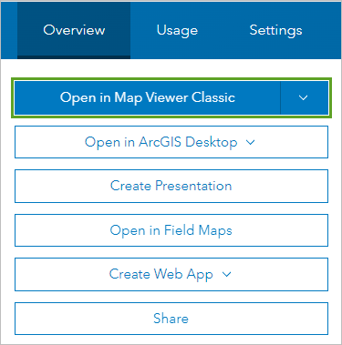

1. In the **Contents** pane, point to the **Emergency Shelters** layer, click **More Options**, and choose **Save Layer**.

### Note:

This menu choice is only available for layers that you've created. You won't see it in the properties for other layers in this map. (If you're an administrator of the organization that owns the content, you'll also see this menu choice.)

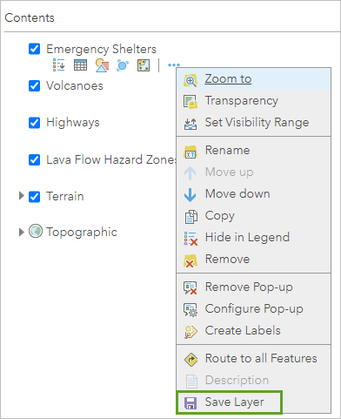

1. In the **Create Item** window, for **Title**, add your initials at the end of **Emergency Shelters** so the layer is named

### Emergency Shelters_yn.

1. For **Tags**, type emergency and press Enter , type shelters and press Enter , and type Hawaii and press

Enter .

1. For **Summary**, type or copy and paste Emergency shelter locations on the island of Hawaii.

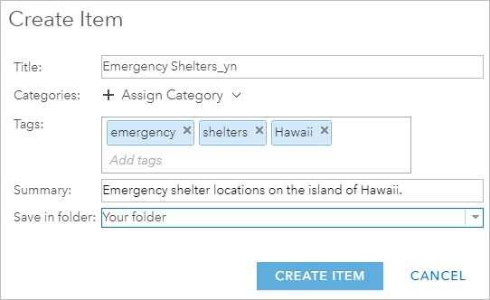

1. Click **Create Item**.
2. Save the map.
3. At the top of the page, click **Home** and choose **Content**.

The **My Content** page appears and the Emergency Shelters layer you just created is visible.

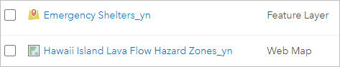

## Create a web app

Now, you'll create your web app. The first step is to share your map so others can see it.

1. Open your **Hawaii Island Lava Flow Hazard Zones** web map.
2. On the ribbon, click the **Share** button.



1. In the **Share** window, for **Choose who can view this map**, click **Your Organization**. You can also choose

**Everyone (public)** if you want share it with everyone.

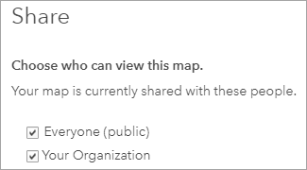

### Tip:

If you want to share the map through social media accounts such as Facebook or Twitter, share it with everyone.

1. If necessary, click **Update Sharing** to adjust the settings of the listed layer so it can be viewed in the web map.

### Note:

If you are not prompted to update the sharing, you can move to the next step

Now that the map is shared, you'll make the web app.

1. In the **Share** window, click **Create a Web App**.

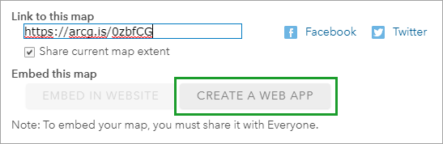

The **Create a New Web App** window appears, presenting a gallery view of the available templates. Some are designed for specific purposes; others are for general use.

The templates are in alphabetical order. You can use the scroll bar to review the full gallery, or you can filter the templates by using the tabs on the left or the search box at the top.

1. In the side menu, click **Showcase a Map**.

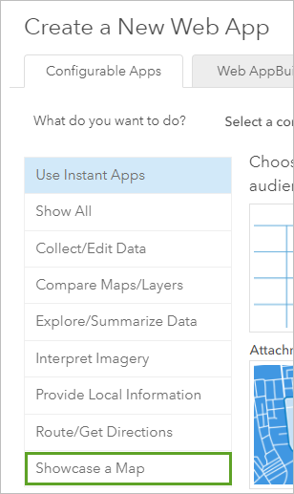

### Note:

If your organization has configured custom galleries, you may not see these same configurable apps.

1. Click the **Basic** template.

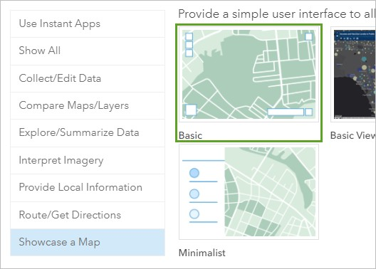

1. Click **Create Web App**.

It won't be a problem that the web app has the same title as the map it's based on, because the two items are of different types.

1. Accept the default title and add the initials for your name after it. For **Tags** and for **Summary**, type a brief description of the app.

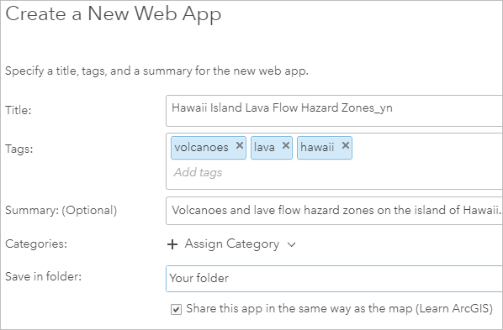

By default, the web app is given the same sharing properties and **Title** as the web map. You are including your initials to ensure unique names for the items that you share.

1. Click **Done**.

The Instant Apps **Configuring** window appears.

1. If necessary, close the **Welcome to the app setup** page. The **Configuring** window shows a preview of the app.

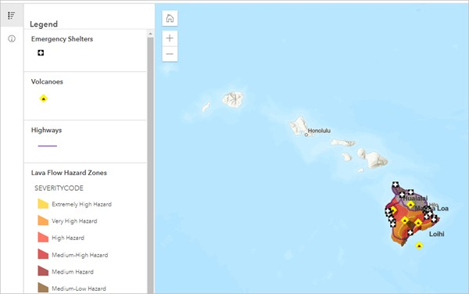

## Configure the app

The app opens and shows the Express mode. Express mode shows only the most essential settings to consider for your app. You can change the web app's configurable properties to give your app the look and feel that you want.

Some of these properties, such as the title, theme, and text color, have default settings. In this section, you'll make changes to some of these settings.

1. In the **Express** pane, click **Step 1. Map**.

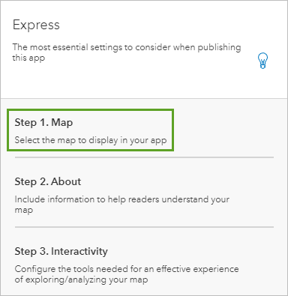

You can see the web map that is used in the app. If you want to use a different map, you can change it here.

1. Leave the default setting for the title, or type a new title of your own.

The **About** panel gives a short description of the map. This text comes from the item summary you created for the web map. You can override this text.

1. Scroll down to the **Map accessibility** section, and for **Map description**, copy and paste the following text: This map contains volcano locations, lava hazard zones, highways, and emergency shelters for the island of Hawaii.

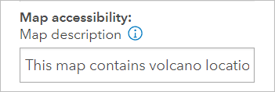

1. Above the web map thumbnail, click **View item details**.

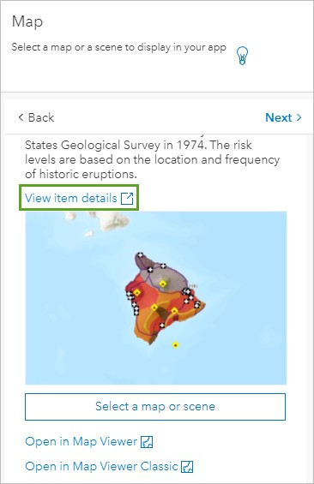

The item details page for your web map appears.

1. For **Description**, click **Edit**.
2. Place your cursor after the last sentence and press Enter twice. Paste the following text: Click a map feature, such as a volcano, shelter, or hazard zone, for more information.
3. Highlight the sentence you just typed and click the **Italic** button to italicize the sentence. Click some white space to deselect the text.

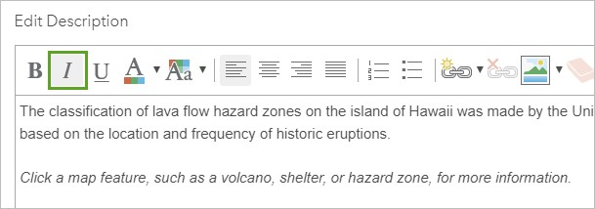

1. In the first line of text, highlight the word classification. On the toolbar, click the **Create Link** button.

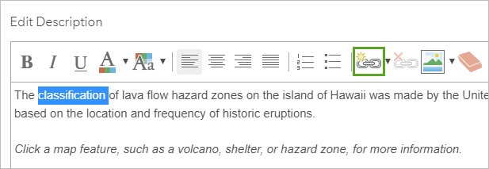

1. 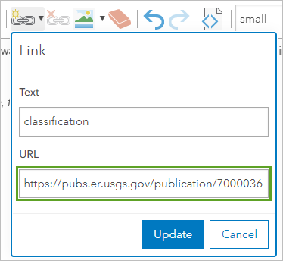In the **Link** box, for **URL**, copy and paste https://pubs.er.usgs.gov/publication/7000036.

This link will take the user to a United States Geological Survey page that describes the hazard zones in more detail.

1. In the **Link** box, click **Update**.

When you update the link, the text for classification appears as a hyperlink.

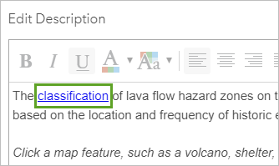

1. Click **Save**.
2. Return to the browser tab that has your web app in it. In the **Express** pane, click **Next**.

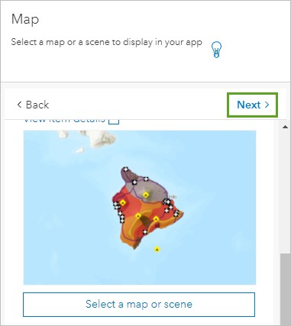

The next panel shows the legend that will display. This is what you want, so you will go to the next panel.

1. Click the **Next** button.

The purpose of your web app is to inform people about volcanoes and areas of lava flow risk. They probably don’t need to look for specific addresses or places on the map. You'll disable the search options.

1. In the **Source** section, for **ArcGIS World Geocoding Service**, under **Edit**, click the options button. Click **Delete**.

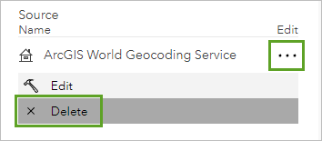

1. Click **Next**. For **Select a theme**, choose **Dark**.

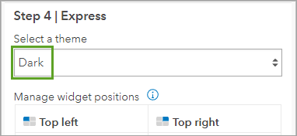

In the **Manage widget positions** section, notice that the widget placement in the panel matches the widget placement in the app preview.

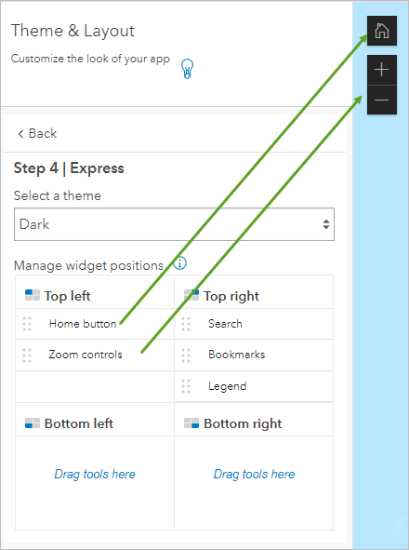

1. At the bottom of the **Express** pane, click **Publish** and click **Confirm**.

The preview of your configured web app updates to show your changes. The **About** panel takes up a lot of space on the map, and the legend is hidden. You'll change the layout so the legend appears when you first open the app.

1. In the **Share** window, click **Launch**.

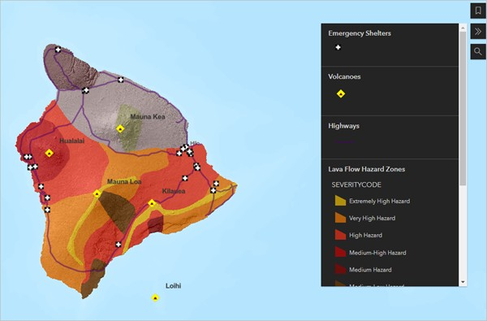

1. At the bottom of the **Express** pane, click **Exit** twice.

You're taken to the web app's item page.

## Edit the app's item details

The item title, summary, and tags are already completed from when you created the web app. You will update some information for your app.

1. On the item details page, for **Terms of Use**, click **Edit** and type None. Public domain data and images.

Click **Save**.

1. In the lower side of the page, for **Credits (Attribution)**, click **Edit** and type Hawaii State GIS Program; United States Geological Survey.

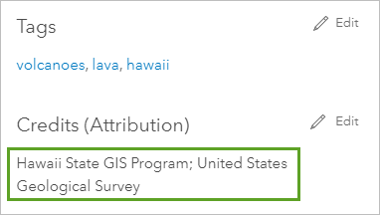

1. Click **Save**.

### Tip:

If you later decide to make changes to the way the web app is configured, open this item page and click

### Configure App.

## View the app

Next, you'll explore the app you created.

1. At the top of the item page, click the thumbnail image to open the application. You can also click **View Application**.

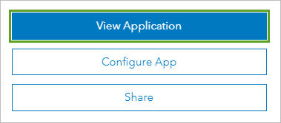

1. Explore the app by navigating the map and opening pop-ups.

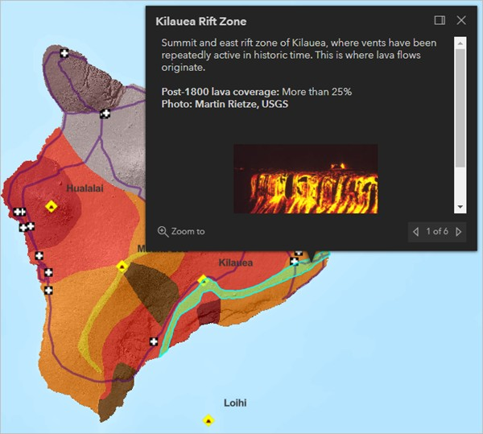

The pop-ups behave the same in the web app as they do in the web map.

1. Click the **Default map view** button to return to the original view of the map.

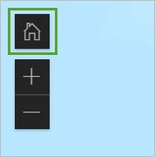

### Note:

Any changes you make to the source web map, such as adding or removing layers, changing symbology, or configuring pop-ups, will be reflected automatically in the app. If you change the sharing properties of the map (or if you delete it), this will affect the app as well.

## Make a thumbnail image

The last thing to do is replace the default generic thumbnail image in the item details with one that shows your app.

1. Capture an image of the app with your image editing software.

### Tip:

If you're not sure how to do that, capture the image with the PrtScr key on your keyboard and paste it into the Windows Paint accessory. In Windows 7, you can open Paint by clicking **Start** > **All Programs** > **Accessories**.

1. Resize the image to a width of 600 pixels, but don't alter the aspect ratio.

### Tip:

The ideal aspect ratio is 3:2. When the image width is 600 pixels, the height should be about 400 pixels. If your height value is substantially different, crop the image to avoid distortion in the thumbnail.

1. Save the image in PNG file format to a folder on your computer.
2. Return to the web app's item details page.
3. Above the default thumbnail image, click **Edit Thumbnail**.

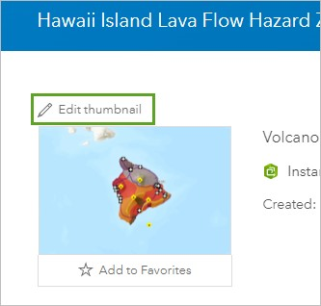

1. In the **Create Thumbnail** window, click **Browse** (or your browser's equivalent command). Browse to the folder where you saved the thumbnail and upload the image, select the image, and click **Open**. Click **Save**.

The new thumbnail image appears.

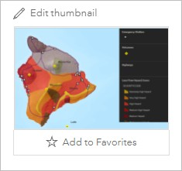

You now know how to make a map, add layers to it, create your own layers from file-based data, configure pop-ups, and publish your map as a web app and share your work with others.

You can find more lessons in the [Learn ArcGIS Lesson Gallery](http://learn.arcgis.com/en/gallery/).