Creating STEM Contents: Solar Power with a Tracking System

Leo Predanic

George Thuita

Brandon Cenci

**Execution and Validation**

REVISION – 1

4 December 2022

Execution and Validation

for

Creating STEM Contents: Solar Power with a Tracking System

Prepared by:

_____________________________

Author Date

Approved by:

_____________________________

Project Leader Date

_____________________________

John Lusher, P.E. Date

_____________________________

T/A Date

**Change Record**

| **Rev.** | **Date** | **Originator** | **Approvals** | **Description** |
| --- | --- | --- | --- | --- |
| **-** | 10/3/2022 | Leo Predanic, George Thuita, Brandon Cenci |  | Draft Release |
| **1** | 12/4/2022 | Leo Predanic, George Thuita, Brandon Cenci |  | Improved figures for execution and validation plans |

**Table of Contents**

**Table of Contents** **42**

**List of Tables** **43**

**1.** **Execution Plan 44**

**2.** **Validation Plan 45**

**List of Figures**

**Figure** **1.** **Execution Plan 44**

**Figure 2. Validation Plan 45**

# Execution Plan

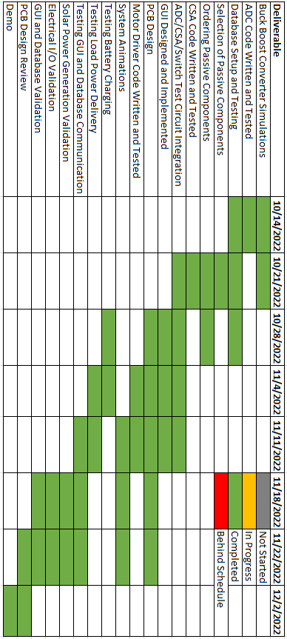

**Figure 1:** Execution Plan

# Validation Plan

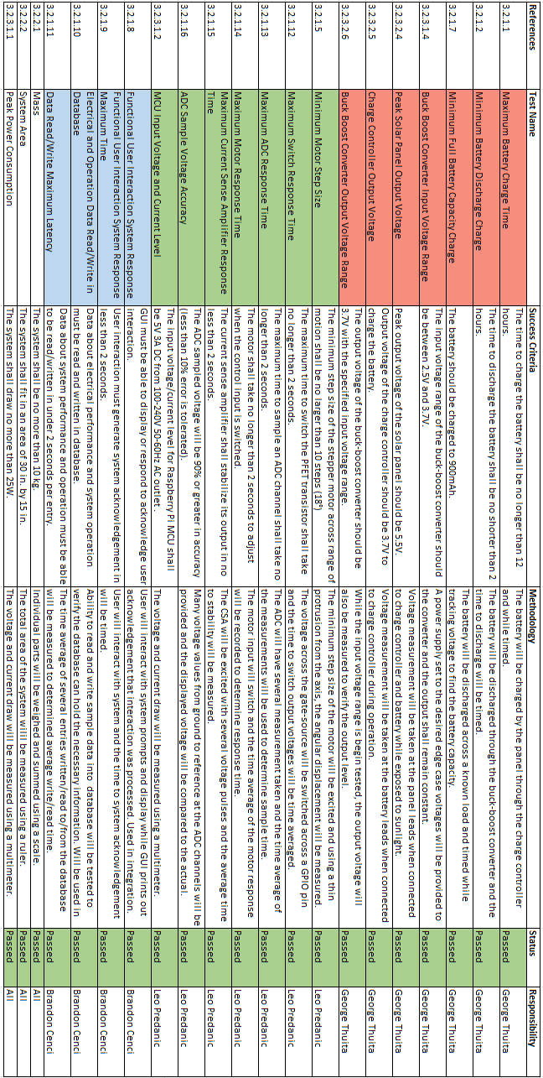

**Table 2:** Validation Plan