Creating STEM Contents: Solar Power with a Tracking System

Leo Predanic

George Thuita

Brandon Cenci

**Functional System Requirements**

REVISION – 1

4 December 2022

Functional System Requirements

for

Creating STEM Contents: Solar Power with a Tracking System

Prepared by:

_____________________________

Author Date

Approved by:

_____________________________

Project Leader Date

_____________________________

John Lusher, P.E. Date

_____________________________

T/A Date

**Change Record**

| **Rev.** | **Date** | **Originator** | **Approvals** | **Description** |
| --- | --- | --- | --- | --- |
| **-** | 10/3/2022 | Leo Predanic, George Thuita, Brandon Cenci |  | Draft Release |
| **1** | 12/4/2022 | Leo Predanic, George Thuita, Brandon Cenci |  | Adjusted page numbers, specifications, and figures |

**Table of Contents**

**Table of Contents** **14**

**List of Tables** **15**

**List of Figures** **16**

**1.** **Introduction** **17**

1.1. Purpose and Scope **17**

1.2. Responsibility and Change Authority **17**

**2.** **Applicable and Reference Documents** **18**

2.1. Applicable Documents **18**

2.2. Reference Documents **18**

2.3. Order of Precedence **18**

**3.** **Requirements** **18**

3.1. System Definition **18**

3.2. Characteristics **20**

3.2.1. Functional / Performance Requirements **20**

3.2.2. Physical Characteristics **2****2**

3.2.3. Electrical Characteristics **23**

3.2.4. Environmental Requirements **25**

3.2.5. Failure Propagation **25**

**4.** **Support Requirements 26**

**Appendix A Acronyms and Abbreviations** **27**

**Appendix B Definition of Terms** **28**

**Appendix C Interface Control Documents** **28**

**List of Tables**

**Table** **1.** **System Partition 17**

**Table 2. Applicable Documents 18**

**Table 3. Reference Documents 18**

**List of Figures**

**Figure 1. Project Conceptual Image** **17**

**Figure 2. Block Diagram of System** **19**

**Figure** **3. System Flow 20**

# Introduction

## Purpose and Scope

As the demand for engineering solutions increases exponentially, it is imperative to inspire future generations of STEM students by creating captivating demonstration tools to drive their interest and creativity. The goal of this system is to foster this latent interest by being a simple and portable apparatus that is interactable and tracks the system’s performance by displaying the information in a digestible format for K-12 students. The Creating STEM Contents (CSC) system will contain a solar power generation solution to drive a physical load that generates visual, tactile, or aural excitations. The system will have an MCU to take various analog measurements and process it to provide relevant data about the system’s performance. The MCU will store information into a database where a GUI can read in the data and display figures and animations about system operation. The GUI will also feature interactive controls to set operation modes and control the circuitry. This allows through explanation of the concepts of solar power, electronics, and computer science to the target audience.

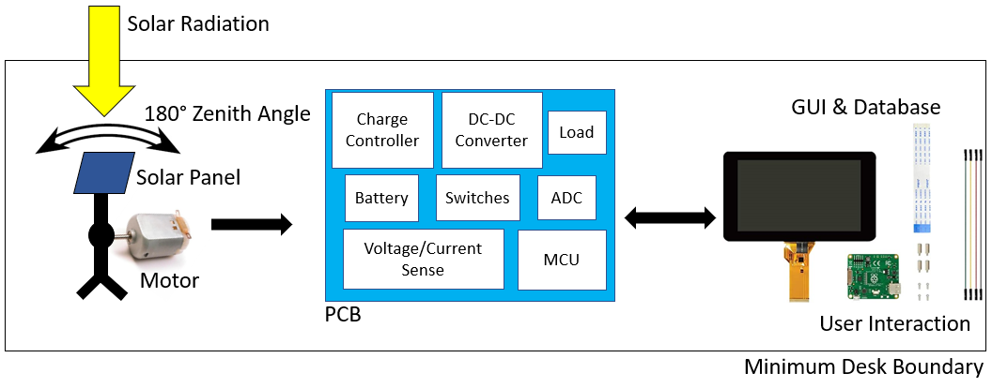

**Figure 1:** Project Conceptual Image

## Responsibility and Change Authority

The team leader, Leo Predanic, will be responsible for verifying the requirements of the project have been satisfied and will track progress. The requirements can only be changed with the approval of the team leader and Doctor Wonhyeok Jang.

**Table 1:** Subsystem Partition

| **Subsystem** | **Manager** |
| --- | --- |
| Solar Power Generation | George Thuita |
| Electrical I/O | Leo Predanic |
| GUI and Database | Brandon Cenci |

# Applicable and Reference Documents

## Applicable Documents

The following documents, of the exact issue and revision shown, form a part of this specification to the extent specified herein:

**Table 2:** Applicable Documents

| **Document Number** | **Revision/Release Date** | **Document Title** |
| --- | --- | --- |
| NEMA 1 | 2001 | Enclosure, Box, & Cabinet - Rating and Definition |
| NEC 210.52(E)(1)-(3) | 2009 | Outdoor Outlets. |

## Reference Documents

The following documents are reference documents utilized in the development of this specification. These documents do not form a part of this specification and are not controlled by their reference herein.

**Table 3:** Reference Documents

| **Document Number** | **Revision/Release Date** | **Document Title** |
| --- | --- | --- |
| IEC 60086-4 | 5/1/2020 | Primary Batteries. Safety Standard for Lithium Batteries. |
| UL 1642 | 9/29/2020 | Safety of Lithium-Ion Batteries - Testing. |
| ASTM E927-19 | 2/25/2019 | Standard Classification For Solar Simulators For Electrical Performance Testing Of Photovoltaic Devices. |

## Order of Precedence

In the event of a conflict between the text of this specification and an applicable document cited herein, the text of this specification takes precedence without any exceptions.

All specifications, standards, exhibits, drawings or other documents that are invoked as “applicable” in this specification are incorporated as cited. All documents that are referred to within an applicable report are considered to be for guidance and information only, except ICDs that have their relevant documents considered to be incorporated as cited.

# Requirements

## System Definition

The CSC system is a low power, portable solar power system that is used as a demonstration tool for K-12 students to stimulate their latent interest in STEM careers. It has a GUI interface that can interact with a user to control the system as well as track the system’s performance and display that information in a digestible format. Since the system is used as a teaching tool, it will also contain animations that describe the physics and computer science of how the system operates, explaining the engineering concepts that are involved in the operation of the system. The CSC system had three subsystems: Solar Power Generation, Electrical I/O, and the Database, GUI, and System Animations/Aids.

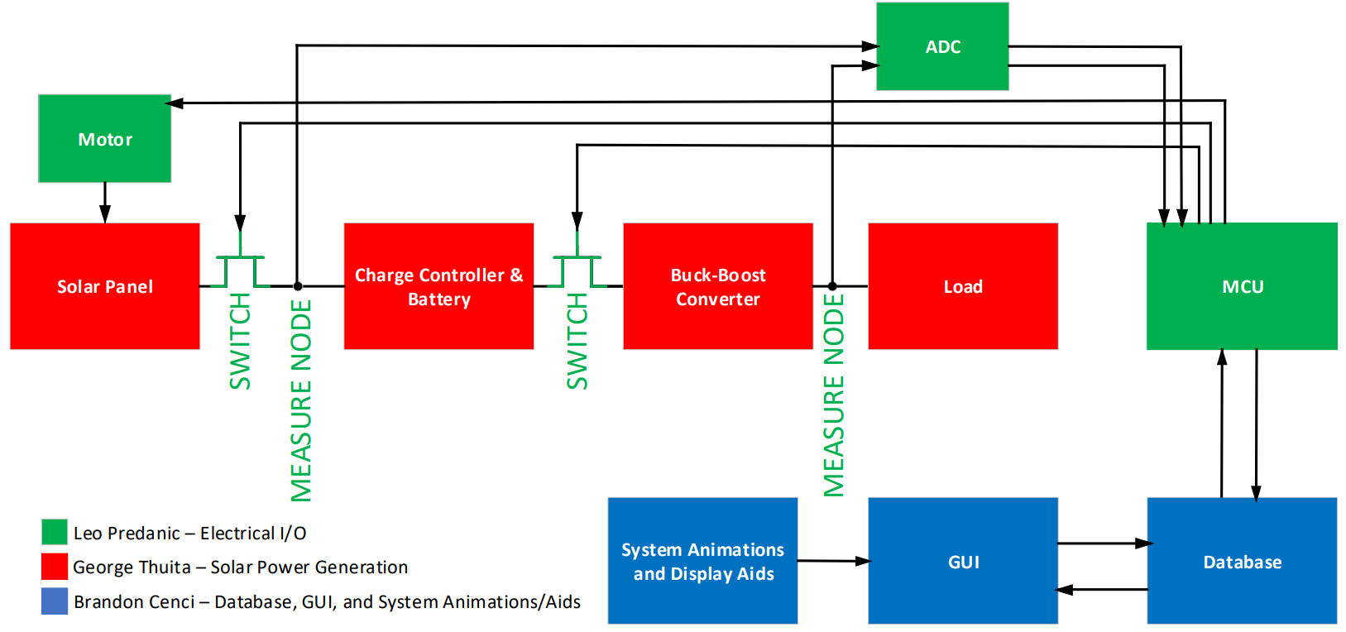

**Figure 2:** Block Diagram of System

There will be a solar panel that will generate electricity from solar energy. Since the system can’t use the power directly from the panel, it will have to charge a battery. To protect the battery, an MPPT charge controller will be used to control the flow of electricity. Between the panel and the controller will be a FET switch to disconnect the two once the battery has completed charging to avoid damaging the system. A motor will also be connected to the stand which the panel is mounted on to control 180 degree rotation across the zenith angle. The battery will then power a buck boost converter which will drive a load that has a visual, tactile, or aural response to demonstrate the flow of power to the K-12 students. Another FET switch will be between the battery and the converter to avoid involuntary discharge of the battery during charging which could have the potential to damage it. An ADC will take voltage readings at the generator and load side. At this node there will also be a current sense resistor. A current sense amplifier will take the differential voltage across it to measure the current flow. The MCU will take both the voltage and current to compute the power. The MCU will then feed this data into a database stored locally on the MCU. A GUI application will read this data in and display it in a digestible format so that K-12 students can understand what is being measured and how it plays into system performance. To further explain system operation, animations will be designed to explain how the system operates. This allows the system to teach and demonstrate all by itself without the need for a STEM instructor. As long as an individual is trained to maintain the system, it will be an independent teaching tool.

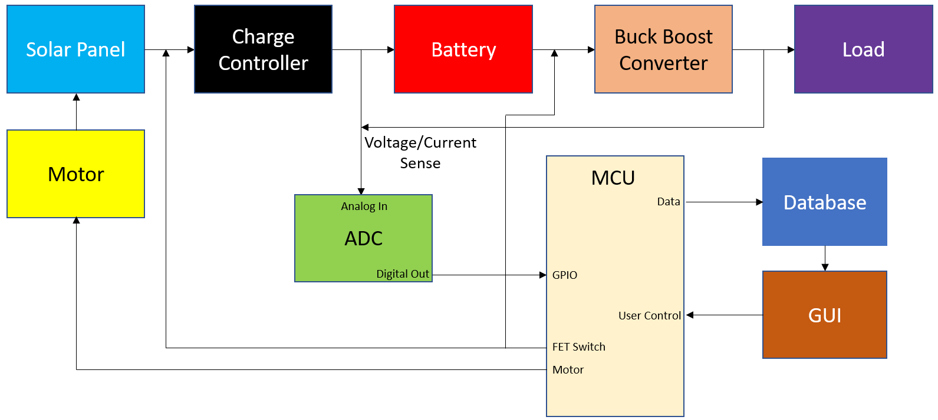

**Figure 3:** System Flow

## Characteristics

### Functional / Performance Requirements

#### System Battery Charge Time

The battery for the system shall take no longer than 12 hours to fully charge.

*Rationale: The system should be charged fully within the day prior to demonstration otherwise it will not meet the portability and speed aspects of the system goals.*

#### System Battery Discharge Time

The battery for the system shall take no sooner than 2 hours to fully discharge.

*Rationale: The system should be fully discharged within a demonstration period to be able to make sufficient use of the system charging mode.*

#### Analog Voltage/Current Generator Side Measurement Timing

The ADC will sample the generator side voltage and current for power tracking no less than 10 times per hour.

*Rationale: Power generation takes a much longer time than power dissipation to prevent unnecessary oversampling and minimize clutter on any power generation figures or graphs that are presented on the GUI.*

#### Analog Voltage/Current Load Side Measurement Timing

The ADC will sample the load side voltage and current for power tracking no less than 50 times per hour.

*Rationale: Power dissipation is expected to take only several hours. To track accurate power curves, the system must sample load side measurements much more frequently than the generator side.*

#### Motor Rotation Discrete Step Sizing

The motor shall have no less than 10 discrete steps across the 180 degrees of rotational freedom.

*Rationale: To have sufficient solar coverage across the zenith angle, the step size should be small enough to follow the sun closely enough to maximize the flux across the surface. This allows the system to maximize the amount of solar radiation captured during Single Axis Operation Mode.*

#### Time for System Response

The time delay between GUI interaction and system response shall be no longer than a minute.

*Rationale: To provide quick feedback to the user about the system performance and operation, the system should be able to communicate from end to end in a reasonable amount of time to be a useful demonstration tool.*

#### Minimum Full Battery Capacity Charge

The battery should be charged to 900mAh.

*Rationale: This is the average charge of the system battery.*

#### Functional User Interaction System Response

GUI must be able to display or respond to acknowledge user interaction.

*Rationale: The system must be able to interact with a user to control system operation.*

#### Functional User Interaction System Response Maximum Time

User interaction must generate system acknowledgement in less than 2 seconds.

*Rationale: This minimizes the time it takes for the user to communicate with the system.*

#### 3.2.1.10. Electrical and Operation Data Read/Write in Database

Data about electrical performance and system operation must be read and written in the database.

*Rationale: This consolidates the location of system data in one location, the database.*

#### 3.2.1.11. Data Read/Write Maximum Latency

Data about system performance and operation must be able to be read/written in under 2 seconds per entry.

*Rationale: This keeps the system operating and providing feedback to the user in short enough time periods not to create high latency between user interaction and system response.*

#### 3.2.1.12. Maximum Switch Response Time

The maximum time to switch the PFET transistor shall take no longer than 2 seconds.

*Rationale: This prevents any large scale transients from occurring when the system switches operation from charging to discharging mode.*

#### 3.2.1.13. Maximum ADC Response Time

The maximum time to sample an ADC channel shall take no longer than 2 seconds.

*Rationale: This minimizes any latency in system measurement to collect accurate data on the time scale that the system needs to charge and discharge.*

#### 3.2.1.14. Maximum Motor Response Time

The motor shall take no longer than 2 seconds to adjust when the control input is switched.

*Rationale: This minimizes any latency to adjust the position of the solar panel to maximize power output in single-axis operation mode.*

#### 3.2.1.15. Maximum Current Sense Amplifier Response Time

The current sense amplifier shall stabilize its output in no less than 2 seconds.

*Rationale: This minimizes any latency in system measurement. Limited mainly by the ADC. See Section 3.2.1.13.*

#### 3.2.1.16. ADC Sample Voltage Accuracy

The ADC sampled voltage will be 90% or greater in accuracy (less than 10% error is tolerated).

*Rationale: To maximize the accuracy of the measurements, the ADC needs to be at least 90% to obtain correct power measurements for the system.*

### Physical Characteristics

#### System Mass

The mass of the CSC system shall be less than or equal to 10 kg.

*Rationale: The premise of the CSC system is to be light and portable. 10 kg is a reasonable weight for most adults and older children to safely carry. The system can also be dragged on a wagon for easier movement and storage.*

#### System Area

The system should be able to fit on a table with a minimum size of 30 in by 15 in.

*Rationale: To support the portability goal of the system, the system should fit on an averaged sized computer desk.*

#### Circuitry and Electronics Area

All used miniaturized electronics and circuitry will have sufficient size to sit on a single PCB.

*Rationale: To satisfy portability, it is imperative to minimize the number of loose parts. Containing all of the circuits and electronics (excluding the touch screen) shall sit on a PCB for easy transportability.*

#### System Bring-Up

All information for system maintenance and usage shall be provided in a tab within the GUI that can be opened when booting up the system. This is to minimize the amount of loose materials that the system is provided with.

*Rationale: Having all information available in the GUI makes for simple and easy access to necessary information without need for paper documentation.*

#### Mounting

Mounting information for the solar panel stand shall also be provided in a tab with System Bring-Up. It will also contain details about proper construction and maintenance.

*Rationale: See Section 3.2.2.4.*

### Electrical Characteristics

#### Inputs

The presence or absence of any combination of the input signals in accordance with ICD specifications applied in any sequence shall not damage the CSC system, reduce its life expectancy, or cause any malfunction, either when the unit is powered or when it is not. No sequence of command shall damage the CSC system, reduce its life expectancy, or cause any malfunction.

*Rationale: By design, should limit the chance of damage or malfunction by user/technician error.*

##### Power Consumption

The maximum peak power of the system shall not exceed 25 watts.

*Rationale: To ensure the battery and converters maintain both thermal and physical integrity, the maximum power output of the system will not exceed a maximum of 25 W to prevent exceeding the rating limits of the system components.*

##### MCU Input Voltage and Current Level

The input voltage and current level for Raspberry Pi MCU shall be 5V 3A DC. This will be generated through an adaptor from 100-240V 50-60Hz AC wall outlet power.

*Rationale: Raspberry Pi 4 Model B Electrical Specification.*

##### External Commands

The CSC system shall document all external commands in the appropriate ICD.

*Rationale: The ICD will capture all interface details from the low level electrical to the high-level packet format.*

##### Buck Boost Converter Input Voltage Range

The input voltage range of the buck-boost converter should be between 2.5V and 3.7V.

*Rationale: This is the expected range for the battery to operate as well as the minimum voltage that the converter can drive the correct voltage output.*

#### Outputs

##### Data Output

The CSC system has output voltage, current, and power data from the system generator and load sides to a CSV based database that is stored locally on the MCU.

*Rationale: To keep all data on the MCU allows the for system to operate without the need for any internet connectivity. This also allows the user to operate the system without a laptop or desktop computer.*

##### Diagnostic Output

The CSC System shall include a diagnostic interface for control and data logging.

*Rationale: Provides the ability to control things for debugging manually and a way to view/download the node map with associated potential targets.*

##### Raw Video Output

The CSC System central unit may include a raw video interface to support external recording.

*Rationale: Since the system will have bring-up, usage, and maintenance information, any necessary videos to accompany these documents shall be stored on the MCU.*

##### Peak Solar Panel Output Voltage

Peak output voltage of the solar panel should be 5.5V.

*Rationale: This is the expected output for the solar panel operating at maximum efficiency.*

##### Charge Controller Output Voltage

Output voltage of the charge controller should be 3.7V to charge the battery.

*Rationale: This is the rated voltage of the battery at maximum charge.*

##### Buck Boost Converter Output Voltage Range

The output voltage of the buck-boost converter should be 3.7V with the specified input voltage range.

*Rationale: This is the desired output voltage to power the load.*

#### Connectors

The CSC system shall use external connectors in accordance with the NEMA 1 Rating.

*Rationale: This is a requirement of the MCU and motor power specification. In order for safe operation, the connector should be used in scenarios that are safe in a NEMA 1 standard.*

#### Wiring

The CSC system shall only use outdoor receptacles during charging mode that are in accordance with NEC 210.52(E)(1)-(3).

*Rationale: Similar rationale to Section 3.2.3.3. Additional standards here are for safe use receptacles in outdoor environments.*

##### Environmental Requirements

The CSC System shall be designed to withstand and operate in the environments and laboratory tests specified in the following section.

*Rationale: The CSC system will need to be able to charge outdoors in conditions similar to Bryan-College Station, Texas.*

#### Pressure (Altitude)

The CSC system shall be able to function correctly at altitudes ranging from sea level to 500 ft above sea level.

*Rationale: See Section 3.2.4.*

#### Thermal

The CSC system shall be able to function correctly at temperatures ranging from 0 degrees Fahrenheit to 110 degrees Fahrenheit.

*Rationale: These are temperatures consistent with average temperatures during the summer and winter months of Bryan-College Station, Texas.*

#### Humidity

The CSC system shall be able to function correctly at humidity levels between 0 and 100% humidity.

*Rationale: These humidity levels are consistent with levels found in Bryan-College Station, Texas.*

### Failure Propagation

The CSC System shall not allow propagation of faults beyond the CSC system interface.

#### Failure Detection, Isolation, and Recovery (FDIR)

The CSC system may have failure detection as a failsafe during system bring-up to ensure safe and proper operation. When the system is booted up, the switches will be set in off mode to ensure that there is no unexpected discharge. The ADC will sample voltage and currents at the measure nodes to ensure that the system is not letting power flow. The motor will be shut off to ensure that there will be no harm caused by unexpected mechanical motions. The system charge will be assessed to determine if the battery is in a safe condition to operate. If any of these checks are unsuccessful, the GUI will display a message indicating that the system might not be in a safe state to operate and advise professional assistance to determine the issue.

##### Built In Test (BIT)

The CSC System shall have an internal subsystem that will generate test signals and evaluate the CSC system responses and determine if there is a failure.

###### BIT Critical Fault Detection

The BIT shall be able to detect a critical fault in the CSC system 90 percent of the time.

*Rationale: This will allow the CSC system to access system operation quality and alert the user if a fault occurs and warn the user not to operate the system.*

###### BIT False Alarms

The BIT shall have a false alarm rate of less than 10 percent.

*Rationale: Limiting the number of false alarms is important to ensure the system can operate when it is safe to operate.*

###### BIT Log

The BIT shall save the results of each test to a log that shall be stored in the CSC system for retrieval and clearing by maintenance personnel.

*Rationale: This will be used as a diagnostic for the user to track system operation quality and health over time and determine if the system has components that should be replaced.*

##### Isolation and Recovery

The CSC system should provide for fault isolation and recovery by enabling subsystems to be reset or disabled based upon the result of the BIT.

*Rationale: In order to protect the user if the integrity of any component is at risk of being compromised, the system will notify the user and shut down or reset depending on the issue.*

# *4. Support Requirements*

The CSC system requires access to a touch screen for the usage of the Raspberry Pi as well as access to a wall outlet to power it. Users should verify that the system is on a clear surface without any clutter to safely operate the system. A wall outlet should be in near proximity to power the RPI and motor. The system is comprised of (1) single-board computer, (1) solar panel, (1) solar panel rotatable stand, (1) motor, (1) motor driver, (1) MPPT charge controller, (1) buck boost converter, (1) load network, (2) ADCs, (2) current sense amplifiers, (2) current sense resistors, (2) FET switches, (1) touch screen.

# Appendix A: Acronyms and Abbreviations

A Amp (Ampere)

AC Alternating Current

ADC Analog-to-Digital Converter

BIT Built-In Test

CCA Circuit Card Assembly

CSC Creating STEM Contents

CSV Comma Separated Values

DC Direct Current

FET Field-Effect Transistor

ft Foot (Feet)

GUI Graphical User Interface

ICD Interface Control Document

IEEE Institute of Electrical and Electronics Engineers

in Inch

I/O Input/Output

K-12 Kindergarten through 12th Grade

kg Kilogram

LED Light-emitting Diode

mA Milliamp

mW Milliwatt

MCU Main Control Unit

MPPT Maximum Power Point Tracking

MTBF Mean Time Between Failure

MTTR Mean Time To Repair

mW Milliwatt

PCB Printed Circuit Board

PMOS P-type Metal-Oxide Semiconductor

RPI Raspberry Pi

SBC Single-Board Computer

STEM Science, Technology, Engineering, and Mathematics

TBD To Be Determined

V Volt

W Watt

# Appendix B: Definition of Terms

# Appendix C: Interface Control Documents