Creating STEM Contents: Solar Power with a Tracking System

Leo Predanic

George Thuita

Brandon Cenci

**Interface Control Document**

REVISION – Final

29 April 2023

Interface Control Document

for

Creating STEM Contents: Solar Power with a Tracking System

Prepared by:

_____________________________

Author Date

Approved by:

_____________________________

Project Leader Date

_____________________________

John Lusher II, P.E. Date

_____________________________

T/A Date

**Change Record**

| **Rev.** | **Date** | **Originator** | **Approvals** | **Description** |
| --- | --- | --- | --- | --- |
| **-** | 10/3/2022 | Leo Predanic, George Thuita, Brandon Cenci |  | Draft Release |
| **1** | 12/4/2022 | Leo Predanic, George Thuita, Brandon Cenci |  | Adjusted page numbers |
| **Final** | 4/29/2023 | Leo Predanic, George Thuita, Brandon Cenci |  | Final Release |

**Table of Contents**

**Table of Contents 31**

**List of Tables 32**

**List of Figures 33**

**1.** **Overview 34**

**2.** **References and Definitions 34**

2.1. References **34**

2.2. Definitions **34**

**3.** **Physical Interface** **3****5**

3.1. Weight **3****5**

3.2. Dimensions **3****6**

3.3. Mounting Locations **3****7**

**4.** **Thermal Interface** **3****7**

**5.** **Electrical Interface** **3****7**

5.1. Primary Input Power **3****8**

5.2. Voltage and Current Levels **3****8**

5.3. Signal Interfaces **3****8**

5.4. User Control Interface **3****8**

**6****.** **Communications / Device Interface Protocol** **39**

6.1. Device Peripheral Interface **3****9**

**List of Tables**

**Table** [**1.**](https://docs.google.com/document/d/1Mm_ppjI8Zv4TLUlPIe0W61OZs6YQgnIf/edit#heading=h.1t3h5sf) **Weight of Solar Power Generation Circuitry 35**

**Table 2. Weight of MCU and Electrical I/O Interface 35**

**Table 3. Weight of User Interface 35**

**Table 4. Dimensions of Solar Power Generation Circuitry 36**

**Table 5. Dimensions of MCU and Electrical I/O Interface 36**

**Table 6. Dimensions of User Interface 36**

**Table 7. Maximum Voltage and Current Levels of Power Providing Blocks 38**

**List of Figures**

[**Figure 1. Suggested Mounting Scheme**](https://docs.google.com/document/d/1Mm_ppjI8Zv4TLUlPIe0W61OZs6YQgnIf/edit#heading=h.1t3h5sf) **37**

[**Figure 2. Electrical Interface Diagram**](https://docs.google.com/document/d/1Mm_ppjI8Zv4TLUlPIe0W61OZs6YQgnIf/edit#heading=h.44sinio) **37**

# Overview

This document will serve to provide detail on how the solar power generation circuitry, ADC, switches, motor, motor driver, MCU, and touch screen will interface. All relevant input, outputs, connections, and how each is controlled will be discussed. First, information on the physical aspects of the system will be provided. This will be followed up by a discussion of thermal and electrical interfaces. Here, in depth detail will be provided on the operation of the system at the block level. Finally, there will be discussion on the communication methodology between the system and the user.

# References and Definitions

## References

**NEMA 1**

**Enclosure, Box, & Cabinet - Rating and Definition.**

2001

**NEC 210.52(E)(1) - (3)**

**Outdoor Outlets.**

2009

**IEC 60086-4**

**Primary Batteries. Safety Standard for Lithium Batteries.**

5/1/2020

**UL 1642**

**Safety of Lithium-Ion Batteries - Testing.**

9/29/2020

**ASTM E927-19**

**Standard Classification for Solar Simulators for Electrical Performance Testing of Photovoltaic Devices.**

2/25/2020

## Definitions

AC Alternating Current

ADC Analog-to-Digital Converter

CSC Creating STEM Contents

DC Direct Current

FET Field-Effect Transistor

in Inch

g Gram

GUI Graphical User Interface

mA Milliamp

mm Millimeter

mW Milliwatt

PCB Printed Circuit Board

TBD To Be Determined

V Volt

W Watt

# Physical Interface

## Weight

### 3.1.1. Weight of Solar Power Generation Circuitry

**Table 1:** Weight of Solar Power Generation Circuitry

| **Component** | **Weight** | **Quantity** | **Total Weight** |
| --- | --- | --- | --- |
| Solar Panel | 80 g | 1 | 80 g |
| Battery | 20 g | 1 | 20 g |
| Charge Controller | 5 g | 1 | 5 g |
| Buck Boost Converter | < 1 g | 1 | < 1 g |
| DC Load | 300 g | 1 | 300 g |
| PCB | 50 g | 1 | 50 g |

### 3.1.2. Weight of MCU and Electrical I/O Interface

**Table 2:** Weight of MCU and Electrical I/O Interface

| **Component** | **Weight** | **Quantity** | **Total Weight** |
| --- | --- | --- | --- |
| Raspberry Pi 4 B (MCU) | 46 g | 1 | 46 g |
| DC 5V 3A Micro USB Power Adaptor | 30 g | 1 | 30 g |
| ADC | < 1 g | 1 | < 1 g |
| Motor | 20 g | 1 | 20 g |
| FET Switch | < 1 g | 2 | < 1 g |
| Motor Driver | < 1 g | 1 | < 1 g |

### 3.1.3. Weight of User Interface

**Table 3:** Weight of User Interface

| **Component** | **Weight** | **Quantity** | **Total Weight** |
| --- | --- | --- | --- |
| Raspberry Pi Touch Screen | 75 g  75 g | 1  1 | 75 g  75 g |

## Dimensions

### 3.2.1. Dimensions of Solar Power Generation Circuitry

**Table 4:** Dimensions of Solar Power Generation Circuitry

| **Component** | **Length** | **Width** | **Height** |
| --- | --- | --- | --- |
| Solar Panel | 15 cm | 13 cm | 0.2 cm |
| Battery | 5.3 cm | 3.5 cm | 0.6 cm |
| Charge Controller | 63 mm | 33 mm | 20 mm |
| Buck Boost Converter | 3 mm | 3 mm | 0.75 mm |
| DC Load | 150 mm | 70 mm | 20 mm |
| PCB | 95.6 mm | 100.7 mm | 10 mm |

### 3.2.2. Dimensions of MCU and Electrical I/O Interface

**Table 5:** Dimensions of MCU and Electrical I/O Interface

| **Component** | **Length** | **Width** | **Height** |
| --- | --- | --- | --- |
| Raspberry Pi 4 B (MCU) | 8.63 cm | 5.59 cm | 1 cm |
| DC 5V 3A Micro USB Power Adaptor | 4 cm | 4 cm | 2 cm |
| ADC | 1.9 cm | 0.64 cm | 0.33 cm |
| Motor | 4 cm | 3 cm | 2 cm |
| FET Switch | 2.9 mm | 1.3 mm | 1 mm |
| Motor Driver | 20 mm | 6.5 mm | 2 mm |

### 3.2.3. Dimensions of User Interface

**Table 6:** Dimensions of User Interface

| **Component** | **Length** | **Width** | **Height** |
| --- | --- | --- | --- |
| Raspberry Pi 4 B Touch Screen | 22 cm | 13 cm | 3.5 cm |

## Mounting Locations

The CSC system will need to be small enough to total fit on an average computer desk. The touch screen will take up the largest space on the desk so the PCB and solar panel stand have to occupy minimal area to allow the entire system to operate on a desk. Additionally, to access power for the MCU, the desk will need to be situated near a wall outlet for mains AC power.

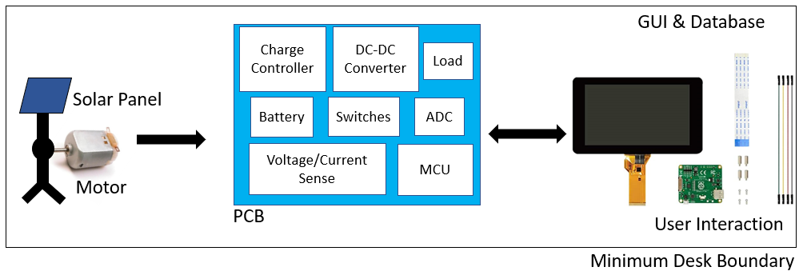

**Figure 1:** Suggested Mounting Scheme

# Thermal Interface

The solar panel is the main thermal interface of this design. The Silicon based photovoltaic cell is most efficient in the temperature range of 54-95 degrees Fahrenheit. Temperatures above this range will result in decreased efficiency. No active or passive cooling method will be used for the solar panel. The Raspberry Pi will be exposed to the heat from the sun, and will also generate its own heat while processing I/O and storing data. The Raspberry Pi will be contained in a kit provided by the Canakit corporation. This kit contains a heatsink, a fan, and a case with the necessary dimensions and ports to maintain positive air pressure inside the kit for the most efficient cooling. The buck boost converter will only need a heatsink to dissipate the heat generated by operation. A heatsink may be installed on the buck boost converter to help it dissipate heat.

# Electrical Interface

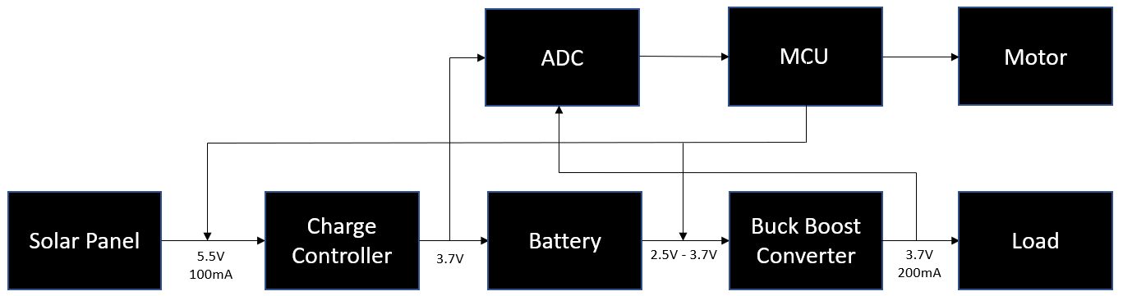

**Figure 2:** Electrical Interface Diagram

## Primary Input Power

### 5.1.1. Solar Power Generation Subsystem Power Delivery

The entire solar power generation subsystem will be powered from the energy generated by the solar panel and stored in the battery.

### 5.1.2. MCU Power Requirement

The MCU will be powered from a 100-240 V receptacle located near the system. The MCU will be able to provide additional power to any modules on the PCB that are not powered by the battery such as the ADC, motor, and FET switches.

### 5.1.3. Touch Screen Power Requirement

The touch screen will be powered from a 100-240 V receptacle through the Raspberry Pi. This means the CSC system will require a total of one wall outlet to power.

## Voltage and Current Levels

### 5.2.1. Maximum Values

**Table 7:** Maximum Voltage and Current Levels of Power Providing Blocks

| **Component** | **Voltage** | **Current** | **Power** |
| --- | --- | --- | --- |
| Solar Panel | 5.0 V | 500 mA | 2.5 W |
| Charge Controller | 3.7 V | 140 mA | 518 mW |
| Battery | 4.2 V | 1 A | 4.2 W |
| Buck Boost Converter Output | 3.7 V | 200 mA | 740 mW |
| Raspberry Pi 4 B (MCU) | 5 V | 3 A | 15 W |

## Signal Interfaces

### 5.3.1. Raspberry Pi GPIO Interface

The ADC, switches, and motor will be controlled via the GPIO pins available. Any additional required controls or power delivery to individual modules will be provided by the Raspberry Pi GPIO pins.

## User Control Interface

The user control interface will be the GUI application that communicates with the database and the MCU. Additionally, it will feature controls to adjust the mode of operation and display data that the MCU measures to track the system performance.

# Communications / Device Interface Protocol

## Device Peripheral Interface

Power to the MCU will be provided by a standard Universal Serial Bus (USB) port located on the MCU. Connection to the touch screen will be provided by an internal display port from the Raspberry Pi.