Creating STEM Contents: Solar Power with a Tracking System

Leo Predanic

George Thuita

Brandon Cenci

**Integration Report**

REVISION – Final

29 April 2023

Integration Report

for

Creating STEM Contents: Solar Power with a Tracking System

Prepared by:

_____________________________

Author Date

Approved by:

_____________________________

Project Leader Date

_____________________________

John Lusher, P.E. Date

_____________________________

T/A Date

**Change Record**

| **Rev.** | **Date** | **Originator** | **Approvals** | **Description** |
| --- | --- | --- | --- | --- |
| **Final** | 4/29/2023 | Leo Predanic, George Thuita, Brandon Cenci |  | Final Release |

**Table of Contents**

**Table of Contents 88**

**List of Tables** **89**

**List of Figures** **90**

**1.** **Introduction** **91**

**2.** **Integrated System** **92**

2.1. System Improvements **92**

2.2. Design Changes and System Characteristics **92**

2.3. Execution and Validation **98**

**3.** **Integration Conclusion 105**

**List of Tables**

**Table** **1.** **Battery Charging, Discharging, and Capacity Rating 100**

**Table 2. I/O Hardware Timing 101**

**Table 3. GUI and Database Timing 104**

**Table 4. Physical and Total Power Attribute Rating 104**

**List of Figures**

**Figure 1. Improved Buck-Boost Converter Schematic** **92**

**Figure 2. Simulated Minimum 2.5V Input Voltage Regulation** **92**

**Figure** **3. Simulated Maximum 4.2V Input Voltage Regulation 93 Figure 4. Final PCB Layout 93** **Figure** **5. Final PCB Schematic 94**

**Figure** **6. Solar Panel Rotation Algorithm Flow 95**

**Figure** **7. Infographics Tab 96**

**Figure** **8. Control (User Interaction) Tab 96**

**Figure** **9. System Charge Animation Tab Operation 96**

**Figure** **10. System Discharge Animation Tab Operation 97**

**Figure** **11. Constructed PCB 97**

**Figure** **12. Constructed System 98**

**Figure** **13. ECEN 404 Execution Plan 98**

**Figure** **14. ECEN 404 Validation Plan 99**

**Figure** **15. Simple Constant Current Load 99**

**Figure** **16. Buck-Boost Converter Output vs. Input 100**

**Figure** **17. Solar Panel Calibration Curve 100**

**Figure** **18. Charge Controller Calibration Curve 101**

**Figure** **19. Max. System Voltage ADC Measurement 102**

**Figure** **20. Max. System Voltage ADC Measurement Error 102**

**Figure** **21. Min. System Voltage ADC Measurement 103**

**Figure** **22. Min. System Voltage ADC Measurement Error 103**

**Figure** **23. Max. System Current ADC Measurement 103**

**Figure** **24. Max. System Current ADC Measurement Error 104**

# Introduction

As the demand for engineering solutions increases exponentially, it is imperative to inspire future generations of STEM students by creating captivating demonstration tools to drive their interest and creativity. The goal of this system is to foster this latent interest by being a simple and portable apparatus that is interactable and tracks the system’s performance by displaying the information in a digestible format for K-12 students. The Creating STEM Contents (CSC) system will contain a solar power generation solution to drive a physical load that generates visual, tactile, and aural excitations. The system will have an MCU to take various analog measurements and process it to provide relevant data about the system’s performance. The MCU will store information into a database where a GUI can read in the data and display figures and animations about system operation. The GUI will also feature interactive controls to set operation modes and control the circuitry. This allows through explanation of the concepts of solar power, electronics, and computer science to the target audience. The complete system has been constructed, tested, and validated. The results will be discussed here.

# Integrated System

## System Improvements

The integrated system sees a number of improvements upon the initial subsystems which will be discussed in this integration report. The main adjustments in the Solar Power Generation subsystem is the replacement of the buck-boost converter which had an oscillation issue. In the Electrical I/O subsystem, the solar panel rotation algorithm has been redone to fit the integrated system and the charge side FET was removed. In the GUI & Database subsystem, major overhauls to the animations, graphing, and user interaction visuals have been implemented but the flow remains the same.

## Design Changes and System Characteristics

### 2.2.1. Buck-Boost Converter

The buck-boost converter was replaced from the LTC3440 to the LTC3441 which boasts a higher output current at 1A compared to the original 200mA output current. Due to them being in the same chip family, the passives around the chip did not need to be replaced as the same design scheme was used in the subsystem report. The simulated range was from the lowest to highest voltage ends of 2.5V to 4.2V which extends past the battery range. The load is modeled a resistor based on maximum current draw at the regulated 3.7V output.

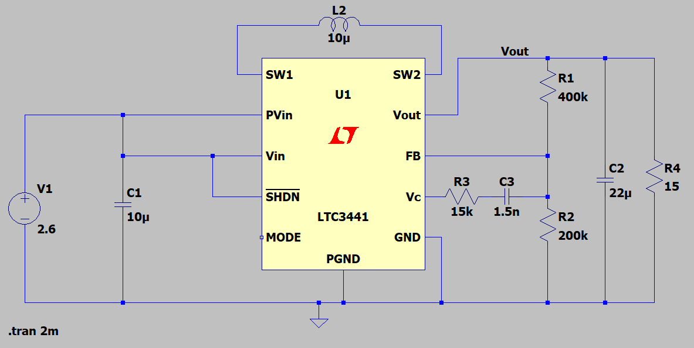

**Figure 1:** Improved Buck-Boost Converter Schematic

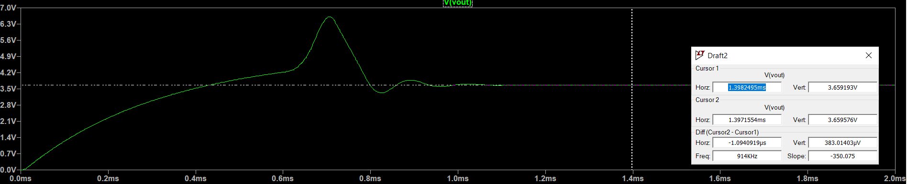

**Figure 2:** Simulated Minimum 2.5V Input Voltage Regulation

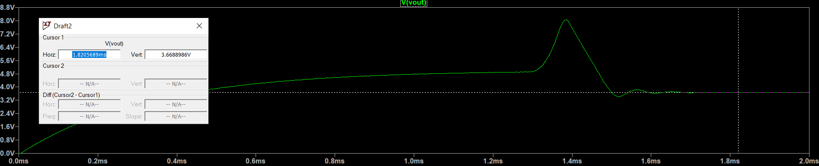

**Figure 3:** Simulated Maximum 4.2V Input Voltage Regulation

### 2.2.2. Final Printed Circuit Board (PCB)

As the system experienced changes in the buck-boost converter chip, there were slight adjustments made to the PCB to compensate for these adjustments. The schematic and layout of the PCB is shown in Figures 4 and 5.

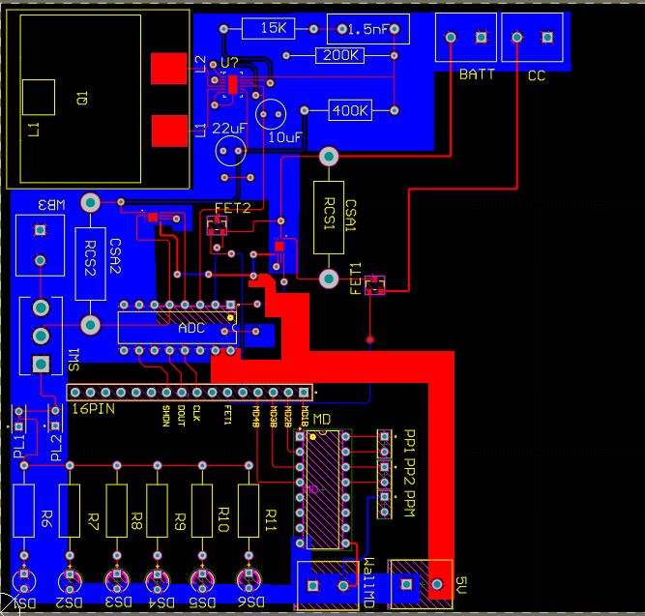

**Figure 4:** Final PCB Layout

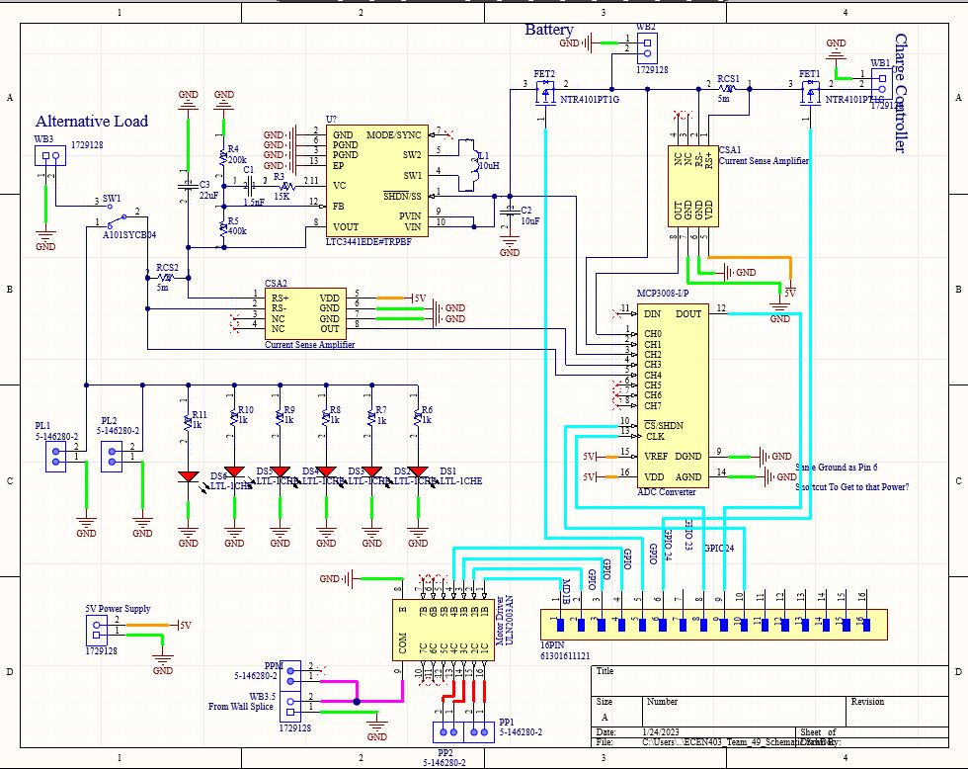

**Figure 5:** Final PCB Schematic

### 2.2.3. PCB Adjustments

Several issues were resolved with the PCB design when in hand. The Din port on the ADC was left floating and is necessary to receive the serial data from the ADC. This was fixed with blue wire that was shorted to an available through-hole pin on the second layer of the PCB. On both current sense amplifiers, the VDD and Vout pins were flipped. The traces were cut and blue wire was used to switch the nets. The charge side FET (FET1) was removed due to a floating VGS issue. Since the drain of the FET is connected to the battery and the source is connected to the charge controller, the source node of the transistor is floating because the charge controller needs to sense the battery voltage to set the output voltage. As a result, the source voltage floats and the transistor is in a state in between on and off which causes the incorrect current to flow from source to drain. Since the charge controller has reverse current protection, the charge side FET can simply be removed to resolve this issue.

### 2.2.4. Solar Panel Rotation Algorithm

The solar panel rotation algorithm is used to rotate the panel while the sun is moving across the horizon to optimally angle itself for maximum irradiation. The user first manually specifies through the GUI the initial location of the panel at the beginning of the day. From there, the user then selects a time for the panel to go through a 180 degree rotation from the initial point. Since the Earth has a constant angular velocity, the panel will rotate linearly with time for optimal solar tracking. The algorithm flow is shown in Figure 6. More details will be discussed with the GUI.

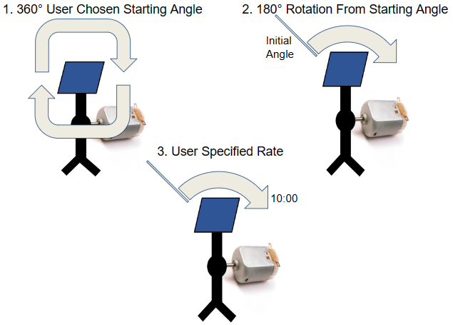

**Figure 6:** Solar Panel Rotation Algorithm Flow

### 2.2.5. Choice of Current Sense Resistors

To have the optimum current sensing, the magnitude of the CSR is important to not saturate the CSA for good current readings. Since the output current draw is expected to not increase over 200mA, a 0.25Ω resistor is used to accurately collect the data at the discharge or load side. At the charge controller output, since the wired charging capability is estimated to reach as high as 500mA, the CSR at the charge side is 5mΩ to avoid saturation of the CSA.

### 2.2.6. GUI, Database, and Animations

The GUI, Database, and Animations flow has not been changed and relies on the same principles that have been outlined in the subsystem report. The main improvements have been to the look and feel of the GUI. Shown in Figures 7-10 are the GUI tabs which contain the infographics, controls, and animations to track and describe the system performance.

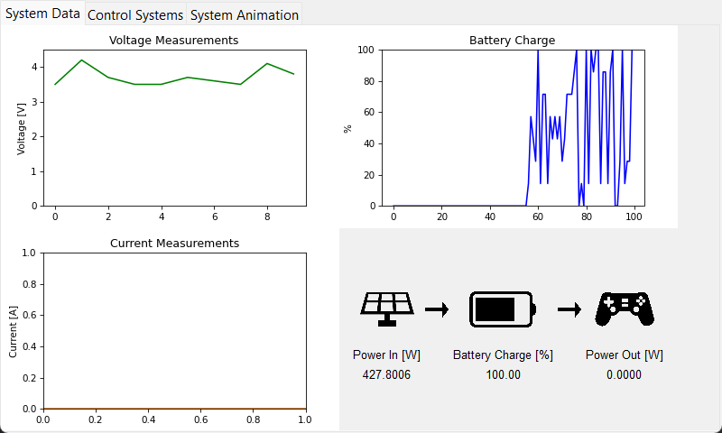

**Figure 7:** Infographics Tab

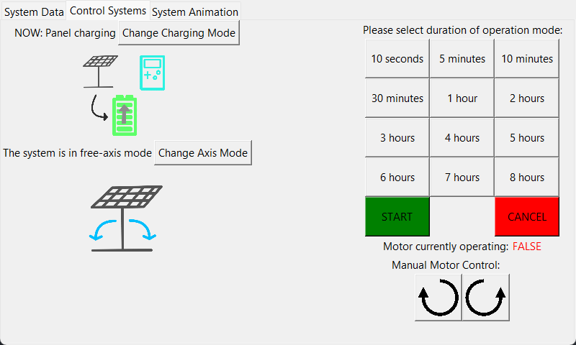

**Figure 8:** Control (User Interaction) Tab

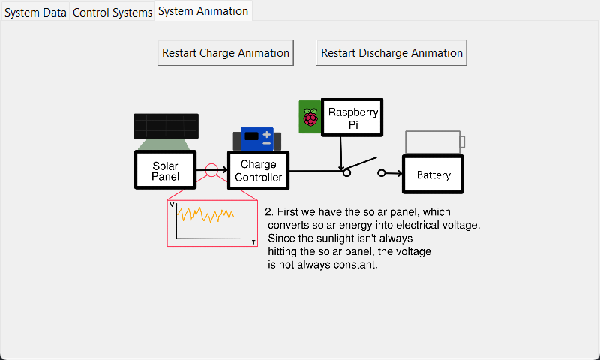

**Figure 9:** System Charge Animation Tab Operation

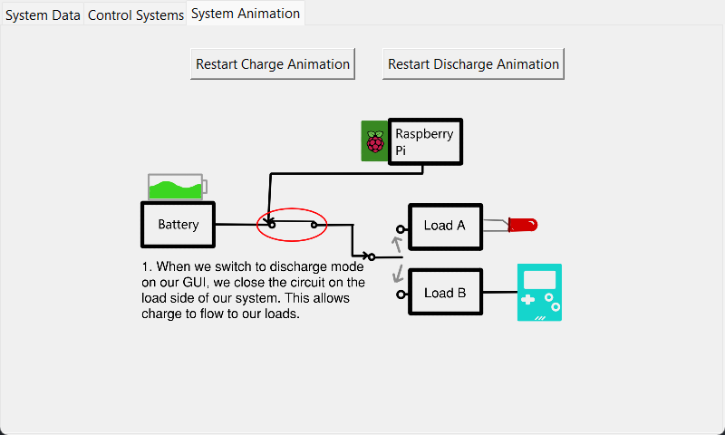

**Figure 10:** System Discharge Animation Tab Operation

The operation of the GUI is simple. The three tabs at the top let the GUI be cycled across all the necessary operation of the system. The control lab allows the systems to be switched between charging and discharging mode. In the infographics tab, the charts and data are automatically adjusted to reflect the system performance in its respective (dis)charge mode. Also, the user can select between single-axis and fixed axis mode where the panel can rotate through the zenith angle or remain stationary, respectively. When initializing the solar panel rotation, the manual controls allows the user to position the panel in an ideal starting position. Then, the duration of rotation can be selected to follow the sun across different times of the year when sunrise to sunset varies. The animations tab allows the charge side animations and discharge side animations to be started and restarted at will.

### 2.2.7. System Construction

The constructed PCB is shown in Figure 11 and the constructed system is shown in Figure 12.

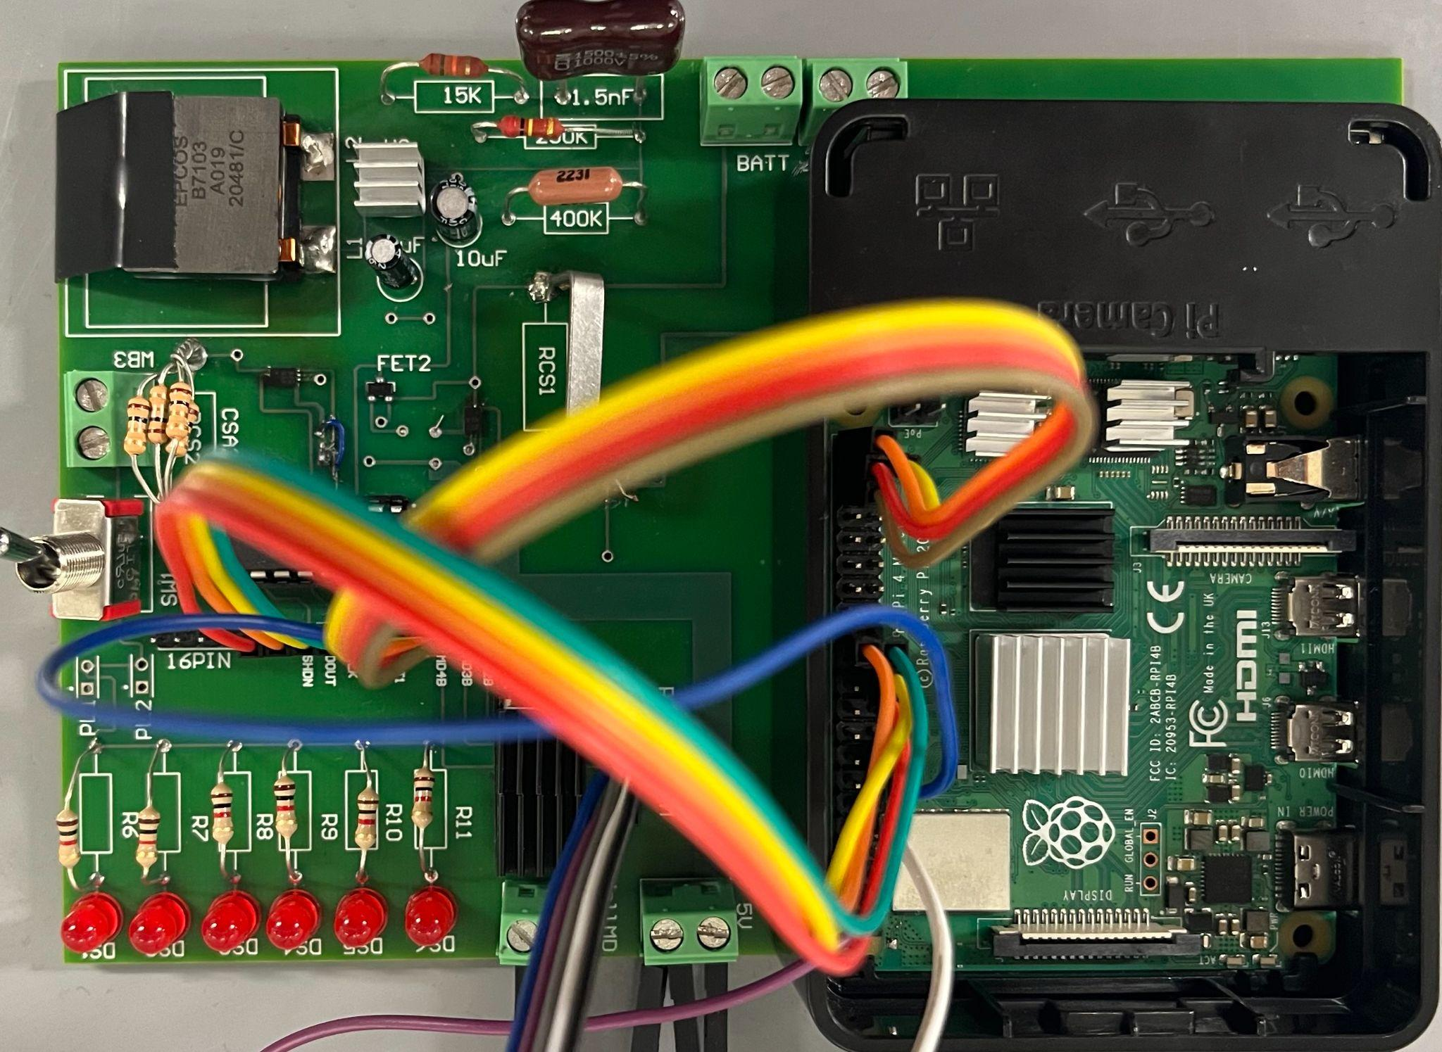

**Figure 11:** Constructed PCB

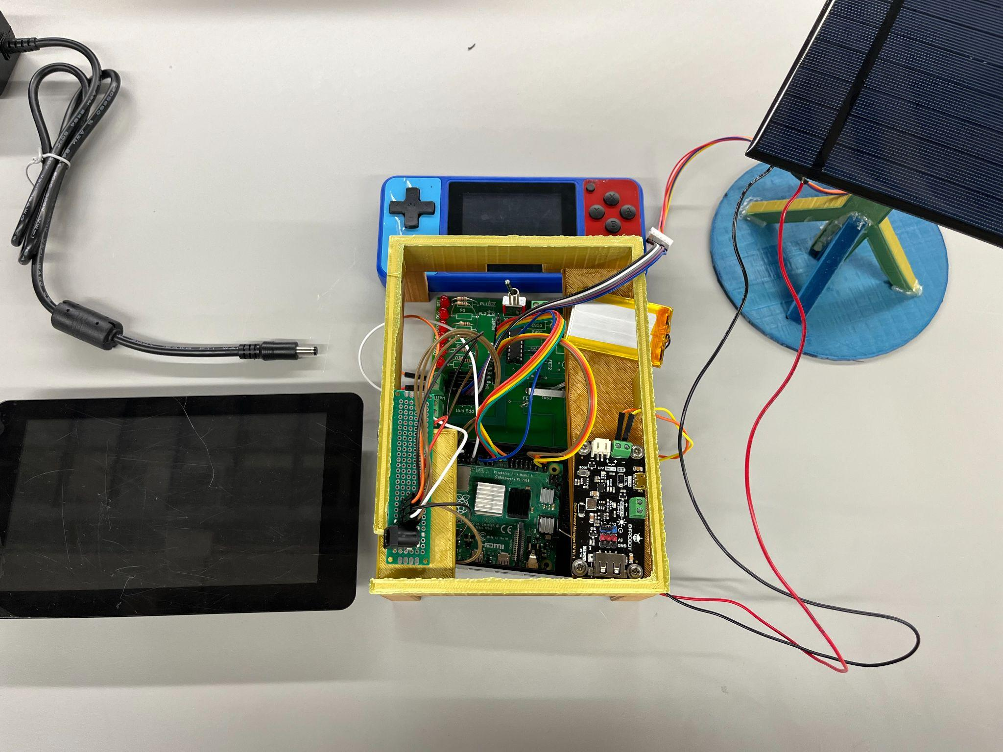

**Figure 12:** Constructed System

## Execution and Validation

### 2.3.1. Execution Plan

The execution plan used in ECEN 404 is shown in Figure 13.

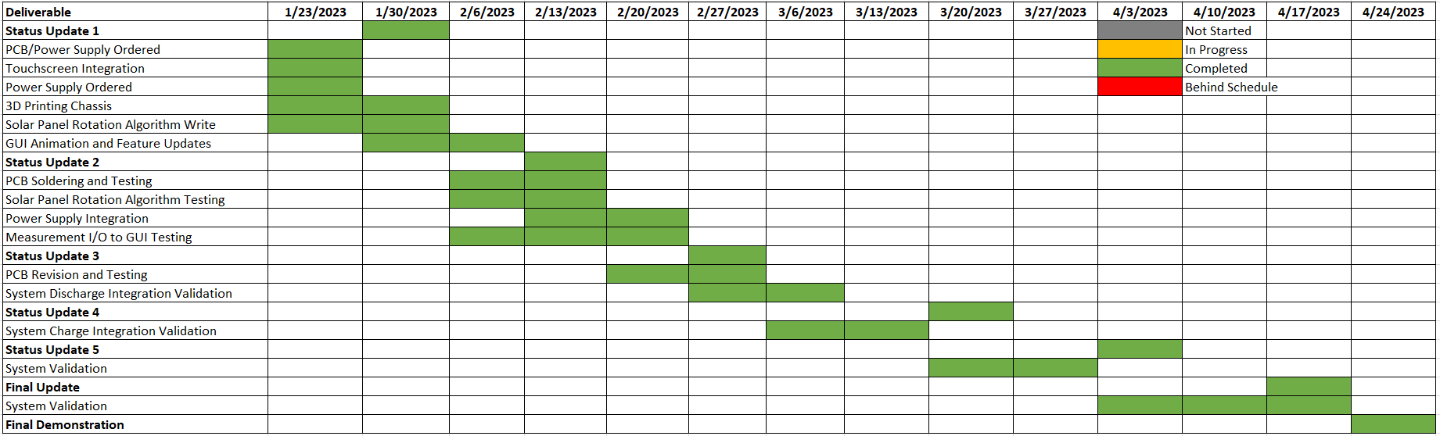

**Figure 13:** ECEN 404 Execution Plan

### 2.3.2. Validation Plan

The validation plan for the integrated system is shown in Figure 14.

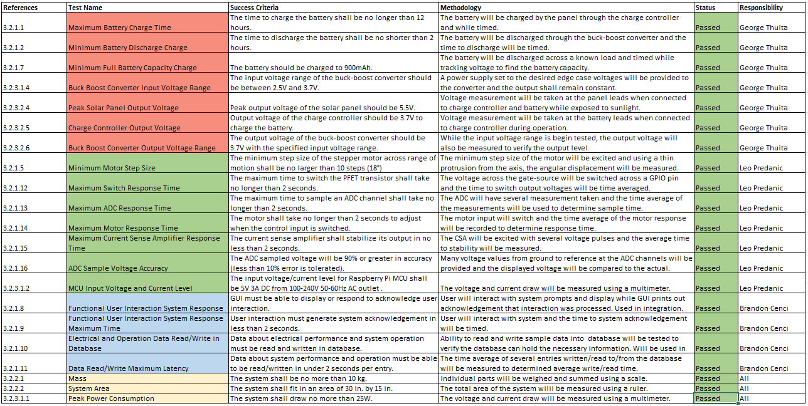

**Figure 14:** ECEN 404 Validation Plan

### 2.3.3. Solar Power Generation Validation Criteria

The FSR criteria 3.2.1.1 and 3.2.1.2 deal with the charge and discharge time of the system. The battery is charged using the system and then discharged across a constant current load shown in Figure 15. Since the current pull is roughly constant across the battery voltage range, the capacity (FSR 3.2.1.7) can also be easily found by multiplying the discharge time by the current. If the current varied across time, the current would have to be measured and characterized across time with an integration performed to determine the total charge and hence the capacity. Table 1 summarizes the timing and capacity of the battery. The charge and discharge times are collected using the system itself while monitoring the output of the ADC to the graphics.

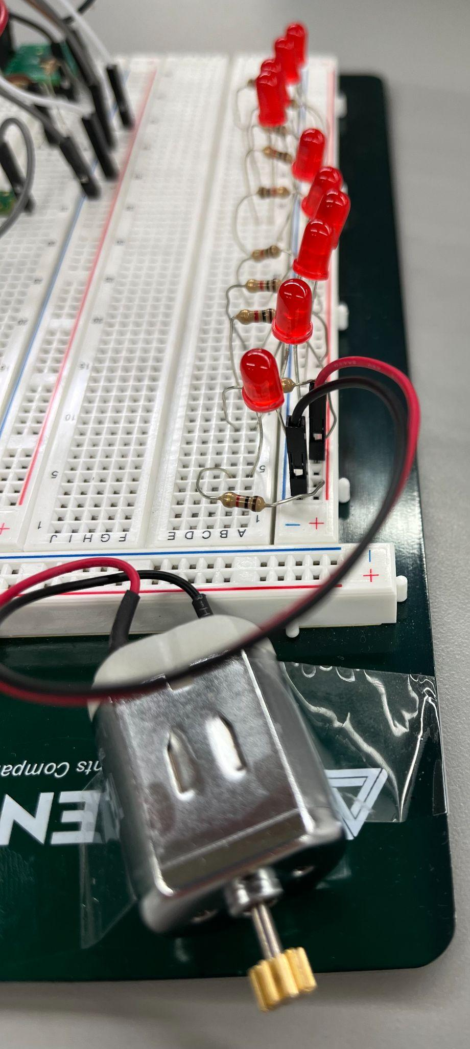

**Figure 15:** Simple Constant Current Load

**Table 1:** Battery Charging, Discharging, and Capacity Rating

| Wired Charging Time (Overcharge - 4.2V) | ~1 hour |
| --- | --- |
| Solar Charge Time (Nominal - 3.7V) | ~8-9 hours |
| Discharge Time (Max. System Load) | ~2.5 hours |
| Battery Capacity (Overcharge - 4.2V) | ~880 mAh |

The buck-boost converter input and output range (FSR 3.2.3.1.4 and 3.2.3.2.6 respectively) were tested by measuring the output voltage at the load while varying the input voltage across the simulated voltage range. The results are shown in Figure 16.

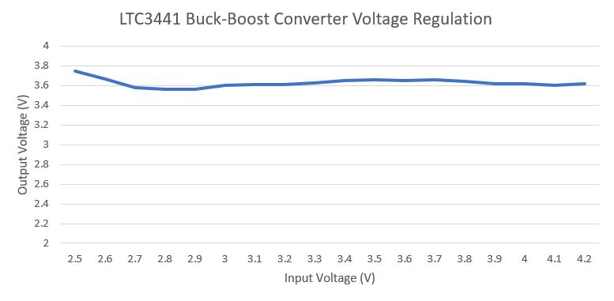

**Figure 16:** Buck-Boost Converter Output vs. Input

The solar panel output voltage and charge control output voltage were characterized across the zenith angle from 0 to 90 degrees against the normal of the panel surface. The results are shown in Figures 17 and 18 respectively.

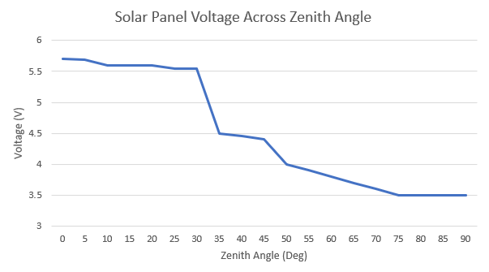

**Figure 17:** Solar Panel Calibration Curve

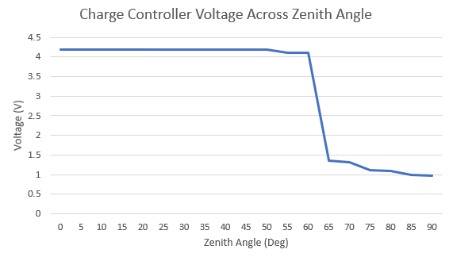

**Figure 18:** Charge Controller Calibration Curve

It can be seen that all of the validation criteria associated with the Solar Power Generation subsystem has passed.

### 2.3.4. Electrical I/O Validation Criteria

FSR 3.2.1.5 specifies the minimum discrete rotation step for the motor to be used. The motor has been programmed as shown in the subsystem report to rotate 360 degrees across 512 steps. To optimize the delay of the system, the rotation algorithm uses 16 discrete steps across 180 degrees of rotation. This means 16 steps are used resulting in a discrete unit of rotation equaling 11.25 degrees per unit. This is less than the specification of 18 degrees.

FSR 3.2.1.12 - 3.2.1.15 specify the minimum response time of the ADC, FETs, and motor from the GUI. On average, the system response is faster than what can be accurately measured through human reaction time so for this reason, the response time is labeled as less than 1 second which meets the less than 2 second response time.

**Table 2:** I/O Hardware Timing

| ADC Response Latency | < 1 s |
| --- | --- |
| CSA Response Latency | < 1 s |
| FET Switch Latency | < 1 s |
| Motor Response Latency | < 1 s |

FSR 3.2.1.16 specifies the minimum ADC voltage accuracy. The voltage and current error are characterized across time with a unit interval (UI) of 1 second however the error pattern repeats on average around 15 seconds. The average known voltage and current values are used to characterize the error and the following equation is used:

Since the accuracy of the ADC improves for higher input voltages, the minimum and nominal voltages are measured along with the maximum current to test CSA saturation characteristics.

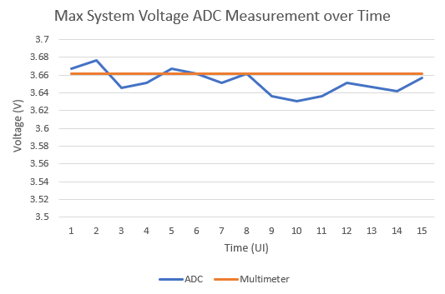

**Figure 19:** Max. System Voltage ADC Measurement

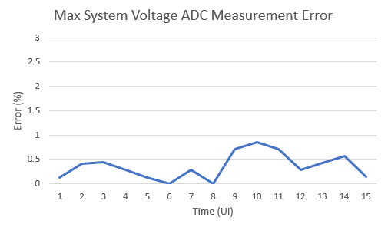

**Figure 20:** Max. System Voltage ADC Measurement Error

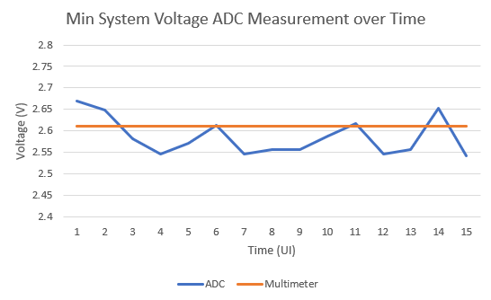

**Figure 21:** Min. System Voltage ADC Measurement

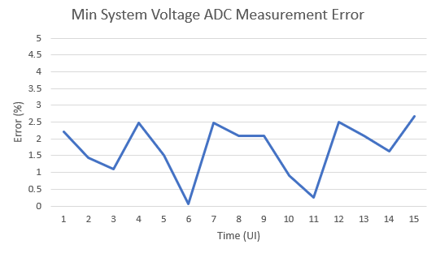

**Figure 22:** Min. System Voltage ADC Measurement Error

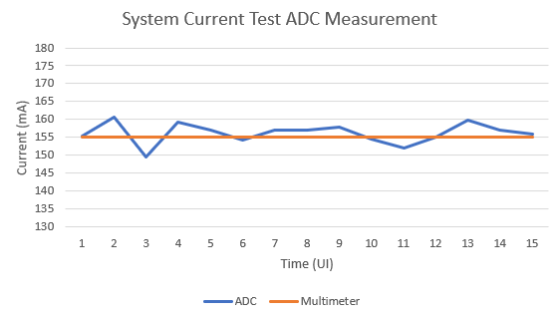

**Figure 23:** Max. System Current ADC Measurement

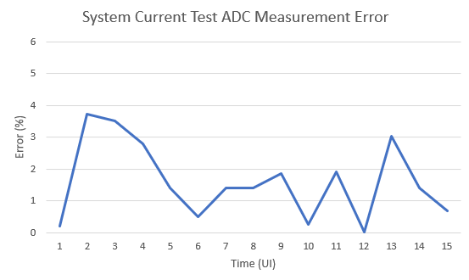

**Figure 24:** Max. System Current ADC Measurement Error

It can be seen that all of the error measurements are below 10% which is the maximum allowed error (90% minimum accuracy). FSR 3.2.3.1.2 specifies the maximum power draw by the MCU. The MCU can be powered from a supply as small as 5V 3A (15W) meeting the MCU power requirements. As such, all the Electrical I/O validation criteria are met.

### 2.3.5. GUI & Database Validation Criteria

The GUI FSR criteria 3.2.1.8 - 3.2.1.11 specify the maximum latency that the system can tolerate from user interaction to system response. Since the solar panel rotation algorithm has been optimized along with the ADC sampling scheme, the response time of all the GUI functionality is less than 1 second from user stimulus. This meets the minimum latency time of 2 seconds per operation.

**Table 3:** GUI and Database Timing

| User Interaction System Latency | < 1 s |
| --- | --- |
| Data Read/Write System Latency | < 1 s |

### 2.3.6. Physical System Attributes Validation Criteria

FSR 3.2.2.1, 3.2.2.2, and 3.2.3.1.1 specify the overall physical attributes of the system and total power consumption. The specifications are summarized in Table 2. The total system is powered from a 5V 30W supply (with margin over 25W) to ensure correct operation.

**Table 4:** Physical and Total Power Attribute Rating

| System Mass | 2.5 kg |
| --- | --- |
| System Area | 24.5 in. by 14.1 in. |
| Peak Power Consumption | 25 W |

It can be seen that the system meets the physical and peak power specifications. It is noted that the system, due to constraints outside of the authors’ control, cannot fully be tested in extreme heat and humidity conditions due to the time of year in which the validation was performed. The system components are rated up to at least 80 degrees Celsius so it is expected that 100 degree Fahrenheit weather is operable. Heating of the system is mainly due to electrical power losses and solar irradiation does not add significant system heating. The system is not water-proof so it is not advised to be operated in rainy weather conditions. Additionally, the system is expected to work in high humidity conditions as long as no condensation develops on the electronics.

### 2.3.7. Solar Panel Torque Calculation

To validate that the solar panel can be held by the motor, the maximum torque exerted on the motor is calculated as follows. The maximum torque the motor can handle is 34.1 mN.

Normalizing units to m and kg, it can be seen that the maximum torque on the motor is 23.52 mN meaning that the motor can handle the weight of the panel.

# 3. Integration Conclusion

In summary, the complete system has been successfully constructed and validated. The system has successfully completed a full test and validation of all the functionality and operation. Further improvements of this design could be seen as even more customizability of the battery, charge controller, and load to satisfy a larger range of components or uses. This system shows itself as a strong demonstration and learning tool for K-12 students while offering ways for them to tinker and explore the system in a safe manner to reap the benefits of beginning a journey of a STEM-based education.