Creating STEM Contents: Solar Power with a Tracking System

Leo Predanic

George Thuita

Brandon Cenci

**Concept of Operations**

REVISION – 1

4 December 2022

Concept of Operations

for

Creating STEM Contents: Solar Power with a Tracking System

Team <49>

Approved by:

_____________________________

Project Leader Date

_____________________________

Prof. Kalafatis Date

_____________________________

T/A Date

**Change Record**

| **Rev.** | **Date** | **Originator** | **Approvals** | **Description** |
| --- | --- | --- | --- | --- |
| **-** | 9/15/2022 | Leo Predanic, George Thuita, Brandon Cenci |  | Draft Release |
| 1 | 10/3/2022 | Leo Predanic, George Thuita, Brandon Cenci |  | Revision 1 |

**Table of Contents**

**Table of Contents** **3**

**List of Figures** **4**

**1.** **Executive Summary 5**

**2.** **Introduction 5**

2.1. Background **5**

2.2. Overview **6**

2.3. Referenced Documents, Standards, and Citations **6**

**3.** **Operating Concept 7**

3.1. Scope **7**

3.2. Operational Description and Constraints **7**

3.3. System Description **7**

3.4. Modes of Operations **8**

3.5. Users **8**

3.6. Support **9**

**4.** **Scenarios 9**

4.1. Fixed Axis Operation Mode **9**

4.2. Single Axis Operation Mode **9**

4.3. System Charging Operation Mode **9**

4.3. System Discharging Operation Mode **10**

**5.** **Analysis 10**

5.1. Summary of Proposed Improvements **10**

5.2. Disadvantages and Limitations **10**

5.3. Alternatives **10**

5.4. Impact **11**

**List of Figures**

**Figure 1. Trend of Engineering B.S. Graduates over Time 6**

**Figure 2. Top Level System Flow Diagram 8**

# 

# Executive Summary

As the electrification and digitization boom further grows, there is a need for more sustainable power generation methodologies as non-renewable sources prove ineffective for long term power generation solutions. For this reason, renewable energy solutions have been proposed and explored over the years. One promising alternative is solar power. Solar power is more complex in the way it generates electricity however it is simpler in its system design and maintenance. As the demand for engineering solutions increases in society, it is imperative that future generations of engineers are inspired as young students to excite them about the pursuit of engineering (or STEM more broadly) as a career path. Due to the miniaturization of solar panels and the simpler nature of their system integration than a power plant, a portable solar solution can be designed with the ability to self-track the efficiency of the system. This solution can show the methodology of solar-based power generation in a way that is digestible for K-12 students while being interesting enough to draw students to the STEM field to help produce new talent for the future of engineering solutions.

# Introduction

The Concept of Operations is an introductory description of the solar power generation system with a tracking scheme. The system itself as well as subsystem operation, system integration, and scenarios of usability will all be discussed. The system will be primarily designed to act as an educational tool for K-12 students to generate interest in STEM as a career path but to also demonstrate the basic operational premise of the solar power generation system while also being able to track its efficiency.

## Background

Engineering is becoming a more expansive field as new solutions are required for problems that did not used to exist prior to the electrification and digitization of society. As such, it is imperative that the engineers of today inspire future generations that will provide solutions once we are gone. STEM has become a very lucrative field yet it is gatekept due to its technical difficulty and dedication that it requires resulting in lower than necessary matriculation rates into engineering programs. As STEM program graduates slowly stagnate [Fig. 1], the demand for solutions continues to grow.

One solution is to increase the number of students that pursue engineering by exposing K-12 students to STEM related concepts early in their education in hopes that it generates interest through their creativity. STEM requires creativity to design innovative solutions to emerging problems and it is imperative that creative students are encouraged to pursue STEM early on to capitalize on their unique viewpoints. The design of a portable and physical device such as the solar power generation system that can present relevant data about itself in a technically digestible manner for young students while also being complex enough to inspire these students in an effective way to address this problem.

In commercial solar power generation, systems that can generate enough energy to power a home or on a larger scale such as a power grid require bulky and heavy panels that are not only expensive but not portable. The solar energy required to power a house would require a large surface area of the roof to be covered by panels while energizing a grid would require a farm of panels to power the load. In order for this system to be portable, a palm-sized panel will be required as well as a similarly sized battery which also meets the panel power specification. The rest of the system has to be designed as small as possible to meet the portability requirement.

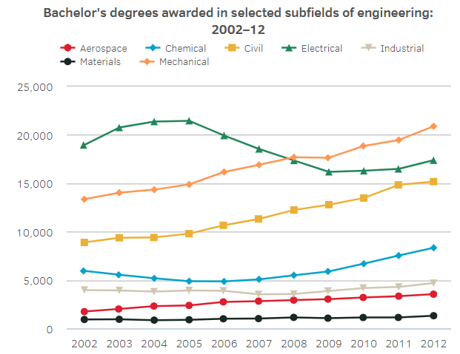

**Figure 1**: Trend of Engineering B.S. Graduates over Time (Section 2.3 Ref. 1)

## Overview

As discussed, the system will be powered by a palm-sized solar panel. Since the power generation of the panel can be sporadic and not consistent, it isn’t sufficient to drive a load directly. A battery will need to be charged so that it can discharge according to a polynomial curve so that relevant power data can be more easily measured. Since the panel will charge the battery over several hours, implementing a battery and load will make it easier to track system performance over longer periods of time as linear operation of the circuits are easily predictable. A microcontroller unit (MCU) will be used to take measurements, process the information, send control signals to the power generation subsystem, and interface with a database and graphical user interface (GUI). The GUI will read information from a database that is written to from the MCU and will display the relevant data as graphical and tabular information onto an interactable display to switch between two operating modes. The figures displayed will be designed to be easily understandable by a young and scientifically amateur audience to effectively demonstrate and explain the process of solar power generation.

## Referenced Documents, Standards, and Citations

1. ‘How many degrees are earned in engineering, and what subfields are the most popular?’, National Science Board.

https://www.nsf.gov/nsb/sei/edTool/data/engineering-01.html

1. Electrical Rechargeable Battery Standards:

https://www.epectec.com/batteries/battery-standards.html

1. Solar Power Standards: https://webstore.ansi.org/industry/solar-energy

# Operating Concept

## Scope

Solar Power with a Tracking System will be a miniaturized system that can generate power from solar energy through the use of solar panels that charge batteries and discharge that energy into a load. Using a MCU, measurements will be taken about the system’s voltage, current, and power while storing that information in a database. Then, a GUI will take the data and display the relevant figures that detail the system performance and efficiency. Since the project is intended to be used as a demonstration tool for K-12 students, the system will be designed to be portable and comprehensible for a more technically amateur audience to convey the basics of power generation, system design, electrical energy, and software.

## Operational Description and Constraints

In order for the system to be used optimally, there are several details that must be discussed and elaborated on to ensure that the system can be used effectively for multiple demonstrations. The solar panels will charge batteries that can be disconnected once the batteries are charged. The batteries are then connected to a buck converter to step the voltage down for safe powering of a load. The battery will also have a disconnect between itself and the load since it doesn’t discharge the system while storing energy from the panel. The MCU will take measurements from the system to be stored in a database and then displayed in a GUI. For the system to operate properly:

* The solar panels must be given several hours of sunlight to properly store the battery.
* The system must have a wired connection to an interface that can allow user input to control the circuits at the power generation side.
* The GUI and database must be designed for a computer or laptop since the connection will be wired and wireless connectivity will not be supported.
* Due to the portability constraint, the solar panel, battery, and circuit board must be small and light enough that the system is easily transportable.
* The battery and MCU must be sufficiently small to be mounted onto a printed circuit board (PCB).
* To satisfy budget constraints, the mechanical arm that holds the panel and hinge for axial rotation will be 3D-printed and must have sufficient range of motion.

## System Description

There are three subsystems to this design including the solar power generation, the electrical I/O, and the database with GUI. One student each will design and manage their subsystem.

Solar Power Generation: The solar panel will be placed into a 3D-printed mechanism that can hold the panel so that the surface faces the sun. There is a hinge with a motor that will serve to rotate 180 degrees to follow the sun as it travels from the eastern to western horizon. The generated power from the panel will be fed directly to a battery storage network. Between the two will be a disconnect circuit that can switch so the battery can be disconnected from the panel when it is fully charged so the battery does not lose structural or chemical integrity. The battery will also connect to another disconnect circuit that will drive a buck converter to step the voltage down. This is so it can more safely drive a resistive load. There will be two measurement points at the battery and load side so that analog voltage measurements can be taken and tracked by the MCU for processing. The network will have a custom PCB designed for it so that it can be cleanly and safely connected for the purpose of visual ease of explanation of system operation.

Electrical I/O: The I/O will be controlled by an MCU which will take measurements, control the system, and interface between the circuit network and the custom display software and database. The MCU will take the analog voltage and current measurements, perform analog-to-digital conversion, and temporarily store the data. It will then compute the current and power based on known loads and transmit the data to the database for permanent storage. Since the GUI will take user input on operation modes (discussed in Section 3.4 and 4.1), it will need to be able to communicate with the GUI to control the operation of the circuit network and motor to control the charging or discharging of the battery and rotate the motor, respectively.

Database and GUI: From the MCU, the database will collect information about voltage, current, and power from the measurement ports in the circuit network in unit time intervals. The GUI will then draw the data from the database and provide graphs, tables, and/or figures to visualize information that track and demonstrate the system performance and operation. The GUI will also serve to take user input on operation mode control and network disconnect control to manage the system in a simple way to avoid additional external control schemes.

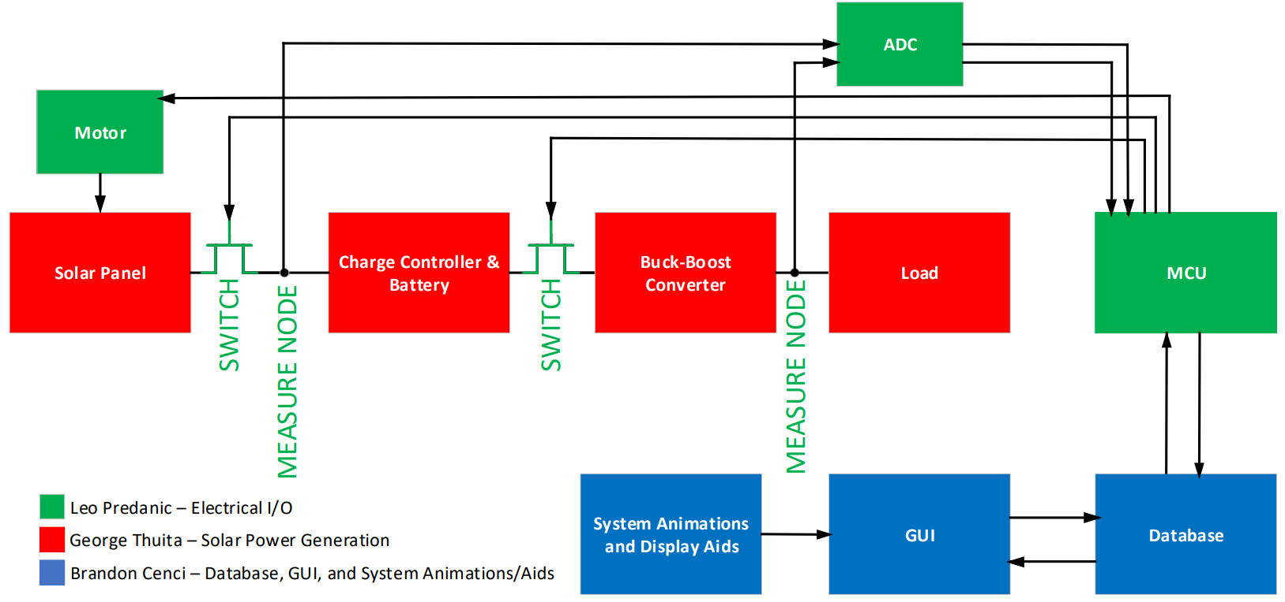

**Figure 2**: Top Level System Flow Diagram

## Modes of Operations

There will be two primary modes of operation based on the rotation of the solar panel’s axis. The first is ‘fixed axis’ as the motor will be set to 90 degrees from horizontal and the panel will remain stationary throughout its power generation process. The GUI will reflect that the system is in fixed axis mode. The second mode is ‘single axis’ where the panel will be able to rotate 180 degrees to follow the sun across the duration of the day. The GUI will also reflect that the system is in single axis mode and will display key metrics on system performance across the two modes for comparison as well as be able to select which mode the system will operate in.

## Users

Since the target audience for this system are K-12 students, the display figures will be catered to the technical knowledge of these students. Due to the mechanics of the system where hardware and software are integrated, students in AP Physics 1 & 2, AP Physics C, and AP Computer Science will also be targeted with more specific details and information due to their background in the subject material and additional technical aids can be used to further elaborate on system design and operation. Because the system will be used as an educational tool, the user interface will be simple so that interaction with the system does not require extensive knowledge of the system. This means that the interface will have only several options for system interaction to avoid malfunction due to user error.

## Support

Support for Solar Power with a Tracking System will be provided as an instruction manual that describes proper system maintenance and usage. To reduce the amount of system components, the manual will be given electronically as a ‘Read Me’ during program boot-up as an option to read prior to any interaction with the system

# Scenarios

## Fixed Axis Operation Mode

In Fixed Axis Operation Mode, the system will not rotate about its axis and collect its energy at 90 degrees from horizontal. This mode will be selected in the GUI where it will notify the MCU that the system is to operate in a stationary mode. The battery will charge while it is disconnected from the buck converter to ensure that no power is driving the load while charging. As the battery charges, the voltage and current will be measured and the power data will be calculated and sent to the database where the GUI will retrieve it and display the relevant information. When the battery is fully charged, the panel will be disconnected and the battery will then be switched to the buck converter which will step down the voltage to drive the load. Measurements will be taken the same way at the load and the information will be displayed in the GUI.

## Single Axis Operation Mode

In Single Axis Operation Mode, the system will operate similarly to Fixed Axis Operation Mode but the MCU will control the rotation of the solar panel via a motor. The measurement data will be collected identically as Fixed Axis Operation Mode and the disconnect will operate the same as well. The GUI will display the collected data and will show the differences in efficiency of the two modes to illustrate how different system operation can affect performance.

## System Charging Operation Mode

In System Charging Mode, the system will be in a state where the panel is charging the battery. The switch between the panel and charge controller will be connected and the switch between the battery and converter will be disconnected. The MCU will sample voltage and current data from the generator side and communicate with the GUI. The panel will either rotate or not depending on whether the system is in Fixed Axis or Single Axis Operation Mode.

## System Discharging Operation Mode

In System Discharging Mode, the system will operate similarly to System Charging Mode but the switch connections will now be reversed. The battery will be driving the load and the solar panel will be disconnected.

# Analysis

## Summary of Proposed Improvements

This system will provide several improvements as an education tool than previous designs. Since the system is interactable, it will help teaching as the system provides instant feedback. The new graphical displays will be designed in a way that is understandable for young students while containing the necessary information to explain the concepts of solar power generation. Since the system is designed at block level, it will be easier to explain the operation without getting too in-depth into the physics and computer science of the system. Its light, portable, and organized design will be beneficial to clearly articulate where system blocks are, connections, and operation. Its dual operation modes are an efficient way of demonstrating different design philosophy and how that contributes to the performance of a system versus its alternatives.

## Disadvantages and Limitations

Due to the miniaturized design, the solar panel output power will not be comparable to commercial systems and therefore will be limited in its ability to do useful work outside of being educational. Another issue of being solar powered is the long charging time. Data collection for power generation will take several hours and might not be demonstrable in real time due to time limitations. Sunny weather is necessary for proper system operation so inclement weather conditions might limit the ability of the system to be demonstrated in a classroom environment. Since cheap batteries are used due to budget constraints, the batteries might self-discharge and not be able to hold enough charge for long periods of time requiring frequent system charging and reducing its frequent demonstration potential.

## Alternatives

As demonstration tools for K-12 students, different systems could be either purely software or purely hardware based. Projects that are software based can be used to encourage interest in computer science related fields whereas purely hardware based systems can feature mechanical systems that are controlled electronically such as robotics which are able to take user input and respond accordingly. For this particular system, instead of using DC-DC conversion, DC-AC conversion could be used to demonstrate the concept of AC power will is more prevalent in power distribution systems due to its less lossy propagation opposed to DC power.

## Impact

Since this system is used for educational purposes, the impact of this system is to demonstrate to students the concept of renewable energy via solar radiation and how it can be used as a power source as the world transitions to cleaner energy. Additionally, it will hopefully capitalize on the creativity of young students and encourage them to pursue careers in STEM, providing innovative solutions to the ever growing list of problems that society faces in the age of electrification and digitization. Some ethical concerns of the system is that it can also be used as a way to discourage students in the pursuit of STEM. If the system’s complexity is too deeply elaborated on, it can drive away student interest as their lack of understanding might create fear and distrust in their abilities to learn STEM concepts and might provide the opposite of the intended effect.