Supplementary Material
Experimental Dataset and Numerical Model Validation of a Lab Scale Solar Volumetric Receiver for High Temperature Industrial Heating

Aysha Melhim¹, Athanasios G. Konstandopoulos^{2,3}, Konstantinos Kakosimos^{1,*}
¹ Chemical Engineering Program, Texas A&M University at Qatar, Doha, Qatar
² Chemical Process and Energy Resources Institute, CERTH, Thessaloniki, P.O. Box 60361, 57001, Greece
³Aerosol & Particle Technology Laboratory, Department of Chemical Engineering, Aristotle University, University Campus, Thessaloniki, 54124, Greece

*Corresponding Author: k.kakosimos@qatar.tamu.edu

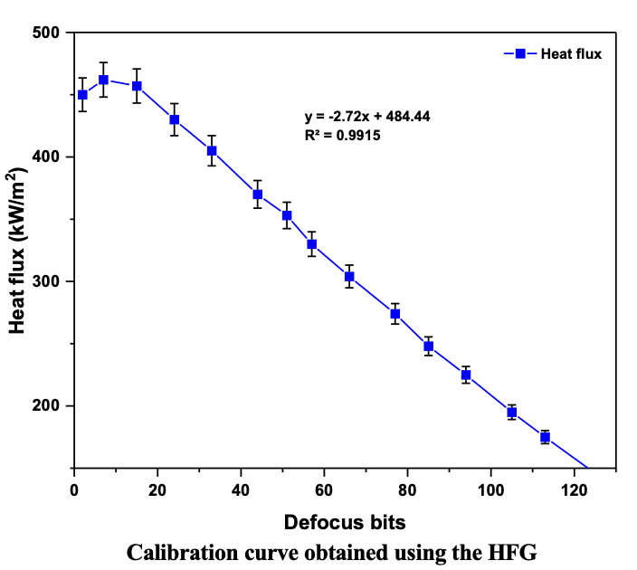
Figure S1. Calibration curve obtained using the HFG.

In Figure S1, the term “defocus bits” in a lamp refers to the control mechanisms that adjust the focus of the light beam through digital commands. These defocus bits enable the lamp to achieve different light intensities by varying its position in the x-direction.

Experimental Results
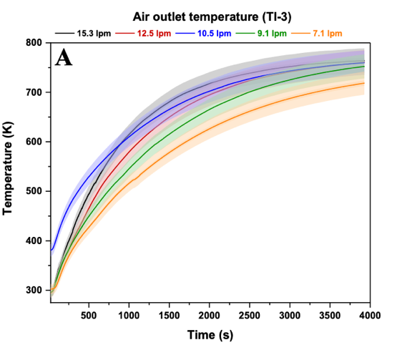 | 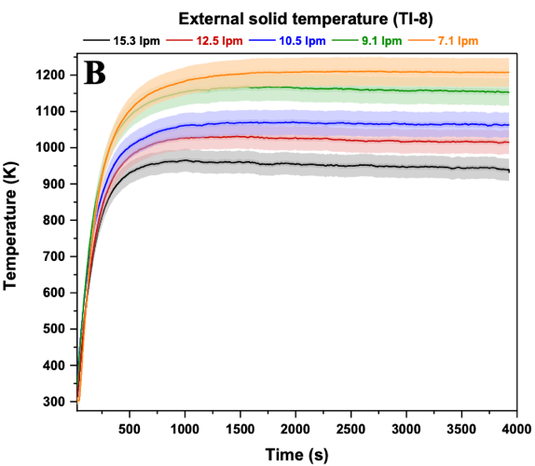
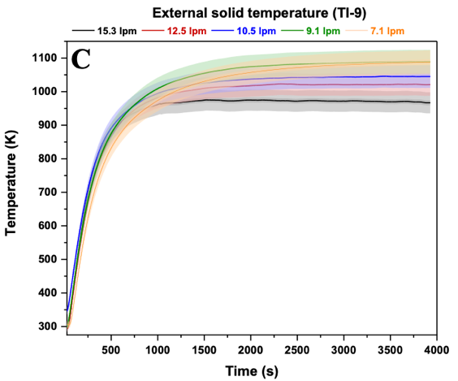 | 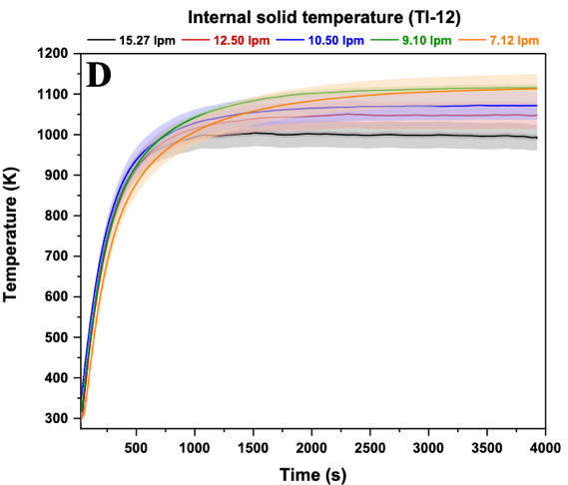
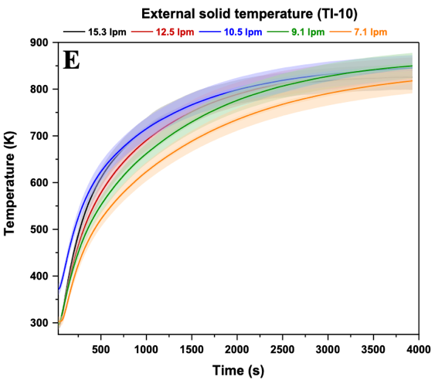 | 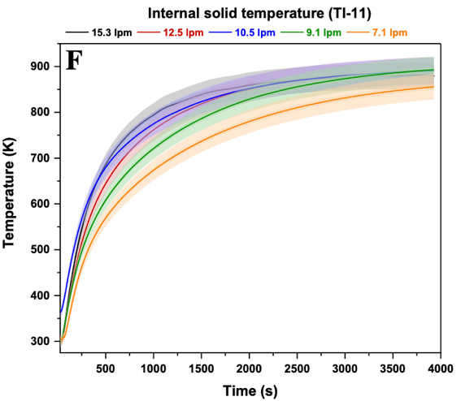
Figure S2. Temperature profiles for the solid and gas domains obtained in E67 to E71 for the available thermocouples (see Figure 3) at an indicative flux of 456 kW/m2. The shaded area reflects the experimental uncertainty.

Figure S3. Temperature profiles for the solid and fluid domains obtained in E72 to E76 for the available thermocouples (see Figure 3) at an indicative flux of 304 kW/m². The shaded area reflects the experimental uncertainty.

Figure S4. Temperature profiles for the solid and fluid domains obtained in E77 to E81 for the available thermocouples (see Figure 3) at an indicative flux of 256 kW/m². The shaded area reflects the experimental uncertainty.
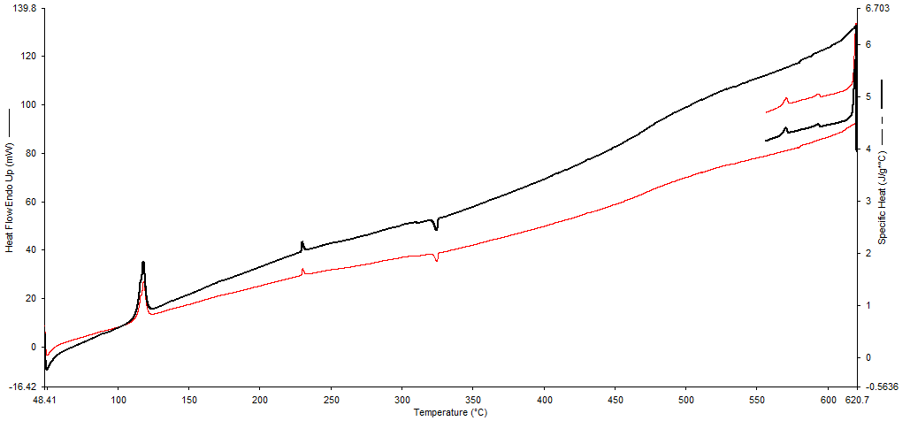
Figure S5. DSC signal obtained for SiC showing the heat capacity as a function of temperature.

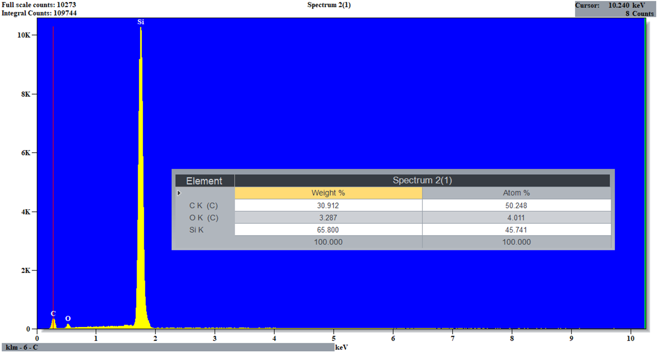
Figure S6. EDX analysis for SiC used as the volumetric receiver.

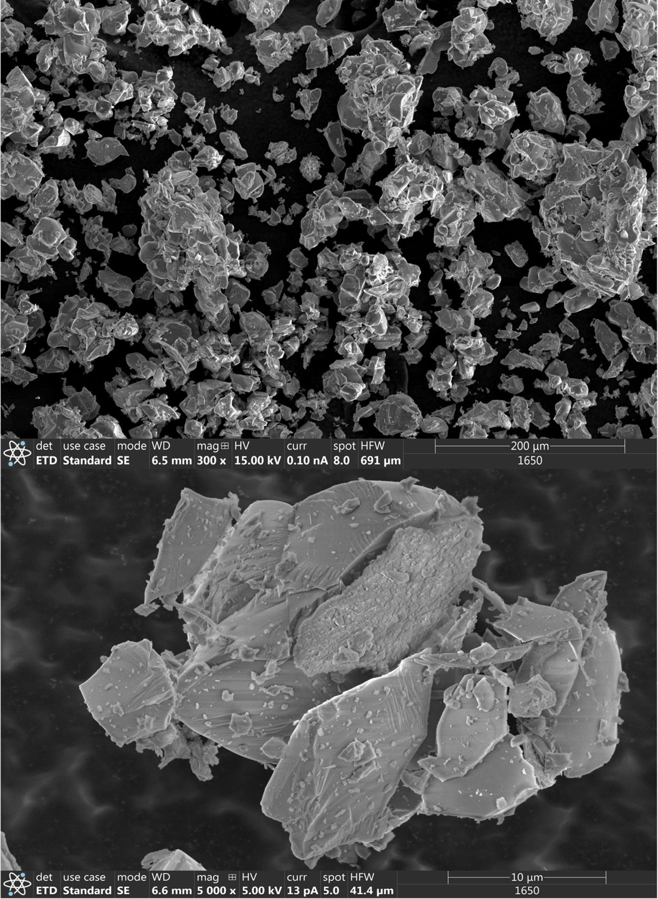
Figure S7. SEM characterization for SiC used as the volumetric receiver.

Appendix B
Model Results
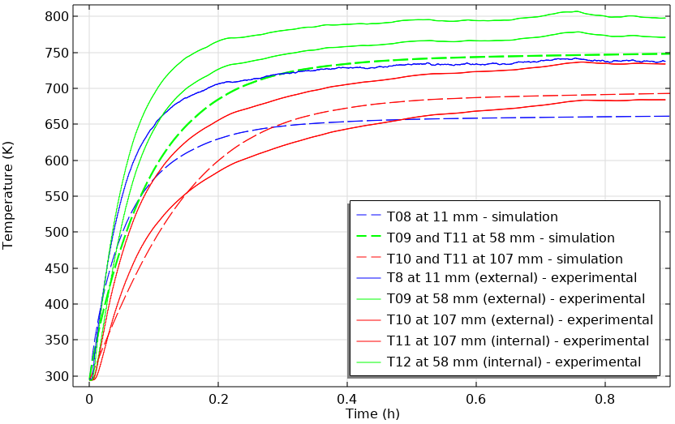
Figure S8. Single channel 3D model temperature profiles of the solid with 4.4$ρ_{s}C_{ps}$ and adjusted flux values (22% increase from 304 kW/m²) representing E72 (single channel).

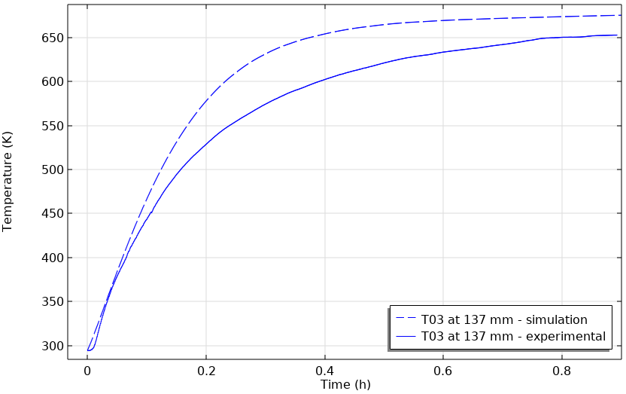
Figure S9. Single channel 3D model temperature profiles of the gas with 4.4$ρ_{s}C_{ps}$ and adjusted flux values (22% increase from 304 kW/m²) representing E72 (single channel).

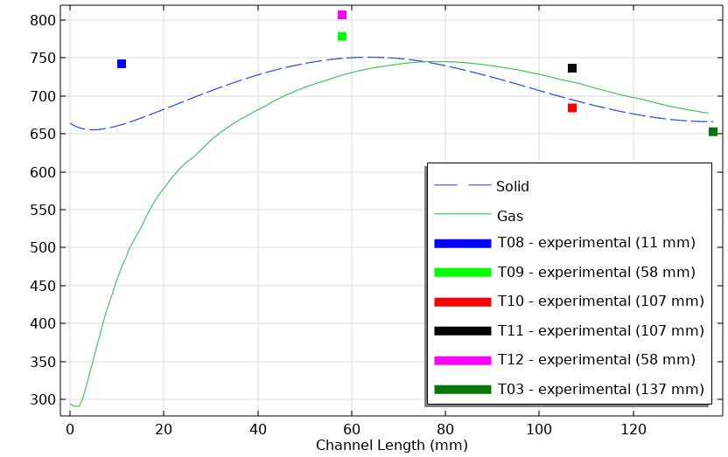
Figure S10. Temperature profiles as a function of receiver length with 4.4$ρ_{s}C_{ps}$ and adjusted flux values (22% increase from 304 kW/m²) representing E72 (single channel).

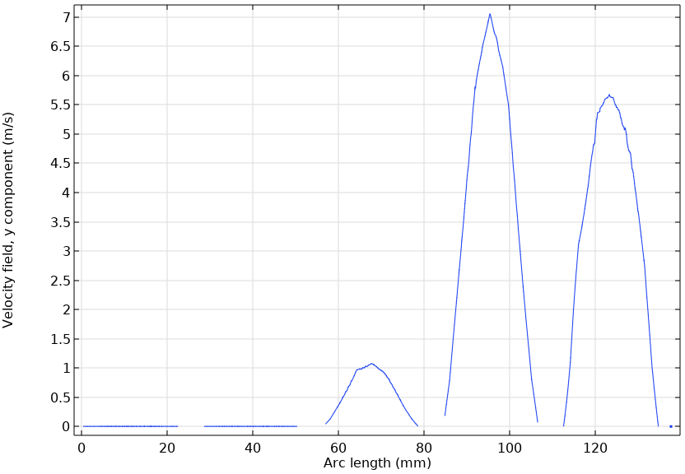
Figure S11. Velocity profile across the length in the 3D conjugated full receiver model for E67 (single channel).

Table S1. Fitted parameters to the gas and solid domains’ transient profiles and steady state temperatures from the lumped model using correlation 5.
Fitted parameter | Value from lumped model | Range reported in Literature | Reference
Factor on $ρ_{s}C_{ps}$ | 4.40 | - | -
A | 19.90 | - | -
B | 0.87 | 0.0088 – 0.53 | [31, 32]
n | 0.56 | 0.31 – 0.66
C | 40.94 | 22.75 – 55.12

Table S2. Lumped model heat transfer coefficient fitted to the gas and solid transient profiles and steady state temperatures using correlation 5.
Flux (kW/m²) | Experiment No. | Flowrate (L/min) | Nu  number | Model Heat transfer coefficient ($\overline{h}$) ($\frac{W}{m^{2}K}$)
456 | E67 | 15.3 | 19.90 | 738.39
456 | E68 | 12.5 | 19.90 | 744.77
456 | E69 | 10.5 | 19.90 | 742.65
456 | E70 | 9.1 | 19.90 | 749.01
456 | E71 | 7.1 | 19.90 | 730.56
304 | E72 | 18.3 | 19.90 | 657.43
304 | E73 | 13.2 | 19.90 | 687.88
304 | E74 | 9.0 | 19.90 | 690.81
304 | E75 | 7.0 | 19.90 | 678.30
304 | E76 | 4.5 | 19.90 | 652.91
256 | E77 | 13.9 | 19.90 | 556.82
256 | E78 | 10.0 | 19.90 | 580.48
256 | E79 | 8.0 | 19.90 | 585.30
256 | E80 | 6.6 | 19.90 | 586.10
256 | E81 | 4.5 | 19.90 | 577.25

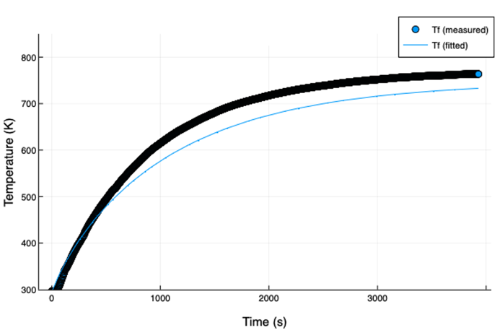 | 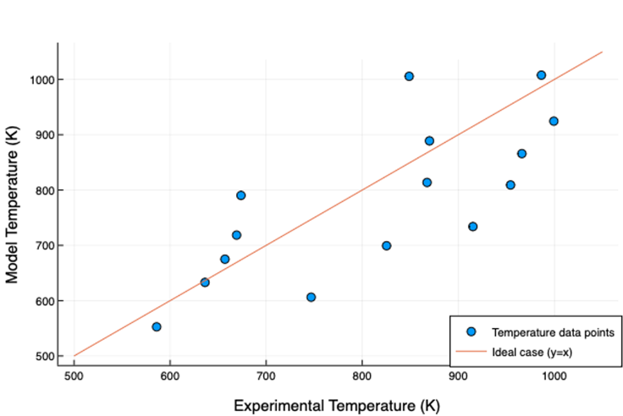
Figure S12. Comparison of transient lumped model results with measurements, for the gas (left) domain at a flux of 442 kW/m² (3% decrease from 456 kW/m²) and air flowrate of 15.3 L/min (E67) using correlation 5 fitted to the gas and solid domains, and comparison of the achieved steady state gas temperatures (parity plot-right) using fitted parameters and heat transfer coefficients for correlation 5.

Table S3. Fitted parameters to the gas domain’s transient profiles and steady state temperatures from the lumped model using correlation 5.
Fitted parameter | Value from lumped model | Range reported in Literature | Reference
Factor on $ρ_{s}C_{ps}$ | 4.40 | - | -
A | 20.00 | - | -
B | 0.55 | 0.0088 – 0.53 | [31, 32]
n | 0.46 | 0.31 – 0.66
C | 35.00 | 22.75 – 55.12

Table S4. Lumped model heat transfer coefficient fitted to the gas’s transient profiles and steady state temperatures using correlation 5.
Flux (kW/m²) | Experiment No. | Flowrate (L/min) | Nu  number | Model Heat transfer coefficient ($\overline{h}$) ($\frac{W}{m^{2}K}$)
456 | E67 | 15.3 | 20.00 | 742.10
456 | E68 | 12.5 | 20.00 | 748.51
456 | E69 | 10.5 | 20.00 | 746.38
456 | E70 | 9.1 | 20.00 | 752.78
456 | E71 | 7.1 | 20.00 | 734.23
304 | E72 | 18.3 | 20.00 | 660.74
304 | E73 | 13.2 | 20.00 | 691.33
304 | E74 | 9.0 | 20.00 | 694.28
304 | E75 | 7.0 | 20.00 | 681.71
304 | E76 | 4.5 | 20.00 | 656.19
256 | E77 | 13.9 | 20.00 | 559.62
256 | E78 | 10.0 | 20.00 | 583.39
256 | E79 | 8.0 | 20.00 | 588.24
256 | E80 | 6.6 | 20.00 | 589.05
256 | E81 | 4.5 | 20.00 | 580.15

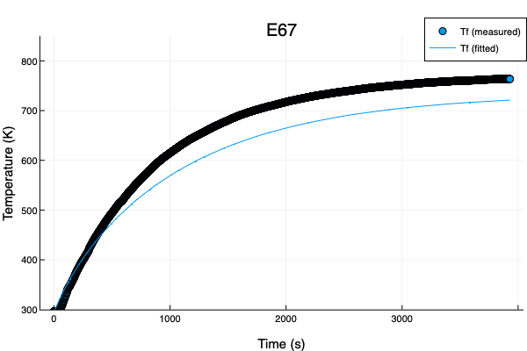 | 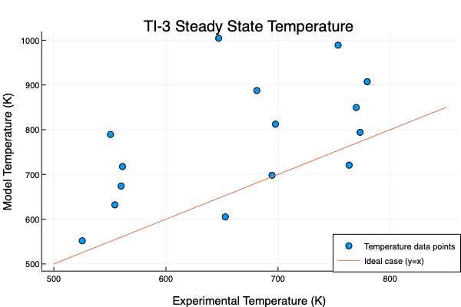
Figure S13. Comparison of transient lumped model results with measurements, for the gas (left) domain at a flux of 442 kW/m² (3% decrease from 456 kW/m²) and air flowrate of 15.3 L/min (E67) using correlation 5 fitted to the gas domain, and comparison of the achieved steady state gas temperatures (parity plot-right) using fitted parameters and heat transfer coefficients for correlation 5.

Table S5. Fitted parameters to the solid and gas domains’ transient profiles and steady state temperatures obtained from the lumped model using correlation 6.
Fitted parameter | Value from lumped model | Range reported in Literature | Reference
Factor on $ρ_{s}C_{ps}$ | 3.83 | - | -
a | 292.97 | 69.90 – 1359.00 | [25] [19]
b | 1.69 | 0.31 – 0.59
c | 15.61 | 6.50 – 16.22

Table S6. Lumped model heat transfer coefficient fitted to the solid and gas transient profiles and steady state temperatures using correlation 6.
Flux (kW/m²) | Experiment No. | Flowrate (L/min) | Nu  number | Model Heat transfer coefficient ($\overline{h}$) ($\frac{W}{m^{2}K}$)
456 | E67 | 15.3 | 0.28 | 0.82
456 | E68 | 12.5 | 0.20 | 0.59
456 | E69 | 10.5 | 0.15 | 0.44
456 | E70 | 9.1 | 0.12 | 0.35
456 | E71 | 7.1 | 0.08 | 0.22
304 | E72 | 18.3 | 0.38 | 1.00
304 | E73 | 13.2 | 0.22 | 0.60
304 | E74 | 9.0 | 0.12 | 0.32
304 | E75 | 7.0 | 0.07 | 0.20
304 | E76 | 4.5 | 0.04 | 0.09
256 | E77 | 13.9 | 0.24 | 0.53
256 | E78 | 10.0 | 0.14 | 0.32
256 | E79 | 8.0 | 0.09 | 0.22
256 | E80 | 6.6 | 0.07 | 0.16
256 | E81 | 4.5 | 0.04 | 0.08

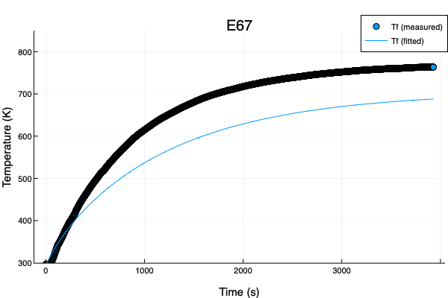 | 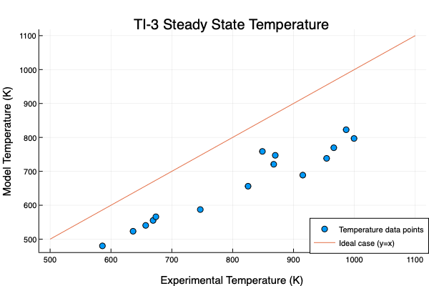
Figure S14. Comparison of transient lumped model results with measurements, for the gas (left) domain at a flux of 442 kW/m² (3% decrease from 456 kW/m²) and air flowrate of 15.3 L/min (E67) using correlation 6 fitted to the solid and gas domains, and comparison of the achieved steady state gas temperatures (parity plot-right) using fitted parameters and heat transfer coefficients for correlation 6.

Table S7. Fitted parameters to the gas domain transient profiles and steady state temperatures obtained from the 1D model using correlation 6.
Fitted parameter | Value from lumped model | Range reported in Literature | Reference
Factor on $ρ_{s}C_{ps}$ | 4.40 | - | -
$$k_{eff}$$ | 11.73 | - | -
$$k_{s}$$ | 13.66 | - | -
a | 588.61 | 69.90 – 1359.00 | [18, 24]
b | 0.84 | 0.31 – 0.59
c | 2.89 | 6.50 – 16.22

Table S8. 1D model heat transfer coefficient fitted to the gas domain transient profiles and steady state temperatures using correlation 6.
Flux (kW/m²) | Experiment No. | Flowrate (L/min) | Nu  number | Model Heat transfer coefficient ($\overline{h}$) ($\frac{W}{m^{2}K}$)
456 | E67 | 15.3 | 1475.40 | 4321.94
456 | E68 | 12.5 | 1247.06 | 3684.65
456 | E69 | 10.5 | 1077.17 | 3173.59
456 | E70 | 9.1 | 955.17 | 2838.27
456 | E71 | 7.1 | 777.26 | 2252.71
304 | E72 | 18.3 | 1720.84 | 4488.23
304 | E73 | 13.2 | 1302.15 | 3553.49
304 | E74 | 9.0 | 948.99 | 2600.79
304 | E75 | 7.0 | 761.64 | 2049.55
304 | E76 | 4.5 | 531.63 | 1377.04
256 | E77 | 13.9 | 1359.26 | 3002.64
256 | E78 | 10.0 | 1035.65 | 2384.97
256 | E79 | 8.0 | 860.79 | 1998.78
256 | E80 | 6.6 | 731.15 | 1700.06
256 | E81 | 4.5 | 531.63 | 1217.46

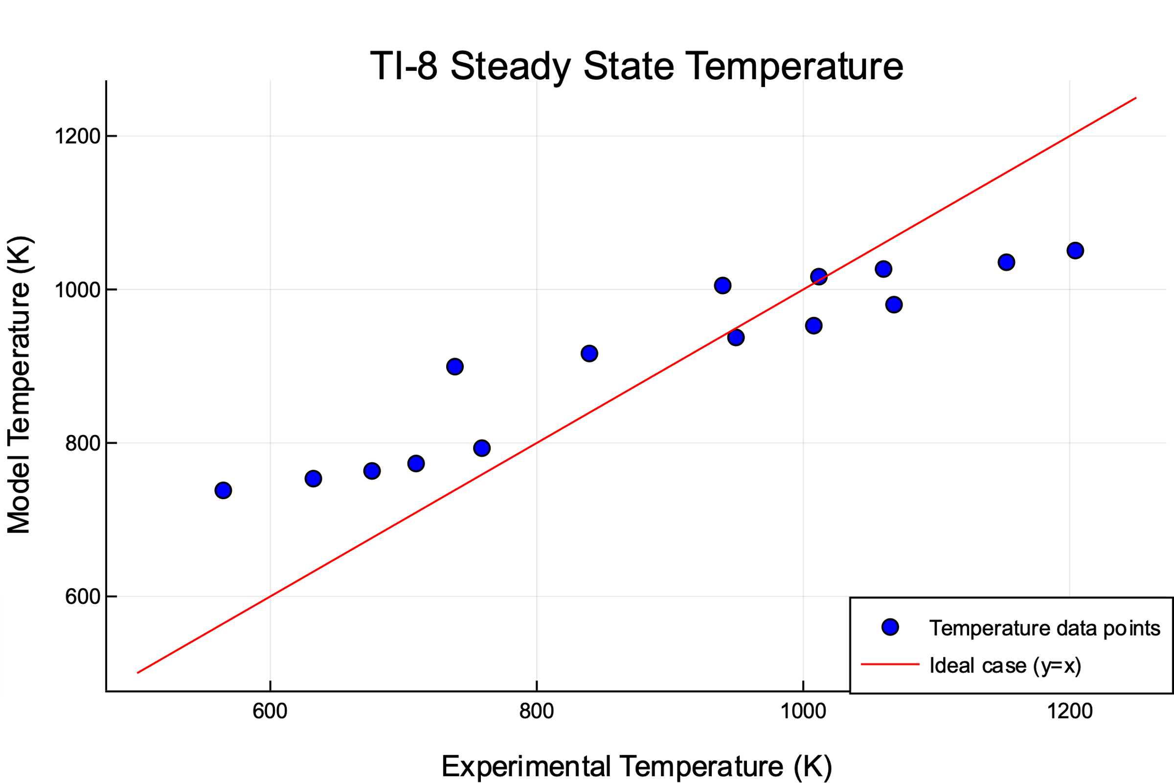 | 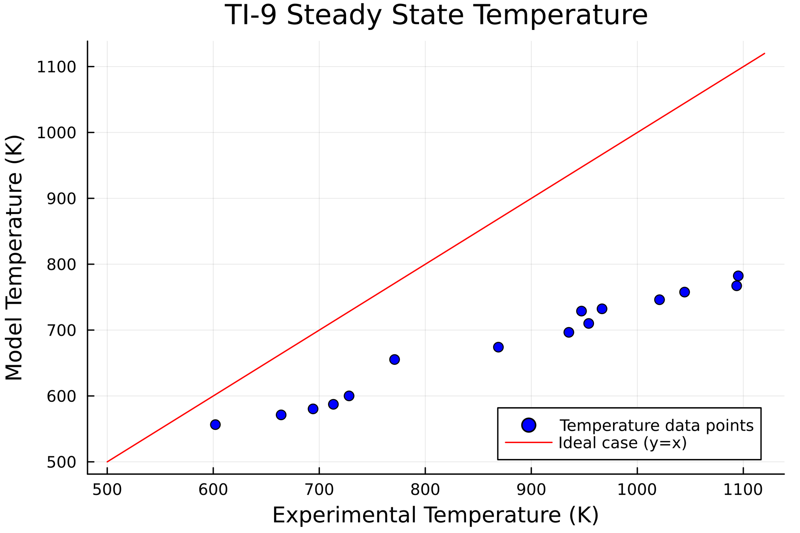
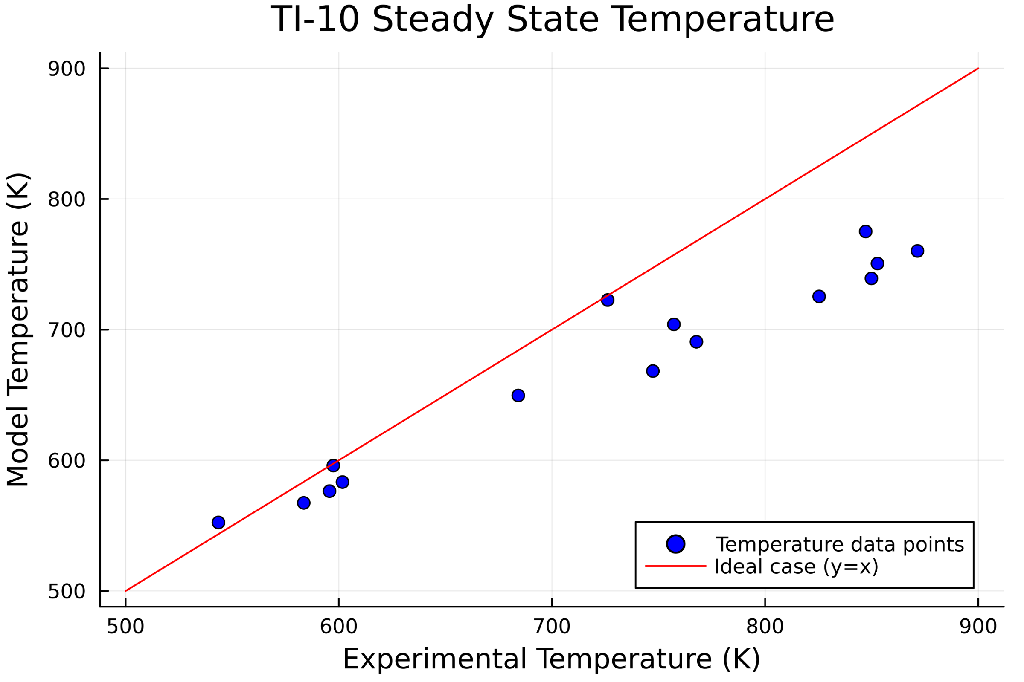 | 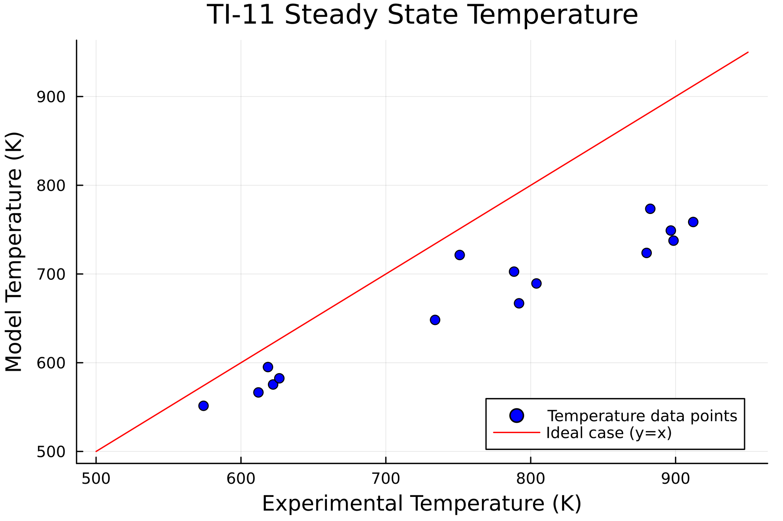
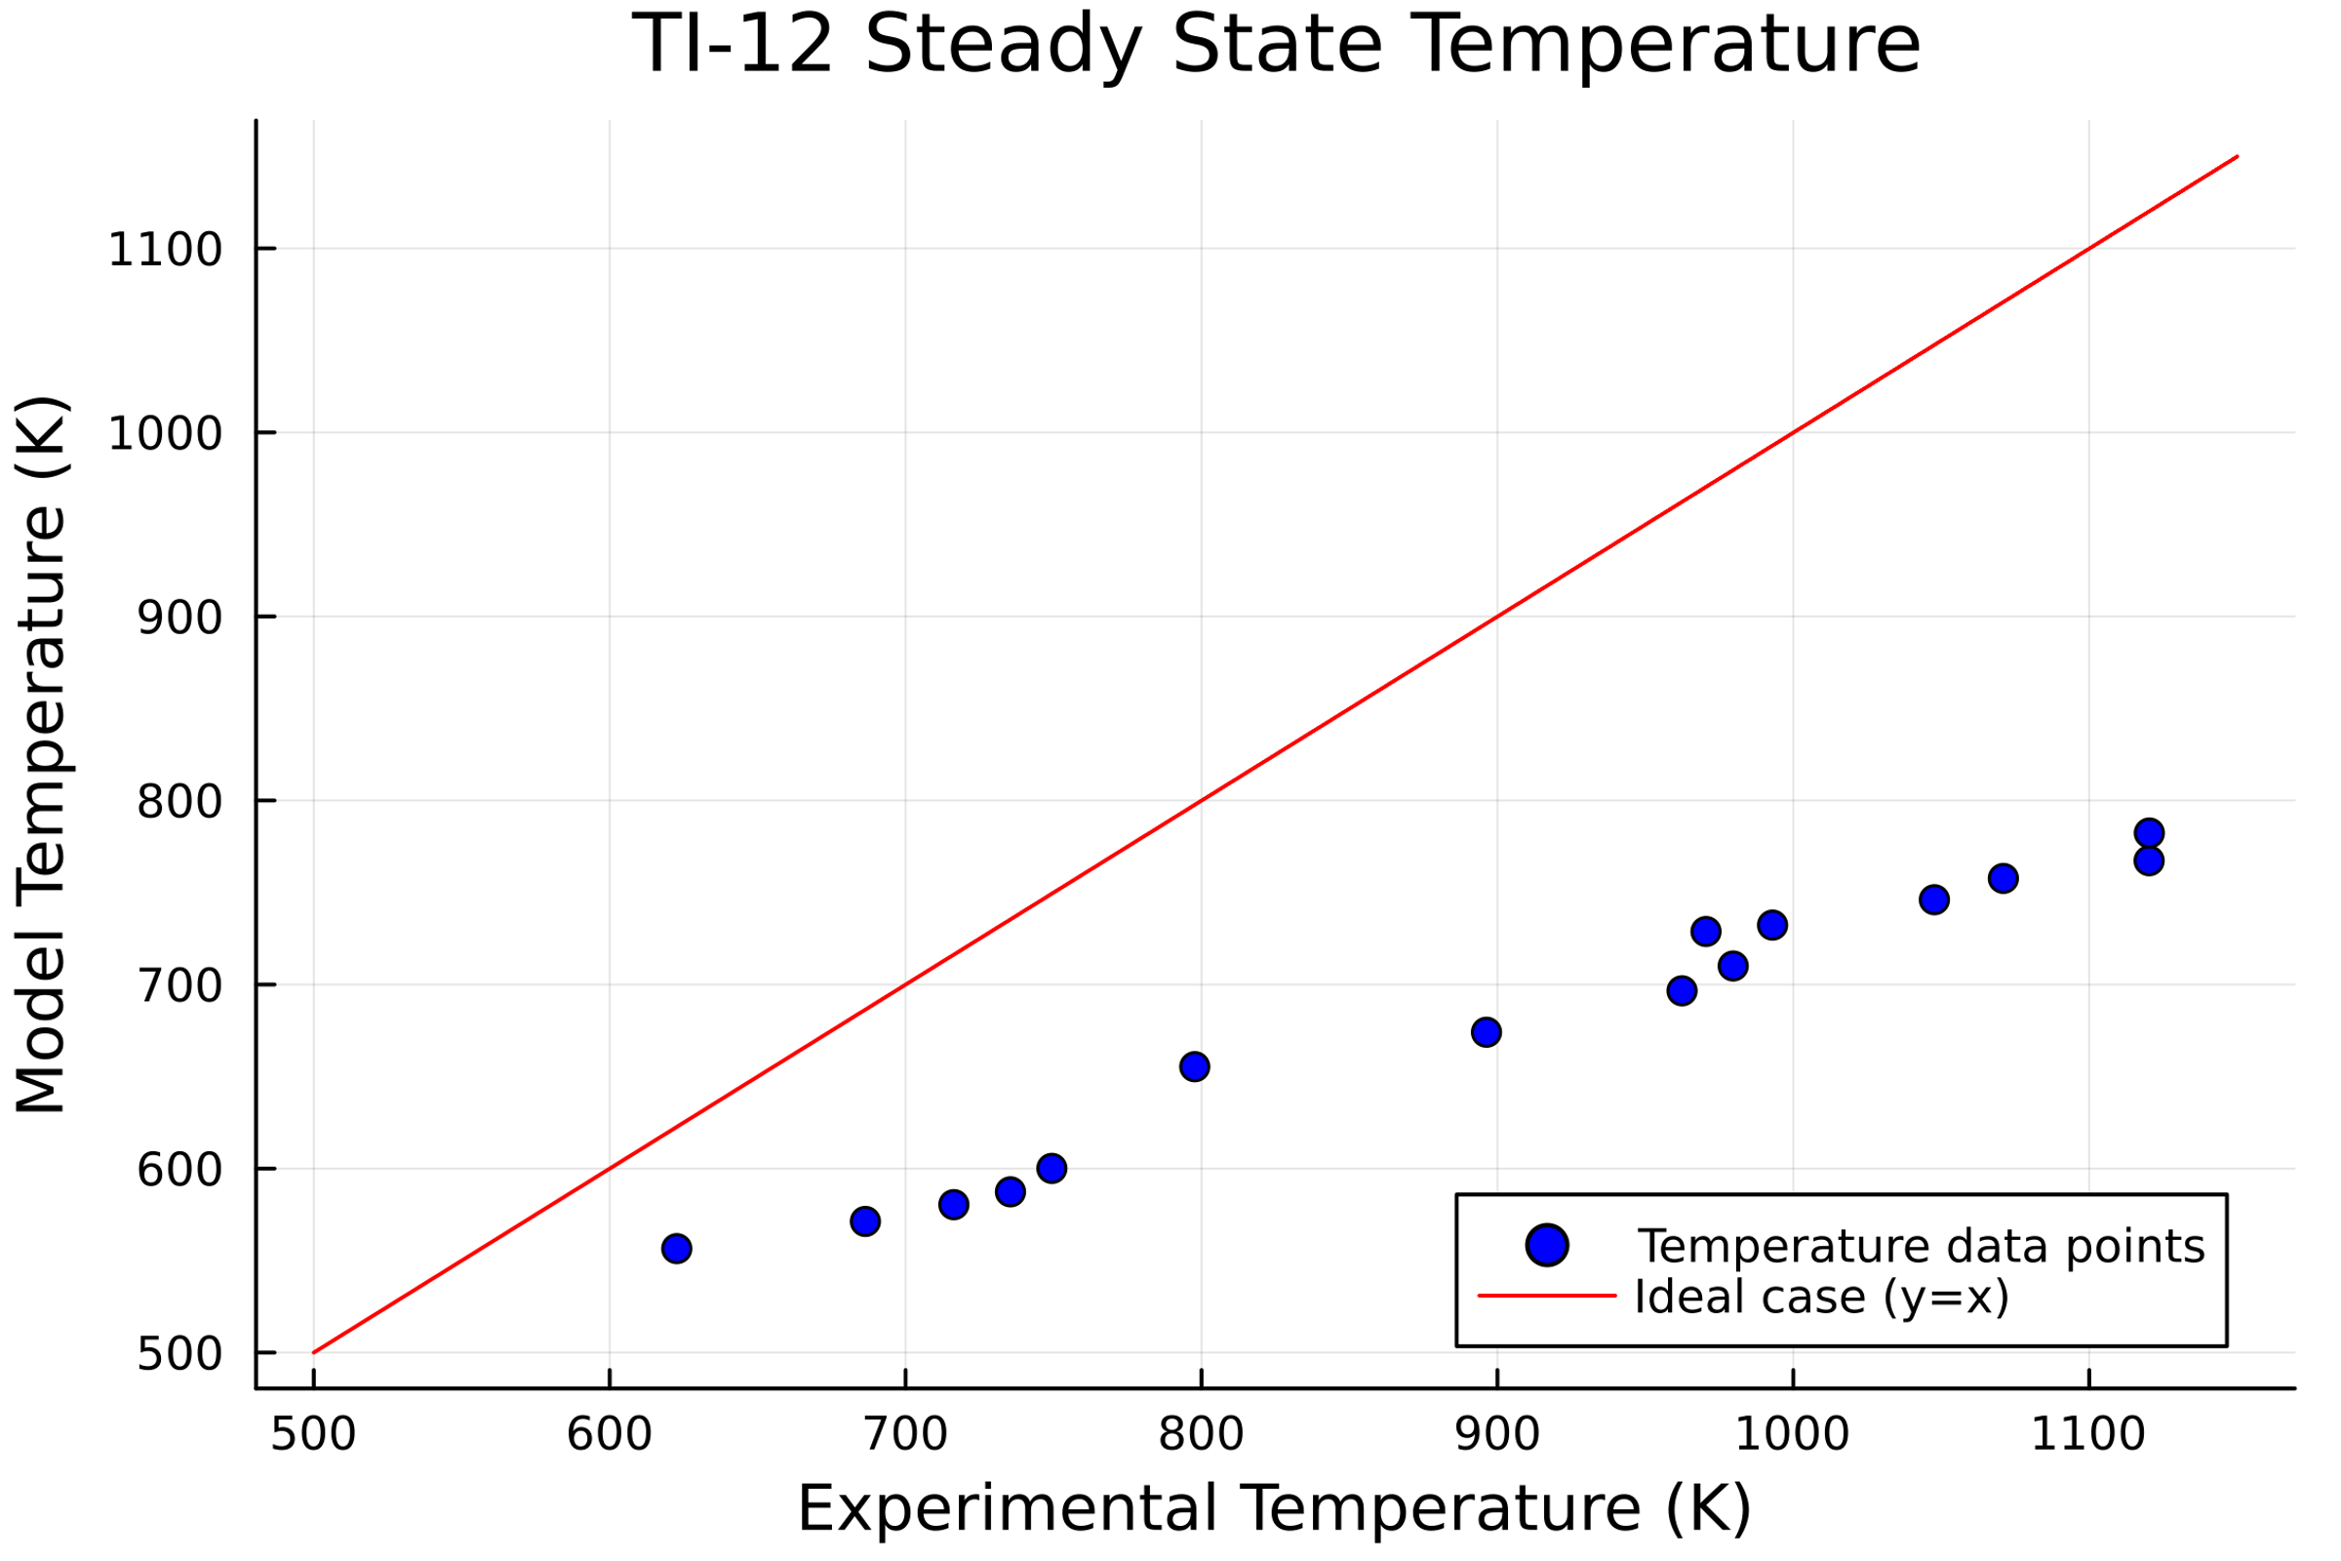
Figure S15. Comparison of the achieved steady state solid and gas temperatures for the 1D model with measurements using the fitted parameters and heat transfer coefficient for correlation 6, at different thermocouple locations (see Figure 3).
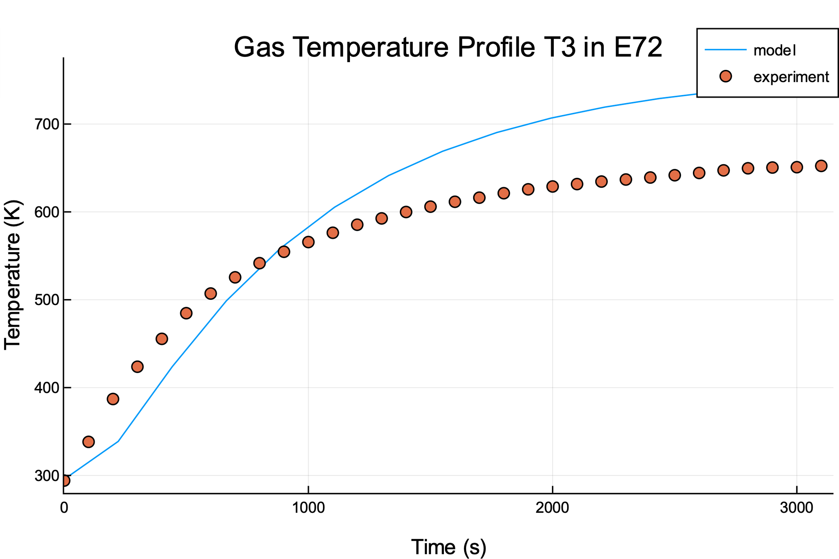 | 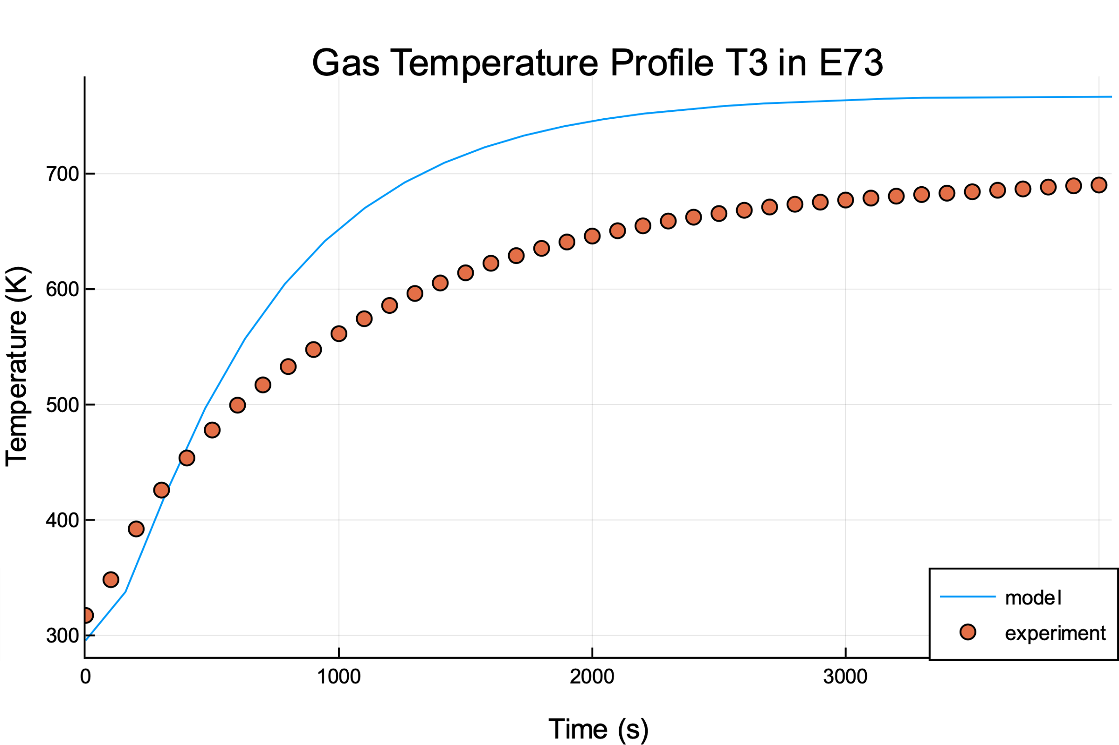
Figure S16. Comparison of transient lumped model results with measurements, for the gas domain at a flux of 372 kW/m² (22% increase from 304 kW/m²) and air flowrate of 18.3 L/min (E72-left), and a flux of 372 kW/m² (3% increase from 304 kW/m²) and air flowrate of 13.2 L/min (E73-right) using correlation 6 fitted to the solid and gas domains.

