Experimental Dataset and Numerical Model Validation of a Lab Scale Solar Volumetric Receiver for High Temperature Industrial Heating

Aysha Melhim¹, Athanasios G. Konstandopoulos^{2,3}, Konstantinos Kakosimos^{1,*}

¹ Chemical Engineering Program, Texas A&M University at Qatar, Doha, Qatar
² Chemical Process and Energy Resources Institute, CERTH, Thessaloniki, P.O. Box 60361, 57001, Greece
³Aerosol & Particle Technology Laboratory, Department of Chemical Engineering, Aristotle University, University Campus, Thessaloniki, 54124, Greece

*Corresponding Author: k.kakosimos@qatar.tamu.edu

Abstract

Concentrated Solar Technology (CST) offers a promising alternative to existing technologies due to its ability to achieve temperatures above 1000ºC and diverse thermal energy storage options, making CSTs suitable for powering chemical processes using volumetric receivers.
Despite many experimental studies on heat transfer in CST receivers, most computational studies are validated against simplified proxies of the actual physical problem. This study addresses the limitations of previous computational studies. High temporal resolution temperature profiles for the solid and gas phases of a silicon carbide (SiC) structured monolith receiver (19x19 mm², 137 mm long, and 42.5% porosity) were collected under various flow and irradiance conditions. The dataset included three replicates of 15 experiments with irradiance levels between 256 and 456 kW/m², air flow rates between 4.5 and 18.3 L/min, covering power ratio levels between 299 to 1211 kJ/kg.
Heat and momentum transport phenomena in the receiver were analyzed using lumped (in-house code), 1D (in-house code), and 3D (COMSOL Multiphysics) mathematical models (conjugated or discrete; single channel or detailed receiver designs) to obtain the heat transfer coefficients $\overline{h}$. The 3D discrete full receiver model, with adjustments to the SiC thermophysical properties, proved most accurate in predicting transient and steady-state temperatures (94.3% accuracy for gas temperature and 84.3% overall accuracy for solid temperatures) and provided a $\overline{h}$ value of 85.0 W/m²·K within the forced convection range. The 1D model outperformed the lumped model in obtaining $\overline{h}$ values resembling the physical system, providing gas temperatures with accuracies between 90.7% – 99.9%.

Introduction
Global carbon dioxide (CO₂) emissions have surged due to extensive fossil fuel use, particularly coal and natural gas, as reported by the International Energy Agency (IEA). Between 1900 and 2020, emissions increased significantly, primarily driven by energy combustion and industrial processes [1]. In 2021, heating activities in the industrial sector alone accounted for 53% of global final energy consumption [2]. Concentrated Solar Power (CSP) technology offers a sustainable solution by using volumetric receivers in CSP plants. These systems concentrate solar radiation onto solid receivers for electricity generation or thermal storage [3]. CSP, especially with point focus systems, improves energy harnessing through concentrated solar radiation and efficient heat absorption, enhancing solar-to-electrical conversion efficiency [4, 5]. CSP can also reduce energy losses by directly converting solar energy into thermal energy with fewer intermediate steps.
To compete with fossil fuels, CSP development focuses on central receivers using air as a heat transfer fluid (HTF) due to its availability and high-temperature capabilities [6, 7]. Open-loop volumetric receivers, incorporating porous structures for efficient heat transfer, face challenges in achieving optimal volumetric efficiency, particularly in fully harnessing the receiver's internal volume [7, 8]. Volumetric efficiency refers to maintaining a cooler temperature at the front of the receiver compared to the temperature of the exiting HTF [7].
Previous computational studies on ceramic foam receivers used 1D modeling for radiation propagation, but these studies were limited to steady-state conditions without considering temporal variations [9]. While transient behavior studies by Roberta et al. [10] and Reddy et al. [11] focused on temperature profiles in porous foam materials, they primarily validated numerical models from existing and limited literature. Structured monoliths, commercially available and commonly used in catalytic systems, offer a standardized alternative for temperature profile validation. This type of receiver, studied by Roldán et al. [12] for thermal analysis and design, was also examined in steady-state 2D numerical models, similar to earlier work by Zaversky et al. [9]. Experimental studies by Zaversky et al. [9], Mey-Cloutier et al. [13], and Capuano et al. [14] have explored porous receivers and their heating efficiency. Ali et al. [15] validated an optical and CFD model using experimental data from Cloutier et al. [13], demonstrating good agreement with experimental results for a SiC honeycomb receiver. Capuano et al. [14] also performed numerical validation using experimental results from synthesized foam receivers.
Despite these efforts, there is a lack of validation studies for transient temperature profiles using structured monoliths, emphasizing the need for complete experimental datasets for such receivers. Previous studies, like those by Roberta et al. [10] and Reddy et al. [11], lacked detailed information on thermocouple placement, complicating the validation and replication of temperature profiles.
This work addresses these gaps by providing a complete experimental dataset of transient temperature profiles for a structured SiC receiver, covering power ratios from 278 kJ/kg to 1124 kJ/kg at three locations along the receiver's length. To validate the model, literature-based Nusselt (Nu) number correlations were assessed, leading to the calculation of new, case-specific heat transfer coefficients ($\overline{h}$).
Earlier studies on honeycomb structures used a continuum-based approach to derive theoretical expressions for effective heat conductivities, considering the influence of micro-geometric attributes like channel shape and void extent [16]. Hayes et al. and Cornejo et al. [17] focused on heat and mass transfer in monoliths, developing correlations for Nu and Sherwood (Sh) numbers and introducing new models based on local rather than average values for these numbers. Recent studies by Avila-Marin et al. [18] numerically determined the convective heat transfer coefficient for air volumetric receivers, highlighting the impact of mesh size and specific surface area.
This work adopts correlations 5 and 6 from the literature (see Table 1) to determine heat transfer coefficients for a structured monolithic receiver. The goal is to bridge the gap between numerical predictions and experimental validation by fitting these correlations to real physical systems.
The objective of this study is to validate a 3D mathematical model with surface-to-surface radiation to obtain temperature profiles for both solid and fluid components. To streamline computational demands and enable detailed radiation modeling, the receiver will be simplified to a single channel. This model will be crucial in evaluating solar-to-thermal efficiency, primarily validated using lab-scale experimental data. Additionally, a numerical model of the absorber, a rectangular honeycomb receiver, will be developed to verify the applicability of Nu correlations and to determine the appropriate parameters for the given geometry. The uniqueness of this work lies in its comprehensive approach, integrating experimental results from a custom-built volumetric receiver setup for validating 0D, 1D, and 3D numerical models.

Table 1. Correlations of Nu and Sh numbers over the past 30 years.
Correlation no. | Correlation | Reference
1 | $$Nu=3.66(1+0.095\frac{D}{L}Re{Pr⁡)}^{0.45}$$  $$Sh=3.66(1+0.095\frac{D}{L}ReSc)^{0.45}$$ | [17]
2 | $$Nu=0.571(Re\frac{D}{L})^{\frac{2}{3}}$$  $$Sh=0.705(Re\frac{D}{L})^{0.43}{Sc}^{0.56}$$ | [19]
3 | $$Nu=0.0767(1+\frac{D}{L}RePr)^{0.829}$$  $$Sh=0.0767(1+\frac{D}{L}ReSc)^{0.829}$$ | [20]
4 | $$Sh=0.766(\frac{D}{L}ReSc)^{0.483}$$ | [21]
5 | $$Nu=A[1+B(Gz)^{n}\exp\left(-\frac{C}{Gz}\right)]$$ | [17, 22, 23]
6 | $$Nu=a{Re}^{b}{Pr}^{c}$$ | [24] [18]

Methodology

This section comprehensively covers the experimental setup, procedural details, and mathematical models employed for validation. Initially, it outlines the experimental system and requisite procedures. Following this, it enumerates the governing equations for the energy and momentum transfer, alongside their associated boundary conditions and simplifications for a 0D (lumped), 1D, and 3D computational models. The method of lines (MOL) and finite differences method (FDM) approaches were used to 1D temperature equations within the solid and fluid domains, and the finite element method (FEM) for addressing momentum and energy equations in the 3D model. The discussion extends to encompass parameters, outcomes, and methodologies utilized for comparing the 0D and 1D models against literature Nu number correlations, and to obtain the appropriate parameters for the given receiver.

  - HFSS and Volumetric Receiver Configuration
The experimental set up utilizes artificial light sources with ellipsoidal reflectors to concentrate the light on the frontal opening of the volumetric receiver. The light source and reflector are what constitutes the high flux solar simulator (HFSS) as depicted in Figure 1B. The HFSS system includes seven lamps with ellipsoidal aluminum coated reflectors (Figure 1B). The lamps were 6 kWe Xe short arc connected to a controller for configuring the positions of the lamps. The lamps were in a squeezed hexagonal configuration with the seventh lamp in the center (Figure 1B). For safety purposes and control of temperature, the HFSS is contained in a 7x3.5x2.5 m³ (LxWxH) compartment made from aluminum composite panels. The reflectors have two focal points; one at 90 mm and another at 2,790 mm from the vertex on the horizontal axis, with a 735 mm opening and 450 mm length. To achieve the maximum flux, the lamp is placed at the first focal point (90 mm from the vertex) and the target object, the volumetric receiver in this case, is placed at the second focal point (2,790 mm from the vertex). More details about the design and operation of the HFSS can be found in the literature [25].
The volumetric receiver used is a commercial square channeled extruded honeycomb made from silicon carbide (SiC) and other additives [Silicon oxide (SiO₂), SiC- Miossanite-6H, and SiC- Miossanite-3C]. It is 137 mm long ($L$) with a width of 19 mm ($w_{total}$) and a total of ($n_{channel}$) 100 channels. A channel has width ($w_{channel}$) 1.5 mm and a wall thickness ( $t_{channel}$) of 0.4 mm. The whole receiver is placed horizontally facing the HFSS, and enclosed in an aluminum cavity (142 mm in diameter) surrounded with alumina felt insulation (~ 0.078 W m⁻¹ K⁻¹) to thermally insulate the peripheral outer walls of the monolith. Figure 2 presents a schematic of the volumetric receiver utilized in the experiments, highlighting the key transport phenomena occurring within it.
To capture the temperature profiles of the different domains, type-N thermocouples, with Nicrotherm DTM sheath (OD 1.5 mm x 150 mm long, ~ ±2.2 ◦C, by TCDirect UK, were placed to on the external walls of the monolith (TI-8, 9, 10). Type-N miniature thermocouples, with Nicrotherm DTM sheath (OD 0.5 mm x 500 mm long, ~ ±2.2 ◦C, by TCDirect UK were placed in the internal walls of the monolith (TI-11, 12) temperatures’ (Figure 3). Two type-N thermocouples were placed to measure the gas inlet (TI-1) and outlet temperature (TI-3) with the same specifications as the external wall thermocouples. The cooling coil and water flanges were placed to cool the air exiting the monolith using type-K with InconelTM 600 sheath (OD 3 mm, IEC60584 Class 1: ~ ± 1.0 ◦C by Omega Engineering Inc UK) thermocouples (TI-4, 6, 7) and in the alumina felt insulation (TI-2) to monitor any temperature change.
The monitoring, control, and operation of the HFSS was carried out using LabView environment by National Instruments. The interface of LabView provided the outputs of the thermocouples in the form of a digital signal as temperature. A temperature input module NI 9213 by National Instruments was used to collect the voltage output as an analog signal with a 1 Hz sampling rate, which is then converted to a digital signal with an error less than 0.25ºC.
Four volumetric flow controllers (type GFC 17 by AALBORG Instruments & Controls, Inc US) in the range of 0 – 5 standard L min⁻¹ (0.02 L min⁻¹ precision, accuracy ± 1.0 % of the full scale) were used to control the air flowrate. The flow controllers are four instead of one to improve the accuracy to 0.05 L.min⁻¹ instead of 0.2 L.min⁻¹. The differential pressure (PI-1) along the monolith was measured using a differential pressure transducer (±200 mbar; PD33X, accuracy ± 0.1 % of the full scale, by Keller and purchased from Comer srl, Italy). An analog input module (ADAM-4117 by Advantech,) was used to measure and collect the analog signals from the flow and pressure controllers with 1 Hz sampling rate.

  - Measurement of Irradiance
To quantify the flux on the target (volumetric receiver), characterization of the heat flux was conducted with the details provided in [25]. Simply put, a three-step method was used for mapping the irradiance on the target, known as flux characterization. This enables the spatial flux distribution determination with minimum direct measurements and high accuracy. In this scenario, the target is a Lambertian reflector (250x250 mm² stainless steel slab plasma coated with Al₂O₃ made to order by Haueter Engineering, Switzerland) mounted on a 3-axis slider (NLS8–500–101, NLS8–300–102, and NLS8–200–101 precision sliders by NewMark) with a resolution of 0.08 μm and a 1 μm repeatability. The Lambertian reflector enforced the incident light to be reflected in all direction equally and the target was equally bright in all viewing angles [26].
In a similar fashion, a heat flux gauge (HFG) that is a Gardon-type circular foil radiometer (HFG by Vatell: TG1000-0 with a colloidal graphite coating, calibrated with 1% repeatability, 2 mV (W cm⁻¹)⁻¹ sensitivity, and a transducer calibration accuracy of ± 3%) was placed at the Lambertian target center to measure the irradiance at several locations. The output of the HFG (order of 0-10 mV) was recorded using a 24-bit thermocouple input module (NI-9211 by National Instruments) at high resolution and voltage (range ± 80 mV) reading mode. The HFG and Lambertian target were connected to type-K thermocouples (OD 3 mm, IEC60584 Class 1: ~ ± 1.0 ◦C by Omega Engineering Inc UK) to maintain their temperature at 25ºC using a water-cooling system (F50-ME chiller by Julabo).
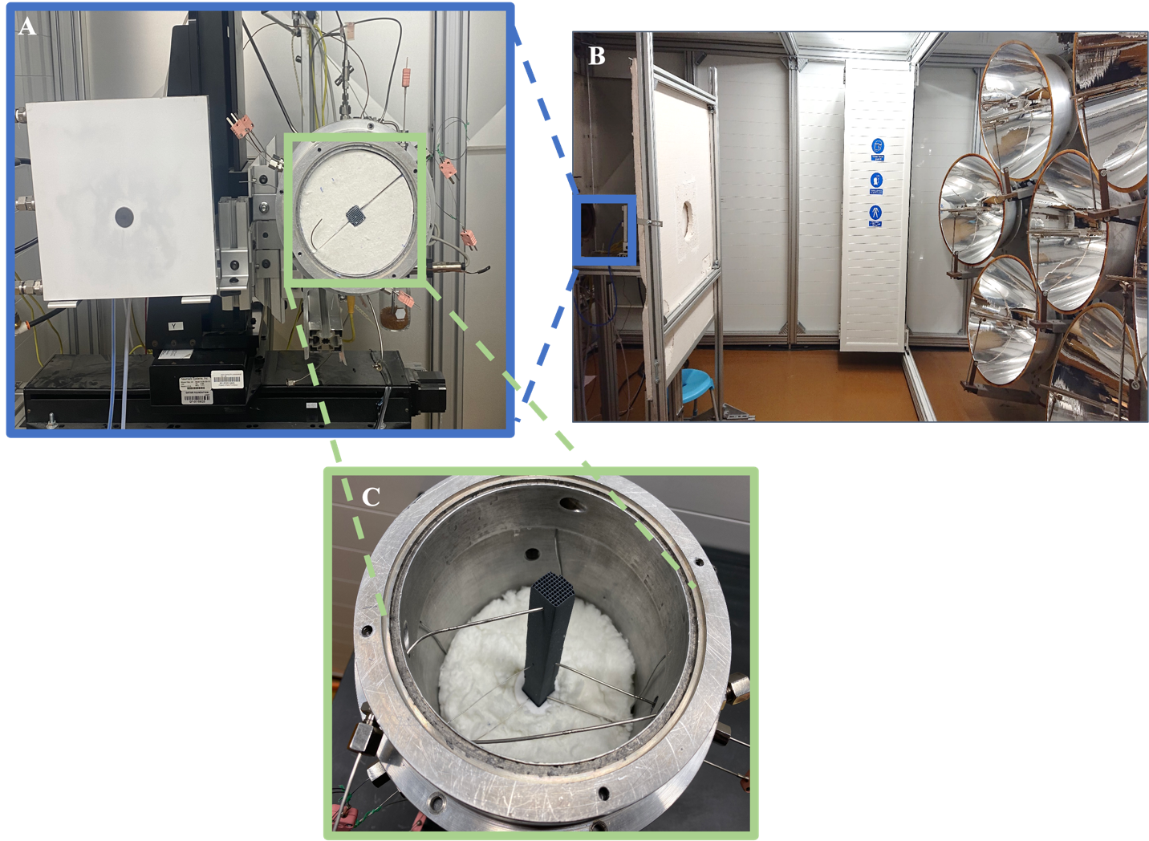
Figure 1. Photos (A) of the assembled volumetric receiver setup and HFG left to the volumetric receiver, (B) the high flux solar simulator, and (C) the receiver during the building stage.

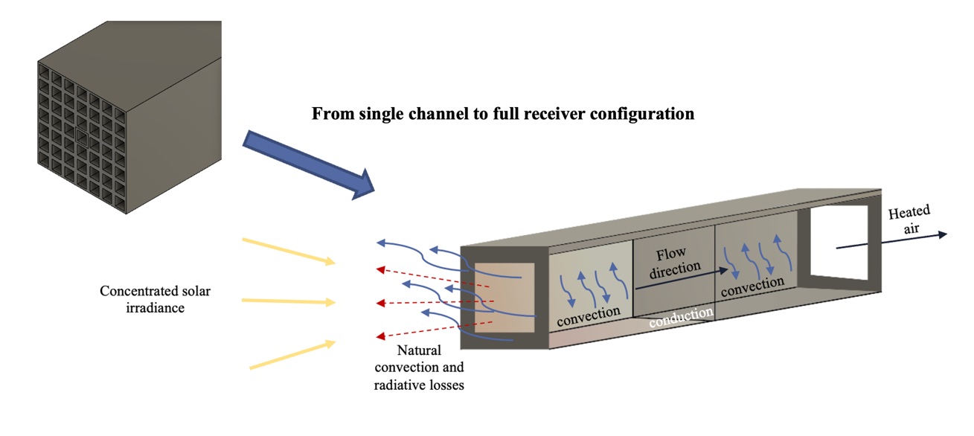
Figure 2. Illustration of the transport phenomena occurring in the volumetric receiver.
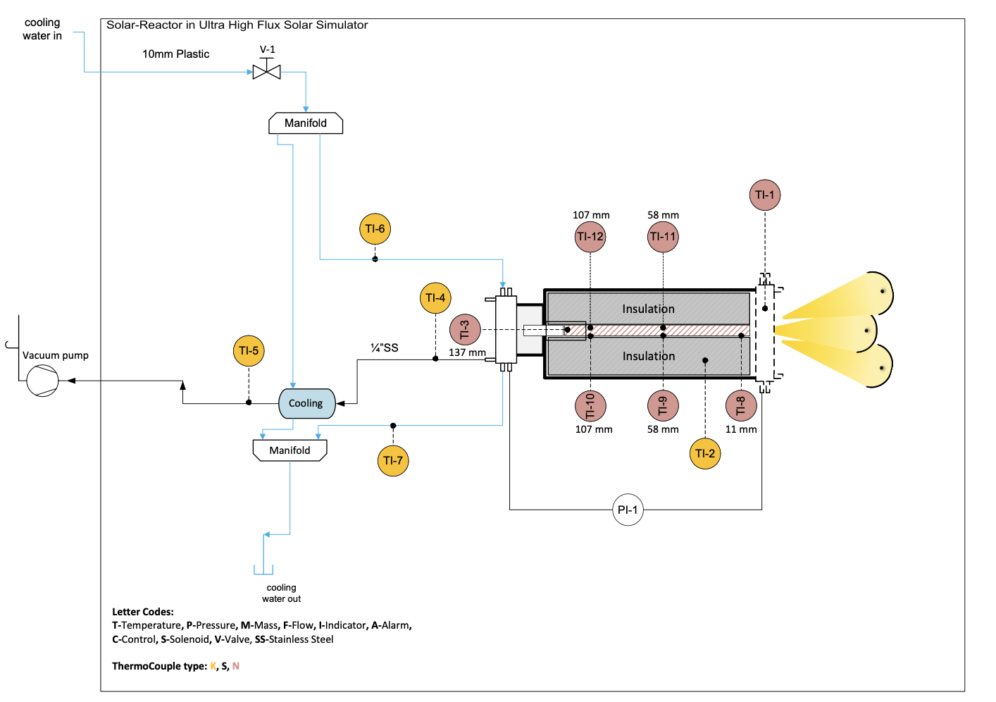
Figure 3. Process and instrumentation diagram (PID) of the experimental solar receiver system.

  - Experimental Design and Procedure
The aluminum cavity, with the receiver, is mounted also on the 3-axis slider (Figure 1A) with its frontal face facing the HFSS light sources. Ambient air is sucked into the receiver because of a vacuum pump (VACUUBRAND RZ 2.5 rotary vane vacuum pump, 2 stages: maximum pumping speed of 2.3 m³/h at 50 Hz and ultimate vacuum of 2x10⁻³ mbar) connected at the outlet of the mass flow controllers (Figure 3 - PID). The experiments were operated at three different (irradiance) powers on the aperture, resulting to several power ratios summarized in Table 2. The air outlet temperature and the solid temperatures were measured at different positions from the inlet (see Figure 3). The full experimental dataset is available at out GitHub repository [https://github.com/tamu-edu/tamuq-chen-secarelab-receiver/tree/OneDimension.].

Table 2. Campaign for the volumetric receiver experiments.
Flux (kW/m²) | Flowrate (L/min) | Power ratio (kJ/kg) | Re number per channel | Average solid external temperature (ºC) | Average solid internal temperature (ºC) | Gas temper-ature (ºC)
456 | 15.3 | 539 | 66 | 649 | 669 | 491
 | 12.5 | 658 | 54 | 695 | 702 | 500
 | 10.5 | 784 | 45 | 717 | 712 | 497
 | 9.12 | 904 | 39 | 771 | 743 | 506
 | 7.1 | 1156 | 31 | 778 | 728 | 480
304 | 18.3 | 299 | 79 | 462 | 499 | 380
 | 13.2 | 417 | 57 | 548 | 572 | 421
 | 9.0 | 608 | 39 | 616 | 612 | 425
 | 7.0 | 790 | 30 | 636 | 611 | 408
 | 4.5 | 1211 | 19 | 641 | 588 | 374
256 | 13.9 | 334 | 60 | 300 | 328 | 252
 | 10.0 | 461 | 43 | 354 | 376 | 281
 | 8.0 | 575 | 35 | 383 | 396 | 287
 | 6.6 | 698 | 28 | 403 | 408 | 288
 | 4.5 | 1020 | 19 | 424 | 413 | 277
In Table 2, the Re number was calculated to be in the range of 19 to 66, falling within the laminar flow region.

  - Numerical Modeling
For the numerical modeling, typical assumptions state that the SiC ceramic material, which serves as the absorber, possesses consistent and uniform properties, exhibits scattering in all directions equally (isotropic scattering), and behaves as a body that emits and absorbs radiation uniformly across all wavelengths (gray emitting and absorbing body). The overall features of the SiC ceramic monolith are determined by its relative density, pore size, thermal conductivity, and mechanical strength [27]. Several models were built to be validated using the experimental data.

Initially, a lumped model was calibrated to match the experimental data by adjusting the thermophysical properties of SiC, the heat transfer coefficient, and the incoming heat flux to improve the accuracy of the temperature profiles as it has few unknowns. Subsequently, these adjusted properties were applied to more complex 1D and 3D models, to further verify the modifications made to the properties of SiC and improve the accuracy of the temperature predictions. This section presents the relevant model equations for the 0D, 1D, and 3D models, along with the initial and boundary conditions applied to each.

2.4.1.Lumped (0D) Model
To simplify the problem, the lumped analysis was applied, assuming the temperature variation across all dimensions is uniform except time. The following equations were applied for the lumped model.

Initially, the lumped model was used to fit the thermophysical properties on the experimental data. The properties that were fitted were the density $ρ_{s}$ and heat capacity $C_{p_{s}}$ of the solid along with $\overline{h}$ using different Nu number correlations shown in Table 1. The PEtab.jl package was used to allow for fitting all set parameters to the 15 experiments including both the solid and gas domains.
Equation 1
$${\left(1-φ\right)ρ}_{s}C_{p_{s}}V_{s}\frac{dT_{s}}{dt}=q_{rad,dep}A_{front}-\overline{h}A_{v}V_{s}\left(T_{s}-T_{f}\right)-A_{front}εσ\left({T_{s}}^{4}-T_{amb}^{4}\right)-{A_{front}h}_{nat}\left(T_{s}-T_{amb}\right)-k_{ins}A_{loss}\frac{r}{r_{0}}\frac{\left(T_{s}-T_{ins}\right)}{\left(r-r_{0}\right)}$$
Where $q_{rad,dep}$ is the incoming flux [W/m²] and $A_{front}=w_{total}^{2}$ [m²], $k_{ins}$ is the alumina insulation thermal conductivity at a value of 0.078 W/m².K and $T_{ins}$ represents the reading from TI-2 shown in Figure 3. The periphery of the receiver A_{loss} is equal to $4×w_{total}×L$, $r_{0}$ is the inner radius of the insulation [23 mm], $r$ is the outer radius of the insulation [42 mm], $ε$ is the solid material’s emissivity and $σ$ is the Stefan-Boltzmann constant [W/m².K⁴]. The natural convection is modeled by a constant heat transfer coefficient $h_{nat}$ at a value of 10 W/m².K taken from [6].

Equation 2
$${φρ}_{f}C_{p_{f}}V_{f}\frac{{dT}_{f}}{dt}={-m}_{f}C_{p_{f}}(T_{f}-T_{amb})+\overline{h}A_{v}V_{s}\left(T_{S}-T_{f}\right)$$
Where $m_{f}$ is the fluid’s mass flowrate [kg/s], $ρ_{f }$is the fluid’s density, and $C_{p_{f}}$ is the fluid’s heat capacity. In the mentioned equations, the s subscript refers to the solid phase and f refers to the fluid phase.
The porosity $φ$ of SiC was calculated using the formula below from [28]:
Equation 3
$$φ=\frac{{w_{channel}}^{2}×L}{(w_{channel}+2t_{channel})^{2}×L}=0.425$$
The convective term in Equations 1 and 2 accounts for the heat transfer between the solid and fluid domains along the receiver length. $A_{v}$ is a parameter dependent on the geometry of the receiver, which represents the heat transfer surface per unit volume and is applied as a ratio of the effective heat transfer surface in the porous medium to the volume of the medium [28] as shown in Equation 4. The product of $A_{v}V_{i}$ represents the actual heat transfer surface in the control volume $V_{i}$ equal to the solid’s volume $V_{s}$ in this problem.
The convective heat transfer occurs between both domains as shown in Figure 4 where $T_{S}$and $T_{f}$ are common variables in both equations.

Equation 4
$A_{v}= \frac{4×w_{channel}×L}{{{(w}_{channel}+t_{channel})}^{2}×L}=1662 m^{-1}$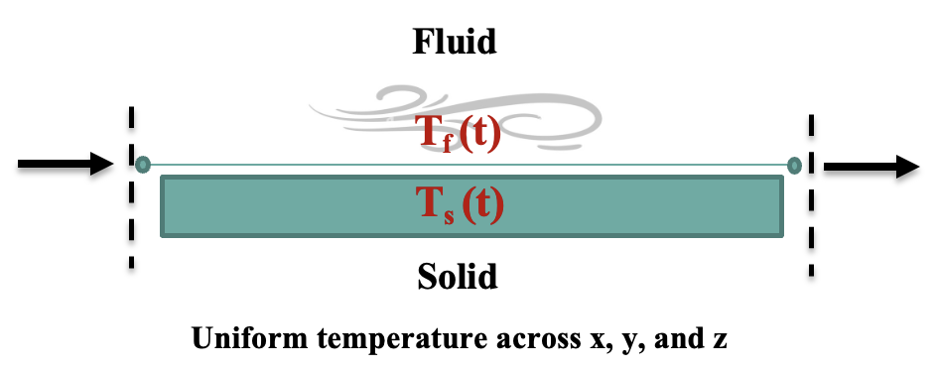
Figure 4. Solid and fluid domains’ energy exchange in the 0D model.

2.4.2.FDM (1D) Model
The entirety of the receiver was modeled as a 1D system to be validated and to mainly evaluate the average heat transfer coefficient and the thermophysical properties of the given receiver. The density $ρ_{s}$ and heat capacity $C_{p_{s}}$ of the solid along with $\overline{h}$ were also obtained using the lumped model. Nonetheless, the 1D model was developed for further validation of the values obtained from the lumped model. The radial heat conduction was considered insignificant compared to the substantial temperature gradient in the axial direction.
For the solid and gas domain, the following temperature equations are used, respectively:
Equation 5
$${\left(1-φ\right)ρ}_{s}C_{p_{s}}V_{s}\frac{dT_{s}}{dt}=k_{eff}A_{front}\frac{d^{2}T_{s}}{dx^{2}}-\overline{h}A_{v}V_{s}\left(T_{s}-T_{f}\right)-k_{ins}A_{loss}\frac{r}{r_{0}}\frac{\left(T_{s}-T_{ins}\right)}{\left(r-r_{0}\right)}$$
Equation 6
$${φρ}_{f}C_{p_{f}}V_{f}\frac{{dT}_{f}}{dt}={{φk}_{f}A_{front}\frac{d^{2}T_{f}}{dx^{2}}-m}_{f}C_{p_{f}}\frac{dT_{f}}{dx}+\overline{h}A_{v}V_{s}\left(T_{S}-T_{f}\right)$$
Where $k_{f}$ is the fluid’s thermal conductivity [W/m.K], $V_{f}$ is the fluid’s volume [m³], and the effective thermal conductivity $k_{eff}$[W/m.K] was used for the solid phase. In honeycomb monoliths, $k_{eff}$can be easily estimated by considering the parallel flow pattern along the channels within the structure using Archie’s law:
Equation 7
$$\frac{k_{eff}}{k_{s}}=1.97(1-φ)^{1.5}$$
To solve the 1D differential equation, an initial condition of time equal zero, the initial temperature is ambient for both domains:
Equation 8
$$at t=0, T_{initial }= T_{amb}$$
The first boundary condition is the frontal solid wall $\left(x=0\right)$ is exposed to the solar irradiance while radiative and convective losses occur to the ambient environment (Equation 9). The Danckwert boundary condition is applied for the fluid (Equation 10).

Equation 9
$${-k}_{s}\frac{{dT}_{s}}{dx}=-εσ\left(T_{s}^{4}-T_{amb}^{4}\right)-h_{nat}\left(T_{s}-T_{amb}\right)+q_{rad,dep}$$

Equation 10
$${-k}_{f}\frac{{dT}_{f}}{dx}=ρ_{f}∆Hu$$
Where $∆H=\int_{T_{upstream}}^{T_{in}}{C_{p}dT}$. Therefore, Equation 10 becomes:
Equation 11
$${-k}_{f}\frac{{dT}_{f}}{dx}=-ρ_{f}C_{p_{f}}u_{x}\left(T_{f}-T_{amb}\right)$$
The second boundary condition at $\left(x=L\right)$ is the insulation of the channel’s back face for the solid and fluid domains (Equations 12 and 13).
Equation 12
$${-k}_{eff}\frac{{dT}_{s}}{dx}=0$$
Equation 13
$${-k}_{f}\frac{{dT}_{f}}{dx}=0$$

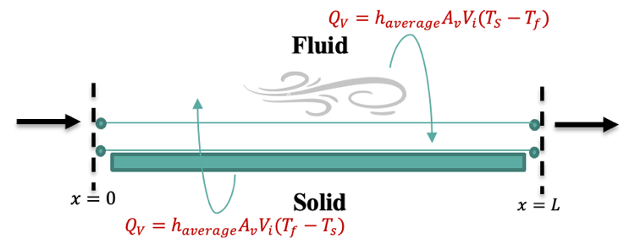
Figure 5. Solid and fluid domains’ energy exchange in the 1D model.

2.4.3.CFD (3D) Model
To model the transient operation of the receiver, heat, momentum, and radiative transport were considered. Initially, a single-channel receiver model was used to reduce computational complexity [29], a common approach for structured receivers. The model was later expanded to represent the full receiver, integrating heat transfer and fluid dynamics. COMSOL Multiphysics® was used to simulate CFD phenomena for single-channel, conjugated full receiver, and discrete full receiver systems, solving continuity, momentum, and energy equations for both solid and fluid domains.
The 3D model employed a conjugate heat transfer approach for the single channel and full receiver, combining gas and solid phases into a single heat transfer equation, eliminating the need for a separate heat transfer coefficient. The discrete full receiver model introduced a heat transfer coefficient, with separate energy equations for solid and fluid domains, exchanging heat via convective transfer.
To model the heat transfer phenomena occurring in the receiver for the solid and fluid, the temperature equation (Equation 14) was used for both domains. The solid phase is stationary; therefore, the velocity component is set to zero $\left(u∙∇ =0\right)$when representing it.
Equation 14
$$ρ_{s}C_{p_{s}}\frac{∂T_{s}}{∂t}+ρ_{s}C_{p_{s}}\left(u∙∇\right)T_{s}=k_{s}∇^{2}T_{s}$$
The fluid’s temperature equation, as outlined in Equation 15 [30]:
Equation 15
$$ρ_{f}C_{p_{f}}\frac{∂T_{f}}{∂t}+ρ_{f}C_{p_{f}}\left(u∙∇\right)T_{f}=k_{f}∇^{2}T_{f}$$
The velocity field $u$ is obtained using the Boussinesq approximation, which assumes the fluid is incompressible and couples the Navier-Stokes and thermal energy equations.
Equation 16
$\frac{∂u}{∂t}+$ $∇∙\left(uu\right)=-∇p_{k}I+v∇^{2}u+\left[1-\overline{β}\left(T-\overline{T}\right)\right]g$
Where $p_{k}=\frac{p }{{(ρ}_{g}-{\overline{ρ}}_{g})}$ is the kinematic pressure [m²/s²], $I$ is the identity matrix, $v=\frac{μ}{{(ρ}_{g}-{\overline{ρ}}_{g})}$ is the kinematic viscosity [m²/s], ${\overline{ρ}}_{g}$ is the density of the fluid at the average wall temperature $\overline{T}$[kg/m³], and $\overline{β}=\frac{1}{ρ_{0}}(\frac{∂ρ}{∂T})_{p}$ is the thermal expansion coefficient obtained at $\overline{T}$ [1/K].
The Boussinesq approximation applies under the application of the continuity assumption (Equation 17) and under the assumption that the fluid is incompressible, Equation 18 is obtained:
Equation 17
$\frac{∂ρ_{f}}{∂t}+$ $∇∙\left(ρ_{f}u\right)=0$
Equation 18
$$∇∙u=0$$
The radiative flux distribution was obtained from TracePro 2018 (Table 3) and implemented as a boundary heat source in the solid phase energy equation. Radiative transport was modeled using a surface-to-surface (S2S) radiation model, calculating net radiative flux as the difference between radiosity and irradiance. Radiosity was determined using the Stefan-Boltzmann law and reflected irradiance. Mutual, external, and ambient irradiance components were estimated with view factors and Monte Carlo Ray Tracing (MCRT). The model was configured in COMSOL, solving heat, momentum, and radiosity equations simultaneously.

Table 3. Reflector and lamp properties used for the validation in TracePro.
Reflector Properties
Shape | Elliptical
Hole radius | 45 [mm]
Length | 454 [mm]
First focal length | 90 [mm]
Second focal length | 2970 [mm]
Diameter | 735 [mm]
Lamp Surface Source Properties
Emission type | Flux in radiometric units
Angular distribution | Lambertian
Wavelength | 500 [$μ$m]
Total number of rays released | 10,000,000
Flux | 6000 [W]
Each channel’s internal surface is divided into discrete surfaces k. A function of orientation, size, and distance of the surface k, known as the view factor, is then computed [15].
The flux leaving one surface and entering another is calculated using the following:
Equation 19
$${q_{out,k}=ε_{k}σT_{k}^{4}+\left(1-ε_{k}\right)q}_{in,k}$$
Where $ε_{k}$ is the solid material’s emissivity for the internal surface k and $σ$ is the Stefan-Boltzmann constant [W/m².K⁴].

For the solid phase, the frontal wall convective and radiative losses along with the incoming flux from the concentrated light were accounted for (Equation 20) and the back wall was assumed to be insulated (Equation 21). The following equations represent the boundary conditions:
Equation 20
$-n∙q=q_{conv,nat}+ q_{conv,amb}+ q_{rad,dep}=-h_{nat}\left(T_{s}-T_{amb}\right)-εσ\left({T_{s}}^{4}-T_{amb}^{4}\right)$ $+ q_{rad,dep}$
Equation 21
$$-n∙q=q_{cond}=0$$
The assumption of external the walls being adiabatic appeared inconsistent with the experimental results. The insulation temperature (TI-2) has increased by approximately 10ºC. This indicated the presence of external heat losses from the walls. Therefore, these losses were accounted for as a function of temperature using the conduction heat transfer equation.
The external wall losses were estimated from the experimental results and implemented in the CFD model as the following:
Equation 22
$$-n∙q=q_{loss}= k_{ins}\frac{r}{r_{0}}\frac{\left(T_{s}-T_{ins}\right)}{\left(r-r_{0}\right)}$$
In the energy equation, the interior channel walls in the solid domain were subject to conduction, forced convection, deposited radiative power, and reradiated energy flux. When the energy equations for the solid and fluid domains are solved individually, this can be regarded as a system boundary for the energy equation.

Results and Discussion

  - Experimental Results
Experiments were conducted at three flux levels on the aperture: 456 kW/m², 304 kW/m², and 256 kW/m², representing high, medium, and low heat flux values. At each flux level, five flow rates were tested, resulting in 15 combinations (see Table 2). The flow rates were determined based on the desired power ratio, and the relationship between outlet air temperature and solid temperature at various system locations was compared with the power ratio in Figure 6.
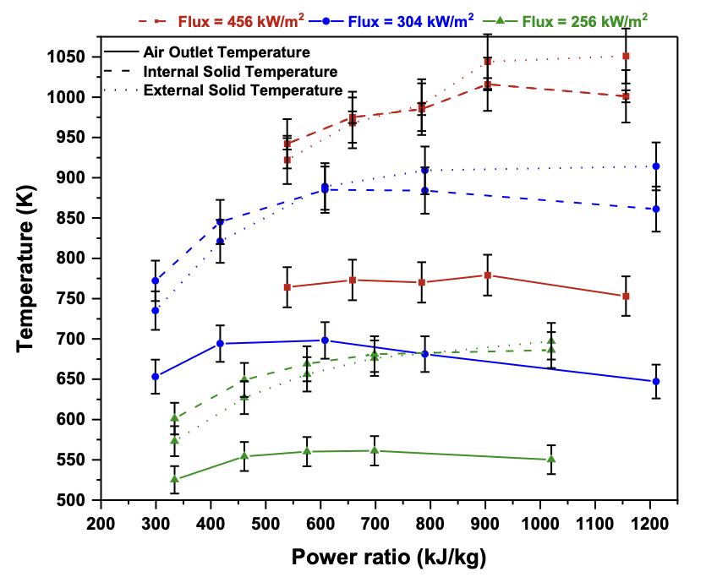
Figure 6. Achieved steady state temperatures at different power ratios.
The observed trends for a fixed flux deviated from the typical linear relationship found in literature, such as that by Capuano et al. [14], which shows a linear increase in air steady-state temperature with power ratio. As expected, steady-state temperatures were highest at the highest flux and lowest at the lowest flux for both solid and fluid domains. However, at 456 kW/m², a critical point was observed around a power ratio of 727 kJ/kg, beyond which a slight decrease in gas temperature occurred at all flux values, with the least decrease at the lowest flux.
At the lowest air flow rate (highest power ratio), the air temperature dropped, likely due to reduced contact between the air and hot walls of the receiver, leading to lower heat transfer and a reduced steady-state air temperature at the outlet. Additionally, as air velocity increases, the Nusselt (Nu) number rises, resulting in a higher heat transfer coefficient ($\overline{h}$), as noted by Avila-Marin et al. [18]. This suggests that low flow rates limit heat transfer, preventing the fluid from reaching its maximum potential temperature.
This decrease in flow also explains the slight temperature drop observed at high-power ratios in the solid domain at lower fluxes (304 kW/m² and 256 kW/m²). Beyond power ratios of ~850 kJ/kg, the system loses energy to the environment rather than benefiting from it, especially at high and medium flux levels. Conversely, at the low flux level (256 kW/m²), the system effectively utilized incoming energy to heat the solid, with a less pronounced gas temperature drop at lower flow rates compared to higher flux cases. This suggests that system design should aim to more efficiently utilize incoming flux at low flow rates.
  - Lumped Model Validation
In this section, the lumped model was validated using the solid and fluid domain experimental data. The validation was conducted through fitting two different Nu number correlations (correlations 5 and 6 in Table 1) and the thermophysical properties $ρ_{s}C_{ps}$of SiC to the experimental data points. The data was fitted to the solid and fluid domains for the transient and steady state temperature profiles (Figure S13 in Supplementary Material). To improve the results, the data was fitted only to the fluid domain for the transient and steady state profiles (Figure 7).
In Table 4, the parameter “A” represents the asymptotic Nu number at the fully developed region. The reason it was not compared with literature is because most studies follow the Graetz problem approach. The asymptotic Nu number value in literature was based either on a constant wall heat flux or constant wall temperature, which is not the case in this system. Therefore, the remaining parameters (B, n, and C) were compared as they are solely dependent on the geometry.
The model averaged experimental data for the solid domain to fit parameters in Tables S1 and S3, potentially leading to inaccuracies, as shown by deviations in Figure S13 for correlation 6. The correlations were then fitted to the gas data, with correlation 6 yielding a better fit than correlation 5 (Figures 7 and S12). The error in steady-state temperature was less than 4.8% (Figure 7), within the literature-reported range (3.6% to 9.2%) [9, 15]. However, Correlation 6 gave $\overline{h}$ values outside the forced convection range for the gas phase (Table 5). In addition, one major parameter that was obtained from the model fittings was the density and heat capacity ($ρ_{s}C_{ps}$). A factor ($ρ_{s}C_{ps}$) was fitted to the experimental data, yielding values between 2.74 and 4.40, which was further validated using a 1D model. Overall, correlation 5 provided parameter values closer to literature ranges compared to correlation 6 when using the lumped model (Tables 4 and S1).

Table 4. Fitted parameters to the gas domains’ transient profiles and steady state temperatures obtained from the lumped model using correlation 6.
Fitted parameter | Value from lumped model | Range reported in Literature | Reference
Factor on $ρ_{s}C_{ps}$ | 2.74 | - | -
a | 750.00 | 69.90 – 1359.00 | [18, 24]
b | 2.40 | 0.31 – 0.59
c | 20.07 | 6.50 – 16.22

Table 5. Lumped model heat transfer coefficient fitted to the gas’s transient profiles and steady state temperatures using correlation 6.
Flux (kW/m²) | Flowrate (L/min) | Nu  number | Model Heat transfer coefficient ($\overline{h}$) ($\frac{W}{m^{2}K}$)
456 | 15.3 | 0.26 | 0.75
456 | 12.5 | 0.16 | 0.47
456 | 10.5 | 0.10 | 0.31
456 | 9.1 | 0.07 | 0.22
456 | 7.1 | 0.04 | 0.12
304 | 18.3 | 0.40 | 1.04
304 | 13.2 | 0.18 | 0.49
304 | 9.0 | 0.07 | 0.20
304 | 7.0 | 0.04 | 0.10
304 | 4.5 | 0.01 | 0.04
256 | 13.9 | 0.20 | 0.45
256 | 10.0 | 0.09 | 0.22
256 | 8.0 | 0.06 | 0.13
256 | 6.6 | 0.03 | 0.08
256 | 4.5 | 0.01 | 0.03

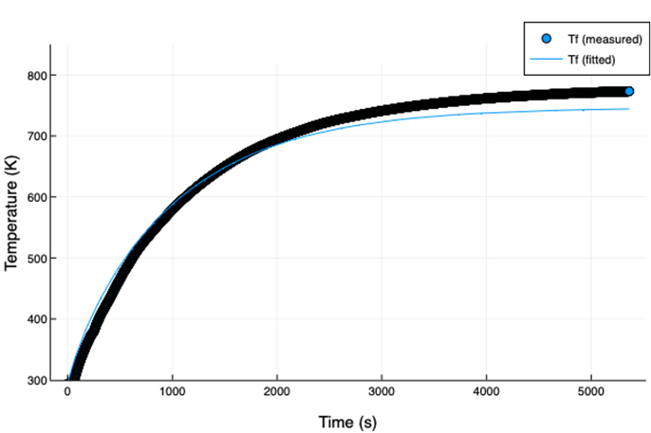 | 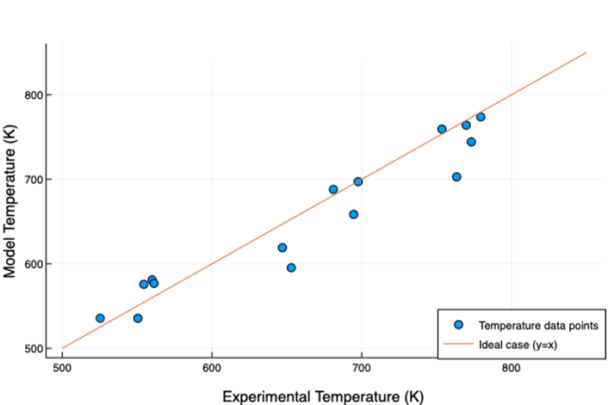
Figure 7. Comparison of transient lumped model results with measurements, for the gas (left) domain at a flux of 442 kW/m² (3% decrease from 456 kW/m²) and air flowrate of 12.5 L/min using correlation 6 fitted to the gas domain, and comparison of the achieved steady state gas temperatures (parity plot-right) using fitted parameters and heat transfer coefficients for correlation 6.
In Figures 7, S12, and S13, the 3% decrease in incoming flux accounts for the HFG's measurement accuracy during the fitting process. The $±$3% margin of error is applied to the incoming flux value, as the reported flux reading can vary within this range. In this instance, a 3% reduction resulted in a more accurate prediction of the experimental profile. Correlation 5 produced heat transfer coefficient ($\overline{h}$) values within the forced convection range (Table S2), while correlation 6 provided very low $\overline{h}$ values (Table 5). Literature states that $\overline{h}$ in free convection ranges from 3 to 20 W/m²·K, while in forced convection it ranges from 10 to 100 W/m²·K [30].
Nonetheless, correlation 6 better predicted the gas temperatures (Figure 7) compared to correlation 5 (Figure S12) when fitted to the gas domain only. This may be due to correlation 5 being designed for estimating the Nusselt (Nu) number in the entry length region, whereas correlation 6 was developed for single-phase forced convection flow, aligning more closely with experimental conditions. The parameters in correlation 6 depend primarily on geometry and not on the asymptotic Nu number [18].

  - FDM Model Validation
Similar to the lumped model, the 1D model was developed to efficiently capture the transient and steady-state temperatures for all experiments through fitting $\overline{h}$ as well as validate the thermophysical properties obtained from the lumped model.
Based on the findings from the lumped model, this section presents the results obtained using correlation 6 as it had a better estimation of the temperatures compared to correlation 5. The solid and fluid domains were fitted to the experimental temperature profiles along with the thermal conductivity only using correlation 6 to observe the performance of the model and its capability of capturing the temperatures of both domains.
In Figures S15 and S16, the 22% increase in the incoming flux is the reproducibility error used in between the repeated HFG calibrations.
The 1D model had better prediction of the solid thermocouples farthest from the inlet (TI-10 and TI-11) compared to those closer to the inlet (TI-8, TI-9, and TI-12) as shown in Figure S15. Thermocouples nearer to the inlet were better predicted at the low flux range (TI-9 and TI-12). The thermocouples farther from the inlet (TI-10, TI-11, and TI-3) were slightly overestimated (Figures S15 and S16) especially the gas domain, while those closer to the inlet (TI-8, TI-9, and TI-12) were underestimated.
Overall, the model could only capture some of the solid temperatures and was unable to capture both domains simultaneously. The obtained heat transfer coefficient values were within the forced convection region and within reported values in literature that go up to 1157 W/m².K [18]. However, the model could not accurately represent the phenomena occurring in the receiver using correlation 6.
Based on the steady state temperature estimation, it was concluded that the 1D model was better at capturing both domains compared to capturing the gas domain only. Therefore, improve the findings, correlation 6 was fitted to the gas and solid domains for both the transient profiles and the steady state temperatures (Tables 6 and 7, and Figure 8).

Table 6. Fitted parameters to the gas and solid transient profiles’ and steady state temperatures from the 1D model using correlation 6.
Fitted parameter | Value from lumped model | Range reported in Literature | Reference
Factor on $ρ_{s}C_{ps}$ | 4.40 | - | -
$$k_{eff}$$ | 18.39 | - | -
$$k_{s}$$ | 21.41 | - | -
a | 1208.98 | 69.90 – 1359.00 | [18, 24]
b | 1.38 | 0.31 – 0.59
c | 7.86 | 6.50 – 16.22

Table 7. 1D model heat transfer coefficient fitted to the gas and solid transient profiles’ and steady state temperatures using correlation 6.
Flux (kW/m²) | Flowrate (L/min) | Nu  number | Model Heat transfer coefficient ($\overline{h}$) ($\frac{W}{m^{2}K}$)
456 | 15.3 | 3.14 | 955.35
456 | 12.5 | 2.86 | 731.77
456 | 10.5 | 2.63 | 574.14
456 | 9.1 | 2.463 | 475.63
456 | 7.1 | 2.19 | 331.07
304 | 18.3 | 3.42 | 1094.27
304 | 13.2 | 2.93 | 725.42
304 | 9.0 | 2.45 | 434.04
304 | 7.0 | 2.17 | 297.34
304 | 4.5 | 1.77 | 158.89
256 | 13.9 | 3.00 | 629.96
256 | 10.0 | 2.58 | 420.80
256 | 8.0 | 2.32 | 313.48
256 | 6.6 | 2.12 | 240.30
256 | 4.5 | 1.77 | 140.47

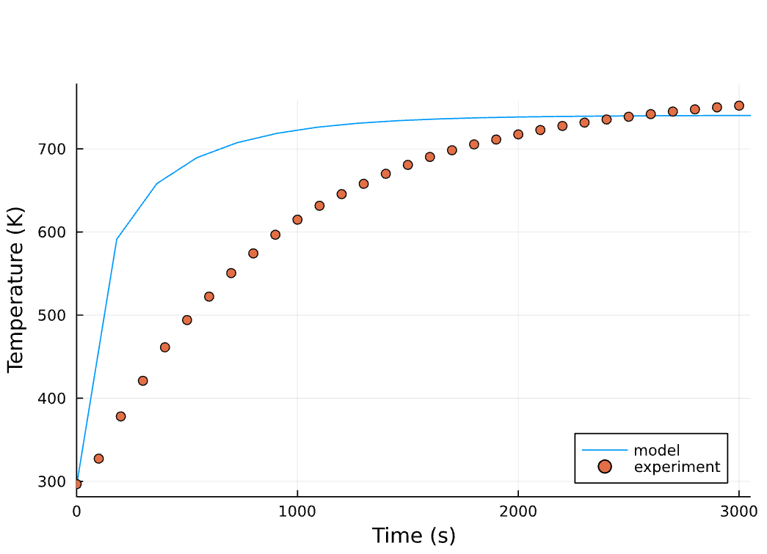 | 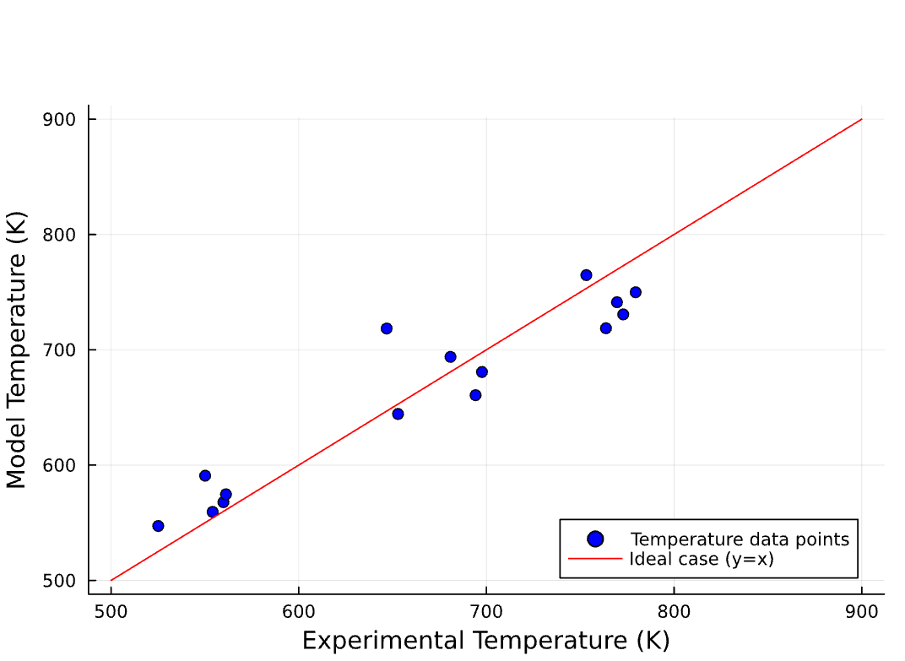

Figure 8. Comparison of transient lumped model results with measurements, for the gas (left) domain at a flux of 442 kW/m² (3% decrease from 456 kW/m²) and air flowrate of 15.3 L/min using correlation 6 fitted to the gas and solid domains, and comparison of the achieved steady state gas temperatures (parity plot-right) using fitted parameters and heat transfer coefficients for correlation 6.

As shown in Figure 8, the 1D model appears to fit the experimental steady state temperatures, more accurately, when fitted to both domains rather than the gas domain only. The heat transfer coefficient values obtained were a hundred times higher than the values obtained from the lumped model (Table 7 compared to Table 5). In addition, the parameter values fitted to the 1D model were closer to the literature ranges compared to those fitted to the lumped model (Tables 4 and 6). Although the lumped model appears to have a more accurate prediction of the temperatures, the obtained heat transfer coefficient falls out of the forced and free convection ranges in correlation 6. The lumped model’s better estimation of the temperatures could have been a result of the simplicity and lower sensitivity it has towards the uncertainty in parameter inputs (flux values, flowrates, initial estimates of the correlation parameters, boundary conditions, etc.).
Although, the 1D model is more detailed, which created an expectation of better temperature estimations, it might be more sensitive to inaccuracies in these inputs, resulting in a larger deviation from the experimental data. In addition, the lumped model requires a lower number of parameters to be introduced in the model, which make the model easier to fit to the experimental data.

  - CFD Model Validation
The 3D model was developed to capture the transient and steady-state profiles of the solid and fluid domains, aligning with experimental data. Initially, a single-channel receiver model was used to reduce computational complexity, incorporating one heat transfer equation for both domains. The model was adjusted to match experimental conditions by including wall losses as a boundary condition. The model was later expanded to represent the full receiver, extending the geometry to include all channels and implementing vacuum pressure at the receiver outlet to simulate the vacuum pump. Conjugated and discrete models were created for the full receiver configuration.
Section 3.4 compares the 3D models tested: the single-channel model, the conjugated full receiver model, and the discrete full receiver model. Thermophysical properties of SiC and air were introduced as temperature-dependent functions based on the works of Agrafiotis et al. [31], and Ali et al. and Munro et al. [15], as detailed in Table 8.
Table 8. Material thermo-physical properties obtained from literature.
SiC
Property | Value/Function | Reference
Thermal conductivity (k_{s}) [W/m.K] | 48.78 | [31]
Specific heat (C_{ps}) [J/kg.K] | $$C_{ps}=8.50×{10}^{-5}T^{2}+5.63×{10}^{-2}T-4.05×{10}^{7}T^{-2}+1125.58$$ | [31]
Density ($ρ_{s}$) [kg/m³] | 3200 | [31]
Absorptivity/emissivity  Porosity ($φ$) | 0.8  0.425 | [15]
Air
Thermal conductivity (k_{f}) [W/m.K] | $$k_{f}=1.52×{10}^{-11}T^{3}-4.86×{10}^{-8}T^{2}+1.02×{10}^{-4}T-3.93×{10}^{3}$$ | [15]
Specific heat (C_{pf}) [J/kg.K] | $$C_{pf}=1.93×{10}^{-10}T^{4}-8.00×{10}^{-7}T^{3}+1.14×{10}^{-3}T^{2}-4.49×{10}^{-1}T+1.06×{10}^{3}$$ | [15]
The geometrical optics physics was used to extract the ray tracing results from TracePro with the specifications mentioned in Table 3.
The radiation is majorly absorbed at the frontal face of the receiver as shown in Figure 9 as expected since the light is concentrated at the location being at the second focal point from the lamp and the only opening to the ambient.

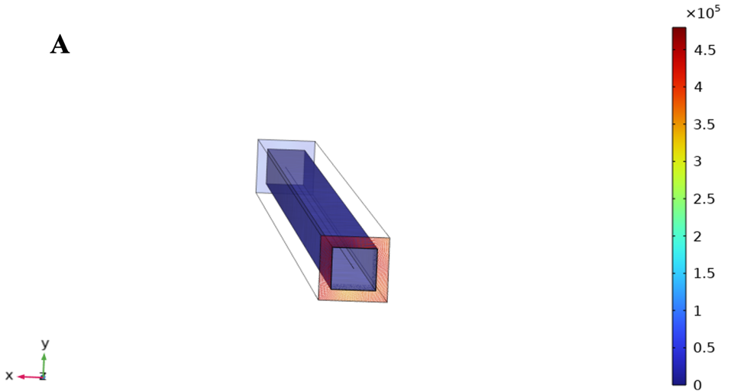
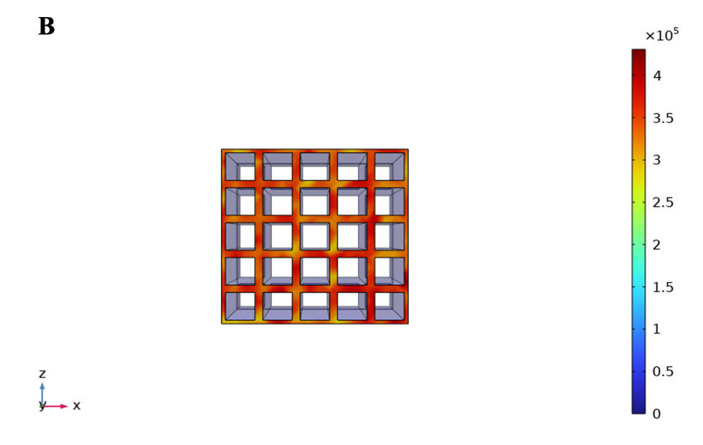
Figure 9. Boundary heat source (absorbed radiative flux density) for a (A) single channel and a (B) full receiver system.
To accurately model the transport phenomena in the receiver, a new geometry was created that closely replicates the experimental setup. A quarter section of the receiver was simulated, using a symmetry boundary condition on two external walls to represent the full receiver. This geometry featured 5x5 channels matching the experimental dimensions described in the Methodology.
Several adjustments were made to the boundary conditions. In the laminar flow physics, the inlet was set as an open boundary, while a vacuum was applied at the outlet, reflecting the actual flow conditions measured at the back of the receiver before air enters the vacuum pump. An additional constraint was added at the outlet to account for the non-uniform flow within the receiver, as depicted in Figure 10.

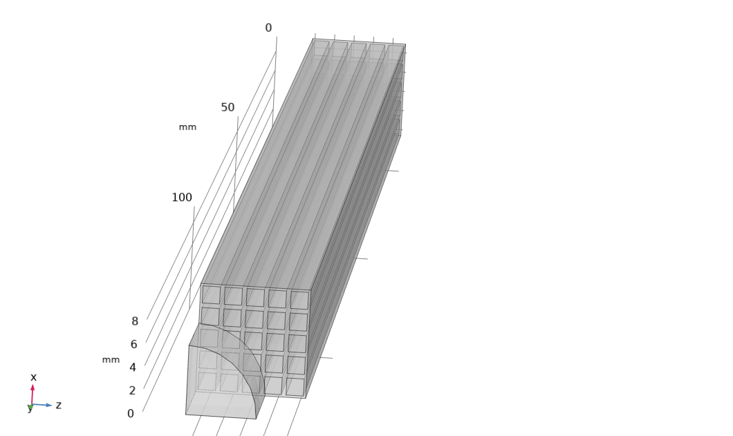
Figure 10. Full receiver geometry for the conjugated and discrete full receiver 3D models.
    - Comparison of Solid and Gas Temperature Profiles in the 3D Heat Transfer Models: Single Channel, Conjugated, and Discrete Configurations
In Figures 11A and 11B, the solid temperature profiles for the different thermocouples are plotted for different cases, while Figures 12A and 12B show the gas temperature profiles.
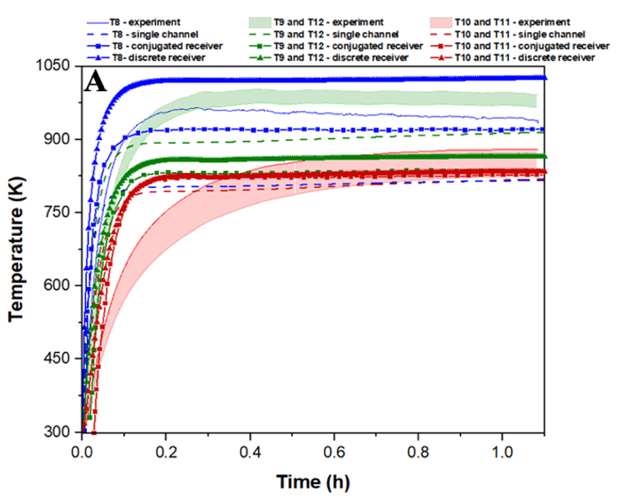 | 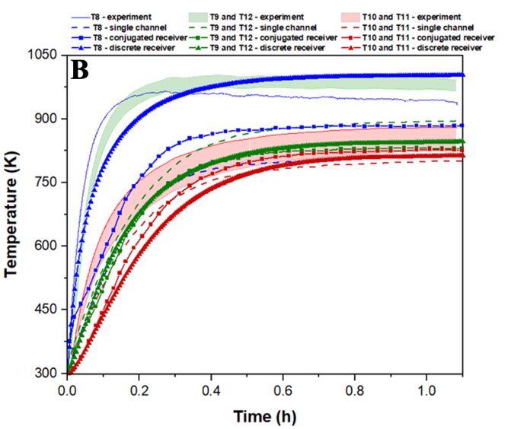
Figure 11. (A) Temperature profiles of the solid at a flux of 456 kW/m² and air flowrate of 15.3 L/min for the single channel, conjugated full receiver system, and discrete full receiver system models for the base case. (B) Temperature profiles of the solid with 4.4$ρ_{s}C_{ps}$ and adjusted flux values (3% decrease from 456 kW/m²).
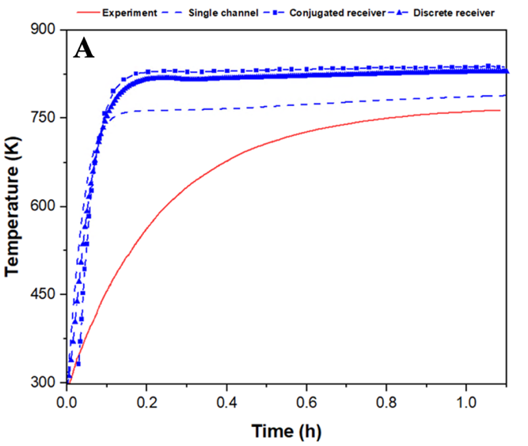 | 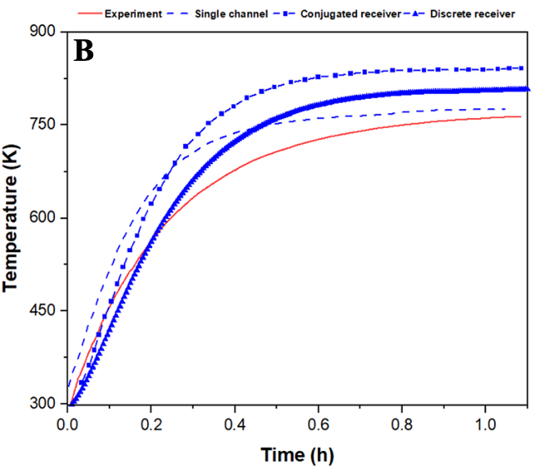
Figure 12. (A) Temperature profiles of the gas at a flux of 456 kW/m² and air flowrate of 15.3 L/min for the single channel, conjugated full receiver system, and discrete full receiver system models for the base case. (B) Temperature profiles of the gas with 4.4$ρ_{s}C_{ps}$ and adjusted flux values (3% decrease from 456 kW/m²).
In Figures 11A and 12A, the base case refers to the unaltered measurements and reported thermophysical properties from literature. Figures 11A and 11B plot external and internal thermocouples on receiver walls, with shaded areas between TI-9 and TI-12 (58 mm from the inlet) and TI-10 and TI-11 (107 mm) indicating the range of model temperature estimations. In Figure 17A, models underestimated TI-8's temperature (11 mm from the inlet) likely due to unaccounted irradiation effects, while the discrete model overestimated it using an average heat transfer coefficient of 85 W/m².K. Models predicted higher losses near the front, with the mid-section (TI-9) showing higher experimental temperatures. The conjugated model captured this profile with 95.4% accuracy. Models accurately estimated thermocouples farther from the inlet (58 mm and 107 mm), with the discrete model at 97.8% accuracy. Figures 12A and 12B display gas temperature profiles, with models overestimating steady-state temperatures. Sensitivity analysis on SiC properties ($k_{s}$, $ρ_{s}$, and $C_{ps}$ also known as the thermal diffusivity) revealed the $ρ_{s}C_{ps}$term significantly impacts temperature change rates compared to $k_{s}$. This can be explained by the $ρ_{s}C_{ps}$ term being in the time derivative in the temperature equation, while the thermal conductivity $k_{s}$appears in the spatial derivative term. For that reason, the change in $ρ_{s}C_{ps}$ largely affected the rate of temperature change with respect to time, in comparison to the change in $k_{s}$. Adjusting density and heat capacity (increased by 4.40) improved transient profiles, matching experimental data. The heat capacity was validated through conducting a Differential Scanning Calorimetry (DSC). The heat capacity of SiC obtained was, approximately, 6352 J/kg.K at 621ºC, indicating that the 3D and lumped model findings of the heat capacity being higher by a factor ranging between ~2.61 and ~4.40 is a fair assumption as observed in the 0D and 1D models. Reducing flux improved gas outlet temperature estimations, with accuracies of 98.4% (single channel), 94.3% (discrete), and 89.9% (conjugated). Overall, the discrete model was most accurate for solid temperatures (84.3%), followed by the conjugated (81.6%) and single channel (80.6%). Accurate full receiver system modeling requires assumptions closely matching the physical system.

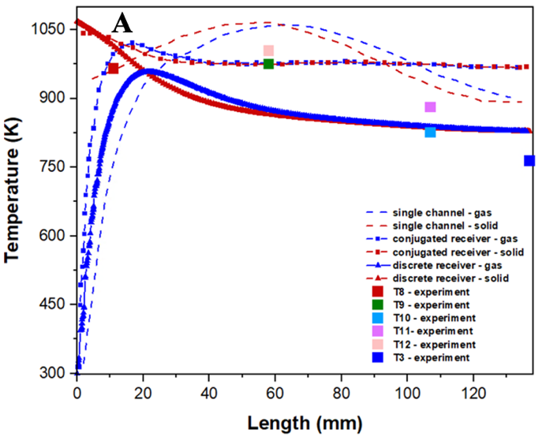 | 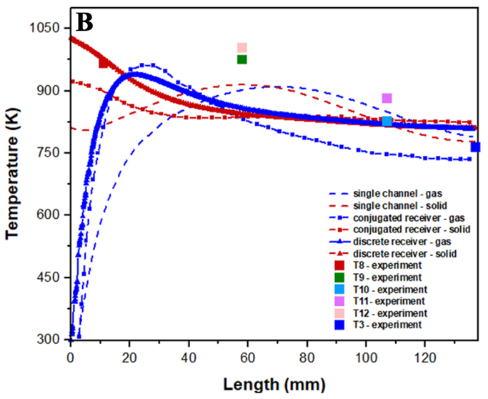
Figure 13. (A) Temperature profiles as a function of receiver length at a flux of 456 kW/m² and air flowrate of 15.3 L/min for the single channel, conjugated full receiver system, and discrete full receiver system models for the base case. (B) Temperature profiles as a function of receiver length with 4.4$ρ_{s}C_{ps}$ and adjusted flux values (3% decrease from 456 kW/m²).
In Figure 13A, changes in $ρ_{s}$ and $C_{ps}$ delayed the transient profiles' steady state compared to Figure 13B. The reduced incoming flux lowered steady-state temperatures (Figure 13B). The single channel model shows the gas outlet temperature surpassing the solid, indicating heat loss and system inefficiency beyond ~65 mm. In the full receiver models, temperature distribution is more uniform, achieving maximum temperature around 60-65 mm. However, the model does not capture the early temperature increase observed experimentally. The discrete and conjugated models predict the highest solid temperature at the inlet, with equilibrium reached around 65 mm, reflecting different flow developments between the single channel and the full receiver models.

Conclusion

An experimental campaign comprising 15 experiments under various operational conditions was conducted, varying the flux on aperture and airflow rates. Initially, a lumped model was created to obtain a fitted average heat transfer coefficient ($\overline{h}$) and thermophysical properties of SiC (density and heat capacity). Two different Nu number correlations (correlations 5 and 6) were fitted to the experimental data. Correlation 5 provided a better estimation of $\overline{h}$ for the solid and gas domains but had large deviations from the steady-state temperature. Consequently, the gas domain was fitted to the transient and steady-state temperatures using correlations 5 and 6, with correlation 6 giving more accurate predictions (~99.0% accuracy) for the gas temperature. However, the obtained $\overline{h}$ values were within the literature free convection range.

A 1D model was also developed to test different Nu number correlations to obtain $\overline{h}$ values within the forced convection range and further validate the thermophysical properties of SiC from the lumped model. Correlation 6 resulted in $\overline{h}$ values within the forced convection range when fitted using the solid and fluid domains’ transient profiles and steady-state temperatures. Testing correlation 5 in the 1D model for both solid and fluid domains’ temperatures resulted in $\overline{h}$ values within the forced convection range higher than those obtained using correlation 6. The model captured the transient profile and some steady states for the gas domain with an accuracy of 90.7%–99.0%. Although the lumped model provided consistent temperature estimates along the experiments, the estimated $\overline{h}$ values were very low and a 100x lower than the values predicted by the 1D model. Therefore, the 1D model using the fluid domain data is better as it provided better predictions of the gas steady-state temperatures.

A 3D finite element model (FEM) using conjugated heat transfer in both fluid and solid domains was developed in two configurations: a single channel and a full receiver. Additionally, a 3D discrete full receiver model was built in COMSOL. The 3D models were also used to verify the thermophysical properties of SiC, and all models (0D, 1D, and 3D) agreed on implementing a factor ranging between 2.74–4.40 on the density and heat capacity, indicating higher values than reported in literature. Additionally, the heat flux was decreased within the heat flux gauge’s accuracy to better fit the experimental temperatures, specifically the gas domain, for experiment 67 (E67).

This adjustment enhanced the accuracy of the models in estimating the gas outlet temperature, achieving 98.4% for the single channel model, 94.3% for the discrete full receiver model, and 89.9% for the conjugated full receiver model. Although reducing the flux improved the gas steady-state temperatures, the accuracy of the solid temperature decreased slightly by approximately 2.0% to 4.0%. This variation is relatively minor, considering it falls within measurement accuracy, and it is more critical to fit the gas temperature since the HTF temperature is essential for the receiver application.

Overall, the discrete full receiver model was the most precise in predicting solid domain temperatures, achieving an accuracy of 84.3%. This was followed by the conjugated full receiver model at approximately 81.6%, and the single channel model with an accuracy of 80.6%. It can be inferred that a single channel can effectively represent the entire receiver system when identical assumptions are applied to both, as shown by the estimated solid and fluid domain temperatures differing by a range of 3.7% to 8.5%. To accurately model a full receiver system, the assumptions used should closely reflect the physical system.

Given the importance of accurately capturing the gas domain profile for large-scale application and system optimization, the 3D discrete full receiver system, with 4.4$ρ_{s}C_{ps}$and 3% reduced flux, was the most accurate among the developed 3D conjugated and single channel models, 1D model, and lumped model, based on proximity to temperature profiles and the real physical system. All models provided good estimations of gas temperature profiles within error ranges reported in literature.

CRediT authorship contribution statement
Aysha Melhim: Conceptualization, Methodology, Software, Data curation, Writing – original draft, Visualization. Konstantinos E. Kakosimos: Conceptualization, Methodology, Writing – review & editing, Supervision, Funding acquisition, Project administration.

Declaration of Competing Interest
The authors declare that they have no known competing financial interests or personal relationships that could have appeared to influence the work reported in this paper.

Acknowledgement

This publication was made possible by an NPRP award (NPRP12S- 0301-190191) from the Qatar National Research Fund (a member of The Qatar Foundation). The graduate student was supported by a fellowship from ExxonMobil – Qatar for the carbon management initiative. The statements made herein are solely the responsibility of the authors.

Appendix A. Supplementary Material
Supplementary material to this article can be found online at https://github.com/tamu-edu/tamuq-chen-secarelab-receiver/tree/OneDimension.

References

1. IEA, Global Energy Review: CO2 Emissions in 2021
Global emissions rebound sharply to highest ever level. 2021.
2. IEA. Renewable heat. 2021; Available from: https://www.iea.org/reports/renewables-2022/renewable-heat#.
3. José Antonio Luceño, E.d.l.F., and Mariano Martín, Optimal Design of Solar Receivers in CSP Plants: Effects of Facility Location. 2021.
4. Fernández, A.G., et al., Mainstreaming commercial CSP systems: A technology review. Renewable Energy, 2019. 140: p. 152-176.
5. Islam, M.T., et al., A comprehensive review of state-of-the-art concentrating solar power (CSP) technologies: Current status and research trends. Renewable and Sustainable Energy Reviews, 2018. 91: p. 987-1018.
6. Ho, C.K. and B.D. Iverson, Review of high-temperature central receiver designs for concentrating solar power. Renewable and Sustainable Energy Reviews, 2014. 29: p. 835-846.
7. Cagnoli, M., et al., Coupled optical and CFD parametric analysis of an open volumetric air receiver of honeycomb type for central tower CSP plants. Solar Energy, 2017. 155: p. 523-536.
8. Salih, F. and K.E. Kakosimos, Exploring and enhancing the volumetric behaviour in solar receivers through specular reflectivity and simplified design. Energy Conversion and Management, 2023. 291: p. 117306.
9. Zaversky, F., et al., Numerical and experimental evaluation and optimization of ceramic foam as solar absorber – Single-layer vs multi-layer configurations. Applied Energy, 2018. 210: p. 351-375.
10. Roberta R. Ribeiro, M.J.S.d.L., Transient behavior and thermal efficiency of volumetric heat receivers. International Journal of Heat and Mass Transfer, 2020. 149.
11. K.S. Reddy, S.N., Thermal analysis of porous volumetric receivers of concentrated solar dish and tower systems. Renewable Energy 2019. 132.
12. Roldán, M.I., et al., Thermal analysis and design of a volumetric solar absorber depending on the porosity. Renewable Energy, 2014. 62: p. 116-128.
13. S. Mey-Cloutier, C.C., A. Kribus, Y. Gray, G. Flamant, Experimental study of ceramic foams used as high temperature volumetric solar absorber. 2016. 136: p. 226-235.
14. Raffaele Capuano, T.F., Hannes Stadler, Bernhard Hoffschmidt, Robert Pitz-Paal Optimized volumetric solar receiver: Thermal performance prediction and experimental validation. Renewable Energy, 2017: p. 556-566.
15. Ali, M., et al., Consistent coupled optical and thermal analysis of volumetric solar receivers with honeycomb absorbers. Renewable Energy, 2020. 145: p. 1849-1861.
16. Groppi, G., E. Tronconi, and P. Forzatti, Investigations on catalytic combustors for gas turbine applications through mathematical model analysis. Applied Catalysis A: General, 1996. 138(2): p. 177-197.
17. Hayes, R.E. and I. Cornejo, Multi-scale modelling of monolith reactors: A 30-year perspective from 1990 to 2020. The Canadian Journal of Chemical Engineering, 2021. 99(12): p. 2589-2606.
18. Avila-Marin, A.L., et al., Numerical determination of the heat transfer coefficient for volumetric air receivers with wire meshes. Solar Energy, 2018. 162: p. 317-329.
19. J. Votruba, O.M., Khue Nguen, V. Hlavacek, and J. Skrivanek, Heat and Mass Transfer in Honeycomb Catalysts - II 1974.
20. C. J. Bennett , R.E.H., S. T. Kolaczkowski and William John Thomas, An experimental and theoretical study of a catalytic monolith to control automobile exhaust emissions. 1992. 439(1907).
21. Ullah, U., et al., Monolithic reactors: mass transfer measurements under reacting conditions. Chemical Engineering Science, 1992. 47(9): p. 2413-2418.
22. Grigull, U. and H. Tratz, Thermischer einlauf in ausgebildeter laminarer rohrströmung. International Journal of Heat and Mass Transfer, 1965. 8(5): p. 669-678.
23. Tronconi, E., Interaction between chemical kinetics and transport phenomena in monolithic catalysts. Catalysis Today, 1997. 34(3): p. 421-427.
24. Frank Kreith, R.M.M., Mark S. Bohn, Principles of Heat Transfer. Seventh edition ed. 2010: Cengage Learning.
25. Daniel Haseler, A.M.A., Konstantinos E. Kakosimos, Positioning and focusing of light sources in light concentrating systems using convolutional neural network modelling. Solar Energy, 2021: p. 445-454.
26. R. Shimokawa, T.T., H. Takato, A. Ozaki, Y. Takano,, μm thin film c-Si cells on near-Lambertian Al2O3 substrates. 2001: p. 593-598.
27. Bai, F., One dimensional thermal analysis of silicon carbide ceramic foam used for solar air receiver. International Journal of Thermal Sciences, 2010. 49(12): p. 2400-2404.
28. Mattia Cagnoli, A.F., Laura Savoldi, Roberto Zanino, Multi-scale modular analysis of open volumetric receivers for central tower CSP systems. Solar Energy, 2019: p. 195-211.
29. Mohammadreza Sedighia, R.V.P., Maree Lakea, Andrew Rosea, Yee Yan Lima, and R.A.T. Jeremy Paul Novaka, c, Design of high-temperature atmospheric and pressurised gas-phase solar receivers: A comprehensive review on numerical modelling and performance parameters. Solar Energy, 2020: p. 701-723.
30. R. Byron Bird, W.E.S., Edwin N. Lightfoot, Transport Phenomena. 2006.
31. Agrafiotis, C.C., et al., Evaluation of porous silicon carbide monolithic honeycombs as volumetric receivers/collectors of concentrated solar radiation. Solar Energy Materials and Solar Cells, 2007. 91(6): p. 474-488.

