**Week-8**

**Airline Flight Database**

**-Tanisha Gotadke (1BM21CS229)**

create database Airline;

use Airline;

create table flights(

flno int,

ffrom varchar(50),

tto varchar(50),

distance int,

departs time,

arrives time,

price int,

primary key(flno));

create table aircraft(

aid int,

aname varchar(50),

cruisingrange int,

primary key(aid));

create table employee(

eid int,

ename varchar(50),

salary int,

primary key(eid));

create table certified(

eid int,aid int,

foreign key(aid) references aircraft(aid)

on update cascade on delete cascade,

foreign key(eid) references employee(eid)

on update cascade on delete cascade);

insert into employee values

(101,'Avinash',50000),

(102,'Lokesh',60000),

(103,'Rakesh',70000),

(104,'Santhosh',82000),

(105,'Tilak',5000);

insert into aircraft values

(1,'Airbus',2000),

(2,'Boeing',700),

(3,'JetAirways',550),

(4,'Indigo',5000),

(5,'Boeing',4500),

(6,'Airbus',2200);

insert into certified values

(101,2),(101,4),(101,5),

(101,6),(102,1),(102,3),

(102,5),(103,2),(103,3),

(103,5),(103,6),(104,6),

(104,1),(104,3),(105,3);

insert into flights values

(1,'Banglore','New Delhi',500,'6:00','9:00',5000),

(2,'Banglore','Chennai',300,'7:00','8:30',3000),

(3,'Trivandrum','New Delhi',800,'8:00','11:30',6000),

(4,'Banglore','Frankfurt',10000,'6:00','23:30',50000),

(5,'Kolkata','New Delhi',2400,'11:00','3:30',9000),

(6,'Banglore','Frankfurt',8000,'9:00','23:00',40000);

**Queries**

i. Find the names of aircraft such that all pilots certified to operate them have

salaries more than Rs.80,000.

SELECT a.aname

FROM aircraft a,certified c,employee e

WHERE a.aid=c.aid

AND c.eid=e.eid

AND NOT EXISTS

(SELECT *

FROM employee e1

WHERE e1.eid=e.eid

AND e1.salary<80000);

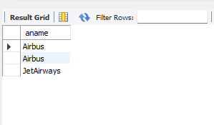

ii. For each pilot who is certified for more than three aircrafts, find the eid and the maximum

cruisingrange of the aircraft for which she or he is certified.

SELECT c.eid,MAX(cruisingrange)

FROM certified c,aircraft a

WHERE c.aid=a.aid

GROUP BY c.eid

HAVING COUNT(*)>2;

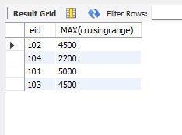

iii. Find the names of pilots whose salary is less than the price of the cheapest route from

Bengaluru to Frankfurt.

SELECT DISTINCT e.ename

FROM employee e

WHERE e.salary<

(SELECT MIN(f.price)

FROM flights f

WHERE f.ffrom='Banglore'

AND f.tto='Frankfurt');



iv. For all aircraft with cruising range over 1000 Kms, find the name of the aircraft and the

Average salary of all pilots certified for this aircraft.

select a.aid, a.aname,avg(e.salary)

from aircraft a, employee e, certified c

where a.aid=c.aid and c.eid=e.eid

and a.cruisingrange>1000

group by a.aid, a.aname;

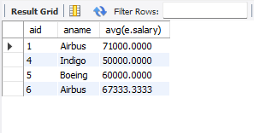

v. Find the names of pilots certified for some Boeing aircraft.

SELECT distinct e.ename

FROM employee e,aircraft a,certified c

WHERE e.eid=c.eid

AND c.aid=a.aid

AND a.aname='Boeing';



vi. Find the aids of all aircraft that can be used on routes from Bengaluru to New Delhi.

SELECT a.aid

FROM aircraft a

WHERE a.cruisingrange>

(SELECT MIN(f.distance)

FROM flights f

WHERE f.ffrom='Banglore'

AND f.tto='New Delhi');

