**Week-3**

**Bank Database**

drop database bankDb;

create database bankDb;

use bankDb;

create table Branch(

branch_name varchar(30),

branch_city varchar(50),

assets float,

primary key(branch_name));

create table BankAccount(

accno int,

branch_name varchar(30),

balance float,

primary key(accno),

foreign key(branch_name)

references Branch(branch_name)

on delete cascade on update cascade);

create table BankCustomer(

customer_name varchar(20),

customer_street varchar(20),

customer_city varchar(10),

primary key(customer_name));

create table depositor(

customer_name varchar(20),

accno int,

primary key(customer_name,accno),

foreign key(customer_name) references BankCustomer(customer_name) on delete cascade on

update cascade,

foreign key(accno) references BankAccount(accno) on delete cascade on update cascade);

create table loan(

loan_number int,

branch_name varchar(30),

amount float,

primary key(loan_number),

foreign key(branch_name) references Branch(branch_name) on delete cascade on update cascade);

insert into branch values('icici_deshpande','bangalore',50619);

insert into branch values('icici_residencyRoad','bangalore',50219);

insert into branch values('icici_shivajiRoad','mumbai',25670);

insert into branch values('icici_parlimentRoad','delhi',10430);

insert into branch values('icici_basavangudi','pune',20066);

select*from branch;

insert into bankAccount values(1,'icici_deshpande',50619);

insert into bankAccount values(2,'icici_residencyRoad',50219);

insert into bankAccount values(3,'icici_shivajiRoad',25670);

insert into bankAccount values(4,'icici_parlimentRoad',10430);

insert into bankAccount values(5,'icici_basavangudi',20066);

insert into bankAccount values(6,'icici_shivajiRoad',25670);

select*from bankaccount;

insert into bankCustomer values('Tanisha','bull_temple_road','bangalore');

insert into bankCustomer values('Hasnain','banerghatta_road','bangalore');

insert into bankCustomer values('Zayd','akbar_road','bangalore');

insert into bankCustomer values('Aadhya','nationalCollege_road','delhi');

insert into bankCustomer values('Yash','prithviraj_road','delhi');

insert into depositor values('Tanisha',1);

insert into depositor values('Hasnain',2);

insert into depositor values('Zayd',3);

insert into depositor values('Aadhya',4);

insert into depositor values('Yash',5);

insert into loan values(1, 'icici_deshpande', 50619);

insert into loan values(2,'icici_residencyRoad',50219);

insert into loan values(3,'icici_shivajiRoad',25670);

insert into loan values(4,'icici_parlimentRoad',10430);

insert into loan values(5,'icici_basavangudi',20066);

select customer_name,count(*),branch_name from depositor d inner join BankAccount b on

d.accno=b.accno group by customer_name,branch_name having count(*)>=2;

select branch_name,branch_city,assets/100000 as assets_in_Lakhs from Branch;

create view loan_sum1 as

select branch_name, sum(amount)

from loan

group by branch_name;

Query

1. Find all the customers who have atleast two accounts at the same branch

select customer_name,count(*),branch_name from depositor d inner join BankAccount b on

d.accno=b.accno group by customer_name,branch_name having count(*)>=2;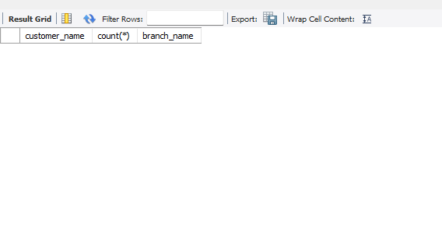

2. Display the branch name and assets from all branches in lakhs of rupees and rename the assets column to ‘assets in lakhs’

select branch_name,branch_city,assets/100000 as assets_in_Lakhs from Branch;

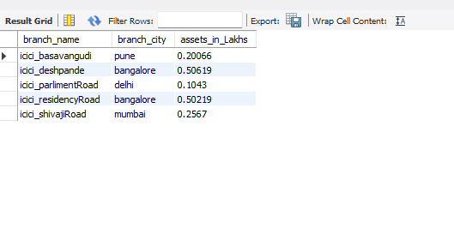

1. Create a view which gives each branch the sum of the amount of all the loans at the branch

create view loan_sum1 as

select branch_name, sum(amount)

from loan

group by branch_name;

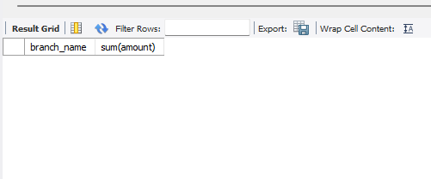



select distinct(customer_name) from depositer d, bankaccount b where (d.accno=b.accno and b.branch_name='sbi_residencyRoad') having(count(*)>1);

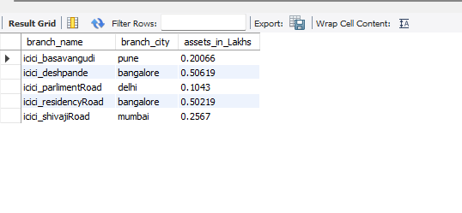  
SELECT DISTINCT(CUSTOMER_NAME) FROM BRANCH B, DEPOSITER D, BANKACCOUNT BA WHERE (D.ACCNO=BA.ACCNO AND BA.BRANCH_NAME=B.BRANCH_NAME AND B.BRANCH_CITY='delhi');

delete from bankaccount where branch_name in(select branch_name from branch where branch_city='mumbai');