**CONVERSION OF INFIX TO POSTFIX EXPRESSION**

-Tanisha Gotadke 1BM21CS229

#include<stdio.h>

#include<conio.h>

#include<string.h>

int index=0,pos=0,top=-1,length;

char symbol, temp, infix[20], postfix[20], stack[20];

void infix_postfix();

void push(char);

char pop();

int pred(char symb);

void main()

{

printf("Enter infix Expression");

scanf("%s",infix);

infix_postfix();

printf("Infix Expression is %s",infix);

printf("Postfix Expression is %s",postfix);

getch();

}

void infix_postfix()

{

length=strlen(infix);

push('#');

while(index<length)

{

symbol=infix[index];

switch(symbol)

{

case '(':

push(symbol);

break;

case ')':

temp=pop();

while(temp!='(')

{

postfix[pos]=temp;

pos++;

temp=pop();

}

break;

case'+':

case'-':

case'*':

case'/':

case'^': while(pred(stack[top])>=pred(symbol))

{

temp=pop();

postfix[pos++]=temp;

}

push(symbol);

break;

default:postfix[pos++]=symbol;

}

index++;

}

while(top>0)

{

temp=pop();

postfix[pos++]=temp;

}

}

void push(char symbol)

{

top=top+1;

stack[top]=symbol;

}

char pop()

{

char symb;

symb=stack[top];

top=top-1;

return(symb);

}

int pred(char symbol)

{

int p;

switch(symbol)

{

case'^':p=3;

break;

case '*':

case'/':p=2;break;

case '+':

case'-':p=1;break;

case'(':

p=0;break;

case'#':p=-1;break;

}

return(p);

}

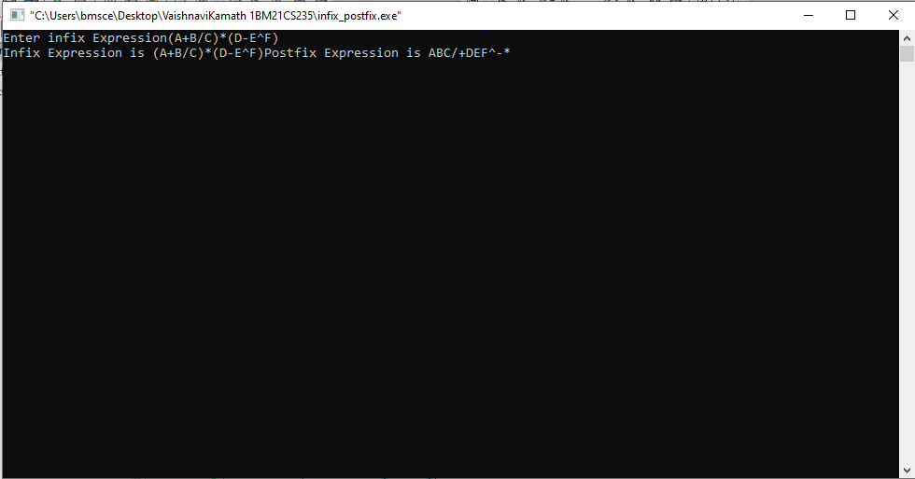**SAMPLE OUTPUT**