**TO DEMONSTRATE QUEUES USING ARRAYS**

-Tanisha Gotadke 1BM21CS229

#include<stdio.h>

#include<conio.h>

#define size 3

int queue[size], rear=-1, front=0, item;

void push();

void pop();

void display();

void main()

{

int choice;

while(1)

{

Printf ("\n 1.PUSH \n 2.POP \n 3.DISPLAY \n 4.EXIT");

printf (" \n Enter your choice");

scanf ("%d",&choice);

printf ("\n");

switch(choice)

{

case 1:

push();

break;

case 2:

pop();

break;

case 3:

display();

break;

case 4:

exit(0);

break;

default : printf("Wrong choice");

}

}

getch();

}

void push()

{

if(rear==size-1){

printf ("Queue is full");

}

else

{

printf("Enter an element");

scanf("%d",&item);

++rear;

queue[rear]=item;

}

}

void pop()

{

int x;

if(rear==-1)

printf ("Queue underflow");

else

{

x=queue[front];

front++;

if(front==size)

{

front=0;rear=-1;

}

}

}

void display()

{

int i;

if(rear==-1)

{

printf("Queue is empty");

}

else

{

for(i=front;i<=rear;i++)

printf("%d",i);

}

}

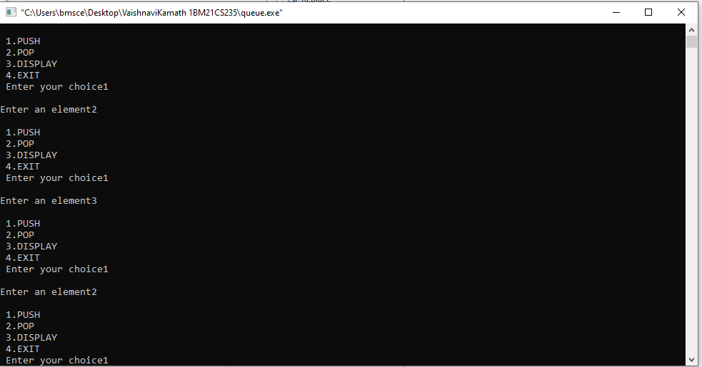**SAMPLE OUTPUT**

