**-Tanisha Gotadke**

1. Assign IP address to PC and gateway in config

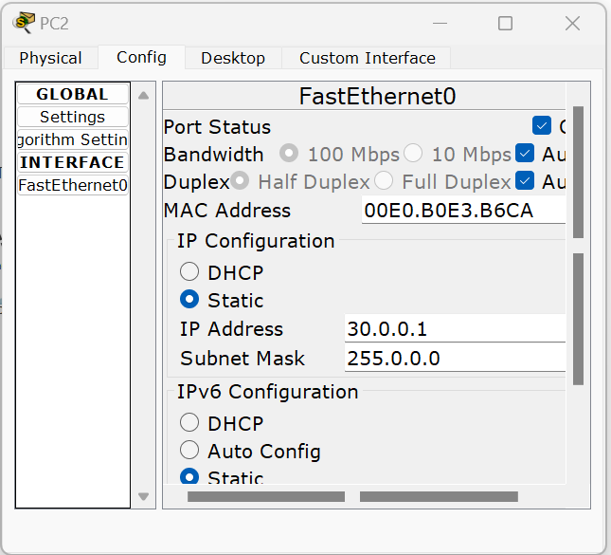

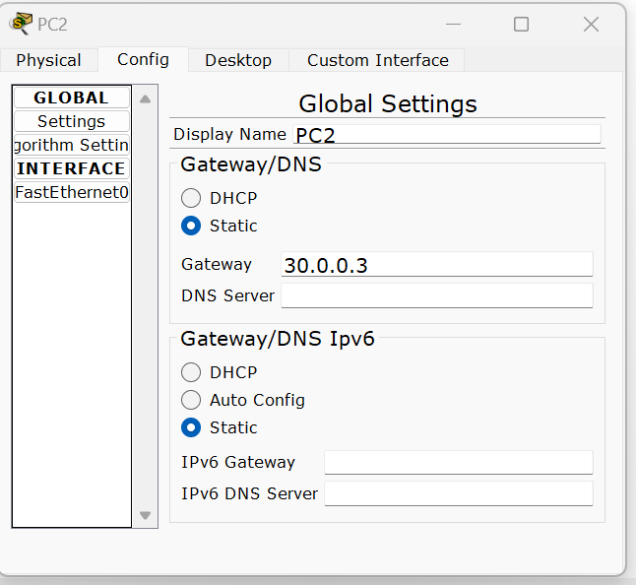

1. Configure interface address of router in CLI mode using these commands

For left router

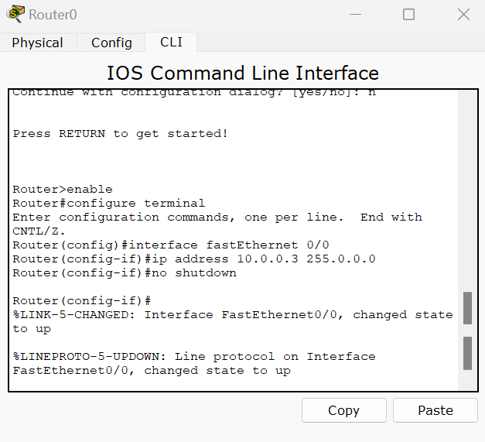

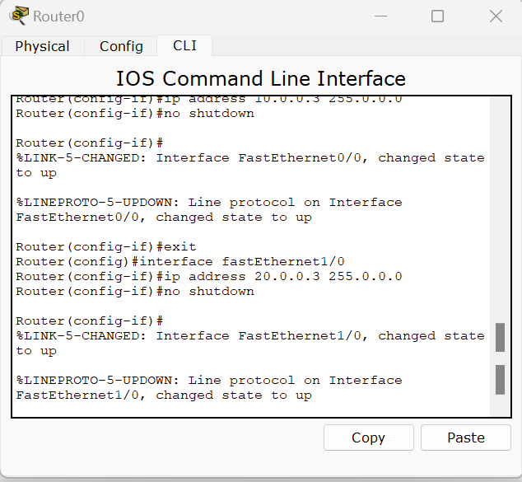

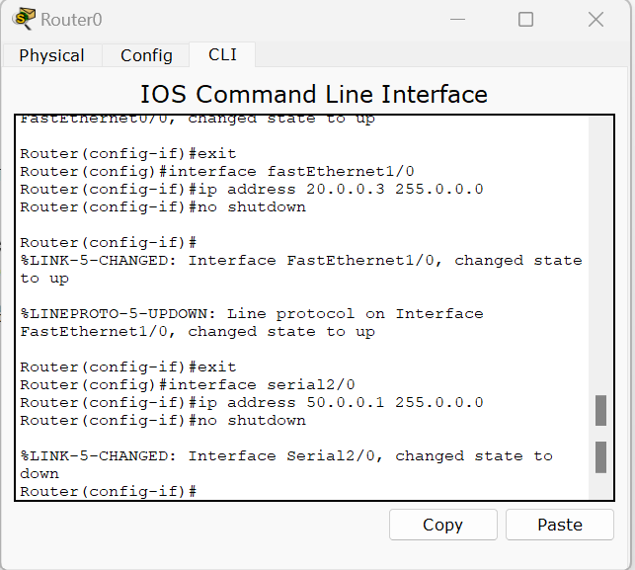

Repeat similarly for right router

For middle router:

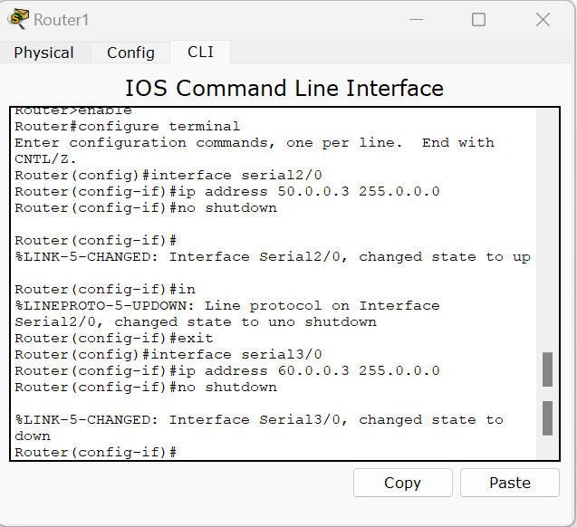

Now do for right router

IP ROUTE TO EACH ROUTER

Connect all networks to each router using its next hop

For left router:

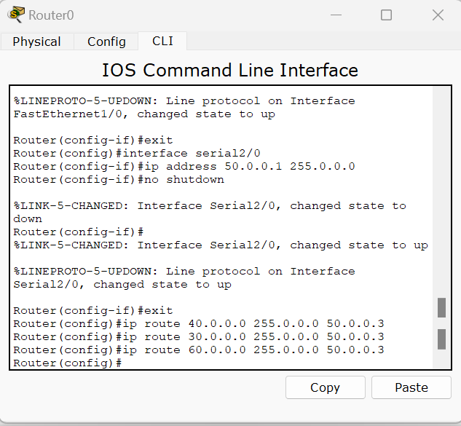

Note 40.0.0.0 means general address of that network.

For middle router

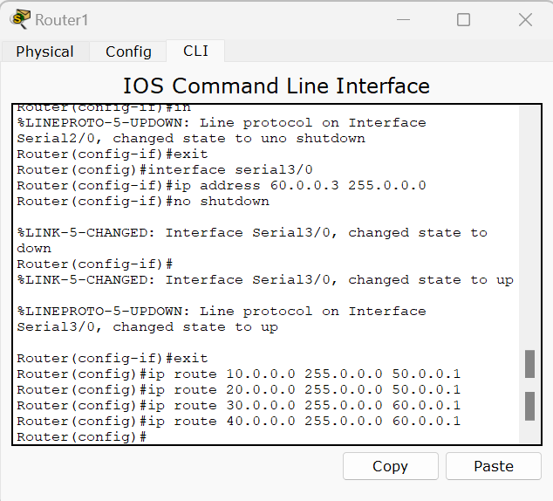

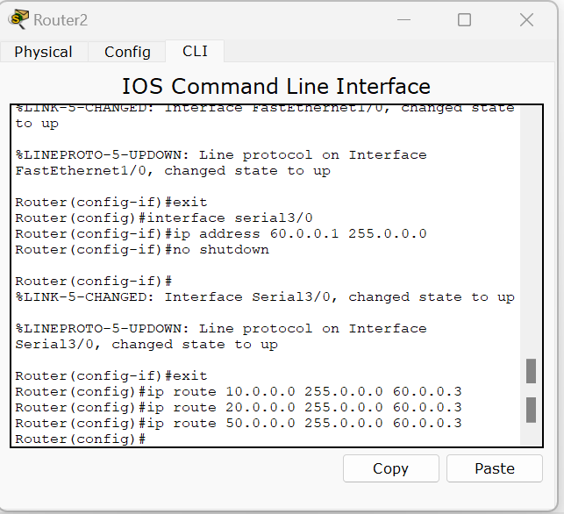

General topology

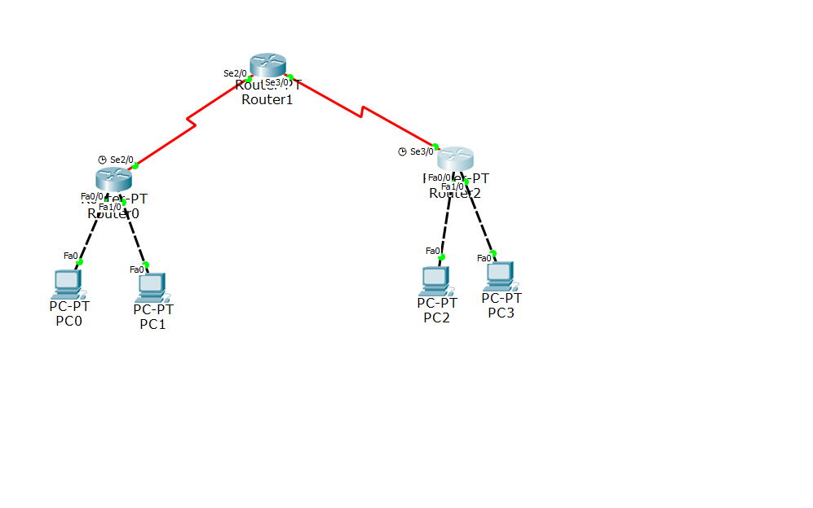

Ping from PC0 to PC 3 and PC2

