# Cheet Sheet

Python

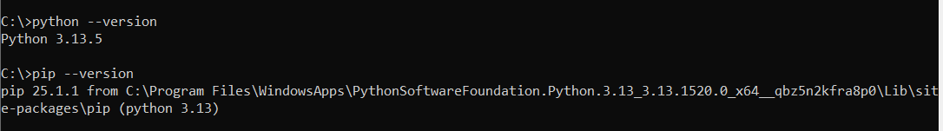

Vent

Set-ExecutionPolicy -ExecutionPolicy RemoteSigned -Scope CurrentUser

python3 -m vent vent

.venv\Scripts\Activate.ps1

pip install python -dotenv

pip install python-dotenv

Python --version

Pip install openai

==pip install faiss-cpu

python get-pip.py

pip install faiss-cpupython -c "import faiss; print(faiss.__version__)"

-1.11.0???

pip install -qU langchain-openai

pip install langchain-community

Clear

%pip install --quiet --upgrade langchain-text-splitters langchain-community langgraph