LPC1768-Based Two-Lane Racing Game with Analog Joystick Steering

ICT 3144 Embedded Systems Lab Mini Project
Vth Sem B.Tech (IT)
School of Computer Engineering
MIT, Manipal

Reg. No. | Name(s)
240911398 | Tanisha Saha
240911368 | Avaneeth Gowda L
240911458 | Powel Lawrence Lewis

October 2026

ABSTRACT
Embedded-systems laboratory work usually exercises one peripheral at a time: an LED pattern, a keypad scan, an LCD message or an ADC reading. Real products, however, must sample inputs, update their internal state and refresh several outputs together within strict time limits, while sharing a limited number of port lines and connectors. An interactive game is a demanding and very visible test of this kind of integration, because any lag in the controls, flicker on the display or missed collision is noticed immediately. The objective of this project is therefore to design and implement a responsive two-lane racing game on the ALS-SDA-ARMCTXM3-01 evaluation kit (NXP LPC1768, ARM Cortex-M3) that combines analog input, digital input, timers, interrupts and two different display devices in a single program.
The firmware is written in Embedded C using Keil µVision4 and downloaded with Flash Magic. A two-axis analog joystick, read by the on-chip 12-bit ADC on channels AD0.0 and AD0.1, moves the car between lanes (Y-axis) and changes its speed (X-axis); its push button, debounced in software, starts the game, activates a temporary shield and pauses play. The on-board 16x2 LCD, driven in 4-bit mode from connector CNC, shows the road using four custom CGRAM characters together with the speed and shield status, while the four-digit multiplexed seven-segment display shows lives and score. A 1 ms Timer 0 interrupt multiplexes the seven-segment display, and a non-blocking main loop organised as a six-state finite-state machine runs the game logic every 10 ms. Obstacles are generated by a xorshift pseudo-random generator under spacing rules that guarantee the road is never fully blocked, and the game speeds up through seven levels as the score rises.
The complete firmware compiles without errors or warnings in strict C89 mode for the Cortex-M3. [Summarise the key results observed on the kit here: responsiveness of steering, stability of the displays, behaviour of the shield, pause and game-over screens.] The work shows that a standard teaching kit, extended with only an inexpensive joystick module, can host a complete real-time interactive application, and it highlights practical embedded-design skills such as connector and pin allocation, interrupt-safe port access, analog-input filtering and state-machine design.

Contents
1. Introduction 1
1.1 Background 1
1.2 Problem Statement and Motivation 1
1.3 Objectives 1
1.4 Organisation of the Report 2
2. Methodology 3
2.1 Components Required 3
2.2 Block Diagram 4
2.3 Description about the Connections 5
2.4 Description 6
3. C Code with Comments 12
4. Results 21
4.1 Test Procedure 21
4.2 Photographs of the Working Model 22
4.3 Discussion 23
5. Conclusion 24
5.1 Limitations 24
5.2 Future Scope 24
References 25
Similarity Report 26

List of Figures
Figure 1: Block diagram of the system 4
Figure 2: Connection diagram 6
Figure 3: State-transition diagram of the game 7
Figure 4: Custom 5x8 characters stored in CGRAM 9
Figure 5: LCD screens of the game 10
Figure 6: Seven-segment display layout 10
Figure 7: Flowchart of initialisation and the main loop 11
Figure 8: Hardware setup: kit, ribbon cables and joystick wiring 22
Figure 9: Start screen and seven-segment display 22
Figure 10: Game in progress: car, obstacles, speed and shield status 22
Figure 11: Collision and game-over screens 23

List of Tables
Table 1: Hardware components 3
Table 2: Software tools 4
Table 3: Cables and wires 5
Table 4: Port-pin allocation 5
Table 5: States of the finite-state machine 7
Table 6: Speed levels 9
Table 7: Game controls 11
Table 8: Functional test cases 21

1. Introduction

1.1 Background
An embedded system is a computer built into a larger device to perform a dedicated function, usually under real-time constraints and with limited memory, pins and power. Microcontrollers such as the NXP LPC1768, based on the ARM Cortex-M3 core, integrate the processor with timers, an analog-to-digital converter (ADC), interrupt control and general-purpose input/output (GPIO), which makes them suitable for interactive devices that must read inputs and update outputs continuously. Small video games are a classic example of such an application: the system must sample the controls, update the game state at a fixed rate and refresh the display without visible delay.

1.2 Problem Statement and Motivation
In the laboratory, each peripheral of the ALS-SDA-ARMCTXM3-01 kit is studied in a separate experiment with its own program and blocking delay loops. Combining them raises problems that the individual experiments do not: the peripherals compete for port lines and the four controller connectors, a display that must be refreshed every millisecond cannot wait for a slow delay loop, a noisy analog signal must be turned into a clean decision, and button presses must be acted on exactly once. This project addresses these problems by building one responsive application that uses the LCD, the seven-segment display, the ADC, timers and interrupts together. A game was chosen because errors in timing or logic are immediately visible to the player, which makes it a strong demonstration of correct embedded design.

1.3 Objectives
- Develop a two-lane racing game on the 16x2 LCD using custom characters for the car, shielded car, obstacles and crash symbol.
- Read an analog joystick through the 12-bit ADC and use it to steer between lanes and to change the game speed.
- Use a hardware timer interrupt for non-blocking timing and display multiplexing, keeping the main loop free of long delays.
- Generate obstacles pseudo-randomly while guaranteeing that the road always remains passable, and detect collisions reliably.
- Implement lives, score, high score, a temporary shield, pause and progressive difficulty using a finite-state machine.
- Allocate pins and connectors so that all peripherals work at the same time on the standard kit, with minimal extra hardware.

1.4 Organisation of the Report
Chapter 2 describes the components, block diagram, connections and the design of the hardware and software. Chapter 3 lists the complete commented C program. Chapter 4 presents the test procedure and results, and Chapter 5 concludes the report with limitations and future scope.

2. Methodology
The project was developed in four stages: study of the kit and its connector pin tables in the laboratory manual [1]; allocation of port lines to each peripheral; incremental development of the firmware (LCD driver, display multiplexing, joystick input, then game logic); and testing on the kit. This chapter describes the result of each stage.

2.1 Components Required
Table 1: Hardware components
Component | Qty | Purpose
ALS-SDA-ARMCTXM3-01 evaluation board (NXP LPC1768, ARM Cortex-M3) | 1 | Main controller running the game
16x2 alphanumeric LCD (on board, socket CN11, interface CNAD) | 1 | Road, car, obstacles, speed and shield status, messages
4-digit multiplexed seven-segment display U8-U11 (on board) | 1 | Lives and score
Analog joystick module, 2-axis with push button (KY-023 type, two 10 kΩ potentiometers) | 1 | Steering (Y), speed (X), game button (SW); purchased separately
10-core FRC ribbon cables | 3 | CNC-CNAD, CNA-CNA2, CNB-CNB2
Female-to-female jumper wires | 5 | Joystick to the CND header and the 3.3 V test point
+5 V regulated power supply | 1 | Powers the kit
DB9 serial cable (CN9) / USB-serial cable | 1 | In-system programming with Flash Magic
Personal computer | 1 | Development, compilation and programming
Digital multimeter | 1 | Checking that the joystick outputs stay within 0-3.3 V

Table 2: Software tools
Software | Use
Keil µVision4 IDE with ARM compiler | Editing, compiling and building the hex file
CMSIS device files LPC17xx.h, system_LPC17xx.c and startup code | Register definitions, clock setup and interrupt vectors
Embedded C (C89/C90) | Programming language of the firmware
Flash Magic | Downloading the hex file to the LPC1768 over the serial ISP link

2.2 Block Diagram
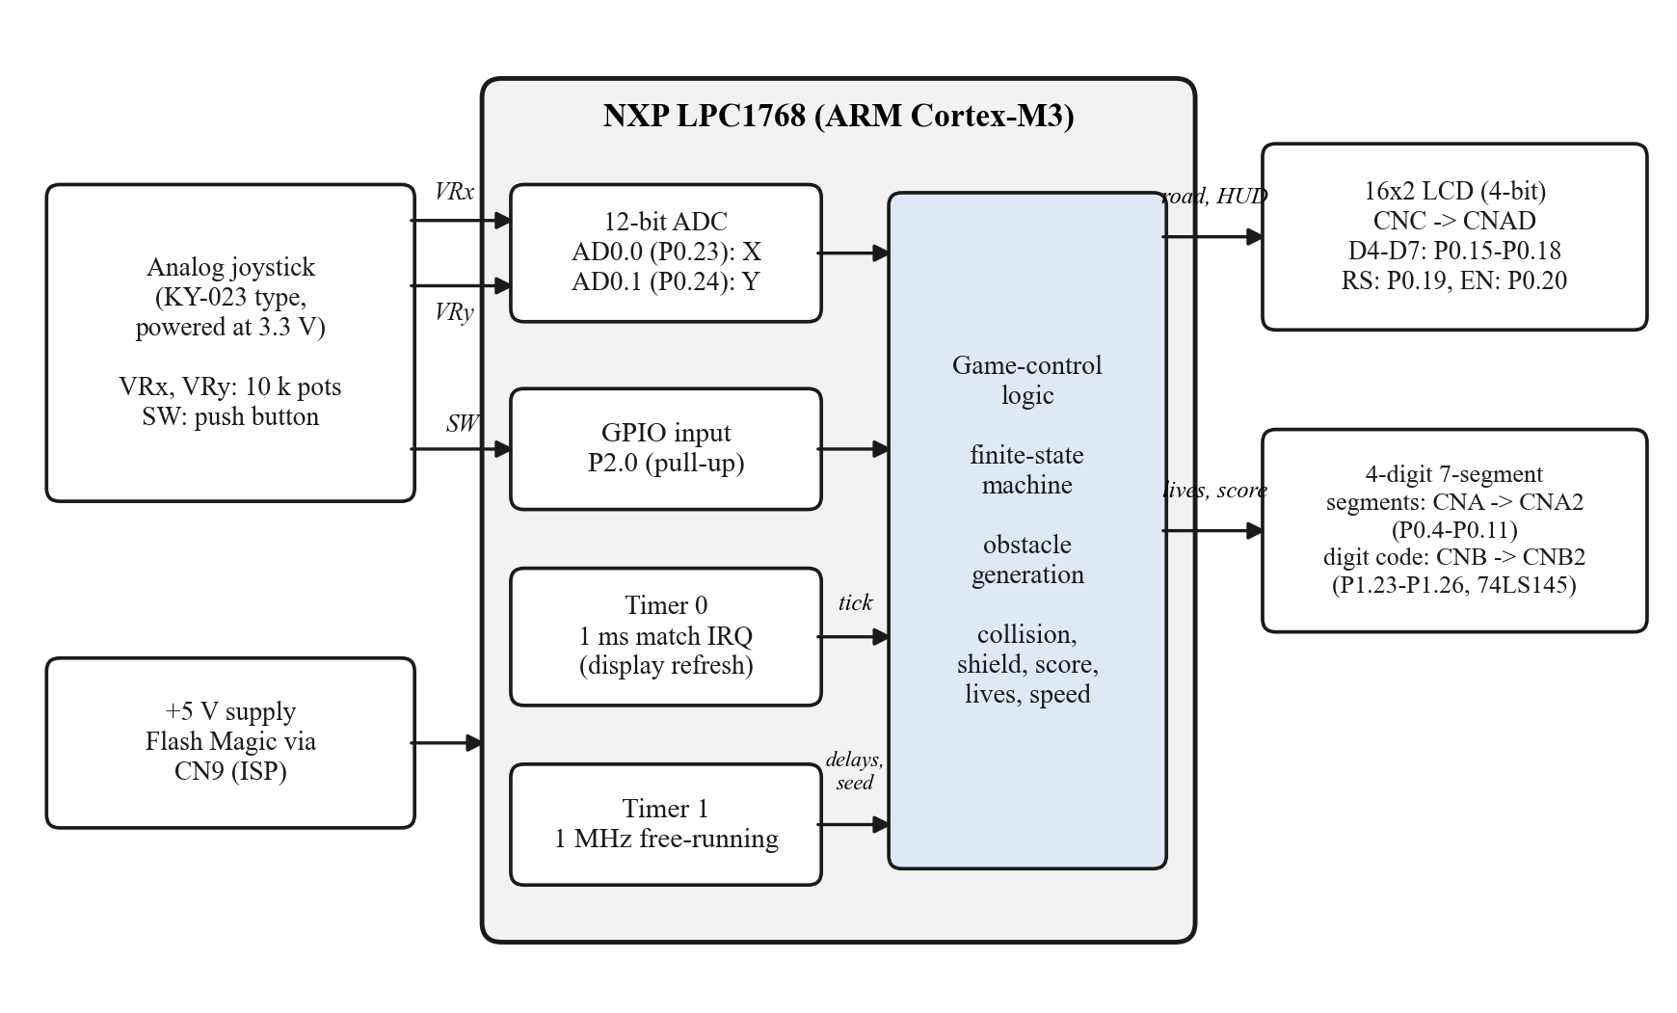
Figure 1: Block diagram of the system
Figure 1 shows the structure of the system. The joystick provides two analog voltages (VRx, VRy) that the LPC1768's 12-bit ADC converts on channels AD0.0 and AD0.1, and a push-button signal read on GPIO pin P2.0. Timer 0 produces an interrupt every millisecond, which provides the time base for the game, refreshes one digit of the seven-segment display. Timer 1 runs freely at 1 MHz and is used for the short microsecond delays of the LCD protocol and to seed the random-number generator. The game-control logic, organised as a finite-state machine, combines these inputs and drives two outputs: the 16x2 LCD (road and status) and the seven-segment display (lives and score).

2.3 Description about the Connections
The kit brings the controller's port lines out on four 10-pin FRC connectors, CNA, CNB, CNC and CND; pin 10 of each connector is ground [1]. The on-board peripheral blocks have their own connectors (CNA2, CNB2, CNAD and others), so each peripheral is attached by a ribbon cable from a controller connector to its block. Table 3 lists the cables and wires used and Table 4 gives the complete pin allocation.
Table 3: Cables and wires
From | To | Type | Function / setting
CNC | CNAD | FRC cable | 16x2 LCD; short JP16 and JP5; adjust contrast with POT3
CNA | CNA2 | FRC cable | Seven-segment segment lines a-g, dp
CNB | CNB2 | FRC cable | Seven-segment digit code to the 74LS145 decoder
Joystick VRx | CND pin 1 | Jumper wire | Speed control, P0.23 / AD0.0
Joystick VRy | CND pin 2 | Jumper wire | Steering, P0.24 / AD0.1
Joystick SW | CND pin 7 | Jumper wire | Game button, P2.0 (internal pull-up)
Joystick GND | CND pin 10 | Jumper wire | Ground
Joystick +5V pin | Board 3.3 V test point | Jumper wire | Supply; must be 3.3 V because the ADC accepts 0-3.3 V only

Table 4: Port-pin allocation
Port pin(s) | Connector | Dir. | Function | Configuration
P0.4-P0.11 | CNA 1-8 | Out | Segments a, b, c, d, e, f, g, dp | PINSEL0 = GPIO
P1.23-P1.26 | CNB 1-4 | Out | BCD digit code to 74LS145 (U8-U11) | PINSEL3 = GPIO
P0.15-P0.18 | CNC 1-4 | Out | LCD data D4-D7 | PINSEL0/1 = GPIO
P0.19 | CNC 5 | Out | LCD RS | PINSEL1 = GPIO
P0.20 | CNC 6 | Out | LCD EN | PINSEL1 = GPIO
P0.23 | CND 1 | Analog | AD0.0, joystick X | PINSEL1 = 01, PINMODE1 = no pull
P0.24 | CND 2 | Analog | AD0.1, joystick Y | PINSEL1 = 01, PINMODE1 = no pull
P2.0 | CND 7 | In | Joystick button, active low | PINSEL4 = GPIO, PINMODE4 = pull-up

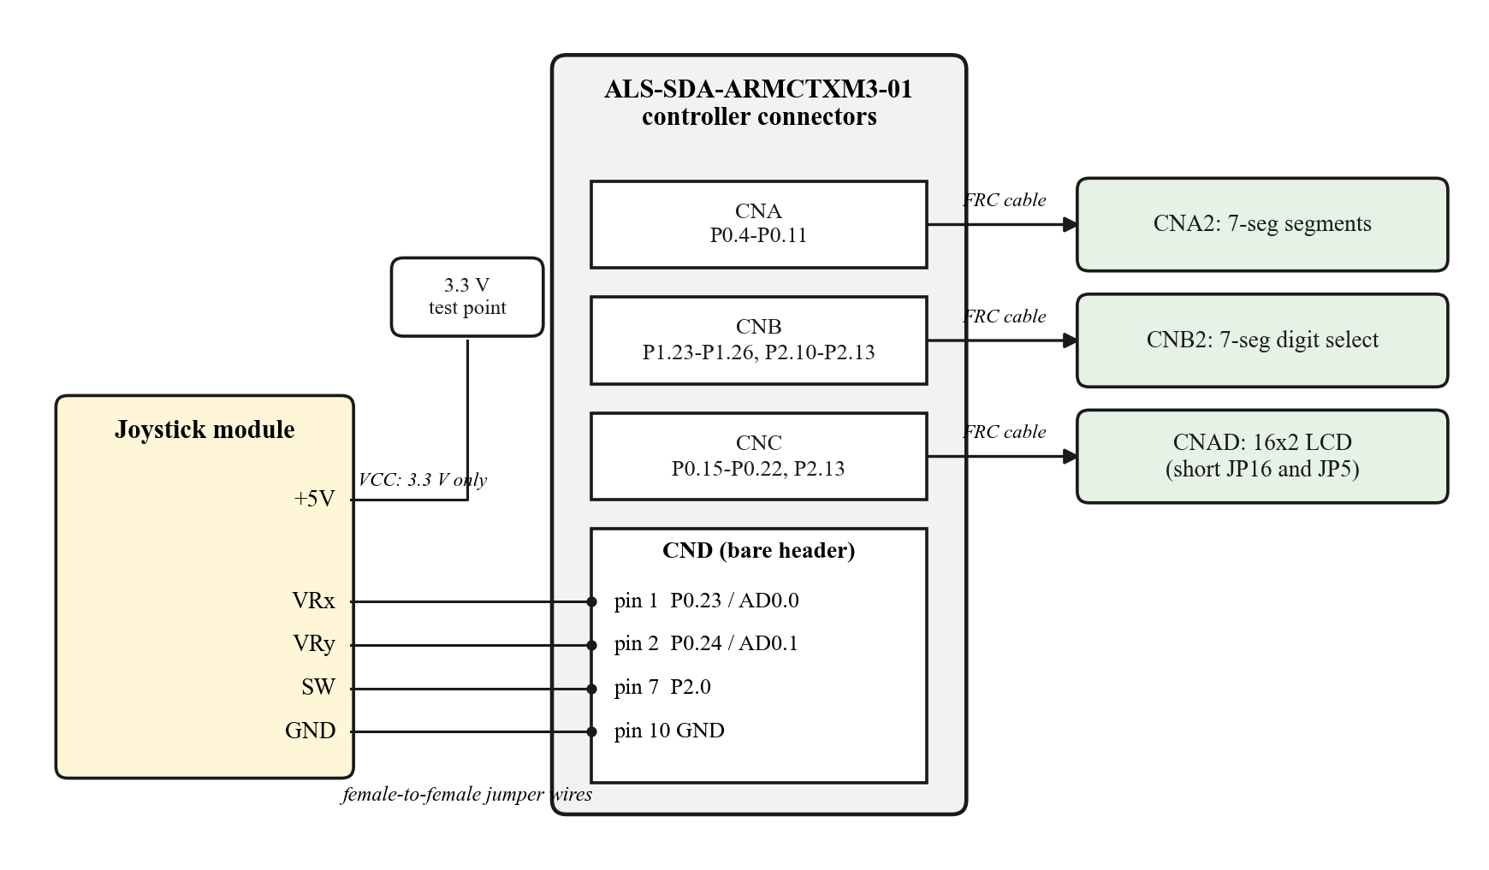
Figure 2: Connection diagram
Pin-allocation decisions. The laboratory manual connects the LCD through CND, whose pins P0.23-P0.26 are also the only free ADC inputs AD0.0-AD0.3 on the kit [1]. The other ADC channels are unsuitable: AD0.5 (P1.31) is hard-wired to the trimmer POT1 with no jumper, AD0.4 (P1.30) is tied to POT4 through JP18, and AD0.6/AD0.7 (P0.3/P0.2) form the serial port used for programming. An earlier version of the design, described in the synopsis, therefore lost its X-axis. In the final design the LCD is moved to CNC, which carries P0.15-P0.20 in the same order as the LCD interface expects (four data lines, RS, EN), freeing CND pins 1 and 2 for the two joystick axes. The button uses P2.0 rather than P0.27/P0.28 because those two pins are open-drain I²C pins without internal pull-up resistors [2].
Safe port access. Port 0 is written both by the Timer 0 interrupt (seven-segment segments) and by the main program (LCD lines). All writes therefore use the FIOSET and FIOCLR registers, which change only the bits written, instead of FIOPIN, which would overwrite pins owned by the other routine [2].

2.4 Description

2.4.1 Software architecture and finite-state machine
The program is a single C file built around a finite-state machine (FSM) with six states, shown in Figure 3 and Table 5. The main loop runs once every 10 ms: it reads the joystick, polls the button and then executes the code of the current state. Because no state waits in a delay loop, the display, inputs and game logic stay responsive at all times.
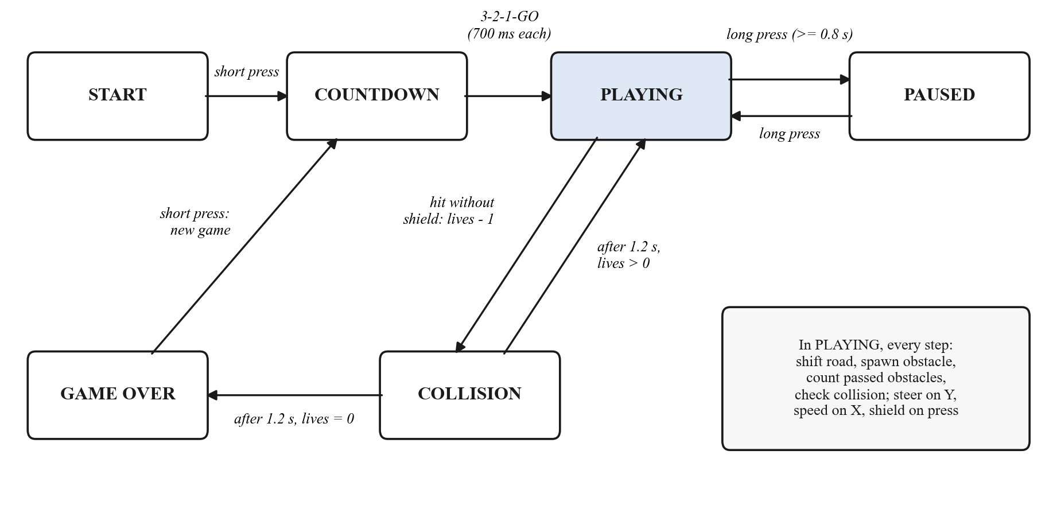
Figure 3: State-transition diagram of the game
Table 5: States of the finite-state machine
State | LCD shows | Leaves when
START | Title "JOYSTICK RACER" and high score | Short button press: new game, go to COUNTDOWN
COUNTDOWN | "GET READY" and 3, 2, 1, GO (700 ms each) | After GO: go to PLAYING
PLAYING | Road, car, obstacles; column 1 shows speed and shield | Long press: PAUSED; hit without shield: COLLISION
PAUSED | "PAUSED / Hold btn: resume" | Long press: PLAYING
COLLISION | Crash symbol blinking every 125 ms for 1.2 s | Lives left: PLAYING (road near car cleared); none: GAME OVER
GAME OVER | Score and high score, or "NEW HIGH SCORE!" | Short press: new game, go to COUNTDOWN

2.4.2 Timers and interrupts
Timer 0 runs from the peripheral clock (CCLK/4 after reset) with match register MR0 set to PCLK/1000 - 1, so it interrupts and resets every 1 ms. The interrupt service routine increments the millisecond counter ms_ticks and refreshes one seven-segment digit: it blanks all digits (decoder code 15), writes the segment pattern of the next digit and then selects that digit. Each digit is therefore lit for 1 ms in every 4 ms, a 250 Hz refresh rate that appears steady to the eye. Timer 1 is configured with a prescaler that makes its counter advance once per microsecond; delay_us() uses it for the LCD's enable-pulse and command timing, and its value seeds the random-number generator when a game starts.

2.4.3 Joystick and button input
The ADC is powered through PCONP, P0.23 and P0.24 are switched to their AD0.0/AD0.1 functions with the internal pull resistors disabled, and the converter clock is set to PCLK/5. Each reading is started in software and the result taken from the global data register once the DONE bit is set; four readings are averaged to reduce noise. At power-on, while the LCD shows "Calibrating / Don't touch joy", 32 readings of each axis are averaged to find the stick's resting centre (accepted between 0x600 and 0xA00, otherwise 0x800 is used). An axis counts as pushed only when it moves more than 700 counts (about 0.56 V) from the centre. This dead zone prevents noise from changing lanes or speed, and because the lane is changed only by a deliberate push, the car stays in its lane when the stick is released.
The button input on P2.0 is active low. It is sampled every 10 ms and accepted only after three consecutive identical samples (30 ms), which removes contact bounce. A press released before 800 ms is reported as a short press (start or shield); a press held for 800 ms is reported once as a long press (pause or resume).

2.4.4 Game logic
The road is stored as a 2 x 16 array, one row per lane. Column 0 is reserved for the status display, columns 1-15 form the road and the car always occupies column 2. At every game step all obstacles move one column to the left; an obstacle reaching column 1 has been passed and adds one point. A new obstacle may then appear in column 15: at least three columns must separate obstacles, after which one is placed with 45 % probability, and one is forced after six columns. Only one obstacle is ever placed in a column, so a free lane always exists. The lane of each new obstacle comes from a 32-bit xorshift generator [8] seeded from Timer 1 when the player starts the game, so every game is different.
A collision occurs when an obstacle enters the car's cell, either because the road moved or because the player steered into it. Without the shield the player loses one of three lives and the game enters the COLLISION state; with the shield active the obstacle is destroyed and scores a bonus point. A short button press activates the shield for 6 game steps, after which it recharges for 25 steps. The speed has seven levels (Table 6). Holding the stick right or left changes the level by one every 300 ms, and the minimum level rises by one for every 25 points, so the game becomes harder as the score increases. The high score is kept in RAM until the board is reset.
Table 6: Speed levels
Level | Step interval (ms) | Road speed (columns/s) | Minimum level reached at score
1 | 450 | 2.2 | 0
2 | 380 | 2.6 | 25
3 | 320 | 3.1 | 50
4 | 270 | 3.7 | 75
5 | 220 | 4.5 | 100
6 | 180 | 5.6 | 125
7 | 140 | 7.1 | 150

2.4.5 Display
The LCD is driven in 4-bit mode using the standard HD44780 command set [5]: after the power-on initialisation sequence the program selects two lines and a 5x8 font, turns the cursor off and loads four user-defined characters into CGRAM (Figure 4). Column 0 is a head-up display: the top row shows the speed level 1-7 and the bottom row the shield state (S = ready, * = active, . = recharging). Figure 5 shows every screen the program can display.
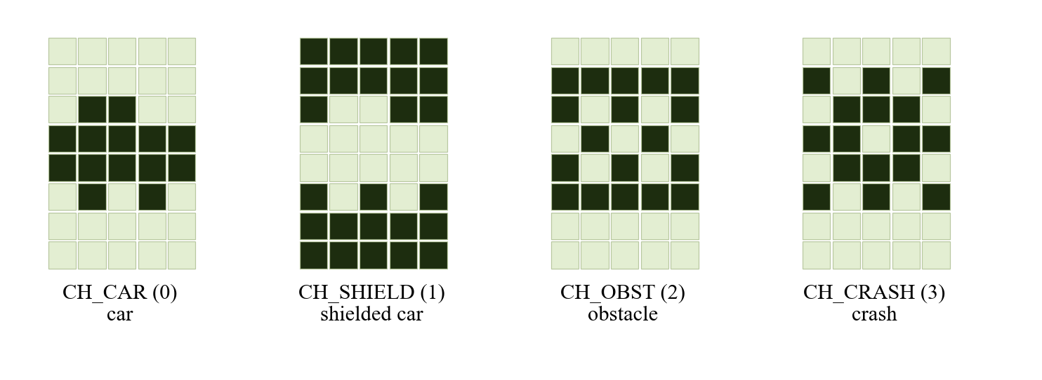
Figure 4: Custom 5x8 characters stored in CGRAM
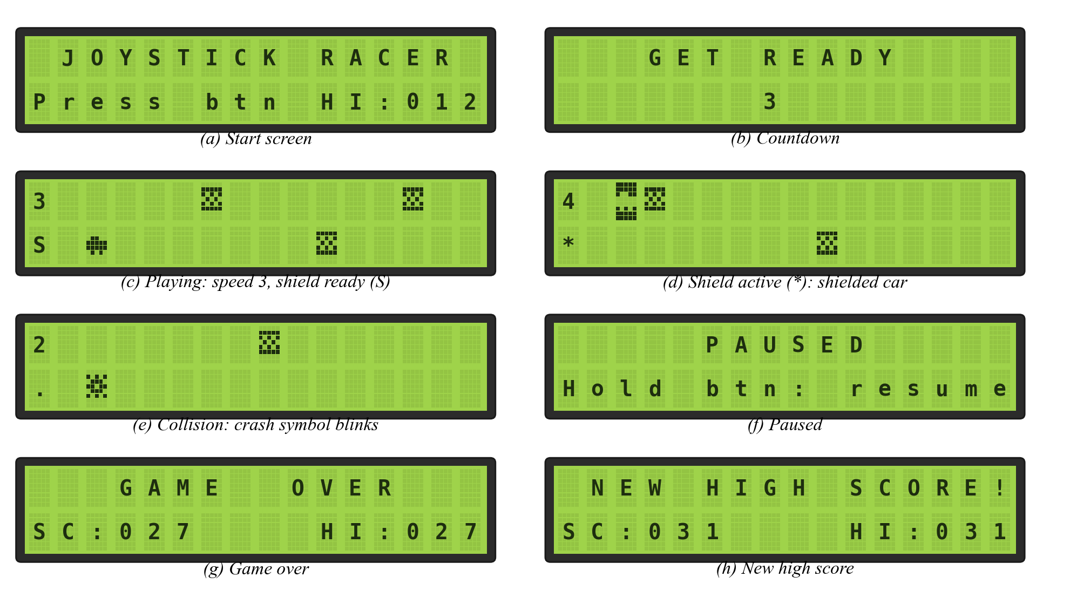
Figure 5: LCD screens of the game
The seven-segment display (Figure 6) consists of four common-cathode digits whose segments are buffered from CNA2 and whose digits are selected through a 74LS145 BCD decoder on CNB2 [1], [6]. The leftmost digit shows the remaining lives and its decimal point lights when the shield is ready; the other three digits show the score from 000 to 999. On the start screen the first digit shows a dash and the others the high score.
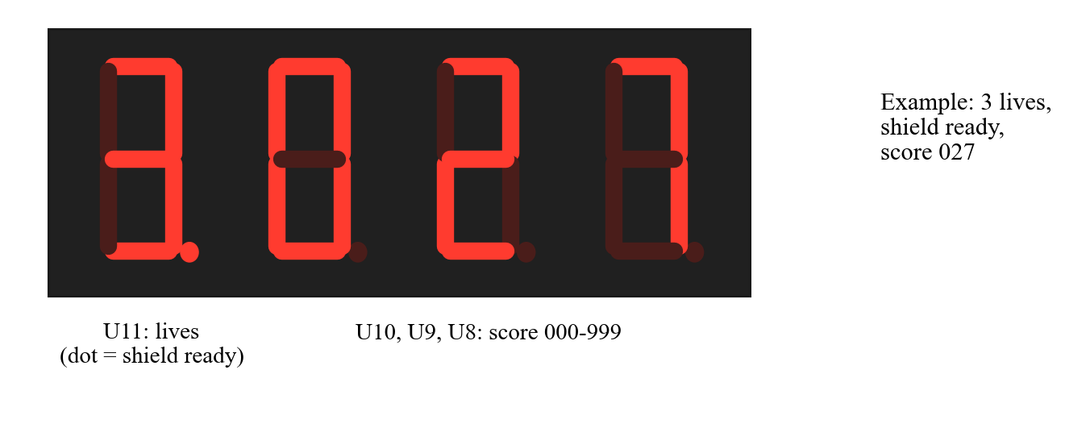
Figure 6: Seven-segment display layout

2.4.6 Program flow
Figure 7 summarises the start-up sequence and the main loop. After initialising the clock, GPIO, both timers, the ADC and the LCD, and calibrating the joystick, the program loops forever, running one pass every 10 ms.
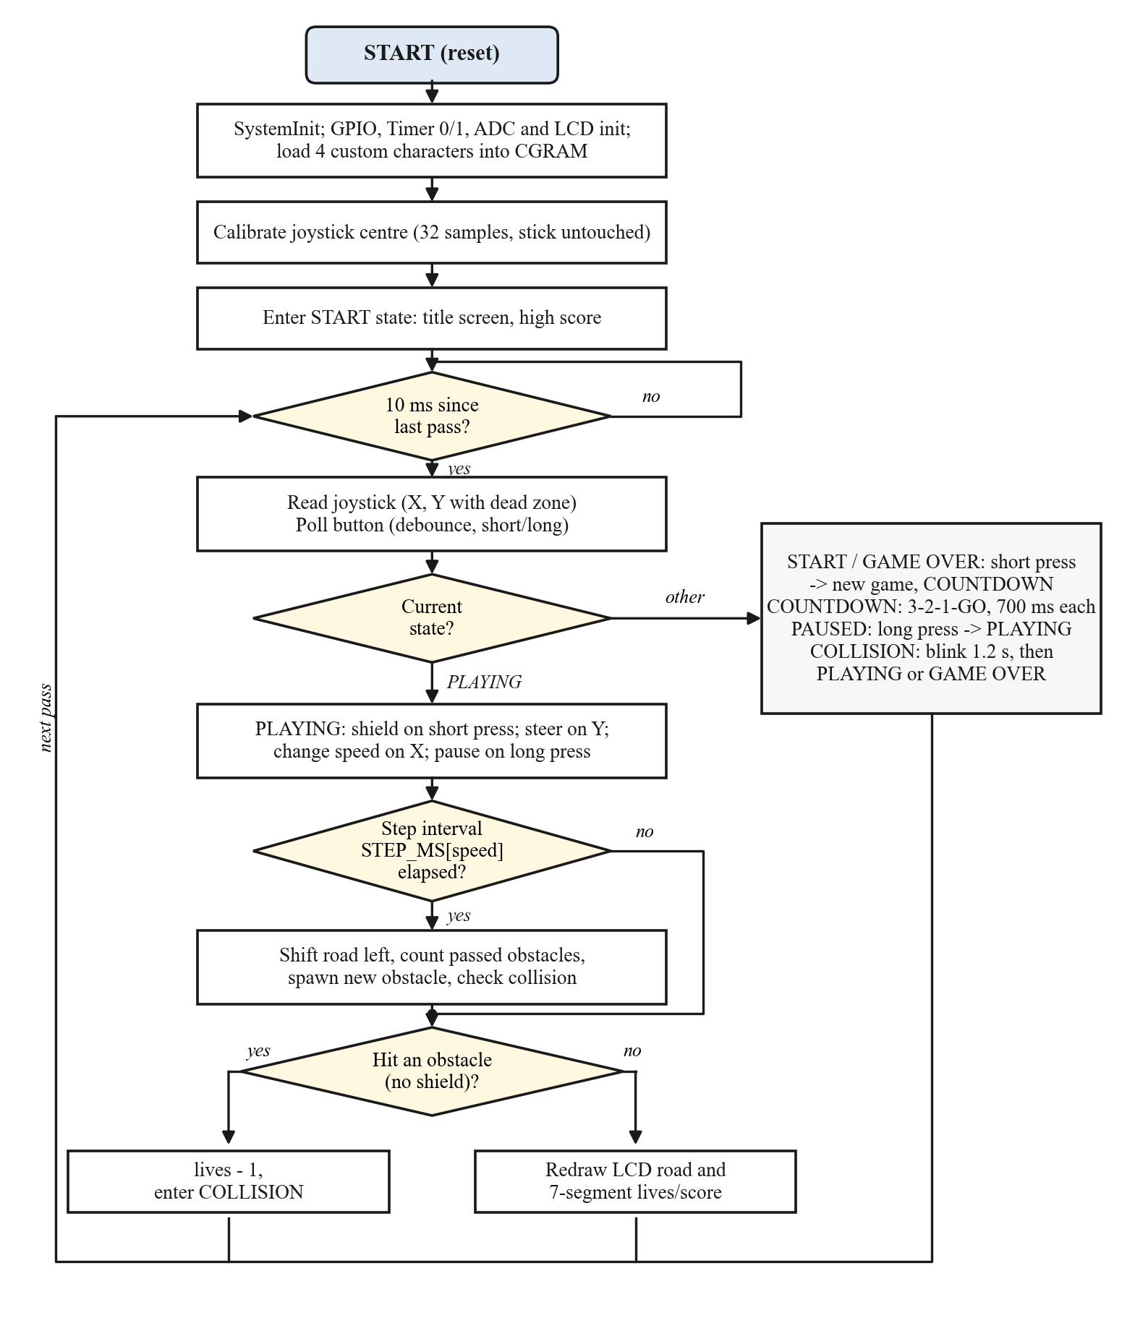
Figure 7: Flowchart of initialisation and the main loop

2.4.7 Controls
Table 7: Game controls
Input | When | Action
Joystick up / down | PLAYING | Move the car to the upper / lower lane
Joystick right / left (held) | PLAYING | Speed level +1 / -1 every 300 ms (not below the score minimum)
Button, short press | START, GAME OVER | Start a new game (3-2-1 countdown)
Button, short press | PLAYING | Activate the shield if it is ready
Button, long press (0.8 s) | PLAYING / PAUSED | Pause / resume

3. C Code with Comments
The complete firmware is a single file, racing_game.c (726 lines), written in C89 for the Keil ARM compiler. It is added to a µVision4 project for the LPC1768 together with the device's startup and system_LPC17xx.c files, built into a hex file and downloaded with Flash Magic. The adjustable settings at the top of the file (stick direction, dead zone, digit order) allow the program to be matched to the hardware without changing the logic. The file compiles without errors or warnings in strict C89 mode.
/*
* LPC1768-Based Two-Lane Racing Game with Analog Joystick Steering
* Board : ALS-SDA-ARMCTXM3-01 (NXP LPC1768, ARM Cortex-M3)
* Tools : Keil uVision4, LPC17xx.h, Flash Magic
*
* Connections (synopsis, Table 1)
* 16x2 LCD, 4-bit : CNC -> CNAD, short JP16 and JP5, POT3 = contrast
* P0.15-P0.18 = D4-D7, P0.19 = RS, P0.20 = EN
* 7-segment : CNA -> CNA2 (segments a-dp on P0.4-P0.11)
* CNB -> CNB2 (BCD digit code on P1.23-P1.26, 74LS145)
* Joystick X : CND pin 1 = P0.23 / AD0.0
* Joystick Y : CND pin 2 = P0.24 / AD0.1
* Joystick button : CND pin 7 = P2.0, active low, internal pull-up
* Joystick VCC/GND : board 3.3 V point / GND (CND pin 10)
*
* P1.31 (AD0.5) is hard-wired to POT1, so the LCD moved off CND to free
* AD0.0-AD0.1 for the joystick. The speed level and shield state are shown
* in the LCD's first column.
*
* Port 0 is written both by the Timer 0 ISR (7-segment) and by the main
* loop (LCD). Every port write therefore goes through FIOSET/FIOCLR,
* which only touch the bits given. Never write FIOPIN or FIOMASK here.
*/

#include <LPC17xx.h>
#include <stdint.h>

/* ------------------------------------------------------------------ */
/* Settings to adjust on the real hardware */
/* ------------------------------------------------------------------ */

#define Y_UP_IS_LOW 1 /* 1: pushing up lowers the Y reading. Flip if steering is reversed */
#define X_RIGHT_IS_HIGH 1 /* 1: pushing right raises the X reading. Flip if speed is reversed */
#define JOY_DEAD_ZONE 700 /* ADC counts either side of centre (12-bit, centre about 0x800) */

/* 74LS145 code for each display position, left to right. The lab manual's
* counter drives the units digit (U8) with code 0, so U8 is the rightmost.
* If digits come out reversed, change this to {0, 1, 2, 3}. */
static const uint8_t DIGIT_CODE[4] = {3, 2, 1, 0};

/* ------------------------------------------------------------------ */
/* Game parameters */
/* ------------------------------------------------------------------ */

#define LCD_COLS 16
#define HUD_COL 0 /* column 0: speed (top) and shield (bottom) */
#define ROAD_FIRST 1 /* road uses columns 1-15 */
#define CAR_COL 2
#define START_LIVES 3
#define SPEED_MIN 1
#define SPEED_MAX 7
#define SPEED_REPEAT_MS 300 /* speed changes one level per 300 ms held */
#define LEVEL_UP_SCORE 25 /* minimum speed rises every 25 points */
#define MIN_GAP 3 /* columns between obstacles (2 empty cells) */
#define MAX_GAP 6 /* force an obstacle after this many columns */
#define SPAWN_PERCENT 45
#define SHIELD_STEPS 6 /* shield lasts 6 game steps */
#define SHIELD_COOLDOWN 25 /* then needs 25 steps to recharge */
#define SCORE_MAX 999

#define INPUT_PERIOD_MS 10 /* joystick and button sampling period */
#define DEBOUNCE_SAMPLES 3 /* 3 x 10 ms stable before accepting */
#define LONG_PRESS_MS 800
#define COUNTDOWN_STEP_MS 700
#define CRASH_SHOW_MS 1200
#define CRASH_BLINK_MS 125

/* Game-step interval for speed levels 1..7 */
static const uint16_t STEP_MS[SPEED_MAX] = {450, 380, 320, 270, 220, 180, 140};

/* ------------------------------------------------------------------ */
/* Port lines */
/* ------------------------------------------------------------------ */

#define SEG_SHIFT 4
#define SEG_MASK (0xFFu << SEG_SHIFT) /* P0.4-P0.11 */
#define BTN_PIN (1u << 0) /* P2.0 */
#define LCD_D_SHIFT 15
#define LCD_D_MASK (0x0Fu << LCD_D_SHIFT) /* P0.15-P0.18 */
#define LCD_RS (1u << 19) /* P0.19 */
#define LCD_EN (1u << 20) /* P0.20 */
#define DIG_SHIFT 23
#define DIG_MASK (0x0Fu << DIG_SHIFT) /* P1.23-P1.26 */

#define ADC_CH_X 0 /* AD0.0, P0.23 */
#define ADC_CH_Y 1 /* AD0.1, P0.24 */

/* ------------------------------------------------------------------ */
/* Display tables */
/* ------------------------------------------------------------------ */

/* Common cathode, bit 0 = a ... bit 6 = g, bit 7 = dp */
static const uint8_t SEG_DIGIT[10] = {0x3F, 0x06, 0x5B, 0x4F, 0x66, 0x6D, 0x7D, 0x07, 0x7F, 0x6F};
#define SEG_DP 0x80
#define SEG_DASH 0x40

/* LCD custom characters (CGRAM 0-3) */
enum { CH_CAR = 0, CH_SHIELD = 1, CH_OBST = 2, CH_CRASH = 3 };
static const uint8_t CGRAM[4][8] = {
{0x00, 0x00, 0x0C, 0x1F, 0x1F, 0x0A, 0x00, 0x00}, /* car */
{0x1F, 0x1F, 0x13, 0x00, 0x00, 0x15, 0x1F, 0x1F}, /* shielded car (invert) */
{0x00, 0x1F, 0x15, 0x0A, 0x15, 0x1F, 0x00, 0x00}, /* obstacle */
{0x00, 0x15, 0x0E, 0x1B, 0x0E, 0x15, 0x00, 0x00}, /* crash */
};

/* ------------------------------------------------------------------ */
/* State */
/* ------------------------------------------------------------------ */

typedef enum { ST_START, ST_COUNTDOWN, ST_PLAYING, ST_PAUSED, ST_COLLISION, ST_GAMEOVER } state_t;

static volatile uint32_t ms_ticks; /* incremented every 1 ms by Timer 0 */
static volatile uint8_t seg_buf[4]; /* segment patterns, left to right */

static state_t state;
static uint32_t t_state; /* time the current state started */

static uint8_t road[2][LCD_COLS]; /* 1 = obstacle; row 0 = upper lane */
static uint8_t lane;
static uint8_t lives;
static uint8_t speed, min_speed;
static uint16_t score, hi_score; /* hi_score kept in RAM until reset */
static uint8_t new_hi;
static uint8_t gap; /* columns since the last obstacle */
static uint8_t shield_steps, shield_cool;
static uint8_t countdown;

static uint16_t x_centre = 0x800, y_centre = 0x800;
static int8_t joy_x, joy_y; /* -1, 0 or +1; +1 = right / up */
static uint8_t btn_short, btn_long; /* one-shot button events */
static uint32_t rng_state = 1;

/* ------------------------------------------------------------------ */
/* Timers */
/* ------------------------------------------------------------------ */

/* Timer 0: 1 ms tick, refreshes one 7-segment digit per tick */
void TIMER0_IRQHandler(void)
{
static uint8_t d = 0;

LPC_TIM0->IR = 1;
ms_ticks++;

LPC_GPIO1->FIOSET = DIG_MASK; /* code 15: all digits off */
LPC_GPIO0->FIOCLR = SEG_MASK;
LPC_GPIO0->FIOSET = (uint32_t)seg_buf[d] << SEG_SHIFT;
LPC_GPIO1->FIOCLR = (uint32_t)(~DIGIT_CODE[d] & 0x0F) << DIG_SHIFT; /* select digit */

d = (d + 1) & 3;
}

static void timers_init(void)
{
uint32_t pclk = SystemCoreClock / 4; /* PCLKSEL reset value: CCLK/4 */

LPC_SC->PCONP |= (1u << 1) | (1u << 2); /* power Timer 0 and Timer 1 */

/* Timer 1: free-running 1 MHz counter for microsecond delays and the RNG seed */
LPC_TIM1->TCR = 2;
LPC_TIM1->PR = pclk / 1000000 - 1;
LPC_TIM1->TCR = 1;

/* Timer 0: match interrupt every 1 ms */
LPC_TIM0->TCR = 2;
LPC_TIM0->PR = 0;
LPC_TIM0->MR0 = pclk / 1000 - 1;
LPC_TIM0->MCR = 3; /* interrupt and reset on MR0 */
LPC_TIM0->IR = 0x3F;
NVIC_EnableIRQ(TIMER0_IRQn);
LPC_TIM0->TCR = 1;
}

static void delay_us(uint32_t us)
{
uint32_t start = LPC_TIM1->TC;
while ((LPC_TIM1->TC - start) < us);
}

/* ------------------------------------------------------------------ */
/* GPIO, 7-segment */
/* ------------------------------------------------------------------ */

static void gpio_init(void)
{
LPC_PINCON->PINSEL0 &= ~0xC0FFFF00u; /* P0.4-P0.11, P0.15 as GPIO */
LPC_PINCON->PINSEL1 &= ~0x000003FFu; /* P0.16-P0.20 as GPIO */
LPC_PINCON->PINSEL3 &= ~0x003FC000u; /* P1.23-P1.26 as GPIO */
LPC_PINCON->PINSEL4 &= ~3u; /* P2.0 as GPIO */
LPC_PINCON->PINMODE4 &= ~3u; /* P2.0 pull-up */

LPC_GPIO0->FIODIR |= SEG_MASK | LCD_D_MASK | LCD_RS | LCD_EN;
LPC_GPIO1->FIODIR |= DIG_MASK;
LPC_GPIO2->FIODIR &= ~BTN_PIN;

LPC_GPIO0->FIOCLR = SEG_MASK | LCD_D_MASK | LCD_RS | LCD_EN;
LPC_GPIO1->FIOSET = DIG_MASK; /* all digits off */
}

/* First digit gets a raw pattern, the other three show n (000-999) */
static void seg_show(uint8_t first, uint16_t n)
{
seg_buf[0] = first;
seg_buf[1] = SEG_DIGIT[n / 100];
seg_buf[2] = SEG_DIGIT[(n / 10) % 10];
seg_buf[3] = SEG_DIGIT[n % 10];
}

/* Lives and score; the lives digit's decimal point means "shield ready" */
static void seg_game(void)
{
uint8_t first = SEG_DIGIT[lives];

if (state == ST_PLAYING && !shield_steps && !shield_cool)
first |= SEG_DP;
seg_show(first, score);
}

/* ------------------------------------------------------------------ */
/* LCD (4-bit, write only) */
/* ------------------------------------------------------------------ */

static void lcd_nibble(uint8_t nib)
{
LPC_GPIO0->FIOCLR = LCD_D_MASK;
LPC_GPIO0->FIOSET = (uint32_t)(nib & 0x0F) << LCD_D_SHIFT;
LPC_GPIO0->FIOSET = LCD_EN;
delay_us(1);
LPC_GPIO0->FIOCLR = LCD_EN;
delay_us(1);
}

static void lcd_write(uint8_t b, uint8_t is_data)
{
if (is_data)
LPC_GPIO0->FIOSET = LCD_RS;
else
LPC_GPIO0->FIOCLR = LCD_RS;
lcd_nibble(b >> 4);
lcd_nibble(b & 0x0F);
delay_us((!is_data && b <= 0x03) ? 2000 : 50); /* clear/home need 1.64 ms */
}

#define lcd_cmd(c) lcd_write((c), 0)
#define lcd_data(d) lcd_write((d), 1)

static void lcd_init(void)
{
uint8_t i, j;

delay_us(20000);
LPC_GPIO0->FIOCLR = LCD_RS;
lcd_nibble(0x3); delay_us(5000);
lcd_nibble(0x3); delay_us(200);
lcd_nibble(0x3); delay_us(200);
lcd_nibble(0x2); delay_us(200); /* now in 4-bit mode */

lcd_cmd(0x28); /* 4-bit, 2 lines, 5x8 font */
lcd_cmd(0x0C); /* display on, cursor off */
lcd_cmd(0x06); /* increment, no shift */
lcd_cmd(0x01); /* clear */

lcd_cmd(0x40); /* load custom characters */
for (i = 0; i < 4; i++)
for (j = 0; j < 8; j++)
lcd_data(CGRAM[i][j]);
lcd_cmd(0x80);
}

static void lcd_goto(uint8_t row, uint8_t col)
{
lcd_cmd((row ? 0xC0 : 0x80) | col);
}

/* Write a full row, padding with spaces */
static void lcd_line(uint8_t row, const char *s)
{
uint8_t i;

lcd_goto(row, 0);
for (i = 0; i < LCD_COLS; i++)
lcd_data(*s ? (uint8_t)*s++ : ' ');
}

static void put3(char *p, uint16_t n)
{
p[0] = '0' + n / 100;
p[1] = '0' + (n / 10) % 10;
p[2] = '0' + n % 10;
}

/* ------------------------------------------------------------------ */
/* ADC and joystick */
/* ------------------------------------------------------------------ */

static void adc_init(void)
{
LPC_SC->PCONP |= (1u << 12); /* power the ADC */
LPC_PINCON->PINSEL1 = (LPC_PINCON->PINSEL1 & ~0x0003C000u) | 0x00014000u; /* P0.23 = AD0.0, P0.24 = AD0.1 */
LPC_PINCON->PINMODE1 = (LPC_PINCON->PINMODE1 & ~0x0003C000u) | 0x00028000u; /* no pull */
LPC_ADC->ADCR = (1u << 21) | (4u << 8); /* on, ADC clock = PCLK/5 */
}

static uint16_t adc_read(uint8_t ch)
{
uint32_t r;

LPC_ADC->ADCR = (1u << ch) | (4u << 8) | (1u << 21) | (1u << 24); /* start now */
do {
r = LPC_ADC->ADGDR;
} while (!(r & (1u << 31)));
LPC_ADC->ADCR &= ~(7u << 24);
return (r >> 4) & 0xFFF;
}

static uint16_t adc_avg(uint8_t ch)
{
uint32_t sum = 0;
uint8_t i;

for (i = 0; i < 4; i++)
sum += adc_read(ch);
return sum / 4;
}

/* Joystick must be untouched while this runs */
static void joystick_calibrate(void)
{
uint32_t sx = 0, sy = 0;
uint8_t i;

for (i = 0; i < 32; i++) {
sx += adc_read(ADC_CH_X);
sy += adc_read(ADC_CH_Y);
delay_us(2000);
}
x_centre = sx / 32;
y_centre = sy / 32;
if (x_centre < 0x600 || x_centre > 0xA00) x_centre = 0x800;
if (y_centre < 0x600 || y_centre > 0xA00) y_centre = 0x800;
}

static int8_t axis_dir(uint16_t v, uint16_t centre, uint8_t high_is_positive)
{
int32_t d = (int32_t)v - (int32_t)centre;

if (!high_is_positive)
d = -d;
if (d > JOY_DEAD_ZONE)
return 1;
if (d < -JOY_DEAD_ZONE)
return -1;
return 0;
}

static void joystick_read(void)
{
joy_y = axis_dir(adc_avg(ADC_CH_Y), y_centre, !Y_UP_IS_LOW); /* +1 = up */
joy_x = axis_dir(adc_avg(ADC_CH_X), x_centre, X_RIGHT_IS_HIGH); /* +1 = right */
}

/* ------------------------------------------------------------------ */
/* Button: debounce, short press on release, long press while held */
/* ------------------------------------------------------------------ */

static void button_poll(uint32_t now)
{
static uint8_t stable = 0, count = 0, long_sent = 0; /* stable: 1 = pressed */
static uint32_t t_press;
uint8_t raw = (LPC_GPIO2->FIOPIN & BTN_PIN) ? 0 : 1;

if (raw != stable) {
if (++count >= DEBOUNCE_SAMPLES) {
stable = raw;
count = 0;
if (stable) {
t_press = now;
long_sent = 0;
} else if (!long_sent) {
btn_short = 1;
}
}
} else {
count = 0;
}

if (stable && !long_sent && (now - t_press) >= LONG_PRESS_MS) {
btn_long = 1;
long_sent = 1;
}
}

/* ------------------------------------------------------------------ */
/* Game logic */
/* ------------------------------------------------------------------ */

static uint32_t rnd(void)
{
rng_state ^= rng_state << 13;
rng_state ^= rng_state >> 17;
rng_state ^= rng_state << 5;
return rng_state;
}

static void new_game(void)
{
uint8_t r, c;

for (r = 0; r < 2; r++)
for (c = 0; c < LCD_COLS; c++)
road[r][c] = 0;
lane = 1;
lives = START_LIVES;
score = 0;
speed = min_speed = SPEED_MIN;
gap = 0;
shield_steps = shield_cool = 0;
new_hi = 0;
rng_state = (LPC_TIM1->TC ^ (ms_ticks << 16)) | 1u; /* seeded by press timing */
}

static void add_score(uint8_t n)
{
score += n;
if (score > SCORE_MAX)
score = SCORE_MAX;

min_speed = SPEED_MIN + score / LEVEL_UP_SCORE;
if (min_speed > SPEED_MAX)
min_speed = SPEED_MAX;
if (speed < min_speed)
speed = min_speed;
}

/* Returns 1 if the car hit an obstacle without the shield */
static uint8_t check_collision(void)
{
if (!road[lane][CAR_COL])
return 0;
road[lane][CAR_COL] = 0;
if (shield_steps) {
add_score(1); /* shield smashes it */
return 0;
}
return 1;
}

/* Move the road one column left; returns 1 on a crash */
static uint8_t game_step(void)
{
uint8_t r, c, hit;

for (r = 0; r < 2; r++) {
for (c = ROAD_FIRST; c < LCD_COLS - 1; c++)
road[r][c] = road[r][c + 1];
road[r][LCD_COLS - 1] = 0;
}

/* Obstacles that just moved behind the car were passed */
add_score(road[0][CAR_COL - 1] + road[1][CAR_COL - 1]);

/* One obstacle per column at most, at least MIN_GAP apart: never blocked */
if (++gap >= MIN_GAP && (gap >= MAX_GAP || rnd() % 100 < SPAWN_PERCENT)) {
road[rnd() & 1][LCD_COLS - 1] = 1;
gap = 0;
}

hit = check_collision();

if (shield_steps)
shield_steps--;
else if (shield_cool)
shield_cool--;
return hit;
}

/* Give the player room after a crash */
static void clear_near_car(void)
{
uint8_t c;

for (c = ROAD_FIRST; c < ROAD_FIRST + 6; c++)
road[0][c] = road[1][c] = 0;
}

/* ------------------------------------------------------------------ */
/* Screens */
/* ------------------------------------------------------------------ */

/* Column 0 shows the speed level (top) and shield state (bottom):
* 'S' ready, '*' active, '.' recharging */
static void draw_road(uint8_t crashed)
{
uint8_t r, c, ch;

for (r = 0; r < 2; r++) {
lcd_goto(r, 0);
for (c = 0; c < LCD_COLS; c++) {
if (c == HUD_COL)
ch = r ? (shield_steps ? '*' : (shield_cool ? '.' : 'S')) : '0' + speed;
else if (r == lane && c == CAR_COL)
ch = crashed ? CH_CRASH : (shield_steps ? CH_SHIELD : CH_CAR);
else if (road[r][c])
ch = CH_OBST;
else
ch = ' ';
lcd_data(ch);
}
}
}

static void show_start(void)
{
char l1[] = "Press btn HI:000";

put3(&l1[13], hi_score);
lcd_line(0, " JOYSTICK RACER ");
lcd_line(1, l1);
}

static void show_countdown(void)
{
char l1[] = " ";

if (countdown) {
l1[7] = '0' + countdown;
lcd_line(1, l1);
} else {
lcd_line(1, " GO!");
}
lcd_line(0, " GET READY");
}

static void show_paused(void)
{
lcd_line(0, " PAUSED");
lcd_line(1, "Hold btn: resume");
}

static void show_gameover(void)
{
char l1[] = "SC:000 HI:000";

put3(&l1[3], score);
put3(&l1[13], hi_score);
lcd_line(0, new_hi ? " NEW HIGH SCORE!" : " GAME OVER");
lcd_line(1, l1);
}

/* ------------------------------------------------------------------ */
/* State machine */
/* ------------------------------------------------------------------ */

static void enter_state(state_t s)
{
state = s;
t_state = ms_ticks;
btn_short = btn_long = 0;

switch (s) {
case ST_START:
show_start();
seg_show(SEG_DASH, hi_score);
break;
case ST_COUNTDOWN:
countdown = 3;
show_countdown();
seg_game();
break;
case ST_PLAYING:
draw_road(0);
seg_game();
break;
case ST_PAUSED:
show_paused();
seg_game();
break;
case ST_COLLISION:
draw_road(1);
seg_game();
break;
case ST_GAMEOVER:
if (score > hi_score) {
hi_score = score;
new_hi = 1;
}
show_gameover();
seg_show(SEG_DIGIT[0], score);
break;
}
}

int main(void)
{
uint32_t now, t_input = 0, t_step = 0, t_speed = 0;
uint8_t redraw, moved, hit, crash_on, crash_shown = 1;

SystemInit();
SystemCoreClockUpdate();

gpio_init();
timers_init();
adc_init();
lcd_init();

lcd_line(0, " Calibrating");
lcd_line(1, "Don't touch joy");
joystick_calibrate();

enter_state(ST_START);

while (1) {
now = ms_ticks;
if (now - t_input < INPUT_PERIOD_MS)
continue;
t_input = now;

joystick_read();
button_poll(now);

switch (state) {
case ST_START:
case ST_GAMEOVER:
if (btn_short) {
new_game();
enter_state(ST_COUNTDOWN);
}
break;

case ST_COUNTDOWN:
if (now - t_state >= COUNTDOWN_STEP_MS) {
t_state = now;
if (countdown == 0) {
t_step = now;
enter_state(ST_PLAYING);
} else {
countdown--;
show_countdown();
}
}
break;

case ST_PLAYING:
if (btn_long) {
enter_state(ST_PAUSED);
break;
}
redraw = moved = hit = 0;

if (btn_short && !shield_steps && !shield_cool) {
shield_steps = SHIELD_STEPS;
shield_cool = SHIELD_COOLDOWN;
redraw = 1;
}

/* Steering: only a push past the dead zone changes lane */
if (joy_y > 0 && lane != 0) {
lane = 0;
moved = 1;
} else if (joy_y < 0 && lane != 1) {
lane = 1;
moved = 1;
}
if (moved) {
hit = check_collision();
redraw = 1;
}

/* Speed: holding left/right steps the level at a fixed rate */
if (joy_x == 0) {
t_speed = now - SPEED_REPEAT_MS; /* next push acts at once */
} else if (now - t_speed >= SPEED_REPEAT_MS) {
t_speed = now;
if (joy_x > 0 && speed < SPEED_MAX)
speed++;
else if (joy_x < 0 && speed > min_speed)
speed--;
redraw = 1; /* update the LCD speed digit */
}

if (!hit && now - t_step >= STEP_MS[speed - 1]) {
t_step = now;
hit = game_step();
redraw = 1;
}

if (hit) {
lives--;
crash_shown = 1;
enter_state(ST_COLLISION);
} else if (redraw) {
draw_road(0);
seg_game();
}
break;

case ST_PAUSED:
if (btn_long) {
t_step = now;
enter_state(ST_PLAYING);
}
break;

case ST_COLLISION:
/* Blink the crash symbol */
crash_on = (((now - t_state) / CRASH_BLINK_MS) & 1) ? 0 : 1;
if (crash_on != crash_shown) {
crash_shown = crash_on;
lcd_goto(lane, CAR_COL);
lcd_data(crash_on ? CH_CRASH : ' ');
}
if (now - t_state >= CRASH_SHOW_MS) {
if (lives == 0) {
enter_state(ST_GAMEOVER);
} else {
clear_near_car();
t_step = now;
enter_state(ST_PLAYING);
}
}
break;
}

btn_short = btn_long = 0; /* events last one pass */
}
}

4. Results

4.1 Test Procedure
The kit was wired as in Table 3 and the firmware downloaded with Flash Magic. Before connecting the joystick signals, its outputs were checked with a multimeter to stay within 0-3.3 V. Each function was then tested as listed in Table 8. [Add any changes made during testing, for example the value chosen for the dead zone or the digit order.]
Table 8: Functional test cases
No. | Test | Expected result | Observed result
1 | Power-on | "Calibrating" message, then the start screen with high score 000 | [to be filled]
2 | Short press on start screen | Countdown 3-2-1-GO, then the road appears | [to be filled]
3 | Push stick up / down | Car moves to the upper / lower lane and stays there when released | [to be filled]
4 | Hold stick right / left | Speed digit in column 1 rises / falls one level every 0.3 s | [to be filled]
5 | Obstacle passes the car | Score on the seven-segment display increases by 1 | [to be filled]
6 | Drive into an obstacle | Crash symbol blinks, lives digit decreases by 1 | [to be filled]
7 | Short press while playing | Shielded car shown, '*' in status column; obstacles destroyed | [to be filled]
8 | Hold button 0.8 s | PAUSED screen; holding again resumes play | [to be filled]
9 | Lose all three lives | GAME OVER screen with score and high score | [to be filled]
10 | Score above 25, 50, ... | Minimum speed level rises automatically | [to be filled]
11 | Long play session | Road never blocks both lanes; displays remain stable | [to be filled]

4.2 Photographs of the Working Model
Paste photograph here
Hardware setup: kit, ribbon cables and joystick wiring
Figure 8: Hardware setup: kit, ribbon cables and joystick wiring
Paste photograph here
Start screen and seven-segment display
Figure 9: Start screen and seven-segment display
Paste photograph here
Game in progress: car, obstacles, speed and shield status
Figure 10: Game in progress: car, obstacles, speed and shield status
Paste photograph here
Collision and game-over screens
Figure 11: Collision and game-over screens

4.3 Discussion
[Describe the results obtained: how responsive the steering and speed control felt, whether the seven-segment display was free of flicker, how the difficulty increased, and any problem found and how it was solved.]
Relevance of the work. The project brings together, in one working system, the topics of the embedded-systems laboratory: GPIO configuration, connector and pin planning, ADC interfacing, LCD and multiplexed-display interfacing, timers and interrupts, debouncing and state-machine design. It also shows practical issues that only appear when peripherals are combined, such as competing uses of the same port lines, interrupt-safe access to shared ports and the voltage limit of the ADC inputs. The same structure, an interrupt-driven time base with a non-blocking state machine, is used in real products such as appliance controllers, handheld instruments and simple game consoles.

5. Conclusion
A two-lane racing game was designed and implemented on the ALS-SDA-ARMCTXM3-01 kit. The firmware reads a two-axis analog joystick through the LPC1768's ADC, drives the 16x2 LCD and the four-digit seven-segment display, and organises the game as a six-state finite-state machine driven by a 1 ms timer interrupt. Careful pin allocation, in particular moving the LCD from CND to CNC, allowed both joystick axes to use free ADC channels while every peripheral works at the same time. The project met its objectives of combining several peripherals into one responsive, non-blocking application and of applying the concepts of the laboratory course to a complete system. [Add one sentence on the final test outcome.]

5.1 Limitations
- The character LCD limits the graphics to two lanes and whole-cell movement.
- The seven-segment display limits the score to 999, and the high score is lost when the board is reset.
- The ADC is read by polling, and the joystick must not be touched during the calibration at power-on.

5.2 Future Scope
- Use the kit's graphic-LCD interface for smoother, pixel-level graphics and more lanes.
- Keep the high score through resets, for example in the battery-backed general-purpose registers of the LPC1768's RTC.
- Read the ADC by interrupt or burst mode to free more processor time.
- Add a two-player mode, or send scores to a PC over the UART.

References
[1] School of Computer Engineering, Manipal Institute of Technology, Embedded Systems Lab Manual (ICT 3143), Manipal, India, Jul.-Nov. 2025.
[2] NXP Semiconductors, UM10360: LPC176x/5x User Manual.
[3] NXP Semiconductors, LPC1769/68/67/66/65/64/63: 32-bit ARM Cortex-M3 microcontroller, product data sheet.
[4] ARM Ltd., Cortex-M3 Technical Reference Manual.
[5] Hitachi Ltd., HD44780U (LCD-II) Dot Matrix Liquid Crystal Display Controller/Driver, data sheet.
[6] Texas Instruments, SN54LS145, SN74LS145 BCD-to-Decimal Decoders/Drivers, data sheet.
[7] Arm Keil, µVision User's Guide.
[8] G. Marsaglia, "Xorshift RNGs," Journal of Statistical Software, vol. 8, no. 14, pp. 1-6, 2003.

Similarity Report
[Append the similarity (plagiarism) index report here.]

