**Deep Learning and its application in computer vision report**

**Requirement:** The doctor

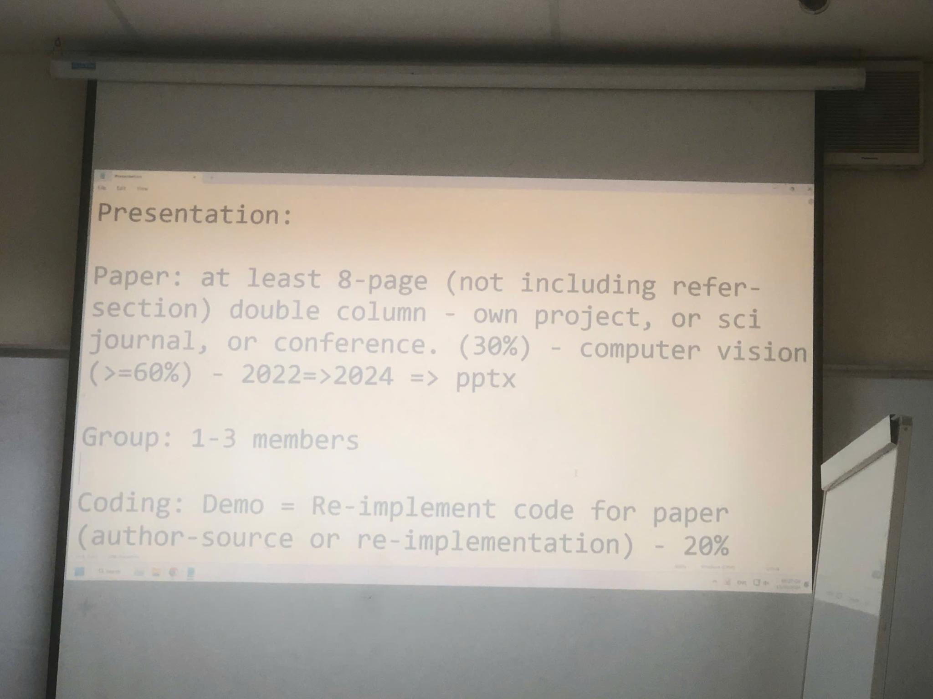

* Newspaper: <https://openaccess.thecvf.com/content/CVPR2024/papers/Lee_Guided_Slot_Attention_for_Unsupervised_Video_Object_Segmentation_CVPR_2024_paper.pdf>
* Code: <https://github.com/Hydragon516/GSANet>

**Seminar section:** 30 minutes for presentation + demo and 30 minutes for Q&A

*A selected paper has to include the algorithm. It is not a type of survey or benchmark papers.*