

Milk Tea Management

* **Faculty: Hồ Hoàn Kiếm**
* **Batch:**
* **Team Member:**
  + - * **Ngô Đức Lương - SE140482**
      * **Trần Gia Hoàng – SE140280**
      * **Trần Nhật Tân – SE140290**
      * **Nguyễn Hoàng Minh – SE140531**

**Ho Chi Minh City, March 2021**

Table of Contents

1. Review 1

* **Problem Definition …………….........…………………………………... 01**
* **Customer Request Specification…………...…………………………… 02**

1. Review 2

* ***Use Case Diagram* 04**
* ***Class Diagram* 15**
* ***Sequence Diagram* 16**
* ***ERD* 18**
* ***Entity Description* 19**
* ***Table Relationship Diagram* 26**

1. Review 3

* Interface Design………………………………………………………..... 27
* Site Map……………………..…………………………………………… 51
* Report ……………………………..………………………………………. 53
* Tasksheet…………………………………………………………………. 56

REVIEW 1

**Problem Definition**

1. **The Object of The Project :**

This project will aim at creation of a Milk Tea management system. This will be accessible to all customers who have a valid User Id and Password. This system provides the following facilities:

To do CURD function on shopping cart user must click on the product user want to custom to do action.

* Add product to shopping cart.
* View shopping cart to see current selected product on cart.
* Remove product from current shopping cart.
* Clear current shopping cart.
* Confirm order and start ordering.

**Customer Request   
 Specification**

1. **Functional Requirements**

Following is a list of functionalities of the system. More functionalities that you find appropriate can be added to this list.

* Customer must have a valid user id and password to login to the system.
* After the valid user logged in. Close the login form and forward to the main form.
* On the main form show product table to let user view available product.
* Beside viewing product table the main form also have many other tabbed pane allow user to select action like
* User can make a funds transfer to another account in the same bank. User is provided with a transaction password which is different from the login password.
* User can transfer funds from his account to any other account with this bank. If the transaction is successful a notification should appear to the customer, in case it is unsuccessful, a proper message should be given to the customer as to why it failed.
* User can request for cheque book/change of address/stop payment of cheques
* User can view his monthly as well as annual statements. He can also take print out of the same.
* Proper help to be provided as and when requested by the user.

# Hardware/ Software Requirements

By adding new technologies such as ASP.NET 3.5, AJAX, Web Service and 3-tier architecture, the web site becomes more interactive with users, security and easily updated.

1. **System Requirement**

* **For Users**
  + **Hardware**
    - CPU: Pentium IV 2.0 GHz or higher
    - RAM: 512 MB or higher
  + **Software**
    - OS: Windows 7 or higher
    - Browser: Internet Explorer 8.0 or higher
* **For Software Developers**
  + **Hardware**
    - CPU: Pentium IV 2.0 GHz or higher
    - RAM: 512 MB or higher
  + **Software**
    - OS: Windows XP Professional/Server 2003…
    - Environment: Microsoft .NET Framework 3.5
    - Database Management System: Microsoft SQL Server 2008
    - IDE: Microsoft Visual Studio 2010
    - Web Server: Internet Information Services (IIS) JSP / Servlets Dev. Kit

|  |  |  |
| --- | --- | --- |
| **Date: March 2021** | **Prepared by TSM’s project team**  **Team Leader:** | **Approved by**  **Mr. Hồ Hoàn Kiếm** |
| **Signature** |  |  |

REVIEW 2

**USE CASE DIAGRAM**

**Customer :**

**Administrators :**

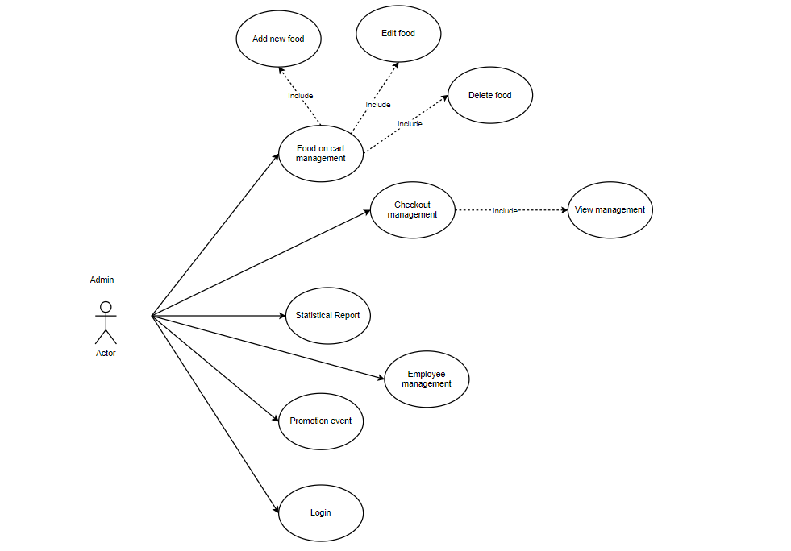

**USE CASE DESCRIPTION**

1. **Actor:**

* **Customers:** include all customer’s user that use this app. Every customer using this app need to sign up before log in.
* **Administrator:** The person(s) that manage and maintain this apps.

1. **Usecase:**

|  |  |
| --- | --- |
| **Usecase** | Sign up |
| **Actor** | Administrator |
| **Short Description** | Create an account for new employee to use app |
| **Pre-Conditions** |  |
| **Post-Conditions** |  |
| **Main flow** | _Admin must provide mandatory information to create an account:   * UserID. * Password. * Confirm Password. * Email. * Identity card. * Set role (Employee or Admin)   _An account needs to provide nessary supplementary information: FirstName, LastName, PhoneNumber, Address to confim create new user account.  _Administrator clicks on Create button. |
| **Alternative flow(s)** | _If the mandatory information that guest provided, is missed or not exactly, system notifying the error. All cases are:   * UserID has existed in Database. * Password is less than 6 characters or more than 30 characters. * Confirm Password and Password are not the same. * Email is invalid or has existed in database. * Identity card has any is digit not a character. * Any fields are blank.   _If supplementary information that guest provided, is invalid form, system notifying the error. All cases are:   * PhoneNumber has any character is not a digit. * Birthday is not along with format “dd/MM/yyyy”.   _System must be inserted the date that guest register to become member.  _ |

|  |  |
| --- | --- |
| **Usecase** | Login |
| **Actor** | Customer and Administrator |
| **Short Description** | Log in user to use any function of member. |
| **Pre-Conditions** | Have an account |
| **Post-Conditions** | Log in as user account |
| **Main flow** | _Guest inputs the login information:   * Login ID. * Password.   _Guest clicks on the Login button.  _System checking the Login ID and Password.  _If Login ID and Password are valid, system will move member to Homepage. |
| **Alternative flow(s)** | _If user back to login form to re-enter, the User ID field and Password field will be blank.  _If User ID field or Password field is invalid form or blank when guest clicks on the “Login” button, system will notify the error. After that the system will show login form again to let user re-insert UserID and pasoword. |

|  |  |
| --- | --- |
| **Use case** | View Promotions |
| **Actor** | Customer |
| **Short Description** | View promotions if the shop have any. |
| **Pre-Conditions** | Login successful |
| **Post-Conditions** | Have an account |
| **Main flow** | _Customer access Main form.  _If customer clicked on view promotions. Show view promotions form |
| **Alternative flow(s)** |  |

|  |  |
| --- | --- |
| **Use case** | View Food |
| **Actor** | Customer |
| **Short Description** | View food list of the shop |
| **Pre-Conditions** | Login successful |
| **Post-Conditions** | Have an account |
| **Main flow** | _Customer access Main form.  _On the left-side of the Main form there will be a table of listed food that shop have and available to order. |
| **Alternative flow(s)** |  |

|  |  |
| --- | --- |
| **Use case** | View Checkout |
| **Actor** | Customer |
| **Short Description** | View current food that customer already added to cart |
| **Pre-Conditions** | Login successful |
| **Post-Conditions** | Have an account |
| **Main flow** | _Customer access Main form.  _If customer clicked on view checkout. Show view checkout form. |
| **Alternative flow(s)** | _If there is no checkout currently show notify error and back to main form. |

|  |  |
| --- | --- |
| **Use case** | Pick food |
| **Actor** | Customer |
| **Short Description** | Pick food that shop have on food list and it to cart |
| **Pre-Conditions** | Login successful |
| **Post-Conditions** | Have an account |
| **Main flow** | _Customer access Main form.  _If customer clicked on any specific food on the tabel. Show detail information about that food.  _After pick any food, customer click add button. The notifycation message will show to notify that product have been add to cart. |
| **Alternative flow(s)** | _If the customer haven’t choose any food but click add, the system will not do anything. |

|  |  |
| --- | --- |
| **Usecase** | Promotion event |
| **Actor** | Administrator |
| **Short Description** | Create a promotion event |
| **Pre-Conditions** | Login in successful as admin role |
| **Post-Conditions** | Have an account |
| **Main flow** | _In main form as administrator role, when user click on View promotions.  _Show view promotions form.  _If user fill promotions information like: |
| **Alternative flow(s)** | _If user haven’t fill all the text feild or fill with wrong fomat of any promotions information but click on create button, system will show notifycation error and allow user to fill all the promotion’s information again. |

|  |  |
| --- | --- |
| **Usecase** | Statistical report |
| **Actor** | Administrator |
| **Short Description** | View popular food and potential customers |
| **Pre-Conditions** | Login in successful as admin role |
| **Post-Conditions** | Have an account |
| **Main flow** | _In main form as administrator role, when user click on Statistical report.  _Show Statistical report form.  _In this form administrator can view most ordered food and potiential customer so that can create suitable promotion event |
| **Alternative flow(s)** |  |

|  |  |
| --- | --- |
| **Usecase** | Food management |
| **Actor** | Administrator |
| **Short Description** | Admin can Add new, edit, delete food to list so that as customer to view available on shop |
| **Pre-Conditions** | Login as admin role |
| **Post-Conditions** | Have an account |
| **Main flow** | _In main form click on specific food on the table.  _If food clicked show information of that food on text field beside.  After the information shown admin can do function like:  ADD:  _All text field with set at blank at default.  _If user fill all the blank with valid information like: ProductID, ProductName, Price, … and click Save button the system will create new food on the List and save it to database. The system will also check if that ProductID is already existed. If that product is existed, show notification and let user to re input UserID.  _If user click on specific food on table. The system will lock the ProductID so that won’t let user change ProductID.  UPDATE  _If user change information on that text field and click save. The system will update that information of that food on the list and save it on database.  DELETE:  _If user click on specific food on the table and click delete button. The system will show notification to let user confirm (Yes/No) if they really want to delete. If user choose (Yes) remove that product on the table and set that product to not available on database. If user choose No, close notification and go back to main form.  _If user click delete button without choosing any product, the system won’t do anything. |
| **Alternative flow(s)** | _If the mandatory information that user provided, is missed or not exactly, system notifying the error. All cases are:   * ProductID is existed. * Price is not a digit character. |

|  |  |
| --- | --- |
| **Usecase** | Download Transaction Report |
| **Short Description** | See and download Transaction Report |
| **Pre-Conditions** |  |
| **Post-Conditions** |  |
| **Main flow** | _Customer access the transaction report page.  _Customer can see the Transaction report on this website.  _If customer want to download the transaction report, he(she) clicks on the link for download transaction report. |
| **Alternative flow(s)** | _If server notifies any error when it’s processing, system must be write report into Log file. |

|  |  |
| --- | --- |
| **Usecase** | Manage Customers |
| **Short Description** | Manage all information about customer. |
| **Pre-Conditions** |  |
| **Post-Conditions** |  |
| **Main flow** | _Manage all information of customer. |
| **Alternative flow(s)** | _If server notifies any error when it’s processing, system must be write report into Log file. |

|  |  |
| --- | --- |
| **Usecase** | Report Customers |
| **Short Description** | Show customer’s report. |
| **Pre-Conditions** |  |
| **Post-Conditions** |  |
| **Main flow** | _Administrator chooses the customer whose administrator wants to see report.  _Administrator clicks on the “Report” button.  _System show the customer’s report to administrator. |
| **Alternative flow(s)** | _If server notifies any error when it’s processing, system must be write report into Log file. |

|  |  |
| --- | --- |
| **Usecase** | View Customer’s Information |
| **Short Description** | Administrator view customer’s information. |
| **Pre-Conditions** |  |
| **Post-Conditions** |  |
| **Main flow** | _Administrator choose the customer that administrator wants to see information.  _Administrator clicks on the “View Information” button.  _System shows the customer’s information to the administrator. |
| **Alternative flow(s)** | _If server notifies any error when it’s processing, system must be write report into Log file. |

|  |  |
| --- | --- |
| **Usecase** | Administrator Edit Account |
| **Short Description** | Edit member’s information. |
| **Pre-Conditions** |  |
| **Post-Conditions** |  |
| **Main flow** | _Admin can edit credit card customer request to suspend use of credit card  _System check this information and save it on the server.  _System notify report to member. |
| **Alternative flow(s)** | _If any information edit are invalid, system’ll notify the error.  _If server notifies any error when it’s processing, system must be write report into Log file. |

|  |  |
| --- | --- |
| **Usecase** | Manage News |
| **Short Description** | Manage news of this website. |
| **Pre-Conditions** |  |
| **Post-Conditions** |  |
| **Main flow** | _Administrator can view, insert, update, delete news.  _Administrator chooses the correlative function.  _System passes administrator to the page that administrator can interact with system. |
| **Alternative flow(s)** | _If server notifys any error when it’s processing, system must be write report into Log file. |

|  |  |
| --- | --- |
| **Usecase** | Edit News |
| **Short Description** | Update, Delete all information about this site. |
| **Pre-Conditions** |  |
| **Post-Conditions** |  |
| **Main flow** | _Administrator can update ,delete , news, drivers…of this site.  _Administrator chooses the correlative function.  _System passes administrator to the page that administrator can interact with system. |
| **Alternative flow(s)** | _If server notifies any error when it’s processing, system must be write report into Log file. |

|  |  |
| --- | --- |
| **Usecase** | Insert |
| **Short Description** | Insert all information about this website. |
| **Pre-Conditions** |  |
| **Post-Conditions** |  |
| **Main flow** | _Administrator can Insert , news… of this site.  _Administrator chooses the correlative function.  _System passes administrator to the page that administrator can interact with system. |
| **Alternative flow(s)** | _If server notifies any error when it’s processing, system must be write report into Log file. |

|  |  |
| --- | --- |
| **Usecase** | Manage Transaction |
| **Short Description** | Manage all information about Transaction. |
| **Pre-Conditions** |  |
| **Post-Conditions** |  |
| **Main flow** | _Administrator can view.  _Transaction reporting in the days, months, years .  _System passes administrator to the page that administrator can interact with system. |
| **Alternative flow(s)** | _If server notifies any error when it’s processing, system must be write report into Log file. |

|  |  |
| --- | --- |
| **Usecase** | View Transaction Information |
| **Short Description** | View details information of Transaction. |
| **Pre-Conditions** |  |
| **Post-Conditions** |  |
| **Main flow** | _Administrator chooses the transaction that administrator wants to see information.  _System shows the details information of this transaction. |
| **Alternative flow(s)** | _If server notifies any error when it’s processing, system must be write report into Log file. |

|  |  |
| --- | --- |
| **Usecase** | Search |
| **Short Description** | Search all information about this site. |
| **Pre-Conditions** |  |
| **Post-Conditions** |  |
| **Main flow** | _Administrator inputs the information that wants to see in the search field.  _Administrator clicks on the “Search” button Or onKeydown  _System shows the result to the administrator. |
| **Alternative flow(s)** | _If server notifies any error when it’s processing, system must be write report into Log file. |

**CLASS DIAGRAM**

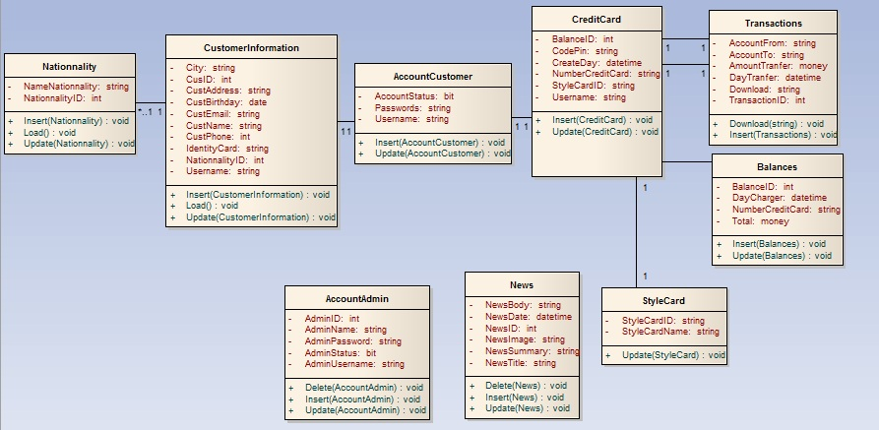

**ENTITY RELATIONSHIP DIAGRAM (ERD)**  
 **Note:  
  
  
ENTITY DESCRIPTION**

Have

Have

Belong

Have

Nationality

Customer  
Information

Account  
Customer

Account  
Admin

Style  
Card

News

Credit  
Card

Transaction

CountHitPage

Contain

Entity

Entity Relationship

One to  
 many relationship

**1.Account Customer :**

**Account  
Customers**

**2. Customer Information :  
3. Nationality :**

**Customer  
Information**

**4. Style Card :  
  
  
  
  
  
  
  
  
5. Transaction :  
  
6. News :**

**Transaction**

**Style Card**

**Nationality**

**News**

**7. Credit Card :**

**8. CountHitPage:**

**Credit Card**

**CountHitPage**

**9. Account Admin :**

**Account  
Admin**

**TABLE DESIGN**

1. **Account Customer :**

|  |  |  |  |  |  |
| --- | --- | --- | --- | --- | --- |
| **No** | **Column Name** | **Data Type** | **Size** | **Check** | **Description** |
| 1 | **🗝**Username | Varchar | 15 | Not Null | Customer ID |
| 2 | Passwords | Varchar | 20 | Not Null | Customer’s password |
| 3 | Account Status | Bit |  | Not Null | Customer’s user name |

1. **Customer Information :**

|  |  |  |  |  |  |
| --- | --- | --- | --- | --- | --- |
| **No** | **Column Name** | **Data Type** | **Size** | **Check** | **Description** |
| 1 | **🗝**CustID | Int | Identity | Not Null | ID |
| 2 | IdentityCard | Varchar | 9 | Null | IdentityCard Customer |
| 3 | CustName | Varchar | 30 | Null | Name Customer |
| 4 | CustBirthday | Date |  | Null | Birthday Customer |
| 5 | CustEmail | Varchar | 50 | Null | Email Customer |
| 6 | CustAddress | Varchar | 100 | Null | Address Customer |
| 7 | CustPhone | Varchar | 15 | Null | Phone Customer |
| 8 | NationalityID | Int |  | Null | Nationality Customer |
| 9 | City | Varchar | 15 | Null | City |
| 10 | Username | Varchar | 15 | Not Null | Customer ID |
| 11 | CustGender | Varchar | 6 | Null | Customer Gender |

1. **Nationality :**

|  |  |  |  |  |  |
| --- | --- | --- | --- | --- | --- |
| **No** | **Column Name** | **Data Type** | **Size** | **Check** | **Description** |
| 1 | **🗝**Nationality ID | Int |  | Not Null |  |
| 2 | Name Nationality | Varchar | 30 | Not Null |  |

1. **StyleCard:**

|  |  |  |  |  |  |
| --- | --- | --- | --- | --- | --- |
| **No** | **Column Name** | **Data Type** | **Size** | **Check** | **Description** |
| 1 | **🗝**Style Card ID | Varchar | 5 | Not Null | Style Card ID |
| 2 | Style Name | Varchar | 10 | Not Null | Name Style Card |

1. **Transactions:**

|  |  |  |  |  |  |
| --- | --- | --- | --- | --- | --- |
| **No** | **Column Name** | **Data Type** | **Size** | **Check** | **Description** |
| 1 | **🗝**Transaction ID | Int |  | Not Null | Transaction ID |
| 2 | Account From | Varchar | 12 | Not Null | Account From |
| 3 | Account To | Varchar | 12 | Not Null | Account To |
| 4 | Day Transfer | Datetime |  | Not Null | Day Tranfer |
| 5 | Amount Transfer | Money |  | Not Null | Amount Tranfer |

1. **News :**

|  |  |  |  |  |  |
| --- | --- | --- | --- | --- | --- |
| **No** | **Column Name** | **Data Type** | **Size** | **Check** | **Description** |
| 1 | **🗝**News ID | Int |  | Not Null | News ID |
| 2 | News Title | Varchar | 300 | Not Null | News Title |
| 3 | News Summary | Varchar | 200 | Not Null | News Summary |
| 4 | News Body | Varchar | Max | Not null | News Body |
| 5 | News Date | Datetime |  | Not Null | News Datetime |
| 6 | News Image | Varchar | 100 | Not Null | News Image |

1. **Credit Card:**

|  |  |  |  |  |  |
| --- | --- | --- | --- | --- | --- |
| **No** | **Column Name** | **Data Type** | **Size** | **Check** | **Description** |
| 1 | **🗝**NumberCreditCard | Varchar | 12 | Not Null | Number Credit Card |
| 2 | Balance | Money |  | Not Null | Balance ID |
| 3 | StyleCardID | Varchar | 15 | Not Null | StyleCard ID |
| 4 | CodePin | Varchar | 250 | Not Null | Code Pin |
| 5 | CreateDay | Datetime |  | Not Null | Create Day |
| 6 | Username | Varchar | 15 | Not Null | Customer ID |

1. **CountHitPage:**

|  |  |  |  |  |  |
| --- | --- | --- | --- | --- | --- |
| **No** | **Column Name** | **Data Type** | **Size** | **Check** | **Description** |
| 1 | Page_Name | Varchar | 100 | Not Null | Page_Name |
| 2 | Dem | int |  | Not Null | Count Page |

1. **Account Admin:**

|  |  |  |  |  |  |
| --- | --- | --- | --- | --- | --- |
| **No** | **Column Name** | **Data Type** | **Size** | **Check** | **Description** |
| 1 | **🗝**AdminID | Int |  | Not Null | Admin ID |
| 2 | AdminStatus | Bit |  | Not Null | Status Admin |
| 3 | AdminUsername | Varchar | 25 | Not Null | Username Admin |
| 4 | AdminPassword | Varchar | 12 | Not Null | Password Admin |
| 5 | AdminName | Varchar | 30 | Not Null | Name Admin |

**Note**

**🗝** Primary key

✓ Unique constraint

**TABLE RELATIONSHIP DIAGRAM**

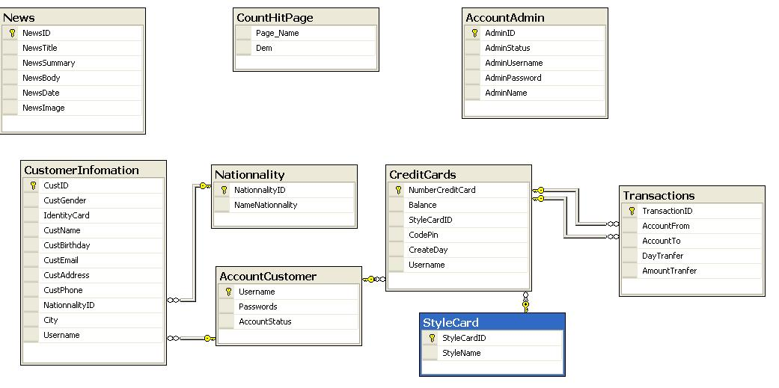

|  |  |  |
| --- | --- | --- |
| **Date: Sep 20, 2012** | **Prepared by Project Group 4**  **Team Leader:** | **Approved by**  **Mr. Ho Hoan Kiem** |
| **Signature** |  |  |

REVIEW 3

**INTERFACE DESIGN**

1. **Home Page**

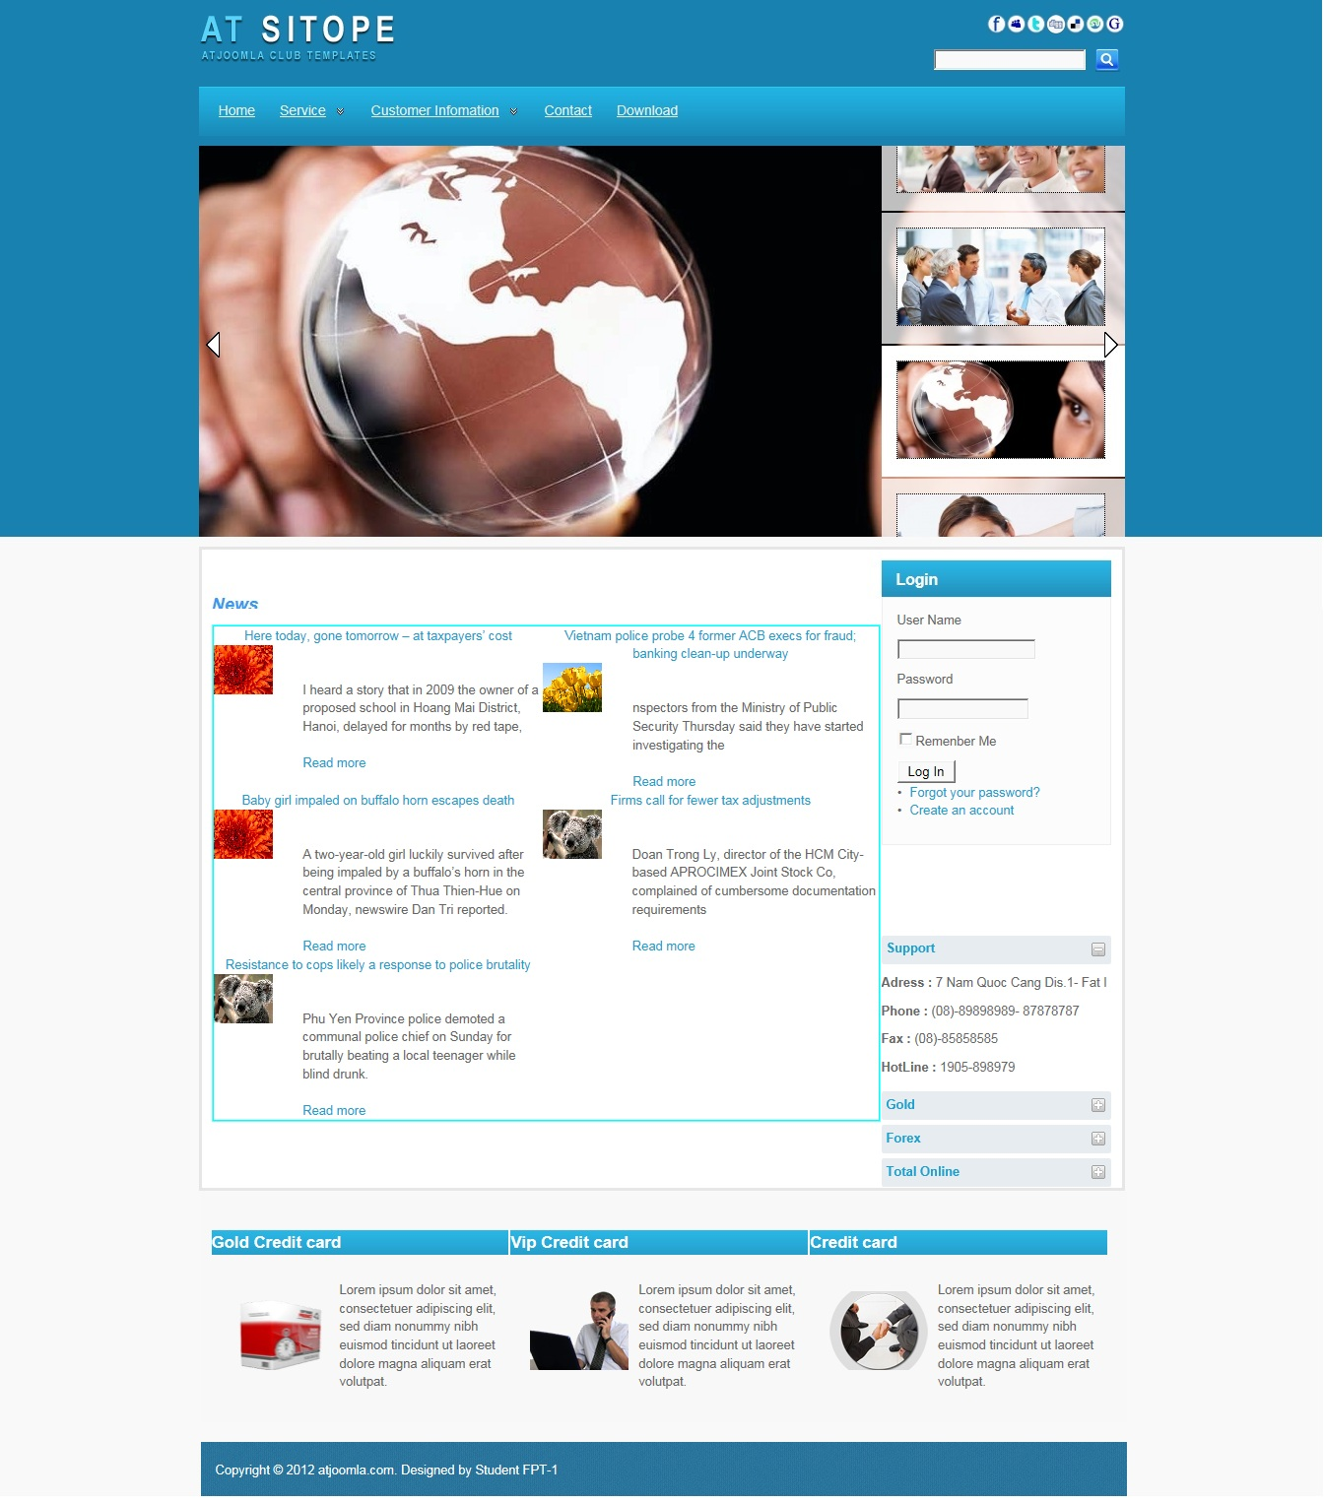

|  |  |  |  |  |  |
| --- | --- | --- | --- | --- | --- |
| **Name** | **Type** | **Event** | **Validation** | **Description** | **Status** |
| User Name | TextBox |  | String, not null | Input Customer’s user name |  |
| Password | TextBox |  | String, not null, | Input Customer’s password |  |
| Remember Me | Check Box |  | Stick | Remember Customer next time |  |
| Login | Button |  | Click | Choose Login |  |
| Forgot your Password | Hyperlink |  | Click | When Customer forgot password, they can help service supply again. |  |
| Create an Account | Hyperlink |  | Click | Create New Account when Customer like to create. |  |

1. **Login:**

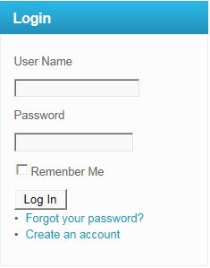

|  |  |  |  |  |  |
| --- | --- | --- | --- | --- | --- |
| **Name** | **Type** | **Event** | **Validation** | **Description** | **Status** |
| User Name | TextBox |  | String, not null | Input Customer’s user name |  |
| Password | TextBox |  | String, not null, | Input Customer’s password |  |
| Remember Me | Check Box |  | Stick | Remember Customer next time |  |
| Login | Button |  | Click | Login |  |

**3.Create Account Customer:**

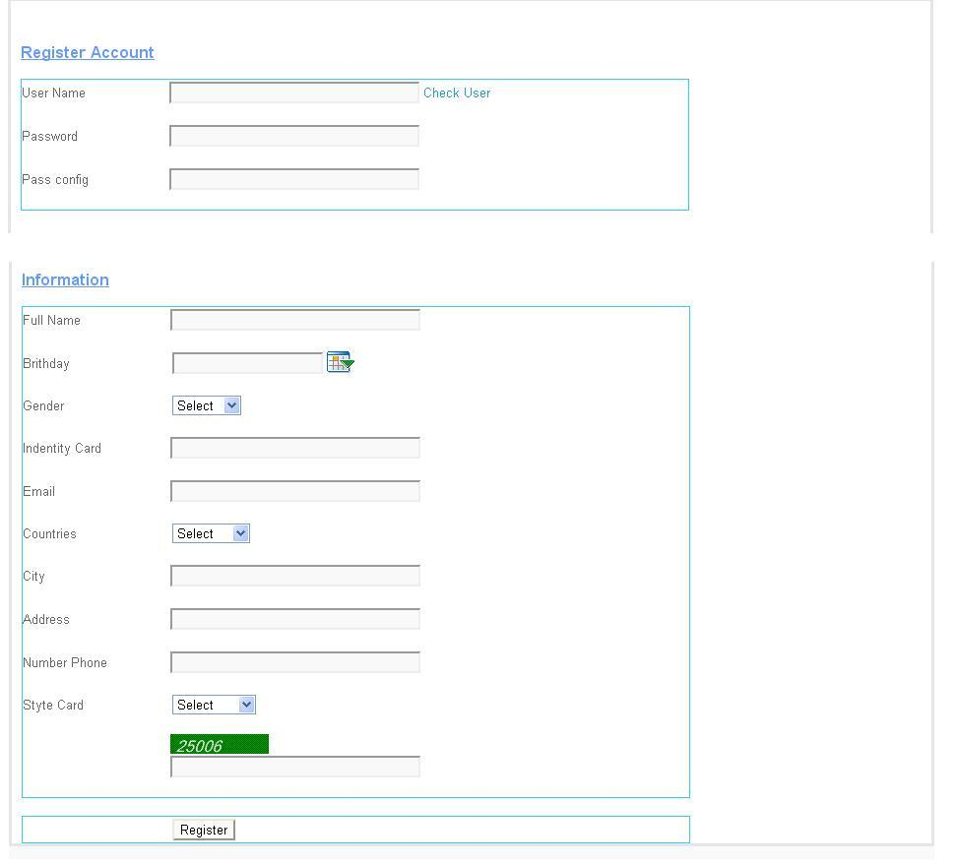

|  |  |  |  |  |  |
| --- | --- | --- | --- | --- | --- |
| **Name** | **Type** | **Event** | **Validation** | **Description** | **Status** |
| UserName | TextBox | Onchange | String, not null | Input UserName Customer |  |
| Password | TextBox |  | String, not null, | Input Customer’s New password |  |
| Config Password | TextBox |  | String,not null | Input Customer’s Config Password |  |
| Full Name | TextBox |  | String, not null | Input Full Name Customer |  |
| Birthday | BasicDate picker |  | Date,not null | Input BirthDay customer |  |
| Gender | DropdownList |  | Select Male,female | Input Male,Female |  |
| Identity Card | TextBox |  | Number, not null | Input Number Identity card |  |
| Email | TextBox |  | String ,not null, have Validation | Input Email Customer |  |
| Countries | Dropdownlist |  | Select | Input Countries Customer |  |
| City | TextBox |  | String, not null | Input City Customer |  |
| Address | TextBox |  | String, not null | Input Address Customer |  |
| Phone Number | TextBox |  | Number,not null | Input Phone Number Customer |  |
| Styte Card | DropDownList |  | Select | Input Styte Card Customer |  |
| CapChar | TextBox |  |  | Input number follow Image at above Text Box |  |
| Register | Button |  | Click | Register Customer |  |

**4.Forgot Password:**

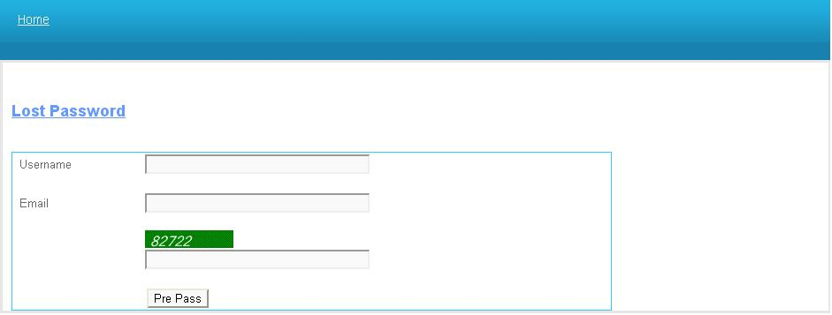

|  |  |  |  |  |  |
| --- | --- | --- | --- | --- | --- |
| **Name** | **Type** | **Event** | **Validation** | **Description** | **Status** |
| UserName | TextBox |  | String,not null | Input UserName Customer |  |
| Email | TextBox |  | String ,not null, have Validation | Input Email Customer |  |
| CapChar | TextBox |  |  | Input number follow Image at above Text Box |  |

**5.Change Password:**

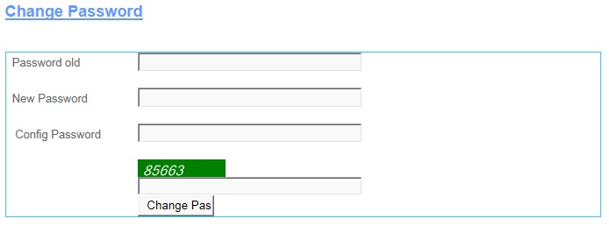

|  |  |  |  |  |  |
| --- | --- | --- | --- | --- | --- |
| **Name** | **Type** | **Event** | **Validation** | **Description** | **Status** |
| Password Old | TextBox |  | String, not null | Input Customer’s Password old |  |
| New Password | TextBox |  | String, not null, | Input Customer’s New password |  |
| Config Password | TextBox |  | String,not null | Input Customer’s Config Password |  |
| CapChar | TextBox |  |  | Input number follow Image at above Text Box |  |
| Change Password | Button |  | Click | Change Password |  |

**6.Change CodePin:**

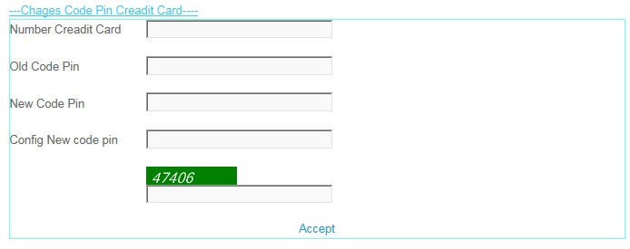

|  |  |  |  |  |  |
| --- | --- | --- | --- | --- | --- |
| **Name** | **Type** | **Event** | **Validation** | **Description** | **Status** |
| Number Credit Card | TextBox |  | int, not null | Input Customer’s Number Credit Card |  |
| Old Code Pin | TextBox |  | int, not null, | Input Customer’s Old Code Pin |  |
| New Code Pin | TextBox |  | int,not null | Input Customer’s New Code Pin |  |
| Config New Code Pin | TextBox |  | int, not null | Input Customer’s Config New Code Pin |  |
| CapChar | TextBox |  | int ,not null | Input number follow Image at above Text Box |  |
| Accept | LinkButton |  | Click | Accept Change code Pin . |  |

**7.Create Information:**

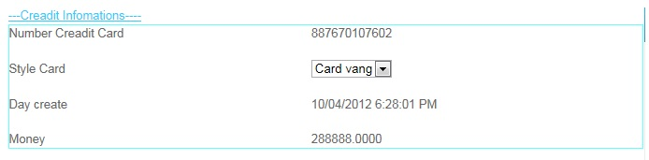

|  |  |  |  |  |  |
| --- | --- | --- | --- | --- | --- |
| **Name** | **Type** | **Event** | **Validation** | **Description** | **Status** |
| Number Credit Card | Label |  | Read Only | View Number Credit Card |  |
| Style Card | Drop Down List |  | Select | View and select Card |  |
| Day Create | Label |  | Read Only | View Day Create |  |
| Money | Label |  | Read Only | View Money |  |

**8.Edit Account User:**

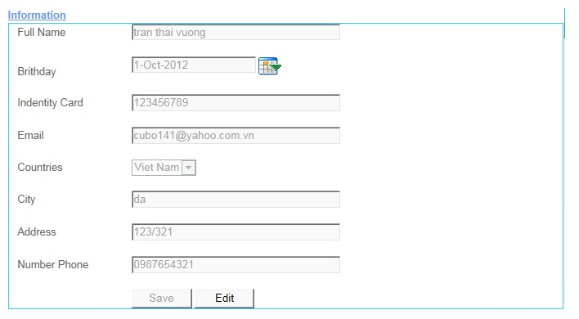

|  |  |  |  |  |  |
| --- | --- | --- | --- | --- | --- |
| **Name** | **Type** | **Event** | **Validation** | **Description** | **Status** |
| Full Name | TextBox |  | String, not null | Input Full Name |  |
| Birthday | TextBox |  | DatetTime | Input DateTime |  |
| Calendar Tool | Calendar |  | Select | Select Date on Calendar |  |
| Identity Card | TextBox |  | Int , not null | Input identity Card |  |
| Email | TextBox |  | String ,not null, have Validation | Input Customer’s Email |  |
| Country | DropDownList |  | Select | Select country |  |
| Address | TextBox |  | Int, not null | Input Customer’s Address |  |
| Number Phone | TextBox |  | Int, not null | Input Customer’s Number Phone |  |
| Save | Button |  | Click | click save edit enable |  |
| Edit | Button |  | Click | click edit Save unenable |  |

**9.Transaction:**

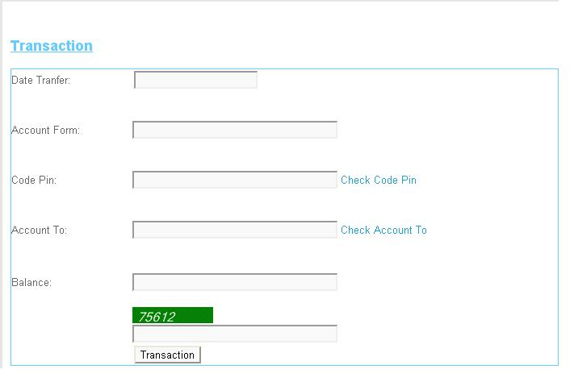

|  |  |  |  |  |  |
| --- | --- | --- | --- | --- | --- |
| **Name** | **Type** | **Event** | **Validation** | **Description** | **Status** |
| Date Tranfer | TextBox |  | DateTime, not null | Input Date Tranfer |  |
| Account From | TextBox |  | DatetTime | Input Account From |  |
| Code Pin | TextBox |  | Int, not null and Valiadaton | Input Code Pin |  |
| Account To | TextBox |  | DateTime, not null and Validation | Input Account To |  |
| Balance | TextBox |  | String ,not null, have Validation | Input Customer’s Balance |  |
| Transaction | Button |  | Click | Transaction |  |
| Check CodePin | LinkButton |  | Click | Check Codepin inval or not inval.. |  |
| Check Account To | LinkButton |  | Click | Check Account Inval or Not inval |  |
| CapChar | TextBox |  | int ,not null | Input number follow Image at above Text Box |  |

**10.Transaction Admin:**

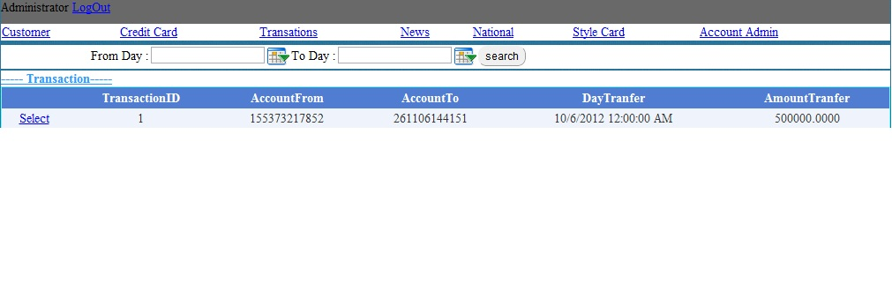

|  |  |  |  |  |  |
| --- | --- | --- | --- | --- | --- |
| **Name** | **Type** | **Event** | **Validation** | **Description** | **Status** |
| Log Out | LoginStatus |  | Click | Click Log Out |  |
| From Day | BasicdatePicker |  | Date time | Input From Date tranfer |  |
| To Day | BasicDatePicker |  | Date Time | Input To Date Tranfer |  |
| Transaction | Drop Down List |  | Select inform | Select Transaction |  |
| List Transaction | Grid view |  | Read Only | View inform Transaction |  |
| Select | LinkButton |  | Select | Select then view Detail |  |

**11.View Transaction:**

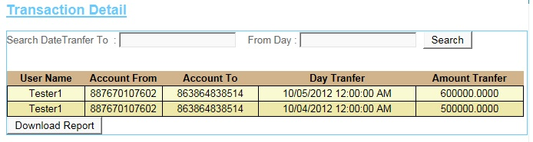

|  |  |  |  |  |  |
| --- | --- | --- | --- | --- | --- |
| **Name** | **Type** | **Event** | **Validation** | **Description** | **Status** |
| Search Date Transfer To | TextBox |  | DateTime , not null | Input DateTime |  |
| From Day | TextBox |  | DateTime , not null | Input DateTime |  |
| Search | Button |  | Click | Search |  |
| Transaction Detail | GridView |  | Read Only | View Inform of Detail’s Transaction |  |
| DownLoad Report | Button |  | Click | DownLoad Report |  |

**12.News:**

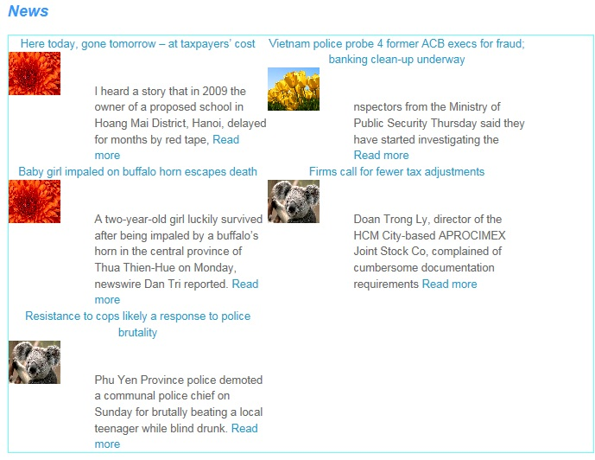

**13.AdminLogin:**

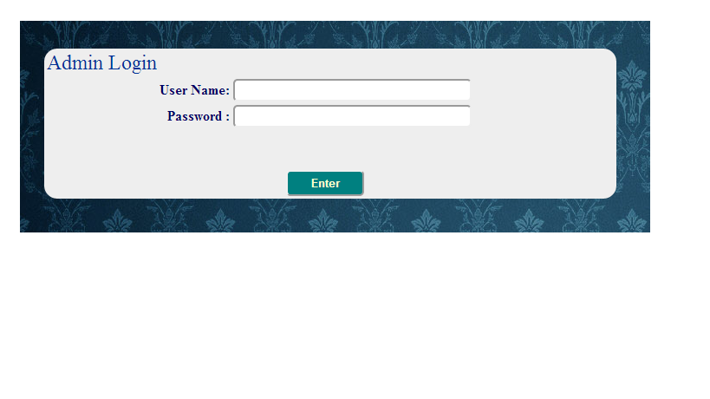

|  |  |  |  |  |  |
| --- | --- | --- | --- | --- | --- |
| **Name** | **Type** | **Event** | **Validation** | **Description** | **Status** |
| User Name | TextBox |  | String, not null | Input Admin’s user name |  |
| Password | TextBox |  | String, not null, | Input Admin’s password |  |
| Enter | Button |  | Click |  |  |

**14.AccountAdmin:**

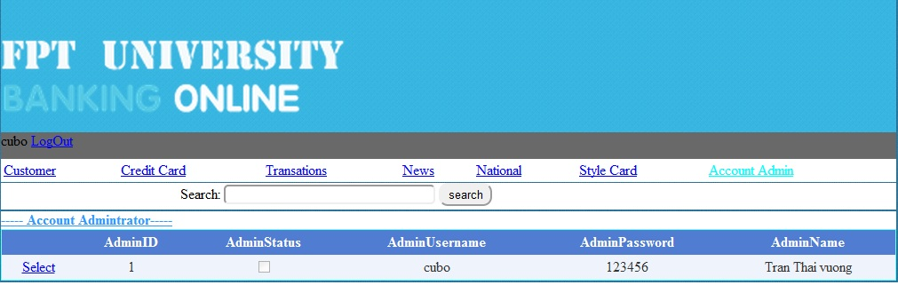

|  |  |  |  |  |  |
| --- | --- | --- | --- | --- | --- |
| **Name** | **Type** | **Event** | **Validation** | **Description** | **Status** |
| Search | TextBox | Onkeydown | String, | Search Admin’s Usernmae |  |
| Select Object | Hyperlink |  |  |  |  |
| DetailView1 | DetailsView |  |  | Select Account Admin |  |
| Select | Linbutton |  |  | Select Details Account Admin |  |

**15.AccountCustomer:**

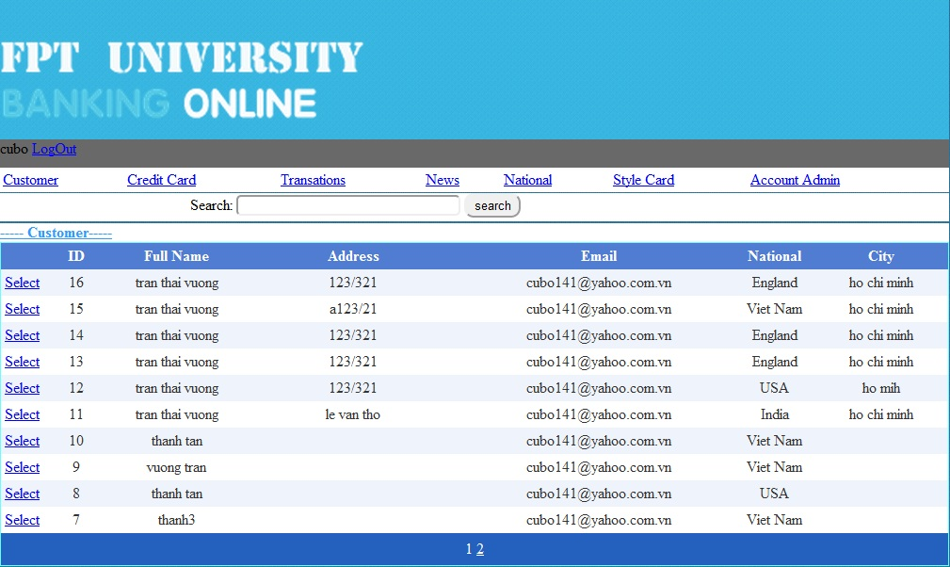

|  |  |  |  |  |  |
| --- | --- | --- | --- | --- | --- |
| **Name** | **Type** | **Event** | **Validation** | **Description** | **Status** |
| Search | TextBox |  | String | Search Customer’s Username |  |
| Select Object | Hyperlink |  |  |  |  |
| GridviewAccountCustomer | Gridview |  |  | Select Account Customer |  |
| Select | Linbutton |  |  | Select Details Account Customer |  |

**16.CreditCard:**

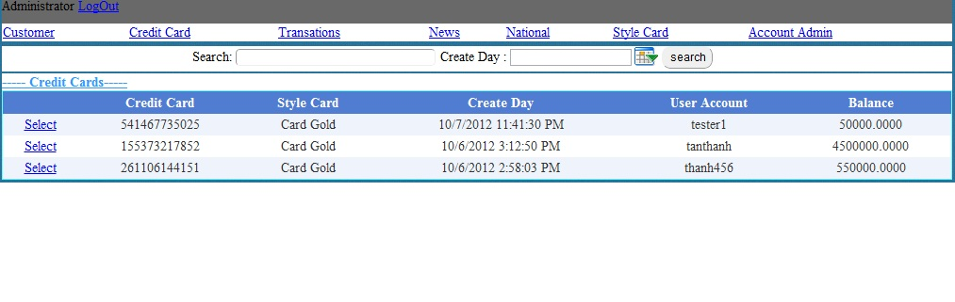

|  |  |  |  |  |  |
| --- | --- | --- | --- | --- | --- |
| **Name** | **Type** | **Event** | **Validation** | **Description** | **Status** |
| Search | TextBox | OnKeyDown | String | Search UserName |  |
| Select Object | Hyperlink |  |  |  |  |
| GvCreditCard | Gridview |  |  | Select ListCreditCard |  |
| Select | Linbutton |  |  | Select Details CreditCard |  |

**17.StyleCard:**

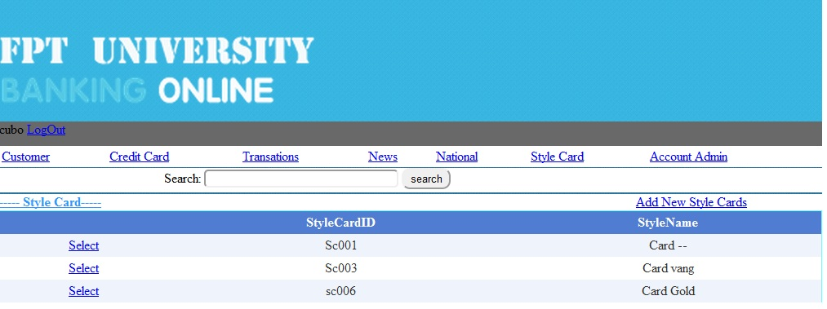

|  |  |  |  |  |  |
| --- | --- | --- | --- | --- | --- |
| **Name** | **Type** | **Event** | **Validation** | **Description** | **Status** |
| Search | TextBox | OnkeyDown | String | Search Style CardName |  |
| Select Object | Hyperlink |  |  |  |  |
| GvStyleCard | Gridview |  |  | Select Style Card |  |
| Select | Linbutton |  |  | Select Details Style Card |  |

**18.News:**

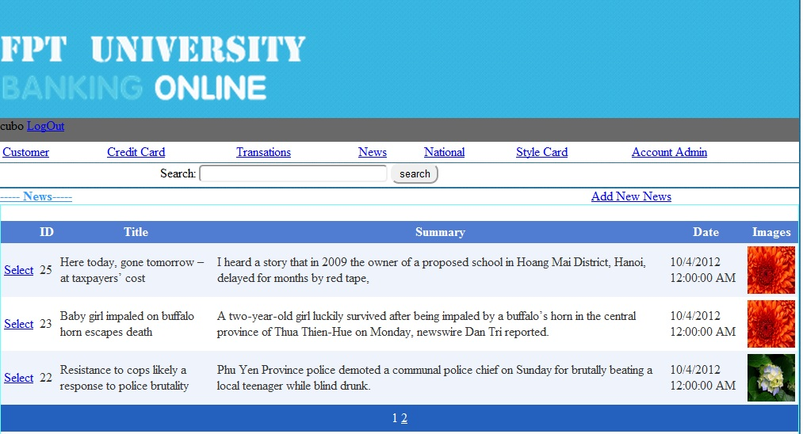

|  |  |  |  |  |  |
| --- | --- | --- | --- | --- | --- |
| **Name** | **Type** | **Event** | **Validation** | **Description** | **Status** |
| Search | TextBox | Onkeydown | String | Search Title News |  |
| Select Object | Hyperlink |  |  | Go Add new News |  |
| GvNews | Gridview |  |  | Select News |  |
| Select | Linbutton |  |  | Select Details News |  |

**19.National:**

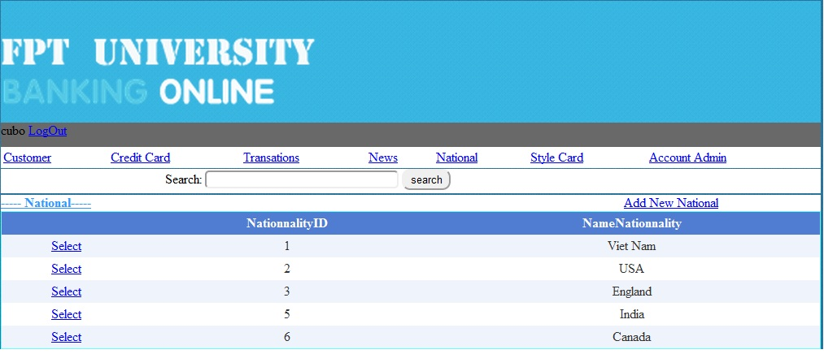

|  |  |  |  |  |  |
| --- | --- | --- | --- | --- | --- |
| **Name** | **Type** | **Event** | **Validation** | **Description** | **Status** |
| Search | TextBox | onKeydown | String | Search Name Nationality |  |
| Select Object | Hyperlink |  |  |  |  |
| Gv Nationality | Gridview |  |  | Select Nationality |  |
| Select | Linbutton |  |  | Select Details Nationality |  |

**20.Details Account Admin:**

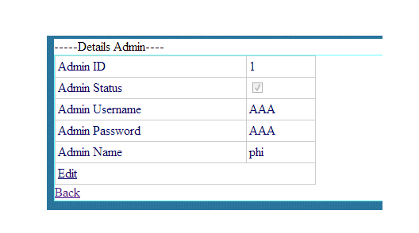

|  |  |  |  |  |  |
| --- | --- | --- | --- | --- | --- |
| **Name** | **Type** | **Event** | **Validation** | **Description** | **Status** |
| Edit | LinkButton |  |  | Edit Account Admin |  |
| Back | LinkButon |  |  | Back to MainAdmin.aspx |  |
| DetailsView1 | DetailsView |  |  | Select Details Admin |  |

**21.Details Account Customer:**

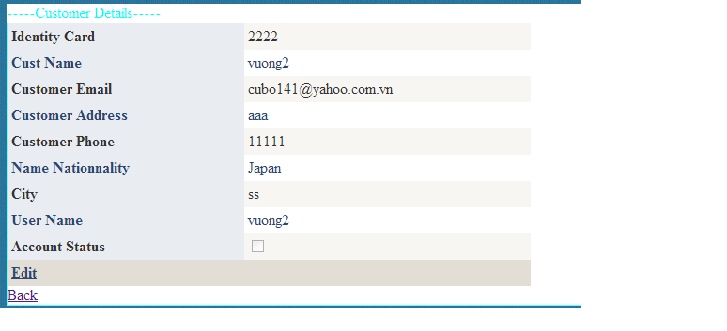

|  |  |  |  |  |  |
| --- | --- | --- | --- | --- | --- |
| **Name** | **Type** | **Event** | **Validation** | **Description** | **Status** |
| Edit | LinkButton |  |  | Edit Account Customer |  |
| Back | LinkButon |  |  | Back to MainAdmin.aspx |  |
| DetailsView1 | DetailsView |  |  | Select Customer Information |  |

**22.Details Credit Card:**

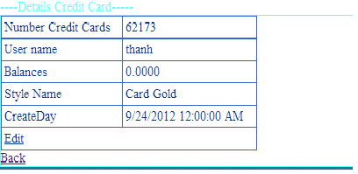

|  |  |  |  |  |  |
| --- | --- | --- | --- | --- | --- |
| **Name** | **Type** | **Event** | **Validation** | **Description** | **Status** |
| Edit | LinkButton |  |  | Edit Balance of Customer |  |
| Back | LinkButon |  |  | Back to MainAdmin.aspx |  |
| DetailsView1 | DetailsView |  |  | Select Details Credit Card of |  |

**23.Details Style Card:**

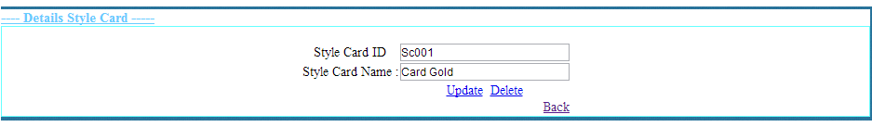

|  |  |  |  |  |  |
| --- | --- | --- | --- | --- | --- |
| **Name** | **Type** | **Event** | **Validation** | **Description** | **Status** |
| txtStyleCardID | TextBox |  | String,Not null | Input Style CardID |  |
| txtStyleCardName | TextBox |  | String,Not null | Input Style Card Name |  |
| Update | LinkButton |  |  | Update Style Card |  |
| Delete | LinkButton |  |  | Delete Style Card |  |
| Back | LinkButtom |  |  | Back to MainAdmin.aspx |  |

**24.News:**

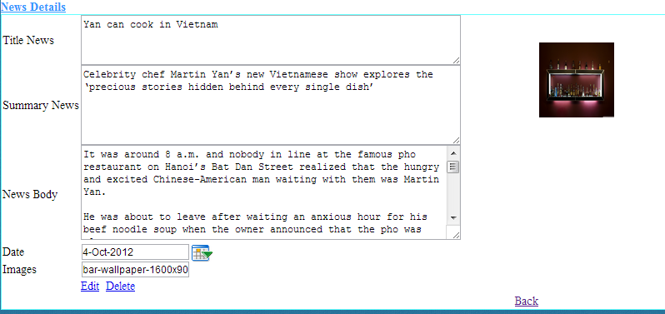

|  |  |  |  |  |  |
| --- | --- | --- | --- | --- | --- |
| **Name** | **Type** | **Event** | **Validation** | **Description** | **Status** |
| txtTitle News | TextBox |  | String,Not null | Input Title News |  |
| txtSummary News | TextBox |  | String,Not null | Input Summary News |  |
| txtNews Body | TextBox |  | String,Not null | Input News Body |  |
| txtDay | BasicDatePicker |  | Datetime,Not null | Input Datetime |  |
| txtImages | TextBox |  | String ,Not null | Input Images |  |
| Edit | LinkButton |  |  | Update Style Card |  |
| Delete | LinkButton |  |  | Delete Style Card |  |
| Back | LinkButtom |  |  | Back to MainAdmin.aspx |  |

**24.Details Nationality:**

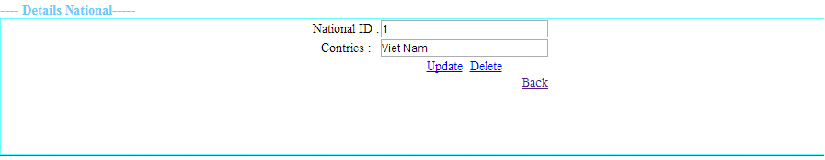

|  |  |  |  |  |  |
| --- | --- | --- | --- | --- | --- |
| **Name** | **Type** | **Event** | **Validation** | **Description** | **Status** |
| txtID | TextBox |  | String,Not null | Input CardID |  |
| txtNationalityName | TextBox |  | String,Not null | Input Nationality |  |
| Update | LinkButton |  |  | Update Nationality |  |
| Delete | LinkButton |  |  | Delete Nationality |  |
| Back | LinkButtom |  |  | Back to MainAdmin.aspx |  |

**Support:**

**+ Connected**

* **Gold :**

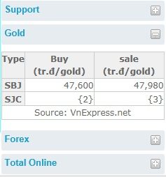

* **Forex :**

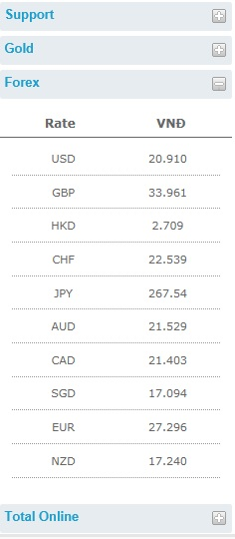

**+Disconnection**

* **Gold :**

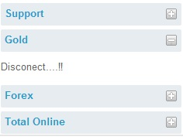

* **Forex :**

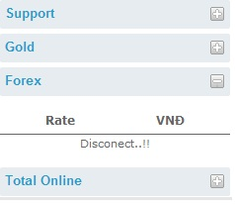

**+Total Online**

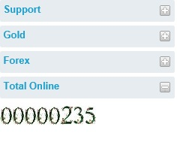

**TASK SHEET**

|  |  |  |  |  |  |  |
| --- | --- | --- | --- | --- | --- | --- |
| **Project Group FFG** | | **Project Title**  **Laptop Shop Online** | | **Date of Preparation** | | **Activity Plan Prepared by**  **Le Hoang Hai** |
| **No** | **Task Title** | | **Planned Start Date** | **Planned Completed Date** | **Team Mate Names** | **Status** |
| 1 | Login Customer | | Sep 10, 2012 | Oct 10, 2012 |  |  |
| 2 | Search admin evevnt onkeydown | |  |
| 3 | Change CodePin Credit Card | |  |
| 4 | Load News Masterpage Customer | |  |
| 5 | Design Masterpage Customer | |  |
| 6 | Register Customer | |  |  |
| 7 | Change Password | |  |
| 8 | Forget Password | |  |
| 9 | Credit card Infomation | |  |
| 10 | Your`s Profile | |  |
| 11 | Login Admin | |  |  |
| 12 | Edit Credit Card | |  |
| 13 | Edit Style Card | |  |
| 14 | Edit National | |  |
| 15 | Masterpage Admin | |  |
| 16 | Edit Status Customer | |  |  |
|  |
| 17 | Show Transaction | |  |
| 18 | Edit Balance | |  |
| 19 | Add, Edit, Delete news | |  |
| 20 | Customer Transaction | |  |  |
| 21 | Detail Transaction | |  |
| 22 | Download Report Transaction | |  |
| 23 | Create Report | |  |
| 25 | Contact | |  |
| 26 | Search Report | |  |
| 27 | Design Masterpage Customer | |  |

|  |  |  |
| --- | --- | --- |
| **Date: Oct 10, 2012** | **Prepared by Project Group 4**  **Team Leader:** | **Approved by**  **Mr. Ho Hoan Kiem** |
| **Signature** |  |  |