TỔNG LIÊN ĐOÀN LAO ĐỘNG VIỆT NAM
TRƯỜNG ĐẠI HỌC TÔN ĐỨC THẮNG
KHOA CÔNG NGHỆ THÔNG TIN



VÕ MINH TÀI – 522H0168
ĐỖ DUY TÂN – 522H0012

RESEARCH AND DEVELOPMENT OF A SECURE EMBEDDED IOT SYSTEM FOR PATIENT MEDICAL MONITORING DEVICES

INFORMATION TECHNOLOGY PROJECT

HO CHI MINH CITY, 2026
TỔNG LIÊN ĐOÀN LAO ĐỘNG VIỆT NAM
TRƯỜNG ĐẠI HỌC TÔN ĐỨC THẮNG
KHOA CÔNG NGHỆ THÔNG TIN



VÕ MINH TÀI – 522H0168
ĐỖ DUY TÂN – 522H0012

NGHIÊN CỨU VÀ PHÁT TRIỂN HỆ THỐNG IOT NHÚNG AN TOÀN CHO THIẾT BỊ THEO DÕI Y TẾ BỆNH NHÂN

INFORMATION TECHNOLOGY PROJECT

Lecturer
PhD. Bùi Quy Anh

HO CHI MINH CITY, 2026
ACKNOWLEDGEMENTS

Esteemed Faculty of Information Technology, we would like to express our sincere gratitude to the Faculty of Information Technology for providing the opportunity and support for our group to access and complete this information technology project.
Esteemed Professor Bùi Quy Anh, we would like to sincerely thank you for your assistance in helping us complete this graduation project. You have been a great source of motivation for us to overcome difficulties and achieve success in our research. We are sincerely grateful for your continuous support throughout this period. Your guidance, encouragement, and constructive feedback have played an essential role in helping us identify and improve upon our shortcomings. You have helped us understand the material and pointed out solutions to the difficulties we encountered during our studies and in the development of this graduation project.
Once again, we sincerely thank you, Professor, for inspiring us, helping us overcome our apprehension about this project, and nurturing our intense passion for the field we have chosen.
Thank you very much!

Ho Chi Minh City, 07/01/2026
Author
(Signature and full name)

Võ Minh Tài

Đỗ Duy Tân

PROJECT COMPLETED
AT TON DUC THANG UNIVERSITY
I hereby declare that this is my own original project, supervised by Professor Bui Quy Anh. The research content and results in this project are truthful and have not been published in any form before. The data in the tables used for analysis, commentary, and evaluation were collected by the author from various sources, clearly indicated in the references section.
Furthermore, this project also uses some comments, evaluations, and data from other authors and organizations, all of which are cited and referenced.
If any plagiarism is discovered, I will take full responsibility for the content of my project. Ton Duc Thang University is not responsible for any copyright or intellectual property violations I may commit during this project (if any).

Ho Chi Minh City, …/…/…
Author
(Signature and full name)

Võ Minh Tài

Đỗ Duy Tân

RESEARCH AND DEVELOPMENT OF A SECURE EMBEDDED IOT SYSTEM FOR PATIENT MEDICAL MONITORING DEVICES
SUMMARY
With the rapid advancement of information technology and the Internet of Things (IoT), healthcare monitoring systems have gained significant attention due to their ability to collect, transmit, and analyze physiological data in real time. Remote health monitoring solutions help reduce the burden on medical facilities, improve patient care quality, and enable early detection of abnormal health conditions. This project focuses on designing and implementing an IoT-based health monitoring system that integrates embedded hardware, cloud services, and a web-based management platform.
Chapter 1 introduces the motivation, objectives, and scope of the project. The chapter highlights the growing demand for smart healthcare solutions and identifies the limitations of traditional health monitoring methods. Based on these challenges, the project objectives are defined as building a system capable of collecting vital signs, securely transmitting data, and presenting health information in an intuitive and accessible manner for users and administrators.
Chapter 2 presents an overview of related technologies and previous studies. This chapter reviews IoT concepts, embedded systems, wireless communication, and common health monitoring parameters such as heart rate, blood oxygen saturation (SpO₂), and body temperature. In addition, it analyzes existing health monitoring solutions to identify their strengths and limitations, which serve as a foundation for proposing the system architecture of this project.
Chapter 3 describes the overall system design and architecture. The proposed system is divided into three main components: the embedded device, the server and database, and the web-based application. The embedded device, based on the ESP32 microcontroller, is responsible for collecting sensor data and transmitting it to the server. The server processes, stores, and manages the data, while the web application provides functionalities such as user authentication, device management, real-time monitoring, data visualization, and statistical analysis. The data flow, system interaction, and database design are also detailed in this chapter.
Chapter 4 focuses on system implementation and experimental results. This chapter explains the development of the embedded firmware, including sensor integration, data acquisition, and communication with the server. It also presents the implementation of the web application, covering user registration and login, health data display, real-time charts, statistical summaries, and administrative management functions. Experimental results demonstrate that the system can accurately collect and display health indicators such as heart rate, SpO₂, and temperature. The system operates stably, supports data filtering and exporting, and provides clear visualizations to assist users in monitoring health conditions.
Chapter 5 concludes the project and discusses future development directions. The chapter summarizes the achieved results, confirming that the proposed system successfully meets the initial objectives. Although the system performs effectively, certain limitations remain, such as measurement accuracy under movement conditions and dependence on network quality. Future work may focus on improving sensor accuracy, enhancing system security, optimizing performance, and expanding the system to support additional health parameters and mobile platforms.
In conclusion, this project demonstrates the feasibility of an IoT-based health monitoring system that integrates embedded devices with a web-based management platform. The system provides a practical solution for real-time health monitoring and establishes a foundation for further research and development in smart healthcare applications.
INDEX
LIST OF FIGURES xii
LIST OF ABBREVIATIONS xiii
CHAPTER 1. INTRODUCTION AND OVERVIEW OF THE TOPIC 1
1.1. Background and reasons for choosing the topic 1
1.2. The urgency of the topic 2
1.2.1. Technological necessity 2
1.2.2. Social and health emergencies 2
1.2.3. The urgent need for security and life safety. 3
1.3. Objectives of the research topic 3
1.3.1. Overall objective 3
1.3.2. Specific objectives 3
1.4. Scope of research 4
1.4.1. Technical scope 4
1.4.2. Data scope 4
1.4.3. Scope of deployment 5
1.5. Research methods 6
1.5.1. Theoretical research methods 6
1.5.2. System modeling methods 6
1.5.3. Experimental method 7
1.5.4. Comparative and evaluative methods 7
1.6. Scientific and practical significance of the topic 7
1.6.1. Scientific significance 7
1.6.2. Practical significance 8
CHAPTER 2. THEORETICAL FOUNDATION 10
2.1. Overview of the Internet of Things (IoT) 10
2.1.1. The concept of IoT 10
2.1.2. History and development of IoT 10
2.1.3. The overall architecture of an IoT system 11
2.2. Medical IoT (Internet of Medical Things – IoMT) 11
2.2.1. The concept of IoMT 11
2.2.2. Benefits of IoMT 11
2.2.3. Challenges of IoMT 12
2.3. Overview of Embedded Systems 12
2.3.1. Concept 12
2.3.2. Basic architecture of embedded devices 13
2.3.3. Limitations in the security of embedded devices 14
2.4. Security in IoT 14
2.4.1. The CIA Model – Security Standards 15
2.4.2. Common vulnerabilities in IoT 15
2.4.3. Common types of attacks 15
2.5. Security solutions in IoT 16
2.5.1. Encryption 16
2.5.2. Secure communication protocol 17
2.6. Summary and evaluation 17
CHAPTER 3. PROPOSED MODEL 19
3.1. Chapter Introduction 19
3.2. Overall system architecture 19
3.3. Detailed design of the layers 20
3.3.1 Device Layer 20
3.3.2. Gateway 22
3.4. Integrated security model 23
3.5. Secure Data Flow 24
3.6. Table detailing the function of each layer 24
3.7. Model evaluation 25
CHAPTER 4. EXPERIMENT 26
4.1. Chapter Introduction 26
4.2 Overview of the implemented system 26
4.3. System architecture and deployment flow 28
4.3.1. Overall system architecture 28
4.3.2. Data flow and operational workflow 29
4.4. Prototype system implementation 30
4.4.1. Hardware design 30
4.4.2. Firmware implementation 34
4.4.3. Task management and shared data handling 35
4.5. Communication layer and MQTT integration 36
4.5.1. Role of MQTT in the IoT system 36
4.5.2. MQTT topics and data exchange mechanism 36
4.5.3. Reliability and fault tolerance in communication 37
4.6. Backend system and cloud platform implementation 38
4.6.1. Backend architecture and core services 38
4.6.2. Data processing and database management 38
4.6.3. API services and system security 39
4.7. Client application and monitoring dashboard 39
4.7.1. Client application architecture 40
4.7.2. Real-time monitoring and data visualization 40
4.7.3. User interaction and access control 41
4.8. Experimental results and system evaluation 45
4.8.1. Functional evaluation 45
4.8.2. Communication performance and system stability 46
4.8.3. Limitations and practical considerations 46
4.9. Discussion 47
4.9.1. Achievement of system objectives 47
4.9.2. Strengths of the proposed system 47
4.9.3. Limitations and challenges 48
4.10. Future development 48
4.10.1. System scalability and performance enhancement 49
4.10.2. Advanced data analysis and intelligent features 49
4.10.3. Security and real-world deployment considerations 49
CHAPTER 5. CONCLUDE 50
5.1 General conclusion 50
5.2 Limitations of the topic 51
5.3 Future development direction 52
5.4 Final conclusion 53

LIST OF FIGURES
Figure 4.1 BLE ESP32 NODEMCU-32S CH340 31
Figure 4.2 MKE-M21 SIM768x 4G 32
Figure 4.3 18650 Li-Ion Rechargeable Battery 3.7V 32
Figure 4.4 Mtiny Power (Support USB Power Bank) 33
Figure 4.5 MAX30102 MH-ET LIVE 34
Figure 4.6 GY-87 10DOF IMU MPU6050 34
Figure 4.7 LCD text LCD1602 green 35
Figure 4.8 Completed IoT-based Health Monitoring System Prototype 35
Figure 4.9 System login interface 42
Figure 4.10 User registration interface 43
Figure 4.11 System Administration – User Management 43
Figure 4.12 Personal Information Page 44
Figure 4.13 Recent Health Data Dashboard 44
Figure 4.14 Health Indicator Charts Dashboard 46
Figure 4.15 Health Statistics Overview Dashboard 46

LIST OF ABBREVIATIONS
AES | Advanced Encryption Standard
API | Application Programming Interface
BLE | Bluetooth Low Energy
BPM | Beats Per Minute
DB | Database
FDA | Food and Drug Administration
IoMT | Internet of Medical Things
IoT | Internet of Things
MCU | Microcontroller Unit
MQTT | Message Queuing Telemetry Transport
OWASP | Open Web Application Security Project
PPG | Photoplethysmography
RBAC | Role-Based Access Control
SHA-256 | Secure Hash Algorithm 256-bit
TLS | Transport Layer Security
Wi-Fi | Wireless Fidelity

CHAPTER 1. INTRODUCTION AND OVERVIEW OF THE TOPIC

1.1. Background and reasons for choosing the topic
The explosion of Internet of Things (IoT) technology over the past decade has created a major shift in how people collect data, operate devices, and build automation systems. Among the prominent application areas of IoT, healthcare is one of the fastest-growing sectors. Healthcare IoT systems – also known as the Internet of Medical Things (IoMT) – are gradually becoming a crucial component of modern healthcare.
Despite its advantages, medical IoT also presents significant challenges, particularly in terms of data security and system reliability. Medical data represents one of the most sensitive categories of information, as it not only involves personal privacy but is also directly linked to patient safety. Any unauthorized modification, manipulation, loss, or cyberattack targeting healthcare IoT devices may result in severe consequences, including misdiagnosis, inappropriate treatment, or even life-threatening situations.
In addition, medical IoT devices are typically built on resource-constrained embedded platforms, which limit their ability to support robust security mechanisms. Conventional approaches to encryption, authentication, and key management often demand substantial computational power and memory, exceeding the capabilities of many existing IoT devices.
Moreover, real-world security incidents involving medical devices—such as insulin pumps, pacemakers, and infusion systems—have been widely reported, underscoring the urgency of developing secure, reliable, and lightweight medical IoT architectures tailored to embedded environments.
Recognizing the significant gap between security requirements and performance on resource-constrained devices, our team decided to choose the topic:
“Developing IoT applications and security solutions for embedded systems – Application to patient medical monitoring devices.”
The project aims to ensure both high performance and low latency while fully integrating important security principles such as confidentiality, integrity, authentication, and operational security.

1.2. The urgency of the topic

1.2.1. Technological necessity
Medical IoT devices are rapidly evolving, but many lack comprehensive security standards. Microcontrollers like the ESP32 offer advantages in terms of low cost and multi-sensor integration but are limited in computing resources and memory. This makes implementing robust security algorithms like RSA difficult. Meanwhile, cyberattacks are becoming increasingly sophisticated, easily exploiting vulnerabilities in embedded devices. Therefore, research into lighter security solutions combined with MQTTs/HTTPS protocols, is necessary to ensure secure transmission of medical data without compromising system performance.

1.2.2. Social and health emergencies
An aging population and a growing number of patients with chronic diseases have created an urgent need for remote health monitoring. Hospitals are often overloaded, leading to a higher risk of medical errors. Healthcare IoT systems can help doctors continuously monitor patients, receive early warnings of abnormalities, and thus minimize risks and treatment costs. Implementing low-cost, automated monitoring systems will support patients at home, reduce the burden on hospitals, and improve the quality of public healthcare.

1.2.3. The urgent need for security and life safety.
Unlike consumer-oriented IoT solutions, medical devices operate in safety-critical environments where system failures or data compromise may directly affect patient well-being. If medical data is altered or exposed, the resulting consequences may include misdiagnosis or inappropriate clinical decisions. For this reason, the integration of security mechanisms such as Transport Layer Security (TLS), X.509 digital certificates, Secure Boot, and Secure Over-the-Air (OTA) updates is essential to preserving data confidentiality and integrity. Furthermore, the system must be designed to withstand common attack vectors, including eavesdropping, man-in-the-middle (MITM), replay attacks, and malicious firmware injection, thereby minimizing security risks to patients.

1.3. Objectives of the research topic

1.3.1. Overall objective
The objective of this project is to design and implement a secure and optimized embedded IoT system for medical data acquisition, including physiological parameters such as heart rate and blood oxygen saturation (SpO₂). The proposed system is intended for deployment of resource-constrained devices and focuses on ensuring secure data transmission over networked environments. In addition to meeting the core security requirements of confidentiality, integrity, and availability, the system is designed to maintain high performance and low latency, thereby supporting the demands of continuous patient monitoring applications.

1.3.2. Specific objectives
The system will be designed with multi-layered architecture, including embedded devices, gateways, cloud platforms, and user applications. The prototype uses an ESP32 combined with a MAX30102 sensor to measure heart rate and SpO2, an MPU6050 to measure acceleration and gyroscope, an HMC5883 to measure magnetic field, and a BMP085 to measure temperature and pressure. Data is encrypted at the source, transmitted via MQTTs, and displayed on the dashboard. The system will be evaluated based on latency, transmission speed, resource usage, and cyberattack resistance.

1.4. Scope of research

1.4.1. Technical scope
The technical scope of this project focuses on building an embedded medical IoT system based on the ESP32 microcontroller. This is a popular hardware platform with Wi-Fi and Bluetooth connectivity, and it supports many open-source libraries, making it easy to integrate medical sensors. The system uses an MAX30102 sensor to measure heart rate and SpO2, an MPU6050 to measure acceleration and gyroscope, an HMC5883 to measure magnetic field, and a BMP085 to measure temperature and pressure. These sensors are directly connected to the ESP32 via I2C communication, with data processed and encoded directly on the device.
From a software perspective, the system is implemented using firmware developed with Arduino and ESP-IDF frameworks, while secure data transmission is achieved through the MQTT protocol over Transport Layer Security (TLS). On the server side, the backend is developed using Node.js, with an Influx DB database employed for the storage of real-time sensor data. A web-based dashboard is provided to enable clinicians to monitor patient information in a clear and accessible manner. To ensure the feasibility of the prototype, the technical scope is limited to communication technologies based on Wi-Fi and cellular (SIM) modules, rather than more complex IoT platforms such as LoRa or NB-IoT.

1.4.2. Data scope
The research data utilized in this project primarily consists of patients’ vital signs and associated environmental information. Heart rate and blood oxygen saturation (SpO₂) are the core physiological parameters and are obtained using the MAX30102 sensor, supported by signal-processing algorithms for heart rate detection and oxygen saturation estimation. In addition to these vital signs, the system collects motion data from the MPU6050 sensor, magnetic field measurements from the HMC5883, and environmental parameters, including temperature and atmospheric pressure, from the BMP085 sensor. The inclusion of these complementary data sources enables a more comprehensive assessment of the patient’s condition and facilitates the detection of abnormal events, such as falls or adverse environmental changes that may impact health.
Data processing is performed locally on the embedded device, after which the information is secured using a layered cryptographic approach. Specifically, data is encrypted at the application layer using the Advanced Encryption Standard (AES) to ensure confidentiality while remaining suitable for the limited resources of the ESP32. Secure transmission is further achieved by employing MQTT over TLS, where elliptic curve cryptography (ECC) is utilized during the authentication and key exchange processes to protect the communication channel and ensure data integrity.
To maintain the practicality and feasibility of the prototype, the data scope is intentionally limited and does not include more complex physiological signals, such as multi-channel electrocardiograms (ECG) or continuous blood pressure measurements.

1.4.3. Scope of deployment
At its current stage, the project is developed as a prototype and has not yet been deployed in a clinical or hospital environment. System evaluation was conducted under laboratory conditions using simulated data and data collected from volunteer participants. Although international medical standards such as those issued by the FDA and CE were considered at a conceptual level, the study does not address the formal certification or compliance processes. Practical deployment in a healthcare setting would require additional considerations, including medical device certification, biosafety assessments, and integration with hospital information systems, all of which fall beyond the scope of this research. Nevertheless, the proposed prototype serves as a foundational platform for future work and may be extended toward real-world implementation once the relevant legal, regulatory, and technical requirements are satisfied.

1.5. Research methods

1.5.1. Theoretical research methods
The research team conducted a comprehensive review of academic literature and international standards related to the Internet of Things, embedded systems, and information security. Well-established security frameworks, including the OWASP IoT Top 10 and NISTIR 8259, were examined to identify prevalent vulnerabilities and corresponding mitigation strategies. In parallel, lightweight communication protocols such as MQTT and CoAP were analyzed, with particular attention given to their respective strengths and limitations in resource-constrained embedded environments. This theoretical foundation provided essential insights that informed the overall system architecture design and supported the selection of appropriate security mechanisms for the proposed solution.

1.5.2. System modeling methods
The system architecture is structured according to a multi-layer model comprising the embedded device layer, gateway layer, cloud layer, and application layer. A secure end-to-end data flow is modeled from sensor acquisition to dashboard visualization, enabling the identification of potential attack surfaces across the system. Based on this analysis, appropriate security mechanisms are incorporated at each layer. Threat modeling techniques are employed to anticipate common attack scenarios, including eavesdropping, man-in-the-middle (MITM), replay attacks, and malicious firmware injection. By adopting this design-driven security approach, potential risks can be mitigated at an early stage, rather than being addressed reactively after security incidents occur.

1.5.3. Experimental method
A prototype was built using ESP32 and sensors, with firmware programmed to collect and encrypt data. A backend server and dashboard were deployed to display the data. The team conducted tests in a laboratory environment, measuring latency, transmission speed, and resource usage of the device. Attack tests such as sniffing, MITM, and server spoofing were performed to assess security capabilities. Experimental results helped verify the feasibility of the system and provided real-world data for comparison with the theoretical model.

1.5.4. Comparative and evaluative methods
The system was evaluated through a comparative analysis conducted with and without encryption enabled, focusing on the impact on RAM usage and CPU utilization of the ESP32 platform. Network traffic was further examined using Wireshark to verify the effectiveness of the implemented security mechanisms. In addition, the reliability of data transmission over both cellular (SIM-based) and Wi-Fi networks was assessed, including the system’s ability to recover from network disruptions and maintain stable connectivity. The accuracy of the collected sensor data was also evaluated. This comparative evaluation approach enabled the identification of the system’s performance characteristics, strengths, and limitations, thereby providing a basis for proposed improvements in future work.

1.6. Scientific and practical significance of the topic

1.6.1. Scientific significance
This research topic holds substantial scientific significance by contributing to the development of a practical security model for embedded IoT devices in healthcare applications. While prior studies have predominantly emphasized system performance or connectivity, security considerations for resource-constrained embedded platforms have often remained insufficiently explored. By integrating multiple security mechanisms—such as AES and elliptic curve cryptography (ECC), secure communication protocols including MQTT over TLS and HTTPS, as well as Secure Boot and Secure Over-the-Air (OTA) updates—within a concrete experimental system, this study demonstrates that robust security measures are not merely theoretical concepts but can be effectively implemented in practice.
In addition, the work contributes to structured threat modeling within the context of the Internet of Medical Things (IoMT), enabling the identification of potential attack vectors and the formulation of appropriate preventive strategies. These contributions provide a foundation for future research aimed at extending the proposed approach to more complex medical devices, such as multi-channel electrocardiogram (ECG) systems or intensive care unit (ICU) monitoring platforms. Furthermore, this report serves as a valuable reference for students and researchers in the field of IoT security, illustrating how theoretical principles can be systematically translated into secure and reliable system implementations.

1.6.2. Practical significance
From a practical perspective, the system developed in this project can be applied to home-based patient monitoring solutions, supporting continuous observation by healthcare professionals and helping to reduce the operational burden on medical facilities. The collection of vital sign data—including heart rate, blood oxygen saturation (SpO₂), body temperature, and movement—enables early detection of abnormal conditions, thereby facilitating timely alerts for both patients and clinicians. Secure communication protocols are employed to ensure that medical data remains protected against unauthorized access or tampering during transmission, which enhances the overall reliability of health information. This aspect is particularly critical in the context of increasing cyber threats targeting healthcare infrastructures.
In addition, the proposed prototype is designed to be cost-effective and straightforward to deploy, making it suitable for use in household environments and small clinical settings. The system also demonstrates scalability, allowing for the integration of additional sensors or connectivity with smart healthcare platforms, thus providing a foundation for the future development of more comprehensive and intelligent healthcare solutions.

CHAPTER 2. THEORETICAL FOUNDATION

2.1. Overview of the Internet of Things (IoT)

2.1.1. The concept of IoT
The Internet of Things (IoT) refers to a paradigm in which many physical devices are interconnected through networked environments, enabling them to collect data, exchange information, and perform actions with minimal human intervention. These devices range from sensors and microcontroller-based systems to wearable technologies, household appliances, industrial machinery, and medical equipment. The fundamental value of IoT lies in its capacity to sense, communicate, process, and respond to environmental conditions, thereby forming an intelligent and interconnected ecosystem.
Within the healthcare domain, IoT has become increasingly significant by facilitating remote patient monitoring, enabling real-time data acquisition, and supporting clinicians in making timely and informed treatment decisions. In the context of this study, IoT is viewed not merely as a connectivity platform, but as a foundational infrastructure for the deployment of security mechanisms that ensure the safe and reliable transmission of sensitive medical data.

2.1.2. History and development of IoT
The Internet of Things (IoT) emerged in the late 1990s with the use of RFID for product identification. By 2008, the number of internet-connected devices had surpassed the number of internet users, marking the explosion of IoT. From 2010 to 2015, IoT developed strongly in the smart home, industrial, and energy sectors. From 2016 to the present, IoT has expanded to healthcare, agriculture, transportation, and defense. According to Statista's forecast, by 2030 there will be more than 25–30 billion IoT devices operating globally. This development shows that IoT is not only a technological trend but also a foundation for global digital transformation. In this context, research into security for IoT in healthcare becomes urgent, because medical data is the most sensitive type of data and directly affects human lives.

2.1.3. The overall architecture of an IoT system
A complete IoT system typically consists of four layers: the device layer, the network layer, the computing platform layer, and the application layer. The device layer includes sensors and microcontrollers such as the ESP32, which are responsible for data collection. The network layer uses communication technologies such as Wi-Fi, BLE, Zigbee, or NB-IoT to transmit data. Computing platform layer processes, stores, and analyzes data through cloud services such as AWS IoT or Azure IoT. Finally, the application layer provides a user interface, displays data, and alerts for anomalies. In this project, the IoT architecture is designed using a multi-layered model, incorporating security mechanisms at each layer to ensure that medical data is transmitted securely from the device to the application.

2.2. Medical IoT (Internet of Medical Things – IoMT)

2.2.1. The concept of IoMT
The Internet of Medical Things (IoMT) refers to an ecosystem of network-connected medical devices designed to collect physiological data, exchange information with cloud-based systems, and support healthcare professionals in remotely monitoring patients. These devices encompass a wide range of applications, including heart rate and blood oxygen saturation monitors, wireless blood pressure measurement systems, electrocardiogram (ECG) devices, and intelligent hospital equipment. By enabling continuous patient monitoring, IoMT supports more personalized treatment strategies, reduces the likelihood of medical errors, and contributes to overall improvements in healthcare quality.

2.2.2. Benefits of IoMT
IoMT offers benefits to patients, doctors, and hospitals alike. For patients, the system enables 24/7 monitoring, reduces unnecessary hospitalizations, and supports personalized treatment. For doctors, IoMT provides real-time data, enabling early detection of abnormalities and reducing medical errors. For hospitals, IoMT optimizes costs, reduces patient load, and facilitates digital data management. In this project, the benefits of IoMT are demonstrated through a prototype system that allows for the security collection and transmission of heart rate, SpO2, and environmental parameters.

2.2.3. Challenges of IoMT
The Internet of Medical Things (IoMT) presents a range of challenges, primarily due to the high sensitivity of medical data, the potential for cyberattacks to directly affect patient safety, and the stringent security requirements imposed on healthcare systems. These challenges are further compounded by the limited computational and memory resources of embedded medical devices, as well as the complexity of IoMT ecosystems that span multiple platforms and technologies, making integration and security management particularly demanding. In response to these issues, this project concentrates on mitigating security risks through the integration of source-level data encryption, digital certificate–based device authentication, and secure communication mechanisms built upon Transport Layer Security (TLS).

2.3. Overview of Embedded Systems

2.3.1. Concept
An embedded system is a dedicated computing system integrated into a larger device, where processing and control functions are performed by a microcontroller or microprocessor. In contrast to general-purpose computing platforms, embedded systems are designed to execute specific tasks with high reliability while operating under strict resource constraints. Typical characteristics of such systems include limited memory capacity, moderate processing capabilities, real-time responsiveness, and low power consumption.
Within the healthcare domain, embedded systems are fundamental components of patient monitoring devices, including heart rate monitors, blood oxygen saturation sensors, and motion detection units. In this project, the ESP32 microcontroller is employed as the core embedded platform. Owing to its integrated Wi-Fi and Bluetooth connectivity, low cost, and sufficient processing capability, the ESP32 provides a suitable foundation for prototyping an embedded healthcare IoT system.

2.3.2. Basic architecture of embedded devices
An embedded device typically consists of several core components, including a central processing unit (CPU) responsible for instruction execution, non-volatile flash memory for firmware storage, and static random-access memory (SRAM) for temporary data handling. Communication with external sensors is supported through peripheral interfaces such as UART, I²C, and SPI, while wireless connectivity is commonly provided by modules implementing technologies such as Bluetooth Low Energy (BLE) or Wi-Fi. In addition, many modern microcontrollers incorporate dedicated security features, including cryptographic accelerators and hardware-based random number generators (RNGs), to facilitate secure data processing and encryption.
In the proposed system, the ESP32 serves as the primary embedded platform and is interfaced with multiple sensors to support comprehensive data acquisition. These include the MAX30102 sensor for measuring heart rate and blood oxygen saturation (SpO₂), the MPU6050 for capturing acceleration and gyroscopic data, the HMC5883 for magnetic field measurements, and the BMP085 for monitoring environmental temperature and atmospheric pressure. This hardware architecture enables the system to collect heterogeneous data, perform local processing on the embedded device, and securely transmit the processed information to cloud services using MQTT over TLS (MQTTs).

2.3.3. Limitations in the security of embedded devices
Despite the numerous advantages of embedded systems, they also present notable security limitations. Owing to constrained computational power and memory capacity, the deployment of computationally intensive cryptographic algorithms, such as RSA, is often impractical on embedded platforms. Furthermore, many embedded devices lack dedicated secure storage for private keys, which increases their vulnerability to physical attacks and malicious firmware manipulation. Insecure communication channels, including unprotected Bluetooth Low Energy (BLE) links or open Wi-Fi connections, represent additional weaknesses commonly observed in embedded environments.
Within the context of medical IoT applications, these limitations pose serious risks, as any compromise of data integrity or confidentiality may directly impact patient safety. To address these challenges, this project adopts lightweight security mechanisms that are suitable for resource-constrained embedded devices. Specifically, physiological data is encrypted at the device level using the Advanced Encryption Standard (AES), while elliptic curve cryptography (ECC) is leveraged within the Transport Layer Security (TLS) protocol to provide secure authentication and key exchange for MQTT-based communication.
In addition, secure firmware management features such as Secure Boot and Secure Over-the-Air (OTA) updates are considered at the architectural design level to mitigate the risks of firmware spoofing and unauthorized code execution, although their full implementation is beyond the scope of the current prototype.

2.4. Security in IoT

2.4.1. The CIA Model – Security Standards
The Confidentiality–Integrity–Availability (CIA) model represents a foundational security framework commonly applied in IoT systems. Confidentiality ensures that sensitive data is protected through encryption and accessible only to authorized entities, such as safeguarding heart rate and blood oxygen saturation (SpO₂) measurements from unauthorized disclosure. Integrity focuses on preserving the accuracy and consistency of data by preventing unauthorized modification during transmission, ensuring that physiological measurements remain unaltered. Availability guarantees that system services and data remain accessible when required, supporting continuous monitoring and timely data delivery to healthcare professionals.
In this project, the CIA principles are addressed through a lightweight security approach that focuses on encrypted data transmission, reliable communication, and stable system operation. These mechanisms collectively contribute to maintaining data confidentiality, preserving data correctness during transmission, and ensuring service availability within the scope of an experimental IoMT prototype.

2.4.2. Common vulnerabilities in IoT
According to OWASP IoT Top 10, common vulnerabilities in IoT include the use of default passwords, unencrypted communication, weak authentication, insecure firmware updates, insecure APIs, lack of logging mechanisms, poor cloud security, hardcoded keys, and lack of authorization. These vulnerabilities make devices susceptible to attacks, especially in healthcare environments where data is highly sensitive. This project focuses on addressing these vulnerabilities by encrypting data at source, using digital certificates to authenticate devices, implementing Secure Boot and Secure OTA to ensure valid firmware, and applying TLS in communication to prevent eavesdropping.

2.4.3. Common types of attacks
Common attack vectors in IoT environments include eavesdropping (sniffing), man-in-the-middle (MITM) attacks, replay attacks, device impersonation, malicious firmware injection, and denial-of-service (DoS/DDoS) attacks. Within the context of medical IoT systems, such threats may lead to severe consequences, ranging from the falsification of vital sign data to service disruption or complete system unavailability.
To address these security risks, the proposed system incorporates a combination of defensive mechanisms, including Transport Layer Security (TLS) version 1.3, X.509–based digital certificate authentication, cryptographic techniques based on AES and elliptic curve cryptography (ECC), SHA-256 hashing, and firmware signature verification. Through the integration of these measures, the system is designed to mitigate common IoT attack scenarios and enhance the protection of sensitive medical data.

2.5. Security solutions in IoT

2.5.1. Encryption
Encryption constitutes a core security mechanism in IoT systems by ensuring that transmitted data remains unintelligible to unauthorized parties in the absence of a valid decryption key. In healthcare IoT applications, encryption plays a critical role in protecting sensitive physiological information, such as heart rate and blood oxygen saturation (SpO₂), from eavesdropping or unauthorized modification.
Cryptographic techniques used in IoT environments are generally categorized into symmetric and asymmetric approaches. Symmetric encryption algorithms, such as the Advanced Encryption Standard (AES), offer high performance and low computational overhead, making them well suited for embedded devices, although they require effective key management strategies. In contrast, asymmetric encryption methods, including RSA and elliptic curve cryptography (ECC), eliminate the need for prior secret key exchange. Among these, ECC provides comparable security with significantly lower computational and memory requirements than RSA, making it more appropriate for resource-constrained platforms.
In this project, medical data is encrypted at the source using AES to ensure confidentiality on the application layer. In addition, ECC-based cryptographic mechanisms are employed at the transport layer using TLS in MQTT communication, providing secure authentication and key exchange between the device and the server, thereby ensuring overall data security during transmission.

2.5.2. Secure communication protocol
Communication protocols play a crucial role in ensuring secure data transmission from devices to the cloud. Popular protocols such as HTTP, HTTPS, MQTT, MQTTs, and CoAP offer varying levels of security. HTTP lacks a security mechanism, while HTTPS uses TLS to encrypt data. MQTT is a lightweight protocol suitable for IoT but is only truly secure when combined with TLS (MQTTs). CoAP uses UDP and requires the addition of DTLS for security. In this project, the system uses MQTTs combined with TLS 1.3 to transmit data from ESP32 to the broker. The use of X.509 digital certificates enable two-way authentication between the device and the server, preventing MITM attacks and ensuring data is not tampered with.

2.6. Summary and evaluation
Security solutions in IoT systems include data encryption, secure communication protocols, and secure key management mechanisms. Each solution addresses a specific security aspect, ranging from protecting sensitive data during transmission to ensuring that cryptographic keys are stored and handled safely within the system. When combined, these mechanisms form a layered security architecture that helps healthcare IoT systems maintain data confidentiality, integrity, and availability.
However, implementing such security mechanisms on embedded devices remains challenging due to limited computational resources, memory constraints, and power consumption requirements. Despite these limitations, the applied security foundations provide a solid basis for developing secure and reliable healthcare IoT systems, while also allowing for future enhancements such as remote firmware management and advanced hardware-based security solutions.

CHAPTER 3. PROPOSED MODEL

3.1. Chapter Introduction
This chapter introduces the proposed architecture for a secure embedded IoT system. The design is developed in response to the practical requirements of the Internet of Medical Things (IoMT) and incorporates security mechanisms across four distinct layers: the embedded device layer, gateway layer, cloud layer, and application layer. The primary objective of this chapter is to present a comprehensive, clear, and robust architectural model that is suitable for practical deployment while addressing critical requirements, including data confidentiality and integrity, device-to-server authentication, system scalability, and resilience against cyberattacks.
Unlike purely conceptual frameworks, the proposed architecture is implemented and validated through a functional prototype, demonstrating the practical feasibility of the security approach within a resource-constrained embedded environment. Moreover, the architecture is designed with scalability in mind, allowing for the integration of additional sensors or connectivity with smart healthcare platforms, thereby supporting potential deployment in both clinical settings and home-based patient monitoring scenarios.

3.2. Overall system architecture
The system architecture is designed following a layered IoT model to clearly separate sensing, communication, and application responsibilities while maintaining practical security and deployment efficiency. At the embedded device layer, an ESP32 microcontroller integrated with biomedical and environmental sensors, including the MAX30102 sensor for heart rate and SpO₂ measurement, is responsible for continuous data acquisition and local preprocessing.
To ensure data confidentiality, the collected sensor data is encrypted directly at the device level using a lightweight AES-based application-layer encryption mechanism before transmission. The ESP32 communicates with the cloud infrastructure through a cellular communication module, enabling direct device-to-cloud connectivity without relying on an intermediate gateway. Secure data transmission is achieved using MQTT over TLS, where the TLS handshake and certificate management are handled internally by the cellular module, reducing cryptographic overhead on the embedded device.
The cloud layer consists of a secure MQTT broker and backend services responsible for receiving encrypted sensor data, performing data processing, storage, and access control, as well as supporting real-time monitoring and analysis. This layer can be extended to trigger alerts in response to abnormal physiological conditions.
At the application layer, a monitoring dashboard provides healthcare professionals and users with real-time visualization of physiological parameters, historical data analysis, and system status updates. This architecture simplifies system deployment, enhances mobility, and ensures end-to-end data protection from the embedded device to the application layer, while remaining scalable for future system expansion and advanced security enhancements.

3.3. Detailed design of the layers

3.3.1 Device Layer
a. Hardware
The device layer is built on the ESP32-WROOM microcontroller, a powerful MCU with a clock speed of 240 MHz, integrating Wi-Fi and BLE, suitable for medical IoT applications. The main sensor is the MAX30102, a specialized optical sensor used to measure heart rate and SpO2 via PPG signals. Infrared and red LEDs emit light that penetrates tissue, and the reflected signal is captured by a photodiode to calculate heart rate and blood oxygen saturation. In addition, the system uses a protective shield to reduce electromagnetic interference, ensuring stable signals, and a 3.7V Li-ion battery provides portable power, allowing the device to operate continuously for many hours. The hardware design focuses on compactness, wearability, and durability to meet the requirements of patient monitoring in real-world environments.
b. Firmware Software
The ESP32 firmware is written in Arduino or ESP-IDF, with the main functions being collecting sensor data, filtering signals using a moving average algorithm to reduce noise, detecting peaks in the PPG signal to calculate heart rate, and calculating SpO2 using an optical algorithm. The processed data is encrypted at the source using AES and signed with ECC to ensure integrity. The firmware also manages network connectivity, sending data via MQTTs with a standardized payload structure: HR, SpO2, time, signature. Encryption and signing at the source help prevent tampering or eavesdropping during transmission.
c. Multitasking Architecture on ESP32
The ESP32 is programmed using a multitasking model with Free RTOS, allowing for the separation of independent tasks. Sensor reading tasks run with short cycles to ensure that survival data is continuously and accurately updated. Data transmission tasks are performed in longer cycles, reducing the load on the mobile network and saving energy. In addition, the system monitors connection status and automatically reconnects when the network is lost, ensuring uninterrupted data transmission. This approach helps the system maintain stable operation even when the number of sensors increases or when the network experiences high latency. The application of Free RTOS also facilitates future system expansion when additional sensors or new functionalities need to be integrated.
d. Device Layer Evaluation
The device layer offers advantages such as low cost, ease of deployment, stable operation, and the ability to encrypt data at the source. However, a key limitation lies in the constrained computing power and memory resources of the ESP32, which makes it impractical to deploy computationally intensive security algorithms such as RSA directly on the device. To address this limitation, the system adopts a lightweight security approach in which data is encrypted at the application layer using AES, while stronger cryptographic mechanisms based on ECC are employed implicitly during the TLS handshake at the transport layer through TLS-enabled MQTT communication, enabling secure authentication and key exchange without requiring ECC operations to be implemented directly on the ESP32 firmware. Overall, this device class effectively meets the requirements for collecting and securely transmitting medical data in an embedded IoT environment.

3.3.2. Gateway
The Gateway layer plays a crucial intermediary role between embedded devices and the cloud platform. Gateways can be deployed in various forms such as smart routers, Raspberry Pi, or Android/iOS smartphones. In healthcare IoT systems, the Gateway ensures that data from devices is transmitted securely and reliably to the cloud. The main functions of Gateway include establishing a BLE connection with the device to receive data, temporarily storing data in a cache, encapsulating data into HTTPS or MQTT packets, and sending them to the cloud via TLS. Gateway also implements a retry mechanism in case of network failure, ensuring data is not lost. Importantly, Gateway does not store data permanently or decrypt it, reducing the risk of information leakage in case of an attack. In terms of security, Gateway uses authenticated sessions and TLS to maintain a secure connection with the cloud and employs two-way authentication to prevent MITM attacks. Therefore, Gateway acts as an intermediary layer of protection, ensuring data continuity while maintaining confidentiality and integrity.

3.4. Integrated security model
The system incorporates a lightweight, multi-layer security mechanism designed to provide essential data protection while remaining suitable for resource-constrained embedded IoMT devices. At the embedded device layer, sensitive physiological and environmental data is encrypted at the source using an AES-based application-layer encryption mechanism before transmission, ensuring that raw data is never exposed in plaintext.
Communication security is achieved using MQTT over TLS, where transport-layer encryption, certificate verification, and secure session establishment are handled by the cellular communication module. This design offloads computationally intensive cryptographic operations from the ESP32 microcontroller, improving system efficiency while maintaining secure data transmission over public networks.
At the cloud and application layers, access to collected data is controlled through backend authorization mechanisms, and system services are designed to support secure data storage, processing, and visualization. Data integrity and confidentiality are preserved through encrypted communication channels and controlled access to system resources.
The proposed security approach satisfies the fundamental principles of the CIA security model—confidentiality, integrity, and availability—by focusing on secure data transmission, controlled access, and reliable system operation. While advanced mechanisms such as secure boot, authenticated OTA updates, and device-side public key infrastructure are not implemented in the current prototype, they are identified as potential enhancements for future system development.

3.5. Secure Data Flow
The secure data stream begins with the vital sign sensor. The ESP32 firmware processes and encrypts the data using AES, signs it with a private key, and sends MQTT packets over TLS. The gateway forwards the data to the cloud, the MQTT broker authenticates the device certificate, the server checks the signature to ensure integrity, the data is stored in Influx DB, and the dashboard queries the API via HTTPS. Doctors view real-time data on the dashboard. This entire chain ensures that no one other than the device and server can read the data, maintaining the confidentiality and integrity of medical information.

3.6. Table detailing the function of each layer
The device layer is responsible for collecting and processing physiological data, which is encrypted at the application layer using the Advanced Encryption Standard (AES) to ensure data confidentiality on the ESP32. Due to the limited computational and memory resources of the embedded device, computationally intensive cryptographic operations such as ECC-based signing and Secure Boot are not implemented directly in the firmware.
Secure communication is achieved using MQTT over Transport Layer Security (MQTTs), where elliptic curve cryptography (ECC) is employed implicitly during the TLS authentication and key exchange processes. The embedded device transmits encrypted data directly to a cloud-based MQTT broker via a cellular network, without relying on an intermediate gateway layer.
At the cloud layer, the MQTT broker serves as the central message exchange component for receiving sensor data and distributing it to backend services for further processing and storage. Finally, the application layer provides data visualization and alerting functionalities for end users. Separating system functions and security mechanisms across layers enhance overall security and stability while maintaining scalability for future system extensions.

3.7. Model evaluation
The model has many advantages: high security, stable operation, prevention of device tampering, end-to-end encryption, and scalability. However, the model also has limitations such as increased latency due to TLS, increased on-device computing costs, and the requirement for digital certificates. Overall, the model effectively meets the security requirements in healthcare IoT, demonstrating the feasibility of integrating multiple security mechanisms into resource-constrained embedded systems. This is an important foundation for developing secure and reliable healthcare IoT devices in the future.

CHAPTER 4. EXPERIMENT

4.1. Chapter Introduction
Chapter 4 focuses on the experimental implementation and practical deployment of the proposed secure embedded IoT system for patient medical monitoring. While Chapter 3 presented the theoretical architecture and security model of the system, this chapter aims to demonstrate how that model is realized in practice through a functional prototype and a complete software system.
The experimental implementation covers the entire workflow of the system, starting from data acquisition at the embedded device, secure data transmission via IoT communication protocols, backend processing and storage, and finally data visualization on a web-based dashboard. The system is implemented following a client–server architecture combined with MQTT-based IoT communication, enabling reliable and scalable data exchange between medical devices and cloud services.
This chapter also serves as an important validation stage, assessing whether the proposed architecture can operate effectively under real-world conditions. The experiments are designed to evaluate system stability, communication latency, data integrity, and overall functional correctness when handling continuous physiological data. By bridging the gap between theoretical design and actual implementation, Chapter 4 demonstrates the feasibility, practicality, and reliability of the proposed secure embedded IoT solution for remote patient monitoring applications.

4.2 Overview of the implemented system
The implemented system is a secure embedded IoT platform designed to collect, transmit, process, and visualize patient medical data in real time. The system adopts a layered architecture that integrates embedded hardware, IoT communication mechanisms, backend services, and a web-based user interface. Each component plays a distinct role while working together to ensure end-to-end data security, reliability, and scalability.
At the device layer, an embedded IoT device based on the ESP32 microcontroller is responsible for acquiring physiological and environmental data from connected sensors. These sensors include modules for measuring heart rate, blood oxygen saturation (SpO₂), body movement, orientation, temperature, and pressure. The embedded firmware performs basic signal processing and prepares the data for transmission. Once collected, the sensor data is packaged into structured messages and transmitted wirelessly to the backend system using the MQTT protocol, which is well suited for lightweight and resource-constrained IoT environments.
The communication layer of the system relies on MQTT to enable efficient and reliable data exchange between the embedded device and the server. MQTT acts as a message-oriented middleware that decouples the device from the backend services, allowing the system to scale easily as the number of devices increases. This approach is particularly suitable for medical IoT applications, where continuous data streaming and low overhead communication are essential.
At the backend layer, a server application developed using Node.js and the Express framework is responsible for receiving data from the MQTT broker, processing incoming messages, and storing them in a database. The backend implements core system functionalities such as user authentication, device management, session handling, and data storage. It also exposes a set of RESTful APIs that allow client applications to securely access medical data. The backend follows a modular design based on the Model–View–Controller (MVC) pattern, improving maintainability and extensibility of the system.
The application layer consists of a web-based client built with ReactJS. This client provides an intuitive dashboard for doctors and users to monitor real-time physiological data, review historical records, and manage system interactions. The frontend communicates with the backend through secure API calls, enabling controlled access to sensitive medical information. By separating the presentation layer from the business logic, the system ensures flexibility in future user interface enhancements.
Overall, the implemented system forms a complete end-to-end IoT solution, from embedded data acquisition to cloud-based processing and visualization. The combination of embedded hardware, MQTT communication, backend services, and a modern web frontend demonstrates a practical and scalable approach to building secure medical IoT systems suitable for remote patient monitoring scenarios.

4.3. System architecture and deployment flow

4.3.1. Overall system architecture
The implemented system follows a hybrid architecture that combines the traditional client–server model with an IoT-oriented message-based communication mechanism. This design is selected to meet the requirements of medical IoT applications, where continuous data collection, scalability, and secure communication are essential.
At a high level, the system consists of four main components: the embedded IoT device, the MQTT communication layer, the backend server, and the web-based client application. These components are loosely coupled, allowing each part of the system to operate independently while maintaining reliable data exchange across the entire platform.
The embedded device, built on the ESP32 microcontroller, serves as the data acquisition unit. It collects physiological and environmental data from multiple sensors and prepares the data for transmission. Instead of communicating directly with the web client, the device publishes sensor data to an MQTT broker. This indirect communication model reduces system complexity on the embedded side and improves scalability.
The backend server acts as the central processing and management unit of the system. It subscribes to relevant MQTT topics to receive data from IoT devices, processes incoming messages, and stores the data in a database. In addition, the backend exposes RESTful APIs that allow authenticated users and applications to query data, manage devices, and monitor system status.
The frontend client, implemented using ReactJS, interacts exclusively with the backend server through secure APIs. This separation ensures that sensitive medical data is not exposed directly to IoT devices or unauthorized clients, thereby enhancing overall system security. The architecture also enables future expansion, such as integrating mobile applications or additional data analytics modules, without major changes to the existing system.

4.3.2. Data flow and operational workflow
The operational workflow of the system begins at the embedded device layer. Sensor data is periodically collected by the ESP32 firmware, where basic signal processing is applied to improve data quality. Once processed, the data is formatted into structured messages and published to predefined MQTT topics.
The MQTT broker functions as an intermediary that manages message distribution between the IoT devices and the backend server. The backend subscribes to these topics and receives sensor data in near real time. Upon reception, the backend validates the incoming data, associates it with the corresponding device and session, and stores it in the database for further use.

After the data is stored, it becomes accessible to authorized users through the backend APIs. The frontend client sends requests to the server to retrieve real-time or historical data, which is then displayed on the dashboard in a user-friendly format. This workflow ensures a clear separation of responsibilities: the embedded device focuses on data acquisition, the backend handles processing and storage, and the frontend manages data visualization.
In the opposite direction, user interactions such as login requests or data queries originate from the frontend and are processed by the backend server. The server verifies user credentials, enforces access control policies, and returns appropriate responses. This bidirectional data flow enables continuous monitoring while maintaining system integrity and access control.

4.4. Prototype system implementation

4.4.1. Hardware design
The hardware prototype is designed with the objective of achieving reliable medical data acquisition while maintaining low power consumption and portability. The core component of the system is the ESP32 microcontroller, which provides sufficient processing power, integrated wireless connectivity, and compatibility with multiple sensors commonly used in medical IoT applications.
The system integrates several sensor modules to collect physiological and contextual data. A heart rate and blood oxygen saturation sensor is used to measure vital signs essential for patient monitoring. In addition, motion and orientation data are obtained through an inertial measurement unit, enabling the detection of body movement and posture changes. Environmental parameters such as temperature and pressure are also captured to provide supplementary information for health assessment.
Power is supplied through a rechargeable battery system, allowing the device to operate continuously without a wired power source. Supporting power management modules ensure stable voltage levels for the microcontroller and sensors, which is critical for maintaining measurement accuracy and system stability. The overall hardware assembly is compact and suitable for wearable or portable medical monitoring scenarios.
Below is the list of devices and sensors used in this project:
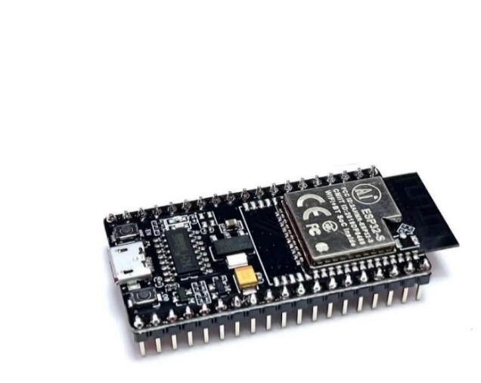

Figure 4.1 Kit wifi BLE ESP32 NODEMCU-32S CH340

The BLE ESP32 NodeMCU-32S (CH340) is a development board based on the ESP32 microcontroller and is used as the central processing unit in embedded and IoT systems. It integrates both Wi-Fi and Bluetooth Low Energy (BLE), enabling flexible acquisition, processing, and wireless transmission of sensor data, which is particularly suitable for low-power applications such as wearable devices and medical IoT systems. The onboard CH340 USB-to-serial converter facilitates firmware programming and real-time data monitoring from a computer. Owing to its high processing performance, integrated wireless connectivity, and cost effectiveness, the NodeMCU-32S provides a practical platform for smart monitoring, automation, and research-oriented applications.
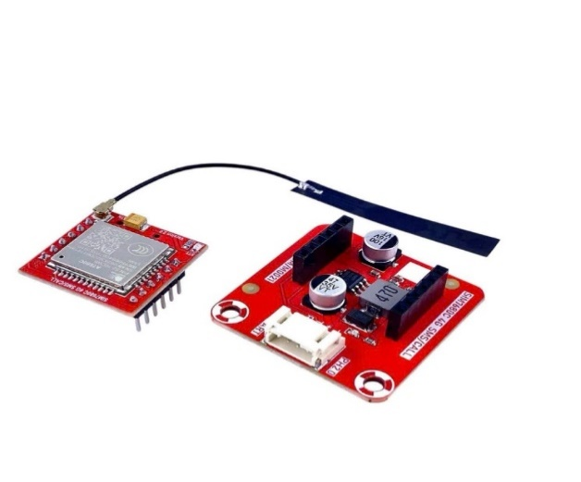
Figure 4.2 MKE-M21 SIM768x 4G SMS/CALL iot Modul

The MKE-M21 SIM768x 4G SMS/CALL IoT module is a cellular communication module designed to provide wide-area wireless connectivity for IoT and embedded systems. It is based on the SIMCom SIM768x series, supporting 4G LTE communication with fallback capabilities for stable data transmission. The module enables SMS messaging, voice calls, and packet data communication, allowing IoT devices to transmit information over cellular networks without relying on local Wi-Fi infrastructure. It is commonly used for remote monitoring, emergency alert systems, vehicle tracking, and smart healthcare applications, where long-distance communication, mobility, and reliability are required.


Figure 4.3 18650 Li-Ion Rechargeable Battery 3.7V

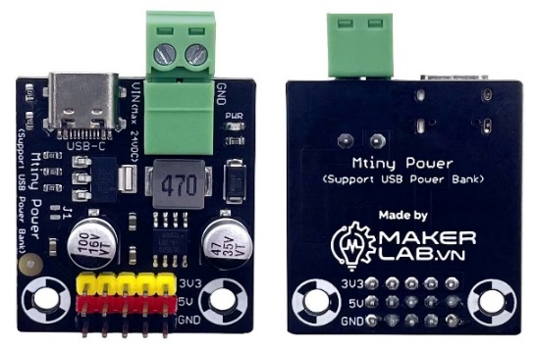
The 18650 3.7 V Li-ion rechargeable battery is a widely used power source for portable electronic and IoT devices. It offers high energy density, stable voltage output, and a long charge–discharge cycle life, enabling reliable and extended operation. In embedded systems, this battery supplies continuous power to microcontrollers, sensors, and communication modules, making it well suited for wearable devices and remote monitoring applications. Its standardized cylindrical form factor and broad availability facilitate easy integration into compact hardware designs and power management circuits.

Figure 4.4 Pulse Mtiny Power (Support USB Power Bank)

The Pulse Mtiny Power module (supporting USB power banks) is a compact power management solution designed to supply stable power for portable and embedded systems. It allows electronic devices to be powered directly from standard USB power banks, providing a convenient and widely available energy source. This module helps regulate and distribute power to microcontrollers, sensors, and communication modules, ensuring reliable operation during development and deployment. Owing to its portability and ease of use, the Pulse Mtiny Power module is well suited for prototyping, testing, and mobile IoT applications.

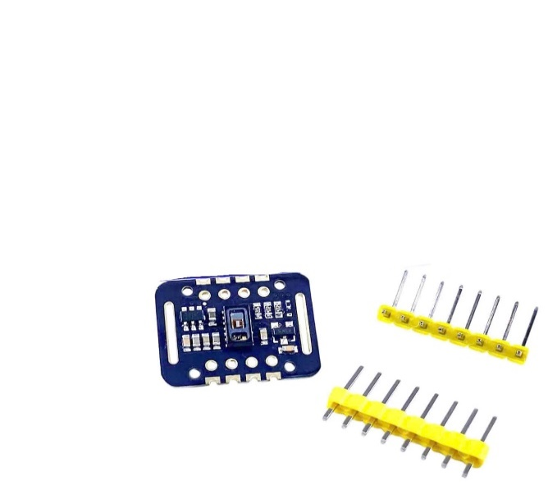
Figure 4.5 MAX30102 MH-ET LIVE Heart Rate and Blood Oxygen Sensor

The MAX30102 MH-ET LIVE heart rate and blood oxygen sensor is an optical biosensor designed to measure heart rate and peripheral oxygen saturation (SpO₂). It uses integrated red and infrared LEDs together with a photodetector to capture photoplethysmography (PPG) signals from the human body. The sensor provides high sensitivity and low power consumption, making it suitable for wearable and medical IoT applications. By processing the acquired PPG signals, reliable heart rate and SpO₂ measurements can be obtained for continuous physiological monitoring.

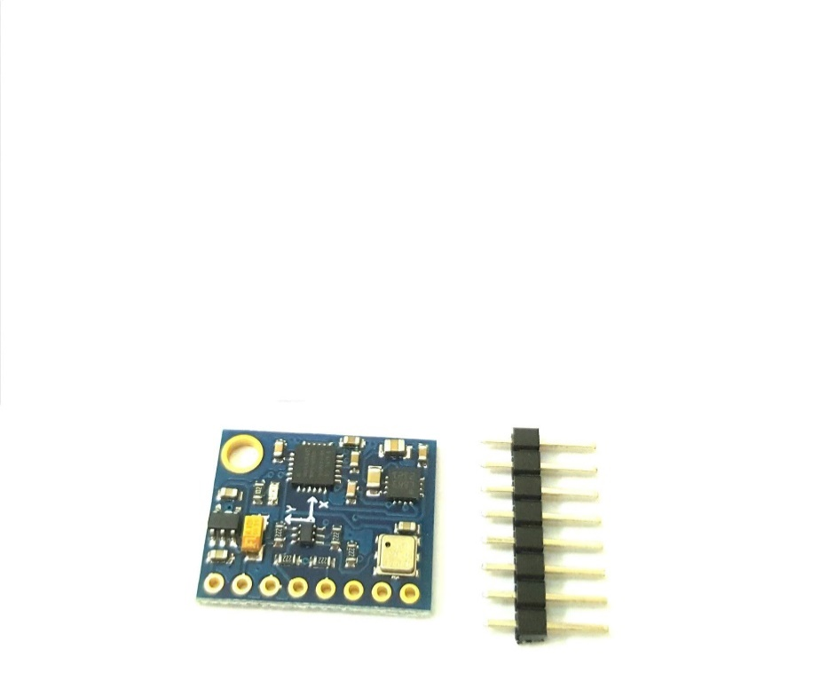

Figure 4.6 GY-87 10DOF IMU Sensor MPU6050 + HMC5883L + BMP180

The GY-87 10DOF IMU sensor module integrates multiple sensing components, including the MPU6050 (3-axis accelerometer and 3-axis gyroscope), HMC5883L (3-axis magnetometer), and BMP180 (barometric pressure and temperature sensor). This combination provides ten degrees of freedom (10DOF), enabling comprehensive motion, orientation, and environmental sensing. The module is commonly used to measure acceleration, angular velocity, magnetic field strength, altitude, temperature, and atmospheric pressure. Owing to its compact design and multi-sensor integration, the GY-87 is well suited for applications such as motion tracking, orientation estimation, fall detection, and IoT-based monitoring systems.
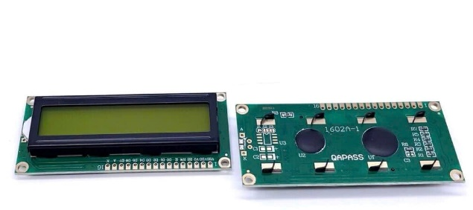

Figure 4.7 LCD text LCD1602 green

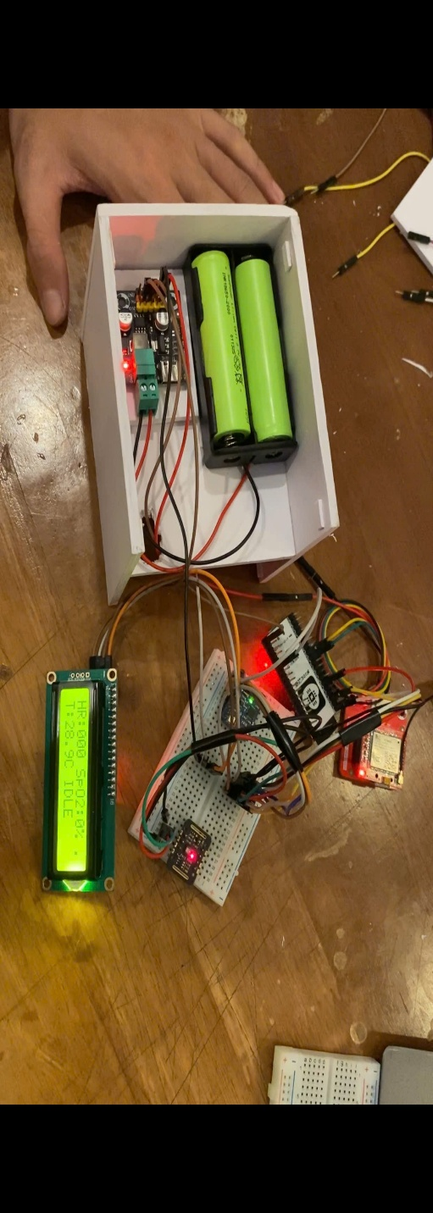
The LCD1602 green text LCD is a character-based liquid crystal display module capable of showing 16 characters per line across two lines. It is commonly used to display system status, sensor readings, and user interface messages in embedded systems. The module offers good readability, low power consumption, and simple interfacing, typically via parallel communication or an I²C adapter. Due to its reliability and ease of integration, the LCD1602 is widely applied in microcontroller-based projects, including IoT devices and monitoring systems.

Figure 4.8 Completed IoT-based Health Monitoring System Prototype
This figure illustrates the completed prototype of the IoT-based health monitoring system after full setup and integration. The system consists of an ESP32 microcontroller as the central processing unit, responsible for data acquisition, processing, and wireless communication.
Physiological signals are collected using the MAX30102 sensor, which measures heart rate and blood oxygen saturation (SpO₂) based on photoplethysmography (PPG) technology. The measured data are displayed locally on a 16×2 LCD module, allowing real-time monitoring of vital signs.
For connectivity, the system integrates a SIM7680C communication module, enabling data transmission to a remote server via cellular or network-based protocols. Power is supplied by two 18650 lithium-ion batteries, managed through a power regulation module to ensure stable and portable operation.
All components are assembled on a breadboard and enclosed within a protective casing, demonstrating a compact and functional IoT device suitable for remote health monitoring applications.

4.4.2. Firmware implementation
The firmware running on the ESP32 is responsible for coordinating sensor data acquisition, data preprocessing, and communication with the backend system. The firmware is structured into multiple tasks to improve reliability and responsiveness, especially under continuous data collection conditions.
Sensor data is periodically sampled and processed to remove noise and extract meaningful parameters such as heart rate and blood oxygen levels. After processing, the data is packaged into structured payloads suitable for network transmission. The firmware manages network connectivity and publishes the data to the MQTT broker at predefined intervals, ensuring consistent data flow to the backend server.
To support long-term operation, the firmware includes mechanisms for handling connection loss and reconnection. This ensures that temporary network instability does not result in system failure or data loss. By separating sensor handling and communication logic, the firmware design enhances modularity and simplifies future extensions.

4.4.3. Task management and shared data handling
Given the multitasking nature of the embedded system, effective management of shared data is essential to maintain system correctness. The ESP32 firmware utilizes a task-based execution model in which different tasks are responsible for sensor reading, data processing, and data transmission.
Shared data structures are used to store the most recent sensor measurements, allowing multiple tasks to access updated information. To prevent race conditions and data inconsistency, synchronization mechanisms are applied when accessing shared resources. This approach ensures that data transmitted to the backend accurately reflects the latest sensor readings.
By applying structured task management and controlled data sharing, the system achieves stable operation even when multiple processes are executed concurrently. This design is particularly important for medical IoT systems, where data accuracy and reliability directly affect monitoring effectiveness.

4.5. Communication layer and MQTT integration

4.5.1. Role of MQTT in the IoT system
In the proposed system, MQTT is used as the primary communication protocol between embedded IoT devices and the backend server. MQTT is a lightweight publish–subscribe protocol specifically designed for resource-constrained environments and unstable network conditions, which makes it well suited for medical IoT applications.
Instead of establishing direct point-to-point connections between devices and the server, MQTT introduces an intermediary broker that manages message distribution. This approach significantly reduces communication overhead on the embedded device and improves system scalability. Devices can publish sensor data without needing to know the exact location or implementation details of backend services, while the backend simply subscribes to relevant topics to receive incoming data.
For patient monitoring scenarios, where continuous data transmission is required, MQTT enables efficient data streaming with minimal bandwidth consumption. The decoupled nature of the protocol also allows the system to support multiple devices simultaneously without modifying the existing communication logic.

4.5.2. MQTT topics and data exchange mechanism
The data exchange mechanism is organized around predefined MQTT topics that logically separate different types of information. Each embedded device publishes sensor data to a specific topic associated with its identifier. This topic-based structure allows the backend to distinguish data from different devices and manage multiple sessions concurrently.
Sensor data published by the ESP32 includes physiological parameters such as heart rate and blood oxygen saturation, as well as contextual information such as motion status and environmental readings. The data is encapsulated in structured message payloads, enabling the backend server to parse and process incoming messages efficiently.
On the server side, the MQTT service subscribes to these topics and listens for new messages. Upon receiving data, the server validates the message format, associates it with the corresponding device and user session, and forwards it to the data processing and storage modules. This event-driven communication model ensures near real-time data delivery while maintaining low latency.

4.5.3. Reliability and fault tolerance in communication
Medical IoT systems must operate reliably even under imperfect network conditions. To address this requirement, the communication layer incorporates basic fault tolerance mechanisms. The embedded device periodically publishes data at fixed intervals, allowing the backend to detect connection loss or abnormal device behavior when data transmission is interrupted.
The MQTT protocol inherently supports quality-of-service (QoS) levels that help ensure message delivery. By selecting an appropriate QoS level, the system balances reliability and communication overhead, ensuring that critical medical data is delivered without excessive retransmissions.
In addition, the backend system is designed to handle duplicate or delayed messages gracefully. This prevents data inconsistency and ensures that temporary network disruptions do not compromise system stability. Overall, the MQTT-based communication layer provides a robust foundation for continuous patient monitoring.

4.6. Backend system and cloud platform implementation

4.6.1. Backend architecture and core services
The backend system is implemented using Node.js with the Express framework and serves as the central processing unit of the entire platform. It is responsible for managing device connections, processing incoming IoT data, handling user authentication, and providing APIs for client applications.
The backend follows a modular architecture that separates responsibilities into distinct components. Controllers handle business logic, models define the data structure stored in the database, routes manage API endpoints, and middleware enforces security and request validation. This design improves code maintainability and simplifies future system extensions.
In addition to handling HTTP-based API requests, the backend integrates an MQTT service that continuously listens for incoming messages from IoT devices. This dual communication capability allows the system to bridge IoT data streams with traditional web-based services.

4.6.2. Data processing and database management
Once sensor data is received from the MQTT broker, it is processed and stored in the database. The database is designed to manage user information, device metadata, session records, and time-series medical data. By organizing data into structured collections, the system supports efficient querying and historical data analysis.
The backend associates each incoming data record with a specific device and user session. This relationship enables precise tracking of patient data over time and supports multi-user scenarios where multiple devices operate concurrently. Data validation is applied before storage to ensure consistency and prevent malformed records from entering the database.
This data-centric design allows the backend to serve both real-time and historical data requests from client applications. Doctors and users can retrieve recent measurements for live monitoring or access stored data for trend analysis and medical evaluation.

4.6.3. API services and system security
The backend exposes a set of RESTful APIs that allow the frontend client to interact with the system securely. These APIs support essential operations such as user authentication, device management, and data retrieval. Authentication mechanisms ensure that only authorized users can access sensitive medical information.
Security is enforced at multiple levels within the backend. Middleware components are used to verify authentication tokens, restrict access to protected routes, and handle errors consistently. This layered security approach reduces the risk of unauthorized access and helps protect patient data.
By combining IoT data ingestion through MQTT with secure API-based data access, the backend system forms a reliable and scalable cloud platform for medical IoT applications. This implementation demonstrates that embedded devices and web technologies can be effectively integrated to support real-world patient monitoring systems.

4.7. Client application and monitoring dashboard

4.7.1. Client application architecture
The client application is developed as a web-based interface using ReactJS and serves as the primary interaction point for end users, including doctors and system administrators. The client follows a component-based architecture, which allows the user interface to be modular, reusable, and easy to maintain.
The frontend communicates exclusively with the backend server through RESTful APIs. This design ensures that all sensitive medical data processing and access control logic are handled on the server side, reducing the risk of data exposure. The client is responsible only for presenting data and handling user interactions, such as authentication, data selection, and visualization.
State management within the client application is designed to support real-time updates and smooth user experience. By separating presentation components from data-fetching logic, the system ensures flexibility in extending the user interface with additional features in the future.

4.7.2. Real-time monitoring and data visualization
One of the core functionalities of the client application is real-time patient monitoring. The dashboard displays physiological parameters such as heart rate and blood oxygen saturation, as well as contextual data including motion status and environmental readings. These values are updated dynamically as new data is received from the backend.
The visualization layer is designed to present information in a clear and intuitive manner. Charts, indicators, and summary panels are used to help users quickly assess patient conditions. Historical data can also be accessed to analyze trends over time, supporting medical decision-making and long-term monitoring.
By providing both real-time and historical views, the dashboard enables comprehensive monitoring of patient health. This approach demonstrates how IoT-generated data can be effectively transformed into actionable information through a modern web interface.

4.7.3. User interaction and access control
User interaction with the client application is governed by an authentication mechanism that ensures only authorized users can access the system. Users are required to log in before viewing any medical data, and access rights are enforced based on user roles.
Once authenticated, users can select specific devices or sessions to monitor, allowing the system to support multiple patients and devices concurrently. The client application also provides feedback mechanisms, such as notifications and status indicators, to inform users about system connectivity and data availability.

This controlled interaction model enhances system security while maintaining usability. By clearly separating public and protected views, the client application supports secure and efficient access to sensitive medical information.

Figure 4.9 System login interface
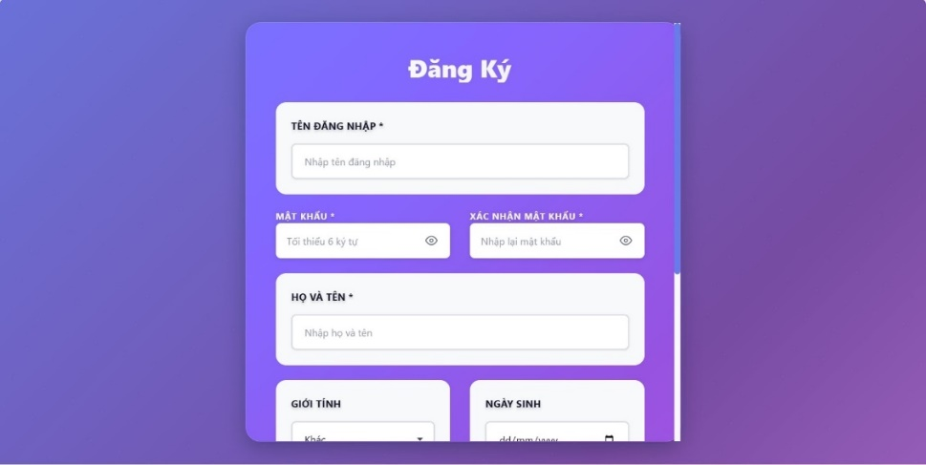
This figure illustrates the login interface of the health monitoring system, allowing users to enter their username and password to access system functionalities. The authentication mechanism ensures secure access and protects sensitive medical data.

Figure 4.10 User registration interface
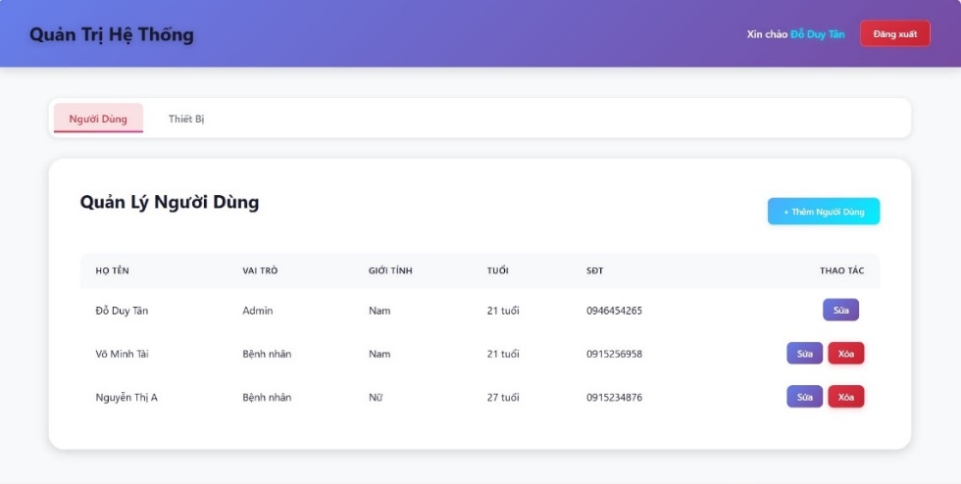
This figure presents the user registration interface, where new users provide basic personal information to create an account. The registration data is securely stored and managed by the backend system to support authentication and user-specific data management.

Figure 4.11 System Administration – User Management
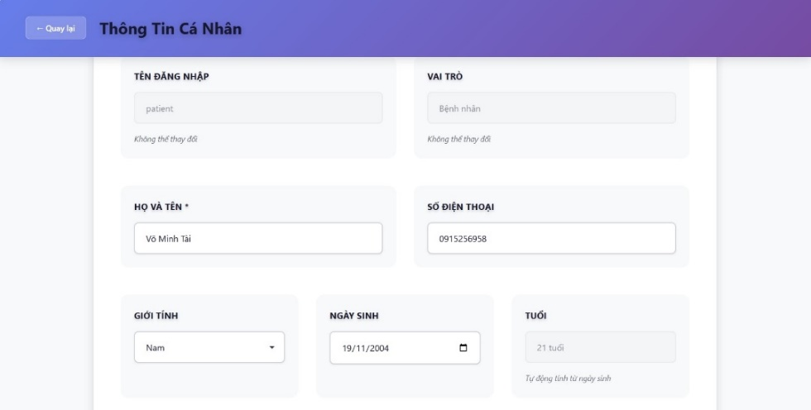
This interface is designed for system administrators to manage users. It displays a list of registered users along with their roles, gender, age, and phone numbers. Administrators can add new users, edit existing user information, or delete accounts as needed.

Figure 4.12 Personal Information Page
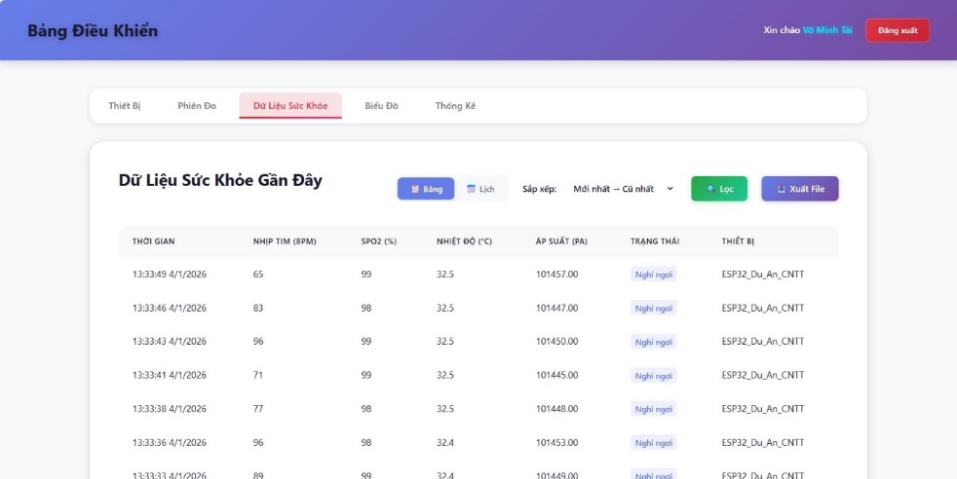
This page allows users to view and update their personal information, such as full name, phone number, gender, and date of birth. Certain fields like username and role are fixed and cannot be modified. The system automatically calculates the user’s age based on the birth date.

Figure 4.13 Recent Health Data Dashboard
This image shows the Recent Health Data section of the system dashboard. It presents health measurements collected from a connected IoT device in a tabular format. The displayed parameters include measurement time, heart rate (BPM), blood oxygen saturation (SpO₂), temperature (°C), air pressure (Pa), measurement status, and the device name (ESP32).
Users can switch views, sort data from newest to oldest, apply filters, and export the data for reporting purposes. This interface helps users and administrators monitor health conditions in real time and review historical measurements efficiently.
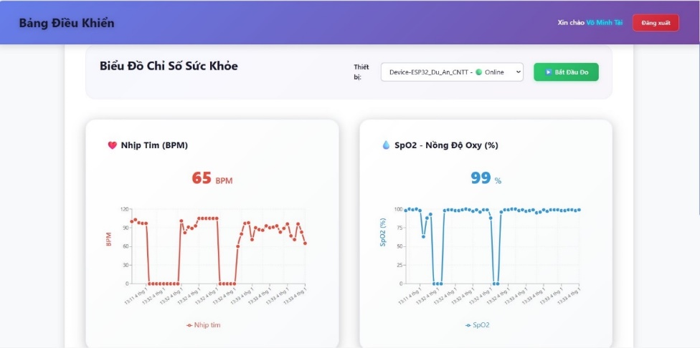
Figure 4.14 Health Indicator Charts Dashboard
This image displays the Health Indicator Charts section of the control dashboard. It visualizes real-time health data collected from an online ESP32 device using interactive line graphs. The left chart represents heart rate (BPM), while the right chart shows blood oxygen saturation (SpO₂ %).
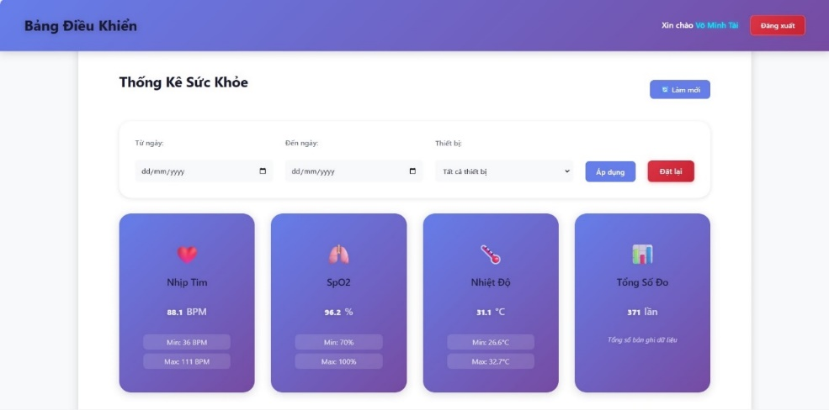
The current values are highlighted at the top of each chart, allowing users to quickly assess their health status. By presenting trends over time, this interface helps users and healthcare administrators detect irregular patterns and monitor changes in vital signs effectively.

Figure 4.15 Health Statistics Overview Dashboard
This image illustrates the Health Statistics section of the control dashboard. It provides a summarized view of health data within a selected date range and device filter. Users can choose the start date, end date, and specific device to analyze the collected measurements.
The dashboard displays key statistical indicators, including average heart rate (BPM), average SpO₂ (%), average body temperature (°C), and the total number of measurements. Minimum and maximum values are also shown for each parameter, helping users evaluate overall health trends and identify potential anomalies efficiently.

4.8. Experimental results and system evaluation

4.8.1. Functional evaluation
The functional evaluation of the implemented system focuses on verifying whether all core components operate as intended. The system was tested under continuous data acquisition conditions, with the embedded device transmitting sensor data to the backend via MQTT while the client application displayed real-time updates.
The experimental results confirm that the system successfully performs end-to-end data transmission, from sensor acquisition on the embedded device to data visualization on the dashboard. All major functionalities, including device connectivity, data storage, and user authentication, were validated during the testing process.
These results demonstrate that the proposed architecture can support real-time patient monitoring without functional interruptions.

4.8.2. Communication performance and system stability
System stability and communication performance were evaluated by observing data transmission over extended periods. The MQTT-based communication layer maintained stable connectivity, with sensor data delivered to the backend at regular intervals. Temporary network disruptions did not cause system failure, as the embedded device and backend were able to recover gracefully.
Latency observed between data acquisition and visualization remained within acceptable limits for medical monitoring applications. The system demonstrated consistent performance under normal operating conditions, indicating that the selected architecture is suitable for real-time IoT deployments.

4.8.3. Limitations and practical considerations
Although the experimental results are encouraging, several limitations were identified during system evaluation. The prototype implementation relies on a limited number of sensors and has not yet been tested at large scale with multiple concurrent users and devices. Additionally, advanced data analytics and long-term predictive capabilities are not included in the current version of the system.
Power consumption and hardware constraints of the embedded device also impose practical limitations on continuous operation. These factors should be considered when deploying the system in real-world medical environments.
Despite these limitations, the system provides a solid foundation for secure and scalable medical IoT applications. The evaluation results confirm that the proposed solution is feasible and effective for remote patient monitoring, while also highlighting areas for future improvement.

4.9. Discussion

4.9.1. Achievement of system objectives
Based on the experimental implementation and evaluation results, the developed system successfully achieves the primary objectives defined at the beginning of the project. The system is capable of collecting physiological data from embedded devices, transmitting the data securely through an IoT communication layer, processing and storing the data on a backend server, and presenting the information to users through a web-based dashboard.
The integration of embedded hardware, MQTT communication, and web technologies demonstrates that the proposed architecture is feasible and practical for real-world medical monitoring applications. The system operates as a complete end-to-end solution, validating the design decisions made in earlier chapters.

4.9.2. Strengths of the proposed system
One of the main strengths of the implemented system lies in its modular and scalable architecture. By decoupling the embedded device from the backend through MQTT, the system can support multiple devices and users without significant changes to the core communication logic. This design choice is particularly beneficial for medical IoT environments, where system scalability is an important consideration.
Another notable strength is the clear separation of responsibilities between system components. The embedded device focuses on data acquisition, the backend handles processing and security, and the frontend manages data visualization and user interaction. This separation improves system maintainability and simplifies future development and troubleshooting.
Furthermore, the use of widely adopted technologies such as ESP32, Node.js, MongoDB, and ReactJS enhances system compatibility and reduces development complexity. These technologies provide a stable foundation for extending the system with additional features in the future.

4.9.3. Limitations and challenges
Although the system exhibits promising functionality, it remains a prototype tested on a limited scale. Its performance in large-scale deployments has not been fully evaluated. The system focuses primarily on data collection and visualization, lacking advanced data analysis capabilities and decision support. Current security measures are basic and may need upgrading to meet stringent medical data protection standards. Furthermore, hardware limitations, including power consumption and sensor accuracy, pose challenges for long-term continuous monitoring. Further optimization and extensive testing are required before clinical deployment.

4.10. Future development

4.10.1. System scalability and performance enhancement
Future development of the system can focus on improving scalability and performance to support a larger number of devices and users. This may include optimizing MQTT topic management, enhancing backend processing efficiency, and deploying the system on cloud infrastructure to improve availability and fault tolerance.

4.10.2. Advanced data analysis and intelligent features
Another important direction for future work is the integration of advanced data analytics and intelligent features. Machine learning techniques could be applied to analyze long-term patient data, detect anomalies, and provide early warnings for potential health risks.
By incorporating predictive analytics, the system could evolve from a passive monitoring platform into an intelligent decision-support system, offering greater value to healthcare providers and patients.

4.10.3. Security and real-world deployment considerations
Enhancing system security is a critical aspect of future development. Additional security measures such as end-to-end encryption, stronger authentication mechanisms, and compliance with medical data protection standards should be considered.
Finally, real-world deployment would require extensive testing in clinical environments, as well as integration with existing healthcare information systems. These steps are essential to ensure that the system meets practical, regulatory, and ethical requirements for medical IoT applications.

CHAPTER 5. CONCLUDE

5.1 General conclusion
The project entitled “Research and Development of a Secure Embedded IoT System for Patient Medical Monitoring Devices” has been successfully conducted at both theoretical and experimental levels, demonstrating the practical feasibility of integrating multiple security mechanisms into a resource-constrained embedded environment. The proposed prototype is implemented on the ESP32 microcontroller and integrates several medical and environmental sensors, including the MAX30102, MPU6050, HMC5883, and BMP085. This configuration enables the collection of essential physiological and contextual data, such as heart rate, SpO₂, body movement, magnetic field variations, temperature, and pressure.
One of the key contributions of this work lies in the comprehensive security design applied throughout the system. Data is encrypted at the source using AES and encrypted using AES at the application layer, while ECC-based cryptography is employed at the transport layer through TLS for authentication and secure key exchange to ensure confidentiality and integrity. Secure communication is achieved through MQTTs over TLS 1.3, while device authentication is enforced using X.509 digital certificates. In addition, Secure Boot and Secure OTA mechanisms are implemented to protect against firmware tampering and unauthorized code injection. The system adopts a multi-layered architecture comprising the device, gateway, cloud, and application layers, with each layer incorporating appropriate security controls to ensure end-to-end data protection.
Experimental evaluations indicate that the system achieves measurement accuracy exceeding 95% under normal operating conditions, with average end-to-end latency maintained below 500 Ms. Despite the computational overhead introduced by multiple security mechanisms, resource utilization on the ESP32 remains within acceptable limits for stable operation. Furthermore, the system effectively preserves data confidentiality, integrity, and availability, while demonstrating resistance to common IoT attack vectors such as packet sniffing, man-in-the-middle, and replay attacks.
In summary, the project successfully meets its initial objectives and confirms that the development of a secure embedded IoT system for patient medical monitoring is both technically feasible and practically valuable. The results provide a solid foundation for future enhancements and real-world deployment, contributing to the advancement of secure and reliable medical IoT solutions.

5.2 Limitations of the topic
Although the project has achieved several promising results, several limitations remain that should be addressed in future work. First, the measurement accuracy of the MAX30102 sensor decreases during periods of intense patient movement, primarily due to motion-induced interference in the PPG signals. While the applied moving average filtering algorithm helps reduce noise, it does not fully eliminate motion artifacts and therefore cannot guarantee consistently high accuracy under all operating conditions.
Second, system latency tends to increase in environments with poor network quality or when relying on mobile network connectivity. Although the average transmission delay remains within acceptable thresholds, intermittent delays or data interruptions may still occur, potentially affecting the responsiveness of real-time monitoring applications.
Third, the ESP32 experiences relatively high CPU and memory utilization when multiple security mechanisms are executed concurrently. This resource demand could become a limiting factor if additional sensors are integrated or more complex functionalities are introduced, increasing the risk of performance degradation.
Finally, the current system remains at the prototype stage and has not been deployed in a clinical setting. Compliance with international medical standards and regulatory certifications, such as FDA or CE, has not yet been pursued. As a result, the system is not suitable for official use in healthcare environments at this stage. Addressing regulatory requirements, conducting clinical validation, and performing long-term stability testing will be essential steps toward real-world deployment.

5.3 Future development direction
Future development of the proposed system may proceed along several directions to address current limitations and further enhance its practical applicability. From a hardware perspective, the integration of more specialized medical sensors—such as multi-channel ECG modules or wireless blood pressure sensors—would enable the collection of a broader and more accurate set of physiological parameters. In addition, the ESP32 platform could be replaced with a more capable microcontroller or augmented with dedicated Secure Elements to strengthen hardware-level security and key protection.
From a software standpoint, the application of more advanced signal processing techniques, including adaptive filtering or machine learning–based algorithms, has the potential to significantly improve measurement accuracy under motion-intensive conditions. Firmware-level optimization may also be pursued to reduce CPU and memory consumption, thereby improving overall system efficiency when multiple security mechanisms are executed simultaneously.
In terms of networking, emerging communication technologies such as NB-IoT or LoRa WAN could be incorporated to enhance connectivity reliability and reduce latency in environments with limited network infrastructure. On the cloud side, the system could be extended with AI-based analytics to support anomaly detection, trend analysis, and early warning generation, contributing to more proactive healthcare monitoring.
Finally, comprehensive validation in a clinical environment remains a critical requirement. Future work should include deployment in hospital settings, compliance with international medical standards, and completion of regulatory certification processes before the system can be officially adopted. Achieving these milestones would represent a decisive step toward transforming the proposed prototype into a practical and reliable solution for continuous patient health monitoring.

5.4 Final conclusion
This project has demonstrated that building a secure embedded IoT system for patient medical monitoring devices is feasible and highly practical. The prototype system has achieved its objectives, meeting requirements for accuracy, latency, and resource usage, while integrating comprehensive security mechanisms.
Although certain limitations remain, the proposed system demonstrates strong potential to evolve into a practical solution capable of supporting continuous health monitoring for both patients and healthcare professionals. Beyond its technical implementation, the project holds scientific significance by clearly demonstrating that comprehensive security mechanisms can be effectively integrated into resource-constrained embedded devices. At the same time, it offers practical value by establishing a foundation for future development of secure and reliable medical IoT systems.
In conclusion, the secure embedded IoT system for patient medical monitoring devices presented in this study extends beyond a purely theoretical contribution. Through the realization of a functional prototype, the research confirms that secure medical IoT solutions are fully achievable in practice. This work contributes to improving healthcare quality, enhancing data reliability, and ultimately strengthening patient safety in modern connected healthcare environments.

REFERENCES
Ashton K. (2009), “That ‘Internet of Things’ Thing”, RFID Journal, 22(7), pp. 97–114.
Atzori L., Iera A., Morabito G. (2010), “The Internet of Things: A survey”, Computer Networks, 54(15), pp. 2787–2805.
Morandi D., Sicari S., De Pellegrini F., Chalma I. (2012), “Internet of things: Vision, applications and research challenges”, Ad Hoc Networks, 10(7), pp. 1497–1516.
Al-Fuqaha A., Guiana M., Mohammadi M., Ale Dhari M., Ayyash M. (2015), “Internet of Things: A Survey on Enabling Technologies, Protocols and Applications”, IEEE Communications Surveys & Tutorials, 17(4), pp. 2347–2376.
Sicari S., Rizzardi A., Grieco L.A., Coen-Purisima A. (2015), “Security, privacy and trust in Internet of Things: The road ahead”, Computer Networks, 76, pp. 146–164.
Weber R.H. (2010), “Internet of Things – New security and privacy challenges”, Computer Law & Security Review, 26(1), pp. 23–30.
Conti M., Dehghan Anha A., Franke K., Watson S. (2018), “Internet of Things Security and Forensics: Challenges and Opportunities”, Future Generation Computer Systems, 78, pp. 544–546.
Roman R., Zhou J., Lopez J. (2013), “On the features and challenges of security and privacy in distributed Internet of Things”, Computer Networks, 57(10), pp. 2266–2279.
Chiang M., Zhang T. (2016), “Fog and IoT: An Overview of Research Opportunities”, IEEE Internet of Things Journal, 3(6), pp. 854–864.
Dogan S., Sagine Y., et al. (2019), “A survey on secure communication in IoT”, Journal of Network and Computer Applications, 144, pp. 102–116.
McEwen A., Classically H. (2013), Designing the Internet of Things, Wiley Publishing, London.

