Program Structure

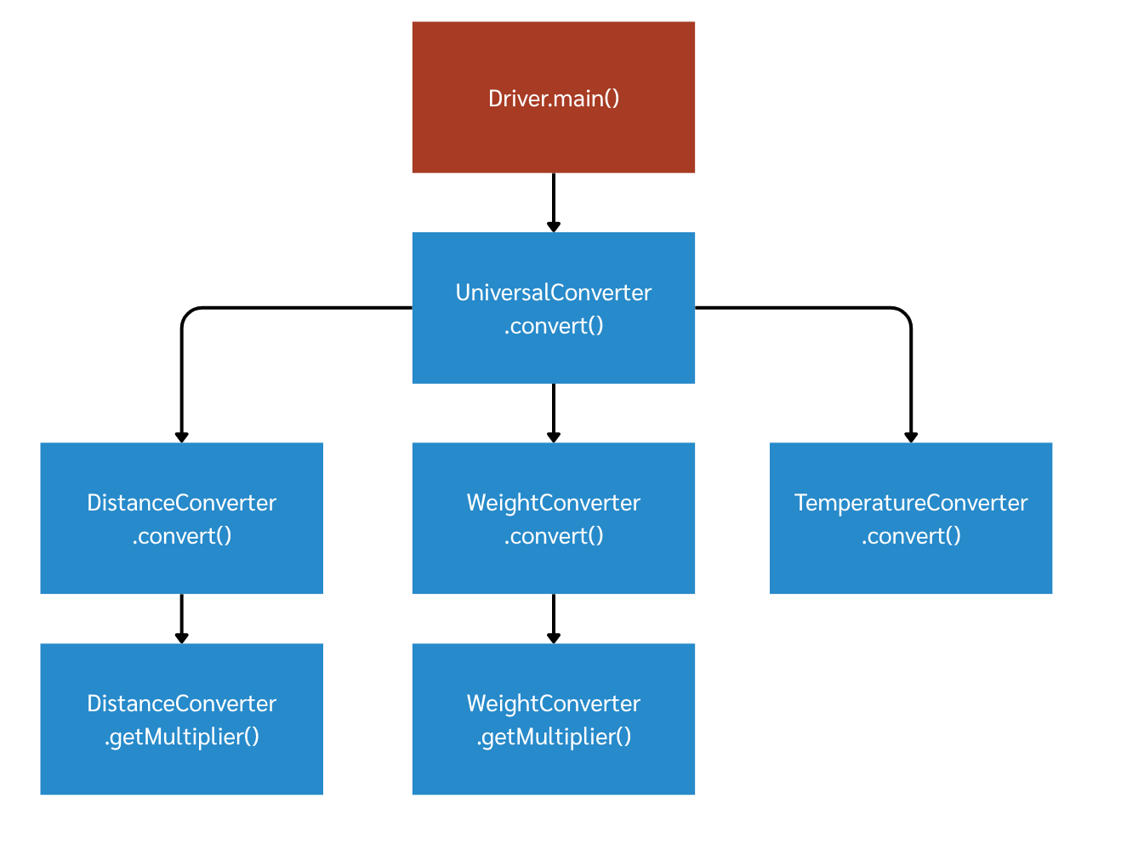

Top-down Integration
Unit under test | List of Stubs/Drivers | result | Stub’s return value | Expected results | Actual results | Pass/Fail/No run
UniversalConverter.convert() | (no DI point - real DistanceConverter used; see note) | convert(1,"Distance","kilometer","meter") | - | 1000.0 | 1000.0 | Pass
UniversalConverter.convert() | (no DI point - real WeightConverter used; see note) | convert(1,"Weight","kilogram","lbs") | - | 2.205 | 2.205 | Pass
UniversalConverter.convert() | (no DI point - real TemperatureConverter used; see note) | convert(0,"Temperature","C","F") | - | 32.0 | 32.0 | Pass
DistanceConverter.convert() | StubDistanceConverter (stubs getMultiplier) | convert(1,"kilometer","meter") | 1000.0 | 1000.0 | 1000.0 | Pass
DistanceConverter.convert() | StubDistanceConverter (stubs getMultiplier) | convert(5,"kilometer","meter") | 1000.0 | 5000.0 | 5000.0 | Pass
DistanceConverter.getMultiplier() | - (leaf, real) | getMultiplier("kilometer","meter") | - | 1000.0 | 1000.0 | Pass
DistanceConverter.getMultiplier() | - (leaf, real) | getMultiplier("mile","kilometer") | - | 1.609 | 1.609 | Pass
WeightConverter.convert() | StubWeightConverter (stubs getMultiplier) | convert(1,"kilogram","lbs") | 2.205 | 2.205 | 2.205 | Pass
WeightConverter.convert() | StubWeightConverter (stubs getMultiplier) | convert(3,"kilogram","lbs") | 2.205 | 6.615 | 6.615 | Pass
WeightConverter.getMultiplier() | - (leaf, real) | getMultiplier("kilogram","lbs") | - | 2.205 | 2.205 | Pass

Bottom-up Integration
Unit under test | List of Stubs/Drivers | result | Stub’s return value | Expected results | Actual results | Pass/Fail/No run
DistanceConverter.getMultiplier() | DistanceConverterDriver | getMultiplier("kilometer","meter") | - | 1000.0 | 1000.0 | Pass
DistanceConverter.getMultiplier() | DistanceConverterDriver | getMultiplier("inch","mile") | - | 0.0000158 | 0.0000158 | Pass
WeightConverter.getMultiplier() | WeightConverterDriver | getMultiplier("kilogram","lbs") | - | 2.205 | 2.205 | Pass
WeightConverter.getMultiplier() | WeightConverterDriver | getMultiplier("gram","kilogram") | - | 1000.0 | 1000.0 | Pass
TemperatureConverter.convert() | TemperatureConverterDriver | convert(25,"C","K") | - | 298.15 | 298.15 | Pass
TemperatureConverter.convert() | TemperatureConverterDriver | convert(298.15,"K","C") | - | 25.0 | 25.0 | Pass
DistanceConverter.convert() | UniversalConverterDriver | convert(2,"kilometer","meter") | - | 2000.0 | 2000.0 | Pass
WeightConverter.convert() | UniversalConverterDriver | convert(2,"kilogram","lbs") | - | 4.41 | 4.41 | Pass
UniversalConverter.convert() | - (top level; Driver.java is the real caller) | convert(1,"Distance","kilometer","meter") | - | 1000.0 | 1000.0 | Pass
UniversalConverter.convert() | - (top level; Driver.java is the real caller) | convert(1,"Weight","kilogram","lbs") | - | 2.205 | 2.205 | Pass

