ECE445L Lab 2 Digital Sampling
Debugging, oscilloscope fundamentals, logic analyzer, dump profiles
This laboratory assignment accompanies the book, Embedded Systems: Real-Time Interfacing to ARM Cortex M Microcontrollers, ISBN-13: 978-1463590154, by Jonathan W. Valvano, copyright © 2026.

Table of Contents
Table of Contents 1
Team Size 2
Goals 2
Review 2
Starter Files 2
Required Hardware 2
Lab Overview 2
Preparation 3
Procedure 4
Lab Checkout 7
Lab Report 7

Team Size
The team size for this lab is 2.

Goals
You should understand the following concepts by the end of the lab:
- real-time data acquisition
- time jitter
- critical sections
- methods to measure noise and calculate SNR
- probability mass functions (PMF)
- central limit theorem (CLT)

Review
- ebook Sections 1.6, Section M.1, or textbook 2.4 on GPIO, Chapter 10 of data sheet
- ebook Section 1.11, or textbook 3.9, 5.9 on debugging,
- ebook Section 2.8, or textbook 5.3 on critical sections,
- ebook Section M.3, textbook 5.7, 6.2 on periodic timer interrupts, Chapter 23 of TRM
- ebook Section M.2, textbook 8.5 on the ADC, Chapter 10 of TRM
- ebook Chapter 2, textbook 10.1, 10.4 and 10.5 on data acquisition systems and noise
- Logic analyzer instructions.

Starter Files
- Example projects from https://users.ece.utexas.edu/%7Evalvano/arm/
  - TimerPeriodicInts (review periodic interrupts)
  - ADC.c (review busy wait ADC)
- Starter project:
  - Lab 2 template provided on the GH Classroom repo.

Required Hardware
Parts | Price | Source (price source)
LP-MSPM0G3507 | $18.69 | TI
GP2Y0A21YK0F  or GP2Y0A41SK0F sensor | $11.85 | Mouser or Lab checkout desk
10 uF tantalum capacitor

Lab Overview
In this lab you will design a simple data acquisition system, calculating a physical parameter and measuring noise. You will measure distance with a GP2Y0A21YK0F or GP2Y0A41SK0F sensor. You will use the oscilloscope, spectrum analyzer, and logic analyzer, and then learn how to profile code using dumps to measure sampling jitter and noise.
You are expected to learn how to use the oscilloscope, spectrum analyzer and logic analyzer in this class, so please ask your TA for a demonstration in the lab if you are unfamiliar with them.
To apply the Central Limit Theorem, we must assume the noise is random. I.e., the noise in each sample is independent from the noise in the other samples, and the noise has zero mean. Look up the ADC Sample Averaging in Chapter 10 of the technical reference manual. The Central Limit Theorem (CLT) states: as the number of samples increases, the calculated average (your data) will approach the theoretical mean (true signal). The CLT also states that regardless of the original probability density function (PDF) of the noise, the PDF of the averaged signal will become Gaussian.

Preparation
Preparation is performed during or before the W/TH lab session.
- Write software to sample the ADC at 1000 Hz. You may use any of the functions on the class web site or the book. Three possible ADC inputs are PA26, PB24, or PA24. The 1000 Hz sampling rate should be created by a periodic timer, and the ADC synchronization should be busy wait.
- Toggle PB22 three times in the ISR, and toggle PB27 once each time through the main loop. Compile, debug, and copy-paste the compiler-generated assembly code of the single toggle of PB27 in the main program. Initially, use this method to toggle a pin creating a critical section bug. The bug is induced by the nonatomic read-modify-write access to the shared global.
GPIOB->DOUT31_0 ^= BLUE; // toggle PB22
GPIOB->DOUT31_0 ^= GREEN; // toggle PB27

Highlight the critical section in the assembly code. More specifically, specify between which instructions causes a bug if the interrupt were to occur. Be prepared to explain each line of this assembly code during checkout. Your assembly code should be like the following

//Loads base address of Port B into R1
0x0000037E 4939 ldr r1, [pc, #0xe4]

//Loads the actual pin high-low state in the port to R0
0x00000380 6808 ldr r0, [r1]
0x00000382 2201 movs r2, #0x1

//Green toggle bitmask
0x00000384 06D2 lsls r2, r2, #0x1b

//Toggle the high-low state data
0x00000386 4050 eors r0, r2

//Store data back into the port
0x00000388 6008 str r0, [r1]
If an interrupt happens between the 2nd LDR and the STR, then the processor will jump to the handler where the blue light is toggled. Before this interrupt happened, the R0 register now contains the version of the pin toggle high-low values that will be outdated after the ISR returns. The issue with this is that once the interrupt is over, we will overwrite the old value that was previously in R0 over the toggle value that was written for the blue color during the ISR.

We can mitigate this issue by making this section atomic. This means that we can disable interrupts before the section runs to make sure that the timer handler isn’t able to interrupt.

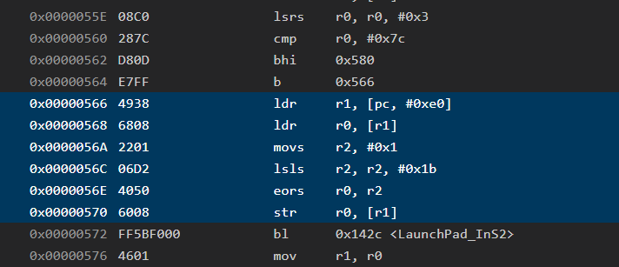

- The starter project calls TimerG12_Init which activates timer G12 without interrupts. Reading TIMG12->COUNTERREGS.CTR will return the 32-bit current time in 12.5ns units. This timer counts down. You will read TIMG12->COUNTERREGS.CTR every time you sample the ADC. Write software to measure sampling jitter. Subtracting two times yields the actual ADC period in 12.5ns. If sampling were perfect each time difference would be exactly 80000 (1ms). Write code that records 1000 ADC samples (DataBuf) and 1000 time measurements (TimeBuf). Calculate sampling jitter as
MaxT = maximum(TimeBuf[i-1] – TimeBuf[i]) for i equals 1 to 999
MinT = minimum(TimeBuf[i-1] – TimeBuf[i]) for i equals 1 to 999
Jitter = MaxT – MinT
In a hard-real time system we do not report the typical or average behavior; rather, we report the worst-case timing. In this course, we define the worst case as Jitter. A hard real-time system guarantees samples were collected with a small jitter.
- Write software to measure the average and standard deviation of the 1000 ADC samples. Assuming the input is constant, we categorize the average as Signal, and the standard deviation as Noise. Calculate SNR as the average/standard deviation. Do not use floating point. There are many definitions for effective number of bits (ENOB). However, in this lab we use
ENOB = log₂(SNR)
- A probability mass function (PMF) is the number of observations plotted versus observed input. A system with a Gaussian noise process has a PMF shaped like a bell-curve. Observe the starter code includes the function CreatePMF, which calculates a PMF of the data. You will use this PMF to study the effects of signal averaging on the noise distribution according to the CLT.

Procedure
Procedure is performed during or before the W/TH lab session.
- Connect the analog circuit to an ADC input, PA26, PB24, or PA24. The IR distance sensor is connected to an analog input. The 10 µF capacitor should be placed as close to the sensor as possible. Figure 2.1 shows the interface without any RSLK hardware.
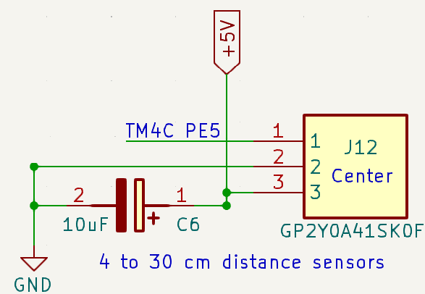
Figure 2.1. Possible hardware connections to create an analog input. The IR sensor measures distance.
Figure 2.2 shows the interface with an RSLK reduced function hardware. Reduced function means it is a RSLK PCB without batteries, motors, or tachometer. It has just the LaunchPad, SSD1306 LCD, and one IR sensor. To operate Lab 2 with a reduced function RSLK hardware, connect both the LP3.3 and LP5.0 jumpers, plug in one IR sensor, and attach the LaunchPad.
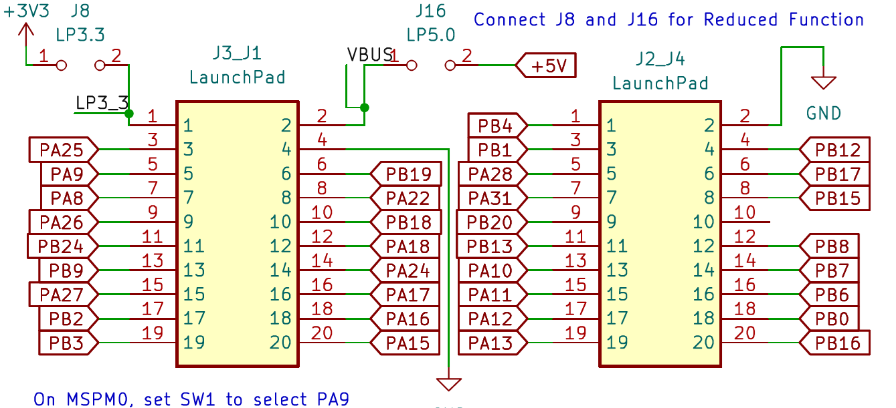
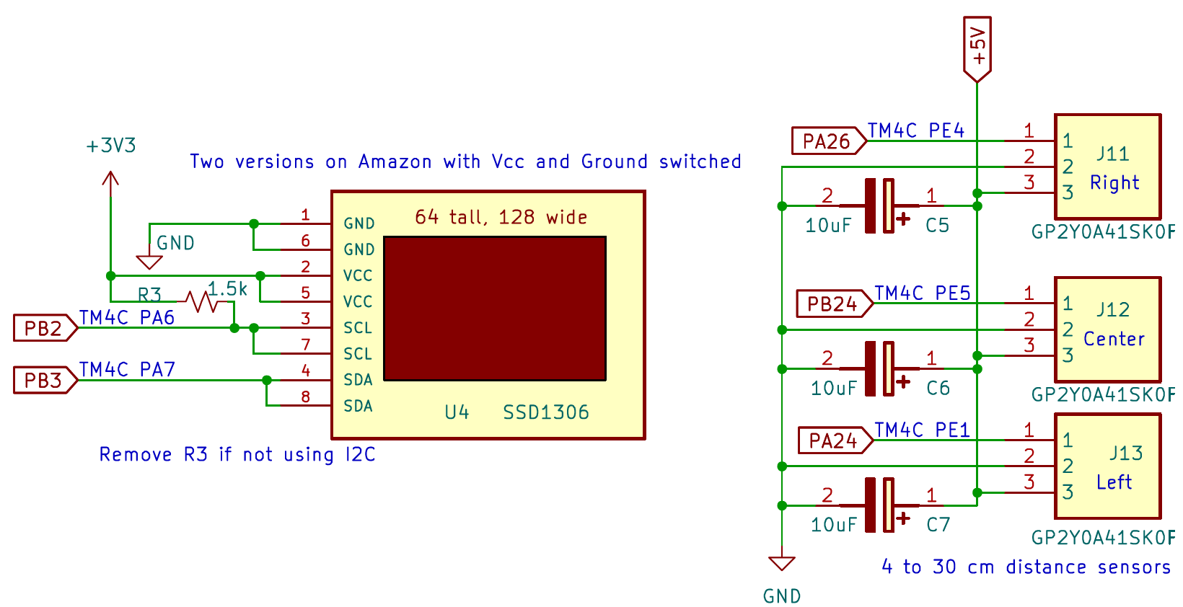
Figure 2.2. Reduced function RSLK robot hardware connections to create an analog input.

- Measuring noise with the DVM. Place a large flat object a constant distance from the sensor, so the sensor voltage is between 1.65V and 3.3V. Take measurements at the ADC input (e.g., PB24). Measure DC voltage (signal), and then measure AC voltage (noise). Calculate signal to noise ratio, SNR = signal/noise, ENOB=log₂(SNR). Note: these calculations will vary with the amplitude of the input.
- Measuring noise with the oscilloscope. Use an oscilloscope to view the voltage at the ADC input (e.g., PB24). Using DC coupling mode, measure DC voltage (signal). Using AC coupling mode measure AC RMS voltage (noise). Calculate signal to noise ratio, SNR = signal/noise, ENOB=log₂(SNR). Note: these calculations will vary with the amplitude of the input. Perform one measurement where the analog voltage is between 1.65 and 3.3V. The image should show the magnitude of the noise in either AC RMS or DC Peak-to-Peak. This can be done via the cursors or adding a dynamic measurement. See Figure 2.3.
- Observing the noise profile with a spectrum analyzer. Use an oscilloscope to view the voltage at the ADC input (e.g., PB24). Using spectrum analyzer mode observe the noise versus frequency. Select a sampling rate that allows you to see frequencies from 0 to 1000 Hz. See Figure 2.4.
- Measuring noise using software. Using the same configuration as steps 2 – 4, run the software sampling (without hardware averaging) and report the calculations of Signal, Noise, and SNR from your software. Calculate ENOB=log₂(SNR)
- Measuring time jitter. Report the time jitter of your real-time data acquisition system.
- Observing the critical section. Connect a scope or logic analyzer to PB22 and PB27. PB22 should toggle 3 times every 1ms. Capture a trace like Figure 2.5 showing the effect of the critical section bug. Edit the software removing the bug. There are lots of ways to remove the bug, pick one to implement and discuss the other options in the report. Figure 2.6 shows the proper behavior.
- Explore the behavior of the CLT. Configure the system with a constant distance. Make a table of SNR and ENOB, as calculated by your software, as a function of hardware averaging, with Averaging from 0 to 6. Pick your choice for averaging and download and plot the PMF for no averaging and your choice, like Figure 2.7. Note: The PMF data are output to the PC via UART0, and you can capture the data with the serial console window in CCS. If you compare two PMFs with the same Averaging value, you will not get the same result because the noise is not stationary
- Calibrate the data acquisition system. Use four distances of known values. Using the averaging settings chosen in step 7, record the Signal for each measurand. Using a nonlinear equation fit the four calibration points to determine the calibrations constant A and B. See the Lab2Calibration.xlsx file. Calculate the average error of the calibration.
Distance (mm) d = A/(Signal + B);
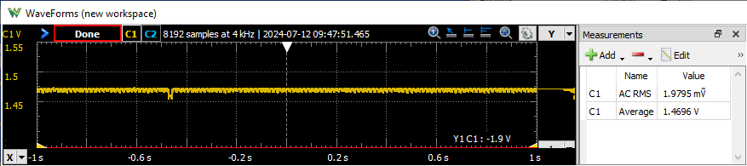
Figure 2.3. Analog voltage versus time measured with a real oscilloscope. Signal =1.5V, Noise=2mV, SNR = 1.7/0.055= 742, which is ENOB= log₂(742) =9.5 bits.
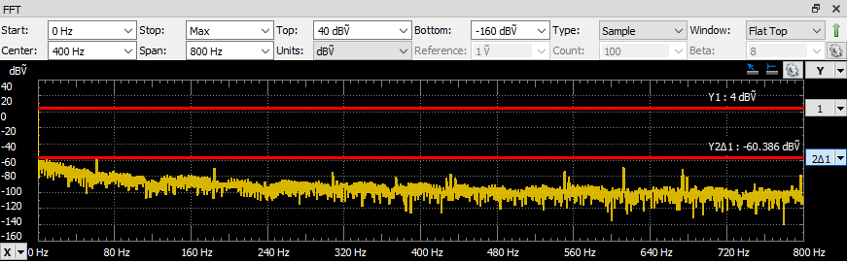
Figure 2.4. Analog voltage versus frequency measured with a real spectrum analyzer. Signal = 4dB, Noise=-60dB, SNR=64dB, 10^{64/20} = 1584, ENOB=log₂(1584) = 10.6 bits.
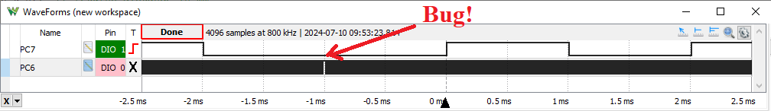
Figure 2.5. Logic analyzer trace showing the critical section bug. PB22 was toggled three times every 1ms, but right at time=-1ms the toggles are missing.
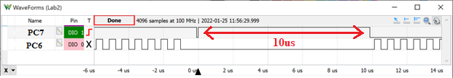
Figure 2.6. Zoomed in view. Note that the main program does not run (As evidenced by PB27 no longer toggling) while the Timer ISR is running. Also note that the time to execute the Timer ISR is about 10us (this is the time between the first and third toggle of PB22; 8us of this 10us occurs converting the ADC, which is running no hardware averaging).

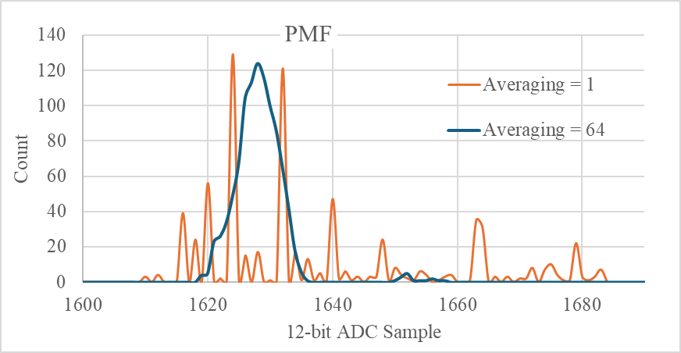
Figure 2.7. The input distance was constant, the ADC was sampled 1000 times at 1 kHz. The PMF is the count versus ADC sample.
Note: If we were to use timer-triggered ADC sampling, even with hardware averaging, there would be no jitter

Lab Checkout
The lab checkout is performed during the M/T lab session.
You should be able to demonstrate:
- Your understanding of the logic analyzer and scope features listed.
- Any of the deliverables: how the data were collected and what they mean.

Lab Report
The lab report shall be submitted by the Friday after the second lab section.
You should complete the Lab02Report.docx file with your data and answers then submit the completed file to Canvas

