ECE 445L Lab 4F
IEE802.11 Wi-Fi communication, TCP, HTTP/Web sockets, IoT
This laboratory assignment accompanies the book, Embedded Systems: Real-Time Interfacing to ARM Cortex M Microcontrollers, ISBN-13: 978-1463590154, by Jonathan W. Valvano, copyright © 2021.

Table of Contents
Table of Contents 1
Team Size 3
Goals 3
Review 3
Starter Files 3
Required Hardware 3
Lab Overview 4
WiFi 5
Introduction to WebSockets 6
WebSocket Connection Mechanism 7
WS Documentation: 7
Lab Preparation 8
Procedures 12
Procedure Flow 12
ESP8266 Setup Procedure 13
Web App Procedure 14
LaunchPad Procedure 15
Merge Lab 3 Code 16
Lab 4F Deliverables 17
Deliverable 1 17
Deliverable 2 17
Deliverable 3 17
Deliverable 4 18
Deliverable 5 18
Deliverable 6 (5pts Extra Credit) 19
Lab Checkout 19
Lab Report 19
Debugging 19
Browser Debug 19
Hints 20
LaunchPad Starter Project 20
ESP8266 Arduino Starter Project 21
Programming the 8266 in the Arduino Environment 21
Web Socket Server Application Starter Project 22

Team Size
The team size for this lab is 2.

Goals
- Implement a “smart object” that connects to a Web application via a WebSocket (WS) interface (I/F) using the ESP8266 WiFi module connected to the MSPM0.
- Remotely control the clock developed in Lab 3 via the WS I/F.
- Build a WebSocket HTML Application to publish “Switch” commands to the MSPM0.
- Send the MSPM0 Clock variables to the “WebSocket” HTML Application once per second.

Review
- ebook Chapter 4 or textbook Section 11.4 on IoT
- WebSocket architecture (see Lab Overview below)

Starter Files
- Starter project: Lab 4F template provided on the GitHub Classroom repo.

Required Hardware
Parts | Datasheet | Price | Source (price source)
EK-MSPM0GXL | EK-MSPM0GXL datasheet | $16.99 | TI
Sitronix ST7735R Color LCD | ST7735R Driver datasheet | $19.95 | Adafruit
8Ω or 32Ω speaker | N/A | N/A | EER Checkout Desk
10kΩ resistor | N/A | N/A | EER Checkout Desk
1uF Tantalum Capacitor | N/A | N/A | EER Checkout Desk
Switches | N/A | N/A | EER Checkout Desk
NTR4501NT1G MOSFET | NTR4501 data sheet | $0.46 | EER Checkout Desk  Or Mouser, Digikey
1N914 Diode | 1N914 datasheet | $0.10 | EER Checkout Desk,  Or Mouser
ESP8266-ESP01 | ESP8266 Datasheet | 3.50 | Get it from the TA’s
ESP01 breadboard adapter | N/A | N/A | Get it from the TA’s
ESP8266 Programmer |  | 10.99 | EER Checkout Desk
LM2937-3.3 Voltage Regulator or any 3.3V regulator | LM2937 Datasheet | 1.68 | EER Checkout Desk

Lab Overview
Labs in ECE445L are very open-ended. For Labs 3, 4 and 5 you will be given a requirements document. Your TA is your client or customer. A grade of B can be achieved by satisfying these minimum specifications. To achieve higher grades, you are expected to expand sections 2.1 and 2.5 of the requirements document describing what your system will do. You are free to make any changes to this document if you achieve the educational goals for the lab. All changes must be approved by your TA.
As always, feel free to adjust the syntax and format of your requirements document as you think appropriate. The goal of the document is to provide a clear and unambiguous description of what the project does. A template of this document is provided in Lab04Report.docx.
In this lab your team will create a “smart object” that connects to a Laptop or Phone via a TCP based WebSocket “Point-2-Point” (P2P) as shown below in Figure 4.1. The ESP8266 will be coded to act as an HTTP Web Socket Server (WSS). The HTML code running on the Laptop/Phone acts as client to the WSS.

Figure 4.1: Lab 4F Block Diagram
The data flow diagram for Lab-4F is shown below. A majority of LAB-3 will be reused for this lab. The switches used in Lab-3 are replaced by the laptop HTML JavaScript interface.
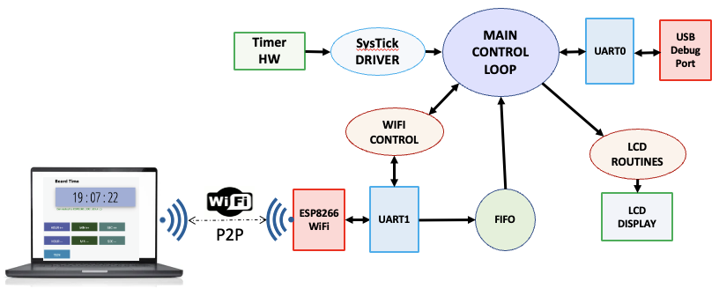
Figure 4.2: Lab 4F Data Flow Diagram
Your system will include:
- A PC running an HTML/JS WebSocket Client that you will develop using the starter code we provide.
- A MSPM0 Launchpad running your Lab 3 software plus a UART peripheral that talks to the ESP8266 Wi-Fi module.
- An ESP8266 Wi-Fi module (Fig. 4.3 below) that is configured with starter WSS code built using Arduino.
- Existing hardware reused from Lab 3, including the display.
Your system will be able to:
- Have the laptop running the HTML/JS Web App, displaying any changes in the MSPM0’s state.
- Have the MSPM0 and its display respond to updates from the web application.
- Display the time including hour, minute and second as well as 7 control buttons: Hour++, Hour--, Minute++, Minute--, Second++, Second--, Toggle 12/24-hour display.
- Measure an external sensor using the ADC (extra credit). Any external sensor and any interface method is okay (ADC, I2C, or SPI).
You are free to define the “look and feel” of your system if you meet the specifications listed above.

WiFi
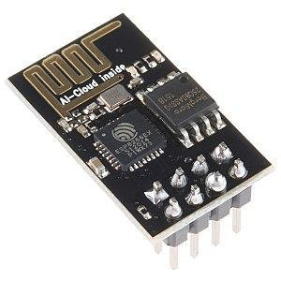
Wi-Fi is the name given to devices that communicate wirelessly employing the IEEE 802.11 standard. They typically operate in the 2.4 GHz Industrial-Scientific-Medical (ISM) unlicensed band that is shared with ZigBee (IEEE 802.15.4) and Bluetooth (IEEE 802.15.1) communications. The IEEE 802.11 standard describes how information is represented via radio frequency signals, i.e., the physical or PHY layer, and how communications are formatted and controlled, i.e., the media access control or MAC layer. Communication requirements beyond the PHY and MAC, e.g., flow control, error recovery, and routing, are handled at higher levels of the internet stack.
Figure 4.3: The ESP8266 WiFi module.

Introduction to WebSockets
WebSockets provide a persistent, full-duplex communication channel over a single TCP connection. Unlike the traditional HTTP request/response model, WebSockets allow both the server and the client to push data to each other at any time, making them ideal for real-time applications such as live chat, online gaming, collaborative editing, and financial dashboards.
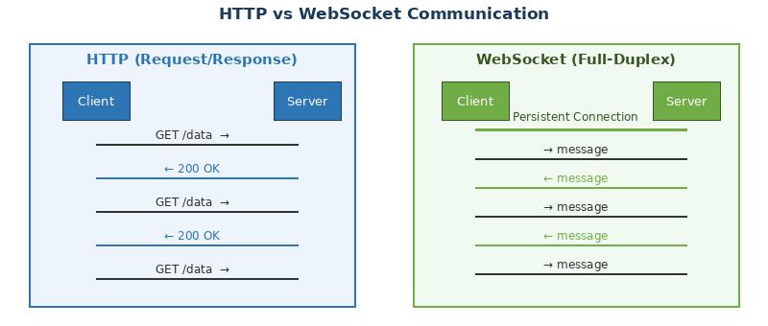
Figure 4.4: HTTP (Request/Response) vs WebSocket (Full-Duplex) Communication

The key advantages of WebSockets* over traditional polling techniques include:
- Low latency — messages are delivered in milliseconds over an open connection. Since the connection is persistent, there's no need to establish a new connection for each message, significantly reducing latency.
- Reduced overhead — no HTTP headers are resent with every message.
- Bidirectional flow — both peers can initiate messages without waiting.
- Efficient resource use — one connection replaces hundreds of polling requests. WebSockets are more efficient than traditional polling techniques, as they don't require the client to continuously ask the server for updates.
- Real-time Updates: WebSockets enable instant data transmission, making them perfect for applications that require real-time updates, like live chat, gaming, or financial trading platforms.
- Lower Overhead: After the initial handshake, WebSocket frames have a small header (as little as 2 bytes), reducing the amount of data transferred.

*WebSocket is defined in RFC 6455 (2011) and is supported by all modern browsers natively via the WebSocket JavaScript API.

WebSocket Connection Mechanism
A WebSocket connection always begins as an HTTP request. The client sends an HTTP/1.1 Upgrade request; the server responds with 101 Switching Protocols, and from that point the TCP socket is repurposed for WebSocket framing.

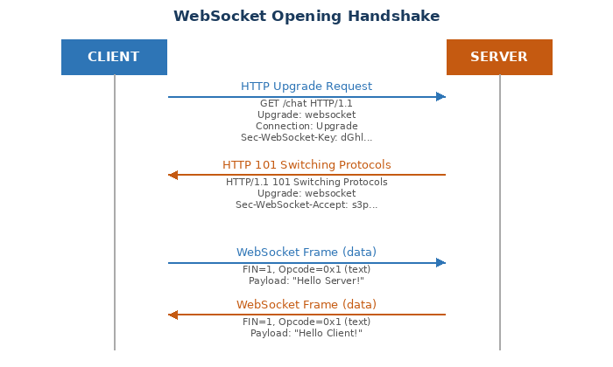
Figure 4.5: WebSocket Opening Handshake (HTTP Upgrade)

WS Documentation:
RFC 6455 (WebSocket Standard): https://datatracker.ietf.org/doc/html/rfc6455
MDN WebSocket API: https://developer.mozilla.org/en-US/docs/Web/API/WebSocket
ws (Node.js library): https://github.com/websockets/ws
Python WebSockets library: https://websockets.readthedocs.io
WebSocket Org.: https://websocket.org

Lab Preparation
Preparation is performed during or before the W/TH lab session.
- Software Review
  - Review the Lab 4F starter code provided in the GitHub classroom repository. There is a hint at the end of this document enumerating notable files in the project. There are three sets of software you should be familiar with which are listed below.
    - The LaunchPad starter project you expanded in Lab 3
    - The ESP8266 starter project, which performs the intermediate parsing and handshakes
    - The WebSocket application starter project which displays the data collected.
- ESP Software Setup
  - Demonstrate to the TA that you can flash the ESP8266 Starter project successfully. A guide to installing the Arduino IDE and project dependencies can be found in the hints section at the end of this lab document. Be prepared to show the ESP interacting with the web interface.

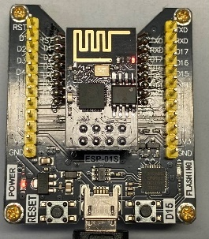
  - You will need to checkout an ESP8266 programmer from the checkout counter if you intend to change the functionality of the ESP8266. The orientation of the ESP8266 is displayed on the programmer. You will burn up the ESP8266 if you install it in the other orientation.

  - The programmer MUST be stored in the box as it is vulnerable to damage from electrostatic discharge (ESD).

  - The programmer MUST be returned in working order and is only available for One-Day checkout.

- WebSocket communication protocol. Figure 4.6 below shows how the starter code is working at the present time. You can use your own protocol or follow the existing protocol.
  - Explain to your TA what protocol you will be using to send data to the WS Server and from the HTML/JS Client.
  - The ESP code has support for the basic “Mode, Hour, Minute, Second” using CSV Format. The MSPM0 will need to send the data once per second.
  - The HTML/JS Client has support to asynchronously send a single command back to the Server.

Figure 4.6: Starter Code WebSocket communication protocol

NOTE: Due to the low overhead of a WS packets, optimizing the number of bytes being sent may not provide a substantial speedup. Keep it simple**

** “The definition of genius is taking the complex and making it simple” – Albert Einstein
"Simplicity is the ultimate sophistication" – Leonardo da Vinci

- Hardware Setup
  - Be prepared to show your TA that you can assemble the hardware for this lab. Before leaving prep, you must collect all hardware needed to perform this lab as listed below:
    - MSPM0 Launch Pad
    - ST7735 TFT Screen
    - ESP01 aka the ESP8266-ESP01 (Can use until the end of the semester if needed)
    - ESP01 breadboard adapter (please give this adapter back along with the ESP01 at the end of the semester)
  - Consider the following power circuit. The ESP8266 draws more current than the 3.3V regulator on the LaunchPad can provide. You must build a separate 3.3V regulator for the ESP01. This is done using the LM2937ET-3.3 linear regulator and two 4.7 µF tantalum bypass capacitors (see Figure 4.7 below).

You must connect ALL grounds together or you WILL have very bizarre circuit operation. You must NOT CONNECT 3V3_ESP to the 3V3 output of the launchpad. Use the circuit below to generate 3V3_ESP.

As always, disconnect power before building this circuit. Verify 3V3 output before continuing.

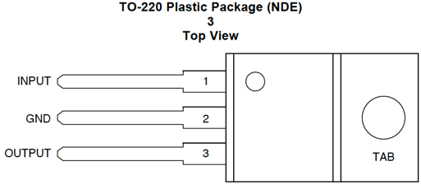
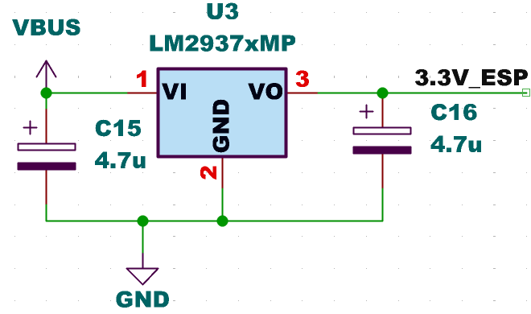

Figure 4.7: Regulator circuit using the LM2937 linear regulator. Please test this circuit before attaching to ESP8266.

  - Consider the interface between the ESP8266/ST7735 and the LaunchPad is shown below in Figures 4.8, 4.9, 4.10. The ESP8266 interface uses GPIO and UART ports on the LaunchPad. The ESP8266 interface uses UART1 running at 115200 bits/sec, 1 stop bit no parity, and no flow control (aka RTS/CTS).

NOTE: There are two different pinout numbering schemes for the ESP8266 on the web. The schematic in Figure 4.9 below uses the pinout numbering scheme in Figure 4.8(B) below.

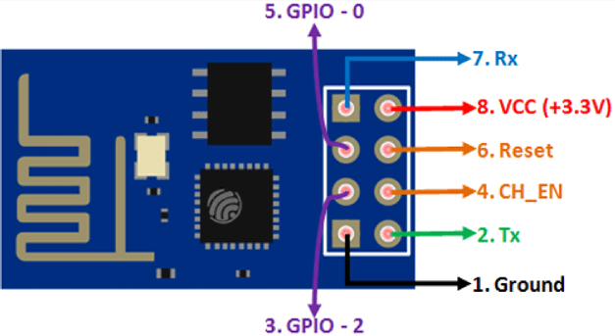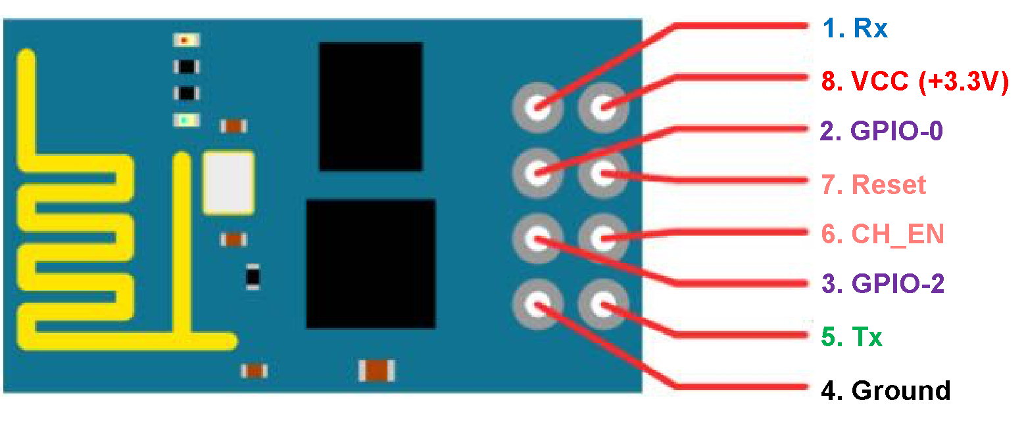

Figure 4.8-A (Left) & 4.8-B (Right): ESP 8266 Pinout numbering

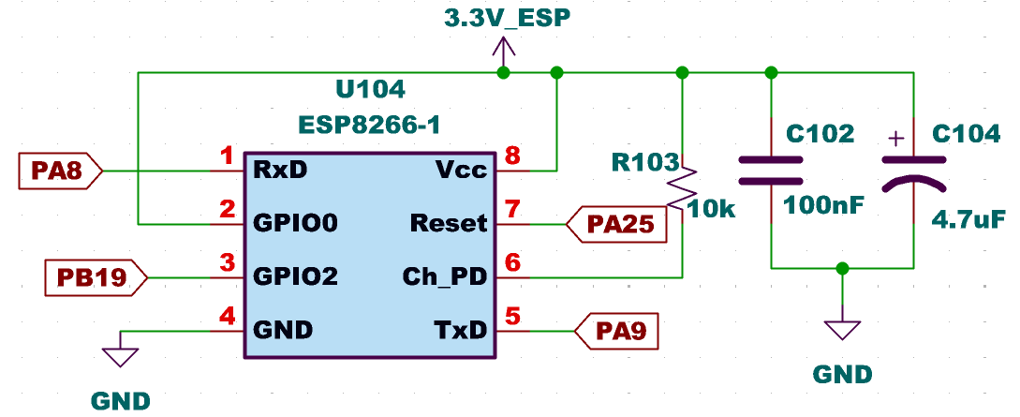

Figure 4.9: Detailed schematic of the ESP8266 interface. UART5 is used. The +3V3 supply for the ESP8266 is different from the regular LaunchPad +3.3V, see Figure 4.6. All grounds are connected together.
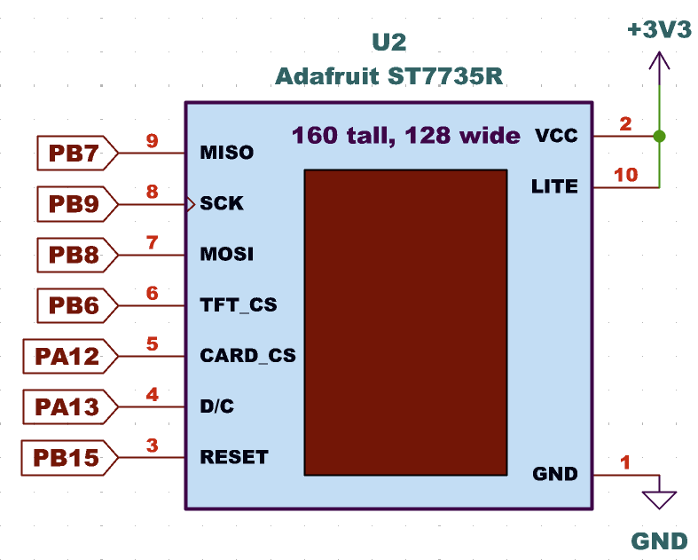
Figure 4.10: Detailed schematic of the ST7735 interface. The CARD_CS pin (pin 5) on the LCD is optional and needed only when the SDC card is being used. This 3.3V supply is the regular LaunchPad 3.3V.

Procedures

Procedure Flow
This lab has a lot of moving parts, so we suggest you perform the lab procedures in a specific order to minimize pain.
- Run the starter code for the ESP8266 and the Web App
- Communicate with the ESP8266 via your laptop’s serial terminal (Arduino IDE or Putty) and the web app console/monitor, seeing changes when data is sent or received.
- Read the code to get an understanding of the data flow between devices.
  - PC -> UART -> ESP -> WIFI -> Laptop Web App
- Extend the system to the MSPM0 replacing the PC or serial terminal (Arduino IDE). View communications sent by the MSPM0 using a logic analyzer, PuTTY, or the ST7735 display.
  - Some code modifications may be required here. At this point students can split up the work, with one person working on the web interface and another on the MSPM0.
- When the MSPM0 facing student has a working unit test that can send messages to the other student’s web interface, then we encourage students to (1) extend the endpoint API to their desired specifications and (2) begin integrating Lab 3 into Lab 4F.

ESP8266 Setup Procedure
The ESP8266 must be configured as Wi-Fi access point (AP). This is done by updating the Arduino Sketch with your group’s SSID. Make sure you are choosing a unique SSID to identify your network among many others in the lab. A good SSID can be your-name_partner-name. Leave the IP address as the default which is: "192.168.4.1".

After flashing the device, you can then connect to the ESP via the Serial Port in the Arduino IDE. If you have enabled Debug2 Mode in the Arduino starter code, you will see the following when the ESP8266 is booting up.

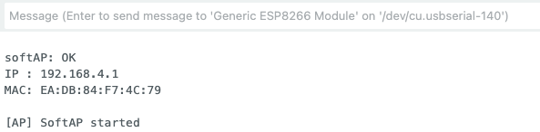
Figure 4.11. Arduino Serial Monitor.
You now need to confirm that softAP has started. This is accomplished by checking if the SSID is being broadcasted and that your laptop or phone can connect to it.

The UART interface on the ESP8266 will ultimately be connected to UART1 on the MSPM0. Thus, as a debugging measure, you can send messages to the ESP to confirm functionality of any changes you make to the Arduino code or Web app code. For example, type the following CSV string on the serial monitor command line:

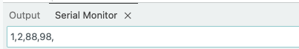
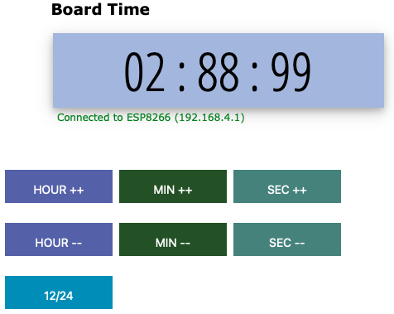
Once your teammate has finished configuring the web page, you may see the following if the web page has connected to the softAP in the ESP8266:

The CSV string is encoded as so: Mode, Hour, Minute and Second.

Note that the web page does not doing any range checking to confirm valid data.

Now it is time to check that the softAP can receive characters from the web page. Press HOUR++, then MIN++ and then 12/24(MODE). You should see the following:

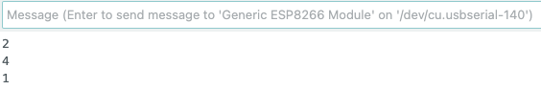
In this example, HOUR++ sends a “2”, MIN++ sends a “4” and MODE sends a “1”. Note all command characters from the web page are terminated by a New Line (NL). At this stage you have confirmed that communication between the ESP8266 and the web page is working.

Web App Procedure
The startup code for the web app consists of three files: main.htm, button.js and styles.css.

Students who work on this portion of the lab, we suggest making a copy of this code so you can use it to continue debugging ESP8266 and MSPM0 functionality. With one set of code (the code you will keep), you will need to make the following modifications:
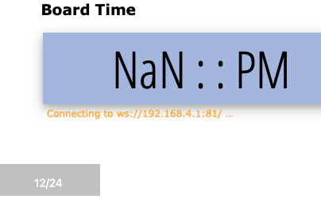
- Modify the default configuration in main.htm if needed. The default is shown to the right.

- Modify main.htm to display the 7 command buttons. Add in a display for an ADC for extra credit (See w3schools for lots of HTML tutorials on adding buttons or displays, etc).

- Modify the default configuration values in button.js for your environment. This includes the default IP address. You will need to get a preassigned IP address from the TA.
// -----------------------------------------------------------------------
// Configuration — fixed softAP address; no discovery needed
//
var esp_host = "192.168.4.1"; // ESP8266 softAP gateway (always this IP)
var ws_port = "81";
var ws_url = "ws://" + esp_host + ":" + ws_port + "/";

- Add additional functions that are needed for your design.

LaunchPad Procedure
In this lab you are going to use UART1 to communicate with the ESP8266 as shown

The TXD signal (PA9) is not routed directly to the J1. There is jumper on J14 that needs to be changed. The default is to connect PB23 to SW1. Move the jumper so that PA9 connects to SW1 as shown below. PA8 is connected to RXD as shown above.

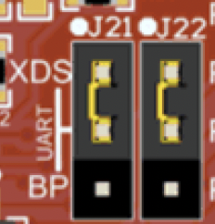
UART0 will be used for debug messages. The TXD (PA10) and RXD (PA9) signals need to be connected to the XDS100 Debug Unit via jumpers J21 & J22 as shown to the right. This is the default configuration but must be confirmed before proceeding. Set up the USB-UART0 using Putty (Windows) or Screen (MacOS).

Messages to and from the MSPM0 and the ESP8266 can be sent to UART0 to confirm that the communication channel is working correctly. The starter code uses 115200 bits/sec, 1 stop, no parity, and no flow control, which can be set in the connection properties for PuTTY or Screen.

You may also output the results on the ST7735 display. There are two #defines in esp8266.h you can select either one or the other, both or neither of the UART0 or the ST7735 LCD for debugging. DEBUG1 activates UART0 debugging and DEBUG3 activates ST7735 debugging.
Next, you will need to debug the hardware interface between the ESP8266 and the MSPM0. The ESP8266 will assert the RDY flag once it is ready to accept commands from the MSPM0. Make sure all debug messages from the ESP8266 are sent to the UART0 debug port.

Merge Lab 3 Code
There are three sections of code in Lab4Fmain.c that you will need to write.

- The first one is in the input() routine. The starter code looks like this:
void Input(void){
char ws_cmd;

if(!((UART1->STAT&0x04) == 0x04)){
ws_cmd = (UART1->RXDATA);
UART_OutChar(ws_cmd);
}

Rewrite this code to use a FIFO to receive data from the WebSocket Client via the ESP8266. Use the inc/FIFO.c as a starting point.

Once the UART1 code has been converted you will need to write a parser. The parser in the starter code looks like this:

uint8_t cmd_num = atoi(&ws_cmd); // Need to convert ASCII command to integer

unsigned short New_Hour;
unsigned short New_Minute;
unsigned short New_Second;

// ---- Command #1: Toggle MODE select
//
if(cmd_num == 0x1) {
if (Mode == 0x1) Mode =0x0;
else if (Mode == 0x0) Mode = 0x1;
}

Modify the parser to include all 7 commands.

- The second routine that you need to write is RESET_8266():
void RESET_8266(void){

#define ESP8266_RST (1<<25) // PA25
// Initialize reset port on PA25
:
:
// Generate a reset signal to ESP8266 on Port PA25
:
:
UART_OutString("\n\rResetting the ESP8266\n\r");
}

- The third routine you need to write is SETUP_WIFI()
void SETUP_WIFI(void) {

// Setup RDY input
:
:
UART_OutString("\n\rWaiting for WiFi RDY signal to be asserted\n\r");

// Loop until RDY input is valid

UART_OutString("\n\r RDY signal asserted\n\r");

}

Lab 4F Deliverables

Deliverable 1
Create a schematic or figure showing all external components connected to the MSPM0 board on KiCad. You do not need to show hardware components on the MSPM0 LaunchPad board. Your schematic should include at least the MSPM0, The ST7735, the LDO, and the ESP.

Deliverable 2
Edit data flow graph (Fig 4.2) to include all components that you added for this lab. Your graph should show how time is updated, how time is displayed on the screen, and how data gets to the web interface.

Deliverable 3
Take screenshots in the debugger showing incoming data dumps, and jitter measurements. This data should be collected using your Lab 2 dump.c code. Specifically, you should use:
- Dump_Capture() to record some of the outgoing data
- Every one second your system sends data to the WS Client. Perform Jitter_Measure() on this real-time task.

Deliverable 4
Take at least two pictures of the final alarm clock demonstrating the features of your system. These pictures should show that:
- The clock and the web interface show the same time.
- The unique features that you demonstrated in lab 3 are still present in the updated lab.

Deliverable 5
Characterize the voltage and current on the 3V3 and 5V0 lines.
- (In Lab) Disconnect the USB cable to the PC. If you have access to the lab bench supply, you can adjust the voltage output to +5V and connect it to VBUS on the LaunchPad. Verify 3.3V on the LaunchPad and 3.3V on the ESP8266. There should be between 40 and 200 mA of current on the 5V line, depending on what hardware you have connected and which software you are running. Take current measurements (both on 5V and on 3.3V to ESP8266) with
  - just the clock;
  - alarm on; and
  - during Wi-Fi communication.
- (Outside of Lab) Disconnect the USB cable to the PC. If you do NOT have access to the lab bench supply, you will remove the 2-pin 3.3V jumper from the LaunchPad and connect a current meter between the pins. Reconnect the USB cable to the PC. Verify 3.3V on the LaunchPad and 3.3V on the ESP8266. There should be between 40 and 200 mA of current on the 5V line, depending on what hardware you have connected and which software you are running. Take current measurements (both on 5V and on 3.3V to ESP8266) with
  - just the clock;
  - alarm on; and
  - during Wi-Fi communication.
If you only have one current meter you can perform the experiment twice repeating the same conditions.
- Turn off power and remove the current meter(s). Connect the regulator output to the ESP8266 supply. Make sure the 2-pin jumper on the LaunchPad is connected and verify the regulator still works using a voltage measurement on the ESP8266 3.3V supply.
Document how you measured currents and report the current values (5V total and 3.3V to ESP8266) for (1) just the clock; (2) alarm on; and (3) during Wi-Fi.

Deliverable 6 (5pts Extra Credit)
Interface any sensor to the ADC of the MSPM0 and have it report on the web interface. The type of sensor and interface is not important. A valid solution will have a code that calibrates the sensors to real results and reports these results in a human readable format to the end user. This measurement must be sent to Web App and be displayed along with the time.
One example is a distance sensor. Here, the values read by the ADC when interface with an IR sensor are recorded for several points, then a function is created based on these measurements to report the distance.
Another example is a digital protractor. Use a potentiometer interfaced to the ADC. Measure several angles and ADC values, then create a function/map that is able to report the angle to which the potentiometer has been turned.

Lab Checkout
The lab checkout is performed during the M/T lab session.

Demonstrate that your system can control the Clock on the MSPM0 display data using the WebSocket Client Application. Demonstrate that your system can read the sensor (extra credit) and time on the MSPM0. Students should be able to display understanding of the data flow through the system and between the web interface.

Lab Report
The lab report shall be submitted by the Friday after the second lab section.

You should complete the Lab04FReport.docx file with your data and answers then submit the completed file to Canvas.

Debugging

Browser Debug
Use the WEB browser to receive console messages from the HTML/JS code. Embed console.log messages in your code: console.log("Connection Lost: " + responseObject.errorMessage);

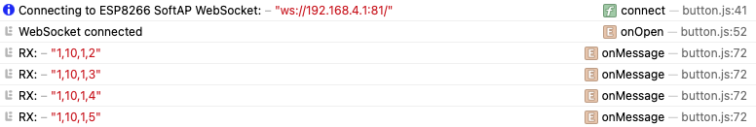
Figure 4.12. web Browser console showing connection success
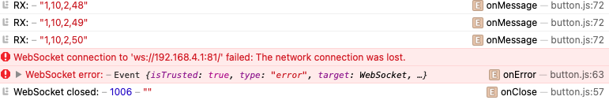
Figure 4.13 Web Browser console showing connection failure

The following will be displayed on the web page when the socket is broken

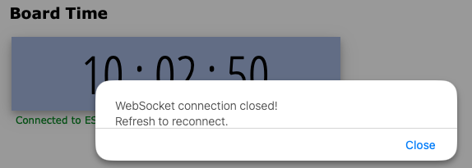

Figure 4.14 Web page message after WS failure

Hints

LaunchPad Starter Project
The LaunchPad starter project contains the following modules:
- Lab4FMain.c is a very basic template containing some basic initialization of the various modules used for Lab 4F. Incorporate your Lab3 into this file.
- Timers:
  - You can use the timer from Lab 3 for both transmitting and receiving data to/from the WSS.
- ESP8266 files
  - You are given two separate files to flash to the esp8266: fifo.c and esp8266.c. These files will need to be merged to complete the lab. The file labeled fifo.c implements a low level UART interface which is required to send data between the esp8266 and the MSPM0. The implementation is interrupt driven and uses a FIFO to buffer data to and from the 8266. Similarly, esp8266.c implements a generic interface that enables communication between the esp8266 and a weather broker. Refer to Lab4FMain.c for how to setup the interface to the WSS.
- inc/ UART.c is an interface to PC for debugging (interrupt driven). Additionally, another UART channel is used to communicate with the esp8266. Use UART1 channel to communicate with the ESP8266
- inc/UARTints.c contains an example of how-to setup UART1 using interrupts.

ESP8266 Arduino Starter Project
The ESP8266 contains a single starter file, ESP_softAP.ino. Observe the following:

- Declaration of variables:
#define AP_SSID "EE445L" // softAP network name (≤ 32 chars)
#define AP_PASS "12345678" // softAP password (≥ 8 chars, or "" for open)
#define AP_CHANNEL 6 // WiFi channel 1-13
#define AP_HIDDEN 0 // 0 = broadcast SSID, 1 = hidden
#define AP_IP_STR "192.168.4.1" // All teams must select a unique IP Address

- Include files:
#include <ESP8266WiFi.h>
#include <WebSocketsServer.h> // arduinoWebSockets by Markus Sattler
You will need to download this WWS helper file into your Arduino environment

- Debug sections:
#ifdef DEBUG2
Serial.printf("\n\nsoftAP: %s\n", ok ? "OK" : "FAIL");
Serial.print ("IP : "); Serial.println(WiFi.softAPIP());
Serial.print ("MAC: "); Serial.println(WiFi.softAPmacAddress());
Serial.println("\n[AP] softAP started");
#endif
This code will print out the MAC address and the IP-Address. It should be sent to the MSPM0 on bootup to confirm that the correct address was used.

Programming the 8266 in the Arduino Environment
  - Download and install the Arduino IDE. Then launch the program and navigate to File --> Preferences. In the Additional board manager URL’s, add the following URL:
http://arduino.esp8266.com/stable/package_esp8266com_index.json

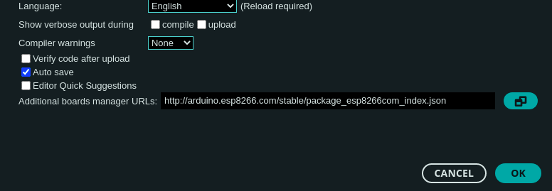
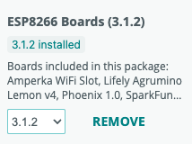

  - On the left bar, open the Board Manager and search for “ESP8266”. Install “esp8266 by ESP8266 Community”. After installing, connect the programmer to your computer via USB and select the board as a Generic ESP8266 module.

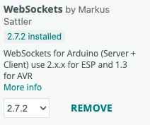
  - On the left bar, open the Library Manager and search for WebSockets by Markus Sattler. Install it if it isn’t already.

Web Socket Server Application Starter Project
The Lab4F Web Application starter project contains the following modules:
- main.html is the entry point for the web application. Open this in your web browser.
- button.js is a JavaScript that handles WebSocket and displays the clocks and the buttons.
- styles.css configures what the clock looks like

