WebSocket Interface
A Comprehensive Tutorial
From Handshake to Real-Time Applications

1. Introduction to WebSockets
WebSockets provide a persistent, full-duplex communication channel over a single TCP connection. Unlike the traditional HTTP request/response model, WebSockets allow both the server and the client to push data to each other at any time, making them ideal for real-time applications such as live chat, online gaming, collaborative editing, and financial dashboards.

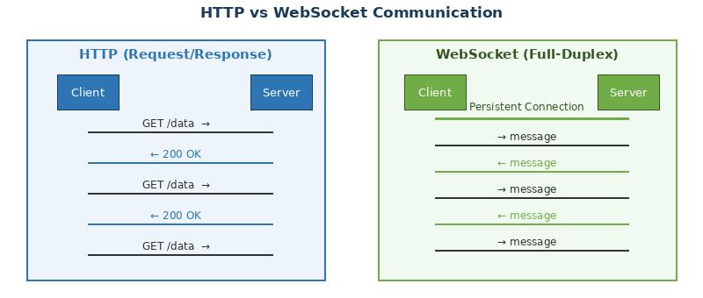
Figure: HTTP (Request/Response) vs WebSocket (Full-Duplex) Communication

The key advantages of WebSockets over traditional polling techniques include:
- Low latency — messages are delivered in milliseconds over an open connection.
- Reduced overhead — no HTTP headers are resent with every message.
- Bidirectional flow — both peers can initiate messages without waiting.
- Efficient resource use — one connection replaces hundreds of polling requests.

📌 WebSocket is defined in RFC 6455 (2011) and is supported by all modern browsers natively via the WebSocket JavaScript API.

2. How WebSockets Work

2.1 The Opening Handshake
A WebSocket connection always begins as an HTTP request. The client sends an HTTP/1.1 Upgrade request; the server responds with 101 Switching Protocols, and from that point the TCP socket is repurposed for WebSocket framing.

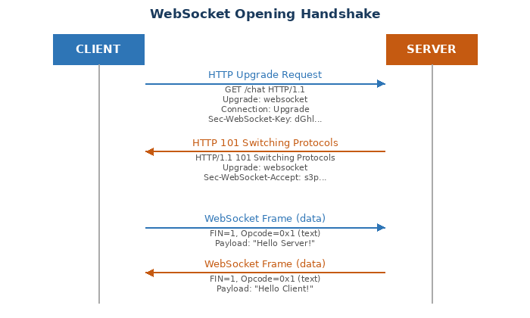
Figure: WebSocket Opening Handshake (HTTP Upgrade)

Client Upgrade Request
GET /chat HTTP/1.1
Host: example.com
Upgrade: websocket
Connection: Upgrade
Sec-WebSocket-Key: dGhlIHNhbXBsZSBub25jZQ==
Sec-WebSocket-Version: 13
Origin: https://example.com

Server Response
HTTP/1.1 101 Switching Protocols
Upgrade: websocket
Connection: Upgrade
Sec-WebSocket-Accept: s3pPLMBiTxaQ9kYGzzhZRbK+xOo=

The Sec-WebSocket-Accept value is computed by the server by concatenating the client key with the fixed GUID 258EAFA5-E914-47DA-95CA-C5AB0DC85B11, applying SHA-1, then Base64-encoding the result. This prevents accidental WebSocket connections from non-WebSocket HTTP clients.

2.2 WebSocket Frames
After the handshake, all data is exchanged as WebSocket frames. Each frame has a small header (2–10 bytes) followed by the payload. Frames can carry text (UTF-8), binary data, or control signals.

Field | Description
FIN bit | 1 if this is the final fragment of a message.
Opcode | 0x1 = text, 0x2 = binary, 0x8 = close, 0x9 = ping, 0xA = pong.
MASK bit | 1 for client-to-server frames (mandatory); 0 for server-to-client.
Payload length | 7-bit field; extended to 16 or 64 bits for larger payloads.
Masking key | 4-byte XOR key applied to payload (client frames only).
Payload data | Application or extension data.

2.3 Connection Lifecycle
A WebSocket connection passes through four distinct states tracked by the readyState property:

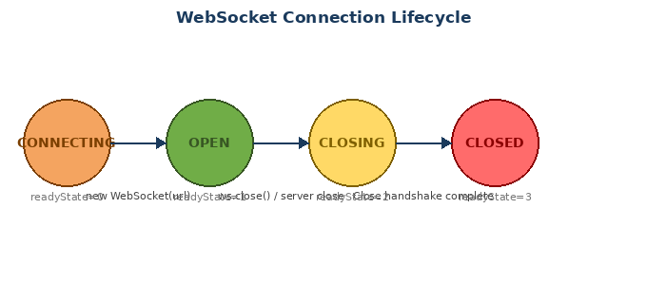
Figure: WebSocket Connection Lifecycle and readyState Values

readyState | Meaning
0 — CONNECTING | Connection is being established; handshake not yet complete.
1 — OPEN | Connection is open and ready to send/receive messages.
2 — CLOSING | Close handshake has been initiated; waiting to finish.
3 — CLOSED | Connection is closed or could not be opened.

3. The WebSocket Browser API
Modern browsers expose WebSocket functionality through the built-in WebSocket constructor. No libraries are required for basic usage.

3.1 Creating a Connection
// Connect to a WebSocket server
const ws = new WebSocket('wss://example.com/chat');

// Optional: specify sub-protocols
const ws = new WebSocket('wss://example.com/chat', ['json', 'xml']);

Use the wss:// (WebSocket Secure) scheme for encrypted connections — always preferred in production. Plain ws:// is equivalent to HTTP and transmits data in clear text.

3.2 Event Handlers
ws.onopen = (event) => {
console.log('Connection opened');
ws.send('Hello Server!');
};

ws.onmessage = (event) => {
console.log('Received:', event.data);
// event.data can be a string or Blob/ArrayBuffer for binary
};

ws.onerror = (event) => {
console.error('WebSocket error:', event);
};

ws.onclose = (event) => {
console.log(`Closed: code=${event.code}, reason=${event.reason}`);
// event.wasClean: true if orderly close handshake
};

💡 Always implement onclose with exponential-back-off reconnection logic for production apps. Temporary network interruptions should not permanently break the user experience.

3.3 Sending Data
// Send a text message
ws.send('Hello!');

// Send JSON
ws.send(JSON.stringify({ type: 'chat', text: 'Hi there' }));

// Send binary data (ArrayBuffer)
const buffer = new ArrayBuffer(4);
const view = new Int32Array(buffer);
view[0] = 42;
ws.send(buffer);

// Check buffered data before sending
if (ws.bufferedAmount === 0) {
ws.send(payload);
}

3.4 Closing a Connection
// Normal closure (code 1000)
ws.close();

// Closure with code and reason
ws.close(1001, 'Going away');

// Common close codes:
// 1000 – Normal closure
// 1001 – Endpoint going away (page navigated)
// 1002 – Protocol error
// 1003 – Unsupported data type
// 1006 – Abnormal closure (no close frame received)
// 1011 – Server encountered an unexpected condition

4. Server-Side WebSockets
WebSocket servers are available in virtually every language and framework. The server must perform the upgrade handshake and then manage a set of open connections, broadcasting or routing messages as needed.

4.1 Node.js with the 'ws' Library
const WebSocket = require('ws');

const wss = new WebSocket.Server({ port: 8080 });

wss.on('connection', (ws, req) => {
const ip = req.socket.remoteAddress;
console.log(`New client connected: ${ip}`);

ws.on('message', (data) => {
console.log('Received:', data.toString());

// Broadcast to all connected clients
wss.clients.forEach((client) => {
if (client.readyState === WebSocket.OPEN) {
client.send(data.toString());
}
});
});

ws.on('close', () => console.log('Client disconnected'));
ws.on('error', (err) => console.error('Socket error:', err));

ws.send(JSON.stringify({ type: 'welcome', message: 'Connected!' }));
});

console.log('WebSocket server listening on ws://localhost:8080');

4.2 Python with websockets
import asyncio
import websockets

connected = set()

async def handler(websocket):
connected.add(websocket)
try:
async for message in websocket:
print(f'Received: {message}')
# Broadcast to all peers
websockets.broadcast(connected, message)
finally:
connected.remove(websocket)

async def main():
async with websockets.serve(handler, 'localhost', 8765):
await asyncio.Future() # run forever

asyncio.run(main())

Install with: pip install websockets

5. Real-World Architecture
In production, WebSocket servers rarely stand alone. They are integrated with authentication services, databases, and message brokers to build scalable real-time systems.

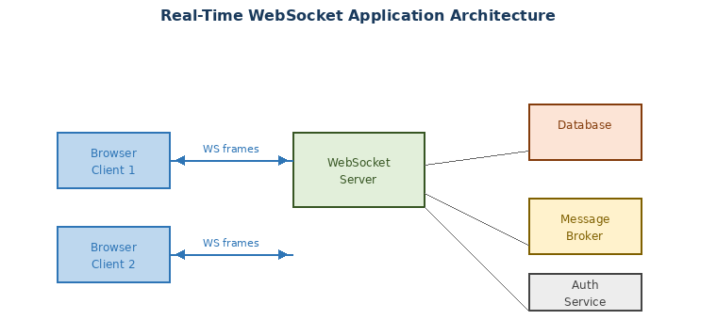
Figure: Real-Time WebSocket Application Architecture

5.1 Scaling with a Message Broker
A single WebSocket server process holds connections in memory. To scale horizontally across multiple server instances, a shared publish/subscribe layer (e.g., Redis Pub/Sub, Kafka) is used to route messages between instances.
// Redis Pub/Sub pattern (Node.js pseudo-code)
const { createClient } = require('redis');
const sub = createClient();
const pub = createClient();

await sub.subscribe('broadcast', (message) => {
// Deliver to all local WebSocket clients
localClients.forEach(ws => ws.send(message));
});

// When a client sends a message:
ws.on('message', async (data) => {
await pub.publish('broadcast', data.toString());
});

5.2 Authentication
Because WebSocket connections cannot carry custom HTTP headers after the upgrade, authentication tokens are typically passed in one of two ways:
- As a URL query parameter during the handshake: wss://api.example.com/ws?token=JWT_HERE
- As the first message sent after the connection opens (application-level auth).

⚠️ Never store long-lived credentials in URL query parameters in production. Use short-lived tokens and validate them server-side immediately on connection.

6. Security Considerations

Threat | Mitigation
Unencrypted traffic | Always use wss:// (TLS). Never use plain ws:// in production.
Cross-site WebSocket hijacking | Validate the Origin header server-side on upgrade. Reject unknown origins.
Denial-of-Service (DoS) | Limit connections per IP, enforce message size limits, and use rate limiting.
Injection attacks | Validate and sanitize all incoming message data before processing.
Zombie connections | Implement periodic ping/pong heartbeats and disconnect idle clients.
Outdated TLS | Require TLS 1.2+ and disable weak cipher suites on the server.

6.1 Heartbeat (Ping/Pong)
WebSocket defines built-in ping (opcode 0x9) and pong (opcode 0xA) control frames. Most server libraries handle these automatically. You can also implement application-level heartbeats:
// Server-side heartbeat (Node.js ws library)
const INTERVAL = 30_000; // 30 seconds

wss.on('connection', (ws) => {
ws.isAlive = true;
ws.on('pong', () => { ws.isAlive = true; });
});

setInterval(() => {
wss.clients.forEach((ws) => {
if (!ws.isAlive) return ws.terminate();
ws.isAlive = false;
ws.ping();
});
}, INTERVAL);

7. Common Use Cases

Use Case | Why WebSockets?
Live chat / messaging | Instant message delivery without polling; typing indicators, read receipts.
Online multiplayer games | Sub-100ms latency for player state synchronization.
Collaborative editing | Real-time document changes (like Google Docs) synchronized across users.
Financial data feeds | Live price ticks, order book updates pushed to traders instantly.
IoT dashboards | Sensor readings streamed from devices to browser in real time.
Live notifications | Push alerts to users without them needing to refresh the page.
DevOps log streaming | Tail server logs in a web terminal (e.g., kubectl logs -f).

8. WebSocket vs Alternatives

Technology | When to Use Instead
HTTP Long Polling | Legacy fallback when WebSockets are blocked by proxies. High overhead.
Server-Sent Events (SSE) | Server-to-client only streams (news feeds, log output). Simpler than WS.
HTTP/2 Server Push | Pushing static assets (CSS, images) during page load. Not for messaging.
WebRTC Data Channels | Peer-to-peer data transfer (video calls, P2P file sharing). No server relay.
gRPC-Web Streaming | Typed, schema-enforced streaming APIs in microservice architectures.

💡 For many notification-only use cases, Server-Sent Events (SSE) are simpler to implement, automatically reconnect, and work well through HTTP/2 multiplexing.

9. Quick Reference

Browser API Cheat Sheet
const ws = new WebSocket('wss://host/path'); // Create
ws.readyState // 0=CONNECTING 1=OPEN 2=CLOSING 3=CLOSED
ws.bufferedAmount // Bytes queued but not yet sent
ws.binaryType // 'blob' (default) or 'arraybuffer'
ws.protocol // Negotiated sub-protocol
ws.send(data) // Send string, ArrayBuffer, Blob
ws.close(code, reason) // Initiate close handshake
ws.onopen = fn // Connection established
ws.onmessage = fn // Message received (fn(event), event.data)
ws.onerror = fn // Error occurred
ws.onclose = fn // Connection closed (fn(event), event.code)

Key URLs and Resources
RFC 6455 (WebSocket Standard): https://datatracker.ietf.org/doc/html/rfc6455
MDN WebSocket API: https://developer.mozilla.org/en-US/docs/Web/API/WebSocket
ws (Node.js library): https://github.com/websockets/ws
Python websockets library: https://websockets.readthedocs.io

