ECE 445L Lab 6
  - PCB Design in KiCad
This laboratory assignment accompanies the book, Embedded Systems: Real-Time Interfacing to ARM Cortex M Microcontrollers, ISBN-13: 978-1463590154, by Jonathan W. Valvano, copyright © 2026.

Table of Contents
Table of Contents 1
Team Size 2
Goals 2
Review 2
Starter Files 2
Required Hardware 2
Lab Overview 2
Preparation 5
Procedure 6
Deliverable 1 13
Deliverable 2 13
Deliverable 3 13
Deliverable 4 13
Deliverable 5 14
Deliverable 6 14
Deliverable 7 (4-5% Extra Credit) 14
Lab Checkout 14
Lab Report 14
Hint (Additional Resources): 15

Team Size
The team size for this lab is 1.

Goals
- PCB schematic and layout design using KiCad
- Systems level approach to embedded system design
- Understand various considerations for PCB design, including:
  - Design for test
  - Power consumption
  - Component part cost
  - Part availability
  - Mechanical mounting constraints

Review
- Data sheet for the MSPM0
- Technical reference manual for MSPM0
- ebook Chapter 6
- KiCAD Tutorial

Starter Files
- Starter project:
  - Lab 6 template provided in the GH Classroom repo.
  - MSPM0_Pins_Assignments.xlsx provided in the GH Classroom repo.

Required Hardware
There is no required hardware for this lab.

Lab Overview
Commercial products are not manufactured using solder-less breadboards like the ones we use in ECE419K and ECE445L. Implementing the embedded system on a PCB, which includes both the microcontroller and the external circuitry, will improve maintainability, testability, and reliability. It will also reduce the size, weight, and cost of the system.
In this lab, you will design a PCB for an embedded system that acts as an analog signal generator. This proposed design allows a user to generate various types of analog outputs by adjusting the wave type, amplitude, and frequency. DO NOT USE A GROUND POUR.
This system has the following defined user inputs, outputs, and debug features.
- User inputs:
  - A push button to change the mode of the program
  - A reset switch to restart the program
  - A potentiometer to adjust the frequency and/or amplitude of the output signal
- User outputs:
  - An analog output consisting of a SPI DAC and an op amp in unity gain (voltage follower configuration)
  - A TFT display for creating a user interface.
- Debug features:
  - At least three supply test points (battery voltage, 3.3V, ground)
  - At least two analog test points (ADC input, DAC output)
  - At least one logic analyzer connector (eight appropriately connected digital signals)
  - One heartbeat LED tied to some digital pin (with resistor)
  - One power LED tied to 3.3V output (with resistor)
The TAs will direct each student to use a particular DAC and op-amp combination, so every student’s design will be semi-unique. The DACs and Op-amp combinations will be one of the following:
- SPI DAC
  - AD5061BRJZ-1500RL7
  - AD5300BRMZ
  - AD8300ARZ
  - AD5541JRZ
- Op-Amp
  - AD8604WARZ
  - AD822ARZ
  - AD823ARZ
  - AD8542ARZ
This system will be powered with a single 3.7V 2600 mAh battery as shown in Figure 6.1. You will need a low dropout voltage regulator to convert this 3.7V into the 3.3V acceptable to the system. We will use the LP2950-33 low drop-out linear voltage regulator because the supply current will be less than 100 mA.
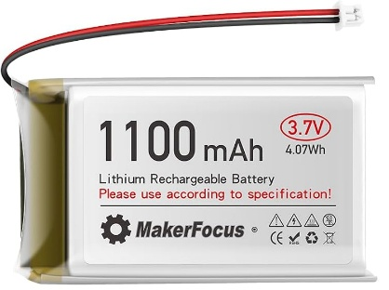
Figure 6.1. MakerFocus 3.7V 1100mAh Flat Rechargeable Battery. JST1.25 female connector
Weight: 20 g, Size: 1.8 by 1 by 0.39 in.
You will edit the VSSOP-32 tab of the MSPM0_Pins_Assignments.xlsx file specifying which MSPM0 pins you will use for your design. The ADC and PINCH tabs will help you choose pins with the correct functionality.
You will edit the BOM tab in the MSPM0_Pins_Assignments.xlsx file, generating a bill of materials. Add columns in this tab for cost and maximum current draw of each integrated circuit on the board.
Finally, we’ll ask you to deliver two pieces of paper representing the PCB layout design (top and bottom) glued to cardboard like Figures 6.2 and 6.3, which could be mounted in one of three enclosures: the Pactec XP, the Hammond 1593Y, or Serpec 151 enclosure, see Figure 6.4. Your design must fit and mount in these enclosures, battery included.
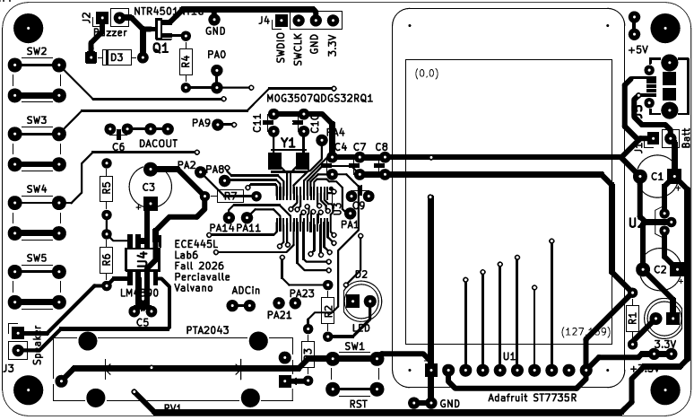
Figure 6.2. Top of PCB layout for a MSPM0 system (black and white is ok).
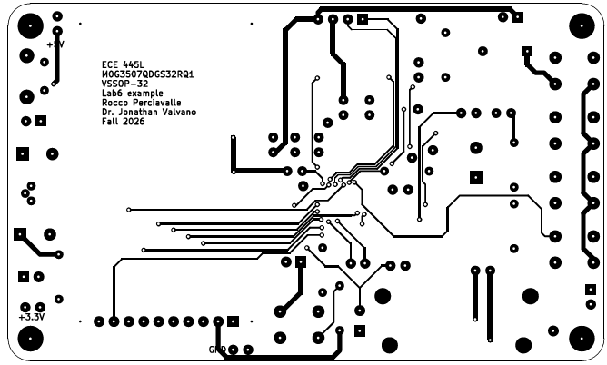
Figure 6.3. Bottom of PCB layout for a MSPM0 system printed mirrored.

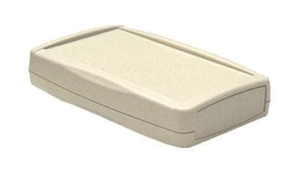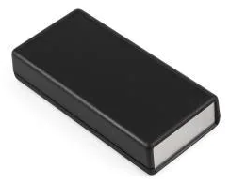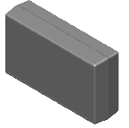
Figure 6.4. PacTec XP, Hammond 1593YALBK, and Serpac 151 enclosures.

Preparation
- Clone the Lab 6 starter project which contains a starter KiCad project and the design file MSPM0_Pins_Assignments.xlsx. Make sure you can open the files in KiCad.
- Ensure that you have access to the 445L KiCad libraries. If you have not added the 445L symbols and footprints to KiCad before, read the “KiCad Adding Libraries” file from the resources folder.
- Find out which DAC and which op amp you are to use from your TA. It will be one of the above combinations.
- Find the availability and price of the component on octopart.com, mouser.com, or digikey.com for your DAC and op amp. There may be several variants of the component based on the ordering quantity or packaging (tape vs reel). Be ready to justify your decision if there are multiple versions. It does not matter if the parts are not available, because you will not actually build Lab 6. Place ordering information and price into the BOM tab of MSPM0_Pins_Assignments.xlsx.
- Find the data sheets and design files for your DAC and op amp on Analog Devices, Mouser, or Digikey. You may use a standard symbol and footprint in KiCAD, or import the design files provided by the manufacturer if any. You may find these design files on your distributor site or on other sites like SnapEDA and UltraLibrarian, as shown in Figure 6.5 and Figure 6.6.
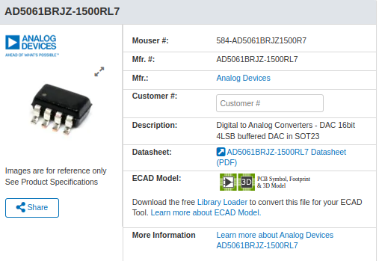
Figure 6.5. Mouser Listing for one of the SPI DACs. Note the ECAD Model section.
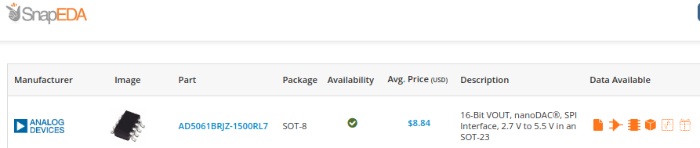
Figure 6.6. SnapEDA listing for the same component.
- Add your DAC and op amp to Lab 6 starter schematic. You will eventually finish the schematic, but for the preparation, simply add your DAC and op amp.

Procedure
- Choose a box in which to enclose the system, see Figure 6.4. Please use one of the boxes available in lab, so that you can demonstrate how your PCB fits into the box. To get the price, you can search a parts distributor (like www.mouser.com or www.digikey.com) or a parts search engine like http://octopart.com/. You will need layout dimensions for placing a PCB board into the box, so bring a ruler or caliper!
- Complete the schematic to meet the design specifications in the Lab Overview section. This includes adding the components to the schematic, making sure that each component is wired up correctly, annotating each component, and assigning each component a footprint in their properties screen (see Figure 6.7). You want to update the system to have analog circuitry, LEDs, power regulation, and battery. You may remove unnecessary components from the baseline schematic. For the battery, you use the JST1.25 socket so the battery directly connects onto the PCB.
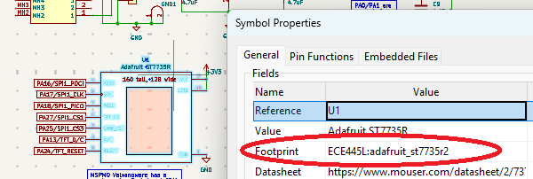
Figure 6.7. Symbol properties window of a component. Note footprint entry.
- Within the schematic editor, execute an Electrical Rules Check (ERC). Some warnings are unwarranted and may be “Approved”. An example is this button having no value. Because many components like resistors and capacitors should have a value specified, KiCad will warn you when a value is missing. We tell KiCad the button doesn’t need a value by hitting approve. Your final schematic should pass ERC with no unapproved warnings. KiCad catches common mistakes, like placing two lines so close to each other, that they look connected on the computer screen, when they are not actually connected.
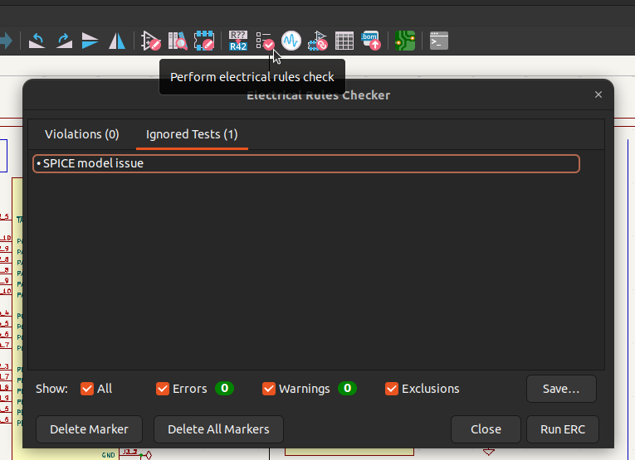
Figure 6.8. Approving ERC warnings.
- Update the BOM tab of MSPM0_Pins_Assignments.xlsx, removing and adding as needed. For the pricing, it doesn’t matter if you use the price for 1 or for 1000 components; just be consistent and be prepared to explain your decision. For the current estimation, please estimate the following active components in your system:
  - The two LEDs (power, heartbeat)
  - The MCU (MSPM0 32-pin VSSOP chip itself, not the LaunchPad)
  - The DAC
  - The LM4041C12ILP shunt diode
  - The Op-Amp
  - The LCD (ST7735R)
  - The LDO regulator (LP2950-33).
For the MSPM0, you measured it in lab, or you can look at data sheet. For the other components, please consult their datasheets. Generally, they will provide current expectations for a given operating mode as shown in Figure 6.9. The current going through the LEDs is derived as a function of current = (supply voltage - diode voltage drop) / current limiting series resistor resistance. Don’t count the current going through regulator associated with the downstream components but do count the quiescent current associated with the regulator alone.
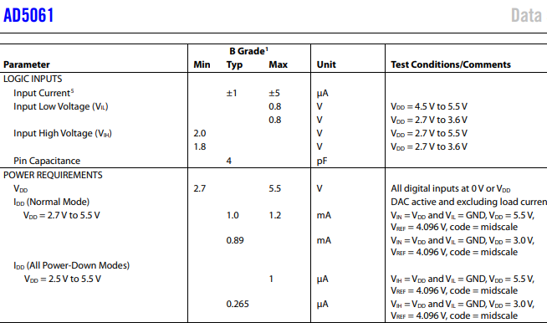
Figure 6.9. Current estimation for AD5061.
- Estimate the total cost of the system. For more information on resistors and capacitors, see
  - http://users.ece.utexas.edu/~valvano/Datasheets/CarbonFilmResistors.pdf
  - http://users.ece.utexas.edu/~valvano/Datasheets/CarbonFilmresistors2.pdf
  - http://users.ece.utexas.edu/~valvano/Datasheets/CapacitorC0G.pdf
  - And http://users.ece.utexas.edu/~valvano/Datasheets/TantalumCap.pdf
- If you were asked to make 1000 copies of the system, think about how you would test each system during manufacturing. The debug port allows you to download and run software on the microcontroller. The test points allow for electrical testing of analog signals. The logic analyzer allows for electrical testing of the digital signals. Attach eight digital signals and ground to the connector. The logic analyzer connector would attach directly to the logic analyzers we have in the lab. If you own a USB-based logic analyzer, then you can interface to it instead of the logic analyzers in lab. A 2.54mm pitch pin header may be sufficient for this purpose.
- Now, switch to the PCB editor and complete the layout of the system. Use the update PCB from schematic button shown in Figure 6.10 to pull in the components you’ve added in the schematic. Completing the layout includes creating the outline of your system with the edge cuts layer, placing components within this outline, and then routing them together until everything is connected. Follow the following guidelines for your PCB:
  - No ground pour (but we will ask why and how it is used)
  - Component references are visible and positioned well
  - Silkscreen text is useful
  - All signals are routed and make sense
  - An attempt has been made to segregate power, analog, and digital signals
  - Board has board name, designer, date, TA/section, version number
  - Passes DRC
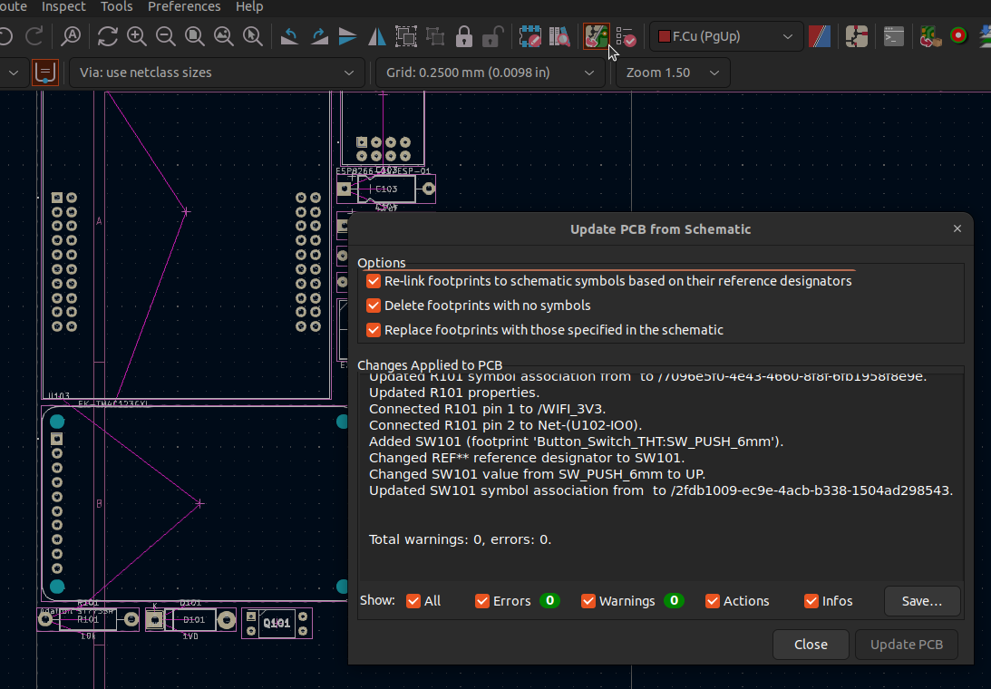Figure 6.10. Importing components into the PCB editor.
When creating the PCB, we recommend that you place the fixed objects first (e.g., drill holes for mounting in the box, LEDs, and switches soldered to the PCB). The next step is to place all remaining components inside the PCB area. Give careful thought when placing components to minimize trace lengths. Put parts next to each other that connect to each other.
If possible, position polarized parts (i.e., diodes, and electrolytic caps) with the positive leads all having the same orientation. Many of the components use a square pad to mark the positive leads of these components. Doing a good job here will make laying the traces much easier. You will save a lot of time by leaving a generous space between ICs for traces. Frequently the beginner runs out of room when routing traces. Leave 0.350" to 0.500" between ICs, for large ICs allow even more. Once all components are placed, print out the PCB top layers. Using a ruler, make sure the large components (LEDs, switches, and connectors) will fit in the box.
Once you are sure everything fits, you will route the nets. I like to route power and ground first. Avoid loops in the signals because loops can pick up EM field noise. Because ground/power planes can impact visibility, increase the difficulty of soldering, and make it harder to fix mistakes with jumpers on the board once it is produced you are not supposed to use ground/power planes or copper pours. As you get more experience (after your 4th PCB design) you can use ground planes as they are great for low noise or high frequency circuits. However, in this class, place ground and power paths like a bus: power and ground extend away from the power source and branches out to each subcircuit (see Figure 6.11).
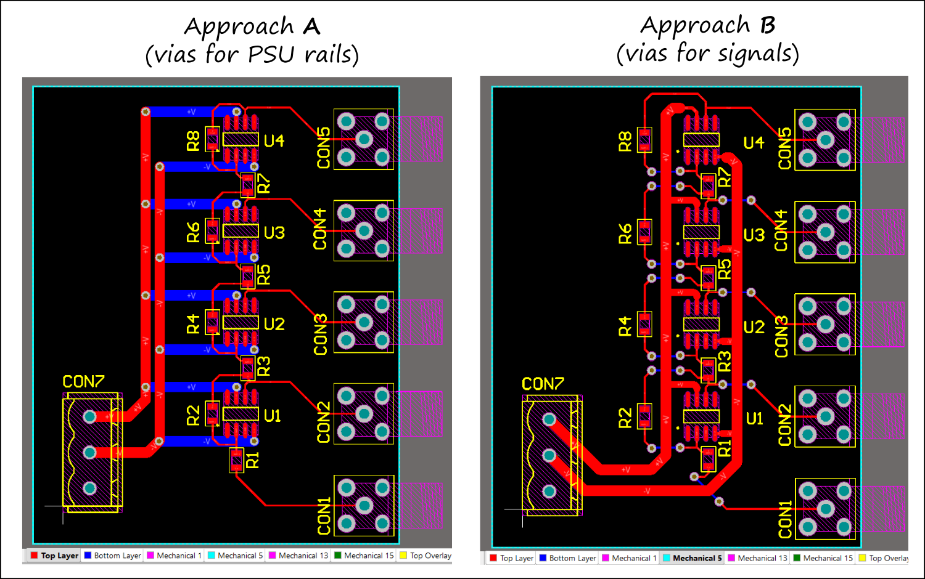Figure 6.11. Power bus example.
Most of the signals in this class can be 0.25mm wide. Use 0.5mm wide signals for power, ground and signals carrying large currents. Whenever possible increase the power and ground paths as will fit. A calculator for high current traces can be found in KiCAD.
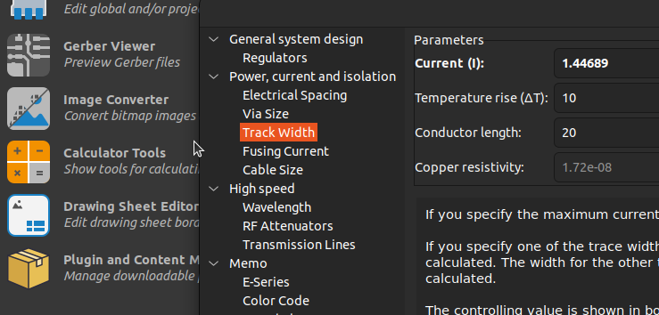
Figure 6.12. Calculator for various guidelines.
- Make sure that you add Top Silkscreen and Bottom Silkscreen labeling to identify your board, with information like subcircuit location, assembly or debug instructions (e.g., Test point is for 3.3V), board name and designer name, etc.

- When you think you are done, execute a Design Rules Check (DRC). This will inform you, among other things, if any wires/holes/vias are too close, and if any connections are not routed. Fix any errors.
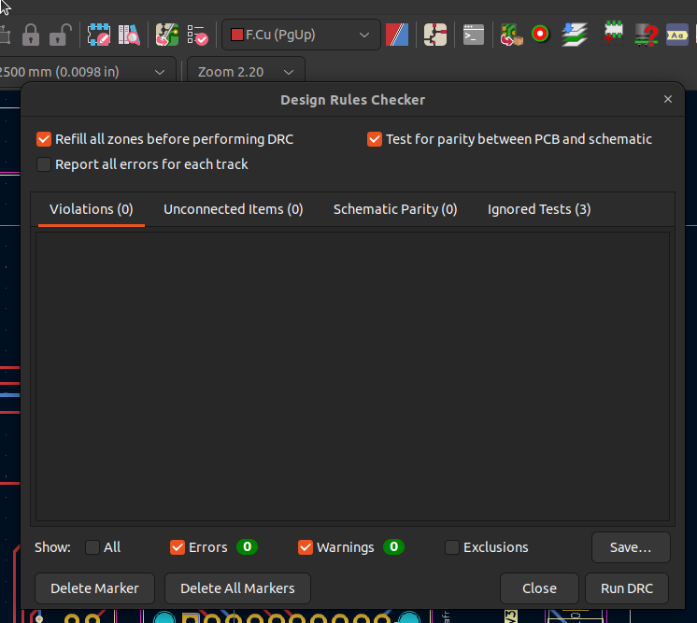
Figure 6.13. Design Rules Checker.
- Lastly, you should experience the process of ordering the board. Use the Plugin and Content Manager utility on the project window to install the JLC PCB Fabrication toolkit. Installing this plugin will display a button in the PCB editor to generate the needed fabrication outputs for the PCB manufacturer (see Figure 6.16).
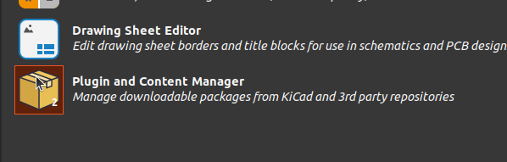
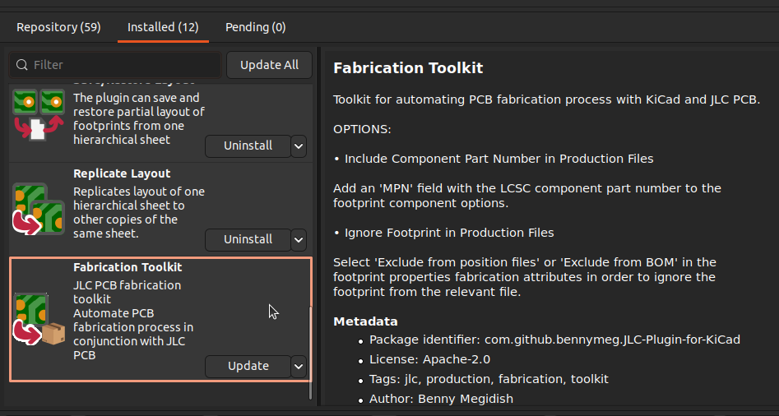
Figure 6.14, 6.15. JLC PCB Fabrication Toolkit.
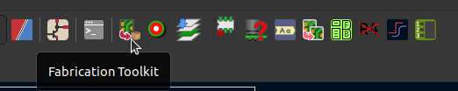
Figure 6.16. Fab button.
- Clicking on this button will open up a window after building the required output files. These files can be provided to https://jlcpcb.com/ through their instant quote process. Upload the zip file to their system and they will provide a quote for the board (Figure 6.187). Take a screenshot of the quote to add to your report.

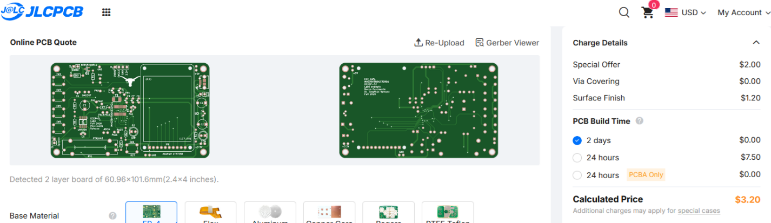
Figure 6.17. JLCPCB Quote, with shipping tax and tariffs, the total cost was $50.92.
- Finally, make four printouts of the circuit with the File > Print function in the PCB editor:
  - Just top copper to be judged for layout style
  - Just bottom copper to be judged for layout style
  - Top copper and top silk, glue to top of cardboard, print at 100%
  - Bottom copper and bottom silk, glue to bottom of cardboard (print mirrored), print at 100%.
- Cut out a piece of cardboard or wood about the thickness of a PCB board and glue the last two printouts to it, like Figures 6.18. Your mockup should fit nicely in the box.
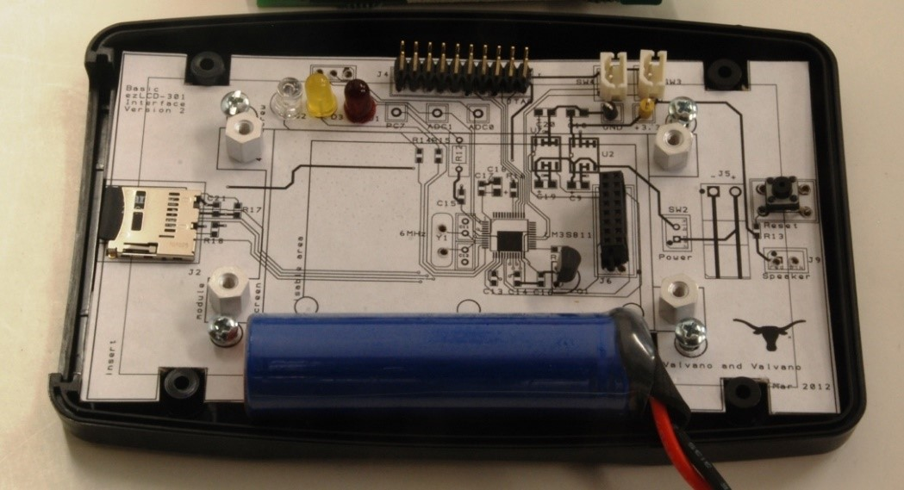
Figure 6.18. Mockup for an LM3S811 system using a PacTec enclosure.

Deliverable 1
Include in your report a screenshot of the final schematic of the PCB. Your screenshot should include a reasonable ERC result. The ERC must either have no errors, OR you must be able to explain why the warnings and/or errors can be ignored).

Deliverable 2
Include in your report a screenshot of the final layout of the PCB. Your PCB should meet the following criteria:
- The PCB must fit within, and have some way of mounting to an enclosure
- The PCB must have a reasonable DRC result
  - The DRC must either have no errors, OR you must be able to explain why the errors can be ignored
- The PCB should have no power or ground loops, and the power and signal traces should be adequately sized

Deliverable 3
Include in your report a picture of a cardboard/paper mockup of the PCB. Specifically, show how you can verify the KiCad footprint using the mockup along with the actual part. The cardboard mockup should reflect the PCB layout (with top copper/silk on top and bottom copper/silk on bottom).

Deliverable 4
Update the MSPM0_Pins_Assignments.xlsx . The VSSOP32 tab shows the pin selections (making sure selected pins for the DAC support SPI functionality. The BOM tab includes cost of all components used in the design and current estimates of the integrated circuits. (Measurement or datasheet numbers are acceptable). The number you calculate should be in line with the data you collected in prior labs.

Deliverable 5
Generate GERBER files and use them to get a cost estimate from JLCPCB. DO NOT ORDER THE PCB. Include the screenshot of order screen on JLCPCB with preview of your design

Deliverable 6 (4-5% Extra Credit)
You may choose one of the following extra credit options:
- Create a custom symbol and use it in your PCB. (4pts extra credit)
Choose an IC or sensor to make a symbol for. Update your schematic to use the symbol and include a pre-made footprint in your PCB. This must be created from scratch without importing anything from an outside source.
- Create a custom symbol and footprint and use it in your PCB. (5pts extra credit)
Choose a unique IC or sensor to make a symbol and footprint for. Update your schematic to use the symbol and footprint in your PCB. The device must have a unique footprint that cannot be found in a footprint library nor easily substituted with something found in a footprint library. These must be created from scratch without importing anything from an outside source.

The device must have a minimum of three pins. Include in your report a picture of the component fitting properly in the paper model of the PCB you created in deliverable 3. To receive these points, you must describe during checkout the process you used to make the symbol, and either where you sourced the footprint or how you made it depending on the option chosen.

Lab Checkout
The lab checkout is performed during the M/T lab session.
For your lab checkout, the TAs will review your design and ask about design decisions that you made, including:
- how you selected/sourced your components
- how did you determine current consumption
- how you placed and routed components on your layout.
Be prepared to discuss alternative approaches and be able to justify your solution. Show the documentation for your DAC and op amp. Show that your PCB fits inside your chosen case.

Lab Report
The lab report shall be submitted by the Friday after the second (W/Th) lab section.
You should complete the Lab06Report.docx file with your data and answers then submit the completed file to Canvas.

Hint (Additional Resources):
- Feel free to use the baseline project example as reference, but we expect the layout to look substantially different for your project.
- Join the official KiCAD discord (https://discord.gg/tWf2w6brRq) to ask questions to other users!
- See the Longhorn Racing Solar Github (https://github.com/lhr-solar) for examples of other PCBs you can emulate.
- YouTube has hundreds of videos and dozens of creators who do PCB tutorials. We recommend Phil’s Lab and Robert Feranec.

