Project 2
Tanaiya Sumter
2025-12-01

GitHub link:
https://github.com/tanaiyasumter/Project-2-721.git

Figure 1 : Seasonal Patterns of CO and Ozone Concentrations
This plot displays the monthly average concentrations of CO and Ozone across a three-year study period.
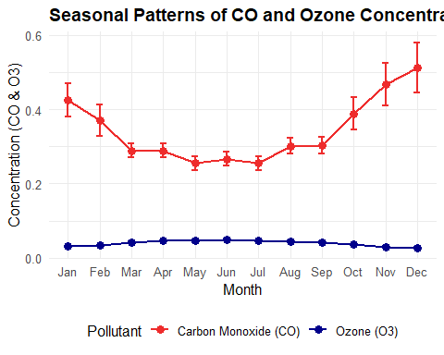
These are the monthly averages across 2018-2020 with 95% confidence intervals. Both of these pollutants show distinct seasonal patterns. CO has elevated levels during fall/winter months while Ozone concentrations has slight elevation during summer months.

Figure 2: PM2.5 Concentration Patterns Across Years
This plot displays the monthly PM2.5 concentrations for each year.
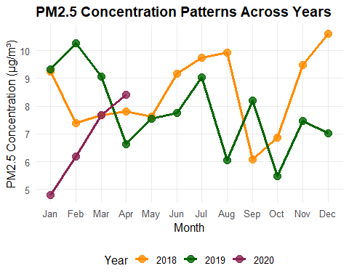
These are the monthly averages by year in Durham County, NC. This pollutant has had elevated levels in summer and winter months across the years.

