Laeek Tanaji Capstone Project:
Smart Retail Analytics

Pipeline Execution Report
Run ID: manual__2026-06-10T14:28:53+00:00
Execution Date: 10 June 2026
Total Duration: ~6 minutes | All 6 Tasks: ✓ SUCCESS

1. Executive Summary
The Smart Retail Analytics pipeline is a fully containerised, end-to-end data engineering system built using a multi-agent Medallion Architecture (Bronze → Silver → Gold). The pipeline successfully completed all 6 stages on June 10, 2026, producing a complete retail analytics report with AI-generated business insights via OpenAI GPT-4o.

6 / 6  Tasks Succeeded | 100 / 100  Data Quality Score | 15,875  Total Rows Processed
2. Pipeline Run Details
DAG ID | smartretail_pipeline
Run ID | manual__2026-06-10T14:28:53+00:00
Run Type | Manual Trigger
Run Date | June 10, 2026
Start Time (UTC) | 14:28:53
End Time (UTC) | 14:34:42
Total Duration | ~5 minutes 48 seconds
Overall Status | SUCCESS — All 6 tasks completed
Executor | LocalExecutor (Apache Airflow 2.9)

Airflow UI — Grid view showing all 6 tasks in green (success) for run manual__2026-06-10T14:28:53+00:00

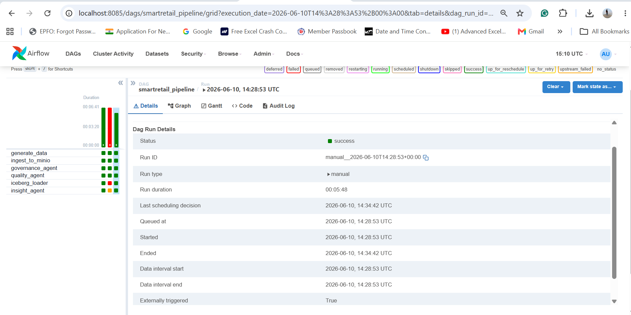

3. Task-by-Task Execution Details

# | Task ID | Status | Start Time (UTC) | End Time (UTC) | Duration
1 | generate_data | ✓ SUCCESS | 2026-06-10 14:28:55 | 2026-06-10 14:29:06 | 11s
2 | ingest_to_minio | ✓ SUCCESS | 2026-06-10 14:29:09 | 2026-06-10 14:29:11 | 2s
3 | governance_agent | ✓ SUCCESS | 2026-06-10 14:29:15 | 2026-06-10 14:29:21 | 6s
4 | quality_agent | ✓ SUCCESS | 2026-06-10 14:29:23 | 2026-06-10 14:29:26 | 3s
5 | iceberg_loader | ✓ SUCCESS | 2026-06-10 14:29:27 | 2026-06-10 14:34:27 | 5m 00s
6 | insight_agent | ✓ SUCCESS | 2026-06-10 14:34:30 | 2026-06-10 14:34:41 | 11s

Run started: 2026-06-10 14:28:55 UTC Run ended: 2026-06-10 14:34:41 UTC Total duration: ~6 minutes

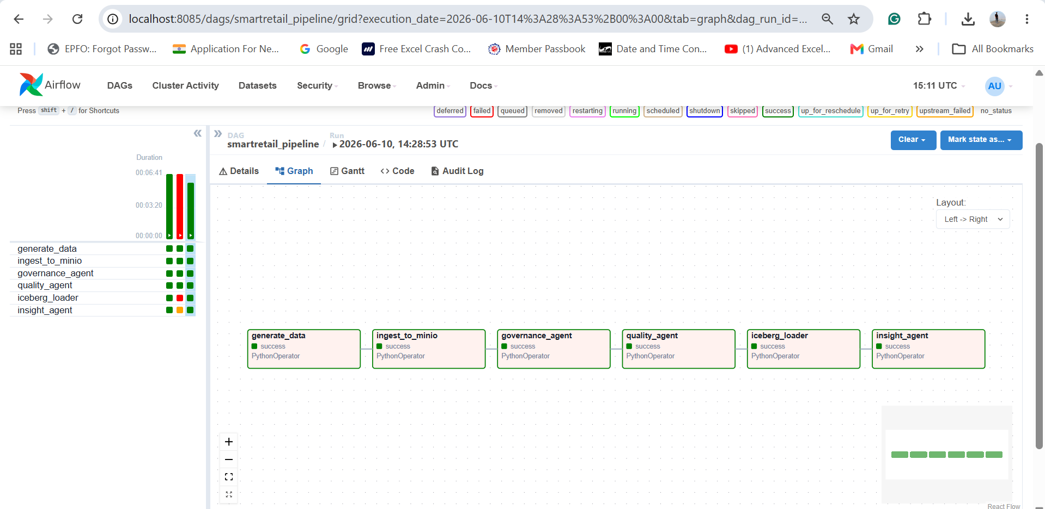

Task 1: Generate Data ✓ SUCCESS
Task ID | generate_data
Start | 2026-06-10 14:28:55 UTC
End | 2026-06-10 14:29:06 UTC
Duration | 11s
Status | SUCCESS

Description
Generates 15,875 rows of synthetic Indian e-commerce data (10,000 orders, 200 customers, 50 products, 5,625 feedback records) using a fixed random seed (42) for reproducibility.
Outputs
- orders_data.csv
- customers_data.csv
- products_data.csv
- feedback_data.csv

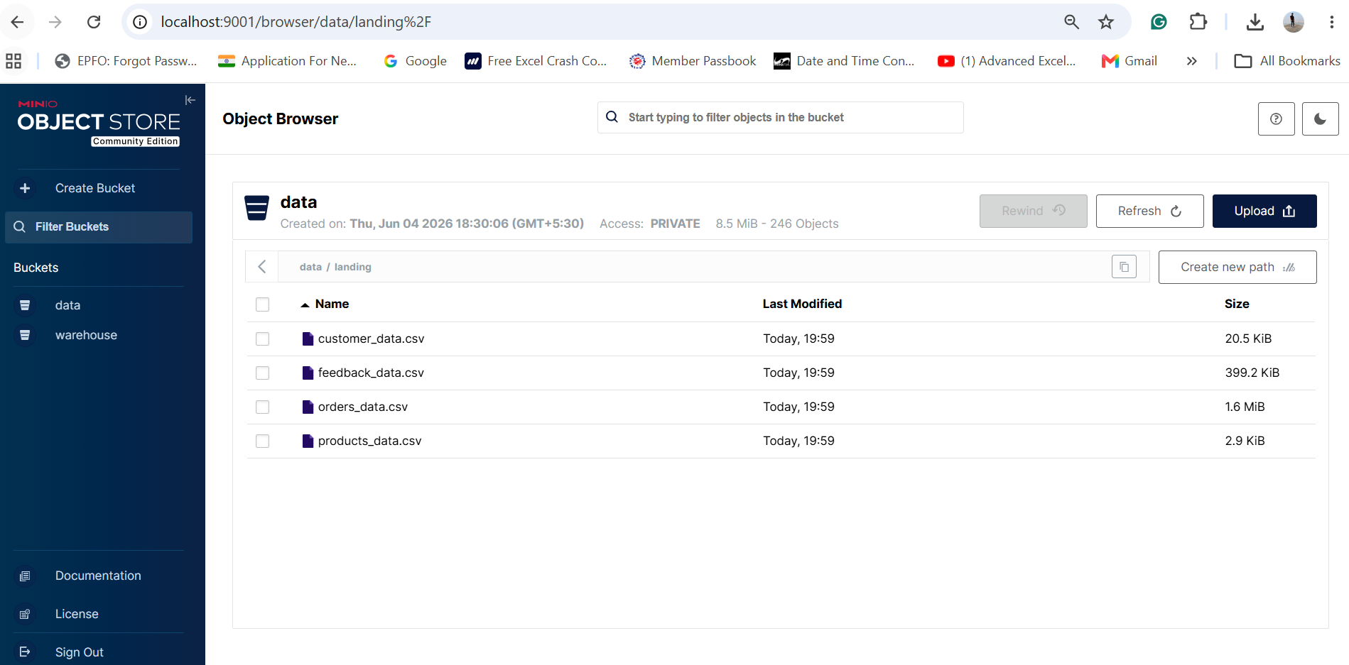

Task 2: Ingest to MinIO ✓ SUCCESS
Task ID | ingest_to_minio
Start | 2026-06-10 14:29:09 UTC
End | 2026-06-10 14:29:11 UTC
Duration | 2s
Status | SUCCESS

Description
Reads CSV files from the local data directory, converts them to Apache Parquet format for columnar storage efficiency, and uploads them to the MinIO Bronze zone (s3://data/bronze/).
Outputs
- s3://data/bronze/orders_data.parquet
- s3://data/bronze/customers_data.parquet
- s3://data/bronze/products_data.parquet
- s3://data/bronze/feedback_data.parquet

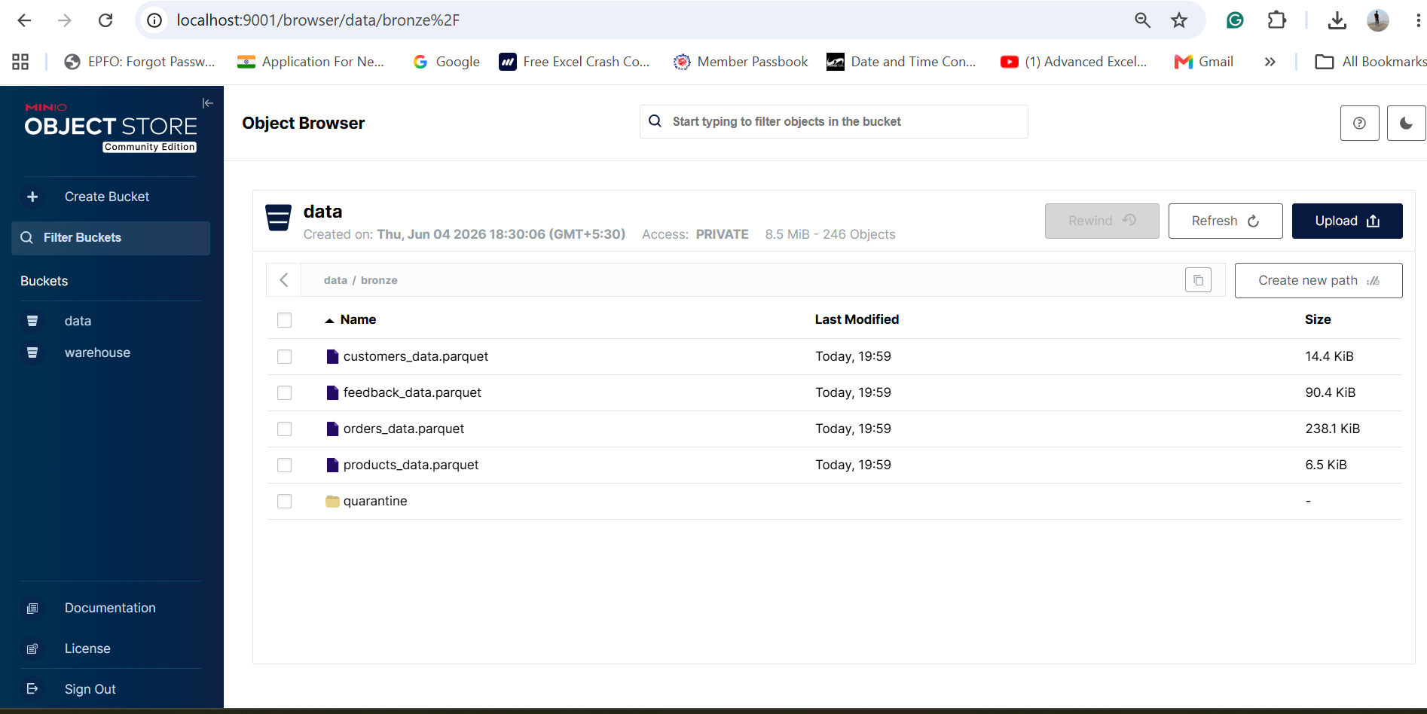

Task 3: Governance Agent ✓ SUCCESS
Task ID | governance_agent
Start | 2026-06-10 14:29:15 UTC
End | 2026-06-10 14:29:21 UTC
Duration | 6s
Status | SUCCESS

Description
Applies schema enforcement, PII masking, and business rule enrichment. Joins orders with customer and product dimensions, derives computed fields (discount_pct, final_amount, is_prime_active), and writes enriched data to the Silver zone.
Outputs
- s3://data/silver/orders_enriched.parquet
- s3://data/silver/customers_clean.parquet
- s3://data/silver/products_clean.parquet
- s3://data/silver/feedback_enriched.parquet

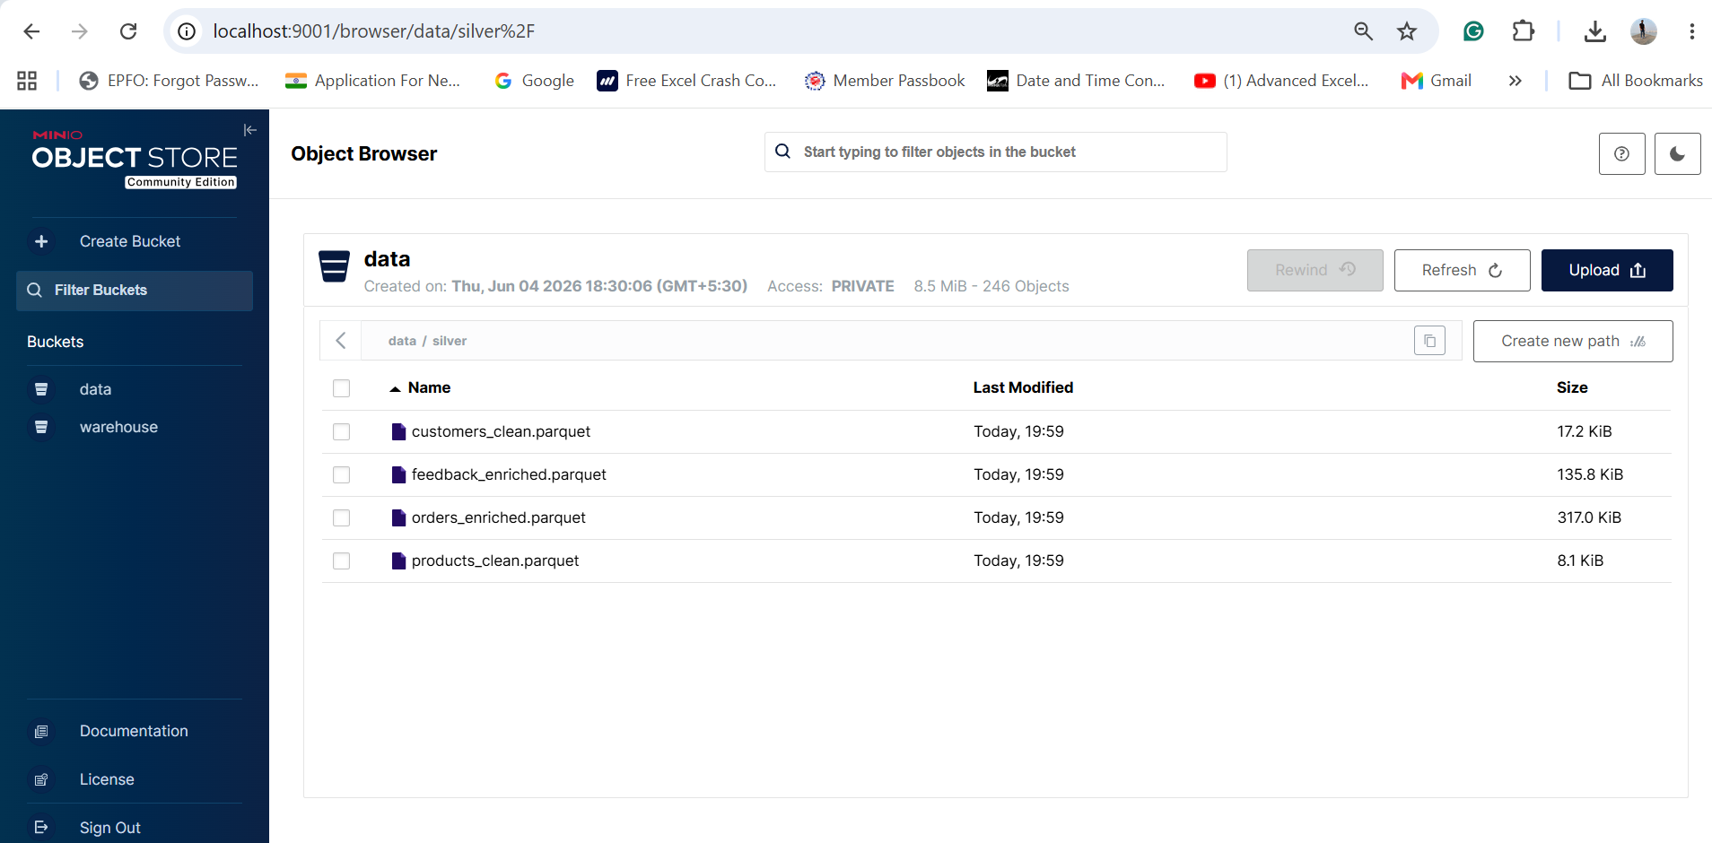

Task 4: Quality Agent ✓ SUCCESS
Task ID | quality_agent
Start | 2026-06-10 14:29:23 UTC
End | 2026-06-10 14:29:26 UTC
Duration | 3s
Status | SUCCESS

Description
Runs 31 data quality checks across all 4 Silver tables — covering null validation, range checks, referential integrity, duplicate detection, and business rule assertions. Produces a scored quality report (0–100).
Outputs
- /data/logs/quality_report.json [Score: 100/100]

Task 5: Iceberg Loader ✓ SUCCESS
Task ID | iceberg_loader
Start | 2026-06-10 14:29:27 UTC
End | 2026-06-10 14:34:27 UTC
Duration | 5m 00s
Status | SUCCESS

Description
Connects to Trino, creates Iceberg tables (DROP + CREATE for idempotent re-runs), and batch-INSERTs 15,875 rows from Bronze Parquet files into the iceberg.landing namespace via 500-row batches.
Outputs
- iceberg.landing.orders_data (10,000 rows)
- iceberg.landing.customers_data (200 rows)
- iceberg.landing.products_data (50 rows)
- iceberg.landing.feedback_data (5,625 rows)

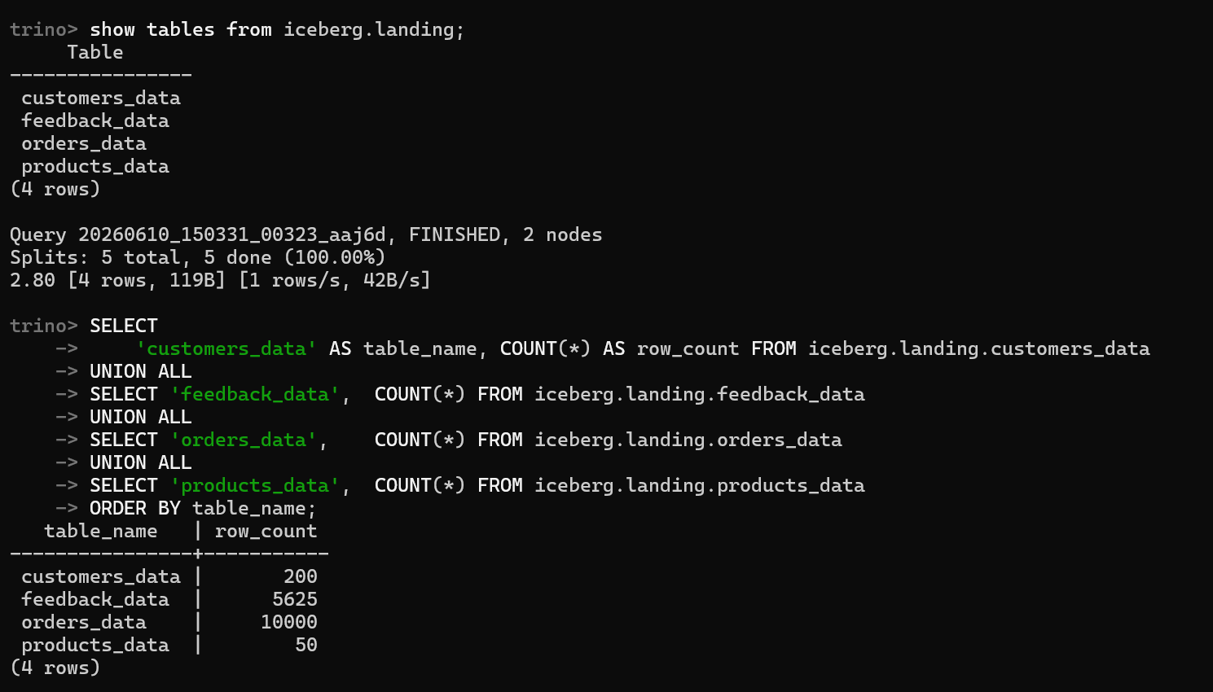

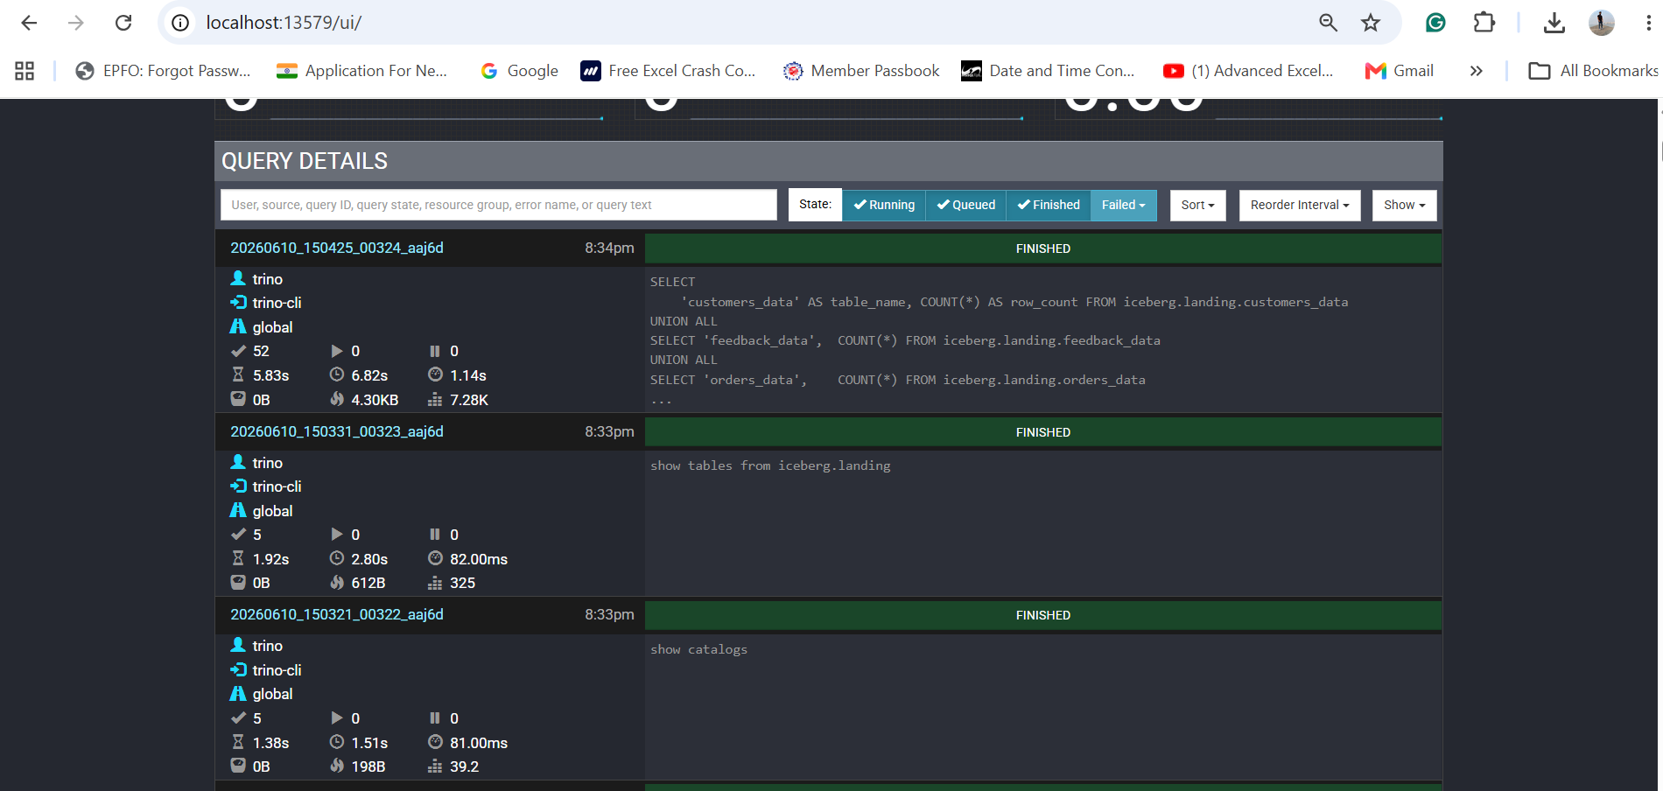

Task 6: Insight Agent ✓ SUCCESS
Task ID | insight_agent
Start | 2026-06-10 14:34:30 UTC
End | 2026-06-10 14:34:41 UTC
Duration | 11s
Status | SUCCESS

Description
Builds Gold layer KPI aggregations (revenue summary, category performance, customer segments, regional breakdown) and calls OpenAI GPT-4o to generate an AI-powered executive insight report in Markdown and JSON formats.
Outputs
- s3://data/gold/revenue_summary.parquet
- s3://data/gold/category_performance.parquet
- s3://data/gold/customer_segment_summary.parquet
- /data/logs/insight_summary.md
- /data/logs/insight_report.json
- /data/logs/lineage_log.json

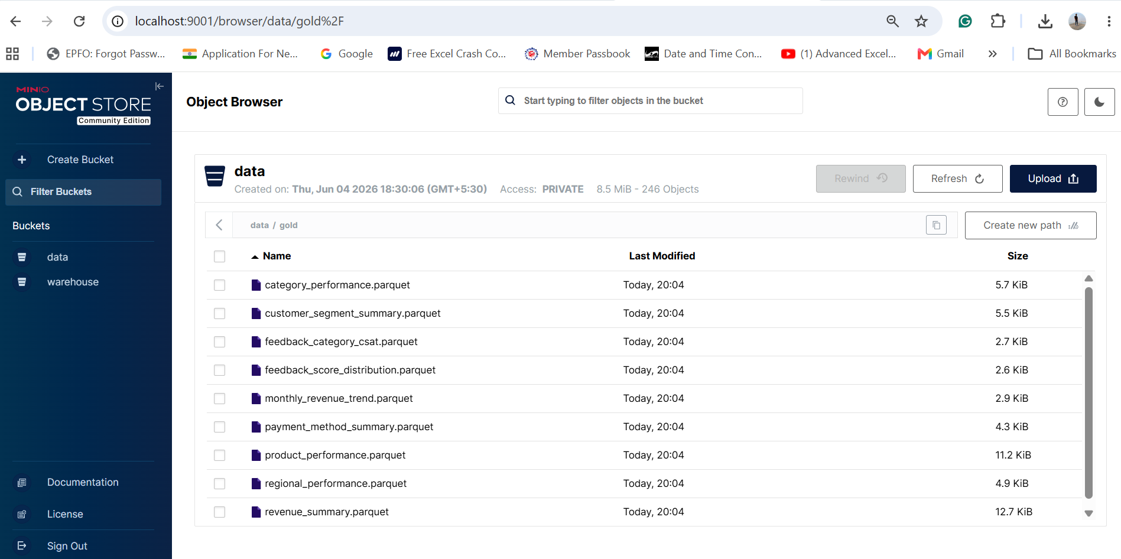

4. Key Business Metrics

Metric | Value
Total Orders | 10,000
Delivered | 8,036
Cancellation Rate | 11.89%
Return Rate | 7.75%
Total GMV | ₹200,308,701
Net Revenue | ₹157,562,821
Avg Order Value | ₹19,607
Prime Customers | 77 / 200
Avg Review Score | 3.82 / 5
Data Quality Score | 100 / 100
Pipeline Duration | ~6 minutes
Total Rows Loaded | 15,875

5. Technology Stack

Orchestration | Apache Airflow 2.9: DAG scheduling, LocalExecutor
Object Storage | MinIO: S3-compatible data lake (Bronze / Silver / Gold zones)
Table Format | Apache Iceberg: ACID transactions, schema evolution
Query Engine | Trino 438: Distributed SQL over Iceberg tables
Catalog | Iceberg REST Catalog + PostgreSQL persistence
Data Processing | Python 3.12 / Pandas: ETT transformations
AI Insights | OpenAI GPT-4o: LLM-generated business intelligence
Containerization | Docker Compose: 12-service local orchestration
Source DBs | PostgreSQL 16 + MySQL 8: simulated OLTP sources

