**Meta Driven Pipeline using MSSQL and MYSQL server**

Suppose we have 2 databases

1. MSSQL server
2. MySQL server

I need to transfer the all tables data from these 2 sources to lakehouse destination in Microsoft fabric

1. **Create one metadata table name is “Config”**

Create table Config

(

Id int primary key,

SourceType varchar(100),

SourceConn varchar(100),

[Database] varchar(100),

SourceTable varchar(100),

TargetLakehouse varchar(100),

TargetTable varchar(100),

FileFormat varchar(100)

)

select * from Config

Add meta data information into this table

Insert into Config values (

1,'MSSQL','MSSQL_Connection','AdventureWorksLT2017','BuildVersion','FabricLakehouse','buildversion','parquet'),

(2,'MySQL','MySQL_Connection','tanajidb','Employee','FabricLakehouse','employee','parquet'),

(3,'MSSQL','MSSQL_Connection','AdventureWorksLT2017','SalesLT.Address','FabricLakehouse','Address_New','parquet')

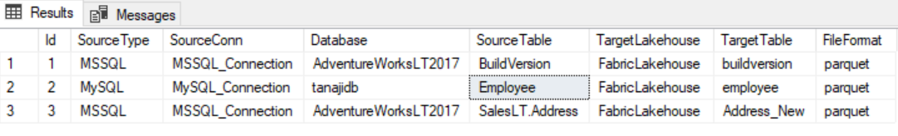

1. Gateway configuration

Install on premises gateway and configure the same.

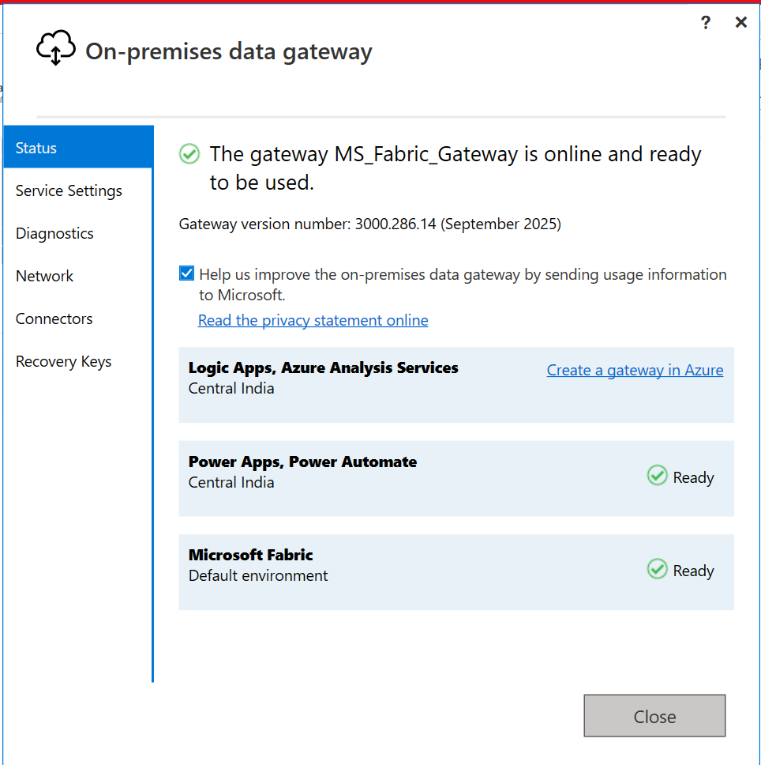

Once gateway connected please check connection established in fabric.

**Go to setting 🡪 Managed connections and Gateways 🡪 on-premises data gateway**

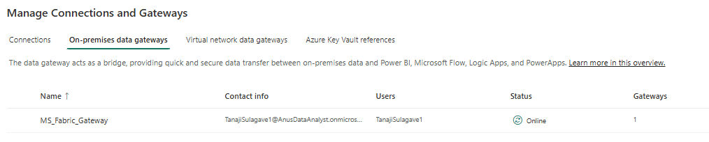

1. **Lookup Activity to read the metadata tables**

So now metadata table available in MSSQL server so our connection is MSSQL server

**Sample connection setting for MSSQL**:- provide server name, Database Name, modify connection name as per your requirement , select Gateway and choose authentication method.

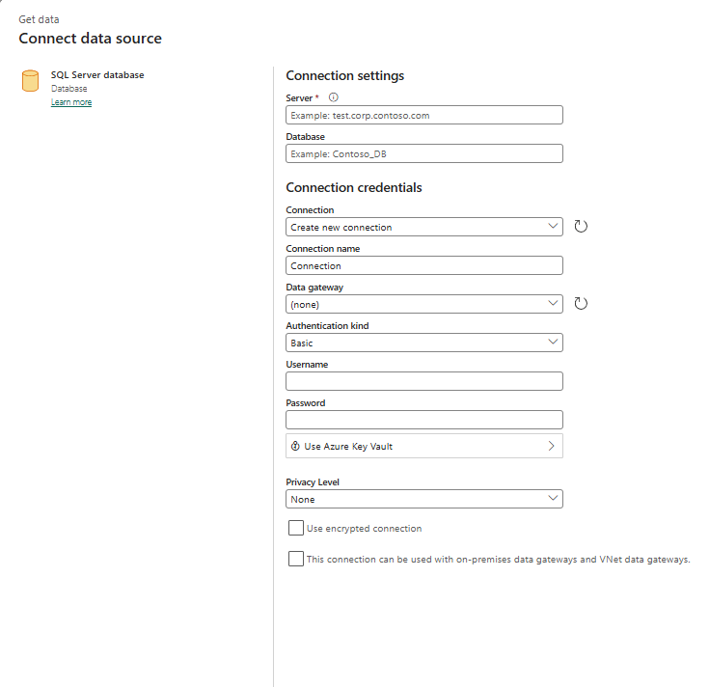

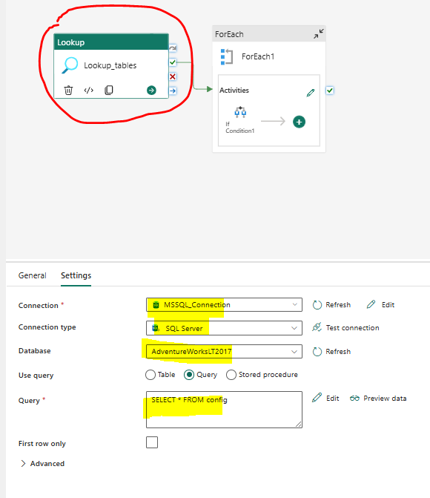

1. **Foreach Activity :-**

Connect foreach activity to one by one data reading from lookup activity

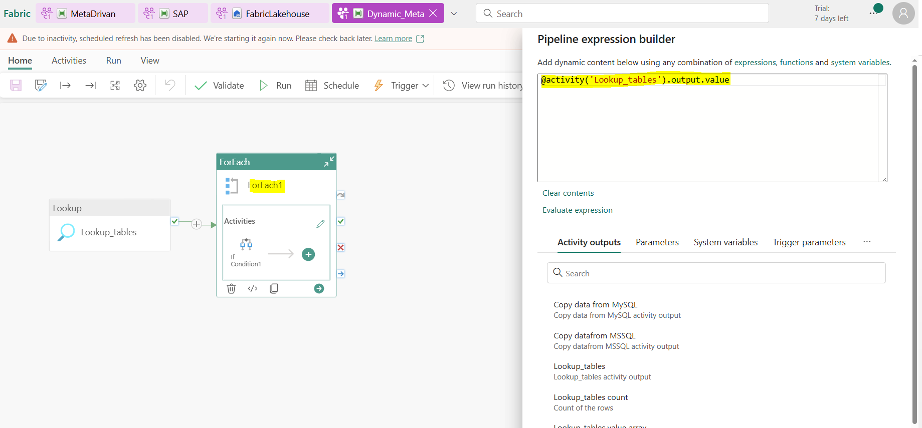

1. **If Condition:-**

Into Foreach activity use IF condition 🡪 In this IF condition in expression we can use add dynamic content 🡪 “@equals(item().SourceType, 'MSSQL')”.

Means true condition we can read SQL server data

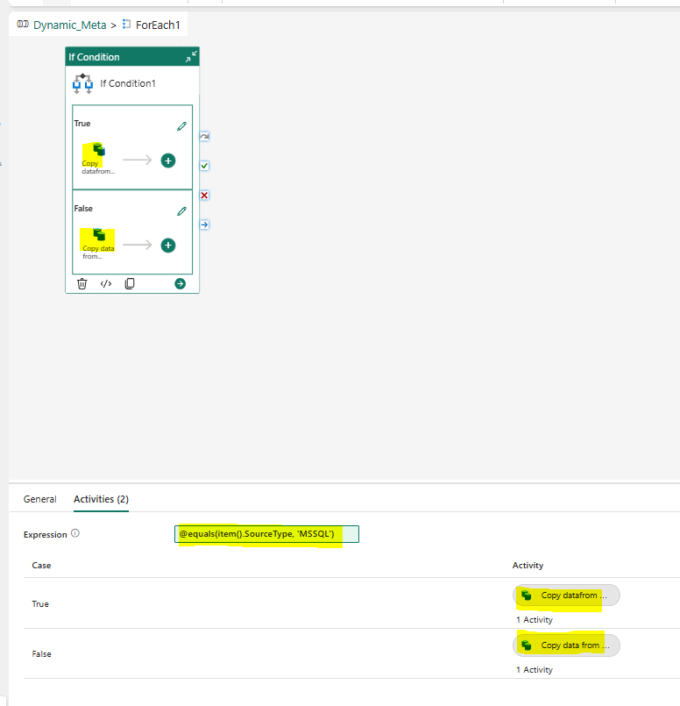

1. **True Condition: - Copy Activity:-**

**Source:-**

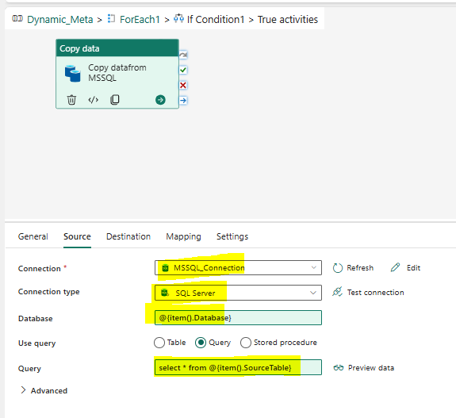

**Destination:-**

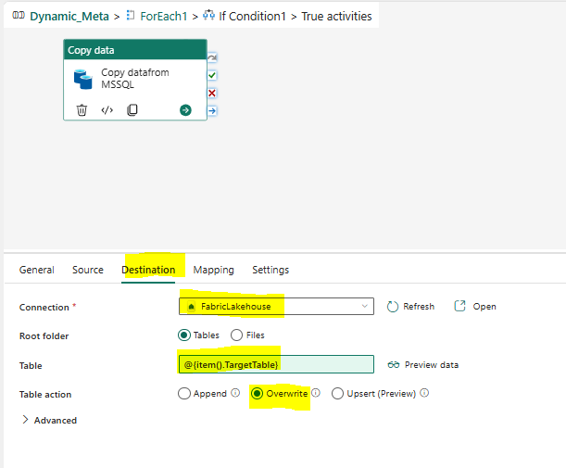

**False Condition (MYSQL) :-**

**Source**

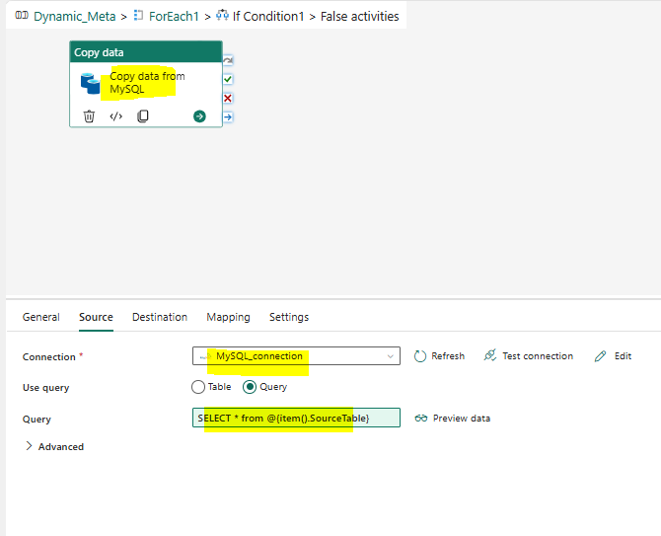

**Destination:-**

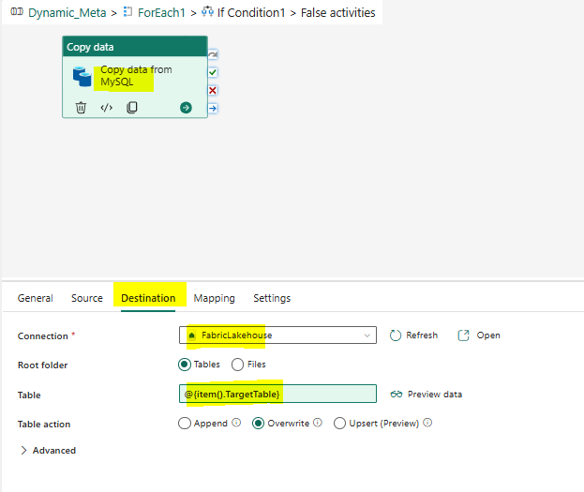

**Note – If you wanted to check all connection**

**Go to Setting 🡪 Managed Connections and gateways 🡪**

