TCP/IP

CCNA Adapted Version

* Defined in Documents called RFCs.
* 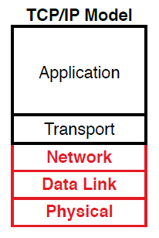Also refers to standards/protocols etc. For example the protocols created by the IEEE
  + Protocols are rules/standards that allow 2 devices to communicate.
* Model is implemented in many things (Software, OS, Hardware …)
* 5 Layers and according protocol
  + Application (eg. HTTP, POP3, SMTP)
  + Transport (eg. TCP, UDP)
  + Network (eg. IP, ICMP)
  + Data Link (eg. Ethernet, 802.11, PPP)
  + Physical
* Each of the Layers has it's own standards and protocols
* The original version is a bit different and features only four layers

Acronyms

OSI vs. TCP/IP 1

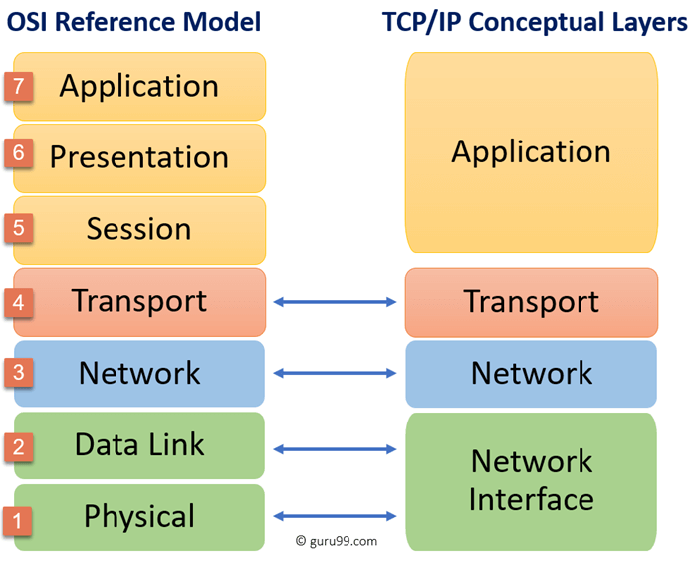RFC = Requests for Comments

OS = Operating System

IEEEE = Institute of Electrical and Electronic Engineers