

Mini Project Documentation
STUDENT RANKING SYSTEM USING HEAP SORT ALGORITHM.
Mini Project Report
Submitted by
TANAKANTI SAI KIRAN 23AK1A05G4
Department of Computer Science and Engineering
Annamacharya Institute of Technology and Sciences, Tirupati
Academic Year: 2025-2026

ABSTRACT
The Student Ranking System is a web-based application developed using Python Flask and SQLite. The primary objective of the system is to manage student records and generate rankings based on academic performance using the Heap Sort algorithm.
The system allows users to add student information, store marks, calculate total scores, and generate rankings efficiently. Heap Sort is used because of its O(n log n) time complexity, making it suitable for handling large numbers of student records.
The project demonstrates the practical implementation of data structures and algorithms in a real-world academic management system.
INTRODUCTION
Managing student records and generating rankings manually is time-consuming and error-prone. Educational institutions require an efficient system to calculate ranks based on academic performance.
The Student Ranking System automates this process by storing student details, calculating total marks, and generating rankings using the Heap Sort algorithm. The system also visually demonstrates the sorting process, helping users understand how rankings are generated.
Objectives
Primary Objectives
- Store student information.
- Manage student marks.
- Calculate total marks.
- Generate rankings using Heap Sort.
- Display ranking results.
Secondary Objectives
- Improve user experience.
- Reduce processing time.
- Maintain data consistency.

Technologies Used

Python

Python is used as the primary programming language due to its simplicity and extensive library support.

Flask
Flask is a lightweight web framework used to build the web application.

SQLite
SQLite is used as the database for storing student information.

HTML
HTML is used for creating web pages.

CSS
CSS is used for styling the user interface.

JavaScript
JavaScript provides interactivity and dynamic behavior.

SYSTEM MODULES
A. Dashboard Module
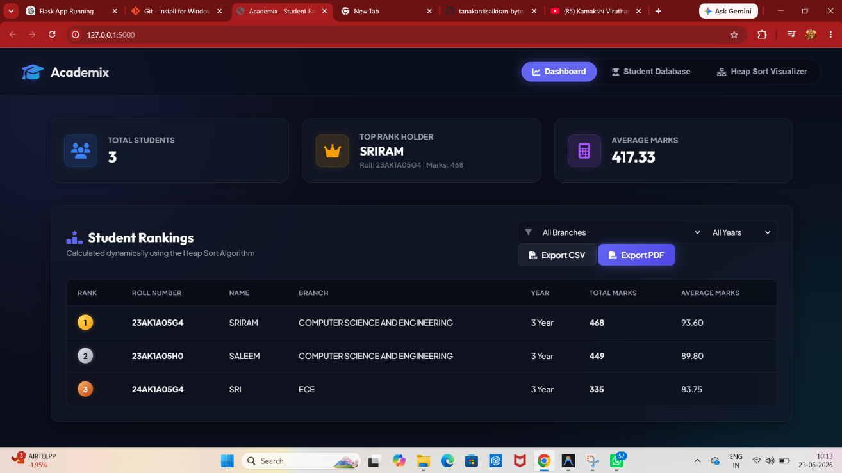
The Dashboard provides a summary of student performance.
Features
- Total Student Count
- Top Rank Holder
- Average Marks
- Student Ranking Table
- CSV Export
- PDF Export
The dashboard automatically displays rankings based on marks calculated using Heap Sort.

B. Student Database Module
This module manages student information.
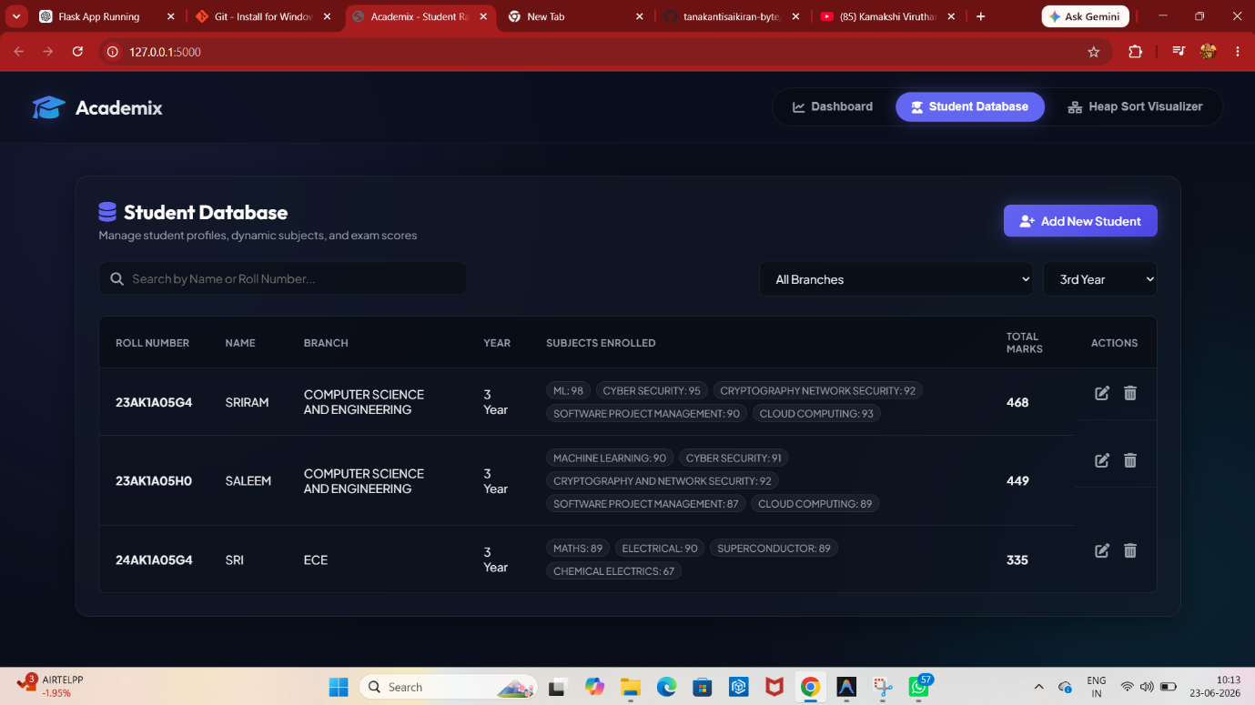
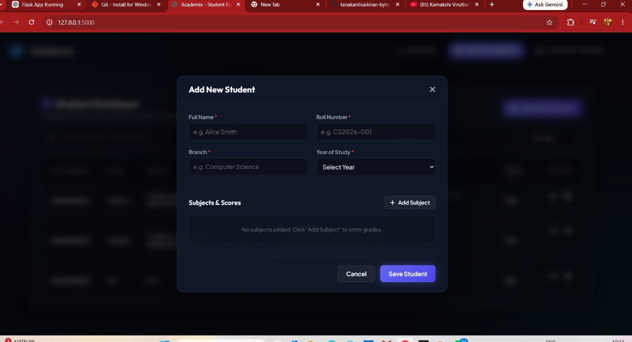

Features
- Add Student
- Edit Student
- Delete Student
- Search Student
- Filter by Branch and Year
- Store Multiple Subjects and Marks
Each student record contains:
- Roll Number
- Name
- Branch
- Year
- Subject & Marks
- Total Marks

C. Heap Sort Visualization Module
This module visually demonstrates how Heap Sort works.
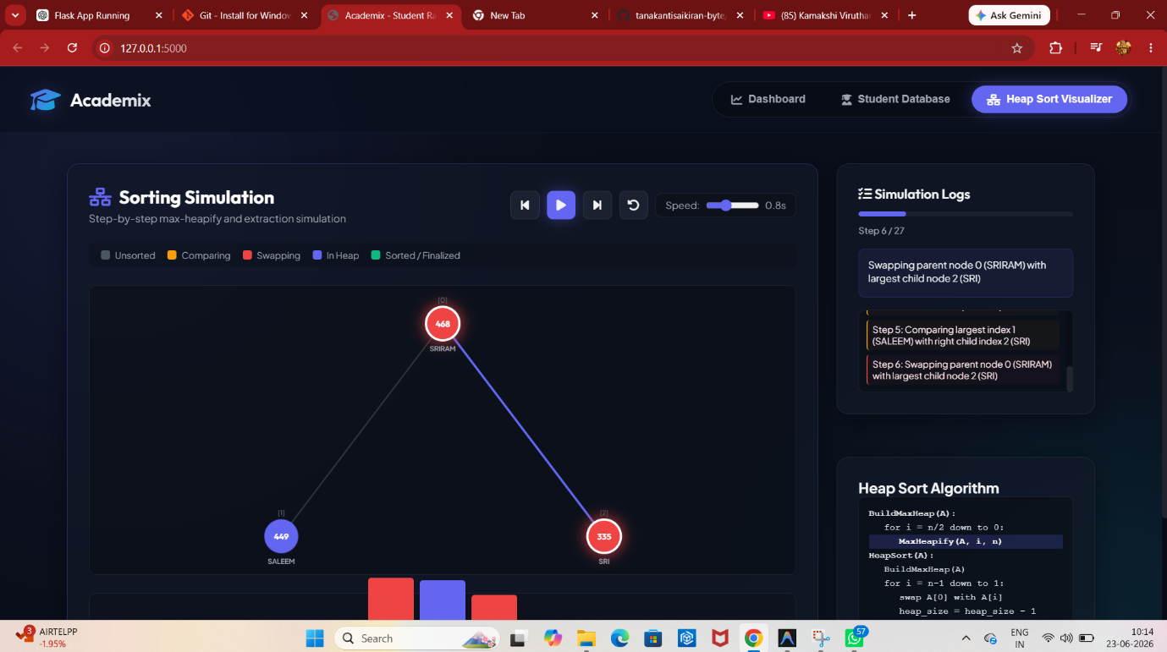

Features
- Heap Tree Representation
- Step-by-Step Sorting
- Simulation Logs
- Sorting Controls
- Algorithm Explanation
The visualization helps users understand the ranking process and Heap Sort algorithm.
ALGORITHM USED
Heap Sort Algorithm
Heap Sort is an efficient sorting algorithm based on the Binary Heap data structure.
Steps
- Create a Max Heap.
- Compare parent and child nodes.
- Move the largest element to the root.
- Swap root with last element.
- Repeat until all elements are sorted.
Time Complexity
Case | Complexity
Best Case | O(n log n)
Average Case | O(n log n)
Worst Case | O(n log n)

RESULTS
The system successfully generated rankings based on student marks.

Sample Ranking
Rank | Student Name | Marks
1 | SRIRAM | 468
2 | SALEEM | 449
3 | SRI | 335

Achievements
- Accurate ranking generation.
- Efficient sorting using Heap Sort.
- Interactive user interface.
- Real-time visualization of sorting process.
GITHUB REPOSITORY LINK:
git clone https://github.com/tanakantisaikiran-byte/student-ranking-system.git

CONCLUSION
The Student Ranking System using Heap Sort Algorithm successfully automates student ranking generation. The system stores student records, calculates total marks, and generates rankings efficiently. The Heap Sort visualization feature makes the project educational and interactive. The project demonstrates the practical application of data structures and algorithms in academic management systems.
REFERENCES
1.Chatgpt
2.Claude AI
3.Heap Sort Algorithm - GeeksforGeeks
https://www.geeksforgeeks.org/heap-sort/
4.Data Structures and Algorithms Tutorial
https://www.tutorialspoint.com/data_structures_algorithms/index.htm
5.W3Schools Web Development Tutorials
https://www.w3schools.com/

