Concepts of Programming Languages
Laboratory Worksheet #4
Assoc. Prof. Dr. Gökhan DALKILIÇ

Res. Asst. Dr. Feriştah DALKILIÇ
Res. Asst. Elife ÖZTÜRK KIYAK
March 19, 2019

Laboratory Aim
In this laboratory section you are expected to exercise syntax analysis.

Syntax Analysis
Syntax analysis or parsing checks whether the input expression (program) is syntactically correct and also constructs a parse tree during the analysis. The syntax of the programming language is defined by the BNF or EBNF of the language.
The EBNF consisting rules required for a simple syntax analyzer is shown below. We need a lexical analyzer to be able to analyze syntactically. Follow the steps and implement the lexical analyzer and the syntax analyzer.
<expr> → <term> {(+|-) <term>}
<term> → <factor> {(*|/) <factor>}
<factor> → <ident>|<int-lit> | (<expr>)
<ident> → <letter> {<letter>|<digit>}
<int-lit> → <digit> {<digit>}
<letter> → a|b|…|z
<digit> → 0|1|…|9

Step
Open Dev-C++ from start menu and create an empty C Project.

Step
Add a new C source file and name it main.c.

Step
Do the following definitions for lexical analyzer.

#include <stdio.h>
#include <ctype.h>

// lexical analyzer code started
#define LETTER 0
#define DIGIT 1
#define OPERATOR 2
#define INT_LIT 3
#define IDENT 4
#define UNKNOWN -1
#define FINISHED -2

char input[100];
int inputIndex=0;

int charClass;
char lexeme[10];
char nextChar;
int lexLen;
// lexical analyzer code finished

Step
Do the following definitions for syntax analyzer.

// syntax analyzer code started
int nextToken=0;
#define PLUS_CODE 5
#define MINUS_CODE 6
#define AST_CODE 7
#define SLASH_CODE 8
#define ID_CODE 9
#define LEFT_PAREN_CODE 10
#define RIGHT_PAREN_CODE 11

void expr();
void term();
void factor();

int exprId=0;
int termId=0;
int factorId=0;
int i=0;
int error=0;
// syntax analyzer code finished

Step
Write the following functions for lexical analyzer.

// lexical analyzer code started
void addChar()
{
if (lexLen<=9)
{
lexeme[lexLen++] =nextChar;
}
else
{
printf("Error - lexeme too long\n");
}
}

char getNextChar()
{
if (input[inputIndex] != '\0')
{
return input[inputIndex++];
}
else
return NULL;
}
void getChar()
{
if((nextChar=getNextChar())!=NULL)
{

if (nextChar=='(' )
charClass = LEFT_PAREN_CODE;
else if (nextChar==')' )
charClass = RIGHT_PAREN_CODE;
else if (nextChar=='+' )
charClass = PLUS_CODE;
else if (nextChar=='-')
charClass = MINUS_CODE;
else if (nextChar=='*' )
charClass = AST_CODE;
else if (nextChar=='/' )
charClass = SLASH_CODE;
else
{
if (isalpha(nextChar))
{
charClass=LETTER;
}
else
{
if (isdigit(nextChar))
charClass = DIGIT;
else
charClass = UNKNOWN;
}
}
}
else
charClass = FINISHED;
}

void getNonBlank()
{
while (isspace(nextChar))
getChar();
}

int lex2()
{
int i;
for (i=0; i<lexLen; i++)
lexeme[i]='\0';
lexLen=0;
static int first = 1;
if (first)
{
getChar();
first=0;
}
getNonBlank();
switch(charClass)
{
case LETTER:
addChar();
getChar();
while (charClass == LETTER || charClass == DIGIT)
{
addChar();
getChar();
}
return IDENT;
break;
case DIGIT:
addChar();
getChar();
while (charClass == DIGIT)
{
addChar();
getChar();
}
return INT_LIT;
break;
case LEFT_PAREN_CODE:
addChar();
getChar();
return LEFT_PAREN_CODE;
break;
case RIGHT_PAREN_CODE:
addChar();
getChar();
return RIGHT_PAREN_CODE;
break;
case PLUS_CODE:
addChar();
getChar();
return PLUS_CODE;
break;
case MINUS_CODE:
addChar();
getChar();
return MINUS_CODE;
break;
case AST_CODE:
addChar();
getChar();
return AST_CODE;
break;
case SLASH_CODE:
addChar();
getChar();
return SLASH_CODE;
break;
case FINISHED:
return FINISHED;
break;
case UNKNOWN:
addChar();
getChar();
return UNKNOWN;
break;

}
return UNKNOWN;
}

int lex()
{
nextToken =lex2();
return nextToken;
}
// lexical analyzer code finished

Step
Write the following functions for syntax analyzer. Complete the code by writing the required code fragments which are marked with the commented lines.
// syntax analyzer code started

void expr()
{
int myExprId =exprId;
exprId++;
printf("expr starting %d\n",myExprId);

term();
while (nextToken == PLUS_CODE || nextToken == MINUS_CODE)
{
printf("lexeme %s\n",lexeme);
lex();
term();
}
printf("expr ended %d\n",myExprId);
}

void term()
{
int myTermId =termId;
termId++;
printf("<term>\n");
printf(" factor starting %d\n",myTermId);
factor();
while (nextToken == AST_CODE || nextToken == SLASH_CODE)
{
printf("lexeme %s\n", lexeme);
lex();
factor();
}
printf("factor ended %d\n",myTermId);
printf("<term>\n");
}

void factor()
{
int myFactorId =factorId;
factorId++;
printf(" factor starting %d\n",myFactorId);
if (nextToken== IDENT || nextToken== INT_LIT)
{
printf(" lexeme %s\n",lexeme);
lex();
}
else if (nextToken == LEFT_PAREN_CODE)
{
printf("lexeme %s\n",lexeme);
lex();
expr();
if (nextToken == RIGHT_PAREN_CODE)
{
printf("lexeme %s\n",lexeme);
lex();
}
else
{
error=1;
printf("No right parenthesis\n");
}
}
else
{
error=1;
printf(" Syntax error\n");
}
printf(" factor ended %d\n",myFactorId);

}
// syntax analyzer code finished

int main()
{
printf("Input your string: \n");
scanf("%s", input);

error=0;

lex();
expr();

if (nextToken!= FINISHED || error)
printf("error");
else
printf("success");
scanf("%s");
return 0;

}

Step
Run your project and paste the screenshot for input: index*2+35/a below.
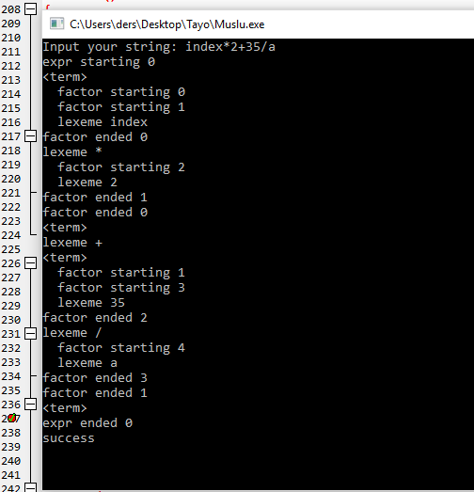

Step
Run your project and paste the screenshot for input: 12-2/1a-b1 below and explain the result.
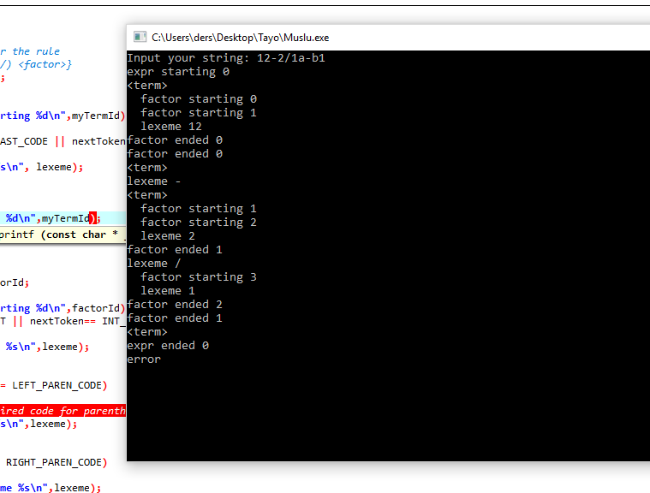
Term sayı ile başladığı için hata veriyor. Sayı sayı şeklinde yada harf harf şeklinde devam etse hata olmuyor.

Step
Run your program for the input “count%25-12”. Do the lexemes “%”, “25”, “-” or “12” exist in the output? Why?
“%” simgesi factorlerde tanımlı olmadığı için burada kesip hataya düşüyor.

