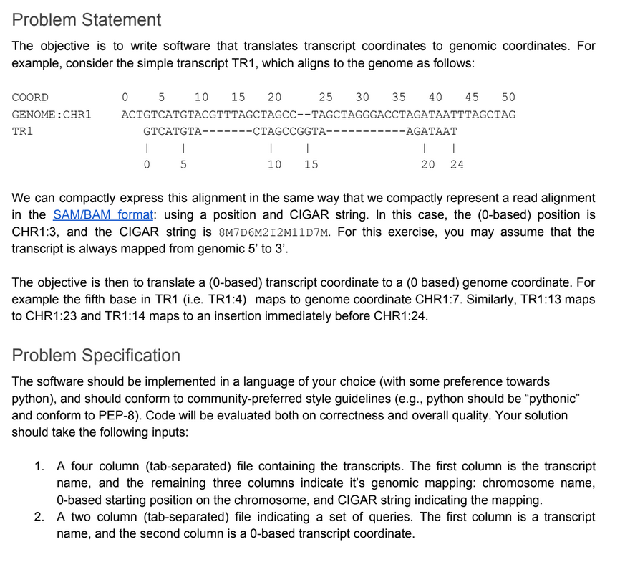

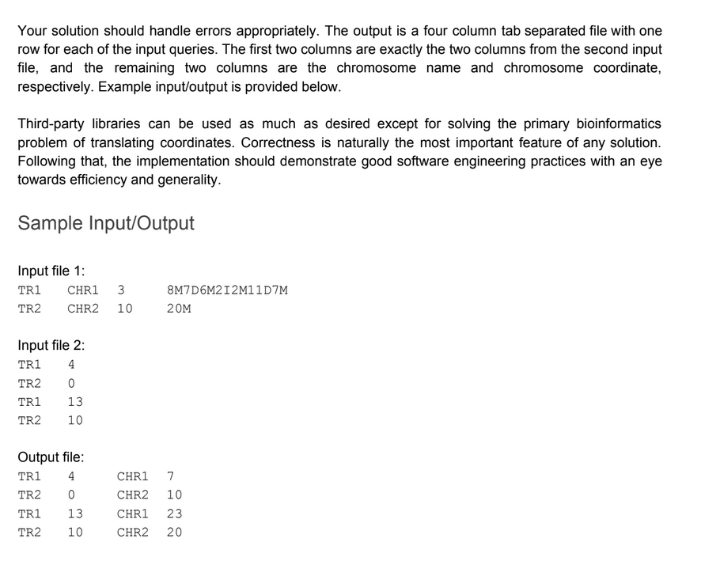

We propose two solutions :

- Solution 1 utilizes a procedural programming approach.

- Solution 2 is built around an object-oriented paradigm.

Version 2 (oop) :

Time Complexity :

Reading the input files : O(p+q), where p is the number of rows in the file “input_transcript_alignments.txt” and q is the number of rows in the file
“input_transcripts_positions.txt”
Merging these data frames : O (p*q)
Iterating over grouped data : L is the number of unique transcript names. If all the transcripts (rows) are unique, the complexity is O(n).
Possibly, for each transcript name, the complexity is O(p), where p is the number of rows associated with a transcript.
Method calls :
transformCigar: O(n), where n is the length of the CIGAR string
findTranscriptIndex : O(m), where m is the length of the transformed CIGAR string
calculateGenomePosition : O(m)
Let’s assume that we have r unique transcripts. In the outer loop, if there is only one transcript, the total time complexity can be summarized as : O(p+q). Inside the inner loop, those 3 methods are called, that have the time complexity O(n), O(m), O(m).

The time complexity can be approximated by O ((p + q) * (n + m) + p * q ), where p is the number of rows in the first file, q is the number of rows in the second file, n is the average length of a cigar_string, m is the average length of a transformed_cigar.

I believe that the solution is efficient for moderate use cases, further optimizations could enhance its performance for larger data sets.

Version 1 (procedural) :

Time Complexity :

Reading the input files : O(p), and O(q)
Functions :
transform_cigar() : O(n)
find_transcript_index : O(m)
calculate_genome_position : O(m)

In the main execution block :

Merging the data frames : O (p*q)

apply(transform_cigar) : O(p+q) * O(n) = O((p+q) * n)
apply(lambda ..) for find_transcript_index : O(p+q) * O(m) = O((p+q) * m)
apply(lambda ..) for calculate_genome_position : O(p+q) * O(m) = O(p+q) * m )

Overall, considering, considering the dominant operations, the time complexity is O ((p + q) * (n + m) + p * q), where p is the number of rows in the first file, q is the number of rows in the second file, n is the average length of a cigar_string, m is the average length of a transformed_cigar.

In terms of time complexity, there's generally no significant difference between the procedural version and the object-oriented version of the code.

