Pseudocode / Python code of popular SORTING ALGORITHMS:

I have used several resources: GeekForGeeks, W3schools, TutorialsPoint, Programiz ; also Gemini, GPT4.0, Perplex AI, Copilot (the python code was generated by Bing Copilot).

Sorting can be comparison-based or non-comparison-based.

Comparison-based Sorting Algorithms :

Bubble Sort
Insertion Sort
Selection Sort
Merge Sort
Quick Sort
Heap Sort
Tim Sort

Non-comparison based Sorting Algorithms :

Counting Sort
Radix Sort
Bucket Sort
Bitonic Sort

The following information was provided by Copilot.

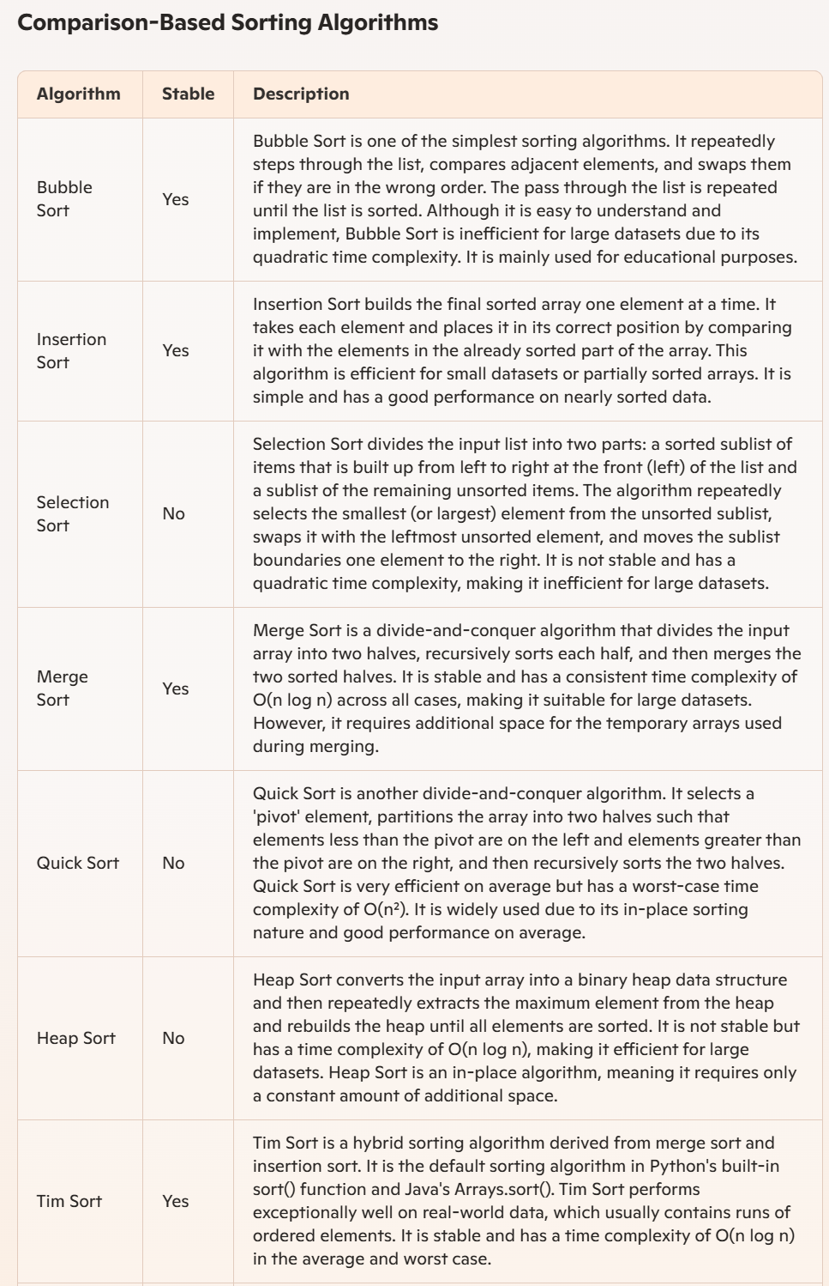
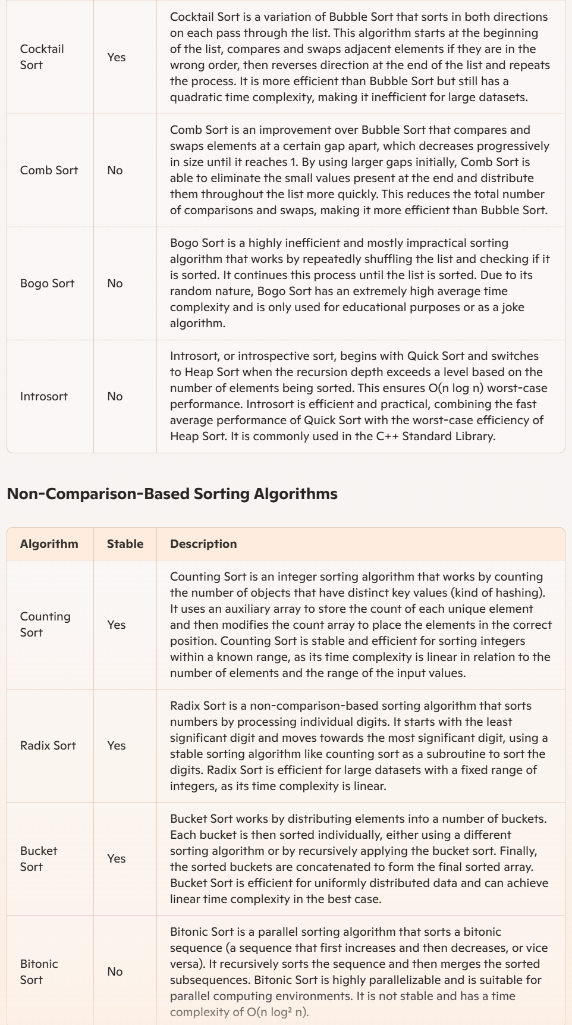

BUBBLE SORT :

BubbleSort(arr):
n = length(arr)
for i = 0 to n – 1:
for j = 0 to n - i - 2:
# Swap if the element found is greater than the next element
if arr[j] > arr[j + 1]:
swap(arr[j], arr[j + 1])

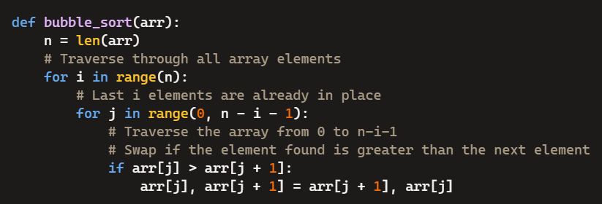

SELECTION SORT :

It sorts an array by repeatedly selecting the smallest (or largest) element from the unsorted portion and swapping it with the first unsorted element. This process continues until the entire array is sorted.
- First we find the smallest element and swap it with the first element. This way we get the smallest element at its correct position.
- Then we find the smallest among remaining elements (or second smallest) and swap it with the second element.
- We keep doing this until we get all elements moved to correct position

SelectionSort(arr):
n = len(arr)
for i = 0 to n - 1:
# Assume the minimum is at index i
min_idx = i
# Find the minimum element in the remaining unsorted array
for j = i + 1 to n - 1:
if arr[j] < arr[min_idx]:
min_idx = j
# Swap the found minimum element with the element at index i
swap(arr[i], arr[min_idx])

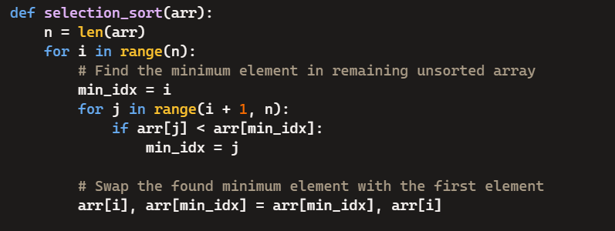

INSERTION SORT :

Insertion sort is a simple sorting algorithm that works by iteratively inserting each element of an unsorted list into its correct position in a sorted portion of the list
InsertionSort(arr):
n = len(arr)
# Start from the second element (index 1) since the first element is trivially sorted
for i = 1 to n - 1:
key = arr[i]
j = i – 1
# Move elements of arr[0..i-1] that are greater than key to one position ahead of their current position
while j >= 0 and arr[j] > key:
arr[j + 1] = arr[j]
j -= 1
# Place the key in its correct position
arr[j + 1] = key

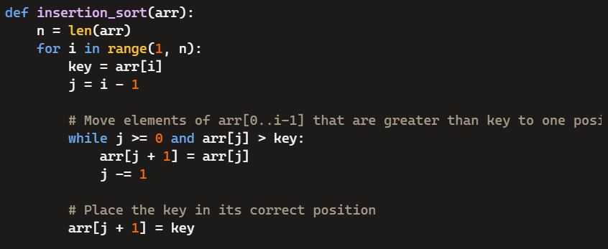

MERGE SORT :

MergeSort(arr):

if length of arr > 1:
# Find the middle point to divide the array into two halves
mid = length of arr / 2
# Call MergeSort recursively on the first half
leftHalf = arr[:mid]
MergeSort(leftHalf)
# Call MergeSort recursively on the second half
rightHalf = arr[mid:]
MergeSort(rightHalf)
# Merge the two halves
i = j = k = 0
# Copy data to an array
while i < len(leftHalf) and j < len(rightHalf):
if leftHalf[i] < rightHalf[j]:
arr[k] = leftHalf[i]
i += 1
else:
arr[k] = rightHalf[j]
j += 1
k += 1

# Check if any element was left in leftHalf[]
while i < len(leftHalf):
arr[k] = leftHalf[i]
i += 1
k += 1

# Check if any element was left in rightHalf[]
while j < len(rightHalf):
arr[k] = rightHalf[j]
j += 1
k += 1

Notes :
i: Used to track the current index in the leftHalf array during the merge process.
j: Used to track the current index in the rightHalf array during the merge process.
k: Used to track the position in the original array (arr) where the next element from either leftHalf or rightHalf should be placed.

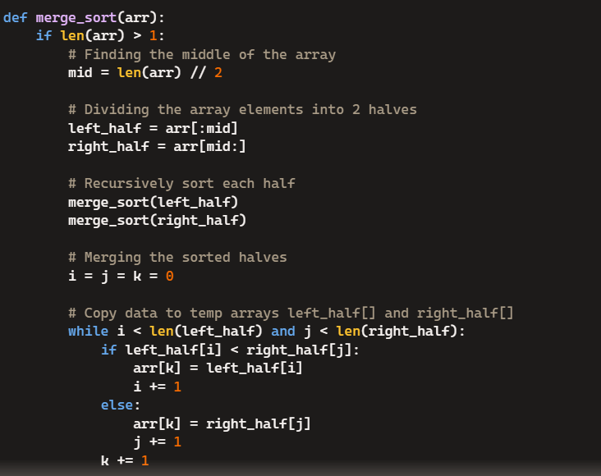
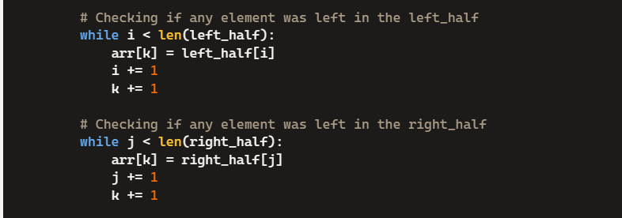

QUICK SORT :
There are mainly three steps in the algorithm:
- An array is divided into subarrays by selecting a pivot element (element selected from the array).
While dividing the array, the pivot element should be positioned in such a way that elements less than pivot are kept on the left side and elements greater than pivot are on the right side of the pivot.
- The left and right subarrays are also divided using the same approach. This process continues until each subarray contains a single element.
- At this point, elements are already sorted. Finally, elements are combined to form a sorted array.

QuickSort(arr, low, high):
if low < high:
# Partition the array around the pivot and get the pivot index
pi = Partition(arr, low, high)
# Recursively sort elements before and after partition
QuickSort(arr, low, pi - 1)
QuickSort(arr, pi + 1, high)
Partition(arr, low, high):
# Select the pivot element (usually the last element in the array : high)
pivot = arr[high]
i = low - 1 # Index of smaller element
# As we iterate through the array, whenever we find an element that is less than or equal to the # # pivot, we increment i and swap the element at i with the current element at j.
for j = low to high - 1:
# If current element is smaller than or equal to pivot
if arr[j] <= pivot:
i += 1
swap(arr[i], arr[j])
# Swap the pivot element with the element at index i+1
swap(arr[i + 1], arr[high])
return i + 1
HEAP SORT:

A max heap is a binary tree where the value of each parent node is greater than or equal to its children. Start from the middle of the array (n // 2 - 1) because nodes beyond this index are leaves and already satisfy the heap property. For each node (from the middle to the root), call the heapify function to ensure the subtree rooted at that node satisfies the heap property.

HeapSort(arr):
n = len(arr)
# Step 1: Build a max heap from the input array
for i = n // 2 - 1 to 0:
heapify(arr, n, i)
# Step 2: Extract elements one by one from the heap
for i = n - 1 to 0:
# Move the root of the heap (largest element) to the end of the array
swap(arr[0], arr[i])
# Call heapify on the reduced heap and ensures that the subtree rooted at index i satisfies the max heap property.
heapify(arr, i, 0)

heapify(arr, n, i):
largest = i # Initialize largest as root
# i: The index of the root of the subtree being heapified.
left = 2 * i + 1 # Left child index
right = 2 * i + 2 # Right child index

# If any child is larger than the root, update largest to that child’s index.
# If the largest value is not the root, swap the root with the largest child.
# If left_child is larger than the root
if left < n and arr[left] > arr[largest]:
largest = left

# If right_child is larger than largest so far
if right < n and arr[right] > arr[largest]:
largest = right
# If largest is not root
if largest != i:
swap(arr[i], arr[largest])
# Recursively heapify the affected sub-tree
heapify(arr, n, largest)

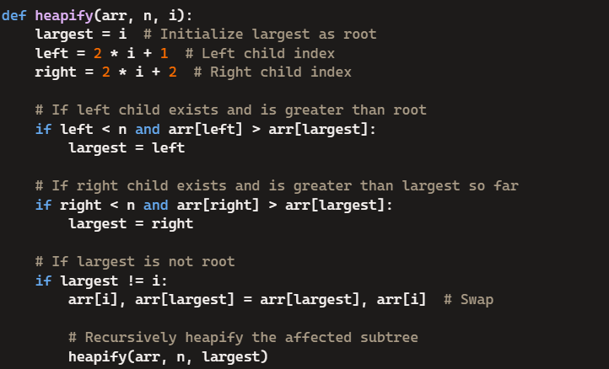
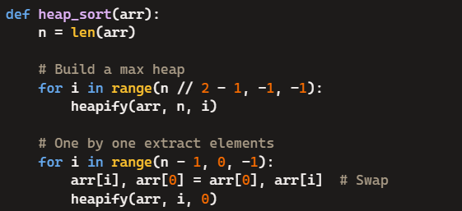

COUNTING SORT:

CountingSort(arr, k):
# arr is array to be sorted.
# k: range of input values (0 to k−1) ; k is the maximum element.
n = len(arr)
# Create a count array to store the count of each unique object
count = array of size k initialized to 0
# Step 1: Store the count of each element
for i = 0 to n - 1:
count[arr[i]] += 1
# Step 2: Modify the count array such that each element at index i contains the sum of previous counts. It helps determine the position of each element in the sorted output.
for i = 1 to k - 1:
count[i] += count[i - 1]
# Step 3: Output each object from the input array into the sorted output array
output = array of size n
for i = n - 1 downto 0:
output[count[arr[i]] - 1] = arr[i]
count[arr[i]] -= 1
# Step 4: Copy the sorted elements into original array
for i = 0 to n - 1:
arr[i] = output[i]

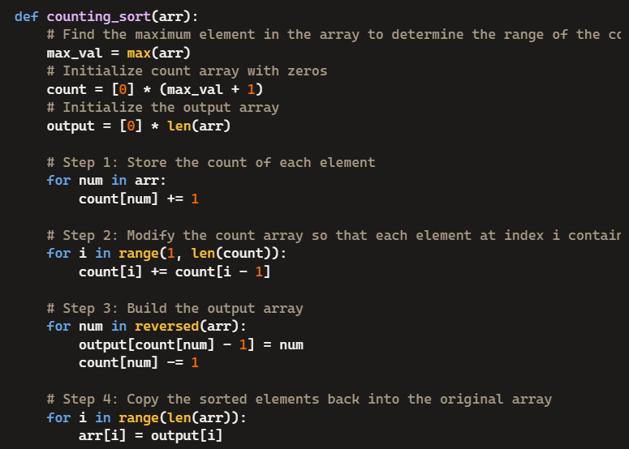

RADIX SORT:

It assumes that sorting numbers digit by digit will eventually result in a fully sorted list. Radix Sort can be performed using different variations, such as Least Significant Digit (LSD) Radix Sort or Most Significant Digit (MSD) Radix Sort. We use a stable sorting technique, such as counting sort, to sort the digits at each significant place
RadixSort(arr, d):
# d is the number of digits in the largest number
for i = 1 to d:
# Perform counting sort on the ith digit
CountingSortByDigit(arr, i)

CountingSortByDigit(arr, digit):
n = len(arr)
output = array of size n
count = array of size 10 initialized to 0

# Store the count of occurrences of each digit
for i = 0 to n - 1:
digit_of_element = (arr[i] // 10^(digit - 1)) % 10
count[digit_of_element] += 1

# Modify the count array to store the actual positions
for i = 1 to 9:
count[i] += count[i - 1]

# Build the output array
for i = n - 1 downto 0:
digit_of_element = (arr[i] // 10^(digit - 1)) % 10
output[count[digit_of_element] - 1] = arr[i]
count[digit_of_element] -= 1

# Copy the sorted elements back into the original array
for i = 0 to n - 1:
arr[i] = output[i]

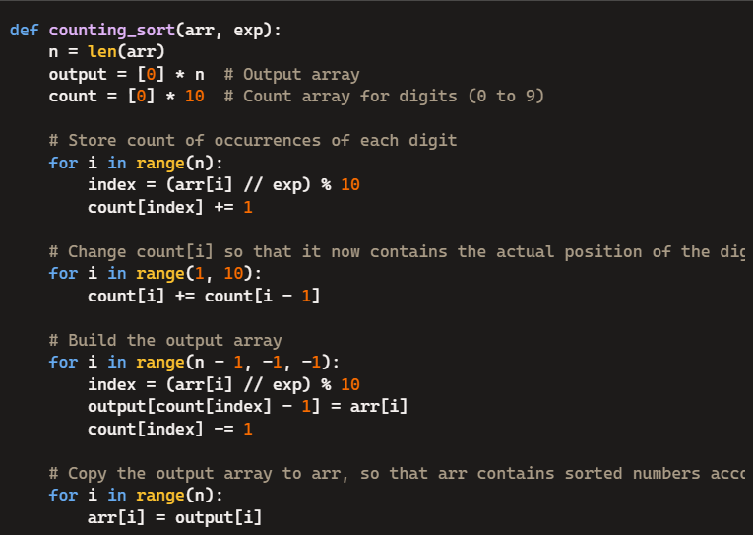

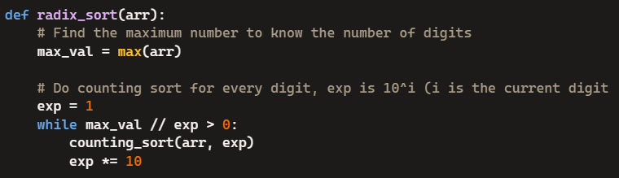

BUCKET SORT:
The process of bucket sort can be understood as a scatter-gather approach.
- First, partition the range into a fixed number of buckets.
- Then, toss every element into its appropriate bucket.
- After that, sort each bucket individually by applying a sorting algorithm.
- And at last, concatenate all the sorted buckets.

BucketSort(arr):
n = len(arr)
# Step 1: Create n empty buckets
buckets = array of n empty lists
# Step 2: Put array elements into different buckets
for i = 0 to n - 1:
bucket_index = floor(n * arr[i]) # Assuming arr[i] is in the range [0, 1)
append arr[i] to buckets[bucket_index]
# Step 3: Sort individual buckets using a suitable sorting algorithm (e.g., Insertion Sort)
for i = 0 to n - 1:
InsertionSort(buckets[i])
# Step 4: Concatenate all sorted buckets into the original array
index = 0
for i = 0 to n - 1:
for j = 0 to length of buckets[i] - 1:
arr[index] = buckets[i][j]
index += 1

InsertionSort(bucket):
for i = 1 to length of bucket - 1:
key = bucket[i]
j = i - 1

# Move elements of bucket[0..i-1] that are greater than key to one position ahead of their # # # current position
while j >= 0 and bucket[j] > key:
bucket[j + 1] = bucket[j]
j -= 1
bucket[j + 1] = key
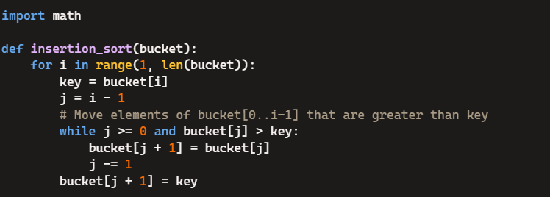
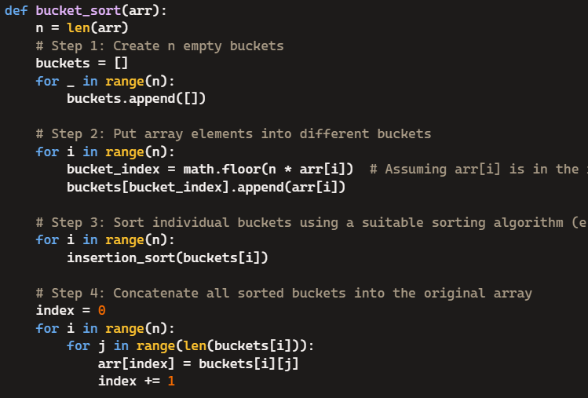

Other SORTING ALGORITHMS :

SHELL SORT (improves Insertion Sort).
COCKTAIL SORT (a bidirectional Bubble Sort)
COMB SORT (improves Bubble Sort)

HYBRID SORTING ALGORITHMS :

TIMSORT : combines Merge Sort and Insertion Sort (implemented in built-in python sort())
INTROSORT : combines Quick Sort, Heap Sort, and Insertion Sort (in C++ standard library).

BOGO SORT (Permutation Sort, for fun) : randomly shuffles the array until it is sorted. The time complexity is O((n* n!). The algorithm successively generates permutations of its input until it finds one that is sorted. For example, if bogosort is used to sort a deck of cards, it would consist of checking if the deck were in order, and if it were not, one would throw the deck into the air, pick the cards up at random, and repeat the process until the deck is sorted.

BITONIC SORT: a PARALLEL SORTING ALGORITHM that is particularly suited for GPUs or multi-core processors. It is based on the concept of a bitonic sequence, which is a sequence of numbers that first increases and then decreases, or vice versa.

Bitonic Sort is used in settings where parallelism is critical because it divides the sorting process into a fixed series of steps that can run simultaneously. Complexity : O(log n * log n).
Bitonic Sort works by recursively:
- Building Bitonic Sequences: Transforming smaller sequences into bitonic sequences.
- Merging Bitonic Sequences: Combining two adjacent bitonic sequences into a larger bitonic sequence.
The "Bitonic Merge" Operation
The core of the algorithm is the "bitonic merge" operation. It takes a bitonic sequence as input and transforms it into a fully sorted sequence. It does this by:
- Comparing and Swapping: Comparing elements that are n/2 positions apart (where n is the length of the sequence) and swapping them if necessary to maintain a sorted order.
- Recursive Merging: Recursively applying the bitonic merge to the two halves of the sequence.

BitonicSort(arr, low, size, direction):
# Base case: If size is 1, the array is already sorted
if size <= 1:
return
# Step 1: Divide the array into two halves
mid = size // 2
# Step 2: Sort the first half in ascending order
BitonicSort(arr, low, mid, True)
# Step 3: Sort the second half in descending order
BitonicSort(arr, low + mid, mid, False)
# Step 4: Merge the two halves into a bitonic sequence
BitonicMerge(arr, low, size, direction)

BitonicMerge(arr, low, size, direction):
# Base case: If size is 1, nothing to merge
if size <= 1:
return
# Step 1: Compare and swap elements based on direction
mid = size // 2
for i = low to low + mid - 1:
if direction == (arr[i] > arr[i + mid]):
swap(arr[i], arr[i + mid])
# Step 2: Recursively merge the two halves
BitonicMerge(arr, low, mid, direction)
BitonicMerge(arr, low + mid, mid, direction)

# Main Function
Sort(arr, size):
BitonicSort(arr, 0, size, True)
# https://www.youtube.com/watch?v=KKuza40Mbwg
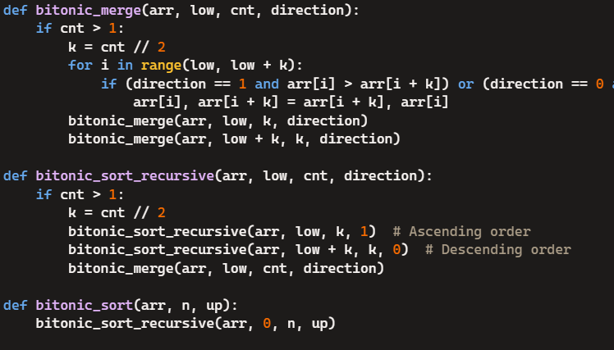
(on the row above)

Time Complexity of the Sorting Algorithms: (source : Copilot)
