**SO2. an ability to apply engineering design to produce solutions that meet specified needs with consideration of public health, safety, and welfare, as well as global, cultural, social, environmental, and economic factors**

**Passing criterion >= 70%**

PI 2-1 identify and formulate engineering problems

PI 2-2 solve problems by applying mathematics and engineering knowledge

========================================================================

PI 2-1 identify and formulate engineering problems

**EGCO334 Microprocessor and Interfacing**

**Midterm Exam**

**การต่อวงจร เพื่อขับมอเตอร์จาก Arduino ตามภาพด้านล่างนี้ มีข้อผิดพลาดอย่างไร? จงอธิบายมาพอสังเขป**

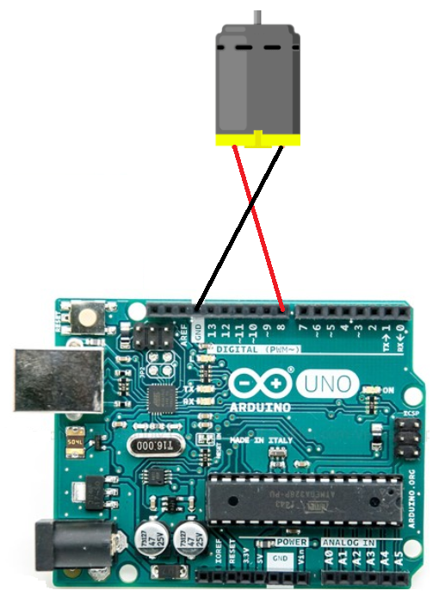

| **Student No.** | **PI 1-1** |
| --- | --- |
| 1 | 🗶 |
| 2 | ✓ |
| 3 | 🗶 |
| 4 | ✓ |
| 5 | ✓ |
| 6 | ✓ |
| 7 | 🗶 |
| Number of Pass | 4 |

PI 2-1: Attainability = 4/7 = 57.0% **Not Attainable**

========================================================================

PI 2-2 solve problems by applying mathematics and engineering knowledge

**EGCO334 Microprocessor and Interfacing**

**Midterm Exam**

**ให้นักศึกษา วาดวงจร การต่อเชื่อมมอเตอร์ กับบอร์ด Arduino ที่ถูกต้อง โดยนักศึกษาสามารถเติม component หรือวงจรเพิ่มเติมได้ ตามความจำเป็น**

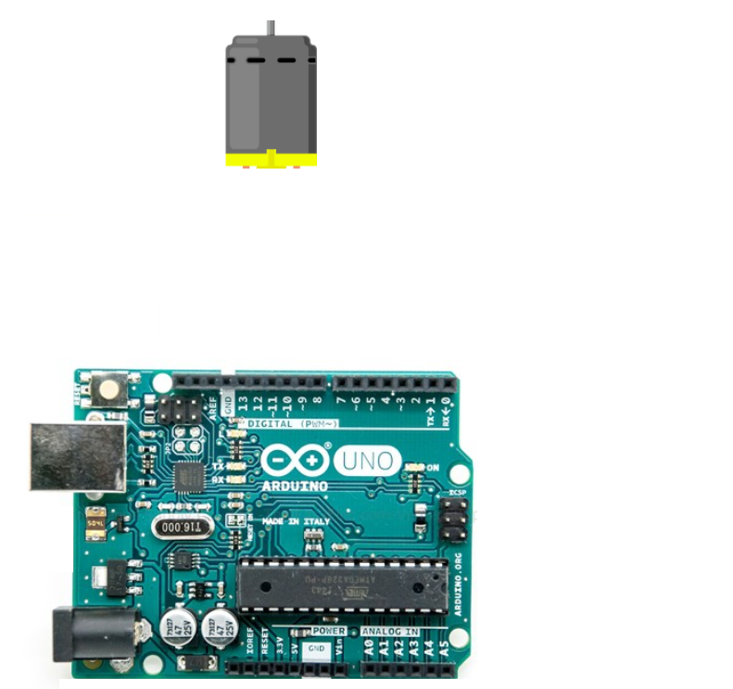

| **Student No.** | **PI 1-2** | **PI 1-3** |
| --- | --- | --- |
| 1 | 🗶 | ✓ |
| 2 | ✓ | ✓ |
| 3 | ✓ | 🗶 |
| 4 | ✓ | ✓ |
| 5 | ✓ | ✓ |
| 6 | ✓ | ✓ |
| 7 | 🗶 | ✓ |
| Number of Pass | 5 | 6 |

PI 2-2: Attainability = 5/7 = 71.4% **Attainable**

**SO2 Conclusion**

|  |  |  |  |  |  |
| --- | --- | --- | --- | --- | --- |
| **PI** | **Attainability** | **Reason** | **Remedial Action** | **Action plan** | **Measurements** |
| 2-1 | 🗶 | Do not understand the concept of low current and high current output | Increase/improve the explanation/demonstration about the topic | Next curriculum revision (3 years) | 4 years |
| Do not understand programming concept | More programming clinics | Next semester | Next semester |
| 2-2 | ✓ |  |  |  |  |

**SO6. an ability to develop and conduct appropriate experimentation, analyze and interpret data, and use engineering judgment to draw conclusions**

**Passing criterion >= 70%**

PI 6-1 develop and conduct appropriate experimentation

PI 6-2 analyze and interpret data, and use engineering judgment to draw conclusions

========================================================================

**EGCO334 Microprocessor and Interfacing**

**Project Presentation Evaluation**

| **Student No.** | **PI 6-1** | **PI 6-2** |
| --- | --- | --- |
| 1 | ✓ | ✓ |
| 2 | ✓ | ✓ |
| 3 | ✓ | ✓ |
| 4 | ✓ | 🗶 |
| 5 | ✓ | ✓ |
| 6 | ✓ | 🗶 |
| 7 | ✓ | 🗶 |
| 8 | ✓ | ✓ |
| 9 | ✓ | ✓ |
| 10 | ✓ | 🗶 |
| 11 | ✓ | ✓ |
| Number of Pass | 11 | 7 |

PI 6-1: Attainability = 11/11 = 100.0% **Attainable**

PI 6-2: Attainability = 7/11 = 63.6% **Not Attainable**

**SO6 Conclusion**

|  |  |  |  |  |  |
| --- | --- | --- | --- | --- | --- |
| **PI** | **Attainability** | **Reason** | **Remedial Action** | **Action plan** | **Measurements** |
| 6-1 | ✓ |  |  |  |  |
| 6-2 | 🗶 | Not enough knowledge on data visualization and analysis | Spend more time on the topic during lectures / give more examples | Next academic year | Next academic year |

**SO7. an ability to acquire and apply new knowledge as needed, using appropriate learning strategies**

**Passing criterion >= 70%**

PI 7-1 acquire and apply new knowledge

PI 7-2 use appropriate sources of knowledge

========================================================================

**EGCO334 Microprocessor and Interfacing**

**Mini Project**

ให้นักศึกษา ทำการค้นคว้าหาวิธีการ และเขียนโปรแกรม ให้ Arduino ขับ LED สองตัวให้กระพริบ ด้วยอัตราที่แตกต่างกัน

| **Student No.** | **PI 7-1** | **PI 7-2** |
| --- | --- | --- |
| 1 | ✓ | ✓ |
| 2 | ✓ | ✓ |
| 3 | ✓ | ✓ |
| 4 | ✓ | ✓ |
| 5 | ✓ | ✓ |
| 6 | ✓ | ✓ |
| 7 | ✓ | ✓ |
| 8 | ✓ | ✓ |
| 9 | ✓ | ✓ |
| 10 | ✓ | ✓ |
| 11 | ✓ | ✓ |
| Number of Pass | 11 | 11 |

PI 7-1: Attainability = 11/11 = 100.0% **Attainable**

PI 7-2: Attainability = 11/11 = 100.0% **Attainable**

**SO6 Conclusion**

|  |  |  |  |  |  |
| --- | --- | --- | --- | --- | --- |
| **PI** | **Attainability** | **Reason** | **Remedial Action** | **Action plan** | **Measurements** |
| 7-1 | ✓ |  |  |  |  |
| 7-2 | ✓ |  |  |  |  |