**SO1. An ability to identify, formulate and solve complex engineering problems by applying principles of engineering, science, and mathematics.**

**Passing criterion >= 70%**

PI 1-1 Identify and formulate engineering problems

PI 1-2 Solve problems by applying mathematics and engineering knowledge

========================================================================

PI 1-1 Identify and formulate engineering problems

**EGCO112 Programming Techniques**

**Q.3.1 Final Exam**

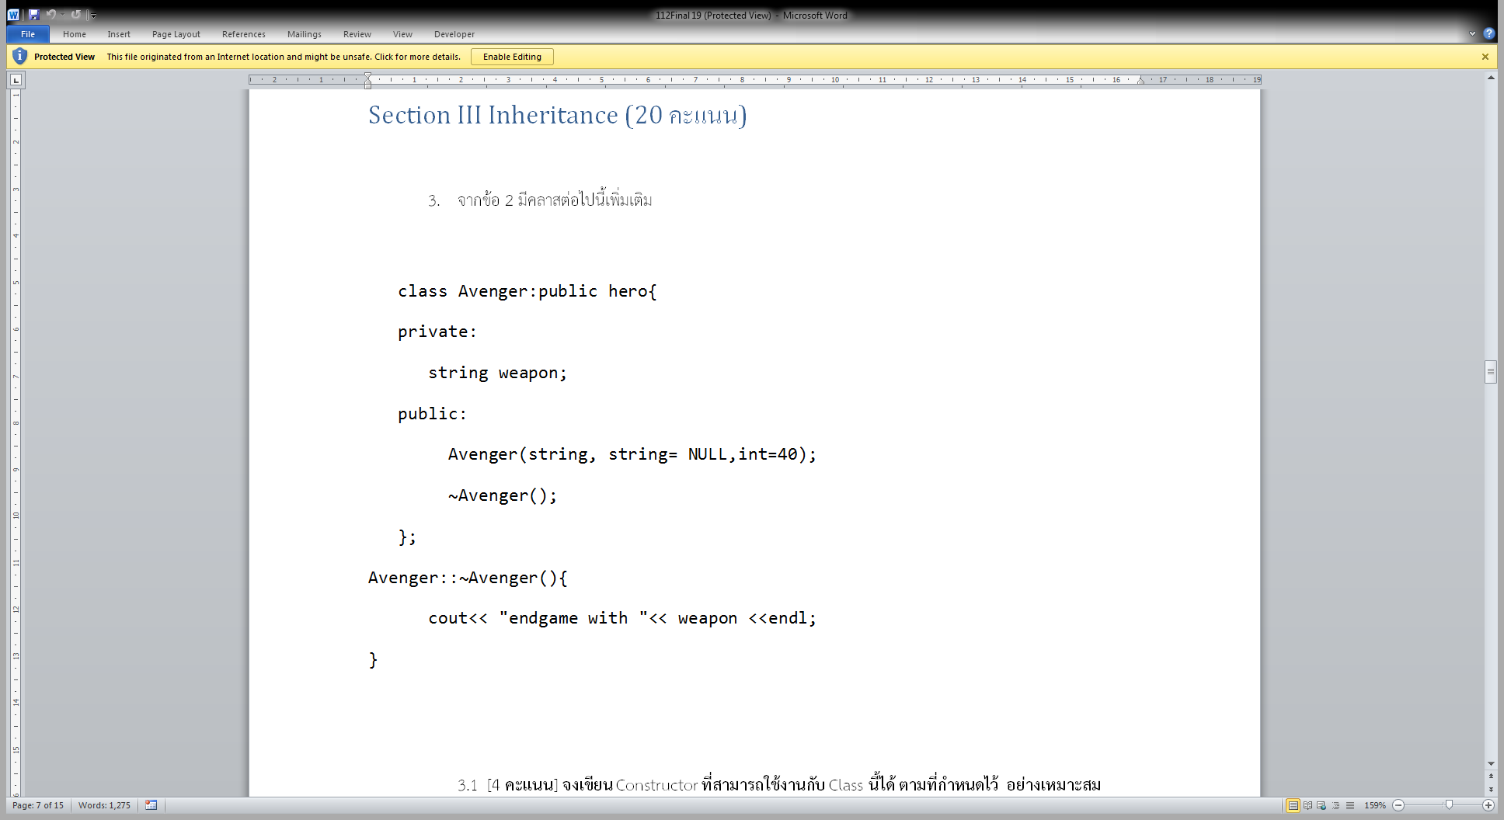

* 1. [4 คะแนน] จงเขียน Constructor ที่สามารถใช้งานกับ Class นี้ได้ ตามที่กำหนดไว้ อย่างเหมาะสม

**ANS**

| **Student No.** | **PI 1-1 (Marks)** | **Pass(>=4)** |
| --- | --- | --- |
| 1 | absence |  |
| 2 | 3 | ✓ |
| 3 | **4** | ✓ |
| 4 | 5 | ✓ |
| 5 | 4 | ✓ |
| 6 | 5 | ✓ |
| 7 | 5 | ✓ |
| 8 | 3 | ✓ |
| 9 | 4.5 | ✓ |
| 10 | 5 | ✓ |
| 11 | 4 | ✓ |
| 12 | 4 | ✓ |
| 13 | 0 | 🗶 |
| 14 | 4 | ✓ |
| 15 | 0 | 🗶 |
| 16 | 4 | ✓ |
| 17 | 3 | 🗶 |
| 18 | 4 | ✓ |
| 19 | 2 | ✓ |
| 20 | 4 | ✓ |
| 21 | 3 | ✓ |
| 22 | 5 | ✓ |
| 23 | 3 | 🗶 |
| 24 | 5 | ✓ |
| 25 | 4 | ✓ |
| 26 | 2 | 🗶 |
| 27 | 2 | 🗶 |
| 28 | 2 | 🗶 |
| 29 | 3 | 🗶 |
| 30 | 3 | 🗶 |
| 31 | 5 | ✓ |
| 32 | 4 | ✓ |
| 33 | 5 | ✓ |
| 34 | 5 | ✓ |
| 35 | 5 | ✓ |
| 36 | 5 | ✓ |
| 37 | 4 | ✓ |
| 38 | 3.5 | ✓ |
| 39 | 4.5 | ✓ |
| 40 | 5 | ✓ |
| Number of Pass |  | 29 |

PI 1-1 Attainability = 29/39 = 74.35 % **Attainable**

PI 1-2 Solve problems by applying mathematics and engineering knowledge

**EGCO112 Programming Techniques**

**Q.4 Midterm Exam**

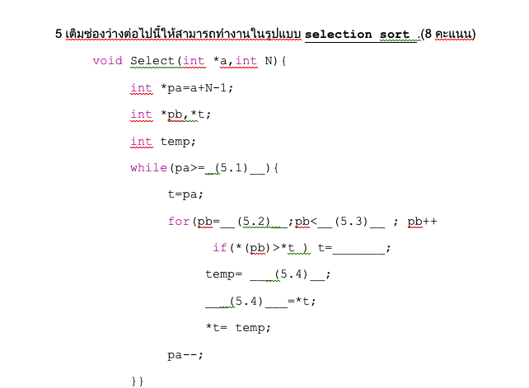

| **Student No.** | **PI 1-2 (Marks)** | **Pass(>=5)** |
| --- | --- | --- |
| 1 | 4 | 🗶 |
| 2 | 5 | ✓ |
| 3 | 8 | ✓ |
| 4 | 0 | 🗶 |
| 5 | 8 | ✓ |
| 6 | 8 | ✓ |
| 7 | 4 | 🗶 |
| 8 | 5 | ✓ |
| 9 | 8 | ✓ |
| 10 | 8 | ✓ |
| 11 | 3 | 🗶 |
| 12 | 3 | 🗶 |
| 13 | 0 | 🗶 |
| 14 | 0 | 🗶 |
| 15 | 0 | 🗶 |
| 16 | 3 | 🗶 |
| 17 | 3 | 🗶 |
| 18 | 0 | 🗶 |
| 19 | 8 | ✓ |
| 20 | 4 | 🗶 |
| 21 | 1.5 | 🗶 |
| 22 | 8 | ✓ |
| 23 | 5 | ✓ |
| 24 | 5 | ✓ |
| 25 | 0 | 🗶 |
| 26 | 1 | 🗶 |
| 27 | 0 | 🗶 |
| 28 | 0 | 🗶 |
| 29 | 3 | 🗶 |
| 30 | 4 | 🗶 |
| 31 | 8 | ✓ |
| 32 | 4 | 🗶 |
| 33 | 0 | 🗶 |
| 34 | 1 | 🗶 |
| 35 | 8 | ✓ |
| 36 | 8 | ✓ |
| 37 | 3 | 🗶 |
| 38 | 0 | 🗶 |
| 39 | 8 | ✓ |
| 40 | 8 | ✓ |
| Number of Pass |  | 16 |

PI 1-2 Attainability = 16/40 = 40 % **Not Attainable**

========================================================================

**SO1 Conclusion**

|  |  |  |  |  |  |
| --- | --- | --- | --- | --- | --- |
| **PI** | **Attainability** | **Reason** | **Remedial Action** | **Action plan** | **Measurements** |
| 1-1 | ✓ |  |  |  |  |
| 1-2 | 🗶 | Lack of critical thinking skills | Add more critical thinking skills in the new curriculum | Next curriculum revision (3 years) | 4 years |

**SO5. An ability to function effectively on a team whose members together provide leadership, create a collaborative and inclusive environment, establish goals, plan tasks and meet objective.**

**Passing criterion >= 70%**

PI 5-1 Assign the appropriate tasks and establish plans to finish work and meet goals on time

PI 5-2 Create fair collaboration

========================================================================

**Project score**

| **Student No.** | **PI 5-1** | **PI 5-2** |
| --- | --- | --- |
| 1 | 🗶 | 🗶 |
| 2 | ✓ | 🗶 |
| 3 | ✓ | ✓ |
| 4 | ✓ | 🗶 |
| 5 | ✓ | ✓ |
| 6 | ✓ | ✓ |
| 7 | ✓ | 🗶 |
| 8 | ✓ | ✓ |
| 9 | ✓ | ✓ |
| 10 | ✓ | ✓ |
| 11 | ✓ | ✓ |
| 12 | ✓ | ✓ |
| 13 | ✓ | ✓ |
| 14 | ✓ | ✓ |
| 15 | ✓ | ✓ |
| 16 | ✓ | ✓ |
| 17 | ✓ | ✓ |
| 18 | ✓ | ✓ |
| 19 | ✓ | ✓ |
| 20 | ✓ | ✓ |
| 21 | ✓ | ✓ |
| 22 | ✓ | ✓ |
| 23 | ✓ | ✓ |
| 24 | ✓ | ✓ |
| 25 | 🗶 | 🗶 |
| 26 | ✓ | ✓ |
| 27 | ✓ | ✓ |
| 28 | ✓ | ✓ |
| 29 | ✓ | ✓ |
| 30 | 🗶 | 🗶 |
| 31 | ✓ | ✓ |
| 32 | ✓ | ✓ |
| 33 | 🗶 | 🗶 |
| 34 | ✓ | ✓ |
| 35 | ✓ | ✓ |
| 36 | ✓ | ✓ |
| 37 | ✓ | ✓ |
| 38 | ✓ | ✓ |
| 39 | ✓ | ✓ |
| 40 | ✓ | ✓ |
| Number of Pass | 36 | 35 |

PI 5-1: Attainability = 36/40 = 90.0% **Attainable**

PI 5-2: Attainability = 35/40 = 87.5% **Attainable**

**SO5 Conclusion**

|  |  |  |  |  |  |
| --- | --- | --- | --- | --- | --- |
| **PI** | **Attainability** | **Reason** | **Remedial Action** | **Action plan** | **Measurements** |
| 5-1 | ✓ |  |  |  |  |
| 5-2 | ✓ | Some group do not share the same amount of responsibilities  However, the measurement method cannot be properly evaluated. | Individual presentation on responsibilities and individual scheduling along with teamwork plan | Next academic year | Next academic year |