**EGCO 221 Data Structures and Algorithms**

**SO 1 An ability to identify, formulate, and solve complex engineering problems by applying principles of engineering, science, and mathematics**

PI 1.1 Identify and formulate engineering problems

PI 1.2 Solve engineering problems by applying mathematics and engineering knowledge

**Passing criterion >= 70%**

PI 1.1 Identify and formulate engineering problems

Assessment 1.1.1 Midterm exam : identify worst case scenarios for searching data

Attainability = 30 out of 39 students (79.6%)

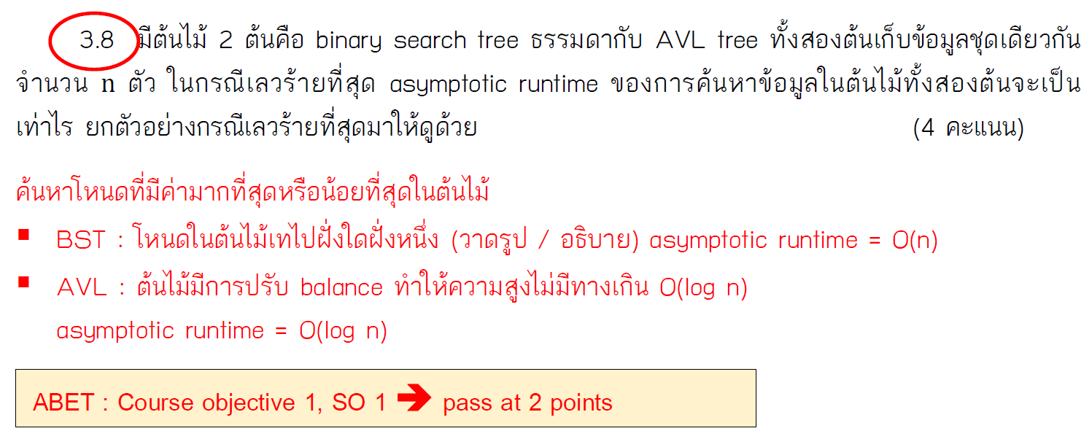

Assessment 1.1.2 Final exam : formulate runtimes from given code

(i.e. code 🡪 set of O(1) operations 🡪 runtime complexity)

Attainability = 33 out of 39 students (84.6%)

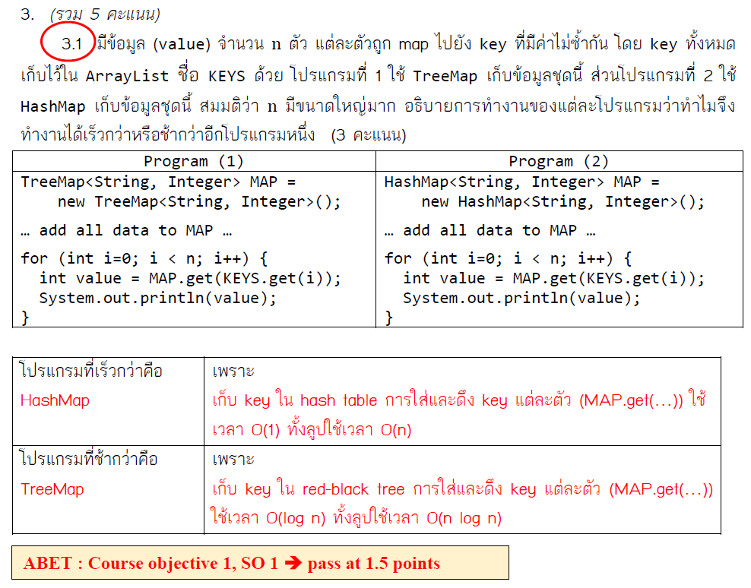

**Average attainability = (79.6 + 84.6)/2 = 82.1%**

Student performance

|  |  |  |  |
| --- | --- | --- | --- |
|  | Student ID | Assessment 1.1.1  Pass at 2 points | Assessment 1.1.2  Pass at 1.5 points |
| 1 | 5913381 | 0 | 0.5 |
| 2 | 6013110 | 2 | 2 |
| 3 | 6013111 | 2.5 | 2 |
| 4 | 6013112 | 2.5 | 3 |
| 5 | 6013113 | 4 | 3 |
| 6 | 6013114 | 0.5 | 3 |
| 7 | 6013115 | 2 | 3 |
| 8 | 6013116 | 4 | 2.5 |
| 9 | 6013117 | 2 | 2 |
| 10 | 6013118 | 2.5 | 0 |
| 11 | 6013119 | 2 | 2 |
| 12 | 6013120 | 0 | 3 |
| 13 | 6013121 | 3 | 2.5 |
| 14 | 6013122 | 2.5 | 3 |
| 15 | 6013123 | 4 | 0 |
| 16 | 6013124 | 2 | 1.5 |
| 17 | 6013125 | 2 | 2.5 |
| 18 | 6013126 | 2 | 3 |
| 19 | 6013127 | 0.5 | 2 |
| 20 | 6013128 | 2.5 | 3 |
| 21 | 6013129 | 2.5 | 3 |
| 22 | 6013130 | 0 | 1 |
| 23 | 6013131 | 2 | 0.5 |
| 24 | 6013132 | 0.5 | 3 |
| 25 | 6013285 | 2.5 | 1 |
| 26 | 6013286 | 2 | 3 |
| 27 | 6013287 | 0 | 3 |
| 28 | 6013288 | 2.5 | 3 |
| 29 | 6013289 | 2.5 | 1.5 |
| 30 | 6013290 | 2.5 | 3 |
| 31 | 6013291 | 3 | 3 |
| 32 | 6013292 | 1.5 | 3 |
| 33 | 6013293 | 4 | 3 |
| 34 | 6013294 | 4 | 2 |
| 35 | 6013296 | 4 | 1.5 |
| 36 | 6013297 | 1 | 3 |
| 37 | 6013298 | 2 | 2 |
| 38 | 6013300 | 2 | 2 |
| 39 | 6013301 | 4 | 3 |

PI 1.2 Solve engineering problems by applying mathematical and engineering knowledge

Assessment 1.2.1 Midterm exam : calculate asymptotic bounds and compare growth rates

Attainability = 29 out of 39 students (74.4%)

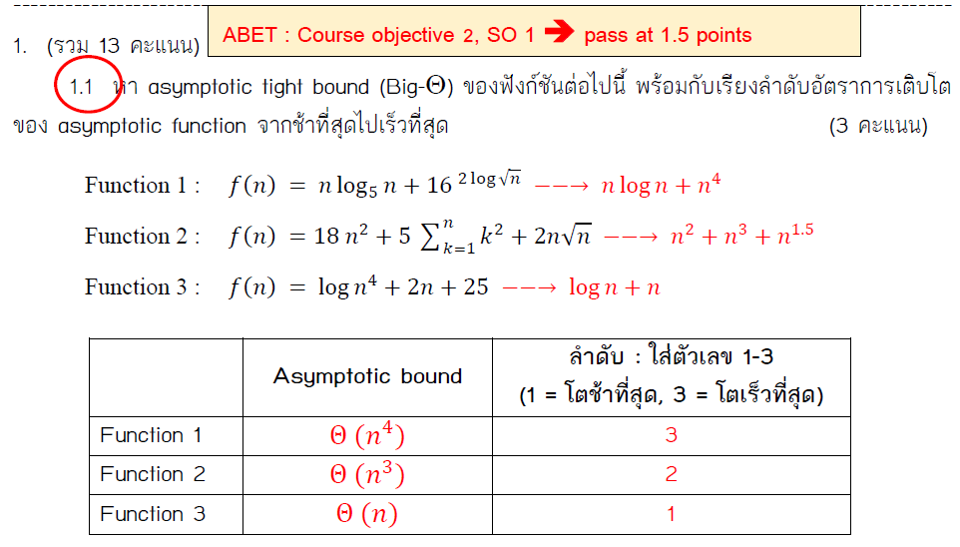

Assessment 1.2.2 Group project 2. Implement Java program to solve word ladder puzzle and write a report explaining data structures and algorithms chosen for the project (pass at 10 out of 15 points)

Attainability = 32 out of 39 students (82.1%)

**Average attainability = (74.4 + 82.1)/2 = 78.2%**

Student performance

|  |  |  |  |
| --- | --- | --- | --- |
|  | Student ID | Assessment 1.2.1  Pass at 1.5 points | Assessment 1.2.2  Pass at 10 points |
| 1 | 5913381 | 1.5 | 0.0 |
| 2 | 6013110 | 3 | 9.0 |
| 3 | 6013111 | 1 | 9.0 |
| 4 | 6013112 | 3 | 14.0 |
| 5 | 6013113 | 3 | 15.0 |
| 6 | 6013114 | 1.5 | 15.0 |
| 7 | 6013115 | 3 | 12.5 |
| 8 | 6013116 | 1.5 | 12.5 |
| 9 | 6013117 | 1 | 15.0 |
| 10 | 6013118 | 1 | 15.0 |
| 11 | 6013119 | 1.5 | 11.5 |
| 12 | 6013120 | 1.5 | 10.5 |
| 13 | 6013121 | 3 | 14.0 |
| 14 | 6013122 | 3 | 12.5 |
| 15 | 6013123 | 3 | 10.5 |
| 16 | 6013124 | 1.5 | 10.5 |
| 17 | 6013125 | 2 | 14.0 |
| 18 | 6013126 | 3 | 15.0 |
| 19 | 6013127 | 3 | 11.5 |
| 20 | 6013128 | 2.5 | 15.0 |
| 21 | 6013129 | 0.5 | 11.5 |
| 22 | 6013130 | 0.5 | 12.5 |
| 23 | 6013131 | 1.5 | 12.5 |
| 24 | 6013132 | 2.5 | 12.5 |
| 25 | 6013285 | 1 | 15.0 |
| 26 | 6013286 | 0 | 15.0 |
| 27 | 6013287 | 2.5 | 9.0 |
| 28 | 6013288 | 1.5 | 12.5 |
| 29 | 6013289 | 1 | 9.5 |
| 30 | 6013290 | 2 | 9.5 |
| 31 | 6013291 | 2 | 12.5 |
| 32 | 6013292 | 1.5 | 15.0 |
| 33 | 6013293 | 3 | 15.0 |
| 34 | 6013294 | 0.5 | 15.0 |
| 35 | 6013296 | 3 | 15.0 |
| 36 | 6013297 | 0.5 | 10.5 |
| 37 | 6013298 | 2 | 9.5 |
| 38 | 6013300 | 3 | 11.5 |
| 39 | 6013301 | 3 | 14.0 |

**Summary**

|  |  |  |  |  |  |  |
| --- | --- | --- | --- | --- | --- | --- |
|  | PI | Attainable  (>= 70%) | Reasons | Remedial Actions | Action Plan | Measurements |
| SO1 | 1.1 | Yes |  |  |  |  |
| 1.2 | Yes | * Some students had weak math background and thus could not calculate logarithms * Students could implement Java program to solve the puzzle correctly but some struggled to explain reasons for choosing certain data structures and/or algorithms | * More emphasis on math in the first few chapters * More examples / case studies on real-world practices | Next year | Next year |