**SO1. An ability to identify, formulate and solve complex engineering problems by applying principles of engineering, science, and mathematics.**

========================================================================

PI 1-1 Identify and formulate engineering problems

**Passing criterion >= 50%**

**EGCO252 System Programming**

**Final Exam**

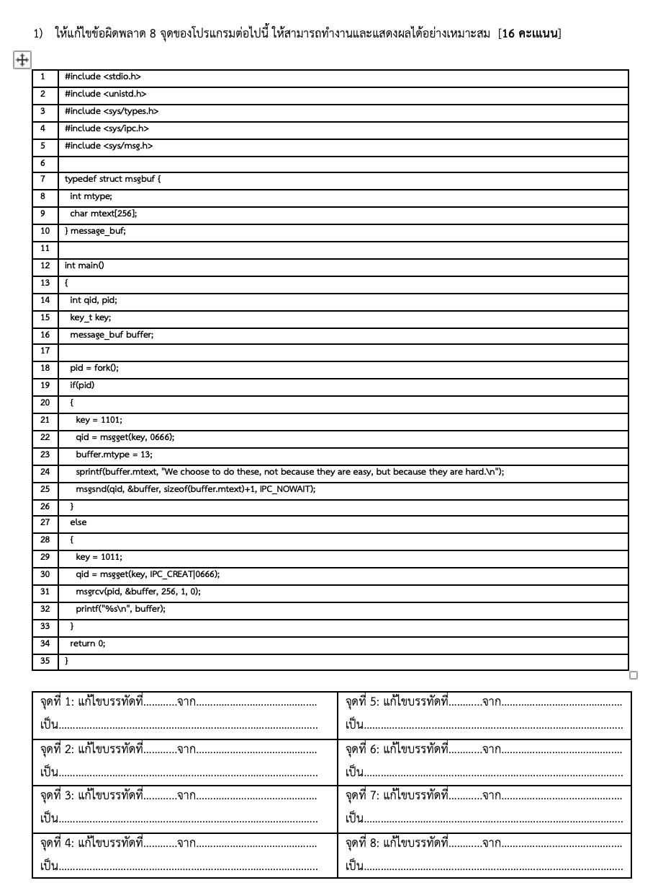

| **Student No.** | **PI 1-1** | **Student No.** | **PI 1-1** |
| --- | --- | --- | --- |
| 1 | ✓ | 19 | 🗶 |
| 2 | ✓ | 20 | ✓ |
| 3 | ✓ | 21 | 🗶 |
| 4 | ✓ | 22 | 🗶 |
| 5 | 🗶 | 23 | ✓ |
| 6 | 🗶 | 24 | ✓ |
| 7 | ✓ | 25 | 🗶 |
| 8 | ✓ | 26 | 🗶 |
| 9 | 🗶 | 27 | ✓ |
| 10 | 🗶 | 28 | ✓ |
| 11 | 🗶 | 29 | 🗶 |
| 12 | ✓ | 30 | ✓ |
| 13 | ✓ | 31 | ✓ |
| 14 | ✓ | 32 | 🗶 |
| 15 | 🗶 | 33 | 🗶 |
| 16 | 🗶 | 34 | 🗶 |
| 17 | ✓ | 35 | 🗶 |
| 18 | 🗶 | 36 | ✓ |
| Number of Pass | 10 | Number of Pass | 8 |

PI 1-1: Attainability = 18/36 = 50% **Attainable**

PI 1-2 Solve problems by applying mathematics and engineering knowledge

**Passing criterion >= 50%**

**EGCO252 System Programming**

**Final Exam**

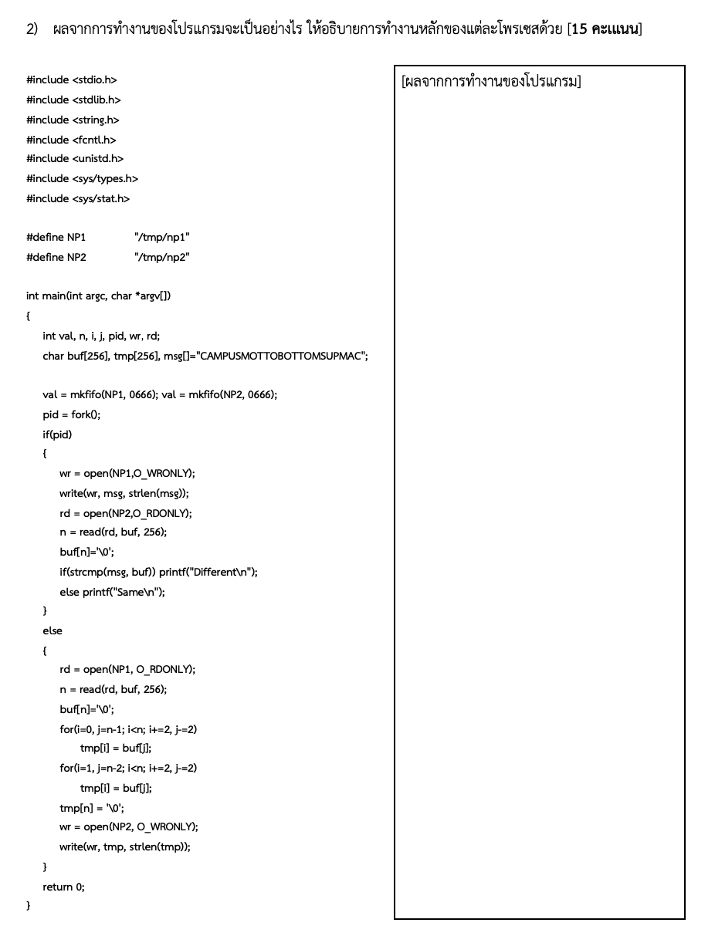

| **Student No.** | **PI 1-2** | **Student No.** | **PI 1-2** |
| --- | --- | --- | --- |
| 1 | ✓ | 19 | ✓ |
| 2 | ✓ | 20 | ✓ |
| 3 | 🗶 | 21 | 🗶 |
| 4 | ✓ | 22 | 🗶 |
| 5 | ✓ | 23 | ✓ |
| 6 | ✓ | 24 | ✓ |
| 7 | 🗶 | 25 | 🗶 |
| 8 | ✓ | 26 | 🗶 |
| 9 | 🗶 | 27 | 🗶 |
| 10 | ✓ | 28 | ✓ |
| 11 | 🗶 | 29 | 🗶 |
| 12 | ✓ | 30 | ✓ |
| 13 | ✓ | 31 | ✓ |
| 14 | 🗶 | 32 | 🗶 |
| 15 | 🗶 | 33 | ✓ |
| 16 | 🗶 | 34 | 🗶 |
| 17 | ✓ | 35 | 🗶 |
| 18 | 🗶 | 36 | 🗶 |
| Number of Pass | 10 | Number of Pass | 8 |

PI 1-2: Attainability = 18/36 = 50% **Attainable**

========================================================================

**SO1 Conclusion**

|  |  |  |  |  |  |
| --- | --- | --- | --- | --- | --- |
| **PI** | **Attainability** | **Reason** | **Remedial Action** | **Action plan** | **Measurements** |
| 1-1 | ✓ |  |  |  |  |
| 1-2 | ✓ |  |  |  |  |

========================================================================

**SO2. An ability to apply engineering design to produce solutions that meet specified needs with consideration of public health, safety, and welfare, as well as global, cultural, social, environmental, and economic factors**

========================================================================

PI 2-1 Produce a design/program that meet a set of requirements, needs, and constraints

**Passing criterion >= 50%**

**EGCO252 System Programming**

**Final Exam**

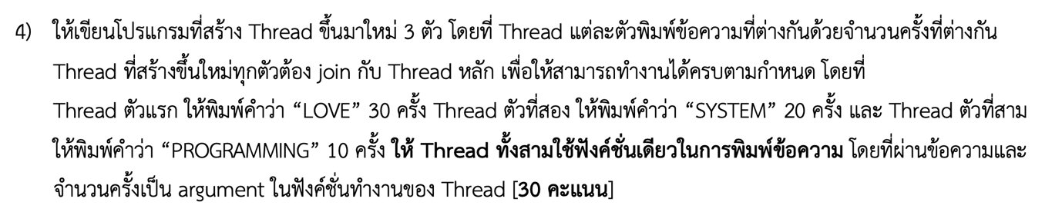

| **Student No.** | **PI 2-1** | **Student No.** | **PI 2-1** |
| --- | --- | --- | --- |
| 1 | 🗶 | 19 | ✓ |
| 2 | ✓ | 20 | ✓ |
| 3 | ✓ | 21 | ✓ |
| 4 | ✓ | 22 | ✓ |
| 5 | ✓ | 23 | 🗶 |
| 6 | ✓ | 24 | ✓ |
| 7 | ✓ | 25 | 🗶 |
| 8 | ✓ | 26 | ✓ |
| 9 | 🗶 | 27 | ✓ |
| 10 | ✓ | 28 | ✓ |
| 11 | 🗶 | 29 | ✓ |
| 12 | ✓ | 30 | ✓ |
| 13 | ✓ | 31 | ✓ |
| 14 | ✓ | 32 | ✓ |
| 15 | 🗶 | 33 | 🗶 |
| 16 | 🗶 | 34 | 🗶 |
| 17 | ✓ | 35 | 🗶 |
| 18 | ✓ | 36 | ✓ |
| Number of Pass | 13 | Number of Pass | 13 |

PI 2-1: Attainability = 26/36 = 72.22% **Attainable**

========================================================================

PI 2-2 Apply appropriately existing solutions

**Passing criterion >= 50%**

**EGCO252 System Programming**

**Final Exam**

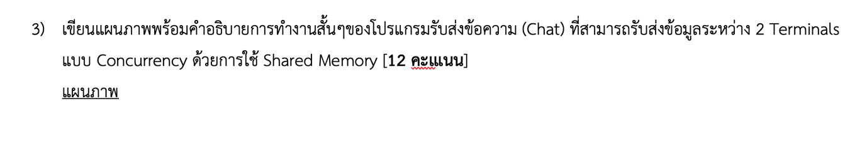

| **Student No.** | **PI 2-2** | **Student No.** | **PI 2-2** |
| --- | --- | --- | --- |
| 1 | 🗶 | 19 | ✓ |
| 2 | ✓ | 20 | ✓ |
| 3 | ✓ | 21 | 🗶 |
| 4 | ✓ | 22 | ✓ |
| 5 | ✓ | 23 | 🗶 |
| 6 | ✓ | 24 | ✓ |
| 7 | ✓ | 25 | 🗶 |
| 8 | 🗶 | 26 | ✓ |
| 9 | 🗶 | 27 | 🗶 |
| 10 | 🗶 | 28 | 🗶 |
| 11 | 🗶 | 29 | 🗶 |
| 12 | ✓ | 30 | 🗶 |
| 13 | ✓ | 31 | ✓ |
| 14 | ✓ | 32 | 🗶 |
| 15 | 🗶 | 33 | 🗶 |
| 16 | 🗶 | 34 | 🗶 |
| 17 | ✓ | 35 | 🗶 |
| 18 | ✓ | 36 | 🗶 |
| Number of Pass | 11 | Number of Pass | 6 |

PI 2-2: Attainability = 17/36 = 47.22% **Unattainable**

========================================================================

**SO2 Conclusion**

|  |  |  |  |  |  |
| --- | --- | --- | --- | --- | --- |
| **PI** | **Attainability** | **Reason** | **Remedial Action** | **Action plan** | **Measurements** |
| 2-1 | ✓ |  |  |  |  |
| 2-2 | 🗶 | Do not understand programming concept | More programming clinics | Next semester | Next semester |

========================================================================