**SO2. An ability to apply engineering design to produce solutions that meet specified needs with consideration of public health, safety, and welfare, as well as global, cultural, social, environmental, and economic factors**

========================================================================

PI 2-1 Produce a design that meet a set of requirements, needs, and constraints

**Passing criterion >= 50%**

**EGCO391 Internetworking Technologies I**

**Final Exam**

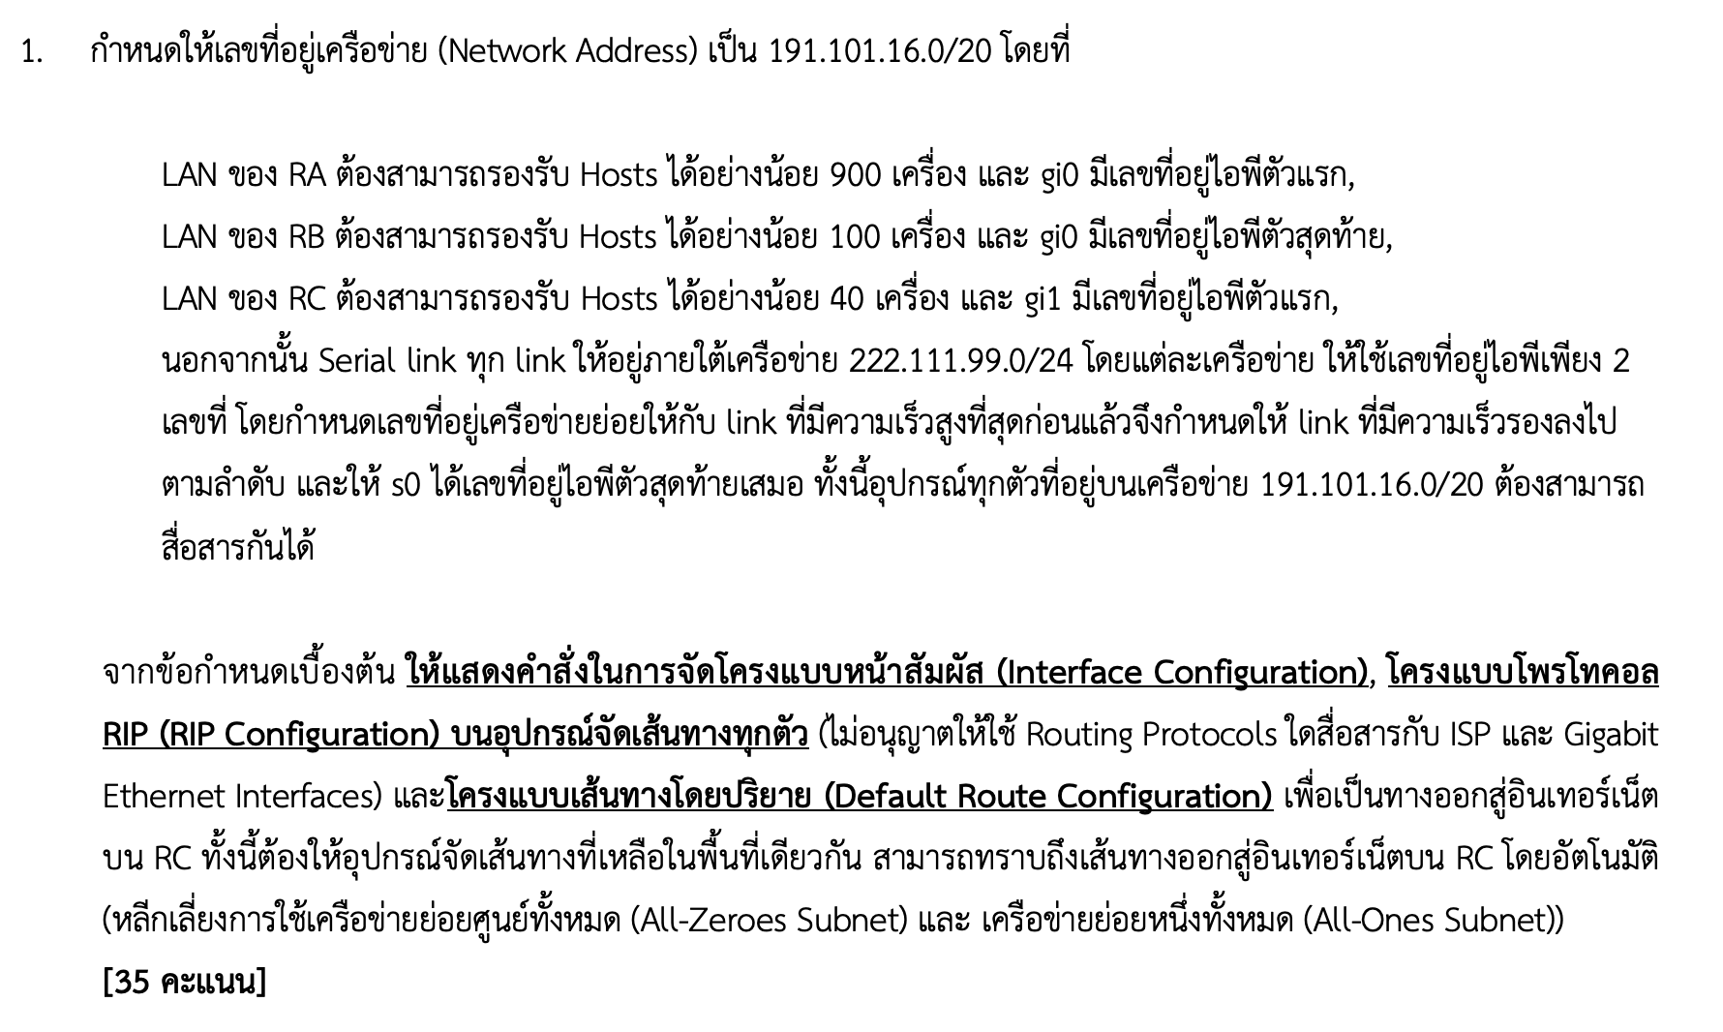



**Gi0**

**S0**

**S1**

**1.544M**

**RA**

**RB**

**Gi0**

**DCE**



**RC**

**64K**

**128K**

**DCE**

**DCE**

**Gi1**

**S1**

**S0**

**S1**

**S0**

**S2**

**S0**

**256K**

**DCE**

**ISP**

**INTERNET**

| **Student No.** | **PI 2-1** | **Student No.** | **PI 2-1** |
| --- | --- | --- | --- |
| 1 | ✓ | 11 | ✓ |
| 2 | ✓ | 12 | ✓ |
| 3 | ✓ | 13 | ✓ |
| 4 | ✓ | 14 | ✓ |
| 5 | 🗶 | 15 | ✓ |
| 6 | ✓ | 16 | ✓ |
| 7 | ✓ | 17 | ✓ |
| 8 | ✓ | 18 | ✓ |
| 9 | ✓ | 19 | ✓ |
| 10 | ✓ | 20 | ✓ |
| Number of Pass | 9 | Number of Pass | 10 |

PI 2-1: Attainability = 19/20 = 95% **Attainable**

========================================================================

PI 2-2 Apply appropriately existing solutions

**Passing criterion >= 50%**

**EGCO391 Internetworking Technologies I**

**Final Exam**

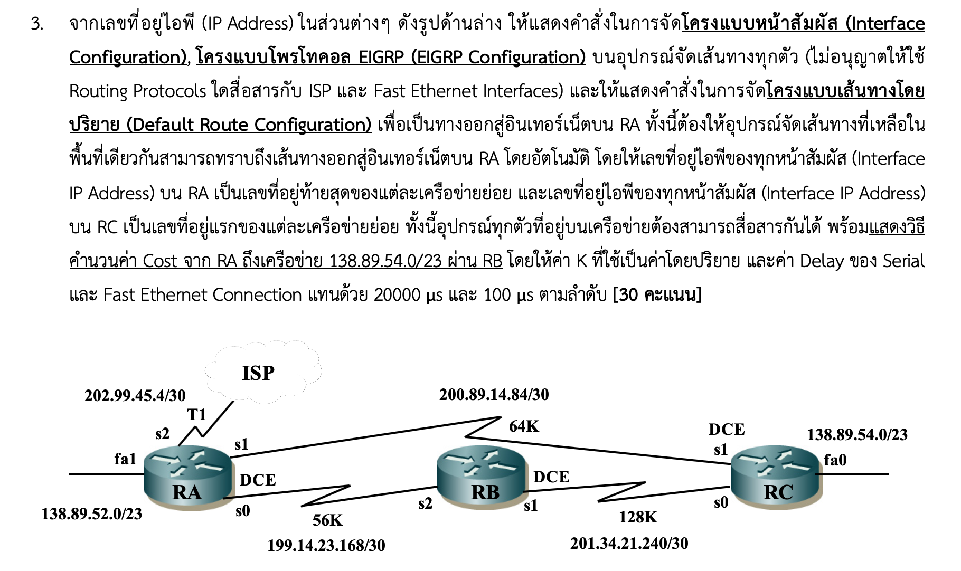

| **Student No.** | **PI 2-2** | **Student No.** | **PI 2-2** |
| --- | --- | --- | --- |
| 1 | ✓ | 11 | ✓ |
| 2 | ✓ | 12 | ✓ |
| 3 | ✓ | 13 | ✓ |
| 4 | ✓ | 14 | ✓ |
| 5 | ✓ | 15 | ✓ |
| 6 | ✓ | 16 | ✓ |
| 7 | ✓ | 17 | ✓ |
| 8 | 🗶 | 18 | ✓ |
| 9 | ✓ | 19 | 🗶 |
| 10 | ✓ | 20 | ✓ |
| Number of Pass | 9 | Number of Pass | 9 |

PI 2-2: Attainability = 18/20 = 90% **Attainable**

========================================================================

**SO2 Conclusion**

|  |  |  |  |  |  |
| --- | --- | --- | --- | --- | --- |
| **PI** | **Attainability** | **Reason** | **Remedial Action** | **Action plan** | **Measurements** |
| 2-1 | ✓ |  |  |  |  |
| 2-2 | ✓ |  |  |  |  |

========================================================================

**SO5. An ability to function effectively on a team whose members together provide leadership, create a collaborative and inclusive environment, establish goals, plan tasks and meet objectives.**

========================================================================

PI 5-1 Assign the appropriate tasks and establish plans to finish work and meet goals on time

**Passing criterion = 100%**

**EGCO391 Internetworking Technologies I**

**Lab Assignments**

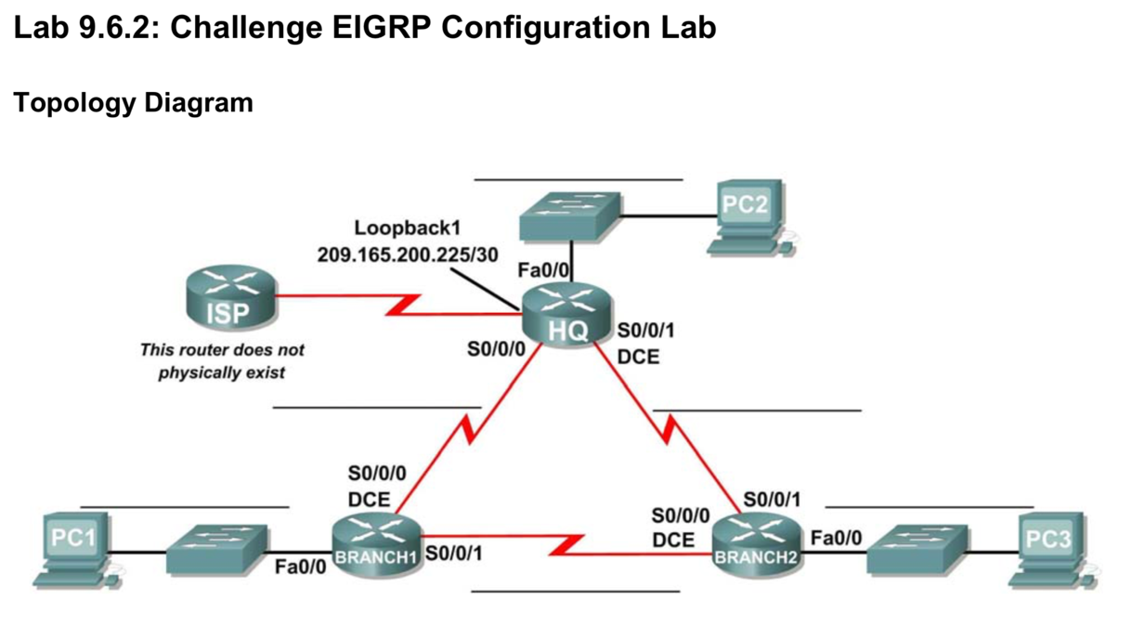

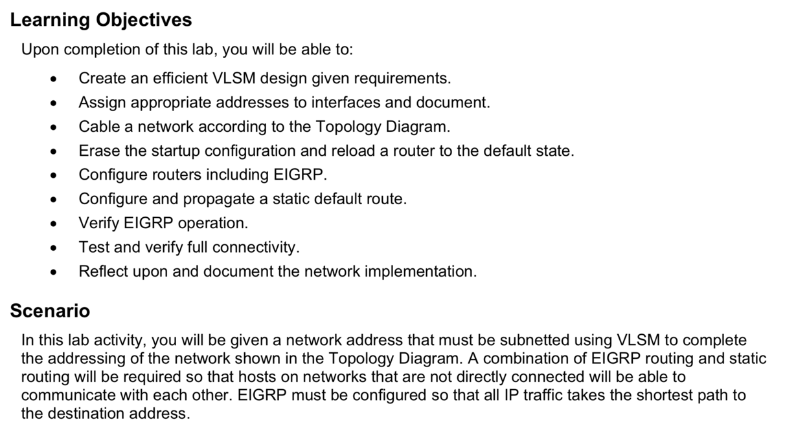

| **Student No.** | **PI 5-1** | **Student No.** | **PI 5-1** |
| --- | --- | --- | --- |
| 1 | ✓ | 11 | ✓ |
| 2 | ✓ | 12 | ✓ |
| 3 | ✓ | 13 | ✓ |
| 4 | ✓ | 14 | ✓ |
| 5 | ✓ | 15 | ✓ |
| 6 | ✓ | 16 | ✓ |
| 7 | ✓ | 17 | ✓ |
| 8 | ✓ | 18 | ✓ |
| 9 | ✓ | 19 | ✓ |
| 10 | ✓ | 20 | ✓ |
| Number of Pass | 10 | Number of Pass | 10 |

PI 5-1: Attainability = 20/20 = 100% **Attainable**

========================================================================

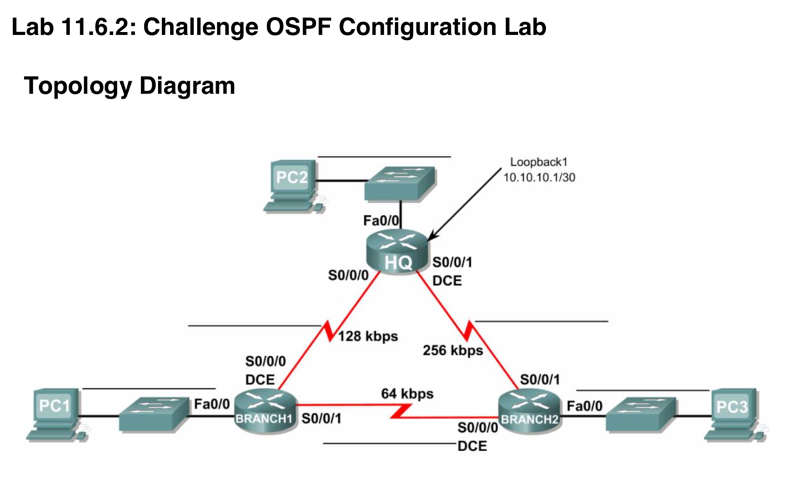

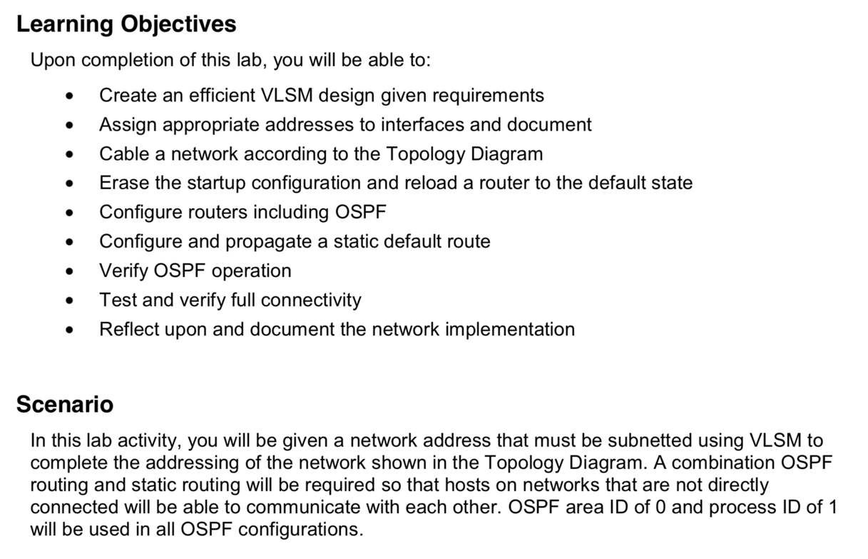

| **Student No.** | **PI 5-1** | **Student No.** | **PI 5-1** |
| --- | --- | --- | --- |
| 1 | ✓ | 11 | ✓ |
| 2 | ✓ | 12 | ✓ |
| 3 | ✓ | 13 | ✓ |
| 4 | ✓ | 14 | ✓ |
| 5 | ✓ | 15 | ✓ |
| 6 | ✓ | 16 | ✓ |
| 7 | ✓ | 17 | ✓ |
| 8 | ✓ | 18 | ✓ |
| 9 | ✓ | 19 | ✓ |
| 10 | ✓ | 20 | ✓ |
| Number of Pass | 10 | Number of Pass | 10 |

PI 5-1: Attainability = 20/20 = 100% **Attainable**

========================================================================

**SO5 Conclusion**

|  |  |  |  |  |  |
| --- | --- | --- | --- | --- | --- |
| **PI** | **Attainability** | **Reason** | **Remedial Action** | **Action plan** | **Measurements** |
| 5-1 | ✓ |  |  |  |  |

========================================================================