Project Tracker
User Role Manual and System Overview
1. System Overview
Project Tracker is a role-based system for tracking participant or participant progress. It uses Supabase as the backend for authentication, database management, and row-level security to enforce data visibility based on each user's permissions.
The main modules include Login, Update Password, Projects, Dashboard, Update Status, Tickets, Participant Status, Admin, Admin Access, Create Project, and Project Settings.
The system also includes back-office capabilities such as automatic participant account creation from CSV files, automatic participant code generation, overall status calculation from project steps, and email notifications when tickets are opened or updated.

2. User Permission Structure
2.1 System Role
Role | Primary Access Rights
Admin | Can view and manage the entire system, including projects, users, access rights, and all admin-only pages.
Internal | Can work on projects where they are members, view dashboards, open and reply to tickets, and update participant status.
Client | Can access projects they have been assigned to, view dashboards and project tickets, but cannot use status update or admin menus.
Participant | Can only view their own status page, track their progress, and open or reply to their own tickets.

2.2 Project Member Role
In addition to system roles, the system also supports project-level roles in the project_members table: admin, editor, and viewer. These roles control permissions within each individual project.
- viewer is suitable for users who mainly need viewing access, such as clients or participants linked to a project.
- editor is suitable for users who need to edit data or update work, such as internal users or admins working directly on a project.
- admin at the project level is intended for deeper project administration, especially when the organization wants dedicated project managers.

3. Summary of Functions by Role

Role | Available Functions
Admin | Access every page in the system, create new projects, configure projects, manage user access, preview the participant view, view dashboards, export CSV/XLSX, open and reply to tickets, and update participant status.
Internal | Access projects where they are members, view dashboards, use Update Status, open and reply to tickets, and view participant data within permitted projects.
Client | Access projects where they are members, view dashboards, and view or reply to tickets within the permitted project scope.
Participant | View their own status, track the progress of each step, open a Request Support ticket, and reply to their own tickets.

4. Screen-by-Screen User Guide
4.1 Login
The Login page is used to enter an email address and password to access the system.
After a successful login, participants are redirected directly to the participant-status page, while other roles are redirected to the projects page.
If a user does not yet have an account, they must contact the system administrator to request access.
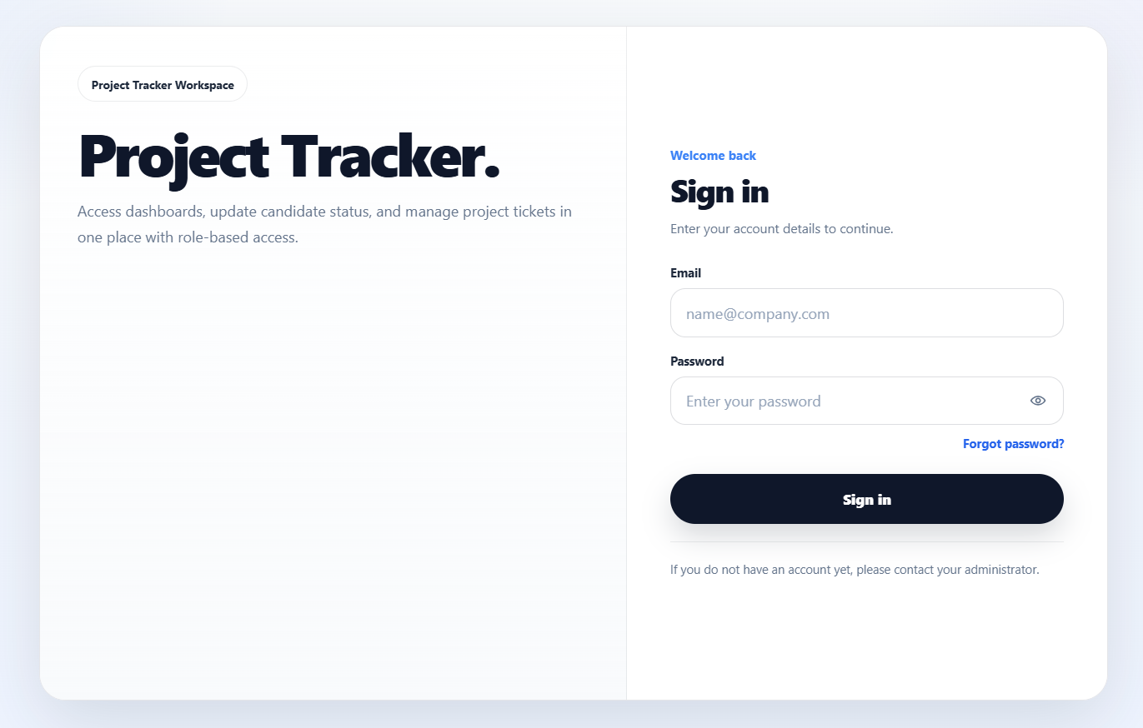

4.2 Update Password
This page is used by users who arrive via a password reset link to set a new password.
The system first verifies that the reset link is still valid, then prompts the user to enter and confirm a new password, with a minimum length requirement of 8 characters.
After the password is updated successfully, the system redirects the user back to the login page.

1. Put email address and click Forgot password? If successful, the green statement will appear saying Password reset email sent. Please check your inbox.
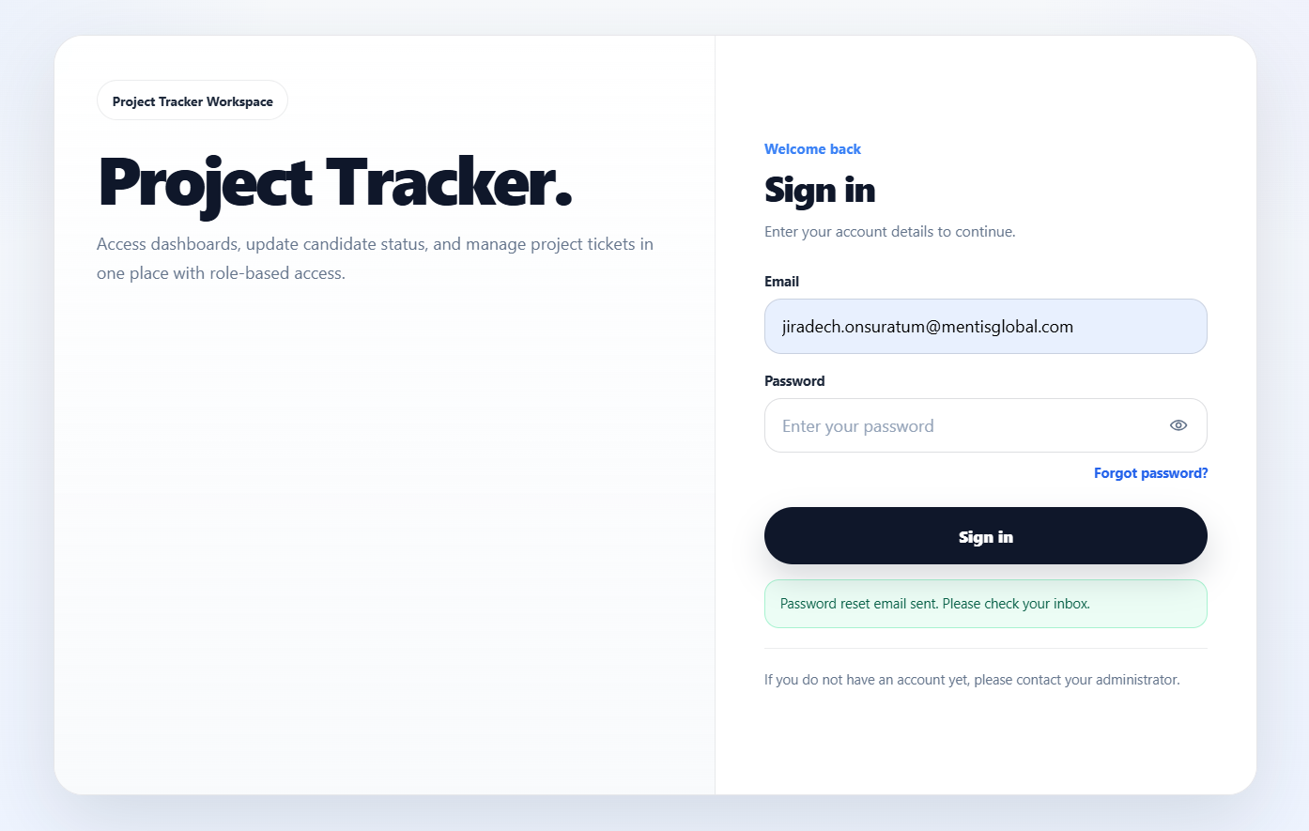
2. Check your mailbox and click the Reset Password and follow the link to the update password page.
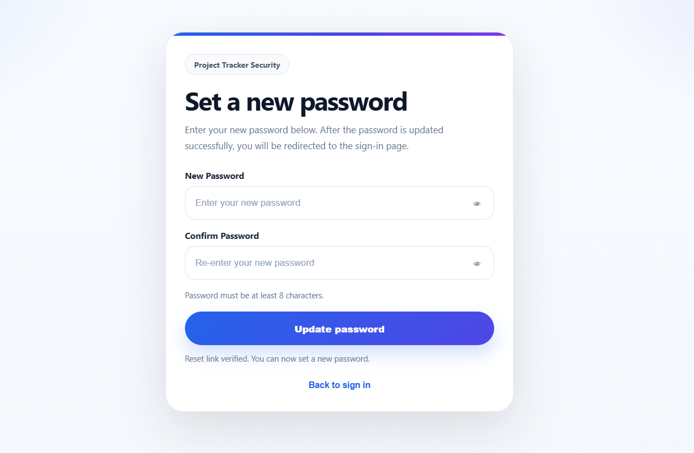

3. Check your mailbox and click the Reset Password and follow the link to the update password page.
Put your new password and if successful, will be redirected to login page and the green statement will appear Password updated successfully. Please sign in with your new password.
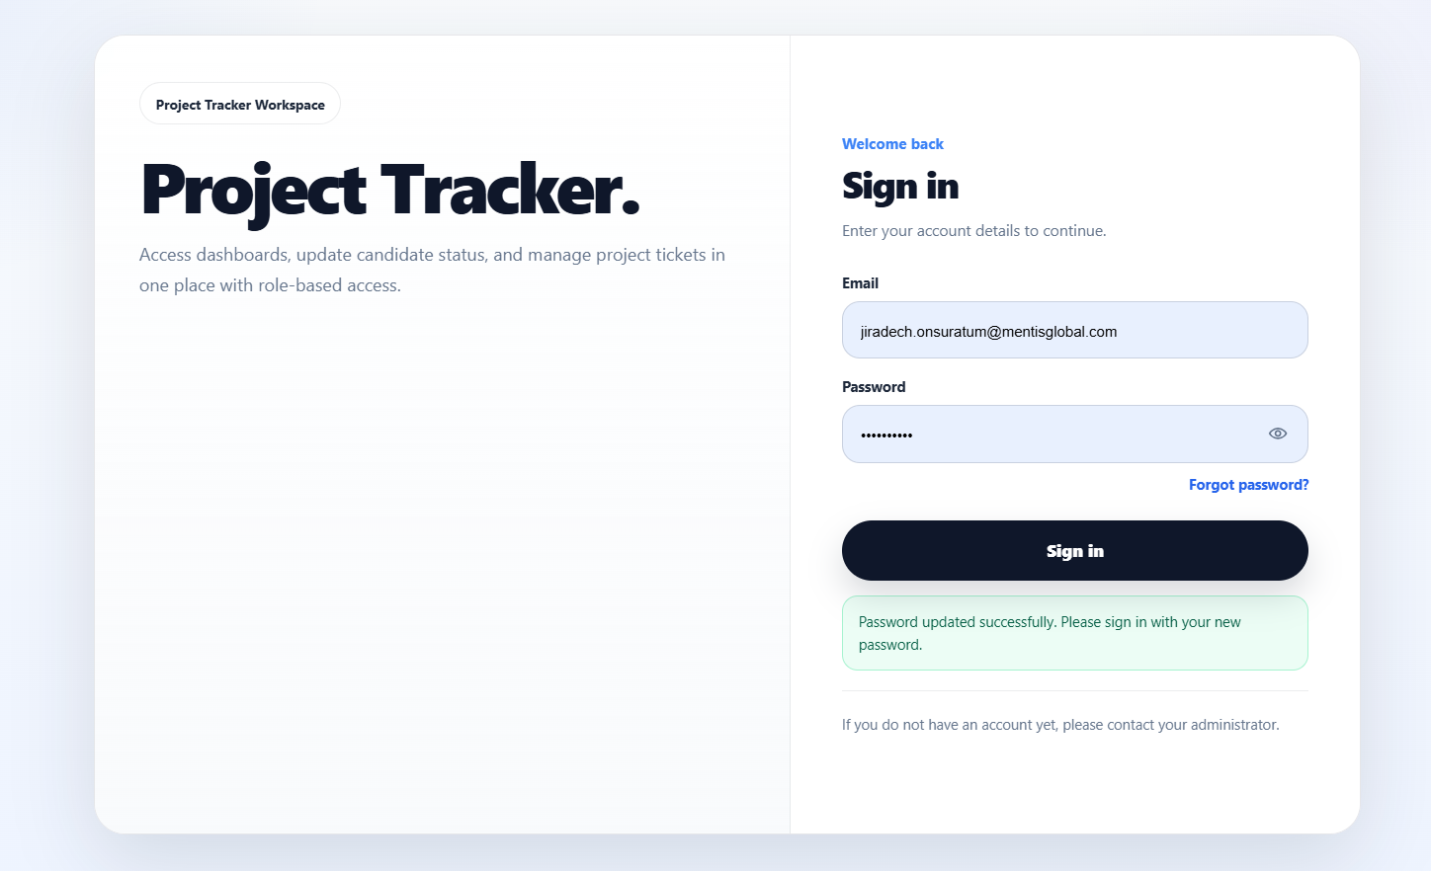

4.3 Projects
The Projects page is the landing page after login for admins, internal users, and clients. It shows only the projects that the current user can access.
After selecting a project, the user can go to the Dashboard, Tickets, or other menus according to their permissions.
This page also serves as the primary project selector for the system and stores the selected project in the session for cross-page use.

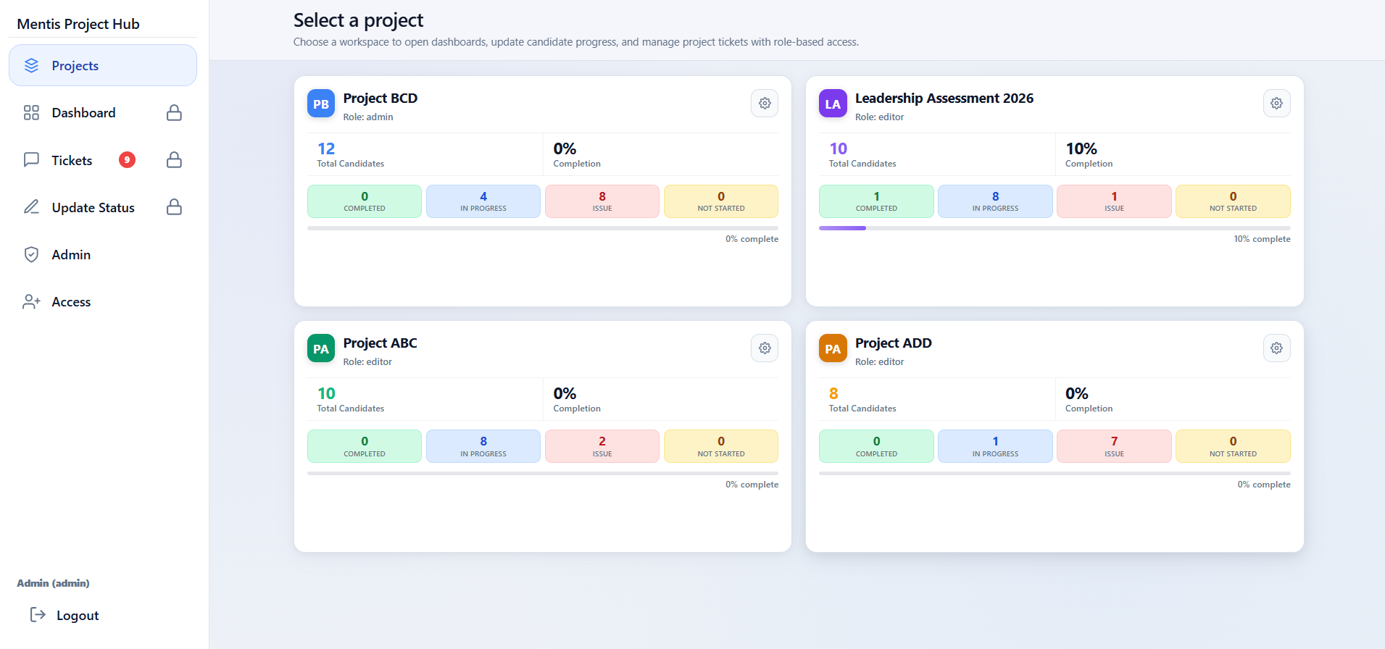

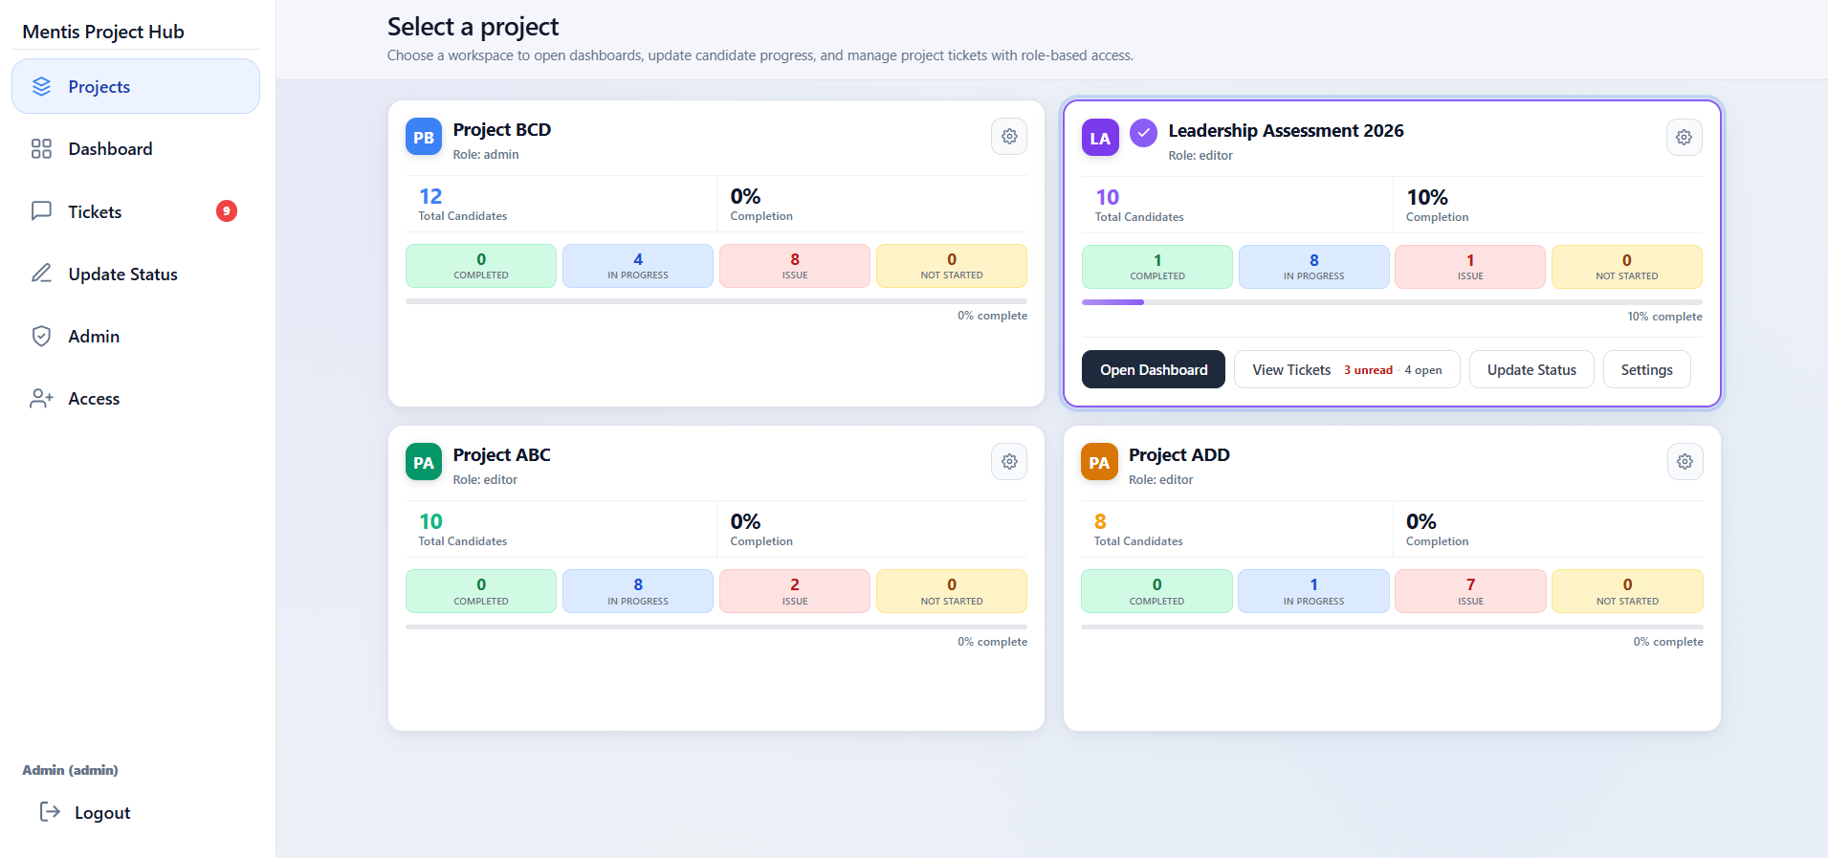
4.4 Dashboard
The Dashboard shows an overview of participants in a project, such as total counts, status breakdowns, charts, and a participant table.
It includes view tabs for switching between the overview and the participant list.
It supports search, filtering by status, and exporting the list as CSV or XLSX.
From the dashboard, users can also open a new ticket for a selected participant.
The columns displayed on the dashboard are controlled by the project's field settings. Fields with show_in_dashboard turned off will not be shown.
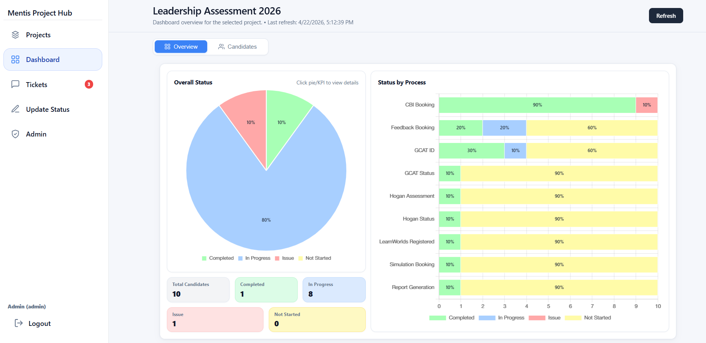
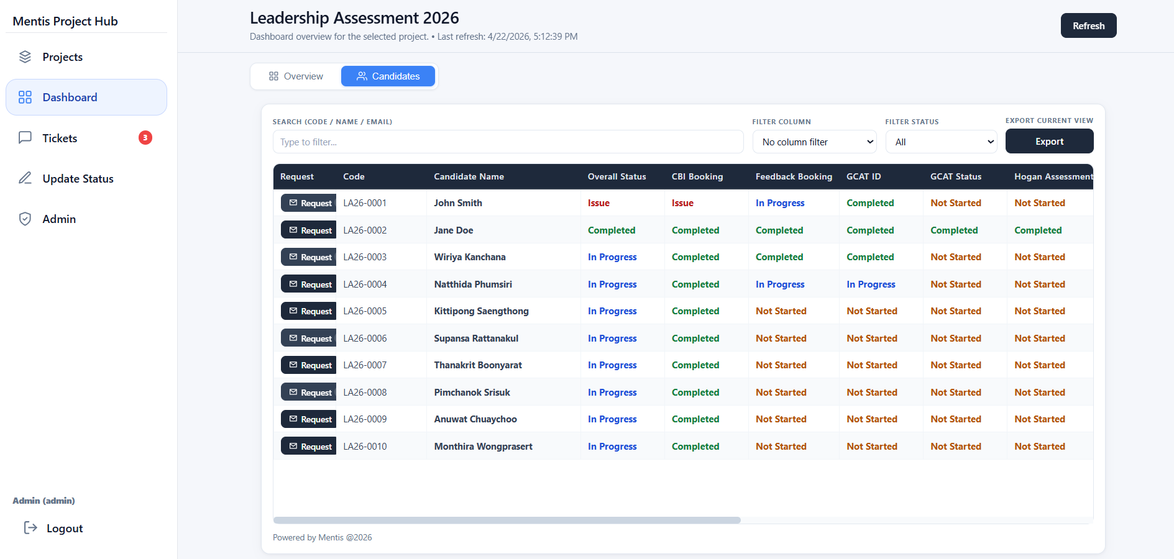

4.5 Update Status
The Update Status page is used by internal users and admins to edit participant data and process status.
Main functions include selecting a participant, adding a new participant, editing the code, name, email, issue, decision, and updating step status with auto-save.
There is a table below for searching, filtering, showing inactive records, and adding participants from both the New Participant and Add Participant buttons.
The system supports deactivating participants instead of permanently deleting their records.
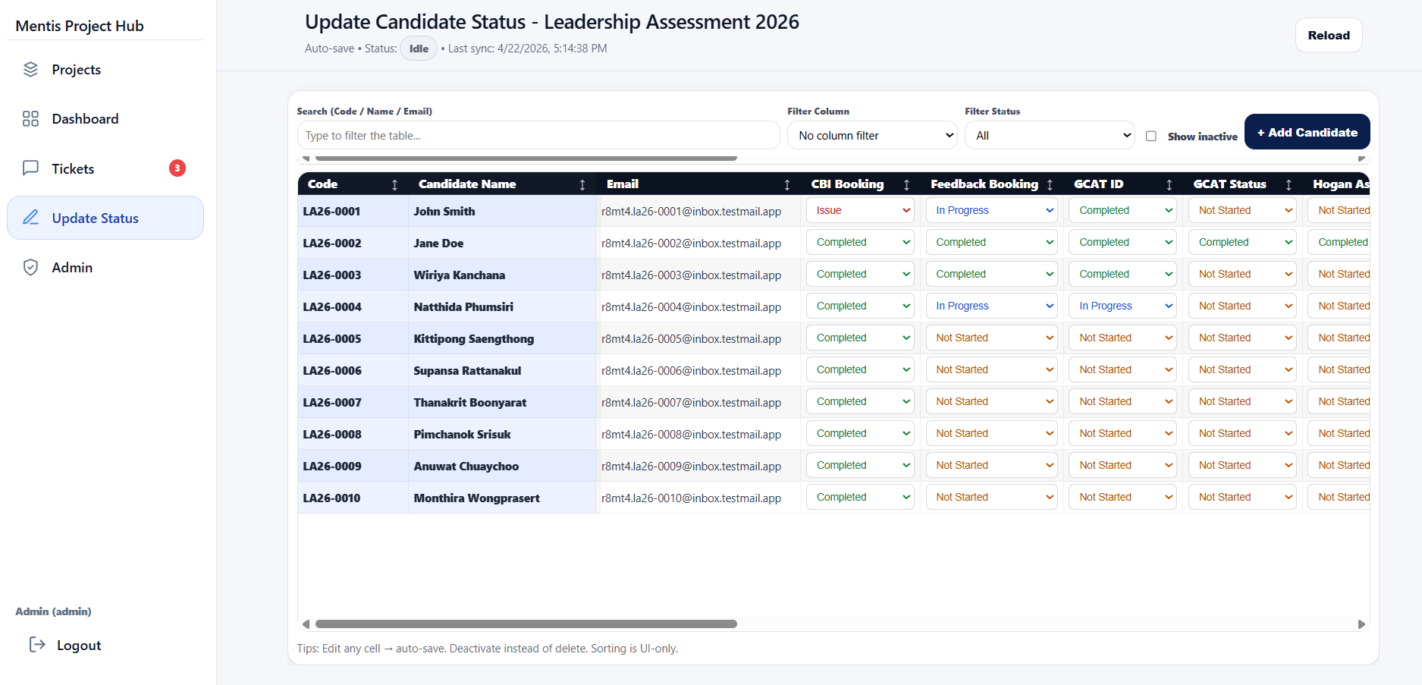
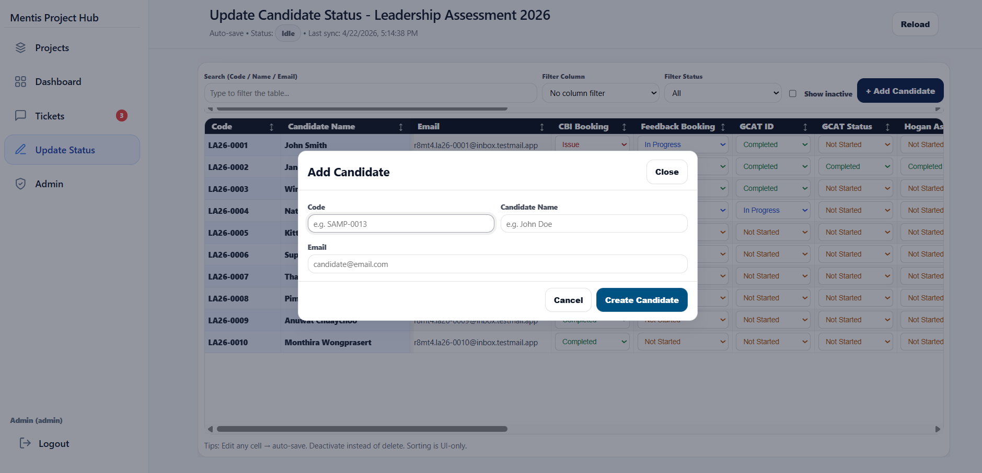
4.6 Tickets
The Tickets page is used to track and communicate requests or issues linked to a participant and project.
Users can search and filter tickets by priority, status, or keyword.
When a ticket is opened, the user can see the original message, reply thread, reply input area, and options to change status or priority based on permissions.
The system has four main priority levels: low, normal, high, and urgent.
When a reply is added or the status changes, the system can call an edge function to send email notifications to relevant users.
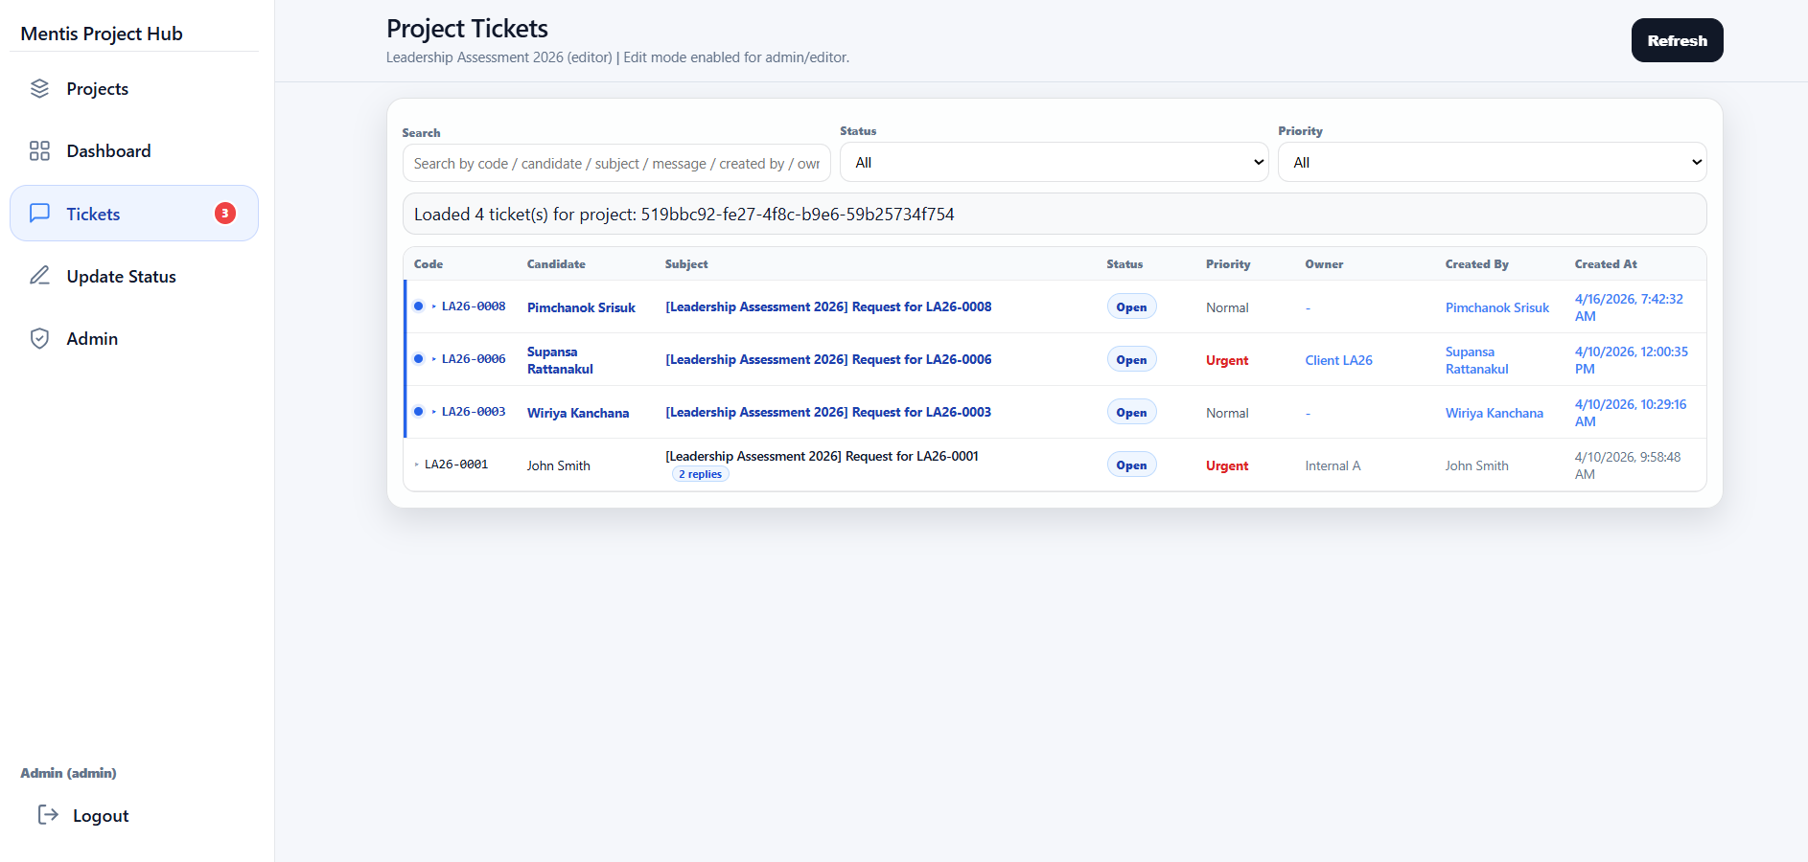
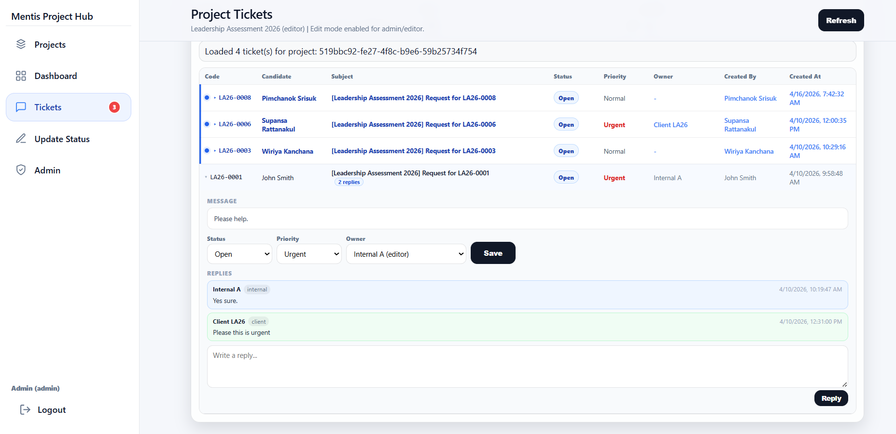
4.7 Participant Status
The Participant Status page is where participants view their own progress.
The page shows a summary of completed, in-progress, and remaining steps, as well as the overall status and the full step list.
Participants can click Request Support to open a new ticket and can also reply within existing tickets.
Admins can open this page in preview mode to view exactly what a participant sees. In this mode, the system shows an ADMIN PREVIEW banner at the top.
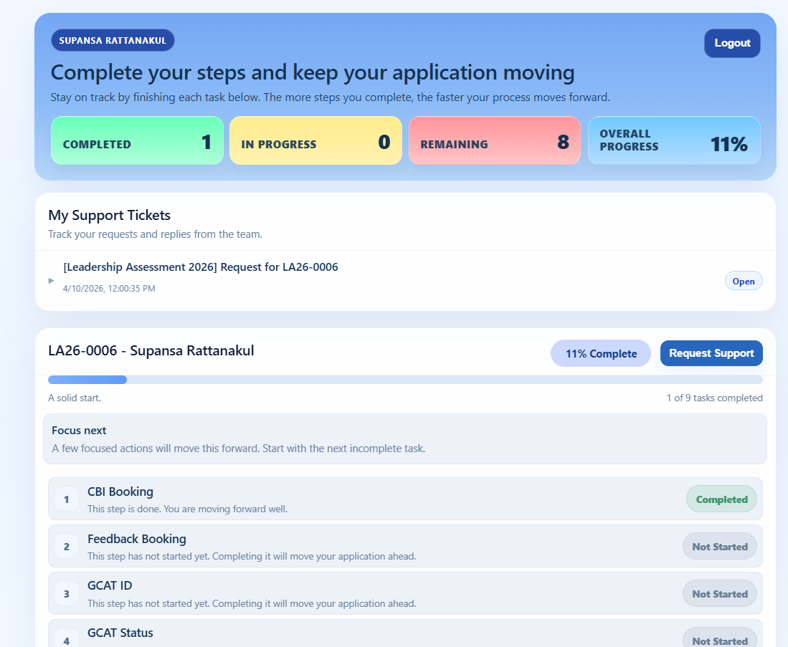

4.8 Admin
The Admin page is a shortcut and system overview page for administrators.
It includes shortcut buttons for the project list, dashboard, update status, create project, project settings, and admin access.
It also shows high-level KPIs such as the number of projects, users, memberships, and records.
It supports participant preview by allowing the admin to choose a project and participant and open the participant-status page in preview mode.
If a non-admin user enters this page, the system automatically redirects them back to Projects.
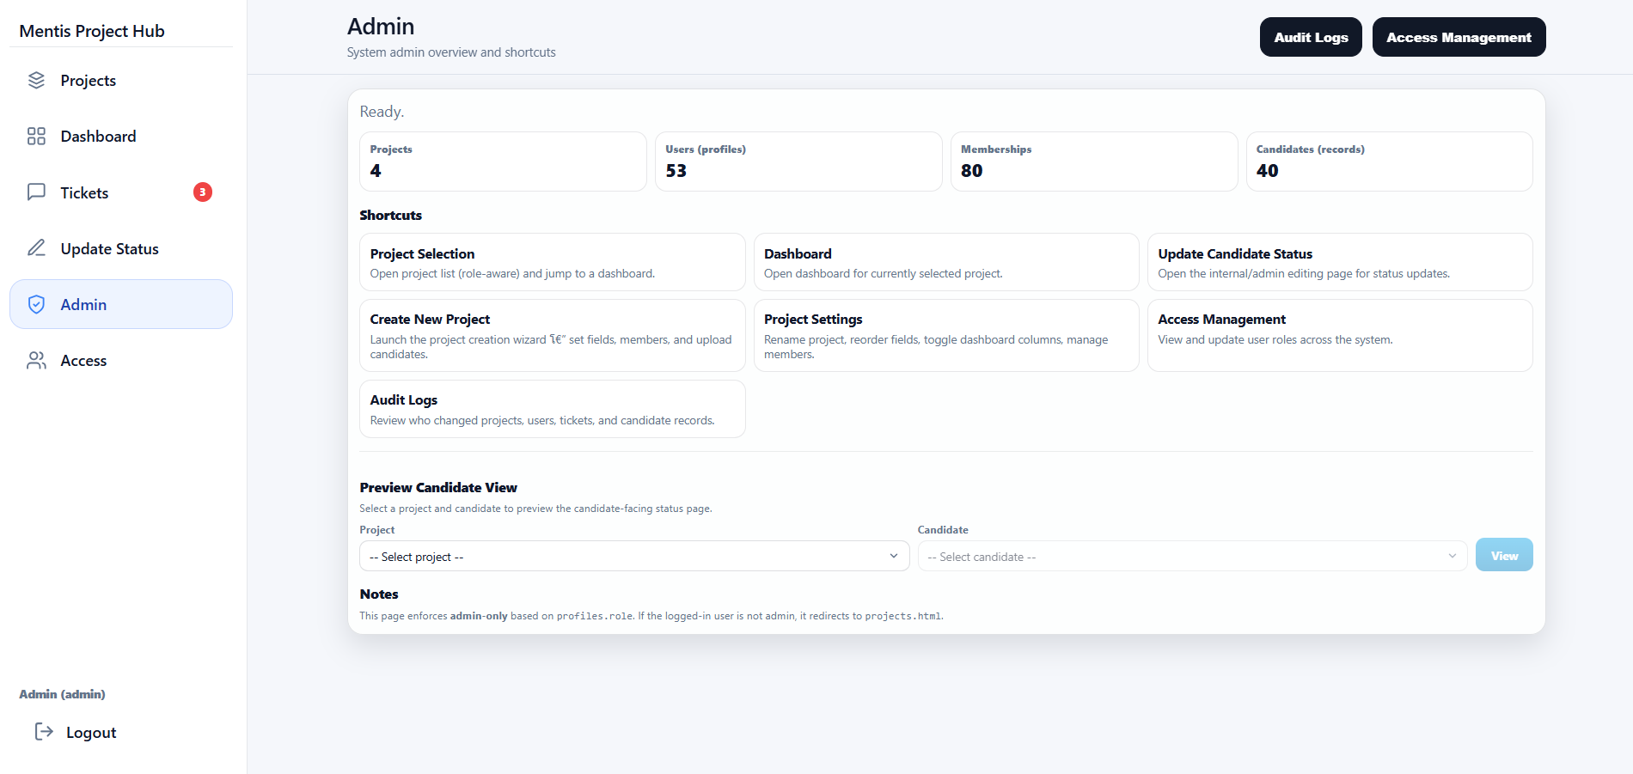

4.9 Admin Access
The Admin Access page is used to manage system-wide user permissions.
Administrators can search for users, change display names, update profiles.role, and manage project membership for each user.
They can add or remove project membership for internal users or clients and assign the project-level role of viewer or editor.
This page is suitable for onboarding new users, adjusting roles, or updating permissions when team assignments change.
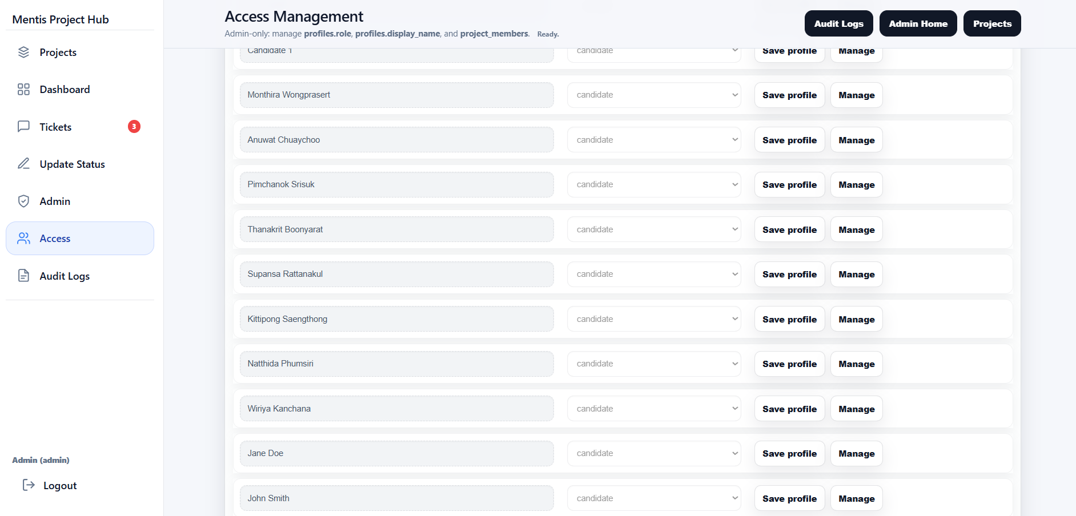

4.10 Create Project
The Create Project page is a 5-step wizard for admins.
1. Project Info: Enter the project name, code prefix, description, start date, end date, and status.
2. Fields: Define project fields, select from the field library, add custom fields, set ordering, and define data types.
3. Members: Select internal users or clients who will access the project and assign their project-level roles.
4. Participants: Upload a CSV file containing name and email columns to create participants in batch. The system automatically generates a temporary password.
5. Review: Review the summary before creating the actual project.
The system uses draft auto-save in localStorage so the user can continue later if the page is closed.
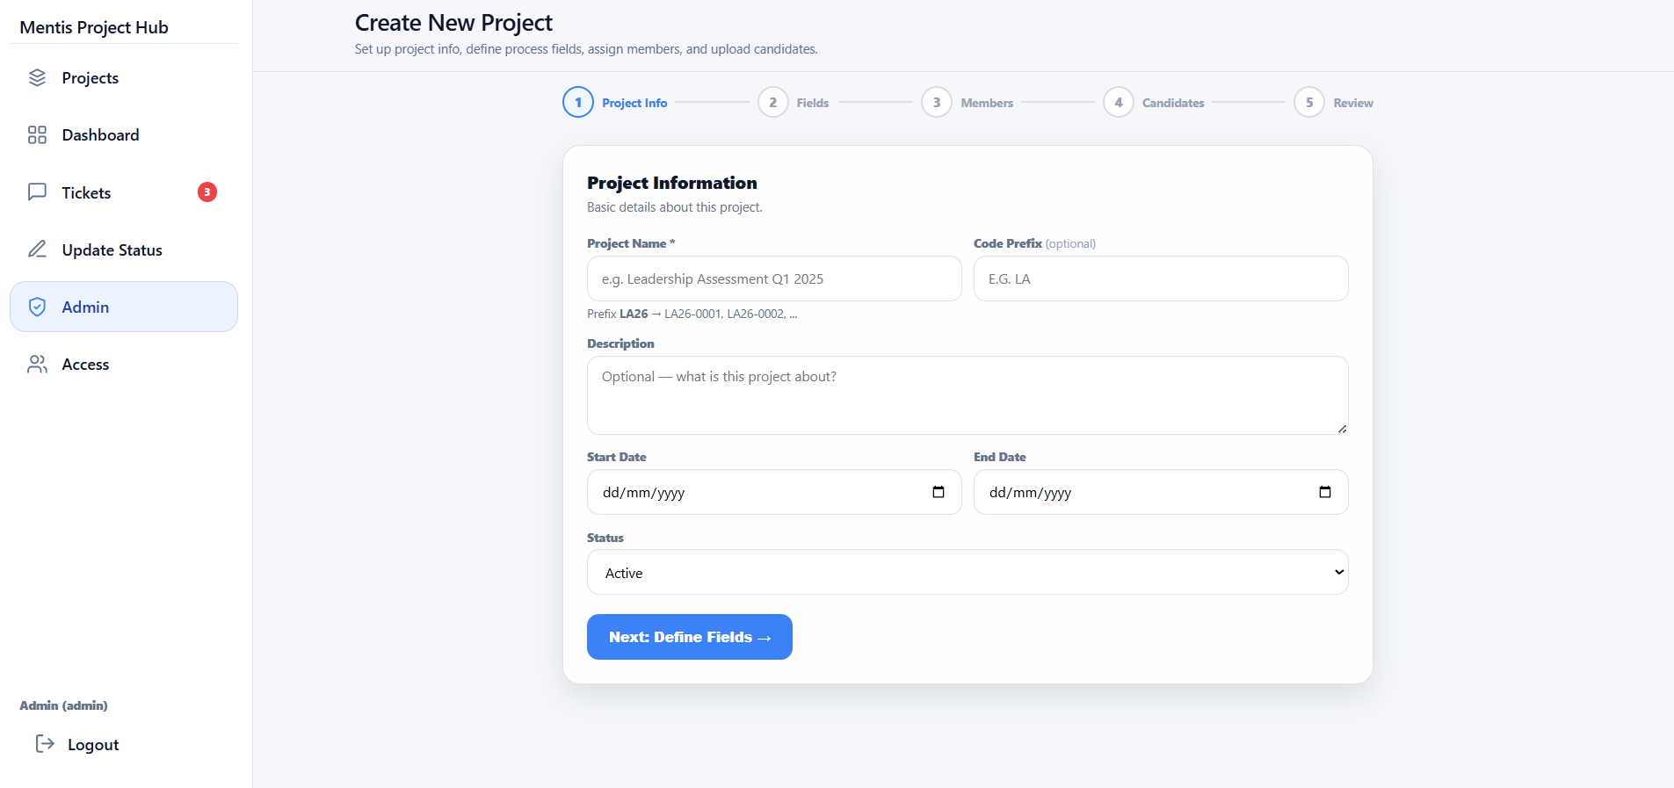

4.11 Project Settings
The Project Settings page is used to modify an existing project. It is divided into four tabs: General, Fields, Members, and Participants.
General: Edit the project name, code prefix, description, start and end dates, and the active, draft, or archived status.
Fields: Change field names, field order, enable or disable fields, and control whether each field appears on the dashboard.
Members: View current members, change member roles, add new members, or remove members from the project.
Participants: Upload a CSV file later to add more participants. The system reuses existing accounts if they already exist or creates new ones automatically.
There is also an Archive Project button to hide the project from the project list while still allowing it to be restored later.
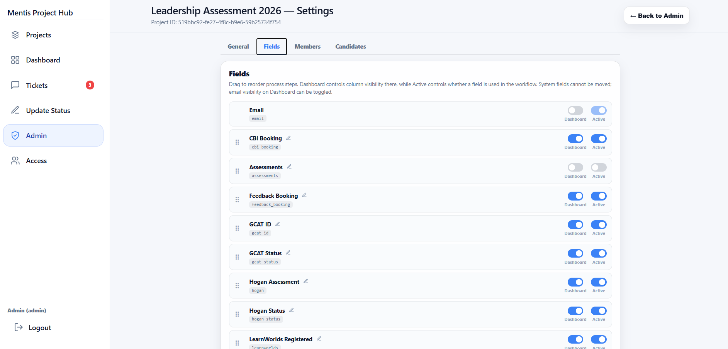

6. Role-Based User Guide
6.1 Admin
- Log in with an admin account.
- Select a project from the Projects page or open the Admin page to use shortcut menus.
- To create a new project, go to Create Project and complete the wizard.
- To manage users, open Admin Access and search for the relevant user.
- To monitor the overall picture, open Dashboard and export data when necessary.
- To update participant status, open Update Status.
- To view the participant experience, use Participant Preview from the Admin page.
6.2 Internal
- Log in to the system.
- Select the assigned project.
- Open Dashboard to review the participant overview and filter the list that requires follow-up.
- Open Update Status to edit participant step status, issue, or decision.
- Use Tickets to follow up on questions or issues from participants or clients and reply within the thread.
6.3 Client
- Log in to the system.
- Select the project you have been granted access to.
- Open Dashboard to review the overall participant progress.
- Open Tickets to view requests, track status, and reply when needed.
- If the required project is not visible, contact an admin to verify your membership.
6.4 Participant
- Log in with your own account.
- The system automatically opens the Participant Status page.
- Review the overall status and each step from the same page.
- If you have a question or issue, click Request Support.
- If you already have an existing ticket, you can open it and reply in the thread.
- If you cannot access the system or need to change your password, follow the organization's password reset process.
7. Automatic Functions and System Rules
- The system calculates the overall status from step fields within the project, so the dashboard and participant-status page automatically reflect the latest status.
- The Update Status page and several other parts of the system use auto-save to reduce repeated manual saving.
- When an admin imports participants from CSV, the system automatically creates the auth user, profile, record, email value, and project membership through the admin-create-user edge function.
- The ticket system calls the ticket-notify edge function to send email notifications to participants, clients, internal users, or admins depending on the event and the replying user.
- The system uses row-level security in the database to enforce actual data visibility, rather than relying only on hiding menu items on the interface.
8. Important Notes and Recommendations
- If an internal user or client does not have project membership, the system may redirect them away from project pages or may not show the expected data.
- Participants should not use internal menus because the system is designed for them to work primarily through the Participant Status page.
- Archiving a project hides it from the project list but does not permanently delete the data.
- CSV import must include name and email columns, and rows with invalid formatting are skipped or shown as errors in the preview.
- To show or hide a dashboard column, adjust Project Settings > Fields > show in dashboard.

